ET-501

Lab Term Project

Top 10 Sports around the World

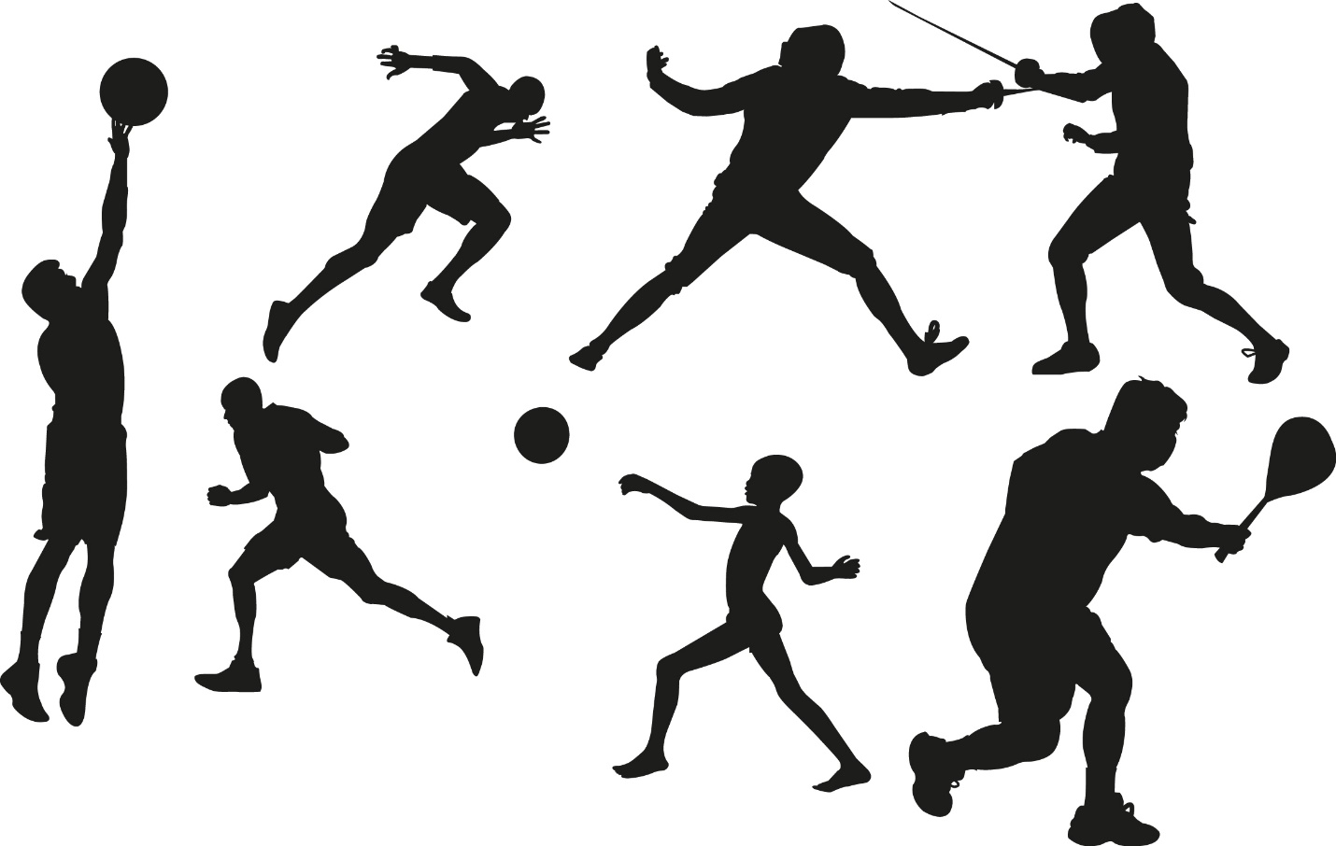

Shuangjie Lin

Here’s some information about the most popular sports around the world right now. At

our first spot is Soccer, but as Europeans call it, Football. Following up is, Cricket, Field Hockey,

Tennis, Volleyball, Table Tennis, Baseball, Golf, Basketball, and American Football.

Here is a chart so you can actually see the percentage of which sport that dominates.

This chart above is based on a total of 12.5 billion people from around the world.

But not every country in the world, play these sports. Here is another chart to show the

countries that actually play. These charts are based on regional popularity of the sport. So some

sports might not be showed, even if the country does play that sport.

Sports are played all other the world and has a really competitive scene between every

country.

From my experience of living in NY, and going to the park around my neighborhood. I

didn’t realized how big of a percentage of the world plays soccer and cricket. I often play

handball, which is a sport that is only in New York, and from what I heard, Florida. Handball is

one of those sports you only play, if you grew up in a culture that actually had that sport.

Before this study, I thought basketball would be a more populated sport, but I didn’t

know soccer had so many more fans. But after the study, I now know there are 3.5 billion

soccer fans. While there is only 400 million basketball fans. That’s nearly 9 times more fans for

soccer than basketball.