PERIPHERALS PLUS

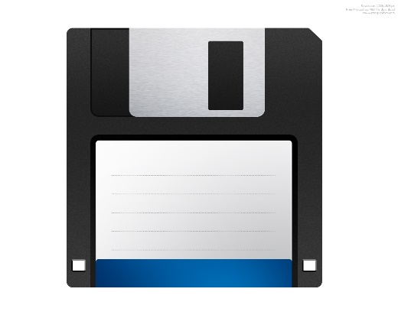

(917)-668-9866

46-33 156st Flushing, NY, 11366

March 2, 2001

Mike

43-35 151st

Flushing, NY, 11353

Dear Mr. Jones:

We would like to take this opportunity to thank you for your recent floppy disk order. We are happy to welcome you as a new customer to Peripherals Plus.

At Peripherals Plus we hope to meet all your computer input, output, and storage device needs. If you ever have any comments or questions, please feel free to contact your service representative, at 800-555-1234.

Sincerely,

Someone