University of Waterloo

Faculty of Mathematics  
Department of Computer Science

Software Requirements Specification Document

Design Lab

Waterloo, Ontario, Canada

Prepared by  
Youjing Li  
20602178  
y864li@uwaterloo.ca  
4B Electrical Engineering

Prepared by  
Daniel Francisco  
20601939  
de3franc@uwaterloo.ca  
4B Computer Engineering

Prepared by  
Zack Zhan  
20628898  
z4zhan@uwaterloo.ca  
4B Computer Science

Prepared by  
Shuangyou Huang  
20683839  
s257huan@uwaterloo.ca  
4B Computer Science  
  
05 April 2020

Table of Contents

1 Introduction 1

1.1 Purpose 1

1.2 Document Conventions 1

1.3 Project Scope 1

1.4 References 2

2 Overall Description 3

2.1 Product Perspective 3

2.2 User Classes and Characteristics 3

2.3 Operating Environment 4

2.4 Design and Implementation Constraints 4

2.5 Assumptions and Dependencies 4

3 System Features 4

3.1 System Feature Descriptions and Requirements 4

4 Data Requirements 8

4.1 Logical Data Model 8

4.2 Data Dictionary 9

4.3 Data Acquisition, Integrity, Retention, and Disposal 15

5 External Interface Requirements 16

5.1 User Interfaces 16

5.2 Software Interfaces 18

5.3 Hardware Interfaces 19

5.4 Communication Interfaces 19

6 Quality Attributes 20

6.1 Usability 20

6.2 Performance 20

6.3 Security 21

6.4 Safety 21

6.5 Efficiency 21

6.6 Portability 22

7 Internationalization and Localization Requirements 22

8 Other Requirements 22

Appendix A: Glossary 24

Appendix B: Analysis Models 26

1. Introduction

Purpose

This SRS document will outline the behaviour of the smartphone app, Review Trips, and will explain the required functionality for Review Trips to operate. The smartphone app being described in this document is an initial iteration and represents the first potential release candidate of Review Trips. Lastly, this document is intended for consumption by all types of readers who are interested in better understanding the Review Trips product. The document is written such that it is understandable to all people regardless of technical background, who are interested in better understanding the Review Trips product.

Document Conventions

An important document convention followed throughout this document is a standard for which bulletin points for a topic are made. For points under a header such as “Project Scope”, the first point will be named “PS-1” and the second “PS-2”, etc. Secondly, any sub-points are to be named “PS-1.1”, “PS-1.2”, etc. The entire document uses size 11 Times New Roman font, and 1.5 spacing with text evenly distributed between margins. A second convention followed throughout this document is the numbering, bolding and increased font size of all headers, such as section titles “1. Introduction” using **size 14, bold Times New Roman** font and and“1.2 Document Conventions” using **size 13, bold Times New Roman** font compared to the standard text used throughout the document that is size 11, Times New Roman font. All headers in tables utilize the same **Times New Roman size 11 font but utilize bold to emphasize them as headers**. Lastly, all table and figure numbers utilize a **bold Times New Roman size 11** font to emphasize them as unique and differentiate them for the other text. This entire SRS document is structured and based on the examples and explanations provided in the CS 445 / CS 645 / ECE 451 lecture on SRS documentation [1].

Project Scope

Review Trips is a smartphone app that will allow travellers with interesting travel experiences to be able to share them with others. The system will be designed to encourage sharing travel itineraries for every type of trip, from casual walks to backpacking adventures and intercontinental travel. There are two main roles a user can take on while using Review Trips. Registered Users who have an account can choose to post itineraries and share their experiences. Both Registered and Unregistered Users can also choose to browse content on the system, optionally by searching and filtering other user’s content by many parameters, including but not limited to, duration of trip, location, difficulty and budget. Registered users can also comment, rank and review other users' itineraries, to either critique them, or add to another user's trip experience.

In addition to the primary user experience, Review Trips also offers a moderation system that employs both artificial intelligence and human driven moderation. Every post when uploaded or edited, is automatically scanned by the artificial intelligence moderator system, which flags potentially inappropriate content such as text, photos or videos. Additionally, all users whether registered or unregistered are also allowed to report posted itineraries they feel are inappropriate. All reported itineraries enter a queue to be reviewed by a human moderator employee of Review Trips. This professional moderator will decide whether or not the content posted in the reported itinerary breaches our terms and conditions, and will either remove the itinerary and send a message to the author warning them why their post was removed, or will confirm the itinerary is acceptable and remove it from the reported queue.

References

1.Sakhnini,Victoria.13_Documentation-SRS, https://learn.uwaterloo.ca/d2l/le/content/508963/viewContent/2889098/View

2. Tim Hickman & Dr. Detlev. The International Comparative Legal Guide to: Data Protection 2018, https://www.osler.com/osler/media/Osler/reports/privacy-data/Data-Protection-Laws-in-Canada-2018.pdf

3. Crunchbase. AutoNavi, https://www.crunchbase.com/organization/autonavi#section-overview

4. Google. Google Maps, https://www.google.ca/maps/about/mymaps/

5. W3Schools. SQL, https://www.w3schools.com/sql/

6. W3Schools. PHP MySQL Database, https://www.w3schools.com/php/php_mysql_intro.asp

1. Overall Description

Product Perspective

Review Trips is an entirely new smartphone application that builds a community where users can share their travel experiences and look at other’s posts. This software provides a platform for those who want to go on a trip but don’t know where to go and those who had a wonderful experience on the trip and feel eager to share with others.

User Classes and Characteristics

UC-1: Administrators

UC-1.1: Human moderators.

Human moderators are in charge of deciding whether the reported posts contain inappropriate content and need to be banned.

UC-1.2: Official accounts

There should exist official accounts to post important information and to give advice to new users.

UC-2: Regular users

UC-2.1: Users who are interested in travelling.

People who are interested in travelling use our APP to look at other travellers' travel experience and discuss their opinions with others.

UC-2.2: Users plan to travel recently.

People who plan to travel use our APP to seek ideas for their destinations, schedules, and must-do activities etc.

UC-2.3: Professional travel bloggers.

Professional travel bloggers use this travel application to get more fans/subscribers in order to raise their popularity.

Operating Environment

OE-1: The software shall operate correctly with the following operating system: Android version 5.0 through 10.0, IOS version 7 through 13.

OE-2: The application should be permitted by the user to access the internet and GPS.UC-2.3: Professional travel bloggers.

Design and Implementation Constraints

CO-1: All important data should be stored in MySQL database [6].

CO-2: All database operations should only use SQL commands [5].

Assumptions and Dependencies

AS-1: User does not use VPN to change his/her real location.

AS-2: Human moderators are expected to deal with reported posts everyday.

DE-1: To find a travel place on a map depends on the Google Map API which is expected to work properly.

DE-2: Reviewing reported posts depends on the change being made by human moderator to decide whether these posts contain inappropriate content or not.

1. System Features

System Feature Descriptions and Requirements

**Table 3-1** presents all the features defined by Review Trips.

**Table 3-1** Features Table of the Review Trips System

|  |  |  |
| --- | --- | --- |
| **System Feature** | **Descriptions** | **Requirements** |
| **Homepage:**   1. Sign up      1. Login      1. Find posts      1. User agreement | **Default initial page to be displayed**  A user entered in the homepage can choose to sign up for a trip-reviewing account to access more features (draft, post, logout, edit, score, delete, review) about itineraries.  A user can choose to sign in for an existing registered account to access more features (draft, post, logout, edit, score, delete, review) exclusive to registered users.  At the homepage a user can attempt to find specific posts with either a search sequence of keywords or a one-to-one mapping between a field in the form with options (duration, location, difficulty, objectives, transportation, budget, number of reviews, ranking).  A user who just installed the application must agree to this user agreement about retaining necessary user data (email, address, name). | Only available for an unregistered user. Need to fill in the form with necessary fields (username, password, email).  Only available for a registered user. Need to enter correct password  and username to access an account.  Available for both an unregistered user and a registered user. Need to enter a sequence of key words or select with options.  Available for both an unregistered user and a registered user. Only for a user who just installed the application on a device. |
| **Itinerary Description:**   1. Rank posts      1. Report posts      1. Score posts      1. Review posts | **Displaying page for entering a specific post**  A user can submit the ranking options (duration, location, difficulty, objectives, transportation, budget, number of reviews, ranking) based on preference to filter the posts accordingly.  A user can choose to report a specific post for detecting potential inappropriate content through a report button in the post.  A user can express his/ her preference through submitting the score (like or  dislike) in the selected post.  A user can add a comment with a selected post to share the thoughts and opinions. | Available for both an unregistered user and a registered user. Need to select the given ranking options.  Available for both an unregistered user and a registered user.  Only available for a registered user. Need to enter a given score options (like or dislike).  Only available for a registered user. Need to enter a sequence of words. |
| **Manage my Itineraries:**   1. Post an itinerary     10. Edit an itinerary    11. Delete posts    12. Create a draft post | **Displaying page for managing itineraries**  A user can share the travelling experience by posting new content at the page of managing my Itineraries.    After posting an itinerary, a user may wish to edit the itinerary, potentially to make large changes, or fix spelling mistakes.  A user may wish to delete posts from the application when the posts may be outdated or inappropriate.  A user may wish to create a draft of a post that eventually wants to add to the system but want to save on the device for future editing. | Only available for a registered user. Need to fill in the form with necessary fields (location, duration, purpose, transportation, budget, reviews)  Only available for a registered user. Need to post an itinerary to be edited, and the user must be the owner.  Only available for a registered user. Need to make a confirmation for the deletion.  Only available for a registered user. Need to submit a request of creating a draft (i.e.: make changes to its post). |
| **AI Scan Queue:**  13. AI Scan | **System queue for storing AI scan items**  Every post that is added to the system will be scanned by the artificial intelligence moderator that tries to find the inappropriate content.  If such content is detected, the post will be removed from the system;  If content is undetermined, it will be added to the reported queue. | Only available for an AI moderator. Posts must be added to the AI queue to be scanned. |
| **Reported Queue:**  14. View reported posts    15. Approve or remove reported posts | **System queue for storing reported items**  Posts that have been flagged by AI or human users for inappropriate content enter a queue that then must be checked by human moderators.  Once human moderators look at a flagged post in the reported queue, they must decide based on their personal judgment whether to take down or leave the post up. | Only available for a human moderator. Need to login as an admin to access this feature.  Only available for a human moderator. Need to login as an admin to access this feature. Need to submit a request for removal or approving. |
| 16. Logout | A user can logout from the account at any displayed pages for privacy and security reasons, as well as potentially to allow another user to login to the same account. | Only available for a registered user.  A user needs to submit a logout request. |

1. Data Requirements

Logical Data Model

The standard operations being addressed by the Review Trips System is shown in Figure 4-1. The data model is a high-level representation of the logical data flow presented in the domain model (see Appendix B).

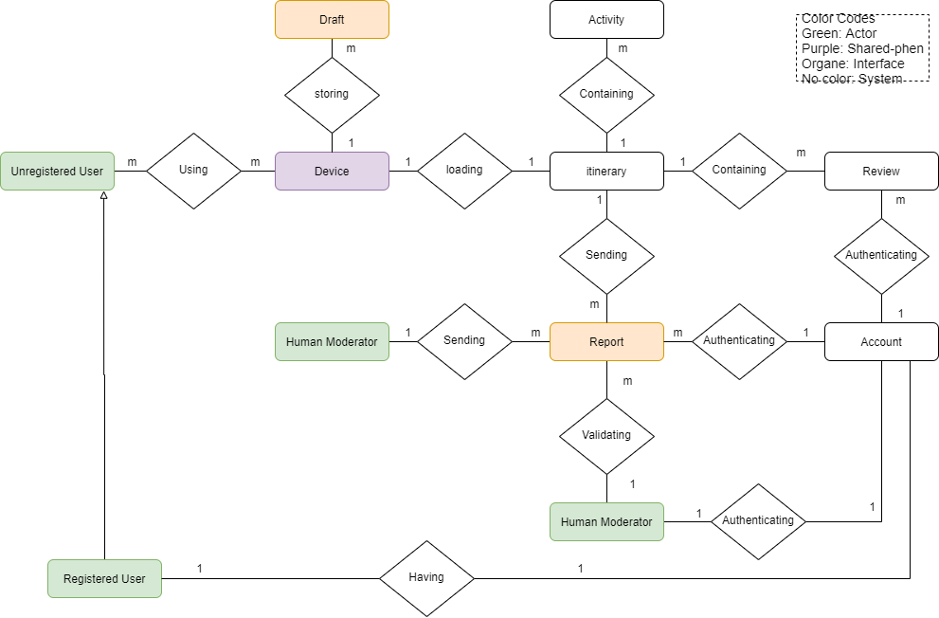

**Figure 4-1** Data model of the Review Trips System

Data Dictionary

**Table 4-1** defines the composition of data structures and the meeting, data type, length, format, and allowed values for the data elements presented in the domain model (see Appendix B).

**Table 4-1** Data dictionary of the Review Trips System

|  |  |  |  |  |
| --- | --- | --- | --- | --- |
| **Data element** | **Description** | **Composition**  **or data type** | **Max length**  **(in # of characters if not specified)** | **Values** |
| Account | user accounts that are used to differentiate users and to restrict activities for certain user groups | •Username: String  •Country: String  •Email: String  •Password: String  •hasConsent: Boolean  •isModerator: Boolean |  |  |
| Device | devices used by users to access itinerary listings | •Country: String  •OS: {Android, IOS}  •Longitude: float  •Latitude: float |  |  |
| Draft | drafted saved locally for users prior to posting | •contentSaved: String  •timeSaved: Timestamp |  |  |
| Itinerary | itineraries are shared travelling experiences that people can view and learn from | •Title: String  •Description: String  •Photos: List<BLOB>  •Videos: List<String>  •Country: String  •Difficulty: int  •isVehicleRequired: Boolean  •Ranking: int |  |  |
| Activity | tracked itinerary activities | •Title: String  •Photos: List<BLOB>  •Videos: List<String>  •Ranking: int |  |  |
| Review | comments and reviews of itinerary from users | •Username: String  •Body: String  •Liked: Int  •Disliked: Int  •Date: Timestamp |  |  |
| Report | potentially inappropriate content filed by users | •timeReported: Timestamp  •Reporter: String  •Title: String |  |  |
| Ranking | average of ranking scores submitted by users submitted by users | •usersRanked: List<Account>  •rankScore: List<int> |  |  |
| Username | unique identification defined by individual users | String | 20 | all characters permitted |
| Country | location of users | String | 20 | only letters |
| Email | contact information of users | String | 50 | local-part@domain where “local-part” and “domain” can be any combinations of characters |
| Password | information used for authentication | String | 20 | all characters permitted |
| hasConsent | condition to specify the presence of user agreement to data usage | Boolean | 5 | {true, false} |
| isModerator | condition to specify if a user has moderator rights | Boolean | 5 | {true, false} |
| OS | operating system of mobile device being used | String | 7 | {Android, IOS} |
| Longitude | GPS information that tells exact location | float | 20 | only numbers |
| Latitude | GPS information that tells exact location | float | 20 | only numbers |
| contentSaved | information being saved locally to device | String | 1000 | all characters permitted |
| timeSaved | time that information is being saved locally to device | Timestamp | yy-MM-dd HH:mm | yy = 20-30 inclusive; MM = 1-12 inclusive; dd = 1-31 inclusive; mm=00-59 inclusive |
| Title | unique identifier for itineraries or activities | String | 50 | only letters |
| Description | details of trip experience shared by users | String | 1000 | all character permitted |
| Photos | a combination with photos related to the experience being shared | List<BLOB> | 30KB | Image files can be in any format of TIFF, JPEG, GIF, PNG, and Raw Image; file size cannot exceed 30KB. |
| Videos | a combination with videos related to the experience being shared | List<BLOB> | 10MB | Video files can be in any format of AVI, FLV, WMV, MP4, and MOV; file size cannot exceed 10MB. |
| Difficulty | a reference score provided by the person who is sharing the experience; higher number indicates challenge | integer | 2 | 0-10 inclusive |
| isVehicleRequired | indicator if a vehicle is required for the trip | Boolean | Boolean | {true, false} |
| rankScore | All ranking scores submitted by people; higher number indicates better experience | List<int> | 2 | 0-10 inclusive |
| usersRanked | All people who ranked | List<Account> | 100 | numbers only |
| Body | details of comments shared by users | String | 1000 | all characters permitted |
| Liked | All people who liked | List<Account> | 100 | numbers only |
| Disliked | All people who disliked | List<Account> | 100 | numbers only |
| Date | time that information is published online | Timestamp | yy-MM-dd HH:mm | yy = 20-30 inclusive; MM = 1-12 inclusive; dd = 1-31 inclusive; mm=00-59 inclusive |
| timeReported | time that inappropriate contents are reported | Timestamp | yy-MM-dd HH:mm | yy = 20-30 inclusive; MM = 1-12 inclusive; dd = 1-31 inclusive; mm=00-59 inclusive |
| Reporter | username of person who reported inappropriate content | String | 20 | all characters permitted |

Data Acquisition, Integrity, Retention, and Disposal

Review Trips makes sure that users’ personal data are safely stored in a secured database and Review Trips complies with all Canadian regulatory and legal provisions of personal data, with emphasis on the following policies stated by Canadian Privacy Statutes [2]:

* **Transparency:** Organisations are to document and to make readily available to individuals, in a form that is generally understandable, specific information about their policies and practices relating to the management of personal information.
* **Right of access to data:** Organisations must, upon request and subject to limited exemptions, inform individuals of the existence, use and disclosure of his or her personal information, and must give them access to that information, including a listing of the third-party organisations with whom the information has been shared.
* **Retention:** Organisations are required to retain personal information for only as long as necessary to fulfil the purposes for which it was collected, subject to a valid legal requirement.
* **Accountability:** Organisations must designate and identify an individual who is accountable for the organisation’s compliance with the other privacy principles and shall implement policies and practices to give effect to those principles.

To address these responsibilities, the following practices are enforced:

* Users are required to grant Review Trips permission to store personal data by signing the user agreement prior to using the application.
* Data information retrieved from secured internet protocols as well as user interactions will be solely used by Review Trips.
* Users remain in control of their own data, including the choices to either archive or permanently delete their information.
* The data are processed in a transparent, confidential and secure manner. Encrypted messages are used to transfer data.
* Review Trips has a dedicated personal data protection team to review user concerns

1. External Interface Requirements

User Interfaces

UI-1: User Itinerary Search and Filter Functionality

UI-1.1: Review Trips allows a user to utilize a search bar to conduct a text-based search of itineraries. Based on the user's search text, the system will compare the search text against attributes of posted itineraries such as duration, location difficulty, objectives, transportation, budget, reviews and ranking of the trip.

UI-1.2: Review Trips also allows users to filter what itineraries they wish to see. Itineraries can be filtered by the same attributes as listed in UI-1.1, but filters can be used to restrict all itineraries shown. An example would be a user who wishes to not see itineraries whose budget is over $1000.

UI-2: User Account Creation

UI-2.1: A non-registered user can choose to register by creating an account within the Review Trips app. As a part of this registration process, a user must add their email address and a password they wish to use. The Review Trips application verifies the email is valid according to a regex, and the password must meet minimum strength requirements based on length and complexity.

UI-2.2: During the account creation process for an unregistered user, all users must agree to the Review Trips Terms and Conditions document by clicking a checkbox asserting they have read and understand these Terms and Conditions.

UI-3: Rank an Itinerary

UI-3.1: Any registered user can choose to rank an itinerary posted by another user on a score of one to ten. Review Trips displays the average of all users ranking on each published itinerary. These rankings are intended to help users see how informative, interesting and overall useful other users have found an itinerary to be.

UI-3.2: Any non-registered user who tries to rank an itinerary will be forwarded to the account creation interface. By creating an account and becoming a registered user, they can then rank this itinerary.

UI-4: Report an Itinerary

UI-4.1: A user, whether or not they are a registered user, is allowed to report an itinerary they believe is inappropriate or in any way a breach of Review Trips terms and conditions. Once an itinerary is reported, it enters a queue of reported itineraries to be reviewed by human, employee moderators of Review Trips.

UI-5: Comment on an Itinerary

UI-5.1: A registered user can choose to comment on any itinerary, whether it is another user or their own itinerary. All comments will be in a chronological, non-hierarchical order. There will not be a concept of unique threads of comments, instead, it will be a simple list of comments written by all users in order based on time.

UI-5.2: A non-registered user who tries to comment on an itinerary will be forwarded to the account creation interface. By creating an account and becoming a registered user, they can then comment on this itinerary.

UI-6: Add or Edit an Itinerary

UI-6.1: A registered user can create a new Itinerary. As a part of adding an itinerary the user can optionally add activities to the itinerary, as well as add details such as budget, location, and other details of their itinerary, such as the description.

UI-6.2: A registered user can choose to either submit their itinerary to be published to Review Trips to be visible to other users or save the itinerary as a draft. If the user does not have internet access, the draft will be saved locally and uploaded to the server once an internet connection is re-established. Otherwise, the draft will be automatically uploaded and backed up the server, even if the user chooses to not yet publish this itinerary.

UI-6.3: A registered user can edit a draft or a published itinerary they have already completed. When editing a draft itinerary, the user can choose to simply save the draft or publish. When editing a published itinerary, the user can either cancel their changes or publish the changes once they are finished editing. They cannot create a draft of an already published itinerary while editing.

UI-7: Human Moderator Review Reported Itineraries

UI-7.1: A human moderator can login using their administrator credentials and enter the moderator console. Once on the console, they can pick from the queue of reported itineraries. These itineraries may have been reported by the AI moderator, users, or both. Once the human moderator picks an itinerary to review, they can either approve the content or remove the itinerary, leaving a comment for the user who uploaded it explaining why it was removed. Once the moderator decides whether to remove or keep the itinerary, it is removed from the queue of reported itineraries.

Software Interfaces

SI-1: Mobile Operating System Integration with Global Positioning System (GPS)

SI-1.1: Review Trips relies on the mobile operating system in order to integrate with the devices Global Positioning System (GPS) system in order to geolocate the user, this location data is used to improve accuracy of itineraries shown to the user.

SI-1.2: Review Trips utilizes the user geolocation information at the time of posting an itinerary as a recommended location to set the itinerary to.

SI-2: Mobile Operating System Integration with Local File System

SI-2.1: Review Trips is required to integrate with the mobile operating systems local file system in order to create and manage a local device database and individual files, such as user account information, cryptographic information and cached data.

SI-3: Artificial Intelligence Moderator Content Scanning

SI-3.1: All content uploaded to the Review Trips, whether it is a newly published itinerary or an update through editing a published itinerary, the artificial intelligent moderator screens the text, photos and videos uploaded in the itinerary for potentially inappropriate content that breaches the Review Trips terms and conditions. All itineraries flagged by the AI moderator are automatically added to the queue of flagged itineraries to be reviewed by human moderators, the employees of Review Trips.

Hardware Interfaces

Review Trips does not directly integrate with any hardware interfaces. As a mobile app, it runs on a mobile operating system such as Android and iOS. Any functionality that requires physical or hardware access, such as GPS location of the user's device, is handled through a software interface with the mobile operating system. The operating system is responsible for the integration with hardware interfaces such as the specific phones physical GPS chip, and these hardware interfaces are outside of the scope of this document. These interfaces will be addressed within the software interfaces section 5.2.

Communication Interfaces

CI-1: Review Trips Interface with Backend Server

CI-1.1: The interaction between the Review Trips app and the backend server is conducted utilizing a RESTful API. This RESTful API is protected using server generated and signed JSON Web Token (JWT) token-based authentication, with the token being generated at the time of user login.

CI-1.2: All communications between the Review Trips app and the backend server strictly occurs over HTTPS, while utilizing TLS v1.2. In such a situation that TLS v1.2 is not supported or possible to be utilized, no application data should be transmitted.

CI-1.3: When the Review Trips app needs to sync draft posts with the server but does not have an internet connection to complete this task, the app will create a notification service with the mobile operating system. The operating system will notify the app through this service when the internet is once again available, and the app will then establish a connection with the backend server and sync the draft(s) between the app and the backend server.

1. Quality Attributes

Usability

USE-1: When there is no network connection, a user can make a draft for their itineraries which will be eventually added to the system but temporarily want to save on the device for future editing.

USE-2: A user should be able to complete 95 percent of a set of all features mentioned in section 3 correctly without needing extra help.

USE-3: The number of interactions including clicks or touch-screen gestures required to perform all features mentioned in section 3 should be in an average of 3, and in a maximum of 5, 90 percent of the time.

Performance

PER-1: A user shall be able to submit a request for all features mentioned in section 3 and get response in an average of 3 seconds, 95 percent of the time. It combines with the optimization of using device CPU and/or GPU and local caches for storing itinerary data, to generate a smooth experience.

PER-2: A display page shall be fully loaded in an average of 5 seconds or less over a 40 megabits/second Internet connection, 95 percent of the time, with possible local caches for these data to generate instant access and display.

PER-3: The AI scan system shall scan for a new posted itinerary in an average of every 0.5 milliseconds with a possible report to human moderator in an average of another 0.5 milliseconds, 90 percent of the time.

PER-4: At least 98 percent of the time, the system shall update the itinerary status display within 1 second on average after the completion of any possible features mentioned in section 3.

Security

SEC-1: The system shall log all attempts to access secure data (password, addresses, reported queue, etc.) by users having insufficient privilege levels.

SEC-2: Encryption of user secure data such as passwords shall be implemented by generating a token which records the corresponding user account and device ID for every time a user successfully login. This token on a device will automatically expire after 30 mins of inactivity in the app and/or login the same account on another device. It requires a user to re-login to regenerate a new token for security purposes.

SEC-3: Only users who have admin access privileges shall be able to view and manage the reported post of itineraries. It allows multiple users who have admin privileges to access and manage.

Safety

SAF-1: The user shall be able to see a highlighted reminder for the itineraries that are known to be in a place that a user may fall victim to scams or crimes or a place that is known to have a high rate of death.

SAF-2: System will encrypt all secure information about an account (password, email, itineraries) to protect user privacy. Only users themselves have control of their own data, including the choices to either archive or permanently delete their information (See Section 4.3).

Efficiency

EFF-1: The system shall provide the user with a warning message when an account tries to upload multiple photo and video files that potentially exceed their size limitations; it will occur when it reaches to 80 percent of these size limitations (See Table 4-1).

EFF-2: The system will use multithreading to optimize the download speed of all relevant itineraries data and cache them to the local device for shortening loading and/or reloading time.

Portability

POR-1: The iOS version and the Android version shall use mostly the same API functions to obtain a device geometry location to ensure low redundancy of the source codes and relative high consistency to maintain user experience.

POR-2: The platform migration tool shall transfer customized user profiles from the server to the new installation with no user action needed.

1. Internationalization and Localization Requirements

The following system requirements are enforced to adapt to various countries. While user inputs are not restricted, the application will comply to the following policies:

* Time is measured at UTC+0 (Universal Time) to adjust world-wide users.
* Location is described in terms of latitude and longitude.
* The system should support the languages and alphabet characters of the following targeted countries: Canada (English), USA (English), Germany (German), Japan (Japanese), Russia (Russian).
* UTF-8 encoding is in place to support the encoding of different languages.

8 Other Requirements

OR-1: Regulatory requirements

OR-1.1: For the interface to use map services, if the connection with Google maps failed and internet is connected, the system should switch to use the AutoNavi API instead of Google Maps API to support map related functions.

OR-1.2: System will send all users notification in special circumstances. For example, when the government is trying to control the spread of COVID-19, the system will inform all users that unnecessary travelling is highly discouraged.

OR-2: Financial requirements

OR-2.1: System should regularly send emails to registered users to give them notifications of hot posts and news if users click on “send me emails for notifications” while registering.

OR-2.2: When out application advertising in the other platform, the advertisement is expected not to be over-embellished.

OR-2.3: In the future, if our APP included paid-content, (For example, tipping author you like) user’s payment information needs to be very secure and should not be accessed by anyone.

# Appendix A: Glossary

**UTF-8:** 8-bit Unicode Transformation Format capable of encoding all 1,112,064 valid code points in Unicode.

**API:** Application Programming Interface defines how the calls and requests that can be made to use a software component or a system from other components or systems.

**UTC+0:** time zone used as standard time to denote the time that is 0h ahead of Coordinated Universal Time.

**MB:** The megabyte is a multiple of the unit byte for digital information--one million bytes of information.

**KB:** The kilobyte is a multiple of the unit byte for digital information--one thousand bytes of information.

**TIFF:** Tagged Image File Format is an image format very commonly used for transporting color or gray-scale images into page layout applications.

**JPEG:** Joint Photographic Experts Group is a standard image format for containing lossy and compressed image data.

**GIF:** Graphics Interchange Format is an image file format commonly used for images on the web and sprites in software programs.

**PNG:** Portable Network Graphics is a raster-graphics file-format that supports lossless data compression and was developed as an improved, non-patented replacement for GIF.

**Raw Image:** A camera raw image file contains minimally processed data from the image sensor of either a digital camera, a motion picture film scanner, or other image scanner.

**AVI:** An Audio Video Interleave file is a commonly used video format that contains both audio and video.

**FLV:** An FLV player is a type of media player that is used for playing Flash video from PC as well as from Internet websites.

**WMV:** Windows Media Video is a series of video codecs and their corresponding video coding formats developed by Microsoft.

**MP4: A** MP4 file (MPEG-4 Part 14) is a multimedia file of container format that can store video, audio, subtitle data, and more depending on content.

**MOV:** A MOV file is a common multimedia container file format developed by Apple and compatible with both Macintosh and Windows platforms.

**APP:** A mobile application is a software application designed to run on a mobile device.

**JWT:** A JSON Web Token (JWT) is an internet standard for creating JSON based access tokens that assert some type of claims. The tokens are typically signed, and often used for authentication.

**AutoNavi:** AutoNavi (also known as Gaode Maps) is a Chinese web mapping, navigation and location-based services provider, founded in 2001[3].

**Google Maps:** Google Maps is a web mapping service developed by Google which offers satellite imagery, aerial photography, street maps, 360° interactive panoramic views of streets (Street View), real-time traffic conditions, and route planning for traveling by foot, car, bicycle and air (in beta)[4].

**SQL:** Structured Query Language is a domain-specific language designed to manage data held in a relational database management system [5].

**MySQL:** MySQL is an open-source relational database management system which is owned by Oracle Corporation [6].

**GPS:** Global Positioning System is a satellite-based radio navigation system that can locate users’ real time position.

# Appendix B: Analysis Models

**State Diagram Overview**

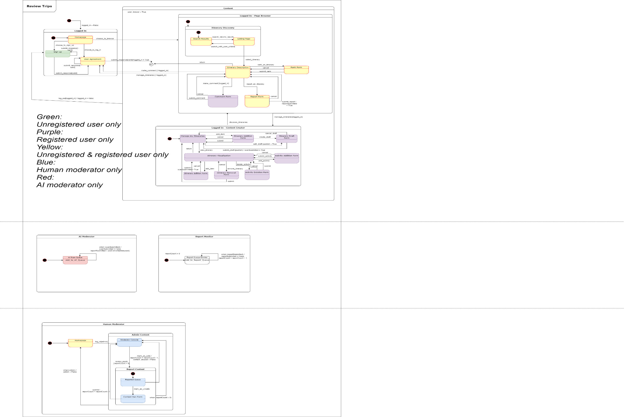

**State Diagram Part 1 Details**

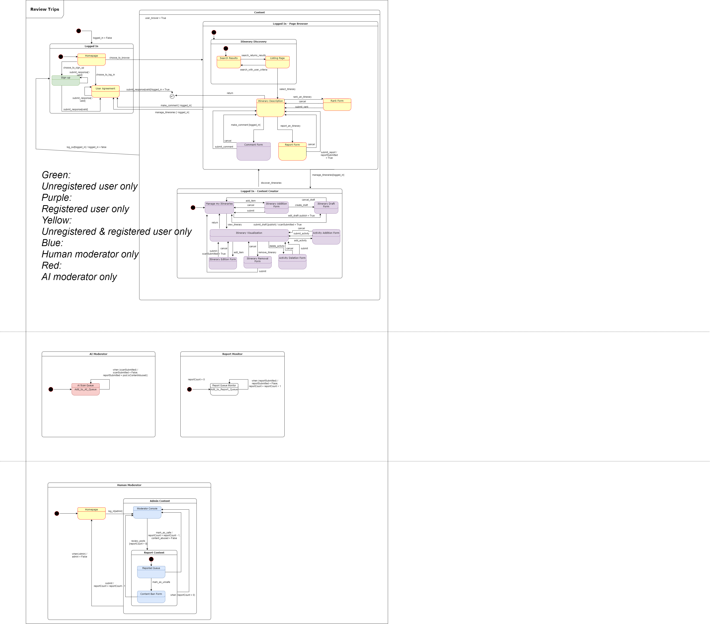

**State Diagram Part 2 Details**



**State Diagram Part 3 Details**



**State Diagram—Legend Table**

|  |  |  |
| --- | --- | --- |
| **Legend** | **Purpose** | **Default Value** |
| admin | Special accounts that people log in to gain moderator rights. Any user who can access the moderator portion is admin(admin=True). | False |
| content_abused | Specifies if content is abused. | False |
| valid | Determines whether a user is permitted to continue with the information entered. | n/a |
| logged_in | Specifies if a user is associated with an account. Special rights are granted to users with status of logged_in(logged_in = True). | False |
| publish | Represents whether a draft being saved should be published (i.e. shown to other users) or not (i.e. user wants to save their draft to edit another time, while keeping it hidden from the public). | False |
| reportCount | Counts the total numbers of itineraries in the report queue either submitted through AI scan feature or report feature. | 0 |
| reportSubmitted | Indicates a particular itinerary has been added to the report queue through report feature. | False |
| scanSubmitted | Indicates a particular itinerary has been added to the AI scan queue through AI scan feature. | False |
| user_browser | Any users who view the itineraries are automatically set to user_browser(user_browser=True) when they enter the content page. Certain actions can only be performed with logged_in or admin statues. | False |

*** The component “Comment Form” also includes the features for reviewing and scoring.

**Domain Model Diagram**

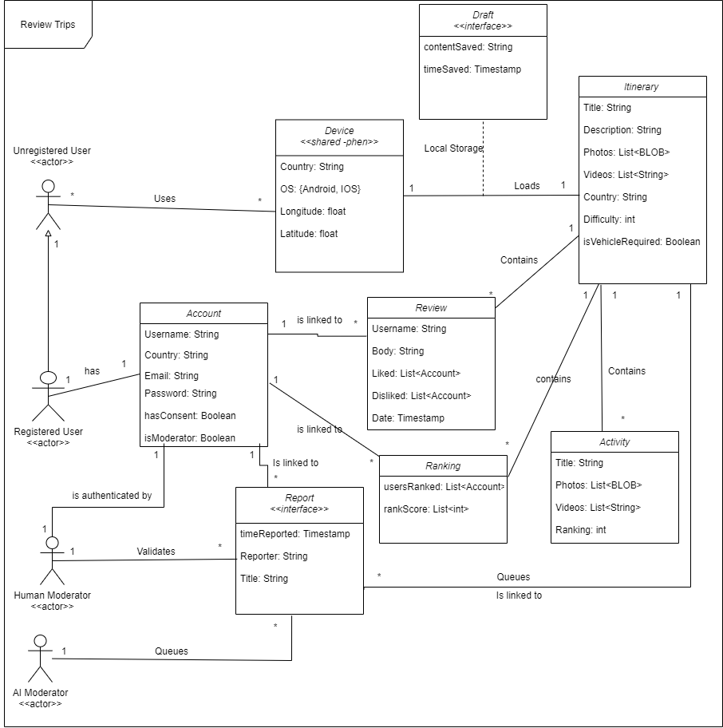

**Use Case Diagram**

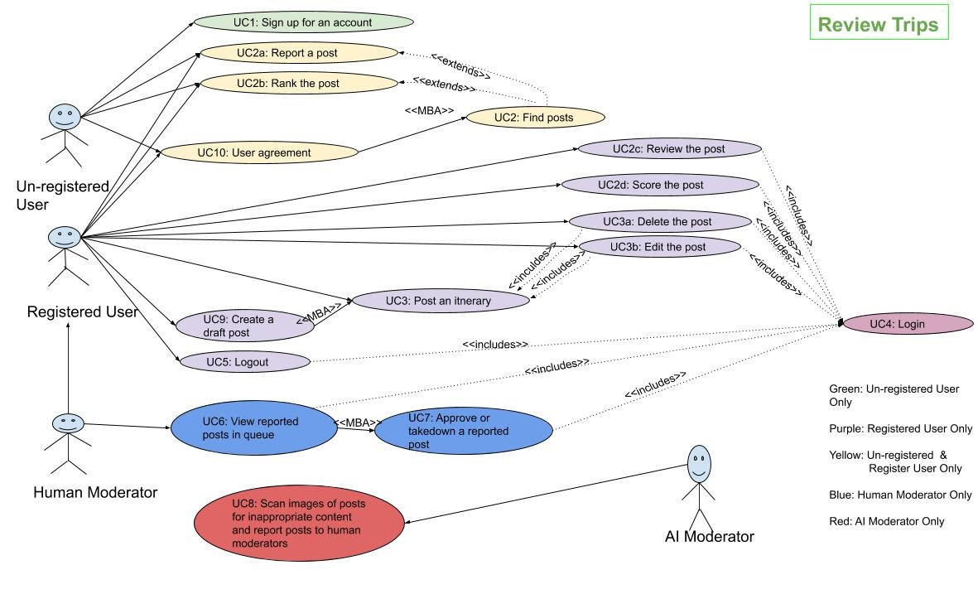

**Use Case Diagram—Use Case Table**

|  |  |  |  |
| --- | --- | --- | --- |
| Use Case Number | Description | Use Case Number | Description |
| 1 | An un-registered user can sign up for a trip-reviewing account. | 2 | Both an un-registered user and a registered user can search for posts with defined criteria. |
| 2a | Both an un-registered user and a registered user can file a report to report inappropriate content. | 2b | Both an un-registered user and a registered user can choose to view posts based on preference |
| 2c | A registered user can add a comment below selected posts. | 2d | A registered user can enter a score to rate posts. |
| 3 | A registered user can share their travelling experience by posting content. | 3a | A registered user can delete their posts. |
| 3b | A registered user can edit their itinerary after posting an itinerary. | 4 | A registered user actor must login to their account in order to access some features. |
| 5 | A registered user may wish to logout. | 6 | A human moderator checks items for inappropriate content in a reported queue. |
| 7 | A human moderator can approve or remove the items in a reported queue. | 8 | An artificial intelligent moderator (secondary actor) can scan the uploaded text, photos and videos in a post for checking inappropriate content. |
| 9 | A registered user can create a draft of a post for saving or future editing purposes. | 10 | Both an un-registered user and a registered user must accept the user agreement to enter the application. |

**Use Case Description**

|  |  |
| --- | --- |
| Name: Sign up for an account | ID: UC1 |
| Authors: Lydia  System: Review Trips  Actors: Un-registered user  Event: Actor chooses to sign up for an account  Overview: Actor signs up for a trip-reviewing account | |
| Actor | System |
| 1. Actor selects to sign up for an account. |  |
|  | 2. System displays a sign-up form. |
| 3. Actor fills in the form with fields (username, password, email address). |  |
| 4. Actor submits the form. |  |
|  | 5. System validates the form with all fields (username, password, email address) to check if they are empty.. |
|  | 6. System displays a success message |
| Exception 1: Form validation fails (step 5) | |
|  | 5.1 System returns the same form with incorrect or empty fields highlighted. |
| 5.2 Actor successfully fills in the highlighted fields. |  |
| 5.3 Actor submits the form. |  |
|  | 5.4 Redirects flow to step 5 of the main use case |
| Exception 2: Username of the actor has been taken (step 5) | |
|  | 5.5 System returns an error message of “the username has been taken to actor” |
| 5.6 Actor receives the error message |  |

|  |  |
| --- | --- |
| Name: Find posts | ID: UC2 |
| Authors: Shuangyou  System: Review Trips  Actors: Un-registered user; registered user  Event: Actor attempts to find posts with either a search of a sequence of keywords or a one-to-one mapping between a field in the form with options.  Overview: Actor searches for posts with defined criteria | |
| Actor | System |
| 1. Actor enters the search page. |  |
|  | 2. System displays a search bar and options (duration, location, difficulty, objectives, transportation, budget,  number of reviews, ranking) to filter the posts below the search bar. |
| Alternative 1: Actor search a sequence of keywords in the search bar (step 2) | |
|  | 2.1 System displays all relevant posts containing the search keyword subsets. |
| Alternative 2: Actor chooses options (duration, location, difficulty, objectives, transportation, budget,  number of reviews, ranking) to filter the posts or the search results.(step 2, step 2.1) | |
|  | 2.2 System displays the posts satisfying the options (duration, location, difficulty, objectives, transportation, budget, number of reviews, ranking), according to the filled fields (location,  duration, purpose, transportation, budget, reviews) in the posts database. |
| Exception 1: No results are returned after the search. (step 2.1, step 2.2) | |
|  | 2.3 System display a message of “No Results Found” |

|  |  |
| --- | --- |
| Name: Report a post | ID: UC2a |
| Authors: Daniel, Zack  System: Review Trips  Actors: Un-registered user; registered user  Event: Actor chooses to report inappropriate content  Overview: Actor files a report | |
| Actor | System |
| 1. Actor submits a report request through a report button. |  |
|  | 2. System adds the corresponding post into the queue of reported posts. |
| 3. Actor receives a success message |  |
| Exception 1: Server failed to add the corresponding post into the queue of reported posts. (step 2) | |
|  | 2.1 System display an error message of “Something is Wrong, Failed to Report” |

|  |  |
| --- | --- |
| Name: Rank the post | ID: UC2b |
| Authors: Shuangyou, Lydia  System: Review Trips  Actors: Un-registered user; registered user  Event: Actor chooses to view posts based on preference  Overview: Actor | |
| Actor | System |
| 1. User submits the ranking options (duration, location, difficulty, objectives, transportation, budget, number of reviews, ranking) to rank posts |  |
|  | 2. System displays the posts in sorted order with selections (ascending or descending), according to the options (duration, location, difficulty, objectives, transportation, budget, number of reviews, ranking). |
| 3. Actor receives a success message |  |
| Exception 1: Server failed to add the ranking scores. (step 2) | |
|  | 2.1 System display an error message of “Something is Wrong, Failed to Rank” |

|  |  |
| --- | --- |
| Name: Review an Itinerary | ID: UC2c |
| Authors: Daniel, Zack  System: Review Trips  Actors: Registered user  Event: Actor wishes to add a review on existing posts  Overview: Actor adds a comment below selected posts | |
| Actor | System |
| 1. Actor submits comments |  |
| Alternative 1: Actor is not in a registered state. | |
|  | 2.1 System directs to UC1. |
| Alternative 2: Actor is in a registered state. | |
|  | 2.2. Add the review comment to the database, record the changes into actor’s data, and display the name in actor’s registered name |
| 3. Actor receives success message |  |
| Exception 1: Server failed to add the review comment. (step 2) | |
|  | 2.3 System display an error message of “Something is Wrong, Failed to Comment” |

|  |  |
| --- | --- |
| Name: Score the post | ID: UC2d |
| Authors: Shuangyou  System: Review Trips  Actors: Register user  Event: Actor wishes to share opinions on his/her liking of the posts  Overview: Actor enters a score to rate posts. | |
| Actor | System |
| 1. Actor requests to score a post |  |
|  | 2. System redirects users to the scoring page. |
| 3. Actor submits the score (like or dislike). |  |
|  | 4. System stores the score in the database and updates the shown score of the post. |
| 5. Actor receives a success message |  |
| Exception 1: Server failed to add the score. (step 4) | |
|  | 4.1 System display an error message of “Something Went Wrong, Failed to Score” |

|  |  |
| --- | --- |
| Name: Post an itinerary | ID: UC3 |
| Authors: Zack, Lydia  System: Review Trips  Actors: Registered user  Event: Actor posts a travel review  Overview: Actor shares their travelling experience by posting content | |
| Actor | System |
| 1. Actor submits the post. |  |
|  | 2. System checks all necessary fields (location, duration, purpose, transportation, budget, reviews) completed by the actor. |
| Alternative 1: At least one of the necessary fields (location, duration, purpose, transportation, budget, reviews) is empty which will be rejected by the system validation checking. | |
|  | 3.1 System directs to UC3b |
| Alternative 2:  System validation succeeds. | |
|  | 3.2 System generates a new post |
| 3.3 User receives success message |  |
| Exception 1: Server failed to make a new post. (step 3.2) | |
|  | 3.3 System display an error message of “Something is Wrong, Failed to Post” |

|  |  |
| --- | --- |
| Name: Delete/remove posts | ID: UC3a |
| Authors: Shuangyou  System: Review Trips  Actors: Registered user  Event: Actor attempts to delete posts  Overview: Actors should be able to delete posts when the posts are outdated or inappropriate. | |
| Actor | System |
| 1.Actor selects “my posts”. |  |
|  | 2.System shows all the posts owned by the user. |
| 3. Actor selects the post to delete. |  |
|  | 4.System display a preview of the post. |
| 5.Actor selects “more->delete” |  |
|  | 6. System shows a message asking the user if he/she really wants to delete the post. |
| Alternative 1:  Actor selects “Yes” | |
|  | 7.1. System remove the post from the database including all related data: comments, likes, etc. |
| 8. Actor receives a success message |  |
| Exception 1: Server failed to remove the post. (step 7.1) | |
|  | 7.2 System displays an error message of “Something is Wrong, Failed to Remove” |
| Alternative 2: Actor selects “No” | |
|  | 7.3. Go back to the preview of the post. (UC3b) |

|  |  |
| --- | --- |
| Name: Edit your post | ID: UC3b |
| Authors: Daniel, Shuangyou  System: Review Trips  Actors: Registered User  Event: Actor attempts to make edits to post content.  Overview: After posting an itinerary, a registered user actor may wish to edit their itinerary, potentially to make large changes, to add to the post, or fix spelling mistakes. | |
| Actor | System |
| 1. Actor selects “my posts”. |  |
|  | 2.System shows all the posts owned by the user. |
| 3.Actor selects the post to edit. |  |
|  | 4.System display a preview of the post. |
| 5.Actor selects “Edit”. |  |
| 6.Actor edits the contents to change. |  |
| 7.Actor save the changes by clicking “Finish editing” |  |
|  | 8. System updates the database with the new content. |
| 9. Actor receives a success message. |  |
| Exception 1: Server failed to update the new content. (step 8) | |
|  | 8.1 System display an error message of “Something is Wrong, Failed to Synchronize” |

|  |  |
| --- | --- |
| Name: Login | ID: UC4 |
| Authors: Daniel  System: Review Trips  Actors: Registered User  Event: Actors are required to login to their account to access some features exclusive to registered users.  Overview: A registered user actor must login to their account in order to access some features. | |
| Actor | System |
| 1. Actor submits a login request. |  |
|  | 2. System shows the page for login. |
| 3. Actor enters the username and password. |  |
|  | 4. System searches the database to find if the password matches the username. |
| Alternative 1: Password matches the username | |
|  | 4.1. The user is logged in and is redirected to the home page. |
| Alternative 2: Password doesn’t match the username. | |
|  | 4.2. Show a message “The username and password entered does not match the records” and direct the actor to the login page. |

|  |  |
| --- | --- |
| Name: Logout | ID: UC5 |
| Authors: Daniel, Zack  System: Review Trips  Actors: Registered User  Event: Actors may wish to logout of their account for various reasons.  Overview: An actor may wish to logout of their account for privacy and security reasons, as well as potentially to allow another actor to login to their account on the same device. | |
| Actor | System |
| 1. User submit a logout request |  |
|  | 2. Clear user account data on local display |
|  | 3. Change local state to unregistered user state |

|  |  |
| --- | --- |
| Name: View reported post in moderation queue | ID: UC6 |
| Authors: Daniel, Zack  System: Review Trips  Actors: Human Moderator  Event: Posts that have been flagged by artificial intelligent or human users for inappropriate content enter a queue that then must be checked by human moderators.  Overview: Trusted human moderators are an important actor to help control the content on the system. By utilizing both the user base’s flagging of inappropriate content as well as artificial intelligence detecting inappropriate content at the time of upload, the system can be properly moderated and inappropriate content can be controlled. | |
| Actor | System |
| 1. View the selected item in moderation queue |  |
| Alternative 1: Consider content is abused | |
|  | 2.1 UC7 (remove) |
| Alternative 2: Content is appropriate | |
|  | 2.2 UC7 (approve) |

|  |  |
| --- | --- |
| Name: Approve or remove reported post | ID: UC7 |
| Authors: Daniel, Zack  System: Review Trips  Actors: Human Moderator  Event: Once a human moderator looks at a flagged post in the moderation queue, they must decide based on their personal judgment whether to take down or leave the post up.  Overview: The reason the system utilizes human moderators to make the final decision for each post is the system will have some set of use guidelines of what is allowed to be posted on the system. These human moderators can understand these guidelines and decide what falls outside these guidelines. | |
| Actor | System |
| Alternative 1:  Request to remove | |
|  | 1.1 Remove it from the reported post queue and then delete the post (UC3a) |
| Alternative 2:  Request to approve | |
|  | 1.2 Remove it from the reported post queue (same post can be reported again in the future). |

|  |  |
| --- | --- |
| Name: Scan images of posts for inappropriate content & report | ID: UC8 |
| Authors: Daniel, Zack  System: Review Trips  Actors: Artificial Intelligent Moderator  Event: Every post that is added to the system by registered user actors will be screened by the artificial intelligence moderator that scans the content for inappropriate content. If such content is detected, the post is about to be removed from the system.  Overview: The artificial intelligence moderator is a crucial component of the overall moderation system as it can immediately flag inappropriate content, potentially before any human users see it. This artificial intelligent moderation system will scan both the uploaded text, photos and videos. | |
| Actor | System |
| 1. Scan text, photos and videos for the selected item in the queue |  |
| Alternative 1. Confirm inappropriate content | |
|  | 2.1 UC7 (remove) |
| Alternative 2. Can not determine | |
|  | 2.2 UC6 |

|  |  |
| --- | --- |
| Name: Create a draft post (offline or online) | ID: UC9 |
| Authors: Daniel, Zack  System: Review Trips  Actors: Registered User  Event: A registered user may wish to create a draft of a post they eventually wish to add to the system but want to save on their phone for future editing.  Overview: Registered users may need this ability both in order to spread out the writing/editing of a large post over more than one time as well as the user may wish to edit/contribute to their post while they have no internet connection, such as on a hike in a rural area. | |
| Actor | System |
| 1. Actors submit a request of creating a draft (i.e.: make changes to its post) |  |
| Alternative 1: Actor is offline | |
|  | 2.1 Saving the draft data. |
| Alternative 2: Actor is online | |
|  | 2.2 Saving the draft and synchronizes the corresponding changes to online server |

|  |  |
| --- | --- |
| Name: User agreement | ID: UC10 |
| Authors: Zack  System: Review Trips  Actors: Registered user; un-registered user  Event: Inform the actors with user agreement for using the local storage to improve the user experience and storing some information about the usage of the application in the database.  Overview: User agreement with retaining necessary user data | |
| Actor | System |
|  | 1. Inform the user agreement to actors |
| Alternative 1: Actor agrees | |
|  | 2.1 Allow actor to enter the app |
| Alternative 2. Actor disagrees | |
|  | 2.2 Exit from the app |