Blurry Photo Cleaner
Find the blurry photos, keep the good ones

Project name | Blurry Photo Cleaner
Your name | [Your name]
Course | Multimedia
Date | November 7, 2026

2. Introduction
Blurry Photo Cleaner helps phone users to find and remove blurry photos to free up storage every day.
Problem: phone galleries fill up with near-duplicate and blurry shots, and finding them by eye means scrolling and zooming through hundreds of photos — slow, tiring, and easy to get wrong.
Who it helps: anyone whose phone storage is full of photos they took in a hurry — parents, students, travelers — anyone who wants to keep the good shots and delete the ruined ones.
Goal: the app scores every selected photo's sharpness inside the browser, groups the photos into Blurry, Needs review, and Sharp, lets the user improve and re-save the blurry ones as HD copies, and makes deleting the bad shots a one-tap, confirmed decision. Photos never leave the device.

3. How It Works
The app is a single web page that runs entirely in the browser — there is no server and no account. Photos are chosen, scored, and reviewed on the device.
Input (what goes in) | Process (what happens inside) | Output (what comes out)
Selected photo files — picked with the file picker, dragged onto the page, or chosen from a folder (when the browser supports it). The files stay on the device. | Each photo is analyzed in a background Web Worker: decode upright, downscale to a 256-pixel working image, convert to grayscale, measure Laplacian variance (edge energy), and normalize to a 0–100 sharpness score, cut into three bands — under 40 Blurry, 40–59 Needs review, 60+ Sharp — shown as “NN% sharp” on every tile. Blurry photos are marked Suggested for deletion. On request, a pool of workers resamples photos larger, optionally sharpens them, and encodes PNG, JPEG, or WebP — the result is previewed first, and a downloaded copy is scored fresh and joins the review at the band it belongs to. Batches convert in parallel (25 photos in about 9 seconds in testing). | A review grid grouped into the three bands, with counts and an “NN% sharp” chip on every tile. One tap selects the keepers (Sharp plus the ticked Needs-review photos). Downloads ask for a format (Original, PNG, JPEG, WebP). The HD Converter shows a before/after wipe slider that animates blurry → clear; the improved copy can be kept in the review with no download at all, and it is re-scored into the band it earns. Photos are removed from the review session after a confirmation dialog — then deleted on the phone in the gallery app.
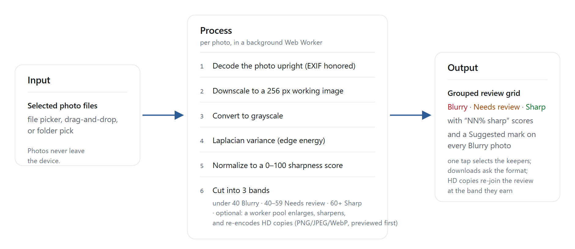
Figure 1. System flow

The screens
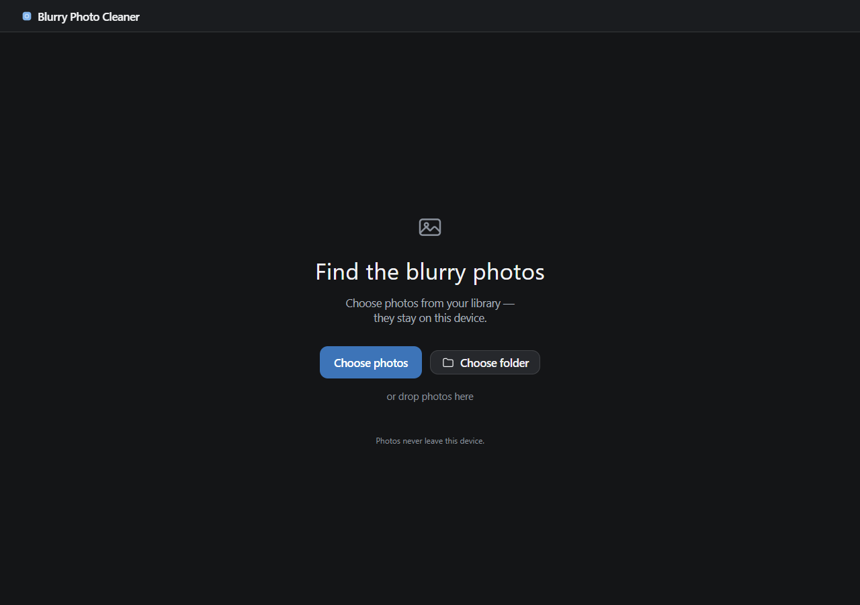
Figure 2. Empty upload screen. Photos never leave the device.
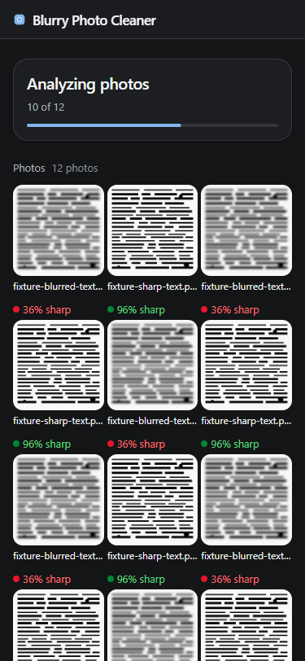
Figure 3. Analyzing photos: progress card over the pending grid (phone view).
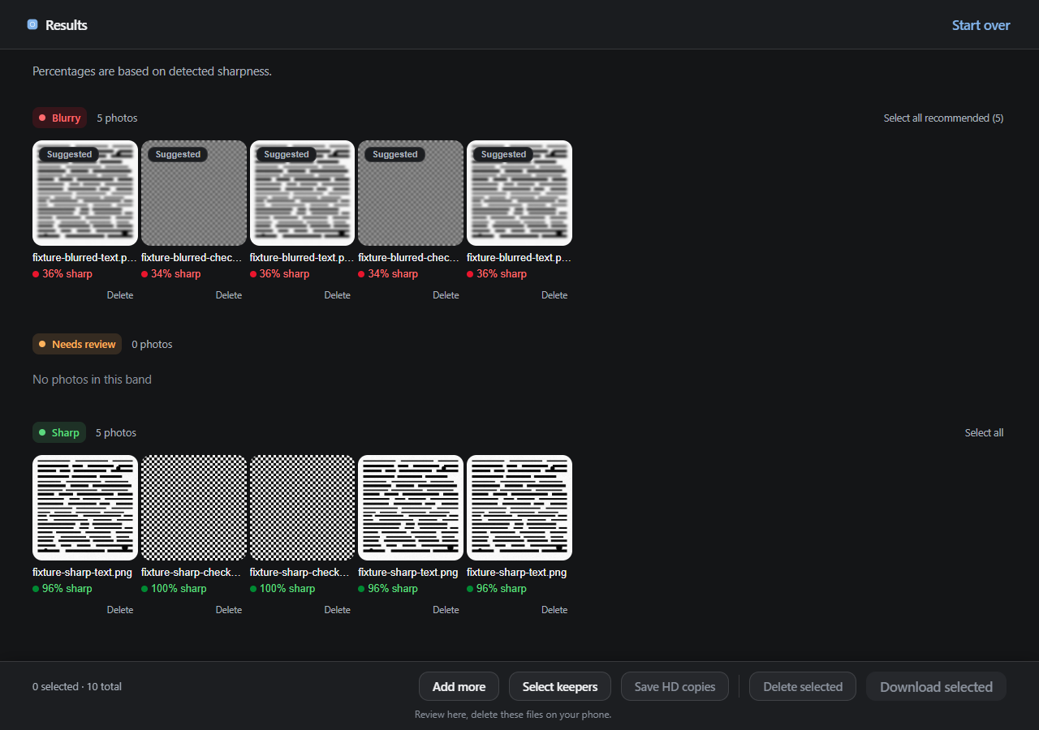
Figure 4. Results grouped into bands, with an “NN% sharp” chip on every tile and a Suggested mark on the blurry ones.
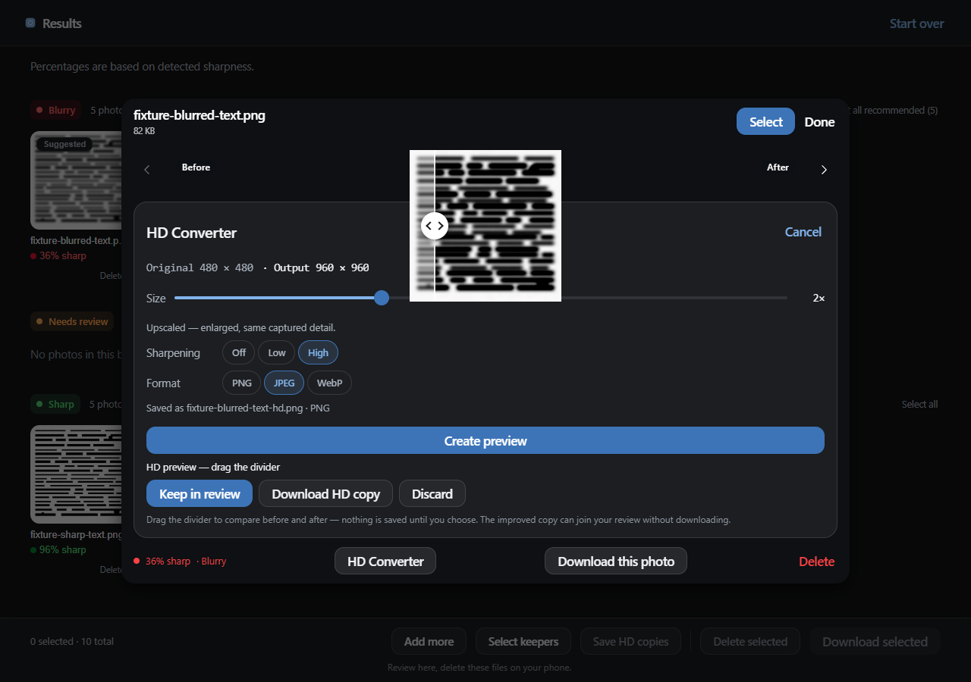
Figure 5. The HD Converter: choose a size, a sharpening level, and a format, then Create preview — the before/after wipe slider auto-sweeps from blurry to clear. No download needed: Keep in review adds the improved copy with a fresh score.
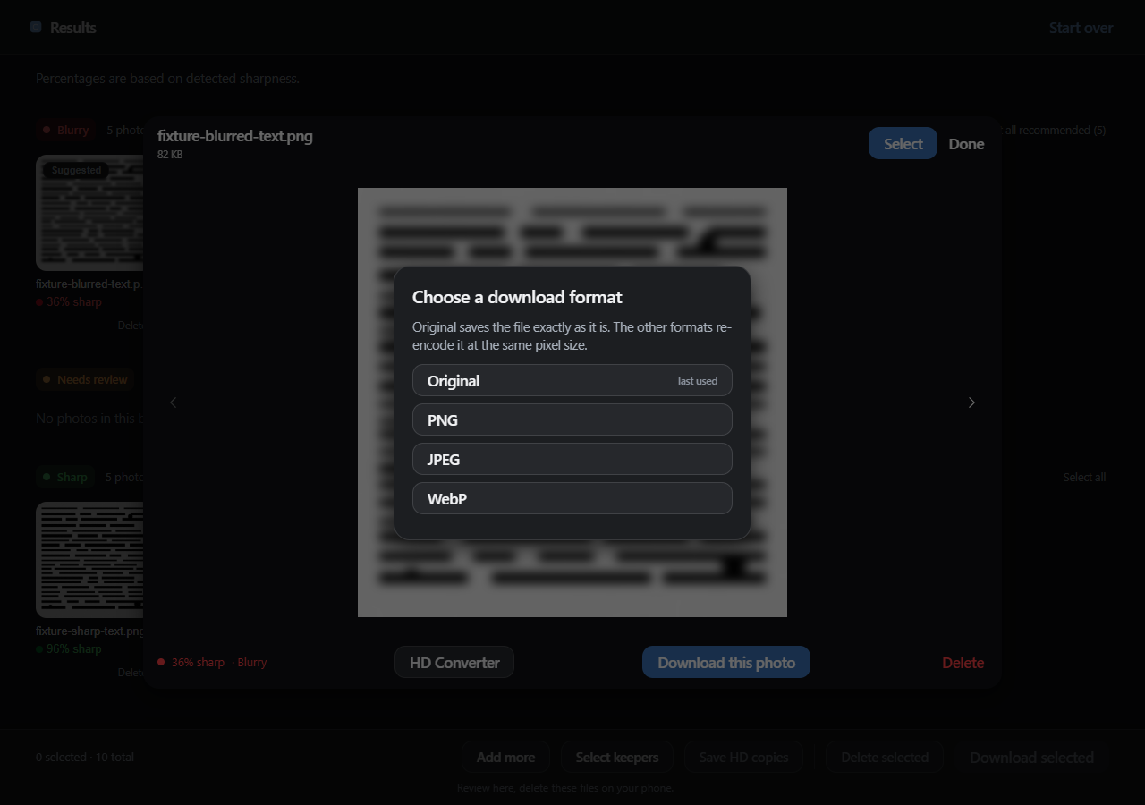
Figure 6. Every download asks for its format: Original, PNG, JPEG, or WebP.

4. Testing
Tests 1–4 check the features of the app. Test 5 compares it with the old manual way of doing the same task. Everything was run against the finished app in automated browser sessions.
Test | What you tried | Expected result | Actual result | Pass or Fail
Test 1  Upload | Picked 1 photo, then 24 photos at once; added a plain .txt file and a fake .heic photo; dragged 2 files onto the page. | Every photo appears as a thumbnail with its name; invalid files are counted in a visible notice and never dropped silently. | All 24 thumbnails rendered with the count “24 photos”; the .txt gave “1 file couldn't be opened” with the name listed; the .heic showed the same notice plus a convert-to-JPEG hint; the drag-drop added 2 photos. | Pass
Test 2  Blur detection and scores | Scored 2 sharp test patterns and 2 deliberately blurred copies; re-ran the same 4 files; read the score chips. | Sharp patterns score high and land in Sharp; blurred copies score low and land in Blurry; the same file always gets the same score; every tile shows its score as a percentage. | Sharp checkerboard 100 → Sharp, sharp text 96 → Sharp, blurred checkerboard 34 → Blurry, blurred text 36 → Blurry; every re-run gave identical scores; the chips read “100% sharp” … “34% sharp” and matched the stored scores exactly. | Pass
Test 3  Grouping, review, and delete | Reviewed batches for band order, counts, the Suggested marks, “Select all recommended”, tapping tiles to select, and deleting through the confirmation dialog (Cancel first, then Delete). | Photos are grouped Blurry → Needs review → Sharp with counts matching the tiles; blurry photos carry a Suggested mark and one tap selects all of them; every removal asks for confirmation first, names the exact count, and Cancel changes nothing. | Bands rendered in order with counts equal to the tiles; the empty middle band showed “No photos in this band”; Cancel and Escape closed the dialog with nothing deleted; confirming removed exactly the named photos and announced the removal; the last removal returned the app to the upload screen. | Pass
Test 4  Download formats, HD copies, and improvement | Pressed Download selected with nothing selected; downloaded with each format (Original, PNG, JPEG, WebP); opened a blurry photo, set sharpening High and 2×, created a preview, downloaded the copy; converted a 25-photo batch in parallel; pressed “Select keepers” and downloaded exactly those. | 0 selected disables the button; Original saves the file exactly as it is; the other formats re-encode at the same pixel size; the HD preview appears before anything is saved; a downloaded copy is scored fresh and lands in the band it belongs to; 25 photos convert in one parallel pass; keepers save only Sharp + ticked Needs-review photos. | With 0 selected the button was disabled; Original downloads stayed byte-identical; the JPEG re-export decoded as a real JPEG named photo.jpg. The sharpened HD copy previewed first, then downloaded and entered the review at 54% sharp — Needs review while its 36% Blurry original stayed untouched: the auto-reband worked. All 25 of 25 batch copies downloaded in 9.2 s. “Select keepers” selected exactly the 2 Sharp photos and dropped the manually ticked blurry one. | Pass
Test 5  Comparison | Same task done with the app and with the manual way — scrolling the phone's gallery and judging each photo by eye. | The app is faster, takes fewer steps, and makes fewer mistakes than judging photos by eye. | App (measured): 20 photos analyzed in 2.6 s while the page stayed responsive; a full run — load 24 photos, review, select 2, download — finished in well under a minute, most of it loading files into the test browser. Manual way (estimate, not measured): scrolling and eyeballing 24 photos takes roughly 3–5 minutes with dozens of scroll-and-judge steps and no score to check the judgment against, so mistakes are likely. The app keeps borderline photos in Needs review instead of guessing for the user. | Pass
Sources for the measured numbers (automated end-to-end runs in the project repository): Test 1 — phase2-e2e-matrix (12/12); Test 2 — phase3-e2e-tester (8/8); Test 3 — phase4-e2e-tester (11/11); Test 4 — the v0.3.0 features suite (keepers, preview, auto-reband 36→54, JPEG check, 25-photo batch in 9.2 s); Test 5 (app side) — 20-photo analysis window 2.61 s. The manual-way time is an estimate, not a measurement. The app never deletes files from the phone: it removes photos from the review session after confirmation and saves the copies to keep, so the files to delete can be found by name in the gallery app.

5. Conclusion
- What works: uploading 1 to 24+ photos with invalid and oversized files counted in a notice instead of dropped silently; sharpness scoring in a background worker that kept the page responsive (20 photos in 2.6 s); the three-band grouping with an “NN% sharp” percentage on every tile and Suggested marks on the blurry ones; one-tap Select keepers; downloads that save the original files byte-identical or re-encode them as PNG, JPEG, or WebP on request; HD copies at a chosen size with a sharpening pass, an animated old-to-new resolution readout, and a preview you approve before anything is saved; a downloaded copy that is scored fresh and automatically joins the band it earns (tested: a 36% Blurry original improved to a 54% Needs-review copy); 25-photo batches converted in parallel in about 9 seconds; deletion behind a confirmation dialog that names the exact count; and the privacy promise — photos never leave the device, verified by running the whole flow with all outside network requests blocked.
- What does not work: the app cannot delete photos from the phone — it removes them from the review session only, and the user deletes those files in the gallery app themselves. Sharpening adds crispness, not captured detail: a genuinely unsharp photo stays limited, and the honest fix is a better photo, not a bigger number. iPhone HEIC photos may need converting to JPEG first, because some browsers cannot decode them. And a single sharpness metric can flag sharp-but-low-texture photos (a sky, a plain wall) as blurry — the Needs review band catches the borderline cases so the user decides, but those photos still need a human eye.
- What I would improve: export all selected photos as one ZIP file instead of one download at a time; add adjustable thresholds for advanced users; add a real detail-enhancing upscale model instead of resampling plus sharpening; and make the app installable and fully offline as a PWA.

