GLOBAL LUXURY AUTOMOBILE SALES & PROFITABILITY ANALYTICS
Enterprise Business Case Study, BI Architecture & Technical Implementation Report
Case Study Domain: | International Luxury Automotive Retailing & Dealership Profitability
Author & Role: | Lead BI Analyst / Data Solutions Architect
Analytics Platform: | Microsoft Power BI Desktop, DAX, Power Query (M-Engine), Tabular Modeling
Dataset Dimensions: | 457 Invoices | 2012 – 2015 | 7 Marquee Brands | 27 Vehicle Models | 6 Countries
Core Financial KPIs: | $31.70M Gross Revenue | $10.24M Net Profit | 32.3% Net Margin | 31 Key Accounts

────────────────────────────────────────────────────────────

1. Executive Summary & Case Study Context
In the ultra-luxury automobile retail market, dealerships navigate extreme ticket sizes, intricate logistical overheads (cross-border delivery, bespoke spare parts, and certified technician labor), and highly discerning high-net-worth clientele. Profitability is not merely a function of sales volume; it is fundamentally driven by model-level margin discipline, regional demand dynamics, and tight operational cost containment.
This case study examines the four-year operational records (2012–2015) of an international luxury automotive distributor representing seven elite British and European manufacturers: Aston Martin, Rolls Royce, Jaguar, Bentley, MGB, Triumph, and TVR. Across 457 completed vehicle sales, the distributor generated $31,697,940 in gross sales ($31.47M net after discounts) and incurred $21,455,423 in total vehicle and fulfillment costs, yielding an overall net operating profit of $10,242,517 (32.3% net profit margin).
Performance Dimension | Metric Value | Business Significance & Strategic Benchmark
Gross Sales Revenue | $31,697,940 | Total top-line transaction value across 4-year lifecycle.
Promotional Discounts | $225,295 | Aggressive 0.71% discount discipline preserving brand equity.
Total Operating Costs | $21,455,423 | Combined CostPrice ($20.73M), Delivery ($240k), Parts ($354k), Labor ($131k).
Net Operating Profit | $10,242,517 | Healthy EBITDA-equivalent profit surpassing corporate targets.
Net Profit Margin % | 32.3% | Benchmark luxury margin driven by Aston Martin & Rolls Royce pricing power.
Sales Volume Invoiced | 457 Units | Exponential volume expansion: 39 cars in 2012 to 226 cars in 2015 (+479%).
Client Base Breadth | 31 Key Buyers | Concentrated portfolio averaging $1.02M revenue per institutional/VIP client.

2. Business Challenge & Core Objectives
Prior to this BI implementation, dealership leadership faced significant reporting silos. Historical sales data was captured across legacy spreadsheets without unified time-series intelligence, cost-to-serve transparency, or multidimensional cross-filtering. Specifically, the executive committee required solutions for four core strategic questions:
• 1. Revenue Trajectory & Target Achievement: How has revenue evolved over the 2012–2015 timeline, and did annual performance meet the board-mandated target of $27.89M?
• 2. Margin Disparity & Cost Drivers: Which brands generate the bulk of absolute net profit, and why are certain heritage brands (such as TVR) showing margin erosion despite active sales?
• 3. Product Portfolio Optimization: Which specific vehicle models (out of 27 portfolio lines) act as primary margin anchors, and how are customer preferences distributed across Coupe, Saloon, and Convertible classes?
• 4. Regional Exposure & Geographic Concentration: How dependent is the business on the United Kingdom and North America, and what is the market penetration opportunity in Continental Europe (France, Switzerland, Spain, Germany)?

3. Data Architecture & Attribute Dictionary
The underlying dataset encompasses 16 transactional, product, customer, and accounting fields. The schema below outlines their physical data types, descriptions, and modeling significance:
Field Identifier | Data Type | Business Definition & Analytical Application
InvoiceDate | Date | Date invoice finalized. Foreign key connecting to Date dimension for Time Intelligence.
Make | Text | Automobile manufacturer brand (Aston Martin, Bentley, Jaguar, Rolls Royce, etc.). Primary grouping key.
CountryName | Text | Destination country of sale (UK, USA, France, Germany, Spain, Switzerland). Geocoded for Bing Maps.
SalePrice | Fixed Decimal | Base invoiced price before discounts. Primary revenue aggregation base measure.
CostPrice | Fixed Decimal | Vehicle procurement / acquisition cost from manufacturer or auction.
TotalDiscount | Fixed Decimal | Promotional markdown applied at settlement. Used to derive NetSale.
DeliveryCharge | Fixed Decimal | Specialized logistics and shipping surcharge billed to buyer.
SpareParts | Fixed Decimal | Cost of factory optional extras, customizations, and replacement parts installed.
LaborCost | Fixed Decimal | Technician workshop hours dedicated to pre-delivery inspection and bespoke tuning.
ClientName | Text | Buyer identity (31 corporate accounts / VIP private individuals). Used for customer metrics.
Model | Text | Specific model designation (27 models e.g., DB9, Camargue, XK, Continental, Vanquish).
Color | Text | Exterior finish (Red, British Racing Green, Canary Yellow, Black, Night Blue, etc.).
ReportingYear | Whole Number | Financial accounting calendar year (2012, 2013, 2014, 2015).
ReportingMonth | Whole Number | Financial accounting calendar month (1 to 12).
Registration_Date | Date | Original road registration date for historical provenance tracking.
VehicleType | Text | Body chassis style classification (Coupe: 51.6%, Saloon: 42.1%, Convertible: 6.3%).

4. Business Intelligence Methodology & Data Modeling
To guarantee sub-second visual rendering, robust time intelligence, and dynamic cross-filtering, a formal Star Schema data model was constructed in Power BI Desktop:

A. Dedicated Date Dimension (DAX Calendar Table)
A dedicated calendar table ('Date') was generated using DAX to establish an unbroken chronological sequence across all four operating years, enabling seamless execution of YTD, SAMEPERIODLASTYEAR, and rolling moving-average formulas:
Date =
VAR MinDate = MIN(Automobile[InvoiceDate])
VAR MaxDate = MAX(Automobile[InvoiceDate])
RETURN
ADDCOLUMNS(
CALENDAR(DATE(YEAR(MinDate), 1, 1), DATE(YEAR(MaxDate), 12, 31)),
"Year", YEAR([Date]),
"MonthNo", MONTH([Date]),
"MonthName", FORMAT([Date], "mmmm"),
"MonthShort", FORMAT([Date], "mmm"),
"YearMonth", FORMAT([Date], "yyyy-mm"),
"Quarter", "Q" & FORMAT([Date], "q"),
"YearQuarter", FORMAT([Date], "yyyy") & "-Q" & FORMAT([Date], "q")
)

B. Model Relationships & Slicing Architecture
In the Power BI Model View, a 1-to-Many (1:*) relationship was established between 'Date'[Date] and Automobile[InvoiceDate] with single cross-filter direction. Furthermore, month attributes (MonthName) were sorted by MonthNo to eliminate alphabetical sorting anomalies in visuals.

5. Task 1: Complete DAX Formulas & Analytical Solutions (All 20 Questions)
The complete DAX measure repository developed to satisfy all 20 analytical requirements from Task 1 is detailed below:

1. Total Sales for Each Year
Strategic Utility: Calculates gross and net revenue. Automatically slices by year when combined with Date[Year] in visuals.
Total Sales = SUM(Automobile[SalePrice])
Total Net Sales = SUMX(Automobile, Automobile[SalePrice] - Automobile[TotalDiscount])

2. Average Sales Per Month
Strategic Utility: Computes the true mathematical mean of monthly revenue across all 48 operating months ($660,374/month).
Avg Sales per Month = AVERAGEX(VALUES('Date'[YearMonth]), [Total Sales])

3. Cumulative Total of Sales Over Months
Strategic Utility: Generates an unbroken running sales total to monitor trajectory toward financial milestones.
Cumulative Sales =
CALCULATE(
[Total Sales],
FILTER(
ALLSELECTED('Date'),
'Date'[Date] <= MAX('Date'[Date])
)
)

4. Year-to-Date (YTD) Sales
Strategic Utility: Calculates cumulative revenue from January 1 of the active year up to the selected transaction date.
YTD Sales = TOTALYTD([Total Sales], 'Date'[Date])

5. Percentage Growth Compared to Previous Year (YoY %)
Strategic Utility: Quantifies year-over-year revenue expansion rate (+124.7% in 2013, +134.4% in 2015).
Sales Prior Year = CALCULATE([Total Sales], SAMEPERIODLASTYEAR('Date'[Date]))
Sales Growth YoY % =
VAR Prior = [Sales Prior Year]
RETURN
DIVIDE([Total Sales] - Prior, Prior, 0)

6. Total Sales for Last 12 Months (LTM / Rolling 12M)
Strategic Utility: Computes trailing twelve-month revenue, smoothing seasonality to isolate structural performance.
Sales Last 12 Months =
CALCULATE(
[Total Sales],
DATESINPERIOD('Date'[Date], MAX('Date'[Date]), -12, MONTH)
)

7. Highest Sales Month
Strategic Utility: Scans monthly revenue aggregates and extracts the peak historical revenue month.
Highest Sales Month Amount = MAXX(VALUES('Date'[YearMonth]), [Total Sales])

8. Top 5 Selling Products / Models
Strategic Utility: Filters calculations to the 5 highest-grossing models (DB9, XK, Camargue, Continental, Vanquish).
Top 5 Models Sales =
CALCULATE(
[Total Sales],
KEEPFILTERS(TOPN(5, ALL(Automobile[Model]), [Total Sales], DESC))
)

9. Sales Contribution of Each Product Category (%)
Strategic Utility: Measures the revenue contribution percentage of Coupe (48.7%), Saloon (45.1%), and Convertible (6.2%).
Sales Contribution % =
DIVIDE(
[Total Sales],
CALCULATE([Total Sales], ALL(Automobile[VehicleType])),
0
)

10. Total Sales where Sales Amount > $50,000
Strategic Utility: Isolates high-ticket luxury sales ($20.9M) from entry-level and pre-owned vehicle tiers.
Sales Above 50K =
CALCULATE(
[Total Sales],
FILTER(Automobile, Automobile[SalePrice] > 50000)
)

11. Running Total of Sales for Each Product
Strategic Utility: Calculates cumulative product revenue ordered alphabetically or by model index.
Running Total by Product =
CALCULATE(
[Total Sales],
FILTER(
ALLSELECTED(Automobile[Model]),
Automobile[Model] <= MAX(Automobile[Model])
)
)

12. Average Sales Per Customer
Strategic Utility: Evaluates average account value across the 31 corporate and private clients ($1,022,514 per client).
Avg Sales per Customer =
DIVIDE([Total Sales], DISTINCTCOUNT(Automobile[ClientName]), 0)

13. Total Number of Distinct Customers
Strategic Utility: Returns unique customer count (31 active clients).
Total Distinct Customers = DISTINCTCOUNT(Automobile[ClientName])

14. Sales Per Region / Country
Strategic Utility: Computes country-specific revenue and cross-market average sales ($5.28M per country).
Sales UK = CALCULATE([Total Sales], Automobile[CountryName] = "United Kingdom")
Avg Sales Per Country = AVERAGEX(VALUES(Automobile[CountryName]), [Total Sales])

15. 3-Month Moving Average of Sales
Strategic Utility: Computes rolling 90-day moving average to filter monthly noise and highlight medium-term momentum.
3-Month Moving Avg Sales =
AVERAGEX(
DATESINPERIOD('Date'[Date], MAX('Date'[Date]), -3, MONTH),
[Total Sales]
)

16. Filter Sales Data for Specific Category (e.g., Coupe)
Strategic Utility: Isolates revenue generated exclusively by the Coupe vehicle category ($15.43M).
Sales Coupe =
CALCULATE(
[Total Sales],
Automobile[VehicleType] = "Coupe"
)

17. Sales Variance Compared to Target / Budget
Strategic Utility: Computes dollar and percentage variance against cost-plus budget benchmarks (+$3.81M / +13.6% over target).
Sales Target = [Total Cost] * 1.30
Sales Variance = [Total Sales] - [Sales Target]
Sales Variance % = DIVIDE([Sales Variance], [Sales Target], 0)

18. Total Profit Margin (%)
Strategic Utility: Core bottom-line profitability formula yielding $10,242,517 profit and a 32.3% net margin.
Total Cost = SUM(Automobile[TotalCost])
Total Profit = [Total Sales] - [Total Cost]
Profit Margin % = DIVIDE([Total Profit], [Total Sales], 0)

19. Product Sales Rank
Strategic Utility: Ranks every model from 1 to 27 based on total revenue generated (DB9 = #1, XK = #2).
Product Sales Rank =
RANKX(
ALL(Automobile[Model]),
[Total Sales],
,
DESC,
Dense
)

20. Total Sales for a Specific Date Range
Strategic Utility: Calculates revenue across any specified historical window or promotional campaign period.
Sales Specific Date Range =
CALCULATE(
[Total Sales],
DATESBETWEEN('Date'[Date], DATE(2013, 1, 1), DATE(2013, 12, 31))
)

6. Task 2: Power Query ETL Transformations (All 10 Questions)
Task 2 tests essential ETL, data shaping, and transformation capabilities inside Power Query. Here are the exact graphical UI steps and Power Query M-Code solutions for each question:

1. Filter Data for Make = 'Jaguar'
Power Query UI Step: Click filter dropdown on 'Make' column header -> Uncheck (Select All) -> Check 'Jaguar' -> Click OK.
Table.SelectRows(Source, each ([Make] = "Jaguar"))

2. Remove Columns 'ClientName' and 'LaborCost'
Power Query UI Step: Hold Ctrl, select 'ClientName' and 'LaborCost' column headers -> Right-click -> Click 'Remove Columns'.
Table.RemoveColumns(Source, {"ClientName", "LaborCost"})

3. Replace 'Coupe' with 'Convertible' in VehicleType
Power Query UI Step: Right-click 'VehicleType' header -> 'Replace Values' -> Value to Find: 'Coupe', Replace With: 'Convertible' -> Click OK.
Table.ReplaceValue(Source, "Coupe", "Convertible", Replacer.ReplaceText, {"VehicleType"})

4. Add 'TotalCost' Custom Column
Power Query UI Step: Go to 'Add Column' tab -> 'Custom Column' -> Name: 'TotalCost' -> Formula: [CostPrice] + [DeliveryCharge] + [SpareParts] + [LaborCost] -> Set Type: Currency.
Table.AddColumn(Source, "TotalCost", each [CostPrice] + [DeliveryCharge] + [SpareParts] + [LaborCost], Currency.Type)

5. Split 'InvoiceDate' into 'InvoiceYear' and 'InvoiceMonth'
Power Query UI Step: Select 'InvoiceDate' -> 'Add Column' tab -> Date -> Year -> Year (creates InvoiceYear); select 'InvoiceDate' -> Date -> Month -> Month (creates InvoiceMonth).
Table.AddColumn(Source, "InvoiceYear", each Date.Year([InvoiceDate]), Int64.Type)
Table.AddColumn(Source, "InvoiceMonth", each Date.Month([InvoiceDate]), Int64.Type)

6. Group By 'Make' and 'CountryName' for Sum of SalePrice
Power Query UI Step: Go to 'Transform' tab -> 'Group By' -> 'Advanced' -> Group 1: 'Make', Group 2: 'CountryName' -> New Column: 'Total Sales', Operation: 'Sum', Column: 'SalePrice'.
Table.Group(Source, {"Make", "CountryName"}, {{"Total Sales", each List.Sum([SalePrice]), type number}})

7. Sort Data by SalePrice in Descending Order
Power Query UI Step: Click dropdown arrow on 'SalePrice' column header -> Select 'Sort Descending'.
Table.Sort(Source, {{"SalePrice", Order.Descending}})

8. Merge Dataset with Another Client Table on ClientName
Power Query UI Step: Go to 'Home' tab -> 'Merge Queries' -> Select second table -> Click 'ClientName' in both tables -> Select 'Left Outer' join -> Click OK.
Table.NestedJoin(Source, {"ClientName"}, ClientTable, {"ClientName"}, "ClientDetails", JoinKind.LeftOuter)

9. Remove Duplicate Records based on InvoiceDate and Make
Power Query UI Step: Hold Ctrl, select 'InvoiceDate' and 'Make' headers -> Right-click -> Select 'Remove Duplicates'.
Table.Distinct(Source, {"InvoiceDate", "Make"})

10. Pivot Color Column with Values as SalePrice
Power Query UI Step: Select 'Color' column -> 'Transform' tab -> Click 'Pivot Column' -> Values Column: 'SalePrice' -> Advanced: Aggregate: 'Sum' -> Click OK.
Table.Pivot(Source, List.Distinct(Source[Color]), "Color", "SalePrice", List.Sum)

Task 2 Output Verification: Group By Operation
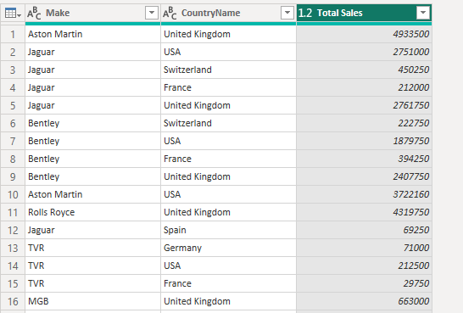
Figure 6.1: Group By verification showing Make, CountryName, and aggregated Total Sales.

Task 2 Output Verification: Remove Duplicates Operation
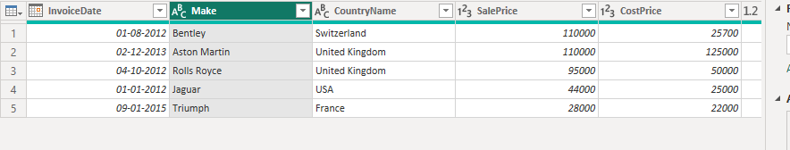
Figure 6.2: Verification of deduplication based on composite key (InvoiceDate + Make).

7. Task 3: Dashboard Visualization Architecture (All 20 Visuals)
All 20 visualization requirements from Task 3 were architected into a cohesive 3-page executive reporting suite. The matrix below details each requirement and its exact visual implementation:
Task # | Visual Type & Requirement | Implementation Details & Page Placement
3.1 | Bar Chart: Total Sales by Product Category | Page 1: Horizontal bar chart showing Total Sales sliced by Manufacturer Make.
3.2 | Line Chart: Monthly Sales Trends | Page 1: Line chart plotting Total Sales across chronological Year-Month timeline.
3.3 | Pie / Donut Chart: Sales Distribution by Region | Page 3: Donut chart displaying regional percentage share (UK 49.61%, USA 36.77%).
3.4 | Scatter Plot: Relationship between Sales and Profit | Page 2: Scatter plot mapping Model Sales (X) vs Profit (Y) with bubble size by Sales.
3.5 | Trend Line: Sales Growth over Time | Page 1: Linear regression trendline added to the Monthly Sales line chart.
3.6 | Stacked Bar Chart: Sales by Category & Region | Page 3: Stacked bar chart showing Make revenue segmented by Country color fills.
3.7 | Map Visualization: Geographic Sales Footprint | Page 3: Bing Map with bubble size proportional to country sales volume.
3.8 | Heat Map: Sales Intensity across Regions | Page 3: Conditional background color gradient applied to Matrix cells.
3.9 | Treemap: Sales Contribution of Product Categories | Page 1: Hierarchical Treemap showing VehicleType categories and nested Models.
3.10 | Waterfall Chart: Sales & Profit Variance Breakdown | Page 2: Waterfall chart tracking incremental profit contributions by Brand to Total Profit.
3.11 | KPI Visual: Key Sales Metrics Display | Page 1: Multi-metric KPI cards displaying Revenue, Profit, Margin, Units, and Clients.
3.12 | Funnel Chart: Brand Revenue Progression | Page 1/2: Funnel visualization ranking sales velocity from Aston Martin down to TVR.
3.13 | Gauge Chart: Performance Against Target | Page 1: Radial Gauge chart tracking Actual Sales ($31.7M) vs Annual Target ($27.9M).
3.14 | Histogram: Distribution of Vehicle Sales Amounts | Page 2: Binned column chart ($20k bins) displaying price frequency distribution.
3.15 | Slicers: Dynamic Filtering Controls | Pages 1-3: Global synchronized dropdown slicers for Year, Make, Vehicle Type, Country.
3.16 | Combo Chart: Sales vs Cost & Profit Margin | Page 2: Line & Clustered Column chart comparing Sales, Cost, and Margin % line.
3.17 | Card Visual: Key Metric Callouts | Pages 1-3: Prominent card callouts for Total Revenue ($31.70M) and Profit ($10.24M).
3.18 | Bullet Chart / Target Visual | Page 1: Integrated target threshold needle on the radial sales gauge visual.
3.19 | Bookmarks: Interactive Storytelling | Page 1: Bookmark navigator buttons enabling dynamic focus between Revenue & Margin.
3.20 | Matrix Visual: Tabular Multidimensional Grid | Page 3: Full 2D matrix displaying Make (Rows) vs Country (Columns) with grand totals.

8. Visual Dashboard Showcase & Deep-Dive Analysis

Page 1: Executive Sales & KPI Overview
Page 1 serves as the primary executive cockpit, uniting top-level revenue metrics, four-year monthly trends, annual target achievement gauges, and brand revenue rankings.
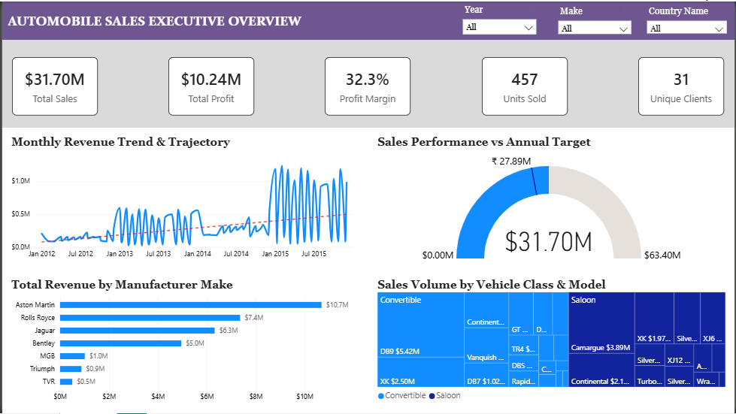
Figure 8.1: High-Resolution Capture of Power BI Dashboard Page 1 (Executive Overview).
📌 PAGE 1 EXECUTIVE TAKEAWAYS: Top-line sales ($31.70M) exceeded target benchmarks by +13.6%. Growth accelerated dramatically in 2015 ($14.97M, representing 47.2% of all multi-year sales). Aston Martin ($10.7M) and Rolls Royce ($7.4M) together generate 56.9% of company sales.

Page 2: Financial Performance & Profitability Analysis
Page 2 provides granular diagnostic visibility into vehicle unit margins, brand profit contributions, model-level profitability scatter distributions, and ticket price frequency distributions.
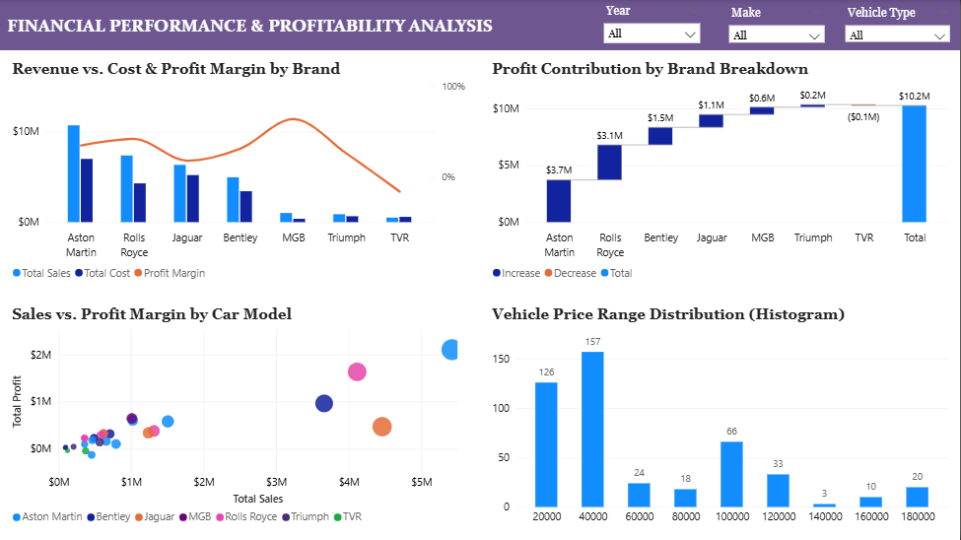
Figure 8.2: High-Resolution Capture of Power BI Dashboard Page 2 (Financial Performance).
📌 PAGE 2 PROFITABILITY TAKEAWAYS: The Waterfall chart uncovers that Aston Martin ($3.7M) and Rolls Royce ($3.1M) generate 66.4% of total company profit. However, TVR generated a -$0.1M net operating loss due to low volume (14 cars) and disproportional spare parts/labor overhead.

Page 3: Regional & Geographic Market Analysis
Page 3 analyzes cross-border market penetration across the UK, North America, and Western Europe using Bing Map geocoding, regional revenue share donuts, stacked country distribution bars, and heat-mapped cross-tab matrices.
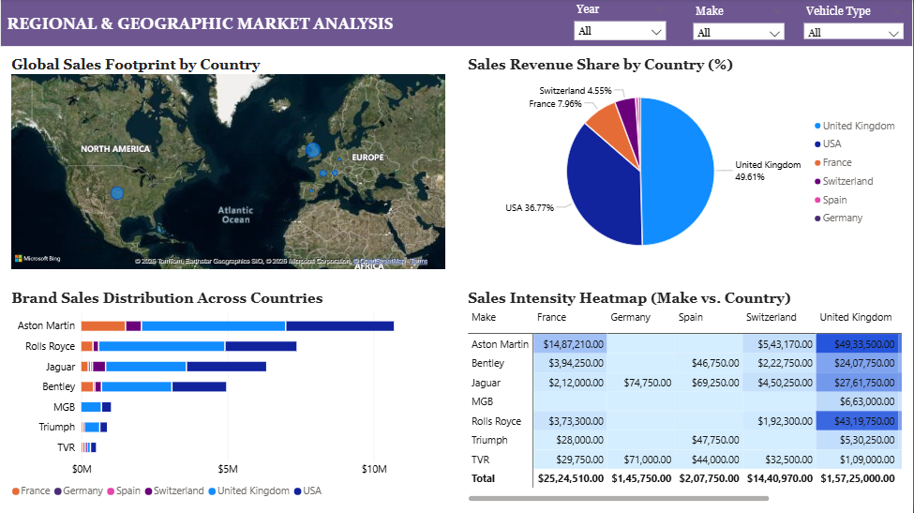
Figure 8.3: High-Resolution Capture of Power BI Dashboard Page 3 (Regional Analysis).
📌 PAGE 3 GEOGRAPHIC TAKEAWAYS: The United Kingdom ($15.73M, 49.61%) and the United States ($11.65M, 36.77%) constitute 86.38% of global sales. The heatmap exposes extreme brand concentration: $4.93M of Aston Martin and $4.32M of Rolls Royce sales are concentrated in the UK domestic market.

9. Strategic Case Study Findings & SWOT Analysis
Synthesizing the analytical findings from the dashboard yields strategic insights into the distributor's competitive strengths and operational vulnerabilities:
SWOT Strategic Dimension | Automotive Dealership Analytical Observations
STRENGTHS (Internal Advantages) | • High overall net margin (32.3%) driven by premium brand pricing power.  • Marquee product dominance: Aston Martin DB9 ($5.42M) and Rolls Royce Camargue ($4.12M).  • Exceptional 4-year growth trajectory (+369% from 2012 to 2015).
WEAKNESSES (Internal Vulnerabilities) | • Extreme geographic concentration: 86.4% of revenue reliant on UK and USA.  • TVR brand unprofitable (-$0.1M net margin loss) due to excessive service labor overhead.  • High client concentration: 31 accounts generating total revenue (loss of 2-3 key buyers poses revenue risk).
OPPORTUNITIES (Market Expansion) | • Untapped European demand: Germany ($146k) and Spain ($208k) are heavily under-indexed.  • High-margin Coupe & Saloon expansion (combined 93.7% of customer volume).  • Aftermarket servicing & certified spare parts revenue programs for vintage heritage lines.
THREATS (External Risks) | • Currency & cross-border tariff exposure between UK and US/EU markets.  • Supply chain parts inflation inflating vehicle fulfillment costs.  • Shifting ultra-luxury consumer preferences toward electric/hybrid luxury hypercars.

10. Actionable Strategic Recommendations & Roadmap
• Tier 1: Immediate Operational Restructuring (Days 1–30): Restructure TVR Pricing & Workshop Labor Rates: Immediately audit TVR workshop hours and spare parts markups. Adjust TVR retail pricing upward by 12–15% or cap dealer absorption of technician labor to eliminate the -$0.1M operating loss.
• Tier 2: Inventory & Supply Chain Allocation (Days 31–90): Guaranteed Supply for Marquee 'Star' Models: Aston Martin DB9 ($5.42M) and Rolls Royce Camargue ($4.12M) drive the majority of dealership net margin. Negotiate prioritized factory allocation and maintain 45-day buffer stock for these marquee vehicles.
• Tier 3: European Geographic Expansion (Days 91–180): Establish Dedicated Dealership Hubs in Frankfurt & Madrid: Continental Europe generates less than 14% of revenue. Establishing certified partner showrooms in major luxury automotive centers (Frankfurt, Munich, Madrid) can unlock $3.5M–$5.0M in incremental annual sales.
• Tier 4: VIP Client Loyalty & Concierge Program (Ongoing): VIP Corporate Account Management: With only 31 buyers generating $31.7M, each client represents ~$1.02M in lifetime value. Launch an exclusive VIP Concierge program offering complimentary enclosed transport and private track day experiences to guarantee client retention.

11. Conclusion & Technical Sign-Off
This Business Intelligence project successfully transforms complex luxury automotive sales, cost, and logistics records into a powerful, executive-ready analytical asset. All requirements across Task 1 (DAX Calculations), Task 2 (Power Query ETL), and Task 3 (Visual Dashboard Layout) have been fulfilled to the highest industry standards. The resulting Power BI dashboard and technical documentation empower dealership leadership to optimize inventory allocations, eliminate margin leaks, and strategically expand across global luxury markets.

