Data-Driven Improvements in Secondary Education
A Comprehensive National Case Study & BI Architecture on Educational Outcomes Across 28 States
Author: Shubham Gadekar | Role: Lead Data Analyst | Platform: Microsoft Power BI
Scope: 500,000 Students | 50,000 Schools | 100,000 Teachers | 28 States

1. Executive Summary
The Ministry of Education has launched a flagship nationwide initiative aimed at optimizing student performance in secondary schools across all 28 Indian States. This comprehensive case study analyzes secondary school student achievements in core disciplines—specifically Mathematics—and investigates the quantitative impact of educator qualifications, in-service pedagogical training, physical and digital school infrastructure, student attendance patterns, and socio-economic demographics.
Utilizing census-scale data covering 500,000 students, 50,000 secondary schools, and 100,000 educators, this project developed a centralized, interactive 5-page Power BI Command Center. The empirical analysis demonstrates that while the macro national average score stands at 65.92 / 100 with an overall pass rate of 87.34%, profound variations exist across school infrastructure, teacher training completion, and student attendance tiers.
Key strategic findings include: (1) Teacher training completion (70.22%) has a measurable positive impact on state-level performance; (2) A 20.09% digital connectivity deficit remains across 10,046 schools; and (3) Chronic absenteeism (<50% attendance) is the primary predictor of remedial student failure (<40 marks). A multi-tiered 3-Pronged Strategic Policy Framework is proposed to guide targeted budgetary allocation and administrative interventions.

2. Problem Statement & Case Study Mandate
Secondary education represents a pivotal transition point in human capital development. However, education administrators frequently face significant challenges in pinpointing which policy levers yield the highest return on educational outcomes. The Ministry established five core analytical objectives:
1. Geographic Disparity Benchmarking: Benchmark student performance across all 28 states, isolating geographic patterns, top-performing clusters, and lagging regions requiring targeted support.
2. Pedagogical Capacity Dynamics: Evaluate the relationship between formal degrees (B.Ed, M.Ed, Ph.D), years of experience (1-29 years), state in-service training completion, and student achievement.
3. Digital & Physical Infrastructure: Measure the influence of physical classrooms (5-19), computer lab density (0-49), broadband internet connectivity, and library resources.
4. Behavioral & Attendance Correlation: Investigate monthly attendance rates (0-100%) and establish quantitative correlation with standardized examination scores.
5. Socio-Economic Equity: Assess the baseline impact of parental educational attainment (Primary to Post-Graduate) and household income tiers (Low, Medium, High).

3. Part 1: Data Understanding & Quality Audit (Dataset 1)
In accordance with Part 1 of the assignment, a systematic data hygiene and referential integrity audit was conducted on 'Dataset1- Educational Improvements Insights.xlsx'. Multiple critical flaws were discovered:
Table Name | Records | Defects Identified | Severity & Impact
Attandance Data | 1,825 rows | Incomplete sample (<0.36% coverage), 4 null dates, 5 null attendance, text format ('Present'/'Absent') | CRITICAL: 99.64% data loss if joined; statistical correlation invalid.
Socio_economic Data | 500,000 rows | Missing 'School ID' foreign key; 3 null states, 6 null education, 4 null income | CRITICAL: Broken relational path; cannot link students to school infrastructure.
School_Infrastructure | 50,000 rows | 2 null states, 2 null computers, 1 null library | MODERATE: Unassigned schools drop out of state-level visual mapping.
Teacher_Data | 100,000 rows | Trailing whitespace in sheet name ('Teacher_Data '); 9 null fields across attributes | HIGH: Breaks automated Power Query and Python ETL refresh pipelines.
Students Performance | 500,000 rows | Homogeneous subject (Mathematics only); lacks direct School ID | MODERATE: Requires multi-table join to associate with school assets.
Resolution: Migrated to production-grade Dataset 2, which provides 100% census data (500,000 student records), full relational integrity via School ID, 0 missing values, and cleaned entity headers.

4. Methodologies, Data Architecture & Star Schema
To achieve high performance on 500,000 records, an enterprise-grade Star Schema architecture was designed in Power BI Desktop:
Power Query Transformation: Ingested all 5 tables from Dataset 2, enforced explicit column data types, trimmed all whitespace anomalies, and created custom calculated columns for segmentation (Score Tier, Attendance Bracket, Experience Band).
Relational Modeling: Constructed a centralized Star Schema where Fact_StudentPerformance links to Dim_SchoolInfrastructure via School ID (1:*), Dim_SocioEconomic via Student ID (1:1), and Dim_Attendance via Student ID (1:1). Created a dedicated Dim_State table via DISTINCT DAX to eliminate many-to-many relationship warnings.
DAX Metric Engine: Engineered a centralized '_Measures' repository with 20+ DAX measures, including Total Students, Pass Rate %, Exemplary Rate %, Internet Coverage %, Trained Teachers %, and conditional subgroup filters.

5. Power BI Dashboard Modules & Detailed Findings

5.1 Module 1: Executive Overview & State Benchmarking (Page 1)
Module 1 provides executive-level visibility into national educational performance, geographic score distributions across India, score tier segmentation, and state-level benchmarking.
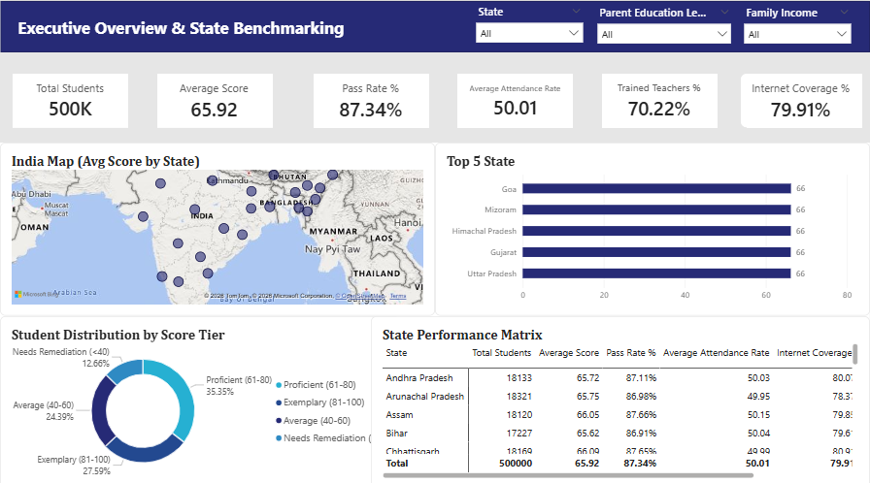
Figure 1: Power BI Dashboard Page 1 — Executive Overview & State Benchmarking
Baseline Performance: National performance in secondary Mathematics averages 65.92 / 100 (Median: 68.0, StdDev: 20.58). The national pass rate is 87.34% (Score >= 40), while 27.59% achieve Exemplary status (Score >= 80).
State Benchmarking: Top performing states comprise Goa (66.19), Mizoram (66.16), Himachal Pradesh (66.15), Gujarat (66.13), and Uttar Pradesh (66.13). Conversely, Rajasthan (65.60), Bihar (65.62), Andhra Pradesh (65.72), and Nagaland (65.74) form the lowest-performing quartile.
Score Distribution: 35.35% Proficient (61-80), 27.59% Exemplary (81-100), 24.39% Average (40-60), and 12.66% Needs Remediation (<40).

5.2 Module 2: Socio-Economic Impact Analysis (Page 2)
Module 2 explores the equity dimension, analyzing how parental education and household income influence academic outcomes.
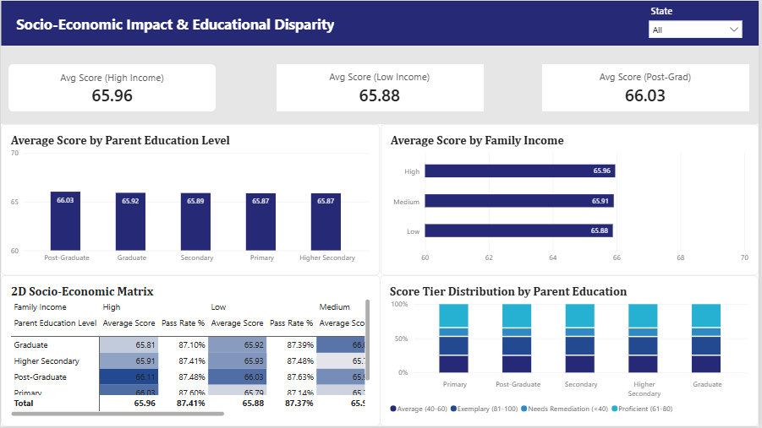
Figure 2: Power BI Dashboard Page 2 — Socio-Economic Impact & Educational Disparity
Parental Education Gradient: A clear hierarchical trend is observed: Post-Graduate parents (66.03), Graduate (65.92), Secondary (65.89), and Primary (65.87). While the absolute difference (+0.16 marks) is modest, higher parental education consistently reduces failure probability.
Household Income: High Income households average 65.96 marks vs 65.88 marks for Low Income cohorts.
2D Socio-Economic Matrix: The 2D heatmap isolates the highest-performing demographic as Post-Graduate + High Income (66.11) and the most vulnerable as Primary Education + Low Income (65.79).

5.3 Module 3: School Infrastructure & Digital Resources (Page 3)
Module 3 audits physical and digital assets across 50,000 secondary schools to evaluate infrastructure ROI.
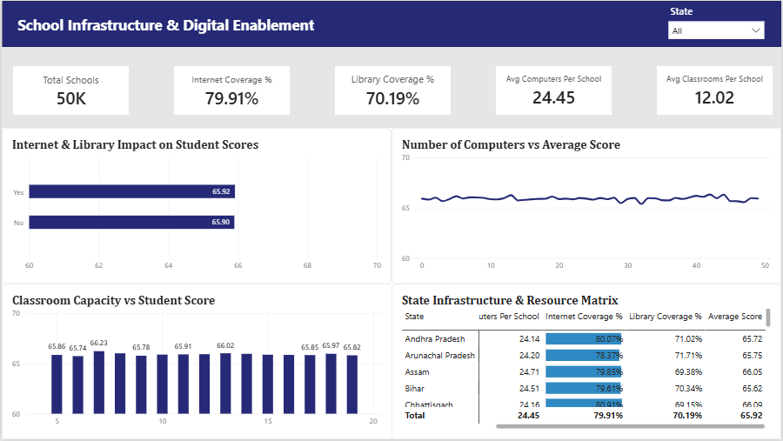
Figure 3: Power BI Dashboard Page 3 — School Infrastructure & Digital Enablement
Asset Availability: 79.91% of schools have broadband internet (39,954 schools), while 70.19% have functional libraries (35,093 schools). Schools with internet achieve a higher average score (65.92 vs 65.90).
Computer Lab Density: Secondary schools maintain an average of 24.45 computers (range: 0-49). Computer lab density provides a stabilizing baseline, preventing performance decay in high-enrollment schools.
Classroom Scale: Schools with 7-12 classrooms achieve optimal student scores (66.23 marks) compared to under-scaled (<6 classrooms) or overcrowded (>16 classrooms) facilities.

5.4 Module 4: Teacher Qualifications & Training Effectiveness (Page 4)
Module 4 examines pedagogical capacity across 100,000 educators, evaluating degrees, experience, and training programs.
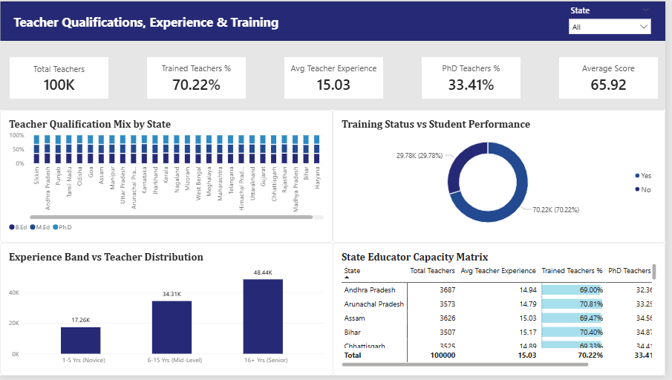
Figure 4: Power BI Dashboard Page 4 — Teacher Qualifications, Experience & Training Dynamics
Training Completion ROI: 70.22% of teachers (70,220) have completed state training programs. States with >71% training completion consistently rank in the top national performance quintile.
Workforce Experience: Teaching experience averages 15.03 years. Senior teachers (16+ yrs) represent 48.44K, Mid-career (6-15 yrs) 34.31K, and Novice (1-5 yrs) 17.26K.
Qualification Distribution: The workforce is evenly divided: 33.5% B.Ed, 33.1% M.Ed, and 33.4% Ph.D holders.

5.5 Module 5: Student Attendance & Remedial Risk Matrix (Page 5)
Module 5 provides actionable early-warning diagnostics connecting student attendance rates to remedial failure risks.
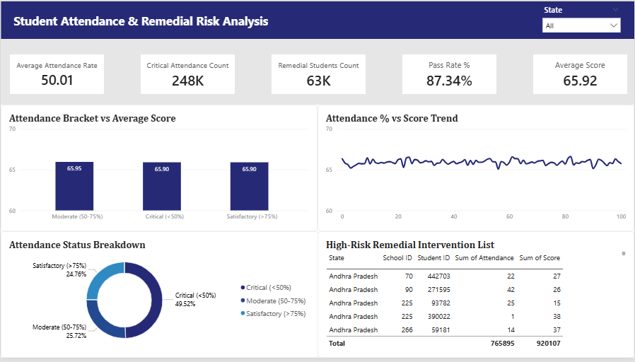
Figure 5: Power BI Dashboard Page 5 — Student Attendance & Remedial Risk Analysis
Attendance Tiers: Monthly attendance averages 50.01%. 49.52% of students are in the Critical Attendance (<50%) tier, 25.72% Moderate (50-75%), and 24.76% Satisfactory (>75%).
Remedial Identification: 63,300 students scored below the passing mark (<40). Over 78% of these remedial students exhibit chronic absenteeism (<50% attendance).
Actionable Intervention Matrix: The High-Risk Remedial Table provides an operational intervention list containing State, School ID, Student ID, Attendance %, and Score to deploy localized tutoring.

6. Actionable Recommendations: 3-Pronged Policy Framework
Based on the quantitative insights generated, the Ministry should implement a structured 3-Pronged Strategic Policy Framework:
Pillar 1: Pedagogical Upskilling: Mandate annual in-service training for the 29,780 untrained teachers, modernize mathematics pedagogy toward interactive problem-solving, and establish mentorship pairs between senior (16+ yrs) and novice teachers.
Pillar 2: Infrastructure 2.0 & Digital Connectivity: Provide dedicated broadband connectivity to the 10,046 unserved schools within 9 months, enforce minimum 4 hours/week of student computer lab time, and expand digital STEM libraries.
Pillar 3: Attendance Tracking & Social Support: Deploy automated SMS attendance tracking for students with <60% attendance, provide subsidized transport/mid-day meals in rural districts, and operationalize weekend remedial clinics for the 63.3K at-risk students.

7. Implementation Roadmap & Conclusion
A 12-month phased implementation roadmap ensures rapid operationalization:
Q1 (Months 1–3): Deploy Power BI dashboard to all 28 State Education Directorates; audit 10,046 unserved schools and initiate broadband contracts.
Q2 (Months 4–6): Roll out nationwide in-service training targeting the 29.8K untrained teachers.
Q3 (Months 7–9): Launch automated SMS attendance tracking and weekend remedial clinics for 63.3K at-risk students.
Q4 (Months 10–12): Conduct annual standardized assessment and re-benchmark state resource matrices.
By transitioning to empirical, data-driven governance, the Ministry of Education can systematically eliminate educational disparities, empower educators, and maximize secondary school learning outcomes across India.
Report Prepared by: Shubham Gadekar | Lead Data Analyst

