Uber Rides Analytics Dashboard
A Power BI Project Report

1. Introduction
This project presents an interactive Power BI dashboard built to analyze ride-hailing operations data modeled on Uber's business. It moves beyond static spreadsheets into a decision-ready analytics tool that surfaces trends across bookings, revenue, vehicles, customers, and locations in a single, navigable report.
The report is built on a connected data model covering bookings, cancellations, revenue, distance, ratings, payments, and customer-level detail, with DAX measures layered on top to power every KPI card, chart, and table in the report.

2. Project Objective
The objective was to design a multi-page, end-to-end business intelligence report that:
- Consolidates ride, revenue, vehicle, and customer data into one interactive report
- Surfaces key performance indicators (KPIs) at a glance for quick decision-making
- Allows drill-down analysis across vehicle type, customer segment, and geography
- Quantifies operational health — cancellations, lost revenue, and completion rates
- Demonstrates practical, end-to-end Power BI skills: data modeling, DAX, and report design

3. Tools & Technologies Used
- Power BI Desktop — data modeling, DAX measures, and report/visual design
- Power Query (M) — data cleaning, shaping, and transformation
- DAX (Data Analysis Expressions) — calculated measures and KPI logic
- Custom icons, 3D vehicle imagery, and consistent visuals — for a clean, branded report experience

4. Key Performance Indicators (KPIs)
Every page of the report is anchored by a consistent KPI strip at the top, giving viewers instant context before they drill into detail. Across the full dataset, the headline numbers are:
KPI | Value (Overall) | What it measures
Bookings | 93K | Total ride bookings received across all vehicle types
Lost Bookings | 57K | Bookings that were cancelled or left incomplete
Revenue | 52M | Total revenue generated from completed rides
Total Distance | 2.51M | Sum of distance (km) travelled across all trips
Average Distance | 24.64 | Average trip distance in km
Average Customer Rating | 4.40 / 5 | Mean rating given by customers
Average Driver Rating | 4.23 / 5 | Mean rating given to drivers

These top-line KPIs are re-contextualized per vehicle type: for example, filtering to Premier Sedan shows 11K bookings, 7K lost bookings, 6M revenue, 302.94K total distance, and 24.60 average distance — the same KPI logic, sliced dynamically.

5. Extra DAX Measures & Calculations
Beyond the core KPIs, the model includes a set of calculated DAX measures that power deeper analysis on the Vehicle, Revenue, Customer, and Location pages:

Revenue Measures
- MoM Revenue % — month-over-month revenue growth rate (e.g. 0.09 / 9%)
- Avg Revenue per Booking — Revenue ÷ Completed Bookings (348.51)
- Lost Revenue — estimated revenue forfeited from cancelled/incomplete bookings (19.80M)
- Revenue per KM — Revenue ÷ Total Distance, a unit-economics measure (20.63)
- Revenue by Payment Method — revenue split across UPI, Cash, Uber Wallet, Credit Card, and Debit Card
- Revenue by Customer — top revenue-contributing customers, ranked

Vehicle Measures
- Top Revenue Vehicle — the vehicle type generating the most revenue (Auto)
- Top Vehicle Revenue % — that vehicle's share of total revenue (24.84%)
- Contribution % (Contri %) — each vehicle type's share of completed bookings
- Ride Completion Rate % — Completed Bookings ÷ Total Bookings (62.21%)
- Ride Incomplete Rate % — Incomplete Bookings ÷ Total Bookings (38.19%)

Customer Measures
- First-Time / Return / Regular Customer counts — customer lifecycle segmentation
- Customer Cancellation % — share of bookings cancelled by the customer (7%)
- Customer Revenue Risk % — revenue exposed to cancellation-prone customers (10%)
- Customer Cancelled Count — number of bookings cancelled by customers (1K)
- Customer Cancelled Revenue Impact — revenue lost specifically to customer-side cancellations (645.11K)
- Top Cancellation Reason — most frequent cause of cancellation (e.g. "Driver asked to cancel")

Location Measures
- Top Pickup / Top Drop Location — highest-volume pickup and drop points (Khandsa, Ashram)
- Vehicle by Total Distance — distance travelled broken down by vehicle type and by location
- Demand by Time Slot — a day-of-week × time-slot matrix showing peak booking windows
Example DAX pattern used for rate-style measures:
Ride Completion Rate % = DIVIDE([Completed Bookings], [Total Bookings], 0)

6. Dashboard Walkthrough
The report is organized into six pages, each focused on a specific business lens. Screenshots of the live report are shown below.

6.1 Home
The landing page introduces the project and provides one-click navigation to every other page in the report.
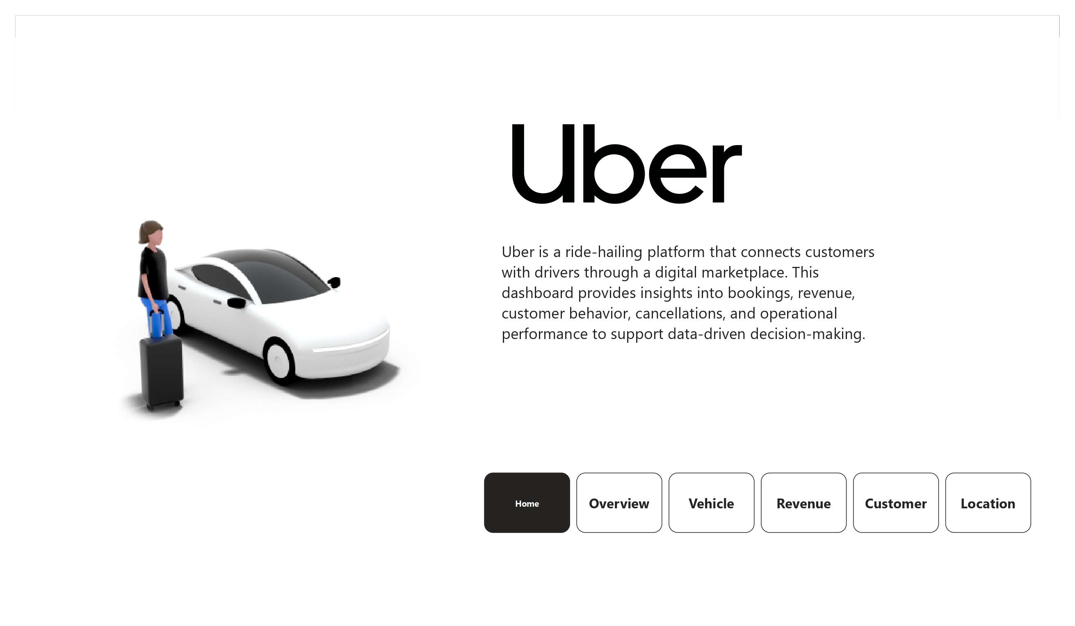
Home — navigation hub and project introduction

6.2 Overview
The Overview page summarizes overall performance: total bookings, lost bookings, revenue, distance, and rating KPIs, alongside monthly booking and revenue trends, a revenue-by-vehicle-type breakdown, and top pickup/drop locations.
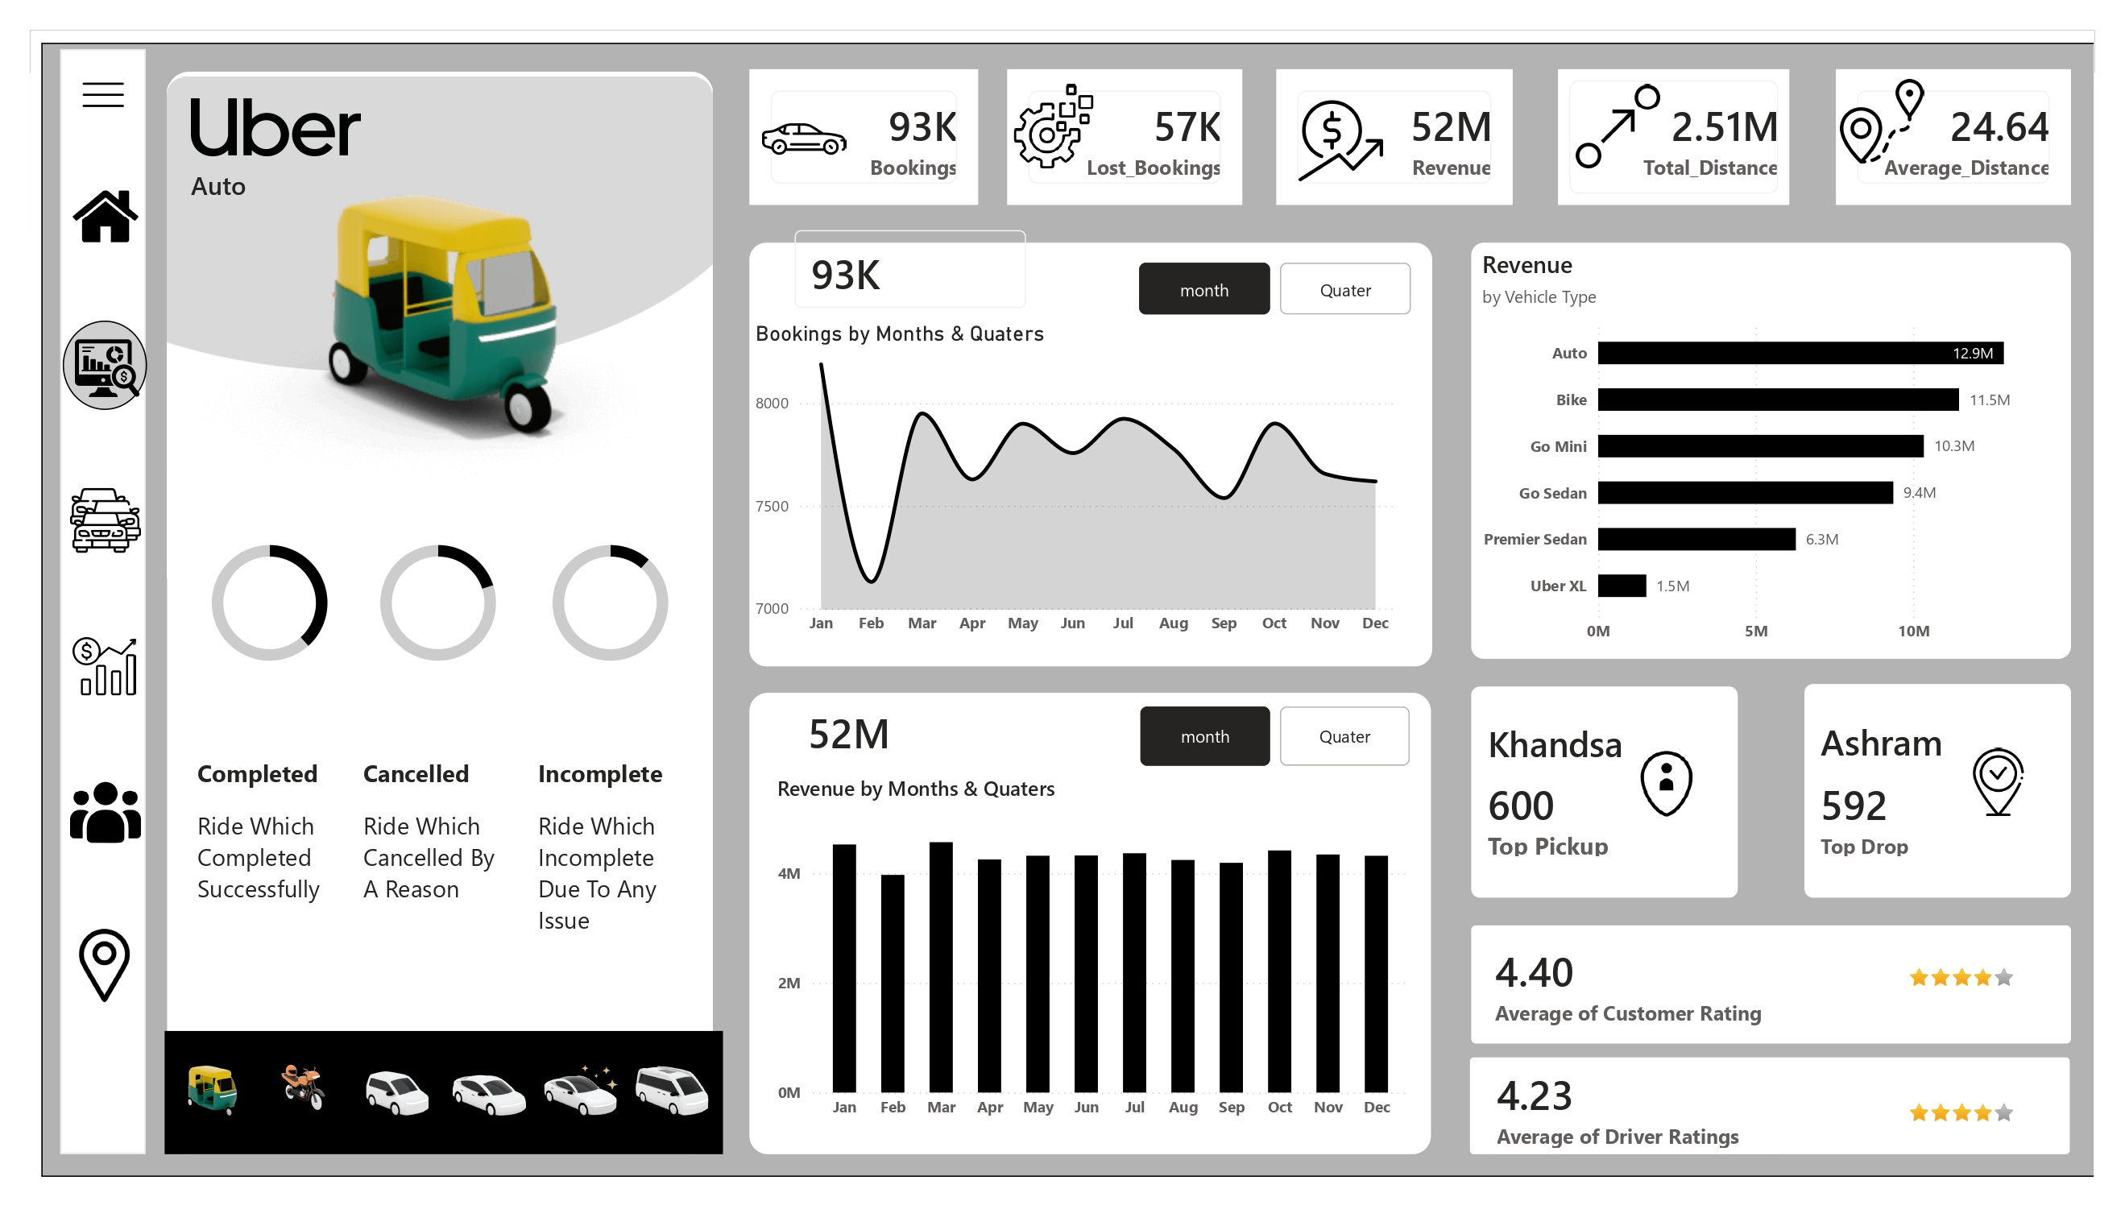
Overview — high-level KPIs and monthly trends

6.3 Vehicle
This page breaks down performance by vehicle type — Auto, Bike, Go Mini, Go Sedan, Premier Sedan, and Uber XL — showing customer count, revenue, completed bookings, contribution %, and a completed-bookings trend sparkline for each, plus Ride Completion / Incomplete Rate KPIs.
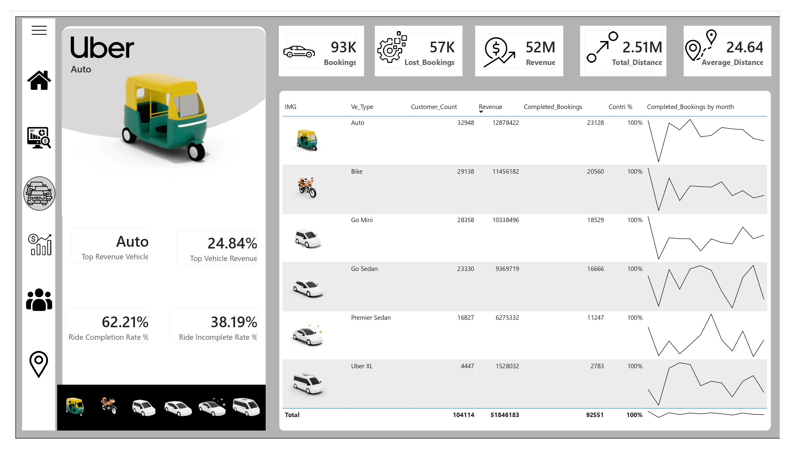
Vehicle — performance breakdown by vehicle type

6.4 Revenue
The Revenue page tracks monthly and quarterly revenue trends, revenue by payment method, revenue by top customers, MoM revenue growth, average revenue per booking, lost revenue, and revenue per km.
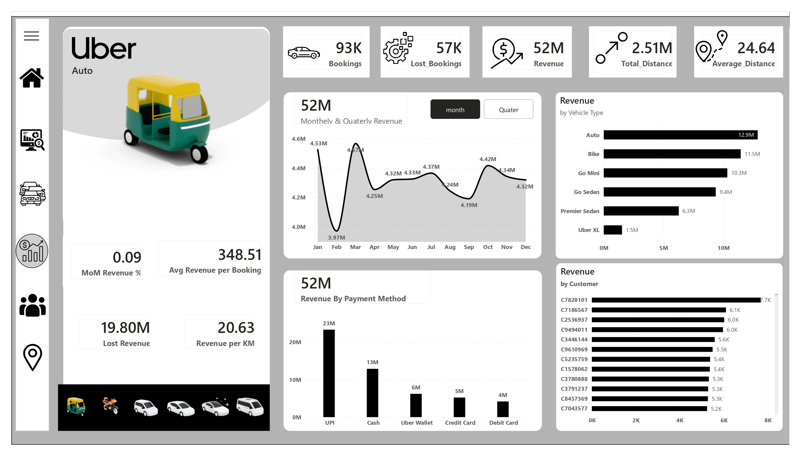
Revenue — trends, payment methods, and unit economics

6.5 Customer
The Customer page segments riders into first-time, return, and regular customers, tracks payment method usage by customer, and quantifies cancellation risk — including customer cancellation %, revenue at risk, cancelled count, cancelled revenue impact, and the top cancellation reason.
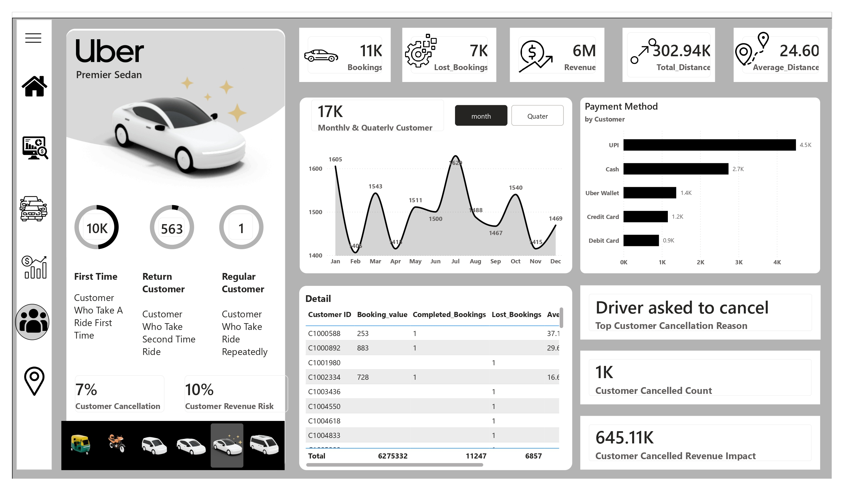
Customer — segmentation and cancellation risk analysis

6.6 Location
The Location page shows distance travelled by vehicle type and by pickup location, along with a day-of-week × time-slot demand heatmap that highlights peak booking windows.
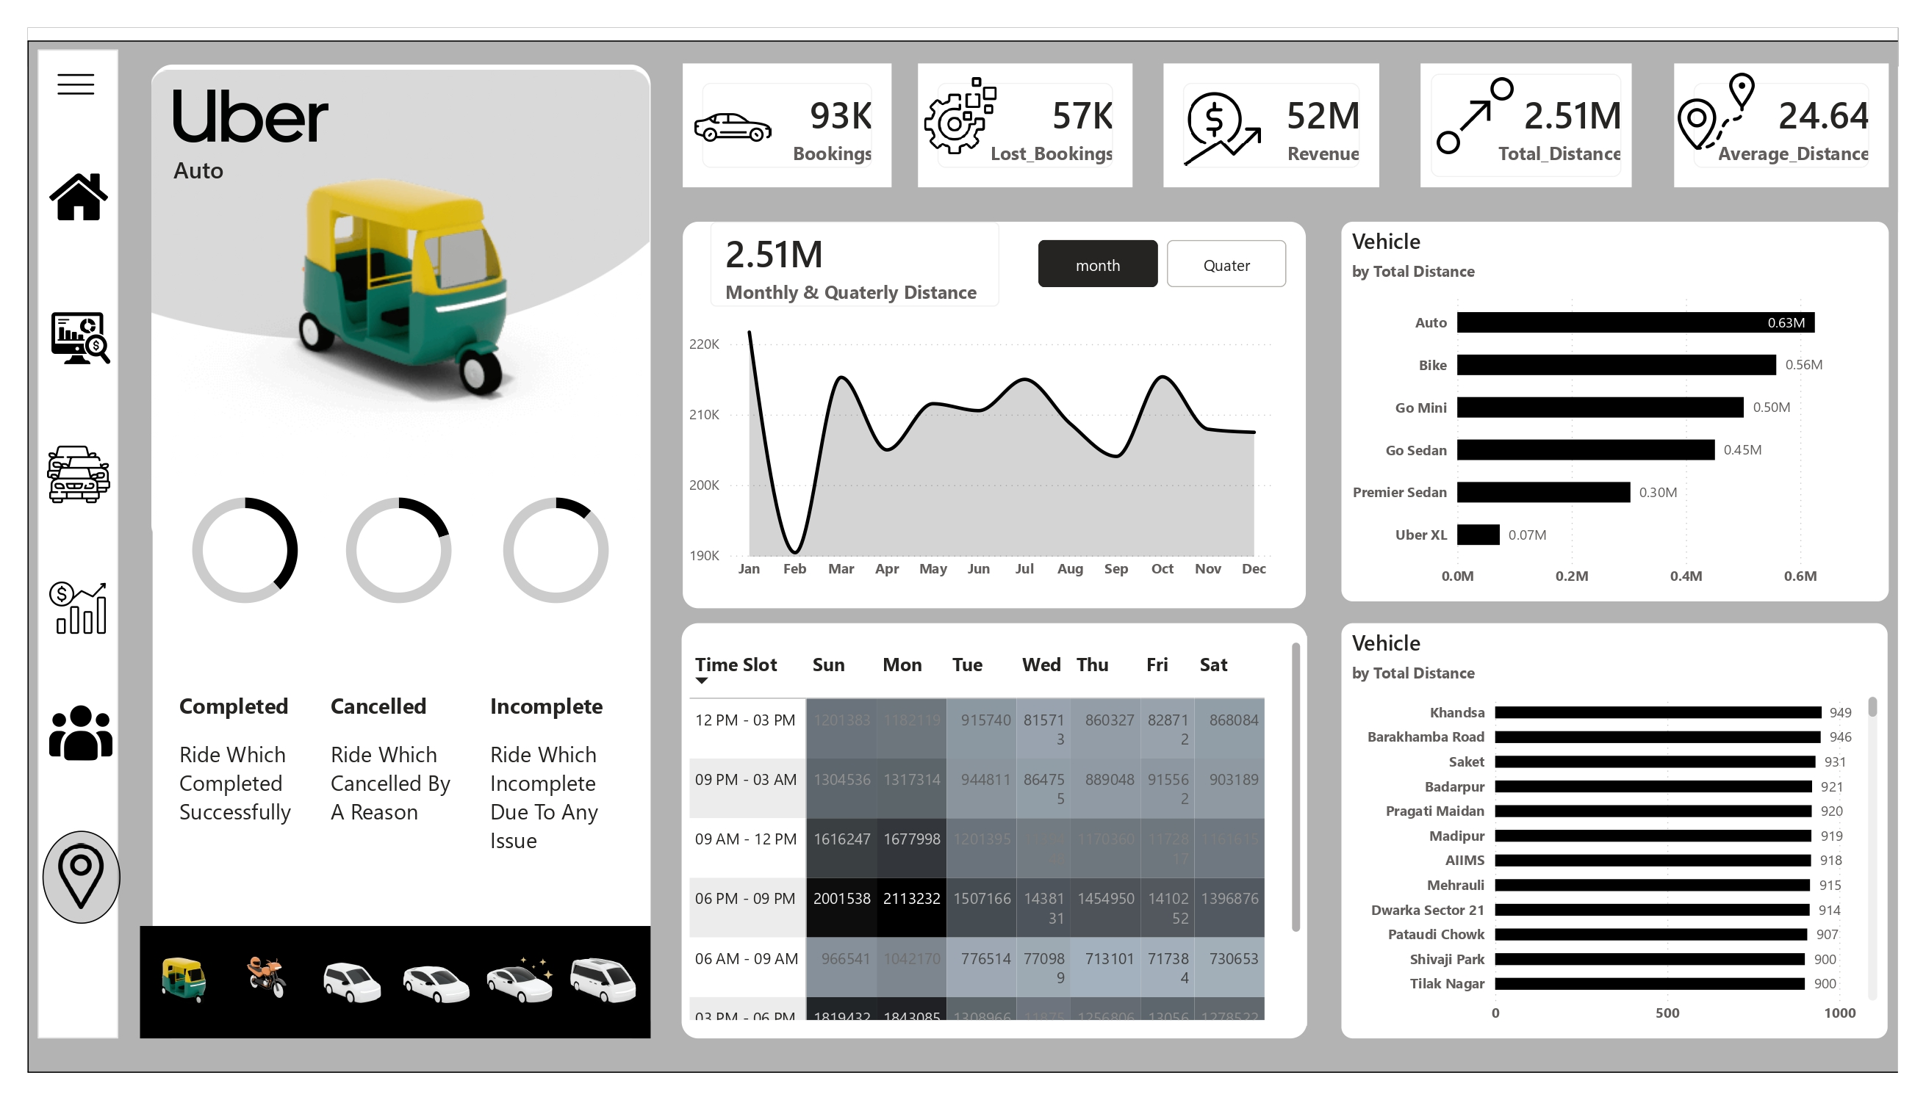
Location — geographic distance breakdown and demand heatmap

7. Key Features
- Multi-page interactive navigation with a dedicated Home hub
- Custom icon set, 3D vehicle imagery, and consistent visual branding across all pages
- KPI cards for at-a-glance executive summaries, dynamically filtered by vehicle type
- Cross-filtering and drill-down across vehicle, customer, and location dimensions
- A dedicated day-of-week × time-slot demand heatmap for operational planning
- Cancellation and revenue-risk analysis at the customer level, not just in aggregate

8. Business Value & Key Insights
By consolidating trip, revenue, vehicle, and customer data into a single interactive report, the dashboard enables faster, evidence-based decisions. Specific insights surfaced by the data include:
- Auto is the top revenue-generating vehicle type, contributing 24.84% of total revenue (12.9M), followed closely by Bike (11.5M) and Go Mini (10.3M).
- Only 62.21% of rides are completed successfully — a 38.19% incomplete rate represents a significant opportunity for operational improvement.
- UPI dominates payment methods at 23M in revenue, more than Cash, Uber Wallet, Credit Card, and Debit Card combined.
- "Driver asked to cancel" is the top customer-reported cancellation reason, pointing to a specific, addressable operational issue.
- Customer-side cancellations put 10% of revenue at risk, with a measured impact of 645.11K in lost revenue.
- Khandsa and Ashram are the top pickup and drop locations respectively, and demand peaks in the 6 PM–9 PM window — useful signals for driver allocation and surge planning.
This mirrors how analytics teams at ride-hailing and logistics companies support operational, pricing, and retention decisions in practice.

9. Conclusion
This project demonstrates practical, end-to-end Power BI capability: from data modeling and DAX through to polished, stakeholder-ready report design. The KPI framework and calculated measures go beyond simple totals to surface completion rates, revenue risk, and cancellation drivers — reflecting a workflow that can be applied directly to real-world business intelligence problems in operations, revenue, and customer analytics.

