**Motor Vehicle Theft 2021 – 2022**

1. **Total Vehicles Stolen**

Select Count(*) as Total_Vehicles_Stolen from stolenVehicles;



1. **Average Model Age in Years**

Select round(avg(year(dateStolen) - modelYear),2) as AverageAge from stolenVehicles;

1. **Average Vehicles Stolen Per Day**

Select round((count(*)/365)*2,0) as Average_Per_Day from stolenVehicles;

1. **Top 5 Vehicles stolen as per vehicle type**

Select vehicleType, count(*) as VehicleTypeCount from stolenVehicles

group by vehicleType

order by VehicleTypeCount desc

limit 5;

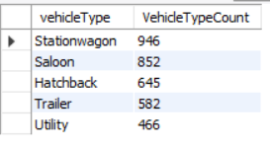

1. **Top 5 Vehicles stolen as per region**

Select region, count(*) as RegionCount from locations l

join stolenVehicles sv on l.locationId = sv.locationId

group by region

order by RegionCount desc

limit 5;

1. **Top 5 Vehicles stolen as per color**

Select color, count(*) as NumberOfVehicles from stolenVehicles

group by color

order by NumberOfVehicles desc

limit 5;

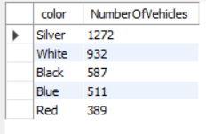

1. **Top 5 Vehicles stolen as per make type**

Select makeName, count(*) as MakeNameCount from makeDetails md

join stolenVehicles sv on md.makeId = sv.makeId

group by makeName

order by MakeNameCount desc

limit 5;

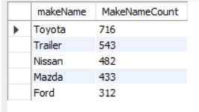

1. **Vehicles Stolen as per Weekdays**

Select dayname(dateStolen) as Weekday, count(*) as NoOfVehicles from stolenVehicles

group by Weekday

order by NoOfVehicles Desc;

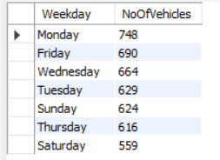

1. **Vehicles Stolen as per Month**

Select monthname(dateStolen) as MonthName, count(*) as NoOfVehicles from stolenVehicles

group by MonthName

order by NoOfVehicles Desc;

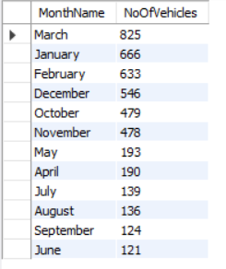

1. **Vehicles Stolen as per Year**

Select Year(dateStolen) as YearName, count(*) as NoOfVehicles from stolenVehicles

group by YearName

order by NoOfVehicles Desc;

