21CSE480T IMAGE AND VIDEO PROCESSING

Assignment Problem Implementation Report
Submitted by
Shuba Bhuvi Matam
Register Number RA2311031010068
B.Tech Computer Science Engineering
with specialization in Information Technology
Submitted to
Dr. R. Abirami
Assistant Professor
Department of Networking and Communications
DEPARTMENT OF NETWORKING AND COMMUNICATIONS
SCHOOL OF COMPUTING
COLLEGE OF ENGINEERING AND TECHNOLOGY
SRM INSTITUTE OF SCIENCE AND TECHNOLOGY
KATTANKULATHUR 603 203
NOVEMBER 2026

Table of Contents
Section | Page
Overview | 1
1 Edge Detection Using Sobel and Canny | 2
2 Lossless and Lossy Image Compression | 3
3 Thresholding and Region Based Segmentation | 4
4 Video Frame Extraction | 5
5 Sampling by Reducing Frame Rate | 6
6 Geometric Transformations | 7
7 Video Frame Difference | 8
8 Spatial Filtering | 9
9 Compression Before Streaming | 10
10 Streaming at Different Bitrates | 12
Consolidated Results | 14
Execution Evidence | 15
References | 16

Navigation Page numbering restarts with the Overview after the front matter.

Overview
Scope One Python program completed all 10 experiments in 50.845 seconds. Every value and figure in this report comes from the completed run and outputs/metrics.json.
Component | Recorded version
Python | 3.13.3
OpenCV | 5.0.0
NumPy | 2.5.4
FFmpeg | ffmpeg version 9.0.2-essentials_build-www.gyan.dev
Platform | Windows-11-10.0.26300-SP0

Experiment inputs
Input | Dimensions | Frames | Rate | Duration | Size
Generated image | 480 x 320 | - | - | - | 90.7 KiB
Generated video | 480 x 320 | 96 | 24 fps | 4.0 s | 5,550.1 KiB
Sintel excerpt | 640 x 360 | 144 | 24 fps | 6.0 s | 4,919.6 KiB

Metrics MSE measures average squared pixel error. PSNR is 10 log10 of 255 squared divided by MSE; a higher value indicates a closer reconstruction. Ratios compare only the explicitly named files.
Reproducibility Source and run instructions are available at https://github.com/Shuba-Matam/ivp-assignment. Run python assignment.py --all to regenerate outputs and python assignment.py --serve to view the local player.

QUESTION 1 Edge Detection Using Sobel and Canny
Problem Implement edge detection using Sobel and Canny operators.
Algorithm Convert to grayscale, smooth with a 5 by 5 Gaussian filter, compute Sobel derivatives and magnitude, then apply Canny non maximum suppression and hysteresis thresholds 70 and 150.

Core implementation excerpt
blurred = cv2.GaussianBlur(gray, (5, 5), 1.1)
gx = cv2.Sobel(blurred, cv2.CV_64F, 1, 0, ksize=3)
gy = cv2.Sobel(blurred, cv2.CV_64F, 0, 1, ksize=3)
magnitude = cv2.magnitude(gx.astype(np.float32), gy.astype(np.float32))
canny = cv2.Canny(blurred, 70, 150, L2gradient=True)
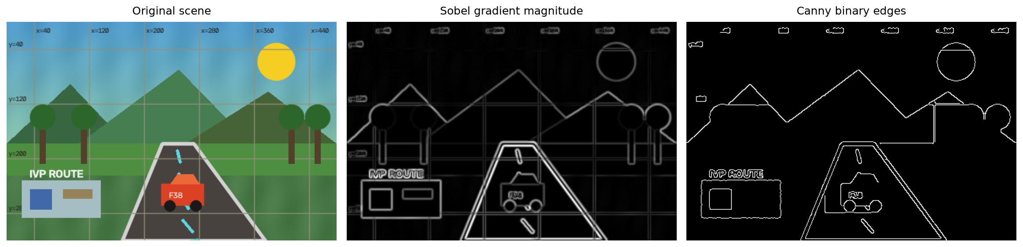
Figure 1 Original image Sobel magnitude and Canny edges
Measure | Value
Sobel maximum magnitude | 361.83
Canny edge pixels | 4,398
Canny edge area | 2.863 %

Observation Sobel preserves graded edge strength, while Canny produces thin, connected contours. Canny marked only 2.863 percent of pixels, making it the more selective outline representation for this input.

QUESTION 2 Lossless and Lossy Image Compression
Problem Implement lossless and lossy image compression and compare reconstructed images using MSE and PSNR.
Algorithm Encode the same image as PNG at compression level 9 and JPEG at quality 35, decode both files, and compare every color sample with the reference using MSE and PSNR.

Core implementation excerpt
save_image(png_path, image, [cv2.IMWRITE_PNG_COMPRESSION, 9])
save_image(jpg_path, image, [cv2.IMWRITE_JPEG_QUALITY, 35])
png_mse, png_psnr = mse_psnr(image, png_decoded)
jpg_mse, jpg_psnr = mse_psnr(image, jpg_decoded)
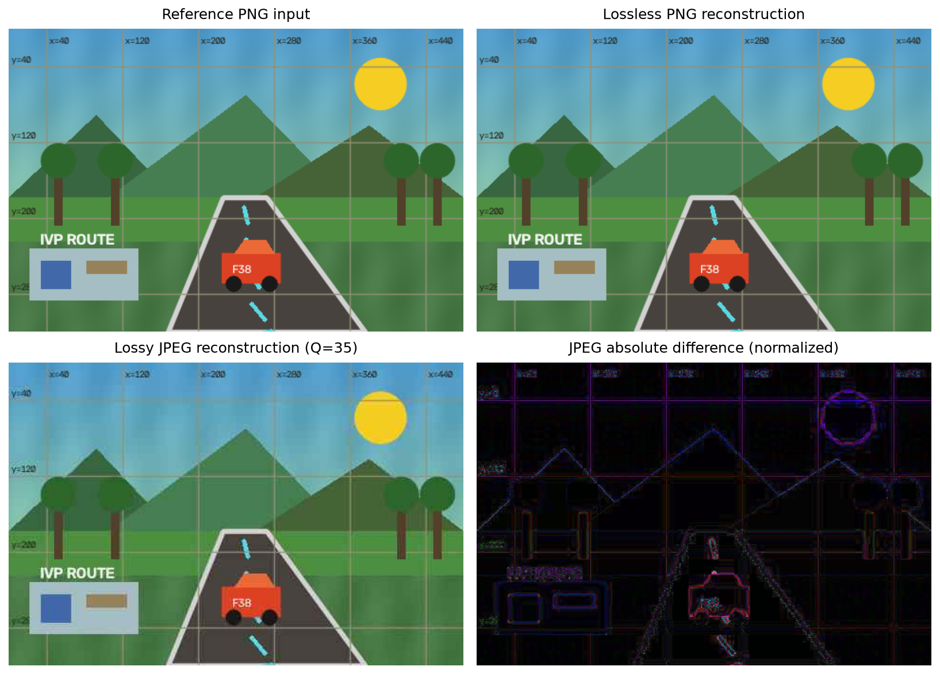
Figure 2 Reference lossless PNG lossy JPEG and JPEG difference
Reconstruction | Size | MSE | PSNR
PNG lossless | 44.1 KiB | 0.000 | infinite
JPEG quality 35 | 9.6 KiB | 68.241 | 29.79 dB

Observation PNG reconstructed every pixel exactly. JPEG was 78.16 percent smaller than the PNG output but introduced ringing and texture error concentrated around high contrast boundaries.

QUESTION 3 Thresholding and Region Based Segmentation
Problem Implement image segmentation using thresholding and region based segmentation techniques and compare the results.
Algorithm Find one global grayscale threshold with Otsu selection, then grow an 8 connected Lab color region from seed 30 30 with distance threshold 27.

Core implementation excerpt
otsu_value, otsu = cv2.threshold(
gray, 0, 255, cv2.THRESH_BINARY + cv2.THRESH_OTSU
)
region = seeded_region_grow(image, seed, threshold=27.0)
iou = intersection / union if union else 1.0
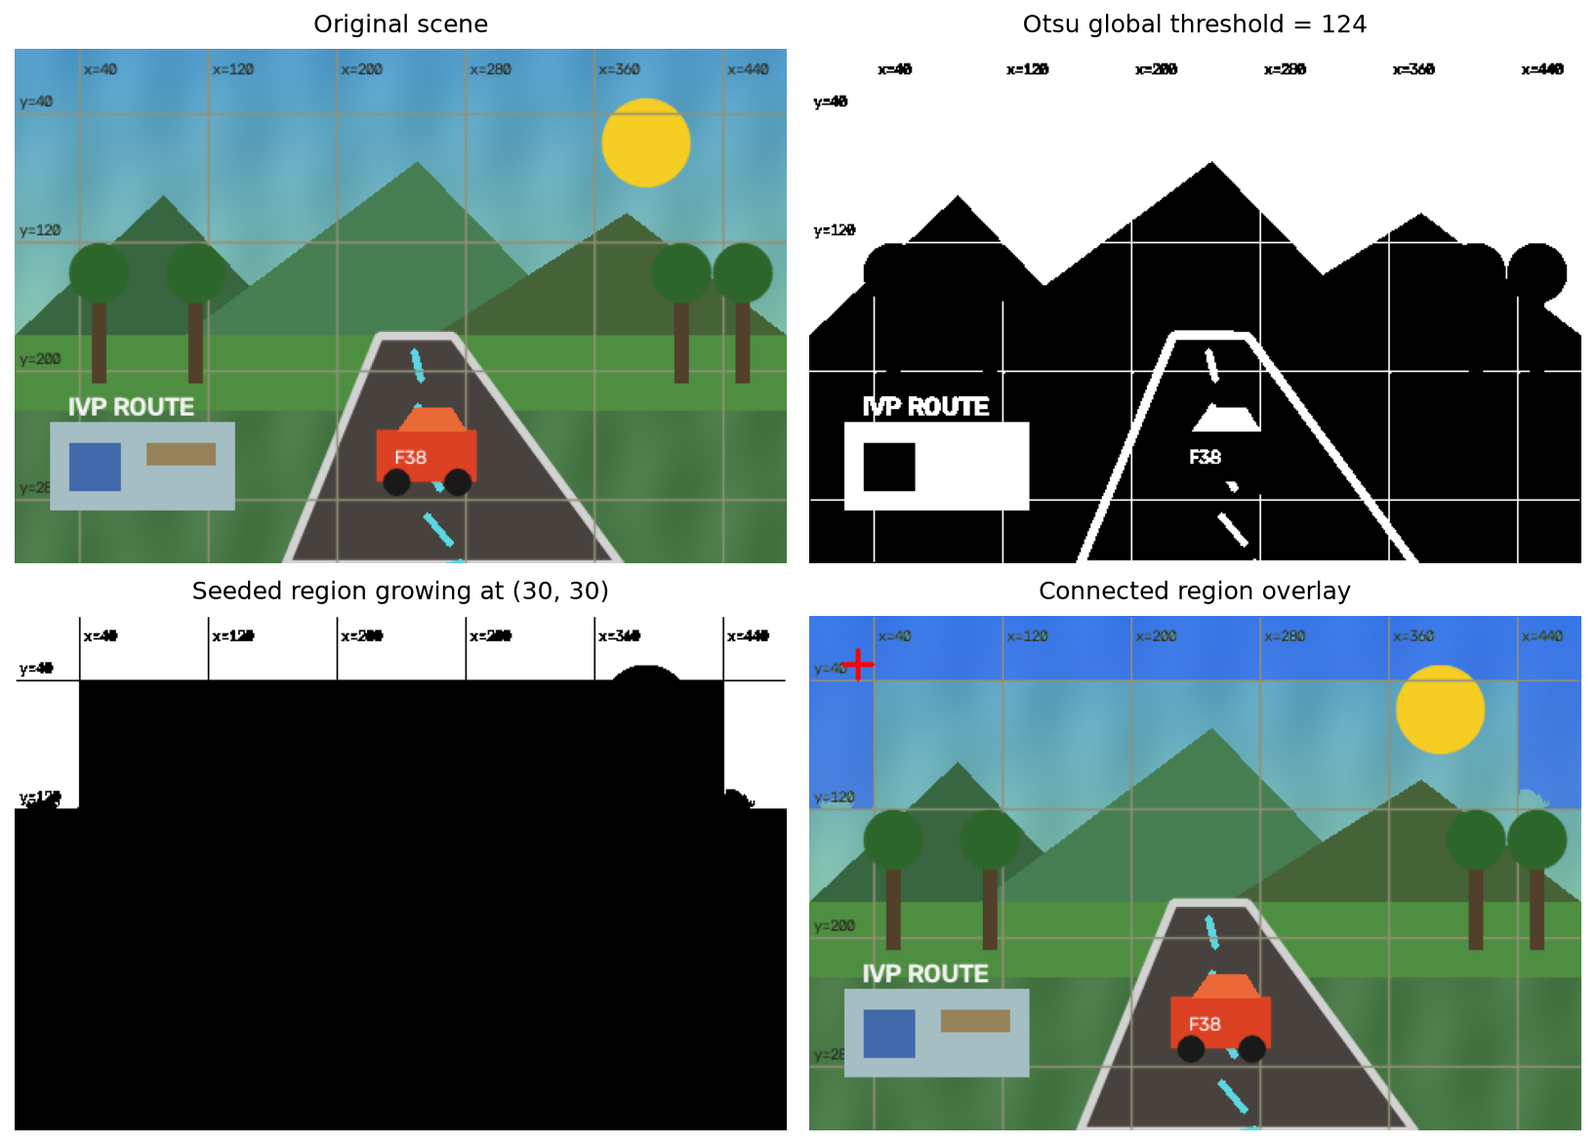
Figure 3 Otsu mask seeded region and connected overlay
Method | Parameter | Pixels | Area
Otsu | threshold 124 | 67,810 | 44.15 %
Region growth | seed 30 30 distance 27 | 23,873 | 15.54 %

Observation The masks have intersection over union 0.351. This value measures agreement between the two masks, not segmentation accuracy against ground truth. Otsu selects a global intensity class; region growth returns only the connected, color-similar component attached to the seed.

QUESTION 4 Video Frame Extraction
Problem Implement video frame extraction and save the extracted frames as individual image files.
Algorithm Decode the source sequentially and write each frame as a zero padded PNG. Check the written count against the video metadata.

Core implementation excerpt
for index, frame in iter_video(DEMO_VIDEO):
save_image(
frames_dir / f"frame_{index:04d}.png", frame,
[cv2.IMWRITE_PNG_COMPRESSION, 6],
)
count += 1
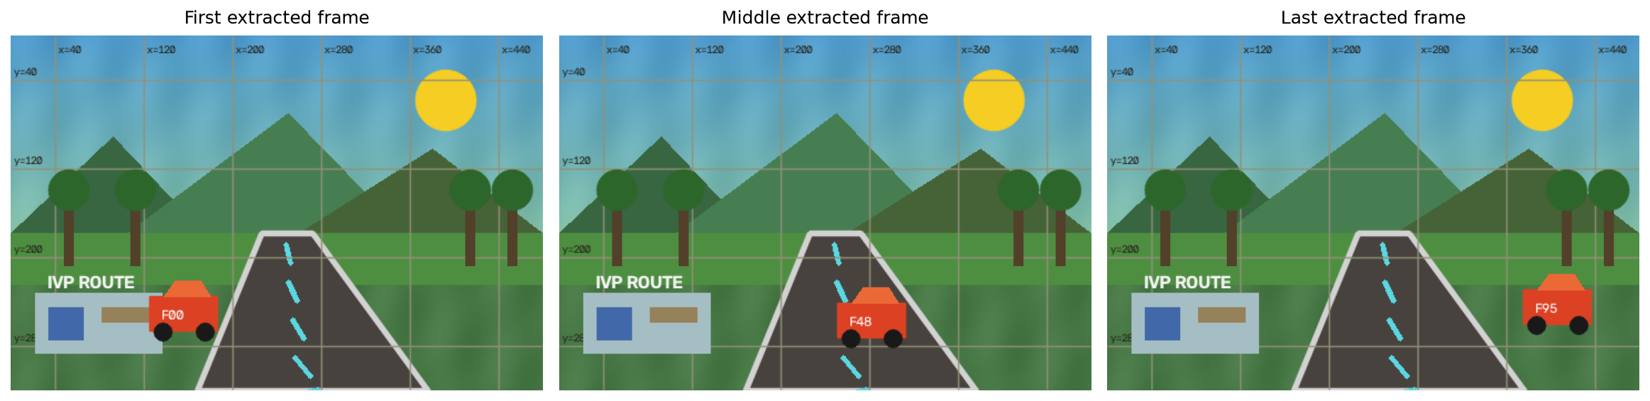
Figure 4 First middle and last extracted frames
Property | Result
Frames written | 96
Source count matched | Yes
First file | outputs/q4/frames/frame_0000.png
Last file | outputs/q4/frames/frame_0095.png
Total PNG data | 4,526.0 KiB

Observation All 96 frames were saved in playback order. Individual lossless files support direct inspection and later per-frame processing without decoding the source again.

QUESTION 5 Sampling of Video by Reducing the Frame Rate
Problem Implement sampling of video signals by reducing frame rate and compare the original and sampled videos.
Algorithm Keep every fourth frame and write the retained sequence at one quarter of the source rate. Hold each sample for four original time instants during quality comparison.

Core implementation excerpt
factor = 4
for index, frame in iter_video(DEMO_VIDEO):
original_frames.append(frame)
if index % factor == 0:
sampled_frames.append(frame.copy())
writer.write(frame)
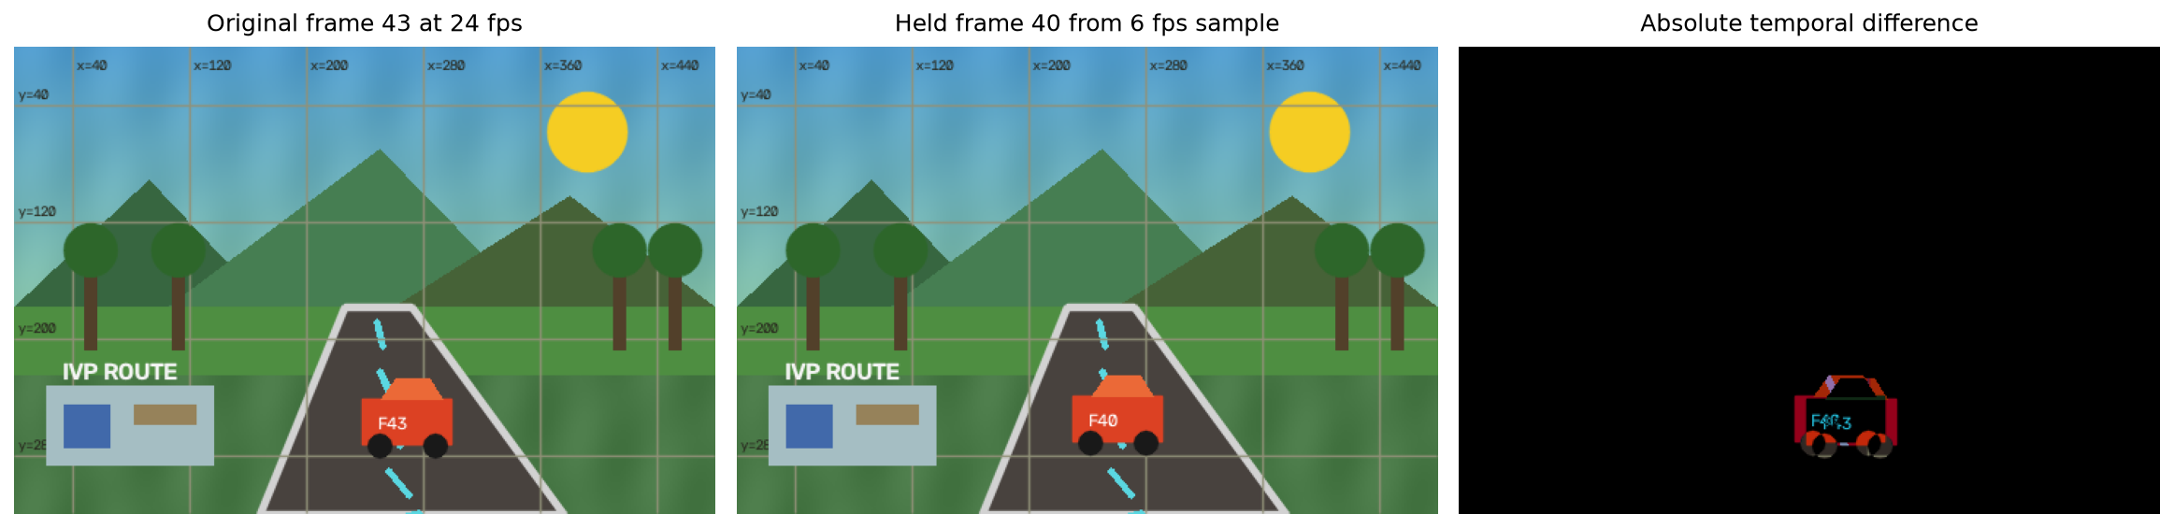
Figure 5 Original held low rate frame and temporal difference
Property | Original | Sampled
Frame rate | 24 fps | 6 fps
Frame count | 96 | 24
Duration | 4.0 s | 4.0 s
Held comparison | - | MSE 44.532 PSNR 31.64 dB

Observation Duration is preserved because frame count and playback rate are reduced together. Motion updates only 6 times per second, so the error appears around moving content between retained samples.

QUESTION 6 Geometric Transformations on Video Frames
Problem Demonstrate translation, rotation, and scaling on video frames and analyze their effects.
Algorithm Apply independent affine translation rotation and scale matrices to every frame on the fixed 480 by 320 canvas, filling uncovered coordinates with dark pixels.

Core implementation excerpt
center = (size[0] / 2, size[1] / 2)
translation_matrix = np.float32([[1, 0, tx], [0, 1, ty]])
translated = cv2.warpAffine(frame, translation_matrix, size)
rotation_matrix = cv2.getRotationMatrix2D(center, angle, 1.0)
rotated = cv2.warpAffine(frame, rotation_matrix, size)
scale_matrix = cv2.getRotationMatrix2D(center, 0, scale)
scaled = cv2.warpAffine(frame, scale_matrix, size)
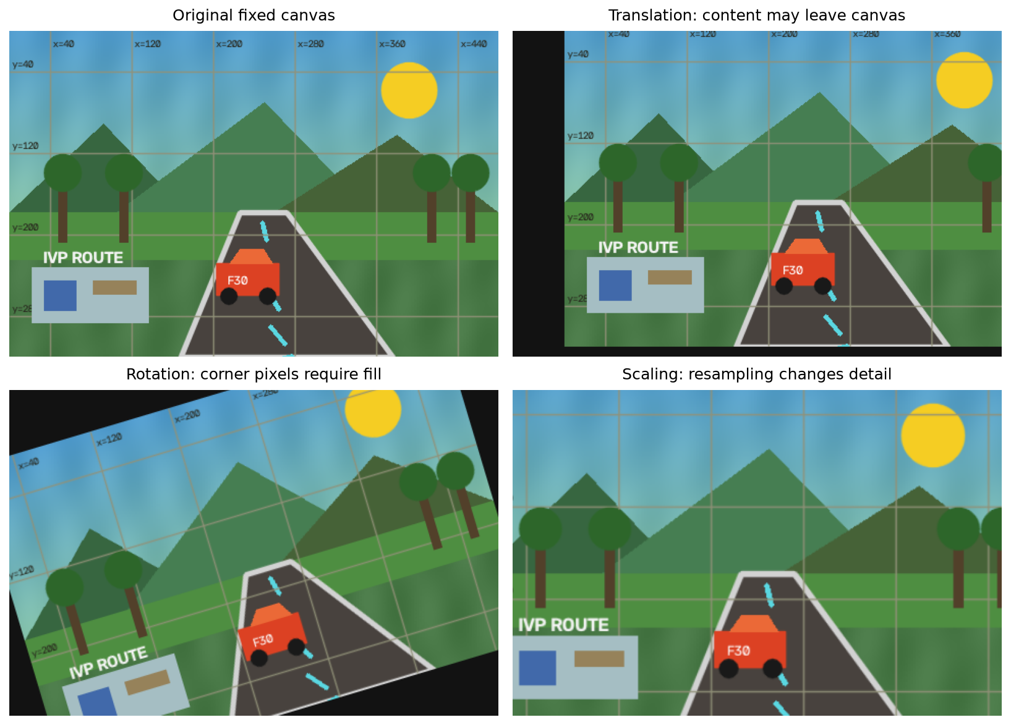
Figure 6 Translation rotation and scaling on a fixed canvas
Transform | Range | Effect
Translation | x -55 to 55 y -25 to 25 | Uncovered borders and clipping
Rotation | -18 to 18 degrees | Interpolation and filled corners
Scaling | 0.70 to 1.15 | Detail loss or edge clipping

Observation All outputs retain the source dimensions. Translation and enlargement can remove edge content, rotation creates corners with no source samples, and downscaling represents detail with fewer pixels.

QUESTION 7 Comparison of Two Video Frames Using Image Difference
Problem Compare two video frames using image difference.
Algorithm Convert frames 20 and 68 to signed 16 bit values before subtraction, take the absolute difference, convert it to grayscale, and threshold values above 28.

Core implementation excerpt
signed = second.astype(np.int16) - first.astype(np.int16)
absolute = np.abs(signed).astype(np.uint8)
gray_abs = cv2.cvtColor(absolute, cv2.COLOR_BGR2GRAY)
_, changed = cv2.threshold(gray_abs, 28, 255, cv2.THRESH_BINARY)
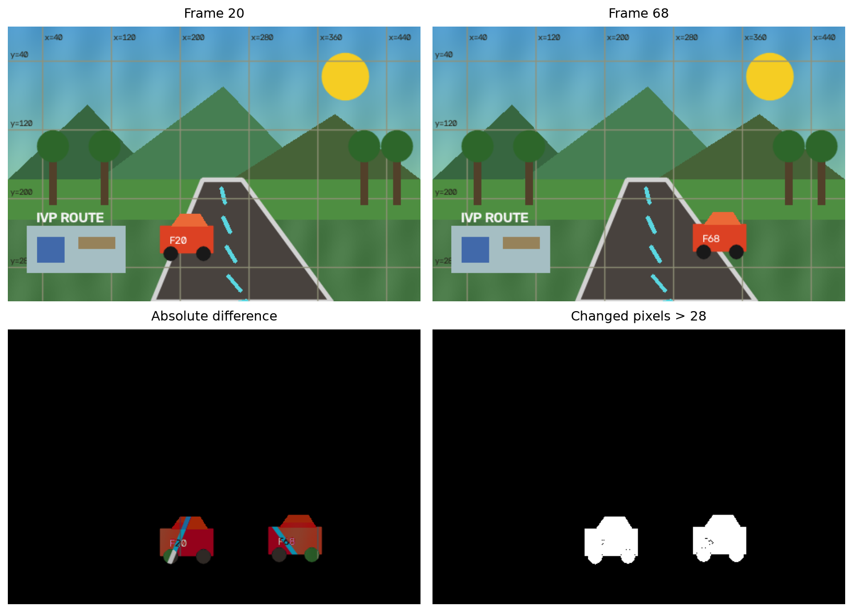
Figure 7 Compared frames absolute difference and changed mask
Measure | Value
Compared frames | 20 and 68
Mean absolute difference | 2.512
Maximum difference | 193
Changed pixels | 5,334 (3.473 %)

Observation Only 3.473 percent of pixels exceeded the threshold, so the fixed background largely cancels while moving objects remain. Signed conversion avoids unsigned-subtraction wraparound.

QUESTION 8 Spatial Filtering of Video Frames
Problem Implement spatial filtering on video frames to remove noise and enhance video quality.
Algorithm Add deterministic salt and pepper noise to 3.5 percent of pixel locations in all frames, then apply a 3 by 3 median filter and compare both videos with the clean source.

Core implementation excerpt
for index, original in iter_video(DEMO_VIDEO):
noisy = add_salt_pepper(original, rng, amount=0.035)
filtered = cv2.medianBlur(noisy, 3)
noisy_writer.write(noisy)
filtered_writer.write(filtered)
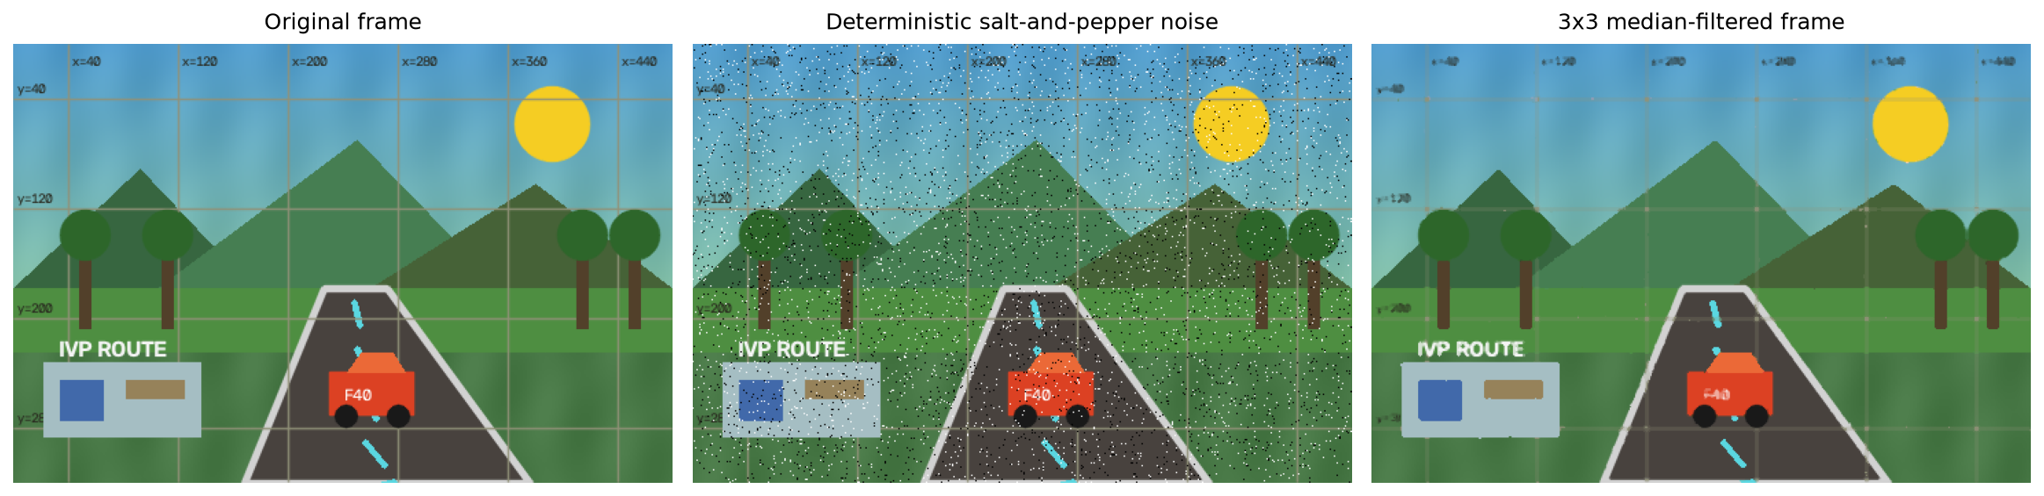
Figure 8 Clean impulse noisy and median filtered frame
Video | MSE | PSNR
With impulse noise | 664.020 | 19.91 dB
After median filter | 59.276 | 30.40 dB

Observation Median filtering reduced MSE by 91.07 percent and improved PSNR by 10.49 dB across all 96 frames.

QUESTION 9 Video Compression Before Streaming
Problem Implement video compression before streaming and compare file size and quality before and after compression.
Algorithm Encode generated and real reference clips with H 264 libx264 medium preset and YUV420 at CRF 29 and 30. Decode every frame and compare with the corresponding decoded reference.

Core implementation excerpt
encoded = out / f"{name}_h264_crf{crf}.mp4"
encode_h264(source, encoded, crf)
quality = compare_decoded_videos(source, encoded)
ratio = source_info["size_bytes"] / encoded_info["size_bytes"]
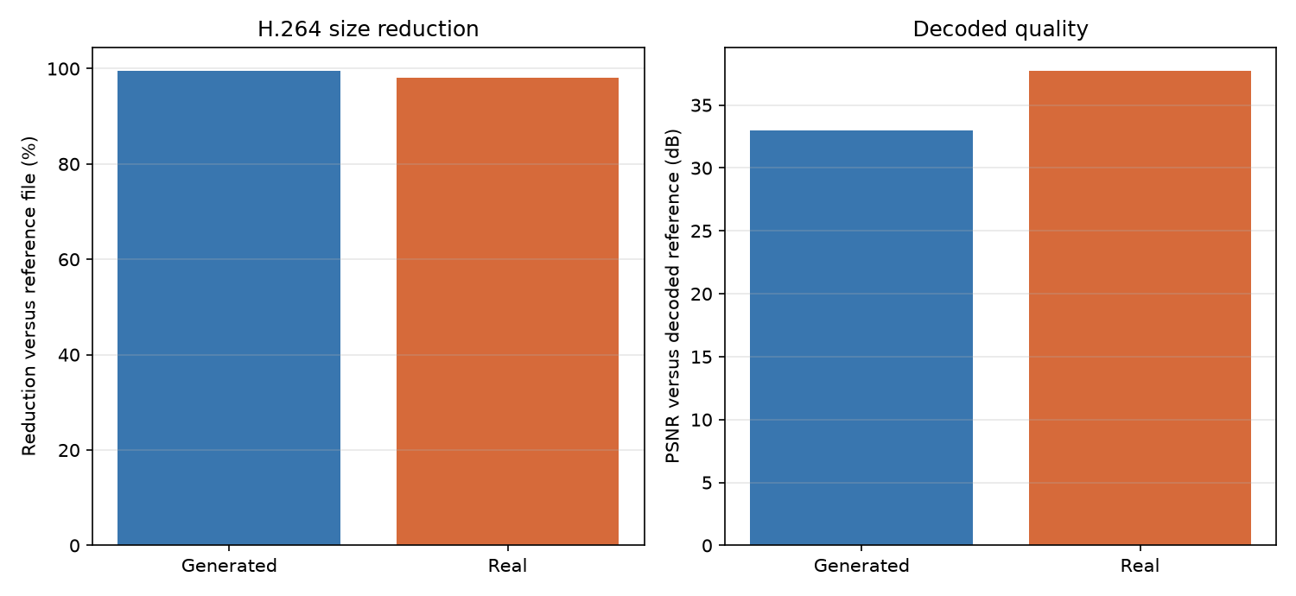
Figure 9 H 264 file reduction and decoded PSNR
Source | Setting | Reference | H 264 | Reduction | PSNR
Generated | CRF 29 | 5,550.1 KiB | 25.5 KiB | 99.54 % | 32.95 dB
Real | CRF 30 | 4,919.6 KiB | 97.3 KiB | 98.02 % | 37.72 dB

Result Both encodes preserved frame count frame rate and dimensions. The generated graphics compress especially strongly because their spatial and temporal content is highly predictable.

QUESTION 9 Reconstruction Evidence and Interpretation
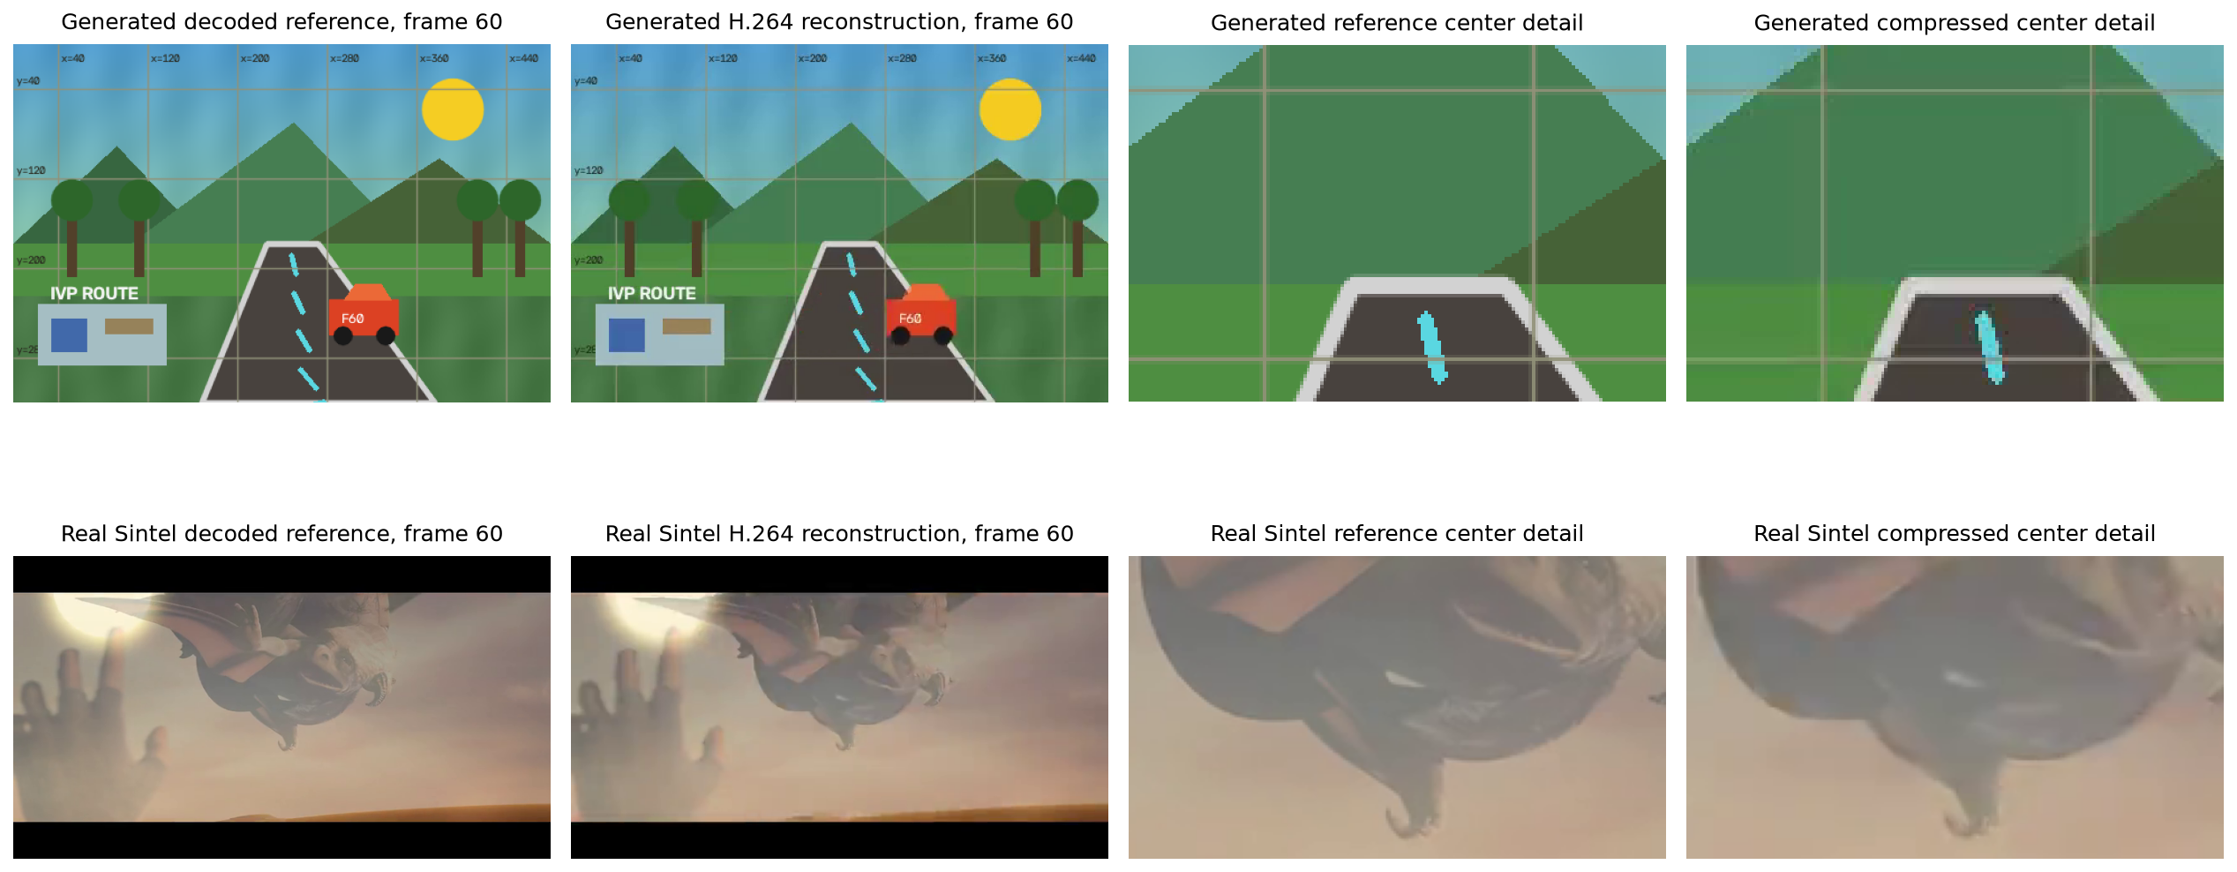
Figure 10 Decoded references H 264 reconstructions and center crops
Real clip interpretation The 00:33 to 00:39 Sintel excerpt is stored as lossless H 264 CRF 0 over decoded YUV420 frames. The downloaded trailer was already compressed. Therefore the 50.55 to 1 ratio and 98.02 percent reduction compare experiment files only and do not represent compression from a production master.
Quality The CRF 30 reconstruction measured 37.72 dB over all 144 paired frames. Detail crops show where quantization affects texture despite high numerical similarity.
Attribution Sintel trailer excerpt (c) copyright Blender Foundation | durian.blender.org Creative Commons Attribution 3.0 Unported.

QUESTION 10 Video Streaming at Different Bitrates
Problem Demonstrate video streaming with different bitrates and analyze the resulting video quality.
Algorithm Encode independent H 264 renditions at 180 420 and 850 kbit per second, package two second HLS segments, serve them on ephemeral localhost, and compare decoded frames with the source.

Core implementation excerpt
playlists = create_hls_ladder(source, destination)
playlist = playlists["low"]
with local_http_server(0) as port:
verification = verify_hls_local_http(
playlist, port, source_info["width"], source_info["height"]
)
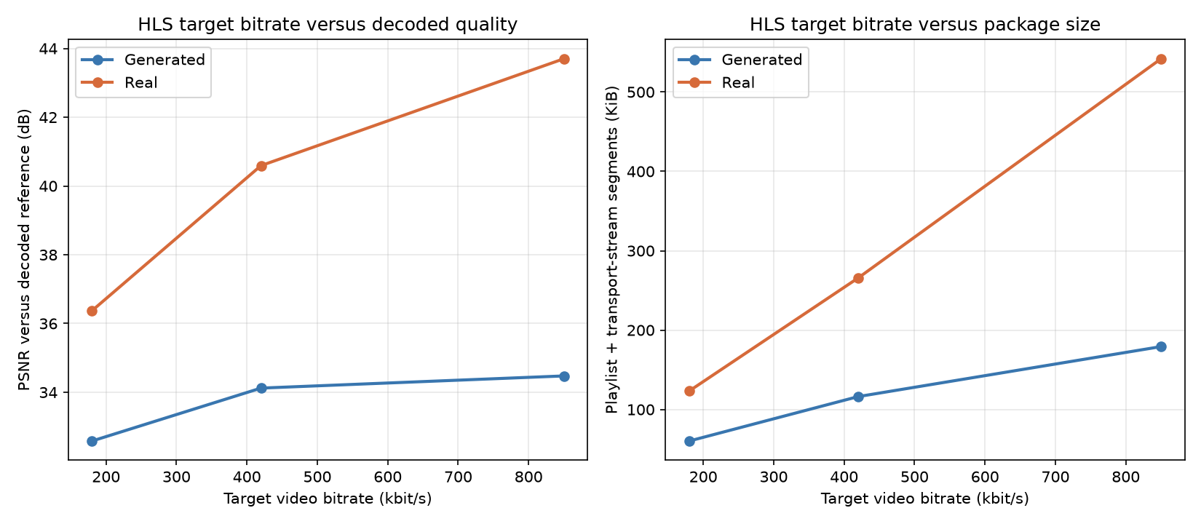
Figure 11 Target bitrate against decoded quality and HLS package size
Source level | Target kbps | TS payload kbps | Package | PSNR | HTTP equals local
Generated low | 180k | 123.0 | 60.2 KiB | 32.58 | Yes
Generated medium | 420k | 237.6 | 116.2 KiB | 34.12 | Yes
Generated high | 850k | 366.6 | 179.2 KiB | 34.48 | Yes
Real low | 180k | 167.9 | 123.2 KiB | 36.37 | Yes
Real medium | 420k | 362.5 | 265.7 KiB | 40.59 | Yes
Real high | 850k | 739.5 | 541.8 KiB | 43.70 | Yes

Observation Quality rises with bitrate, while package size also increases. The generated sequence gains little above 420 kbit/s, whereas Sintel improves from 36.37 dB at 180 kbit/s to 43.70 dB at 850 kbit/s.

QUESTION 10 HLS Reconstruction and Delivery Verification
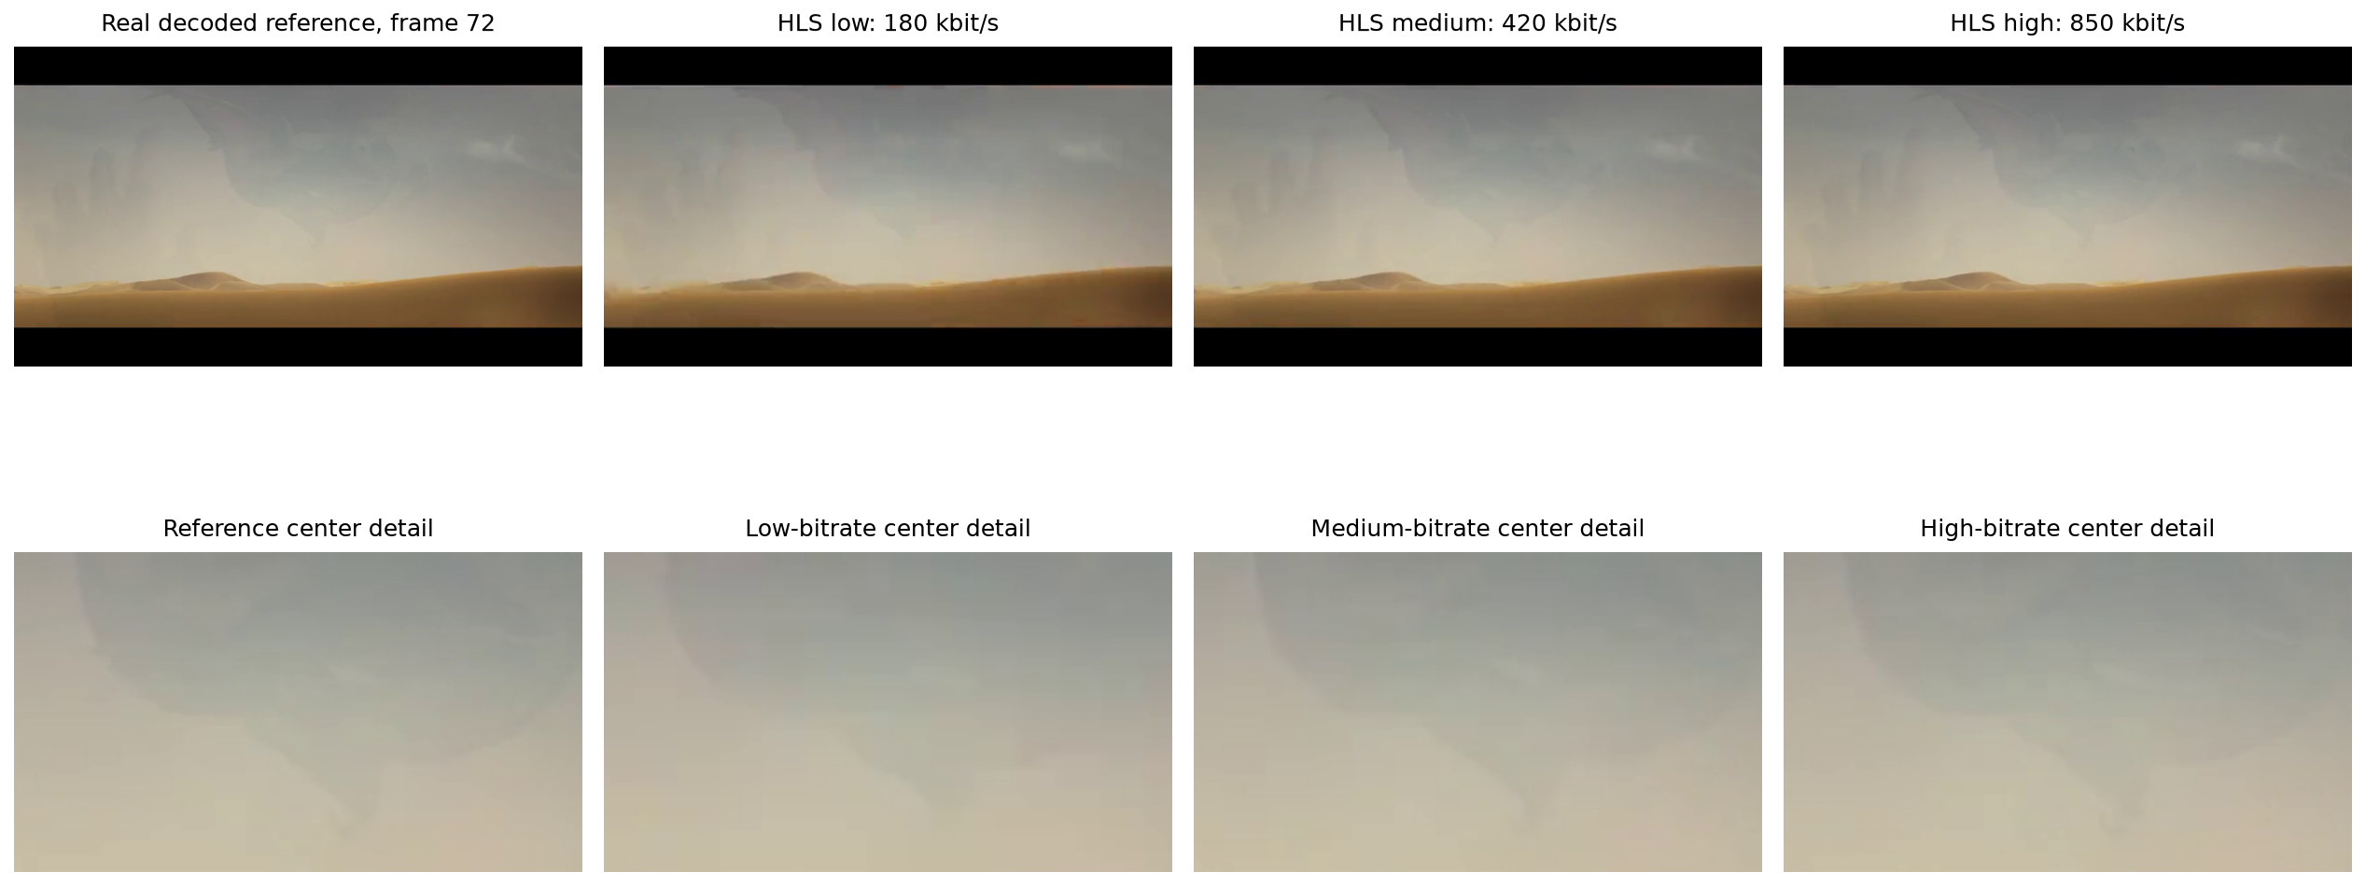
Figure 12 Sintel reference and three HLS reconstructions with detail crops
Delivery verification Every generated variant decoded 96 frames and every real variant decoded 144 frames through local file and HTTP playlist access. Local and HTTP decoded RGB SHA 256 values match for all six variants, so transport introduced no additional pixel change beyond encoding.
Player FFmpeg validated HTTP delivery for all six HLS variants by comparing locally decoded and HTTP-delivered RGB frame hashes. The browser player uses vendored hls.js 1.6.13 and offers Auto, 180, 420, and 850 kbit/s selections.
Interpretation This fixed six-second clip demonstrates the bitrate-quality tradeoff. The bitrate required for a given quality depends on content, resolution, motion, texture, encoder settings, and the acceptable reconstruction error.

Consolidated Results
Q | Task | Evidence backed result
1 | Edge detection | Canny 4,398 edge pixels
2 | Image compression | PNG exact JPEG 29.79 dB
3 | Segmentation | Otsu 44.15 % region 15.54 %
4 | Frame extraction | 96 PNG frames saved
5 | Frame rate sampling | 24 to 6 fps 31.64 dB
6 | Geometry | Three affine transformation videos
7 | Frame difference | 3.473 % changed
8 | Median filtering | PSNR gain 10.49 dB
9 | H 264 compression | Sintel CRF 30 37.72 dB
10 | HLS ladder | Sintel 36.37 to 43.70 dB at 180 to 850 kbit/s

Image findings Canny produced sparse contours, PNG was exact, JPEG traded detail for size, and global thresholding differed from seed connected segmentation.
Video findings Frame rate reduction lowered temporal fidelity, median filtering removed most impulse noise, and additional streaming bitrate improved the detailed real clip more consistently than the generated scene.
Limitations The study uses one generated image, one four-second generated video, and one six-second adapted trailer excerpt. PSNR measures pixel similarity rather than perceived quality, and every compression result depends on the stated codec parameters and reference files.

Execution Evidence
Completed run The native desktop launcher executed assignment.py as a real subprocess. Its status file recorded exit code 0, and outputs/metrics.json records all ten questions completed in 50.845 seconds.
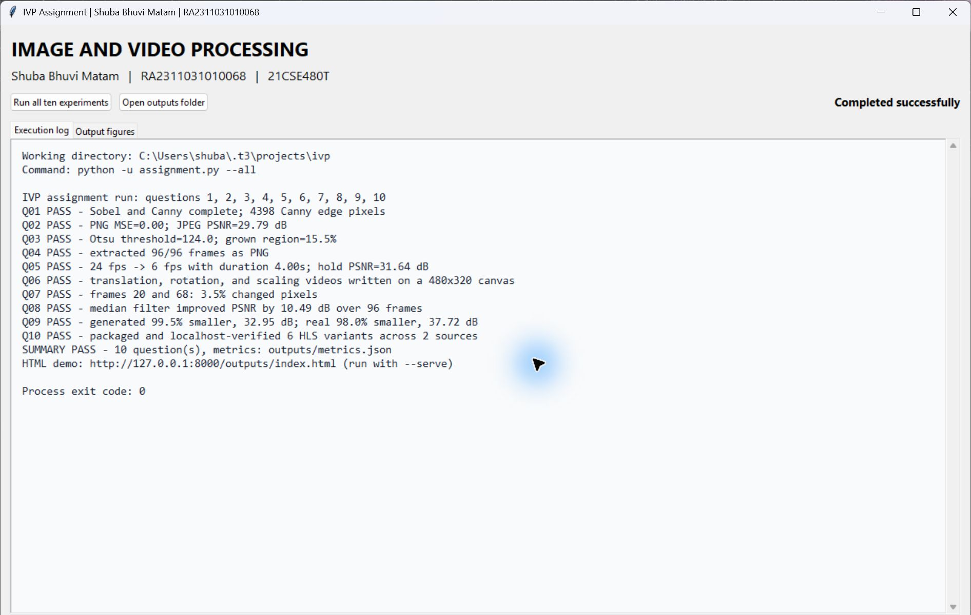
Figure 13 Native Tkinter execution window after successful completion
Evidence scope The screenshot demonstrates successful Python execution and access to the generated figures. HLS transport correctness is supported separately by the six FFmpeg local versus HTTP decoded RGB hash comparisons recorded in metrics.json.

References
[1] SRM Institute of Science and Technology. 21CSE480T assignment problem implementation brief.
[2] OpenCV. Image processing and video input output documentation. https://docs.opencv.org/
[3] FFmpeg Project. Formats codecs and HLS documentation. https://ffmpeg.org/documentation.html
[4] Video dev community. hls.js 1.6.13 project and Apache License 2.0. https://github.com/video-dev/hls.js
[5] Blender Foundation. Sintel trailer source. https://download.blender.org/durian/trailer/sintel_trailer-480p.mp4
[6] Blender Foundation. Sintel sharing and copyright information. https://durian.blender.org/sharing/
[7] Creative Commons. Attribution 3.0 Unported license. https://creativecommons.org/licenses/by/3.0/
[8] Shuba Bhuvi Matam. IVP assignment repository. https://github.com/Shuba-Matam/ivp-assignment
Media attribution The adapted Sintel trailer excerpt covers 00:33 to 00:39, is 640 by 360 at 24 fps with audio removed, and is licensed under CC BY 3.0. (c) copyright Blender Foundation | durian.blender.org.

