**DELIVERY DRONE SIMULATOR**

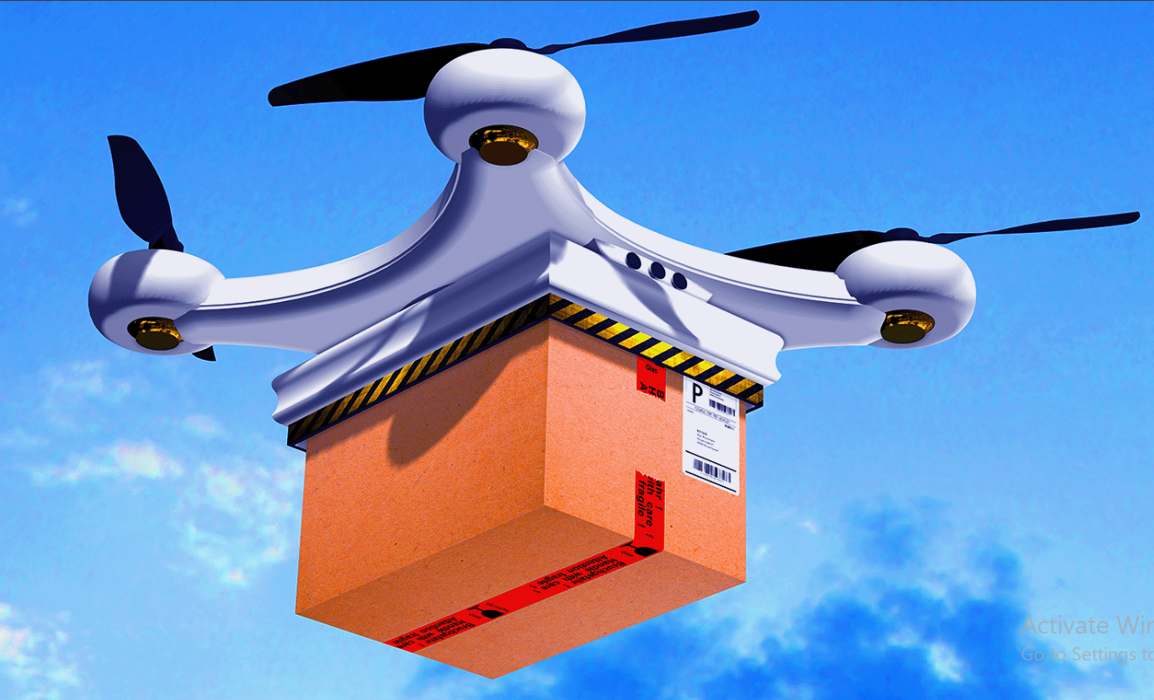

**A Project by:**

**Muhammad Shahmeer Shaheedi (565007) – Logic Designer & Tester**

**Shubham Kumar (571672) – Programmer & Git Manager**

**Project Overview:**

The code presented deals with a delivery drone, allowing it to make its own decisions based on weather patterns and other, later stated conditions. To be more specific, it will choose whether to delay the expedition, conduct the delivery normally, recharge, or cancel the mission and mark it as a “failure” altogether. It seems to be an interesting solution to optimize delivery businesses by introducing automated machines that make choices on their own to ensure the safety of the package, and even save time, considering the fact that the drone will be able to avoid the daily on-ground traffic. Along with this, it will save the company money that usually goes into hiring and paying manpower, allowing them to cut on labor costs (operational costs might not reduce significantly, though).

**Program Design/Logic:**

We allowed the system to pick random numbers to simulate real-world problems in this case. For example, we had one random number picker to simulate weather conditions (sunny, windy, or rainy) and also one to determine if there will be an obstacle in the drone’s regular route, causing the device to reroute and drain more battery for one trip.

Then, as for the main function, where we let nature and chance run their due time, we used a for loop for 3 deliveries. The loop was nested with if-else statements, each depicting the steps the drone takes automatically. For clear, sunny weather, the delivery goes normally, giving us a battery drain of 10-25 percent per trip. If the conditions are windy, and the battery is below 40 percent, the drone goes back to the station to recharge. If the weather’s rainy, the delivery gets delayed. Furthermore, the presence of an obstacle in the pre-determined route causes the drone too reroute, which of course results in additional 5% battery loss.

The flowchart for each weather-based decision made is presented below. Keep in mind that this is only one iteration of 3, which is why there is an arrow going back from “END” to “START”. This indicates the end of the prior loop/iteration and the start of a new one. Once again, this is purely based on environmental conditions. Had we made a flowchart representing all the possibilities in the code (e.g the presence of obstacles, system malfunctions, and user-commanded recharging session), it would have been a large and messy flowchart with several junctions of crisscrossing arrows and blocks so small it would be difficult to read their contents. However, we are open to the possibility of a larger, but easy to follow flowchart. The current flowchart, though, is present on the next page:

START

“Delivery

Successful”

10<Battery rain < 25

Weather =

Sunny?

If battery<40, recharge (+10%)

10< Battery Drain< 25

Weather =

Windy?

?

“Delivery Successful”

Battery Drain = 0

Weather =

Rainy?

“Delivery Delayed”

END

**Team Collaboration Summary:**

The simplest way to put it is that Muhammad Shahmeer Shaheedi is the Logic Designer and the Code Tester/ Documenter. He started the project by tackling basic logical problems, such as the if-else relationships between the environmental/delivery conditions, and the choices that the software within the device. Moreover, he is the main code tester and documenter of this project. He ran the code multiple times to see if it ran smoothly and proposed additional improvements. He played the major role in documenting the project and took over the tasks relating to Readme and organized the deliverables.

On the other hand, Shubham Kumar is the main Programmer and Git Manager. He built the major code on top of Shahmeer’s basic logic-based decision determination code, ensuring that the code was well readable and didn’t drop a huge mass of information at once when it was run. He also created the group’s GitHub repository after the initial repository was facing issues with uploads, as can be seen in the images below. We had created a repo a week prior, but faced problems when Shubham was trying to push his file onto it.

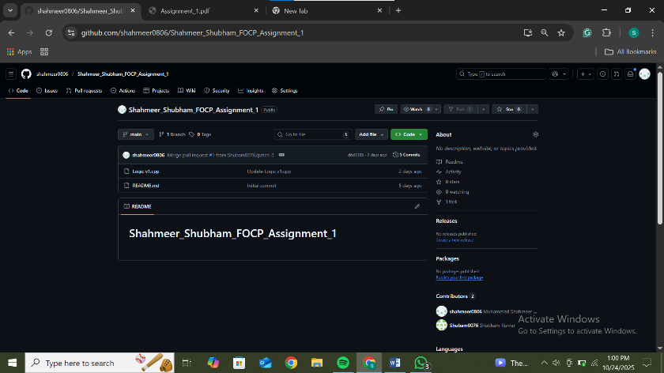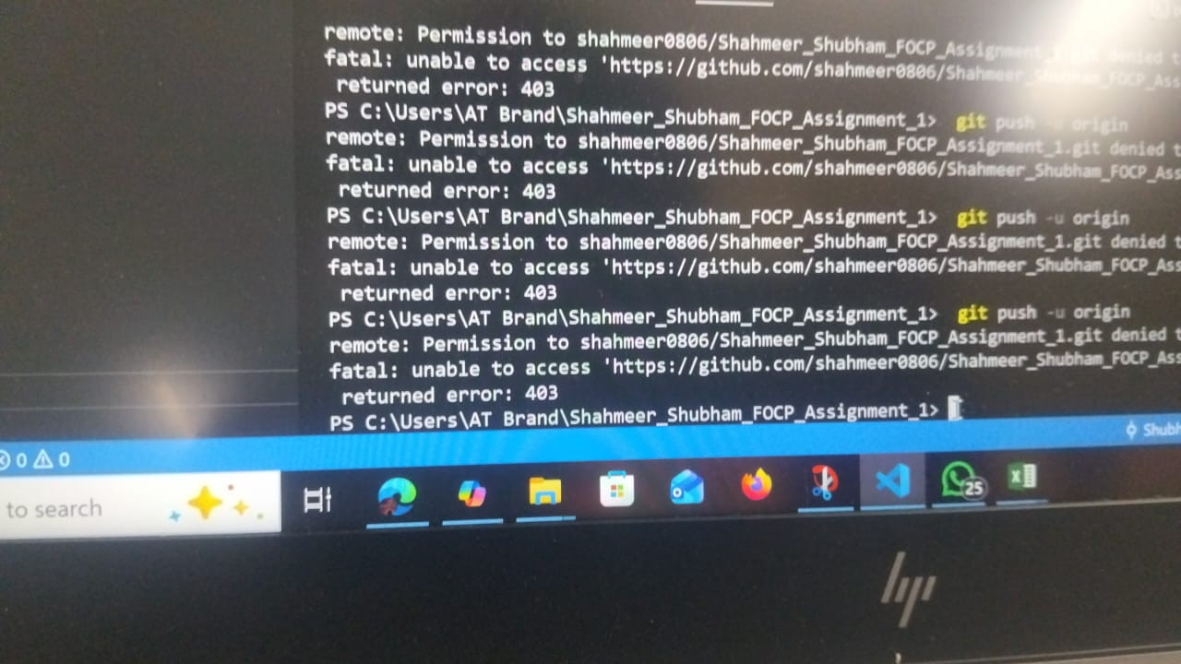

After making the new repository, though, Shubham put up his edited version of Shahmeer’s Logic-based code (file named “Logic v1.cpp”). Then, he pushed his main code onto the repository, but there was still room for improvement. This readme sample is based on said main code (titled “tempCodeRunnerFile.cpp”). After completing this document sample, Shahmeer will push the file on GitHub to allow a cross-check with Shubham so the latter could give his insight on the information conveyed. Currently, before the committing of this document, the repository looks like this:

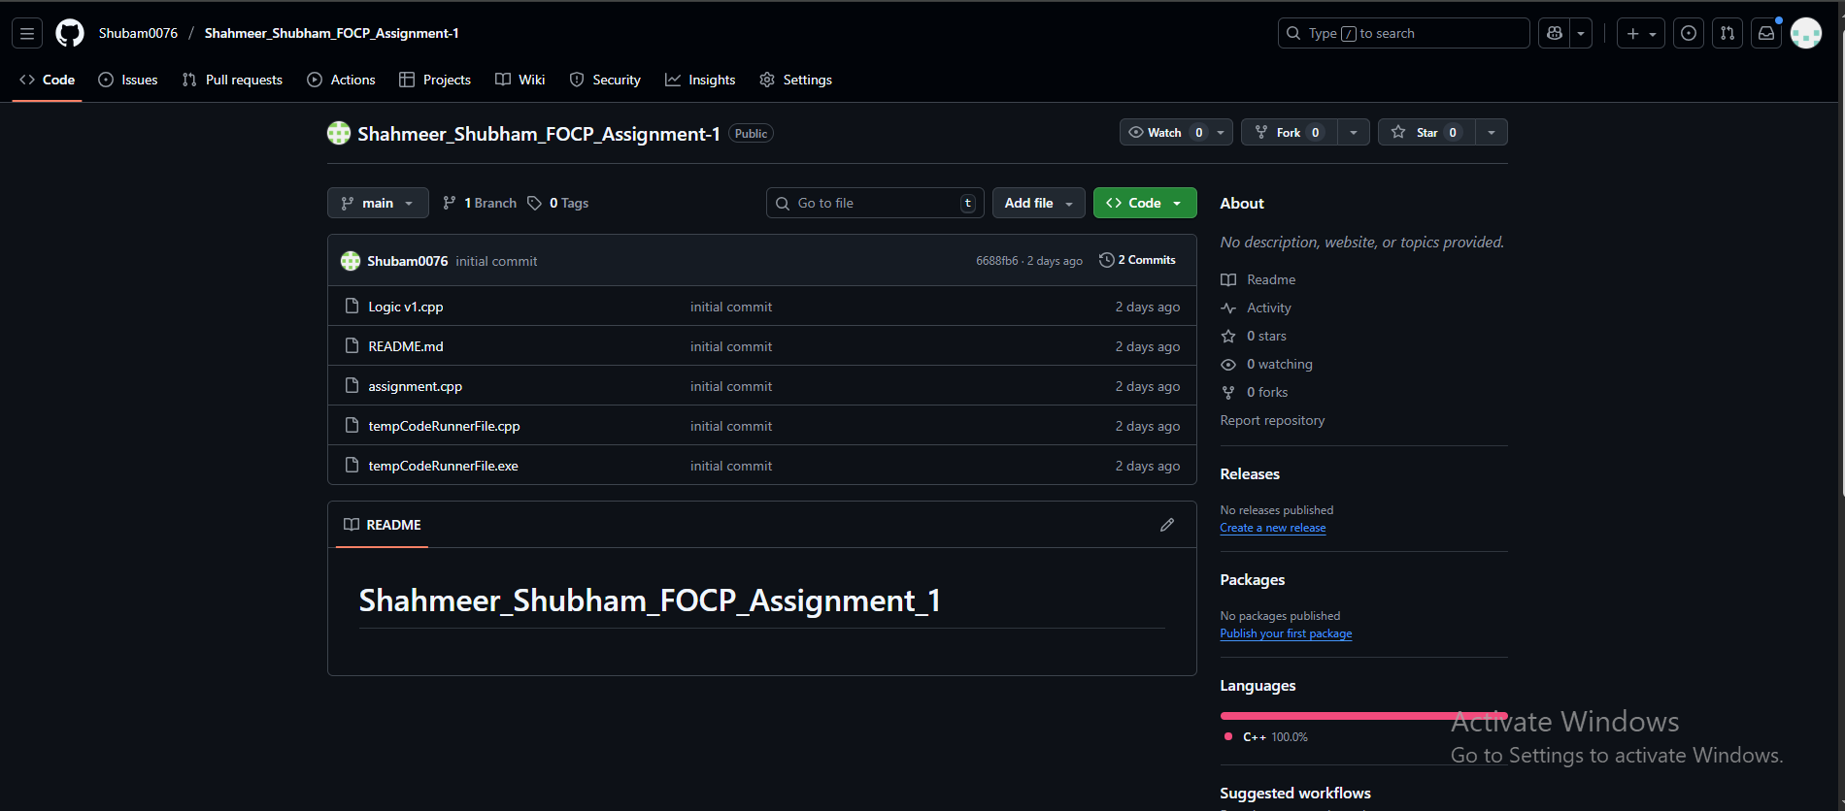

**AI Tool Reflection (if any):**

During the process of refining the code/adding extra features to the code, we did refer to GitHub Copilot for minor aid at times. To be more specific:

* We turned to AI to help us make a small string of code that allows the user to simulate the start of the day by pushing the “Enter” button on his keyboard.
* Additionally, we referred to AI while trying to come up with a definitive equation for the performance score. It must be noted that we didn’t use the AI tool to come up with the code for said equation, we just required a mathematical representation of what the equation was supposed to look like.
* Moreover, we were slightly confused about how we were supposed to go about the 10% system malfunction event, which is why we turned to AI to help clear our concerns/confusion. We got to know that we supposed to merely put in a *rand* function to execute the random system error.

**Future Improvements:**

Of course the project we’ve made is merely a primitive model, and a lot of improvements can be made in the future to make sure that the device is well optimized and travels with higher battery efficiency. We do have a few proposals on how this could be improved:

* We could ask the operator if he wants the drone to recharge after every trip. This is to avoid any battery problems that could take place once the drone has officially taken flight to the desired location (e.g an overheating of the battery or multiple obstacles showing up on the way to a certain delivery address).
* We could also design the drone in a way such that it carries multiple packages at once. Now of course, carrying more weight would cause a greater battery drain during certain trips when the combined weight is greatest.