**Wireframe Document**

**Wine Data Analytics**

WIREFRAME DOCUMENT DESIGN

**Document Control**

|  |  |  |  |
| --- | --- | --- | --- |
| **Date** | **Version** | **Description** | **Author** |
|  |  |  |  |
| 03/10/2023 | 1.0 | Introduction, | Shuba Sarkar |
|  |  | Problem Statement |  |
|  |  |  |  |
| 03/10/2023 | 1.1 | Dataset Information, | Shuba Sarkar |
|  |  | Architecture |  |
|  |  | Description |  |
|  |  |  |  |
| 03/10/2023 | 1.2 | Final Revision | Shuba Sarkar |
|  |  |  |  |



**Introduction & Problem Statement**

While the wine industry generally has been very proactive about dealing with climate change, from capturing fermentation carbon totrialling new varieties, this is ultimately a political problem. To find an effective solution for this problem you were asked to help in ETL process.

Do ETL : Extract-Transform-Load the dataset and find for me some information from this large data. This is form of data mining.

What all information can be achieved by mining this data, would bebrainstormed by the interns

Find key metrics and factors and show the meaningful relationships between attributes. Do your own research and come up with your findings.

Wine Data Analytics

WIREFRAME DOCUMENT DESIGN

**We Performed Exploratory Data Analysis on Jupyter Notebook and then created a Power BI Dashboard.**

1. Total Columns and their names from dataset

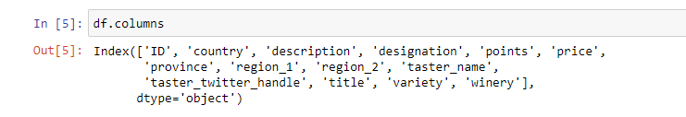

1. Total rows and columns

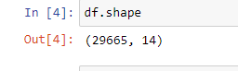

1. Average of Points

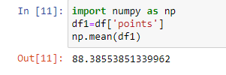

1. Sum of price of wines

