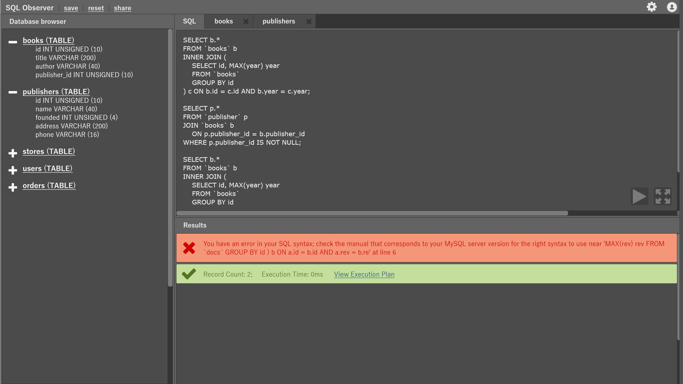

List of HTML-elements that are needed to suggested prototype

1. [<a>](https://developer.mozilla.org/en-US/docs/Web/HTML/Element/a)
2. [<abbr>](https://developer.mozilla.org/en-US/docs/Web/HTML/Element/abbr)
3. [<b>](https://developer.mozilla.org/en-US/docs/Web/HTML/Element/b)
4. [<body>](https://developer.mozilla.org/en-US/docs/Web/HTML/Element/body)
5. [<button>](https://developer.mozilla.org/en-US/docs/Web/HTML/Element/button)
6. [<div>](https://developer.mozilla.org/en-US/docs/Web/HTML/Element/div)
7. [<em>](https://developer.mozilla.org/en-US/docs/Web/HTML/Element/em)
8. [<footer>](https://developer.mozilla.org/en-US/docs/Web/HTML/Element/footer)
9. [<form>](https://developer.mozilla.org/en-US/docs/Web/HTML/Element/form)
10. [<h1>](https://developer.mozilla.org/en-US/docs/Web/HTML/Element/Heading_Elements)
11. [<head>](https://developer.mozilla.org/en-US/docs/Web/HTML/Element/head)
12. [<header>](https://developer.mozilla.org/en-US/docs/Web/HTML/Element/header)
13. [<hr>](https://developer.mozilla.org/en-US/docs/Web/HTML/Element/hr)
14. [<html>](https://developer.mozilla.org/en-US/docs/Web/HTML/Element/html)
15. [<i>](https://developer.mozilla.org/en-US/docs/Web/HTML/Element/i)
16. [<iframe>](https://developer.mozilla.org/en-US/docs/Web/HTML/Element/iframe)
17. [<input>](https://developer.mozilla.org/en-US/docs/Web/HTML/Element/input)
18. [<label>](https://developer.mozilla.org/en-US/docs/Web/HTML/Element/label)
19. [<li>](https://developer.mozilla.org/en-US/docs/Web/HTML/Element/li)
20. [<p>](https://developer.mozilla.org/en-US/docs/Web/HTML/Element/p)
21. [<script>](https://developer.mozilla.org/en-US/docs/Web/HTML/Element/script)
22. [<small>](https://developer.mozilla.org/en-US/docs/Web/HTML/Element/small)
23. [<span>](https://developer.mozilla.org/en-US/docs/Web/HTML/Element/span)
24. [<strong>](https://developer.mozilla.org/en-US/docs/Web/HTML/Element/strong)
25. [<style>](https://developer.mozilla.org/en-US/docs/Web/HTML/Element/style)
26. [<table>](https://developer.mozilla.org/en-US/docs/Web/HTML/Element/table)
27. [<tbody>](https://developer.mozilla.org/en-US/docs/Web/HTML/Element/tbody)
28. [<td>](https://developer.mozilla.org/en-US/docs/Web/HTML/Element/td)
29. [<textarea>](https://developer.mozilla.org/en-US/docs/Web/HTML/Element/textarea)
30. [<tfoot>](https://developer.mozilla.org/en-US/docs/Web/HTML/Element/tfoot)
31. [<th>](https://developer.mozilla.org/en-US/docs/Web/HTML/Element/th)
32. [<title>](https://developer.mozilla.org/en-US/docs/Web/HTML/Element/title)
33. [<tr>](https://developer.mozilla.org/en-US/docs/Web/HTML/Element/tr)
34. [<ul>](https://developer.mozilla.org/en-US/docs/Web/HTML/Element/ul)
35. [<input type="email">](https://developer.mozilla.org/en-US/docs/Web/HTML/Element/input/email)
36. [<input type="password">](https://developer.mozilla.org/en-US/docs/Web/HTML/Element/input/password)
37. [<input type="text">](https://developer.mozilla.org/en-US/docs/Web/HTML/Element/input/text)

More detailed prototype could be found along this document under *.PSD file.