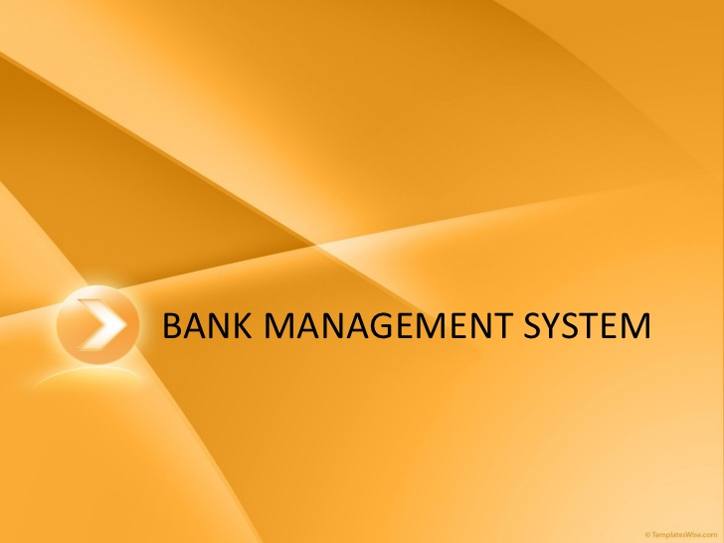 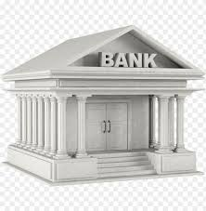

**By,**

**Deepankar,Shubhankar,Meitreya**

**XII-A**

**<<CBSE Roll_No>>**

**AISSCE 2022-2023**

**Certificate**

**This is to certify that this project on “Qatar Travels” is the bona fide work of Deepankar, Shubhankar and Meitreya for the subject INFORMATICS PRACTICES for Class 12th and satisfies all criteria to be submitted as the final project requisition for accomplishment of AISSCE 2020-21 through the Central Board of Secondary Education.**

**Manish Kumar Sharma External**

**IP Teacher**

**ACKNOWLEDGEMENT**

**Apart from the efforts of myself, the success of any project depends largely on the encouragement and guidelines of many others. I take this opportunity to express my gratitude to the people who have been instrumental in the successful completion of this project. I would like to show my greatest appreciation to Mr. Manish Kumar Sharma. I can’t say thank you enough for his tremendous support and help. Without his encouragement and guidance this project would not have materialized.**

**Manish Kumar External**

**IP Teacher**

**Index Page**

**Advantages of PYTHON**

**Advantages of MYSQL**

**Preface**

<<Write about your project>>

**Advantage of Software**

**THEY CAN PROCEED LIKE THIS:**

<<Paste Project Code here with snapshot of windows>>

Database Tables

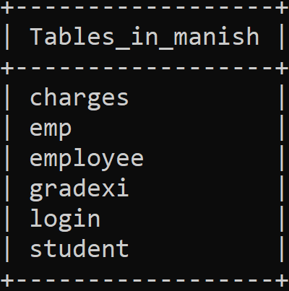

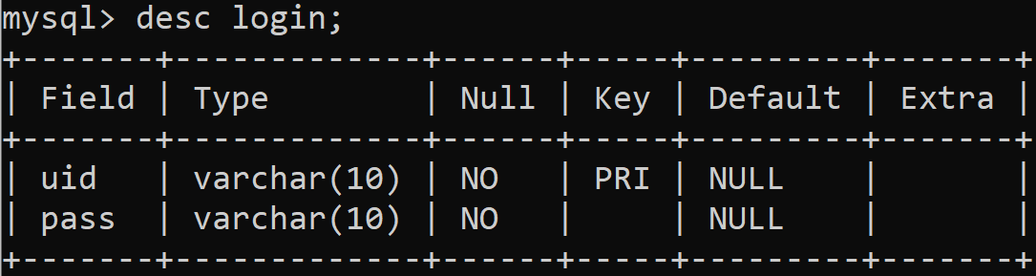

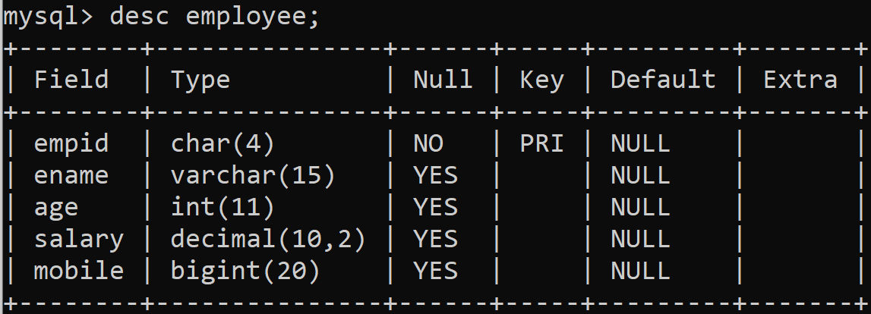

**Bibliogrphy**

**Remarks**