Assignment 1.2 Testing Report
Entertainment Guild Online Store
Student Name | Wang Zuzan
Role | Tester
Project | Entertainment Guild Online Store
Submission | Assignment 1.2 SCRUM
Report Type | Testing Progress Report and Test Cases

1. Progress Report
For Assignment 1.2, my responsibility is testing. I tested the current front-end prototype of the Entertainment Guild online store. The main focus was to check whether the pages can open correctly, whether the navigation links work, and whether the basic customer and admin flows are usable. The website currently supports page navigation, product category display, product details, Add to Cart, cart page access, customer login page, admin login page, register page, forgot password page, and several admin pages.
Current limitation: the project is not connected to the real database yet. Therefore, the front-end functions can be tested with current/sample data, but real database functions such as real product loading, login validation, cart database saving, and permanent admin database updates are not fully testable yet.

2. What I Tested
Home page loading: I opened the website home page and checked that the banner, search bar, navigation bar, and popular picks area displayed correctly.
Navigation links: I clicked Home, Books, Movies, Games, Deals, Contact, Login, and Cart to check whether the customer pages could be opened.
Product category pages: I checked Books, Movies, and Games pages to make sure the selected category page opened and displayed related product content.
Product detail and cart functions: I clicked View Details on a product and confirmed that the detail page opened. I also clicked Add to Cart and confirmed that the product could be added to the cart using the current front-end/sample data.
Account-related pages: I tested customer login, admin login, register, and forgot password pages to confirm that they could open correctly.
Admin functions: I tested the admin dashboard, item management page, user management page, orders link, reports link, settings link, and logout link. Dashboard, Item Management, User Management, and Logout could be opened. Orders returned to the home page, while Reports and Settings did not navigate correctly in the current version.
Admin management actions: I also checked the item and user management actions. Item and user information can be deleted in the current prototype. However, detailed editing is not fully available, and adding new item/user information is not working yet. These functions need further development and later database testing.

3. Test Cases
ID | Function | Test Steps | Expected Outcome | Actual Outcome | Status
TC01 | Home Page | Open the home page | Home page loads successfully | Home page loaded with banner, search bar, navigation bar, and popular picks | Pass
TC02 | Customer Navigation | Click main customer navigation links | Links open related pages or current placeholder pages | Home, Books, Movies, Games, Deals, Contact, Login, and Cart can be opened | Pass
TC03 | Books Page | Click Books | Books page shows book products | Books page opened and displayed book content | Pass
TC04 | Movies Page | Click Movies | Movies page shows movie products | Movies page opened and displayed movie content | Pass
TC05 | Games Page | Click Games | Games page shows game products | Games page opened and displayed game content | Pass
TC06 | Product Details | Click View Details | Product detail page opens | Product detail page opened using current/sample data | Pass
TC07 | Add to Cart | Click Add to Cart | Product is added to cart | Product could be added to cart using current/sample data | Pass
TC08 | Cart Page | Open Cart page | Cart page opens and shows cart content | Cart page opened and showed current cart content | Pass
TC09 | Login Pages | Open customer/admin login | Login pages display correctly | Customer and admin login pages opened correctly | Pass
TC10 | Register/Forgot Password | Open register and forgot password pages | Pages display correctly | Both pages opened correctly | Pass
TC11 | Admin Dashboard | Open admin dashboard | Admin dashboard displays summary panels and admin navigation | Admin dashboard opened and showed dashboard content | Pass
TC12 | Admin Basic Navigation | Click Dashboard, Item Management, User Management, and Logout | Main admin links open the correct pages or return to the correct flow | Dashboard, Item Management, User Management, and Logout could be opened | Pass
TC13 | Admin Orders Link | Click Orders in the admin sidebar | Orders page should show all orders | Orders currently returns to the home page, so all orders cannot be viewed | Issue Found
TC14 | Admin Reports/Settings Links | Click Reports and Settings in the admin sidebar | Reports and Settings pages should open | Reports and Settings do not navigate correctly in the current version | Issue Found
TC15 | Admin Delete Action | Delete item/user information | Selected item/user information should be removed from the current list | Item and user information can be deleted in the current prototype | Pass
TC16 | Admin Add/Edit Action | Click add new item/user or edit details | Admin should be able to add new information and edit details | Detailed editing is not fully available, and adding new information does not work yet | In Progress
TC17 | Real Database Product Loading | Load real database products | Products load from provided database | Not testable because database connection is not finished | Not Testable Yet
TC18 | Real Login and Database Updates | Test real login, cart saving, and admin updates | System validates users and saves updates to database | Not testable because backend/database connection is not finished | Not Testable Yet

4. Issues Found
The main front-end pages, customer navigation, product details, cart flow, admin dashboard, item management page, and user management page are working in the current prototype. The main issue is that the prototype is not connected to the real database yet. Because of this, real product loading, real login validation, cart database saving, and permanent admin database updates cannot be fully tested at this stage. The Orders link in the admin sidebar currently returns to the home page, so all orders cannot be viewed. Reports and Settings also do not navigate correctly. Item and user delete actions can be used, but detailed editing and adding new information are not fully available yet. These items are not marked as Fail because some functions are still under development.

5. Next Steps
- Retest product loading after the database connection is completed.
- Retest customer and admin login with real database credentials.
- Test whether cart data can be saved and loaded from the database.
- Retest admin functions for adding, editing, and deleting products/users after backend updates.
- Retest admin Orders, Reports, and Settings navigation after these pages are fixed.
- Update the actual outcomes and mark final results as Pass or Fail in the next testing stage.

Appendix A: Testing Evidence
Place the key screenshots in this appendix. Seven evidence screenshots are recommended to cover both customer and admin testing while keeping the report short and clear.
Figure 1. Home Page
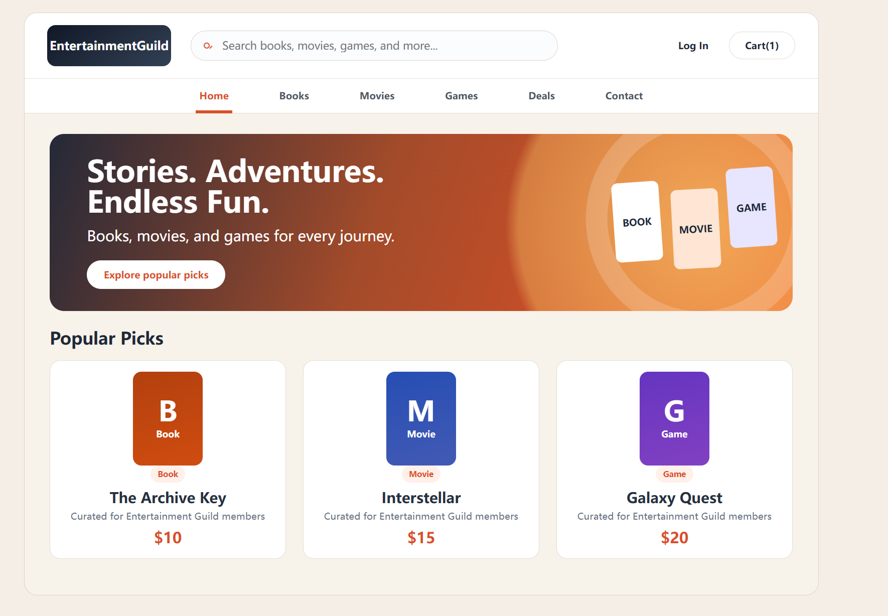

Figure 2. Product Category Page or Cart Page
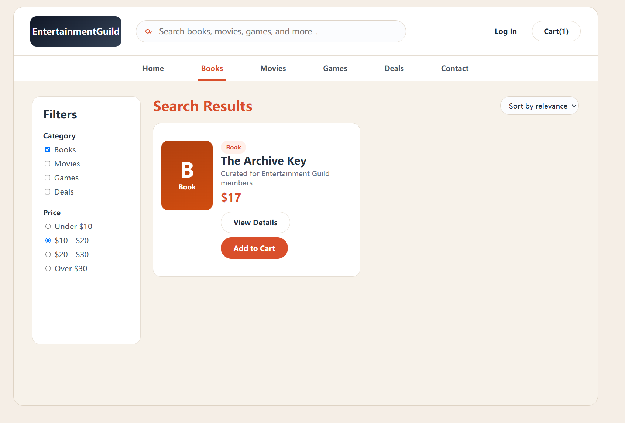
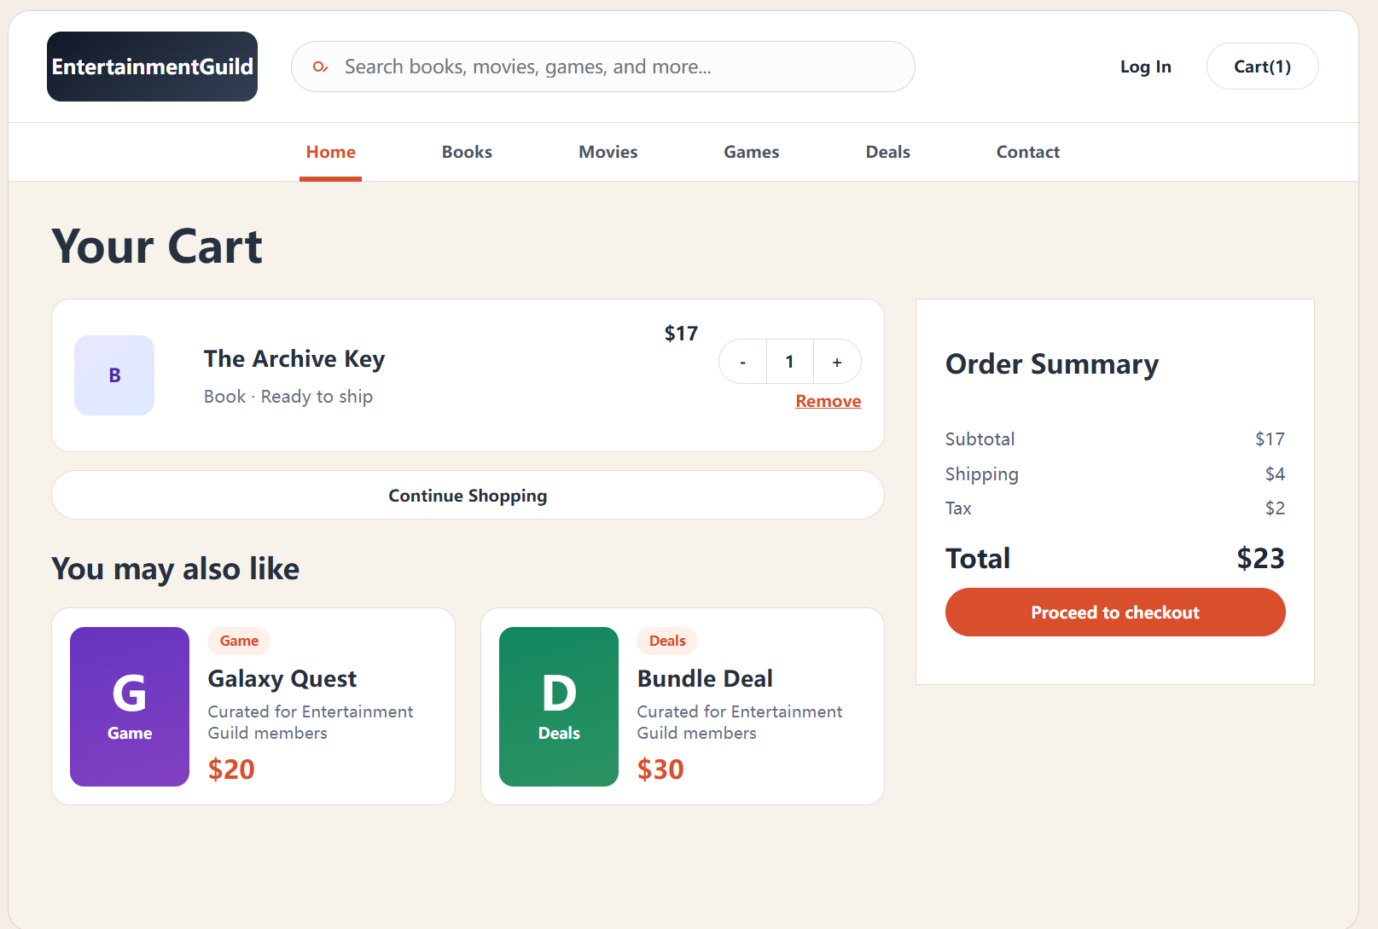

Figure 3. Product Detail Page or Cart Page
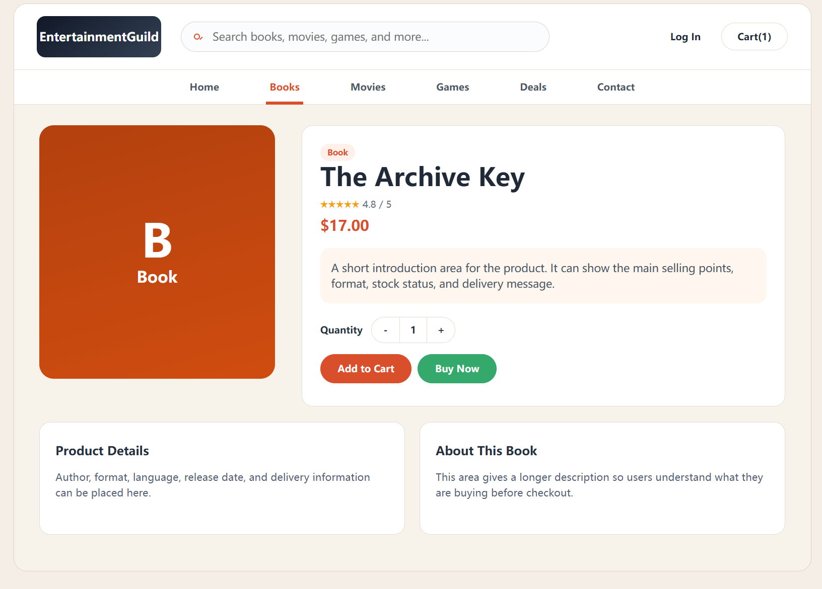

Figure 4. Customer Login or Register Page
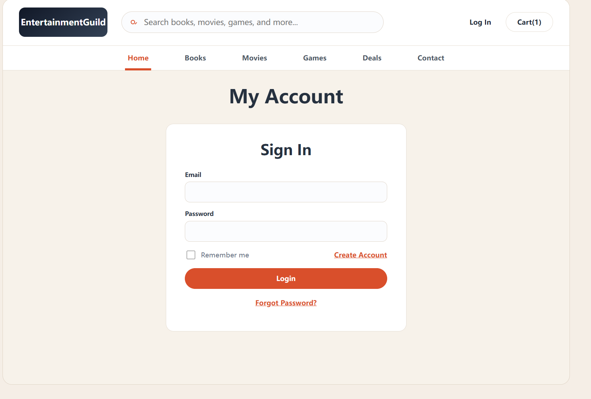

Figure 5. Admin Dashboard Page
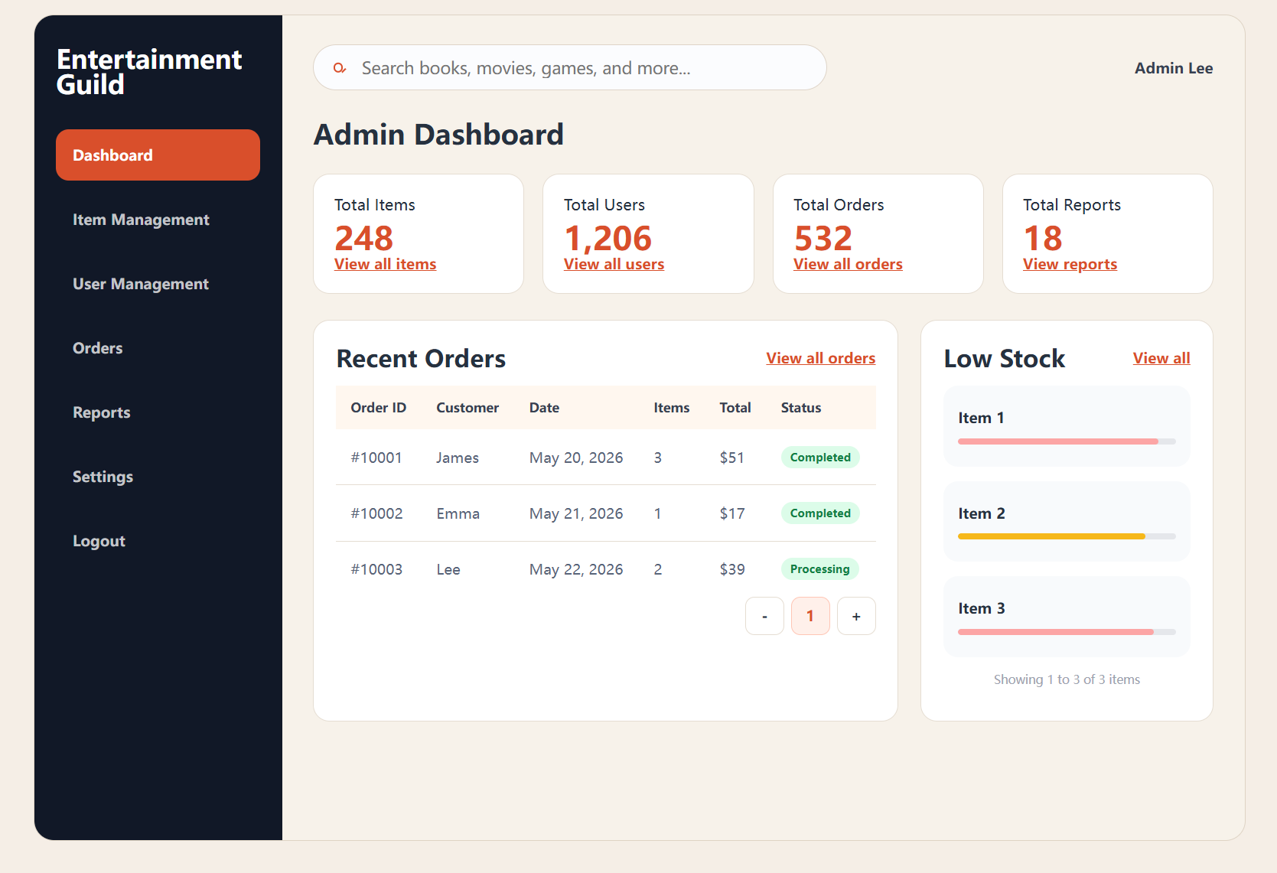
Figure 6. Admin Item Management or User Management Page
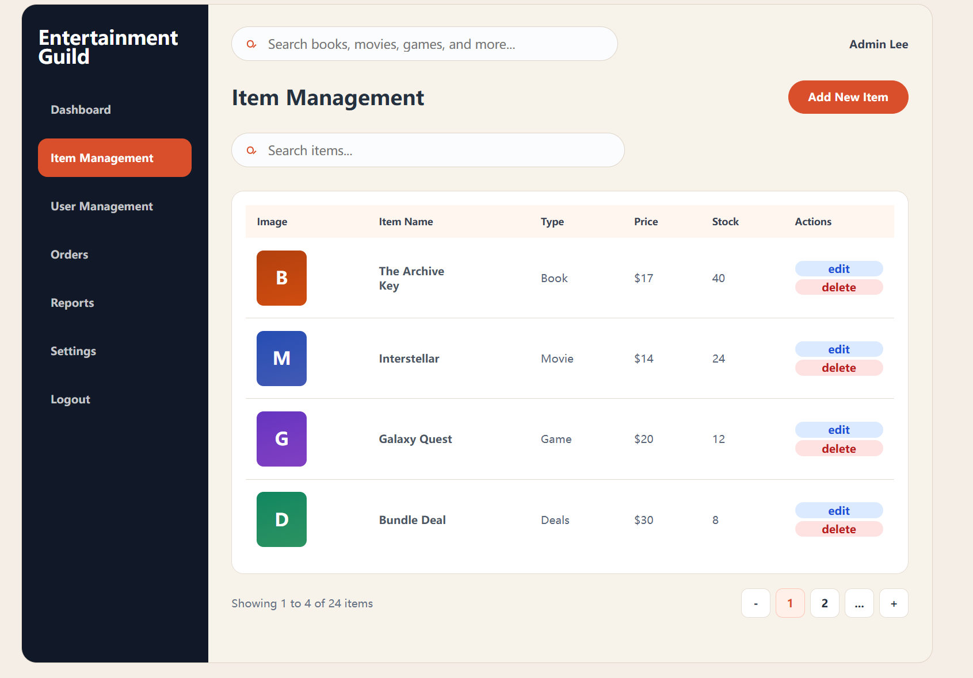
Figure 7. Admin Navigation Issue.After clicking Orders, the system returned to the Home Page instead of opening the Orders page. Reports and Settings also did not navigate correctly in the current version.
