Individual Contributions Report
Entertainment Guild – Online Store Management System (React + provided database)
Student | Chen Shibo — Student #: C3552557
Team role | Leader + UI / Frontend Lead
Checkpoint | Progress SCRUM 1 (Week 6)
Date | 16 / 06 / 2026
Contribution summary
Since the Start-Up SCRUM submission (our team plan, the five-page wireframes and the signed Group Code of Conduct), I have moved from planning into building the frontend. This report covers my contributions for Progress SCRUM 1.
Working through my individual Gantt chart, I first set up the React project — its routing, folder structure and the Git branching strategy — and then built the shared design system and component library: the navigation bar, the page layout shells, buttons, form controls and a single, consistent colour and typography theme. On that base I implemented the customer pages in order: the Home page; the Search / Results page with category and price filters (Business Scenario 1); and then the Product Detail page (description, price, quantity and add-to-cart) and the Cart page with its order summary, reusing the shared components so the pages stay consistent and quick to extend.
I also created the navigation for every page, so that all pages — including the login, registration, account and admin screens — link and route to one another correctly, and a logged-out visitor is taken to the sign-in flow instead of straight into the account page.
The Login / Register and Account pages are currently in progress and are being finished this week. Because the database and API have not yet been provided, these pages run on temporary front-end state only; the responsive-layout pass, the W3C accessibility pass and the frontend-to-backend integration are scheduled for the later weeks (Progress SCRUM 2 and the Final SCRUM) and have not been started yet.
Alongside my own block I have continued my Leader duties — merging each member’s branch, fixing frontend bugs, and preparing the team master Gantt and this progress report — to keep the whole team’s work aligned.
(approx. 280 words)
MEETING MINUTES
Week 2 — Group 8
TEAM  Group 8 | PLACE  Main Wing | DATE / TIME  19/05/2026, 3:00 PM
In attendance: Wang Zuzan, Zhang Lei, Gao Chang, Chen Shibo, Yang Feng Apologies: None
Agenda
Previous matters
- None
Main discussion
- Assign tasks to each member.
- Create a design outline to support the smooth progress of the project.
Next meeting: 25/05/2026, 5:00 PM, Main Wing.
Next meeting agenda
- Check each member’s task completion and discuss whether improvements are required.
- Discuss how to improve the content of the individual project plan report.
Action sheet
Task | Responsible | Due | Notes
Optimize the layout of the wireframe and add the functions that were not included. | Chen Shibo | 23/05/2026 | After the team members place the necessary functions of the basic wireframe on the corresponding pages, they will review and optimize it.
Business scenario clarification + initial draft of test cases. | Wang Zuzan | 23/05/2026 | Divide the four core business scenarios into detailed steps, including textual procedures and abnormal branches.
Database ER diagram + data dictionary compilation. | Yang Feng | 24/05/2026 | Familiarize yourself with the provided database, create an ER diagram, clarify field meanings, data types and constraints, and organize them into a data dictionary document.
Requirement document organization + technology selection confirmation. | Gao Chang | 23/05/2026 | Integrate the three original documents; extract the functional list and non-functional requirements (security / ease of use); confirm the technical stack, define the tool division, and set up the Git repository.
Create the basic wireframe diagram. | Zhang Lei, Wang Zuzan | 24/05/2026 | Place all required functions in the corresponding pages as specified in the task requirements (layout is not a concern at this stage; this facilitates later optimization by others).
Meeting decisions & next steps
Each member will complete their assigned work before the due date listed in the action sheet.
The next meeting will focus on checking task progress and improving the individual project plan report.
MEETING MINUTES
Week 3 — Group 8
TEAM  Group 8 | PLACE  Stem Wing | DATE / TIME  25/05/2026, 5:00 PM
In attendance: Wang Zuzan, Zhang Lei, Gao Chang, Chen Shibo, Yang Feng Apologies: None
Agenda
Previous matters
- Check everyone’s task completion status and discuss whether optimization is needed.
- Discuss how to improve the content of the individual plan reports.
Main discussion
- The wireframe contains too little information; discuss the details that need to be added.
- Discuss the contents of the database dictionary and add additional data types for use.
- Discuss the report format and the Gantt charts, and complete the Gantt chart for each section; the team leader will then improve and merge them.
Next meeting: 04/06/2026, 5:00 PM, Stem Wing.
Next meeting agenda
- Check the new wireframe for any missing information.
- Share the report format and provide feedback on areas for improvement.
- Familiarize yourself with the content of each section and prepare the SCRUM responsibility report.
Action sheet
Task | Responsible | Due | Notes
Improved wireframe. | Chen Shibo, Zhang Lei | 26/05/2026 | One person is responsible for revising the text; the other is responsible for providing ideas and inspiration.
Add content to the database dictionary. | Yang Feng | 26/05/2026 | Based on the content discussed at the meeting, appropriately fill it into the original document.
General format for the report. | Chen Shibo | 26/05/2026 | Compile the necessary content for the report and format it neatly.
Organize the Gantt charts that each person is responsible for. | All members | 27/05/2026 | Compile the Gantt chart for each section and submit it to the team leader to merge into a master Gantt chart, which will then be included in the report.
Meeting decisions & next steps
Each member will complete their assigned work before the due date listed in the action sheet.
MEETING MINUTES
Week 4 — Group 8
TEAM  Group 8 | PLACE  Main Wing | DATE / TIME  04/06/2026, 2:00 PM
In attendance: Wang Zuzan, Zhang Lei, Gao Chang, Chen Shibo, Yang Feng Apologies: None
Agenda
Previous matters
- Check the new wireframe for any missing information.
- Share the report format and provide feedback on areas for improvement.
- Familiarize yourself with the content of each section and prepare the SCRUM responsibility report.
Main discussion
- Create a GitHub repository and upload the final version of the wireframe and other necessary files.
- Listen to the teacher’s suggestions and rearrange the tasks accordingly, allowing those with simpler tasks to contribute more to other sections.
- Discuss task cooperation, with each member informing the others which tasks require their cooperation.
Next meeting: 11/06/2026, 2:00 PM, Main Wing.
Next meeting agenda
- Evaluate the component design of the system and provide suggestions for improvement; otherwise, skip this step.
- Discuss whether the API design is reasonable; if not, discuss improvement plans and make modifications.
- Review the first test case draft.
Action sheet
Task | Responsible | Due | Notes
Design system & shared components. | Chen Shibo | 12/06/2026 | Build the reusable navigation, layout, buttons and form controls, and the shared colour / typography theme.
API contract with frontend. | Zhang Lei | 13/06/2026 | Agree the API request / response contract with the frontend (Chen Shibo).
Initial test cases draft. | Wang Zuzan | 12/06/2026 | Draft the first set of functional test cases from the scenarios.
Item Management: API, DB & React UI. | Yang Feng | 13/06/2026 | Build item management end-to-end: API, database and React admin UI.
Meeting decisions & next steps
Each member will complete their assigned work before the due date listed in the action sheet.

Team Communication Records
Screenshots from the team chat (in Chinese) evidencing coordination during this sprint; each caption explains what the screenshot shows.
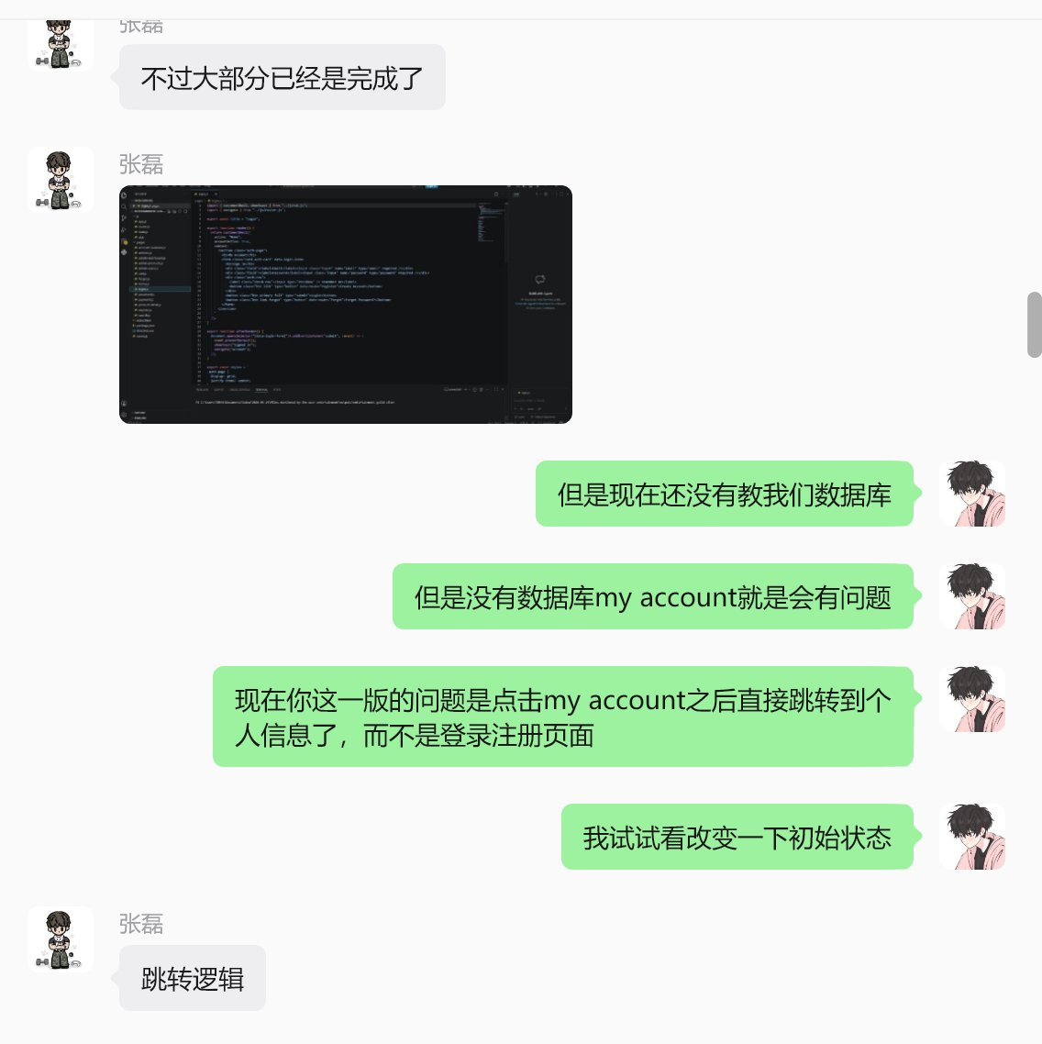
Figure 1 — Authentication-state discussion. The team agreeing that clicking “My Account” should lead to the sign-in / registration flow rather than jumping straight to the profile page, and that the default logged-in state and redirect logic need fixing.
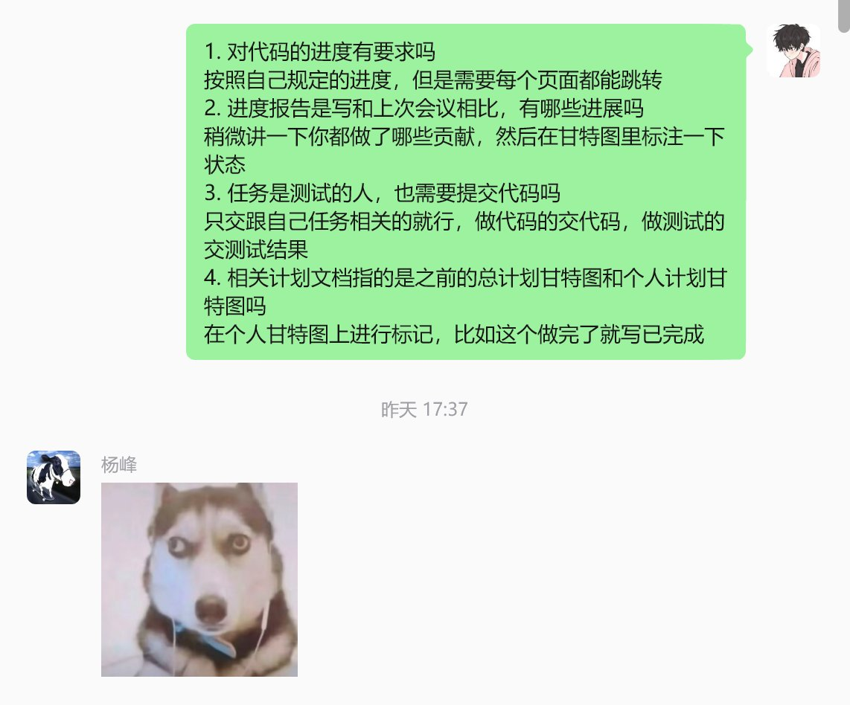
Figure 2 — Clarifying the Progress SCRUM requirements. Confirming what counts as code progress, what to include in the progress report, what the testers submit, and that each task’s status is marked on the individual Gantt chart.
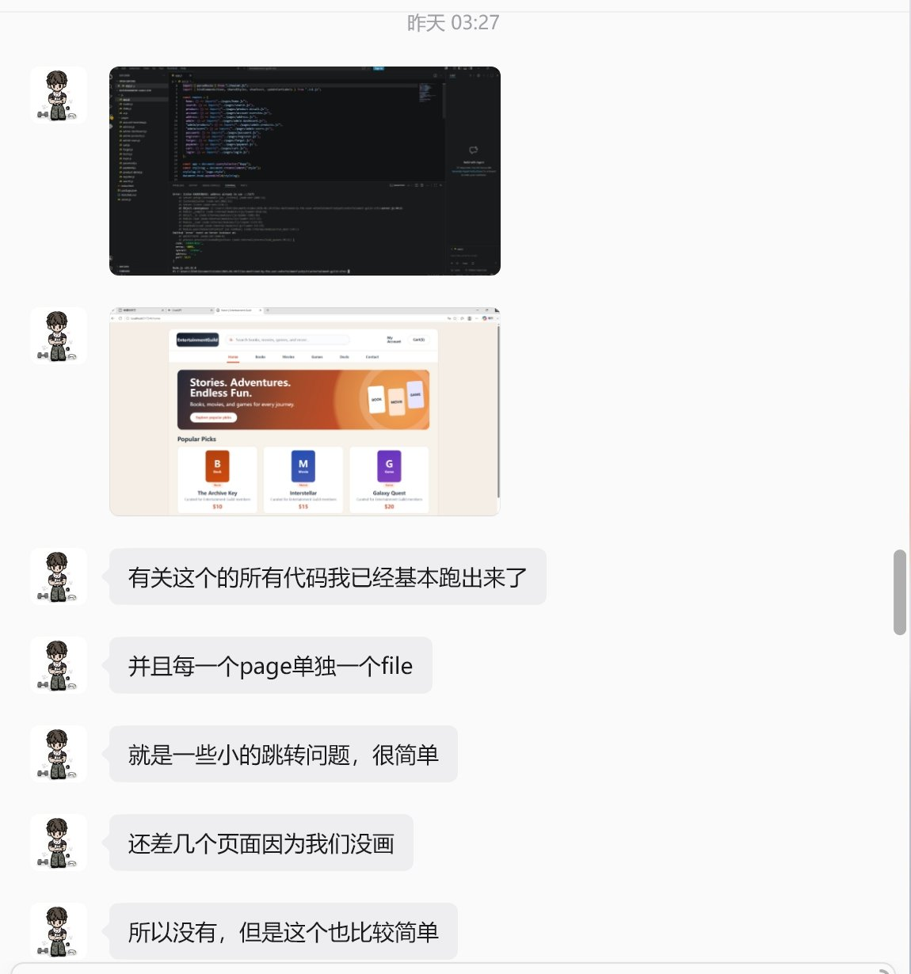
Figure 3 — React frontend running locally. The store’s home page running from the React build, with each page implemented as its own file; only minor navigation issues remained.
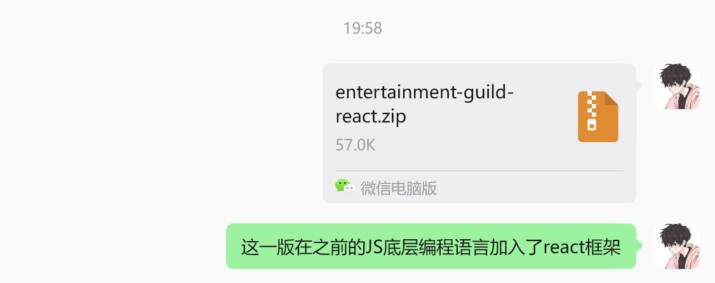
Figure 4 — Sharing the React build with the team. Sending the packaged project (entertainment-guild-react.zip); this version adds the React framework on top of the earlier JavaScript base.
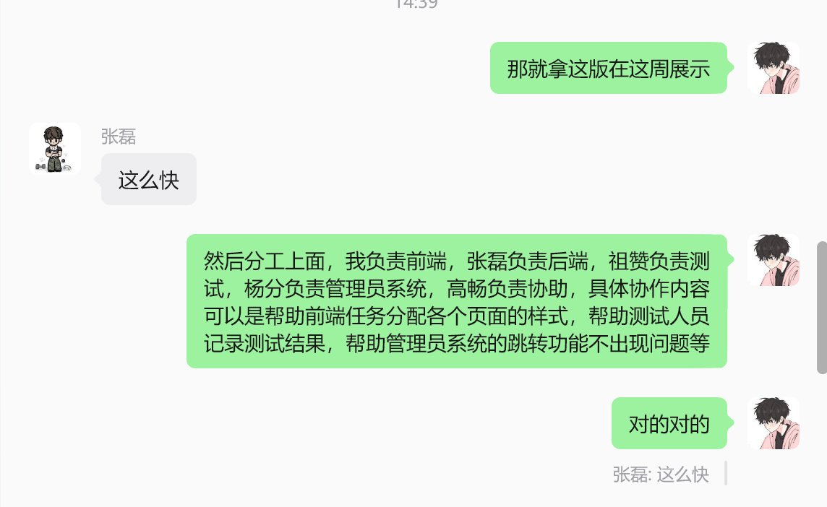
Figure 5 — Agreeing the demo and task division. Deciding to demo this version for the week and confirming each member’s responsibility (frontend, backend, testing, admin module and support).

Related Documents
My individual 12-week Gantt chart (UI / Frontend), with a Status column added. Status is shown as of Progress SCRUM 1 (Week 6): green = completed, yellow = in progress, red = not started. Blue bars are scheduled build tasks; grey bars are continuous duties; gold cells mark the SCRUM checkpoints.
Task (Leader – UI / Frontend) | Days | Description | Status | W1 | W2 | W3 | W4 | W5 | W6 | W7 | W8 | W9 | W10 | W11 | W12
SCRUM checkpoints (S1 = Week 6, S2 = Week 8, S3 = Week 10) |  |  |  |  |  |  |  |  | S1 |  | S2 |  | S3
Wireframes (5 core pages) + interaction notes | 8 | Low-fidelity wireframes for the Home, Search, Login / Register, Cart and Account pages, with notes on navigation, page states and form validation. | Completed
React project scaffold, Git repo & branching | 5 | Create the React project, folder structure and routing, and set up the Git repository and branching strategy for parallel work. | Completed
Design system & shared UI components | 8 | Build reusable components — navigation, layout, buttons and form controls — and the colour / typography theme to one consistent, accessible style. | Completed
Home + Product Search / Results pages | 8 | Implement the landing page and the search / results page with category and price filters (Business Scenario 1). | Completed
Product Detail + Cart pages | 8 | Build the item detail page (description, price, quantity, add to cart) and the cart page with its order summary. | Completed
Login / Register + Account / Profile UI | 8 | Build the sign-in, registration and account pages (profile, address book, order history); covers Business Scenarios 3 and 4. | In progress
Responsive layout (desktop / mobile) | 6 | Adapt every page to desktop and mobile breakpoints. | Not started
Accessibility pass (W3C) | 5 | Apply the W3C recommendations — contrast, labelled fields, alt text and keyboard navigation. | Not started
Frontend ↔ Backend API integration | 12 | Connect the frontend to the database through the API, handling loading, empty and error states and the approved / declined / timed-out payment responses. | Not started
UI polish & system-test support | 6 | Refine styling, fix layout issues and support system testing (links, role-based access, data accuracy). | Not started
Final demo & presentation prep | 3 | Prepare the demo build and the final presentation. | Not started
Code merge / integration / frontend bug fixing | — | Continuous — review and merge each member’s branch, resolve conflicts and fix frontend bugs. | In progress
Team coordination & SCRUM preparation (Leader) | — | Continuous — run SCRUMs, track progress, keep deliverables aligned and prepare submissions. | In progress
Status legend
Completed | In progress | Not started
Summary of completed work (as of Week 6)
The wireframes, the React project setup and the shared design system are complete, and the Home, Search / Results, Product Detail and Cart pages are built and working. I drew the wireframes first to fix the page layout, then scaffolded the React project with routing and a Git branching strategy so the team could work in parallel; next I built a shared component library (navigation, layout, buttons, form controls and one common theme) and implemented the four customer pages on top of it, with navigation wired so every page links correctly. The Login / Register and Account pages are still in progress, and the responsive layout, the W3C accessibility pass and the frontend-to-backend integration are scheduled for the later weeks.

