Here is the code of the Developing Number Management HTTP Microservice

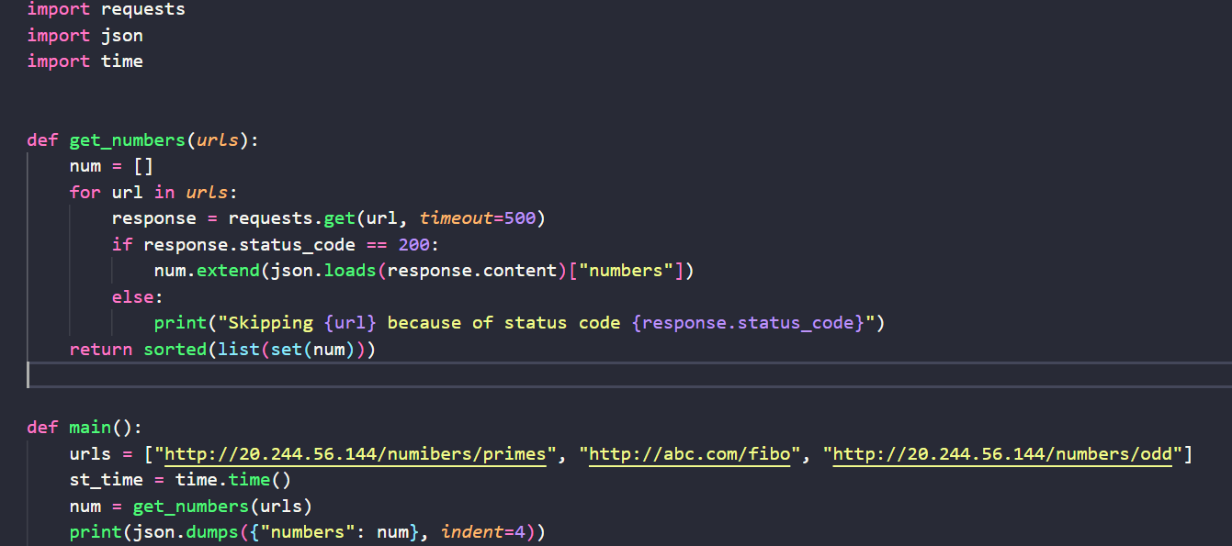

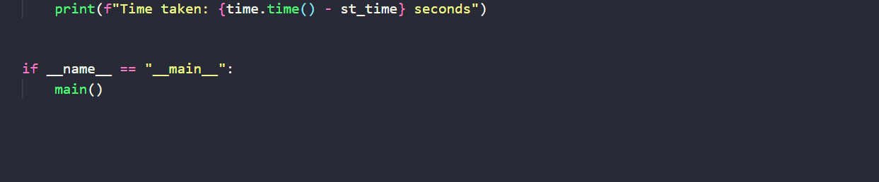

Here is the output of the code

