**Industrial Internship Report on**

**“Crop and Weed Detection”**

**Prepared by**

**Shubham Kamble**

|  |
| --- |
| *Executive Summary* |
| This report provides details of the Industrial Internship provided by upskill Campus and The IoT Academy in collaboration with Industrial Partner UniConverge Technologies Pvt Ltd (UCT).  This internship was focused on a project/problem statement provided by UCT. We had to finish the project including the report in 6 weeks’ time.  My project was about Detecting crops from weed which will create a system that only sprays pesticides on weed and not on the crop Which will reduce the mixing problem with crops and reduce the waste of pesticides.  This internship gave me a very good opportunity to get exposure to Industrial problems and design/implement solution for that. It was an overall great experience to have this internship. |





**TABLE OF CONTENTS**

1. Preface .............................................................................................................................................. 3
2. Introduction ....................................................................................................................................... 4
   1. About UniConverge Technologies Pvt Ltd ....................................................................................... 4
   2. About upskill Campus .................................................................................................................... 8
   3. Objective ..................................................................................................................................... 10
   4. Reference.................................................................................................................................... 10
   5. Glossary ...................................................................................................................................... 10
3. Problem Statement .......................................................................................................................... 11
4. Existing and Proposed solution ......................................................................................................... 12
5. Proposed Design/ Model .................................................................................................................. 13
   1. High Level Diagram ...................................................................................................................... 13
   2. Low Level Diagram ...................................................................................................................... 14
   3. Interfaces .................................................................................................................................... 14
6. Performance Test ............................................................................................................................. 15
   1. Test Plan/ Test Cases ................................................................................................................... 15
   2. Test Procedure ............................................................................................................................ 15
   3. Performance Outcome ................................................................................................................ 15
7. My learnings .................................................................................................................................... 16
8. Future work scope ............................................................................................................................ 17

# 1 Preface

I started the project “Crop and weed detection” by first analysing the dataset. The dataset access was the tricky part since it was given in YOLO format. After that I trained my ML model to differentiate between crops and weed. I used a CNN model to extract the relevant features from the image dataset. Finally, The trained ML model was able to classify the test images accurately.

This Internship helped in my personal growth and helped me identify what areas I am good at and what areas do I need to improve upon. Internship are a critical step in one’s career.

My project was about Detecting crops from weed which will create a system that only sprays pesticides on weed and not on the crop Which will reduce the mixing problem with crops and reduce the waste of pesticides.

This was a golden opportunity given to me by Uni-Convergence-Technology ltd. (UCT/USC). I was able to fully develop my skills and could complete the tasks successfully.

The Program was planned very meticulously. The course allowed me to improve upon my skills. The program organizers gave us clear schedule which helped keep my reports on tracks.

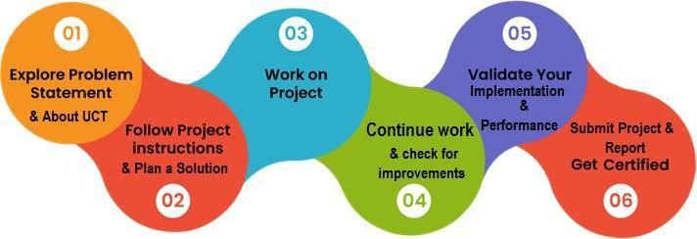

This internship contributed to my learning significantly. It helped me grow in a professional as well as in a personal way. I became more proficient in my field of study i.e., Data Science and Machine Learning.

I thank all my co-mentors and the internship organizer for giving me this opportunity to work on my skills and help me in my career growth.

I thereby give small advice to all my juniors and peers that no matter how tough it gets to manage your time to complete all the weekly assignments, keep working hard and do not give up. Since the result will be very fruitful.

# 2 Introduction

## **2.1 About UniConverge Technologies Pvt Ltd**

A company established in 2013 and working in Digital Transformation domain and providing Industrial solutions with prime focus on sustainability and RoI.

For developing its products and solutions it is leveraging various **Cutting Edge Technologies e.g. Internet of Things (IoT), Cyber Security, Cloud computing (AWS, Azure), Machine Learning, Communication Technologies (4G/5G/LoRaWAN), Java Full Stack, Python, Front end** etc.



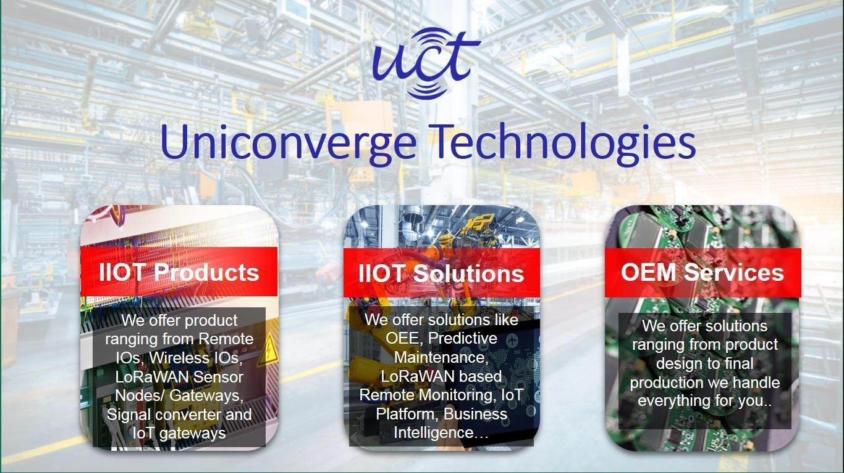



# i. UCT IoT Platform ( )

**UCT Insight** is an IOT platform designed for quick deployment of IOT applications on the same time providing valuable “insight” for your process/business. It has been built in Java for backend and ReactJS for Front end. It has support for MySQL and various No SQL Databases.

* It enables device connectivity via industry standard IoT protocols - MQTT, CoAP, HTTP, Modbus TCP, OPC UA
* It supports both cloud and on-premises deployments.

It has features to

* Build Your own dashboard
* Analytics and Reporting
* Alert and Notification
* Integration with third party application(Power BI, SAP, ERP)
* Rule Engine

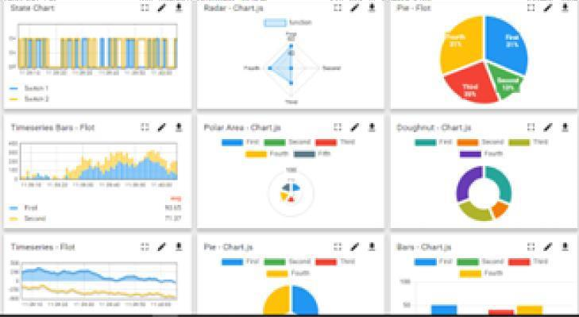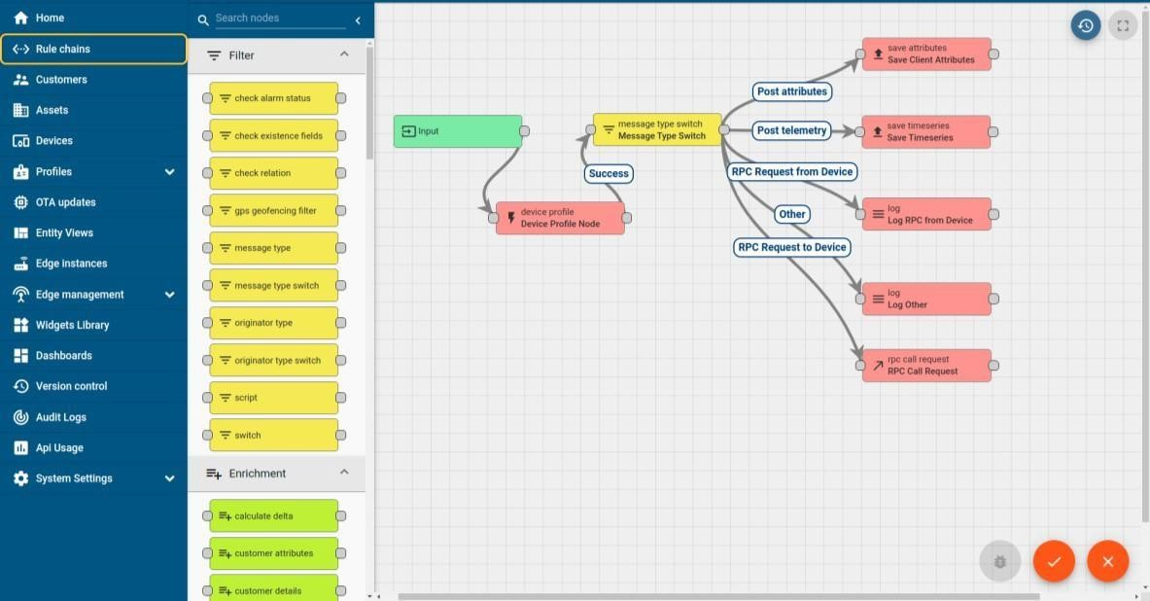



ii. **Smart Factory Platform ( )**

Factory watch is a platform for smart factory needs.

It provides Users/ Factory

* with a scalable solution for their Production and asset monitoring
* OEE and predictive maintenance solution scaling up to digital twin for your assets.
* to unleased the true potential of the data that their machines are generating and helps to identify the KPIs and also improve them.
* A modular architecture that allows users to choose the service that they what to start and then can scale to more complex solutions as per their demands.

Its unique SaaS model helps users to save time, cost and money.

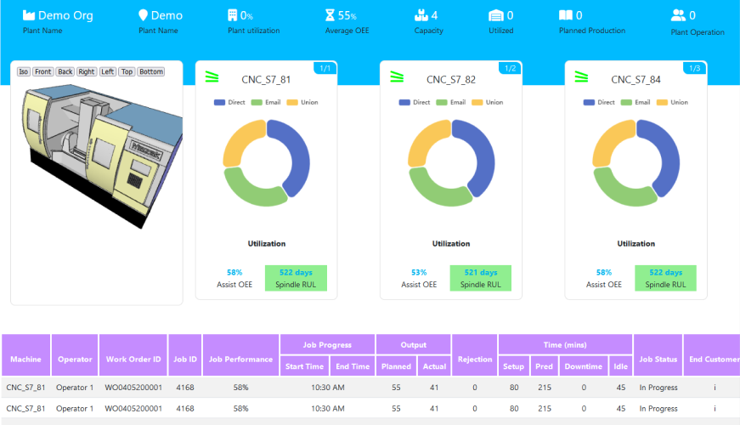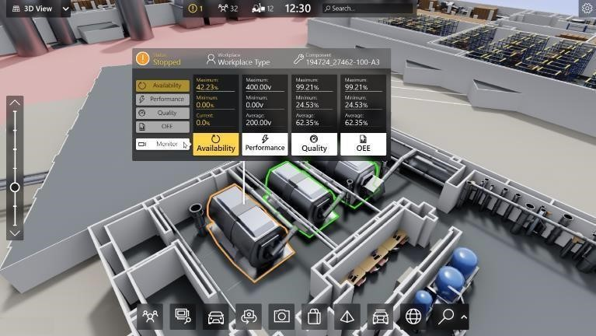



## iii. based Solution

UCT is one of the early adopters of LoRAWAN technology and providing solution in Agriculture tech, Smart cities, Industrial Monitoring, Smart Street Light, Smart Water/ Gas/ Electricity metering solutions etc.

## iv. Predictive Maintenance

UCT is providing Industrial Machine health monitoring and Predictive maintenance solution leveraging Embedded system, Industrial IoT and Machine Learning Technologies by finding Remaining useful life time of various Machines used in production process.

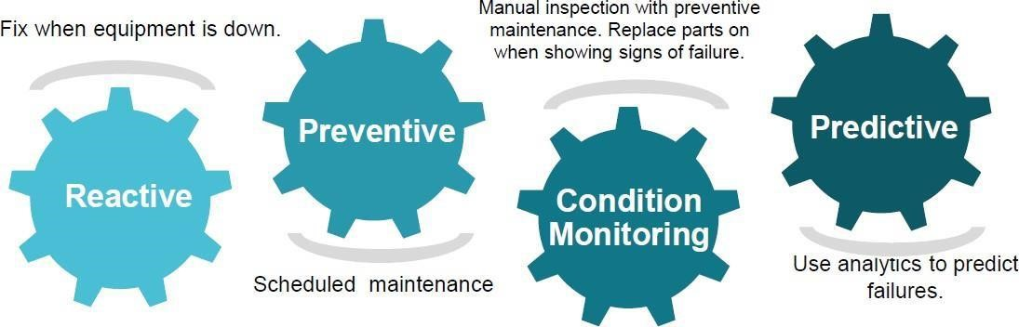

### 2.2 About upskill Campus (USC)

upskill Campus along with The IoT Academy and in association with Uniconverge technologies has facilitated the smooth execution of the complete internship process.

USC is a career development platform that delivers **personalized executive coaching** in a more affordable, scalable and measurable way.



Seeing

need

of

upskilling

in

self

paced manner along

-

with

upSkill

Campus

aiming

to upskill 1 million

additional support services e.g. learners in next 5 year

Internship, projects, interaction with Industry experts, Career growth Services <https://www.upskillcampus.com/>



Profile

building



Skill

Assessment



upskilling

Courses



Interview

Preparation

and skill building



Discussion/QA

forum



Mentorship



Alumni

Connections



Tech

updates



Discussion

forum



Project

collaboration



Freelancing

projects



Internship

portal



Job

portal

Career

growth/upskilling

Professional networking

Collaboration

platform

Job/internship

platform

### 2.3 The IoT Academy

The IoT academy is EdTech Division of UCT that is running long executive certification programs in collaboration with EICT Academy, IITK, IITR and IITG in multiple domains.

### 2.4 Objectives of this Internship program

The objective for this internship program was to

☛ get practical experience of working in the industry.

☛ to solve real world problems.

☛ to have improved job prospects.

☛ to have Improved understanding of our field and its applications.

☛ to have Personal growth like better communication and problem solving.

### 2.5 Reference

[1] https://[www.researchgate.net/publication/356914203_WEED_DETECTION_USING_IMAGE_PROCESSING](http://www.researchgate.net/publication/356914203_WEED_DETECTION_USING_IMAGE_PROCESSING) [2] https://www.diva-portal.org/smash/get/diva2:1447357/FULLTEXT01.pdf

[3]

### 2.6 Glossary

|  |  |
| --- | --- |
| Terms | Acronym |
| Convolutional Neural Network | CNN |
| You Only Look Once | YOLO |
| Machine Learning | ML |
|  |  |
|  |  |

### 3 Problem Statement

In the assigned problem statement, I had to create a system for detecting crops from weed that only sprays pesticides on weed and not on the crop which will reduce the mixing problem with crops and reduce the waste of pesticides. Weed is an unwanted thing in agriculture. Weed use the nutrients, water, land and many more things that might have gone to crops. Which results in less production of the required crop. The farmer often uses pesticides to remove weed which is also effective but some pesticides may stick with crop and may causes problems for humans. For this purpose, this system of detection of crop and weed is created.

### 4 Existing and Proposed solution

Earlier solutions provided previously was basically trying to solve the same problem but the accuracy obtained in solving the problem was low and sometimes the model could not classify the crop and weed correctly.

I have proposed in severely training my model in such a way that the CNN model will be able to provide correct classification when tested on test images.

#### 4.1 Code submission (GitHub link)

https://github.com/dnyanesh3005/upskill-internship.git

**4.2 Report submission (GitHub link):**

https://github.com/dnyanesh3005/upskill-internship.git

### 5 Proposed Design/ Model

**Design Flow of The Solution**

The starting stage of the model is preprocessing the images for training. Then the model is prepared for training to detect the weeds. The model is then trained using CNN. Then the predictions are made using the deep learning model.

#### 5.1 High Level Diagram (if applicable)

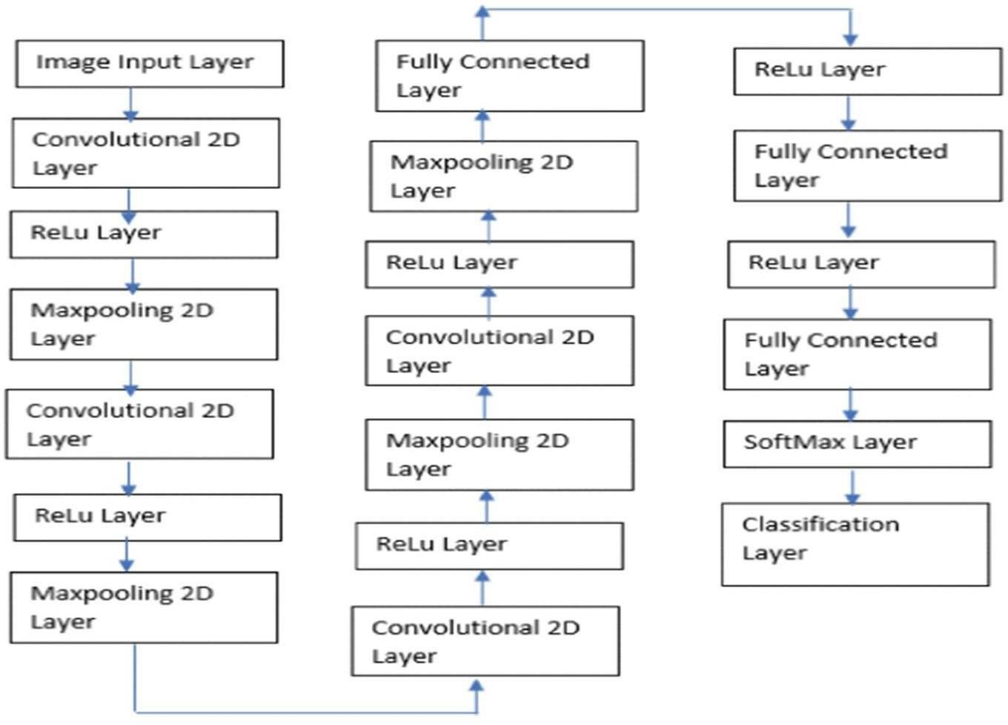

**Figure 1: HIGH LEVEL DIAGRAM OF THE SYSTEM**

#### 5.2 Low Level Diagram

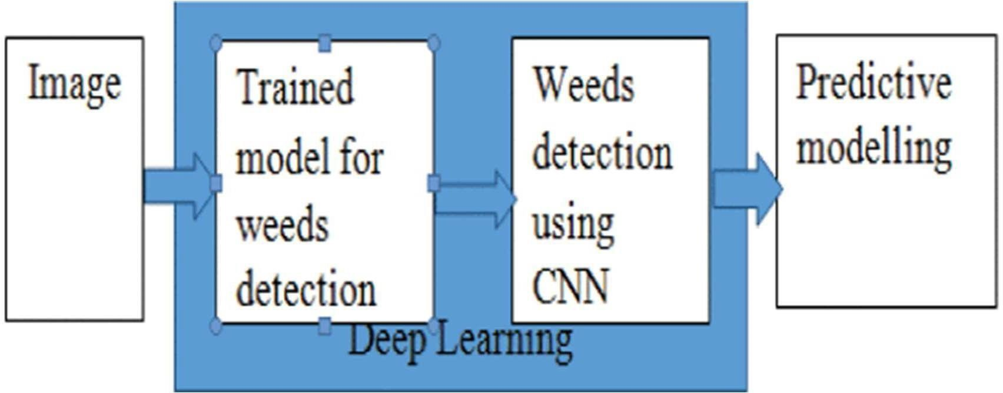

#### 5.3 Interfaces

**Block Diagrams**

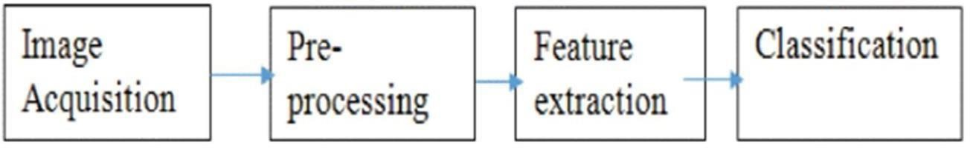

### 6 Performance Test

Performance test plays a major role and defines why this work is meant of Real industries, instead of being just academic project.

Constraints in my project was accuracy and speed with which output is generated.

In my design I trained my model several times with various machine learning algorithms like Decision tree, random forest to find the algorithm which is best suitable to produce highest accuracy.

The test results were significantly improved compared to those of the work done by other projects. Identification of constraints plays a major role in training a model for a real-life application.

#### 6.1 Test Plan/ Test Cases

My main testing plan involved in testing the already trained model with various images so that model could become equipped with how to classify the crop and weed.

#### 6.2 Test Procedure

First step was to train the model with epoch using the CNN. Then the images not used in training was used to test the accuracy of the model in the classification task.

#### 6.3 Performance Outcome

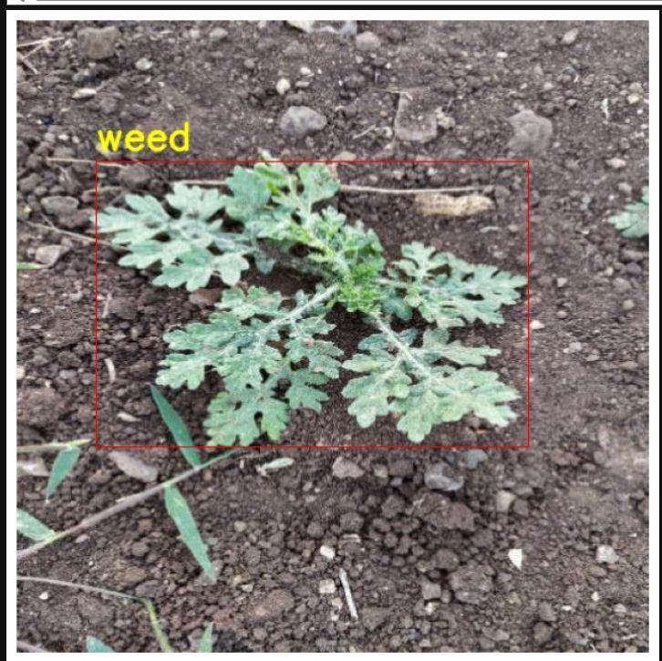

### 7 My learnings

I learnt the importance of machine learning libraries and how they help us in solving real life problems. The problem statement the classification of crops and weed is of real practical importance and can be used by farmers all around the world. The knowledge obtained through this internship will help me have a successful growth development in both professional and personal life.

### 8 Future work scope

I wanted to add my code for crop and weed detection into a flask module, so that farmers all around the world can make use of this project to identify the crops and weeds present in the farms. The model integration with the webpage will give this project an edge and will make it easy for the farmers or any layman to use.