

WOOD

### TEAM MEMBER’S:

SHUBHAM RAJ (CE19B030)

ANKIT KHILDIYAL (CE19B005)

Date of submission:

20th November ,2020

KARTIK GAUTAM (CE19B016)

Summary:

Here we will be discussing about the various types of trees nature offers us and some of their properties, and mainly focusing on the variety which has engineering application (Exogenous), then we will get to know about the structure of wood following with preservatives used in wood. After that we will move to the Physical properties section discussing about Thermal properties, specific gravity, flexibility, moisture content and shrinkage, then some of the various wood defects. After learning all these things we will move to the Mechanical properties of wood such as modulus of elasticity, strength, modulus of rupture, hardness etc.Having learnt about all these Physical, Mechanical properties we will move to Testing section which includes flexure test and structural bend test.

INTRODUCTION:

We will begin our introduction with types of tree.

Types of Trees:

1. Endogenous
2. Exogenous

Distinction between Endogenous and Exogenous:

* 1. In case of endogenous trees the new materials are being added up in the inner side of the bark while in case of the exogenous trees the new materials are being added at the outer side of the bark
  2. In case of endogenous tree the material being added up in the form of longitudinal fibrous mass while in case of the exogenous trees the materials are being added in the center in the form of new bark

layer.

* 1. Examples of Endogenous tree are bamboo, sugarcane and banana while the example of exogenous trees are coniferous.

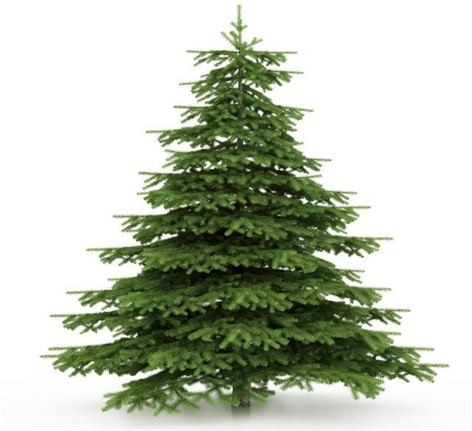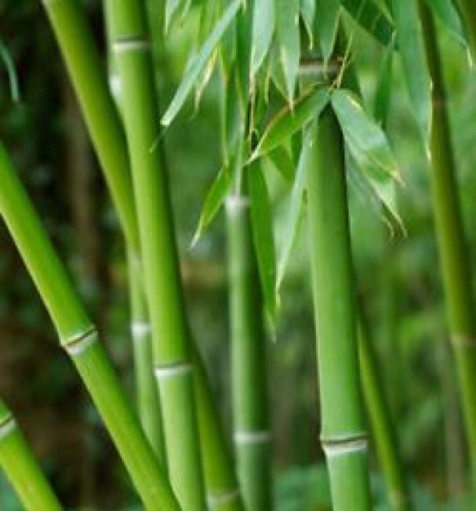

### Endogenous Tree Exogenous Tree

Wood from endogenous tree are not used for engineering applications whereas exogenous does.

So Here we will be discussing about Exogenous only: Exogenous trees are further classified as:

1. Deciduous (Producing Hardwood)
2. Conifers (Producing softwood)

Distinction between Hardwood and Softwood:

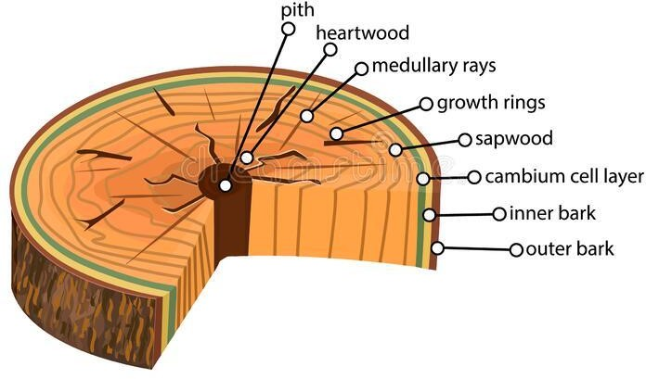

|  |  |  |
| --- | --- | --- |
|  | Hardwood | Softwood |
| Structure | Lower sap | Higher sap |
| Grain | Close | Loose |
| Fire Resistance | Good | Poor |
| Density | Harder | Softer |
| Price | Expensive | Less expensive |
| Origin | Deciduous | Conifers |
| Example | Oak, Teak | Pine, spruce |

Structure of Wood:

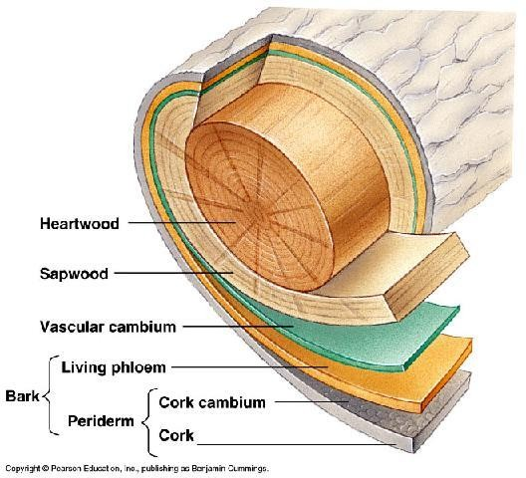

1. Dimensional illustration of Wood -section

WOOD PRESERVATION:

What causes the degradation of wood products?

There are few organisms which degrade the wood:

* 1. Fungi
  2. Bacteria
  3. Insects
  4. Marine Organism

### Fungi:

Essential condition for their growth:

1. Food
2. Proper range of temperature (5°C to 40°C)
3. Moisture (Above fiber saturation point)
4. Oxygen

By controlling these four conditions we can stop fungal damage.

### Insects:

They enter the structure through the region which is in contact with ground or wet. Some examples are beetles and termites.

Degradation can be prevented by proper cutting, dipping or spraying with appropriate chemicals.

### Marine Organisms:

They are totally confined to salt or brackish water. Some examples of these organism are Shipworm,

pholads, Limnoria and Sphaeroma .

### Bacteria:

These growths are encouraged by prolonged storage in contact with soils, this results in softening of

outer wood layers.

# Preservatives:

1. Waterborne preservatives
2. Petroleum-Based Solutions

The degree of preservation depends on the preservative and degree of penetration. Pressure increases the degree of penetration.

Waterborne Preservatives:

Some examples of waterborne preservatives are Ammoniacal copper arsenate, chromated copper arsenate (CCA), and ammoniacal copper zinc arsenate.

The advantage of waterborne preservatives over oil-based are cleanliness and ability to be painted.

The level of potential danger to humans from being in contact with pressure treated CCA is controversial.

### Petroleum Based Solutions:

They are usually used for commercial purpose with high degree of environmental exposure, for example utility poles, railroad ties.

Some oil-based preservatives are coal-tar creosote, petroleum creosote, creosote solutions etc.

The key for long-life of woods is retaining of preservatives.

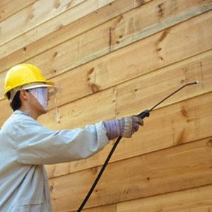

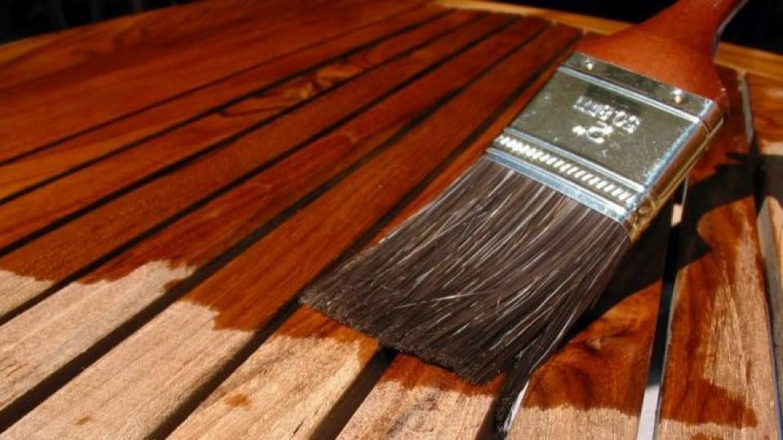

**Physical Properties of Wood Timber:**

Some of the properties of wood that makes it easy and convenient to use in construction:

Thermal Properties:

Wood is a very good heat insulator but exposure for extended periods to temperatures above about 100°F greatly affect its strength and other. The combination of high humidity and high temperatures, in an unventilated attic areas, can have devastating effects on roof covering materials and structural elements due to the risk of attack by decay of organisms. Simple remedies and caution can easily prevent such problems.

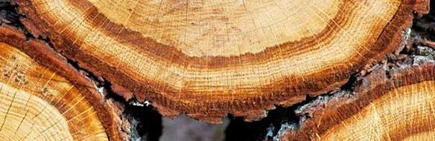

## Specific Gravity:

Density of wood is defined as the mass of a unit volume of wood, and specific gravity is defined as the ratio of the density of wood to that of water. Specific Gravity or relative density and the strength properties of wood are directly related. Specific Gravity for the usually used structural species ranges from roughly 0.30 - 0.90.

Greater allowable design values are assigned to those pieces having narrower annual rings (more rings per inch) or more dense latewood per growth ring and, hence, higher Specific Gravity.

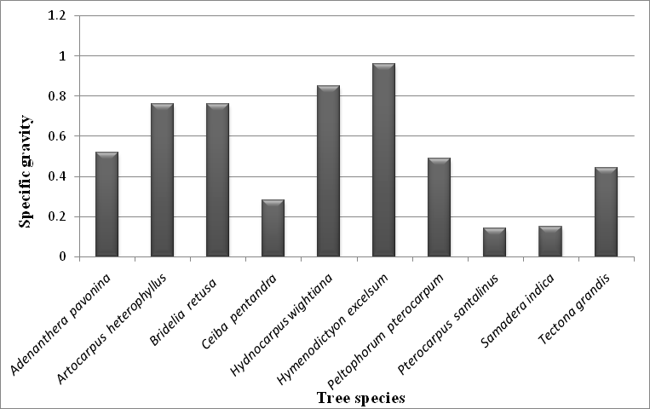

## Environmentally friendly

Timber is the most environmental friendly material used in construction. Timber has low production energy requirements and maybe a net carbon absorber. Timber is a renewable resource.

## Strong and lightweight:

Timber is robust, light, and reliable making timber construction simpler and safer than steel as well as concrete construction

The lightweight structures possible in wood grant advantages in reduced foundation costs, reduced earthquake loading, and easy and cheap transportation. Building components and complete constructions are simple and safe, and cheaper to deconstruct as well as reusing is pretty easier.

## Flexible:

One of the simplest properties of wood is its flexibility of design forms. This flexibility can also be seen in the convenience with which existing buildings are often added to or modified to suit changing circumstances. User friendly versatile timber usually gives building designers a creative freedom providing homeowners with flexible design choices. Timber is just the simplest artifact for builders and designers. It may be used to construct the homes which are fancy and good to look at, structures we admire and warehouses, commercial buildings and other structures. The timber frame method of building gives designers an upper-edge in flexibility in both, layout and external appearance.



## Safe:

Timber has very low levels of toxicity, therefore it requires no special safety precautions to work with, other than normal protection from clouds of dust and splinters. Timber frame construction requires little in the way of heavy lifting equipment making building sites safer workplaces. Timber is non-conductive therefore is advantageous in terms of electrical safety



## Moisture Content and Shrinkage:

Wood’s moisture provides many problems as compared to its uses. Wood has a tendency to absorb moisture in nature. It picks up or gives off moisture to equalize with the humidity in surrounding’s and temperature within the atmosphere. As it does so, it changes in strength. Wood also shrinks because it dries, or swells because it picks up moisture. Critical thing during this process is the fiber saturation point.

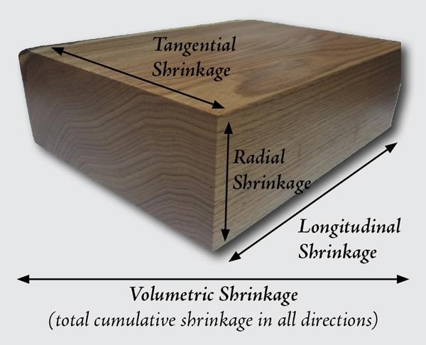Fiber saturation point is the point below which the hollow center of the cell loses its fluid contents, the cell walls start to shrink, and the wood’s strength increases.

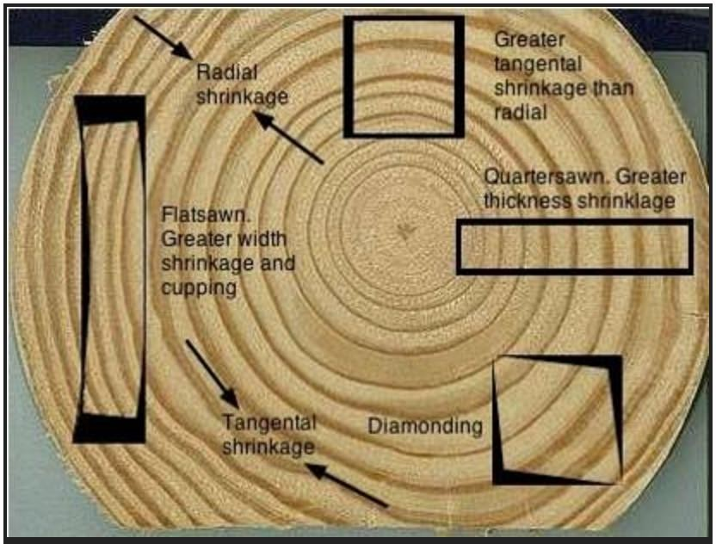

## Wood Defects:

Some of the very common wood defects are as following:

* 1. Wood-decay fungus
  2. Dry rot
  3. Wet rot
  4. Termite

## Wood-decay fungus:

Wood-decay fungus is any kind of fungus that consumes moist wood, causing it to rot. there's a large kind of wood- decay fungi and they are best identified by the kind of rot that they cause, the foremost common including soft, white, and plant disease.

Wood rot is one of the most dangerous wood defects as a result of how quickly it can consume the bones of a building once it acquires contact with them, finishing the strength of lumber and successively causing cracks, leaks, and overall structural damage. The moisture that comes with wood rot is additionally an enormous draw for pest animals or insects which will move in, giving rise to further many problems.

Wood-decay fungus generally requires 4 specific things to grow: oxygen, a sufficient amount of food, favorable temperatures, and water. This only happens when the moisture content of wood exceeds 20 to 30 percent, including a perfect temperature of between 40 and 90 ° Fahrenheit. Your best bet in determining and preventing the sort of fungi that's within your house is having knowledgeable who is an expert in wood- destroying pests and organisms to return in and assess the difficulty.

Moisture control is the user’s best way to prevent the spread of wood-decaying fungi. One should confirm only building or developing structures with wood that's treated, so it's less likely to soak up nearby moisture, and if you begin to note moisture build-up in any area of your home thanks to a plumbing leak or crack, call knowledgeable to repair it immediately. Keep your gutters and downspouts beyond debris, since water build-up is a common side effect of their lack of cleanliness.

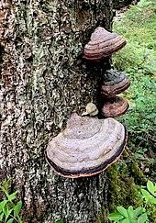

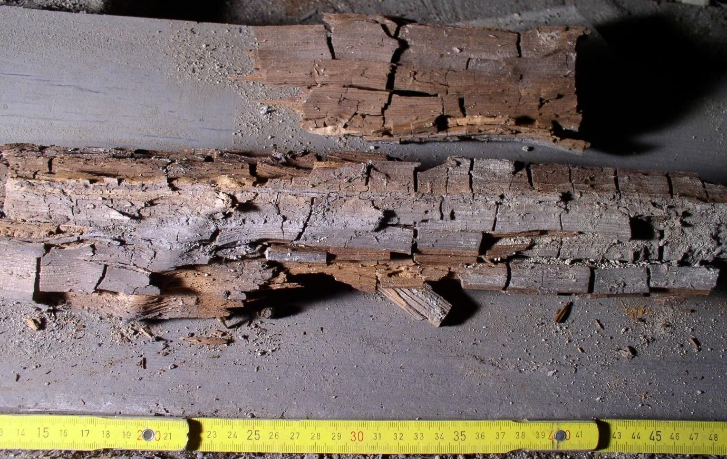

## Dry Rot:

Dry rot is an aggressive form of fungal growth on wood that can cause devastating degradation to any wood or timber it comes into contact with.

This process leaves the timber in an exceedingly dry and brittle state with visible cracks running through it, making any affected surface in your home very vulnerable indeed.

Requiring urgent action to avoid extensive damage, dry rot differs from wet rot because although both of them need a source of moisture to begin growing, dry rot can spread far beyond this initial water source. In its search for timber to consume, dry rot spores can even spread through thick walls and over surfaces.

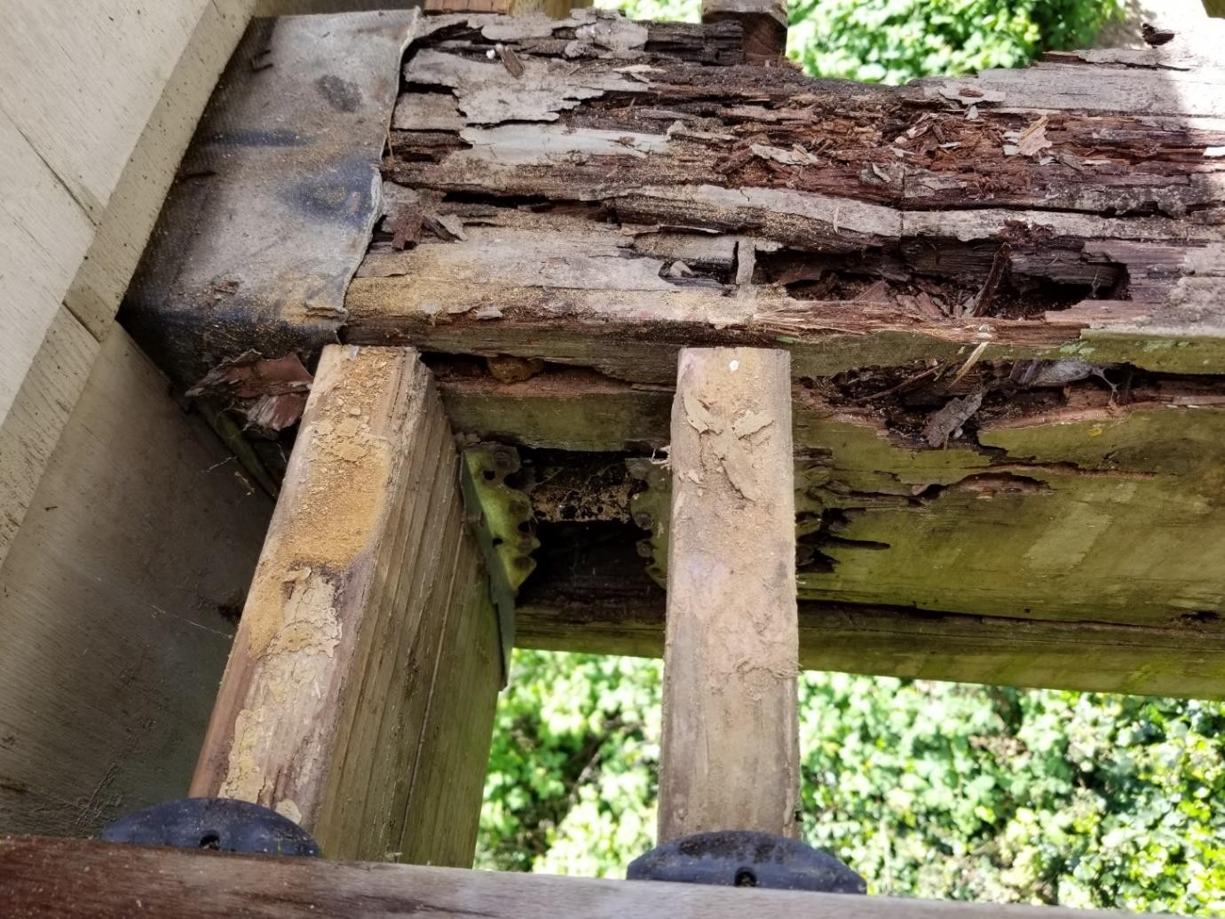Dry rot usually results in the looks of a mushroom-style body called a sporophore.

## Wet Rot:

Wet rot is a type of natural decay of timber because of high moisture levels. It occurs in timber with a moisture content of around 30%-50%, in contrast to dry rot that happens in timbers with a lower moisture content of around 20%.

Wet rot is caused by a fungus that's drawn to very damp wood and feeds off the timber, destroying it during the whole operation.

Wet rot is confined to a localized damp area and doesn't spread, making it less destructive than dry rot. However, wet rot is often even as destructive as dry rot, and, if left untreated, can seriously weaken structural timbers and cause major structural damage.

Wet rot needs moisture to grow, as wet rot spores have an interest in wet wood with high moisture content. This moisture source could occur as a result of any number of issues including defective plumbing, leaking gutters, leaking roof, broken pipes, leaking washer, or a leaking bath or shower tray.

Timber that's usually exposed to excess moisture grants the right environment for wet rot growth, because it allows fungal spores to germinate and grow,

as they use the timber as a food source and eat away the wood, and ultimately weakening woods structural integrity.

Wet rot is often difficult to spot because it is usually present in dark, poorly ventilated, non-visible areas like cellars, lofts, roofs, under floorboards, window and door frames, and under stairs.

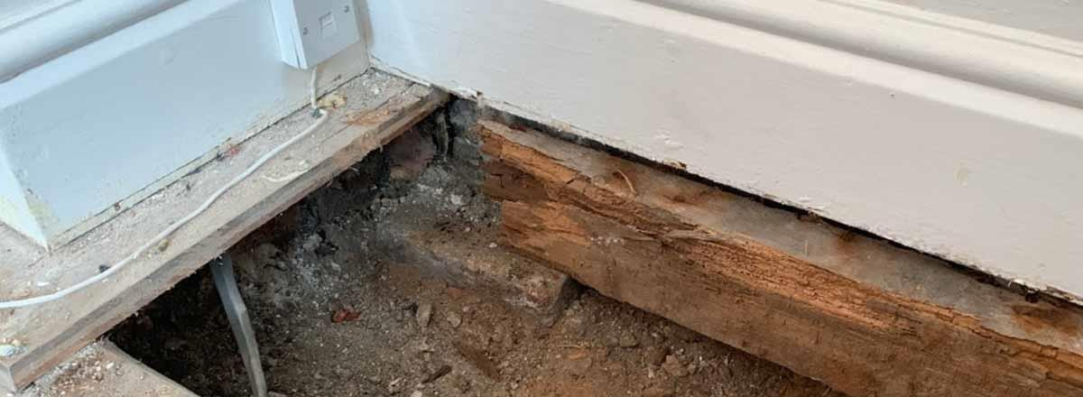

## Termite:

## Termites are widespread throughout most of the world. They’re adaptable critters which will infest not only a home but other wooden structures like fences and sheds.

Termites are widespread. They live everywhere in the world in all types of climates. If there are wood and moisture, chances are termites are there too. They’re

closely related to another prolific pest: the cockroach but, unlike cockroaches, termites work together as a group or team, like ants.

**Few major reasons for termite attack on structures are:**

**Moisture**

**Crack Opening**

**Some common types of termites are:**

**Subterranean termite**

**Drywood termite**

**Dampwood termite**

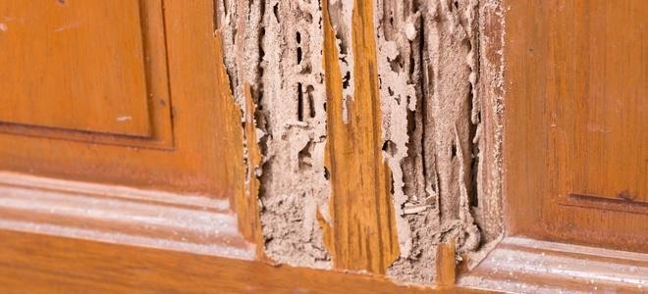

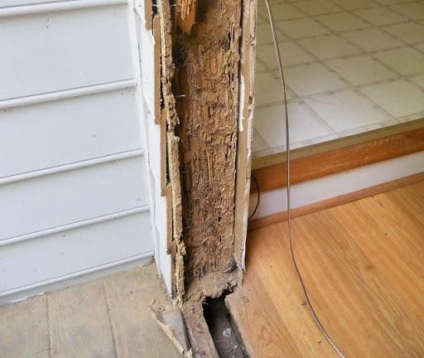

# MECHANICAL PROPERTIES OF WOOD

## MODULUS OF ELASTICITY OF WOOD

The typical stress–strain relationship of wood is linear up to a certain limit, after which rupture occurs.The modulus of elasticity of wood is the slope of the linear portion of the representative stress–strain curve.

In the simplest terms, the modulus of elasticity (MOE) measures a wood’s stiffness, and is a good overall indicator of its strength.

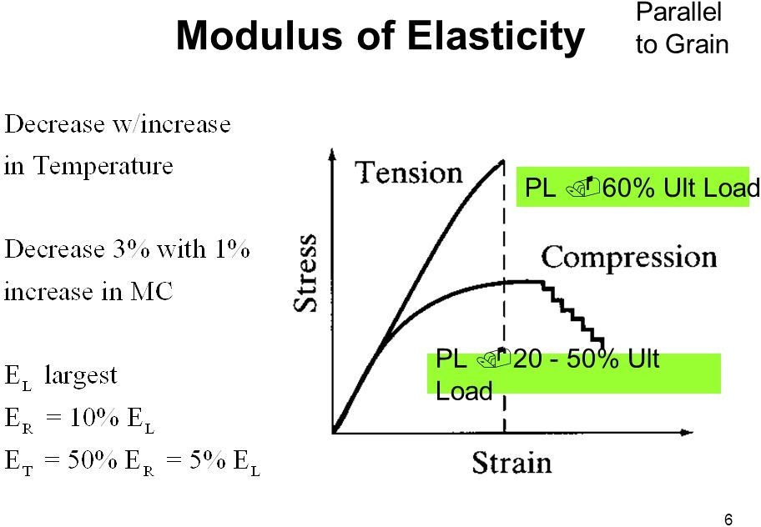In different species of wood the stress-strain curve founds to be a little bit different due to factors like moisture content and specific gravity in different woods. Also, since wood is anisotropic, different stress–strain relationships exist for different directions. The moduli of elasticity along the longitudinal, radial, and tangential axes are typically different.

STRENGTH PROPERTIES

#### The strength of wood depends on its density, strength increases as there is increment in density.

When evaluating the density of wood, the level of

moisture also comes into the picture, so that its mass and volume must always be known. Most commonly the density of wood is given as dry air density,

whereby the mass and volume of the wood are

measured with its level of moisture at 15% (or 12%).

The strength of wood depends on the direction in which it is loaded in relation to the grain. In the

direction of the grain, the bending strength is directly

proportional to the density of the wood.

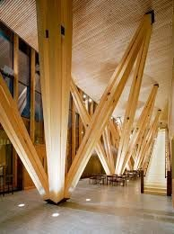

-Tensile strength in the direction of the grain is usually 10-20 times more than strength perpendicular to the grain. Tensile strength also depends on the density of the wood.The compression strength of air-dry wood is about half of the corresponding tensile strength.

-The shearing strength of wood is nearly 15% of its tensile strength in the direction of the grain.

#### Shearing strength is weakened by cracks that appear in the wood. And knots and fault are also responsible for the weakening of its strength.

The elasticity and durability of wood in directly proportional to its density. The modulus of elasticity of wood in the direction of the grain may go up to a hundred times more than the same parameter when

its perpendicular to the grain. In the radial direction, the modulus of elasticity is about twice as great as the same parameter in a tangential direction.

MODULUS OF RUPTURE

##### It is the maximum load carrying capacity of a member in bending and is proportional to maximum moment borne by the specimen. In simple words , it is the maximum stress faced by wood fibres at the time of failure in the bending position. Modulus of rupture is an accepted criterion of strength,as it is not a true stress because the formula by which it is computed is valid only to the elastic limit.

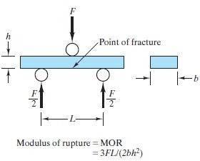

Hardness—Generally defined as resistance to indentation using a modified Janka hardness test, measured by the load required to embed a 11.28-mm (0.444-in.) ball to one-half its diameter. Values presented are the average of radial and tangential penetrations.

Work to maximum load in bending—Ability

to absorb shock with some permanent deformation and more or less injury to a specimen. Work to maximum load is a measure of the combined strength and toughness of wood under bending stresses.

Compressive strength parallel to grain—Maximum stress sustained by a compression parallel-to-grain specimen having a ratio of length to least dimension of less than 11.

Compressive stress perpendicular to grain—Reported as stress at proportional limit. There is no clearly defined ultimate stress for this property.

##### Shear strength parallel to grain—Ability to resist internal slipping of one part upon another along the grain. Values presented are average strength in radial and tangential shear planes.

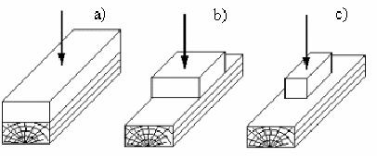

Tensile strength parallel to grain—Maximum

tensile stress without failure in parallel parallel to the grain. In the absence of sufficient tension test data, modulus of rupture values are sometimes substituted for tensile strength of small, clear, straight grained pieces of wood. The modulus of rupture is considered to be a low or conservative estimate of tensile strength for clear specimens (this is not true for lumber).

Tensile strength perpendicular to grain—Resistance of wood to forces acting across the grain that tend to split a member.

TESTING TO DETERMINE MECHANICAL PROPERTIES OF WOOD

FLEXURE TEST- Flexural testing measures the force

required to bend a beam of wood material and determines the resistance to flexing or stiffness of a material.

Flexure test is also referred to as bend test.

* The flexural test provides values of the modulus of elasticity in bending, flexural stress, flexural strain and the flexural stress-strain curve of the material.
* The main advantage of a three point flexural test is the ease of the specimen preparation and testing.
* The flexural modulus is used as to find a material’s stiffness.
  + However, this method also has some

disadvantages: the results of this method are sensitive to specimen and loading geometry and strain rate.

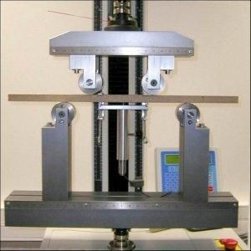

There are two main testing techniques for obtaining the particular strength parameters: the testing of timbers of structural sizes and the testing of representative, small, clear specimens.

-Testing of structural-size timbers provides relationships among mechanical and physical properties, working stress data, correlations between environmental conditions, wood imperfections, and mechanical properties.

-On the other hand, testing of small, clear specimens provide us with the mechanical properties of various species and provides a means of control and comparison among all other different substances in production activities.

-Testing of structural-size members is more important than testing small, clear specimens as the design

values are more applicable to the actual size members.

Tests for actual structural-size lumber according to

ASTM D198 includes :

* Flexure (bending)
* Compressing (short column)
* Compressing (long column)
* Tension

Tests for small-clear wood specimens according to ASTM D143 includes :

* Static bending (flexure)
* Impact bending
* Compressing parallel to the grain
* Compressing perpendicular to the grain
* Tension parallel to the grain
* Tension perpendicular to the grain

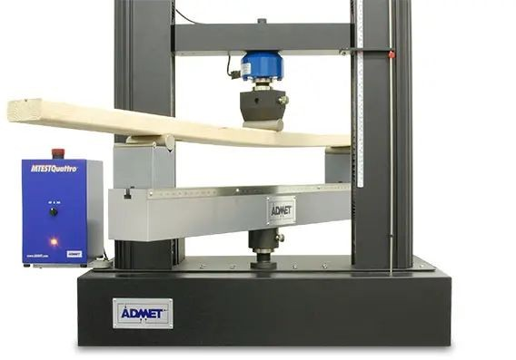Structural bend testing:

Conclusions after the test:

ASTM D198 have several test methods to conclude the physical properties of various wood structural members including sawn lumber, glue laminated timbers, composite lumber, pre-fabricated I-joists, and others. Test methods like flexure, compression, tension, and torsion testing are included in this. The flexure method within ASTM D198 is one of the most popular and best test methods used. In this test, a structural wood member is supported at its ends and a flexure load is applied at the center, or at two points located equidistant from the supporting locations.

The results of this test can be used in several applications, such as the development of grading rules and specifications, development of working stresses, and checking .

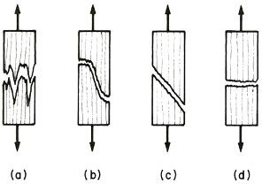Testing for small wood specimens

It is conducted on small specimens which helps in the getting the values of basic properties of materials.

It differs from the structural testing as there the whole member is tested, but here we are interested in getting the substance properties. Above shown, small specimens are chosen to be tested.

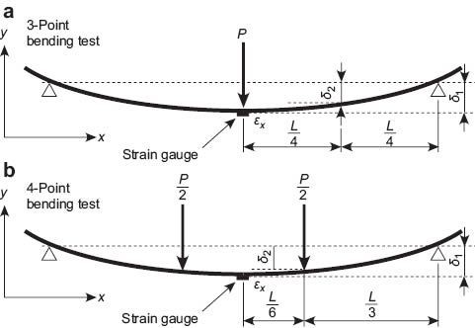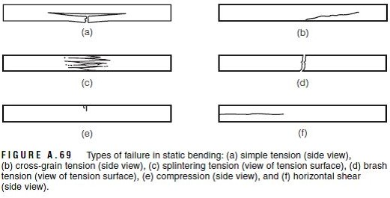

Bending Test Example

Some Amazing Construction work using wood:

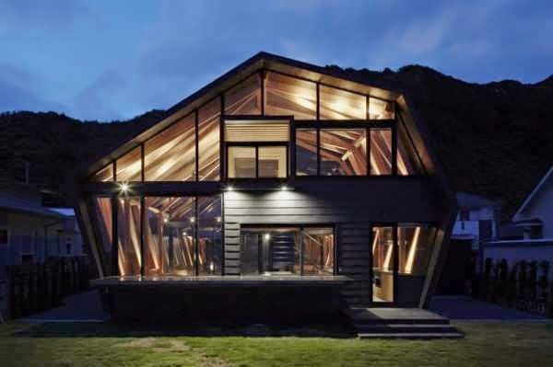





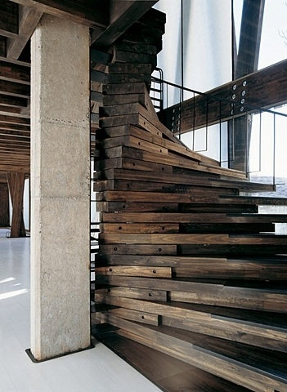

Conclusion:

We conclude our report by highlighting all the important variety of trees along with their applications Providing the commercial as well individual benefits and use of preservatives (petroleum-based and waterborne) with the upper-hand of waterborne over oil-based. Following with mechanical and physical properties which helps in getting a deep and better understanding of wood which is one of the major construction material when it comes to luxury, and we specially focus on enlightening one about the flexibility , durability , defects and properties of wood.

Sources:

Materials for civil and construction Engineers by S Mamlouk.

Google

Wikipedia