

Shubh Verma

BUDGETY PROJET — PLANNING GUIDE

The Budget App

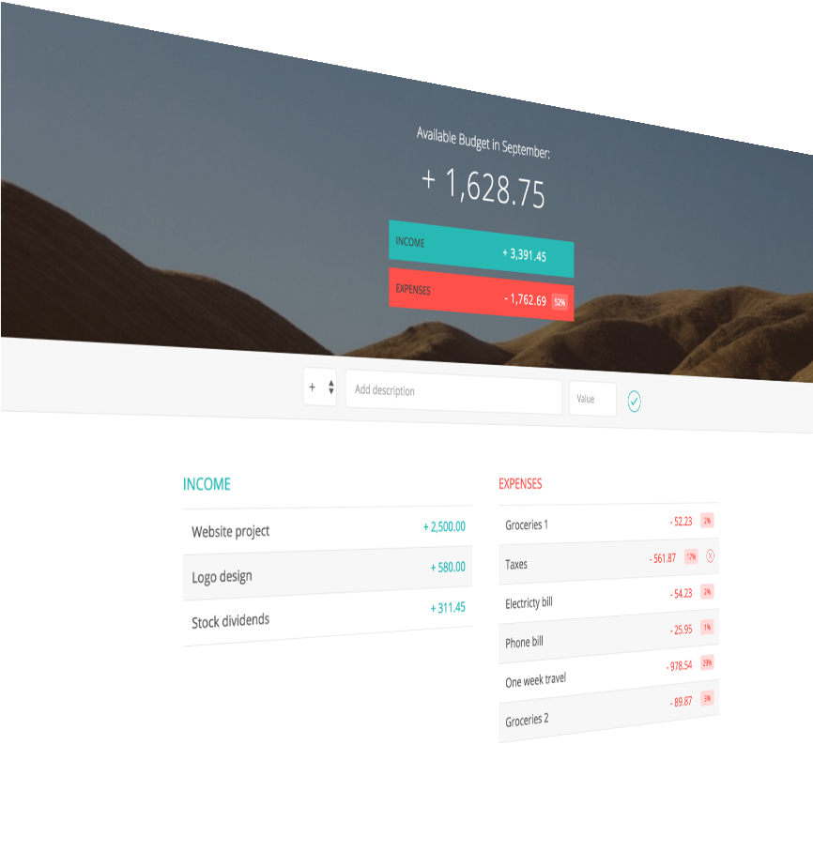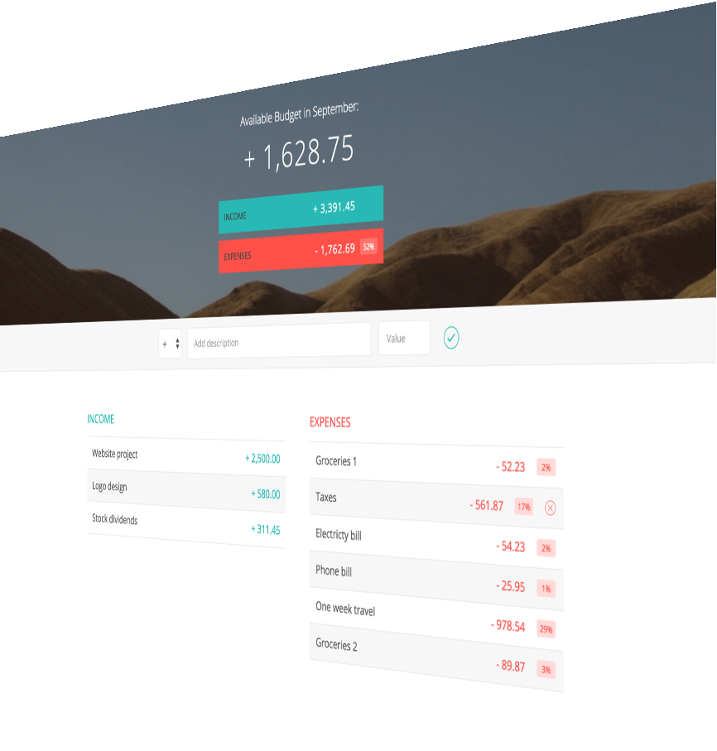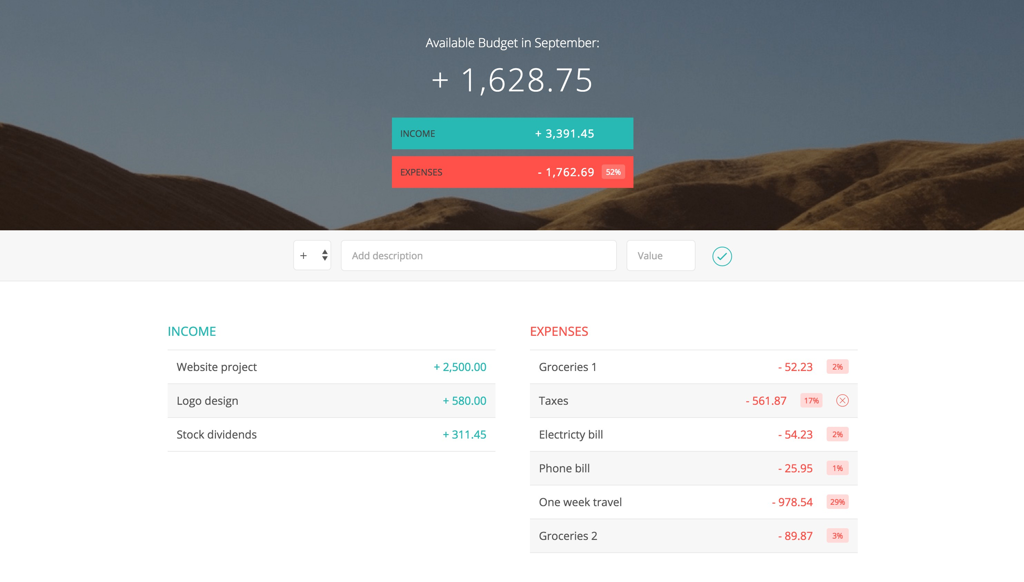

PLANNING STEP 1



**TO-DO LIST**

Update the UI

Calculate budget

Add the new item to the UI

Add the new item to our data structure

Get input values

Add event handler

ARCHITECTURE STEP 1

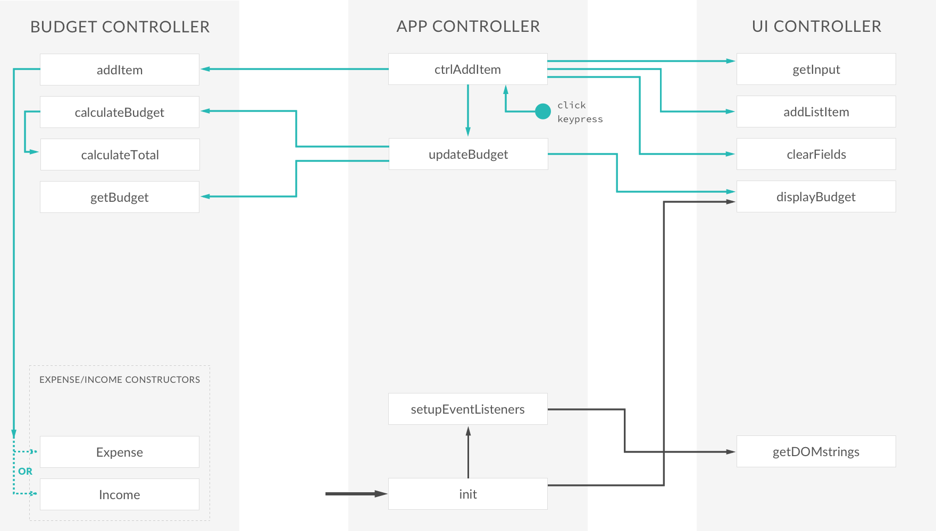

PLANNING STEP 2



**TO-DO LIST**

Update the UI

Re-calculate budget

Delete the item to the UI

Delete the item from our data structure

Add event handler

ARCHITECTURE STEP 2

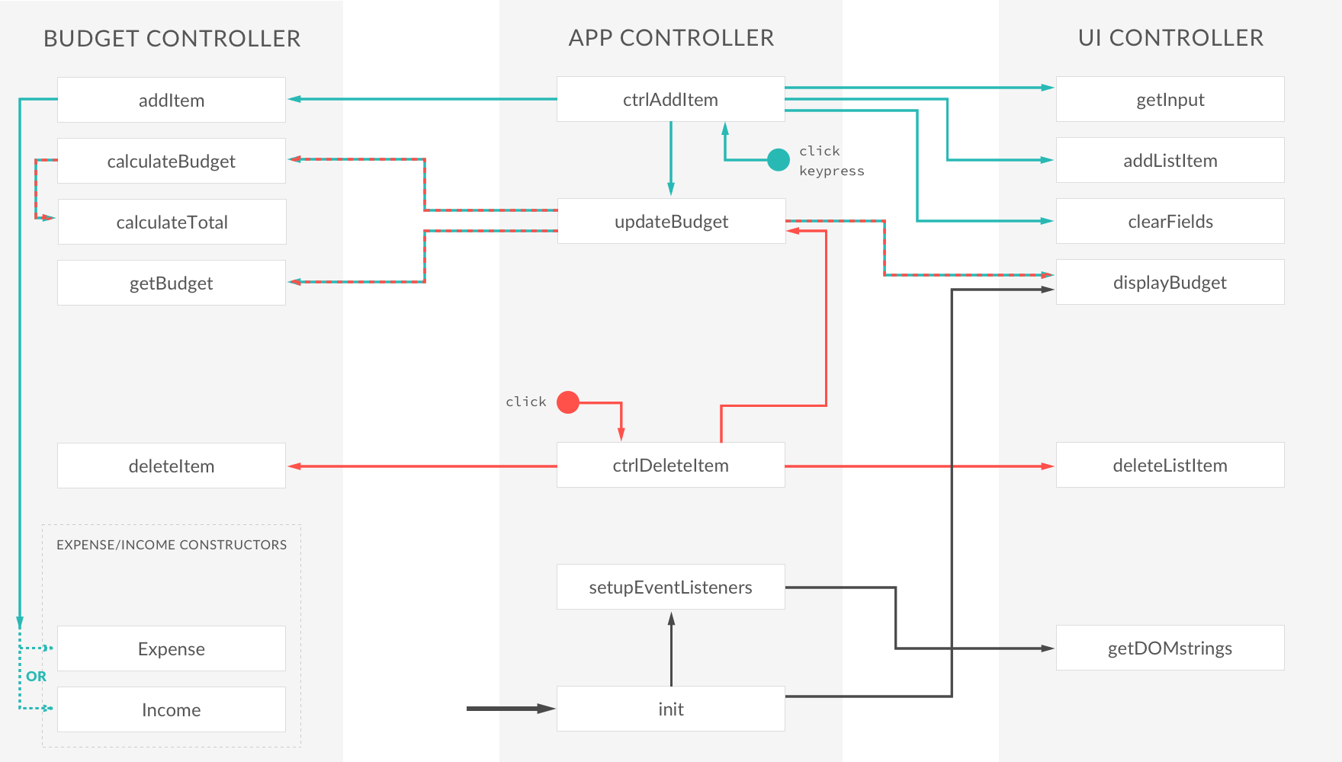

PLANNING STEP 3



**TO-DO LIST**

Improve input ﬁeld UX

Number formaOng

Display the current month and year

Update percentages in UI

Calculate percentages

ARCHITECTURE STEP 3

