|  |  |
| --- | --- |
| HTML-5 | Shubh Verma |

Let start from installation

First you need to install Visual Studio Code go to this link and install [this](https://code.visualstudio.com/). You can choose your favourite editor as well but I will use this editor.

Basic HTML Tags

So, there are many tags to learn but first we need some basics to learn so see the image at the bottom, but before that we need to make a file name index.html you can name it anything like myfirstpage.html but it should end with .html.

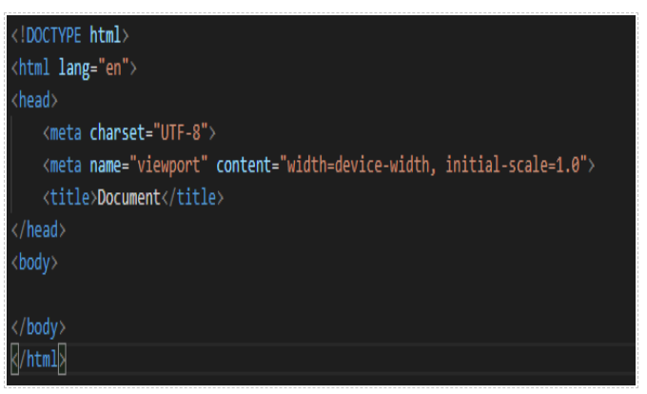

Now we have covered the basics so let us now learn how to add headings and paragraphs. Type in <h1>Here we can add our heading for our site. </h1> and if we want to add paragraphs, we should do <p>Here we can put paragraphs</p>.

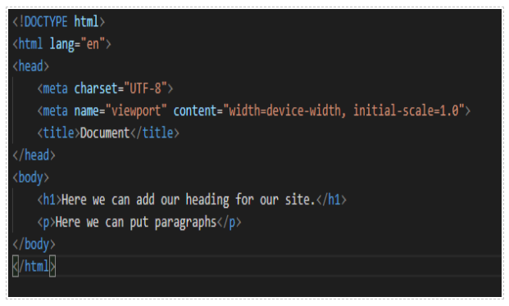

And now I will show you a preview from the chrome

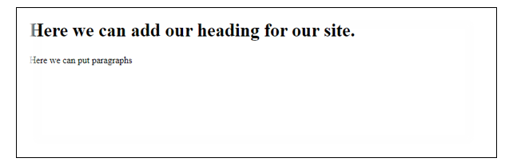

Ok now let us learn about some special characters so if you want to add a copy sign then you need to do &copy; tag for this there are more like &nbsp; this tag gives spaces. Put this in a paragraph and run this in chrome.

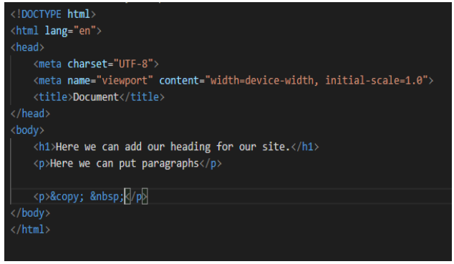

Now let’s view in chrome

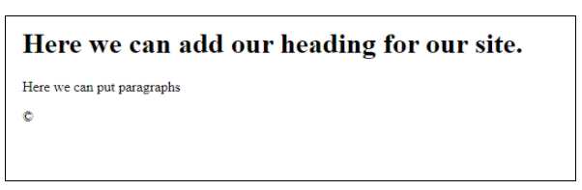

Now let’s cover out Images for this you will need an image.

You can also use this image , the image name could be anything.



For this you will need this tag <img src=”your-image-name-comes-here.the-file-name” alt=”any-name-for-the-image”>

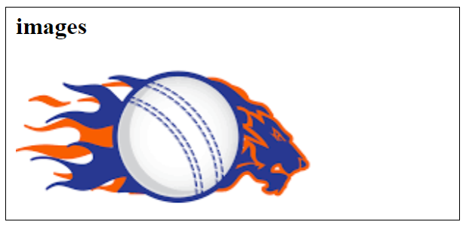

So now the turn for lists so you need to know a bit about lists so there are 2 types of list in html one is unordered list and one is ordered list so unordered list are bullet point like “•” the ordered list is “1”.

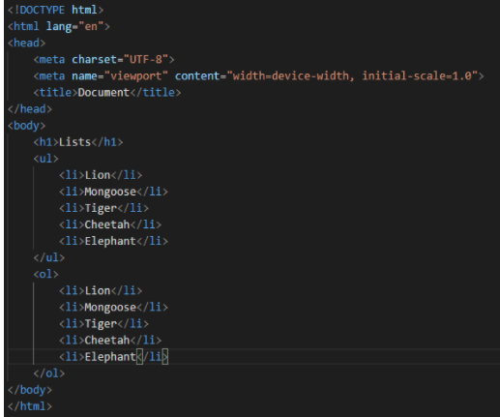

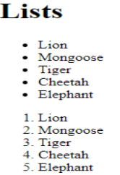

Now is the time to cover tables so let us cover them.

For a table we simply use the table tag that is <table></table> in this table tag we should put a row for that we do and the we put data so see.

<table>

<tr>

<td>Price</td>

<td>Quantity</td>

<td>Item Name</td>

</tr>

<tr>

<td>$ 2.00</td>

<td>5</td>

<td>Apple</td>

</tr>

<tr>

<td>$ 5.00</td>

<td>6</td>

<td>Banana</td>

</tr>

</table>

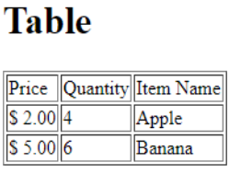

Now finally let’s do forms and then your basic HTML 5 practice is over. So, for forms I will show you some code

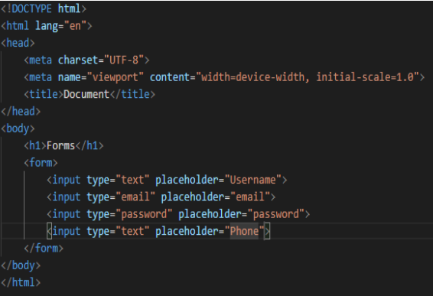

Let’s go through, input is the text field that you can type inside.

Type is defining what kind of value is there.

Placeholder is the text inside the field that is only for reading.

This is the browser preview.

|  |
| --- |
|  |

To get some code please check my [Github](https://github.com/verma-shubh-1704).

Check my [YouTube channel](https://www.youtube.com/channel/UCeQdXEciKUBWMIjdGu3ejig) and please subscribe it.