Finland is a Nordic Country

Finland, Sweden, Norway, Denmark and Iceland are Nordic Countries. These five countries form a  fairly cohesive area in the northern part of Europe. In total there are over 27 million people living in  the Nordic Countries.

The Nordic countries are bordered by the North Sea in South, the land border between Germany  and Denmark and the Baltic Sea. In the east, the boundary is the border between Finland and  Russia. In the north, the Nordic countries are bordered by the Barents Sea and in the west by the  Atlantic Ocean.

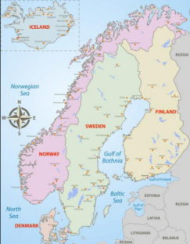

History and Cooperation

Shared rulers and battles for land areas are a part

of the history of the Nordic countries. For example,

Finland has been part of Sweden and Denmark has

ruled Norway and Iceland. Nowadays Finland,

Sweden and Denmark are part of the European

Union (EU) however Norway and Iceland are not

part of the member nations of the EU.

There is a lot of cooperation between the Nordic

countries. For example, people living in the Nordic

countries can travel from one country to another

without a passport.

Nordic Languages

Many of the languages spoken in the Nordic countries are related, e.g. Swedish, Norwegian, Danish  and Icelandic are quite similar. This is because the countries are neighbours with a common history  and their languages have developed to be quite similar. The people speaking these languages can  understand each other a little bit.

The Sami language is also spoken in Finland, Norway and Sweden. The Sami are the only native  people of the Nordic countries.