Landscapes in the Nordic Countries

**The topography of the Nordic countries varies, in other words there is both highland and  lowland in the Nordic countries.** **Denmark consists of only lowland whereas in Norway there  are many mountain tops that are over 2000 metres high.**

**There is a lot of old bedrock in the Nordic countries** that has been molded by the ice age. The  bedrock influences the topography. **Iceland has the youngest bedrock of all of the Nordic  countries.** The island was born as a result of volcanic eruptions.

Highlands

**There are lots of highlands in the Nordic countries. Highlands are areas of land higher than  200 metres above the sea level.** **Almost all of the Norway and Iceland is highland. Central and  northern Sweden and northern Finland are also highlands.**

**The largest mountain range is called the Scandinavian Mountains that are situated on the  border of Sweden and Norway. A mountain range is a large group of mountains.** Both  individual mountain tops as well as deep, steep valleys can be found in the Scandinavian  mountain range. **The Scandinavian mountains are high all the way to the Atlantic coast in  Norway. In Sweden, the mountains become gradually lower as they approach the cost of the  Gulf of Bothnia. The rounded, low mountains of Lapland are called fells.**

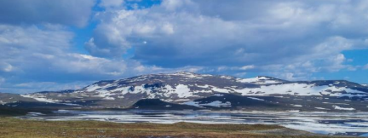Halti **Fell is part of the Scandinavian mountain range.**

Lowland with Hills

**Lowlands are land areas that are 0-200.**

**metres above the sea level. The lowest areas**

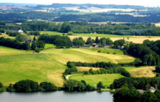**of the Nordic countries are Denmark, the**

**western cost of Finland and part of southern**

**Sweden.** The land surface is usually hilly in

the lowlands. There are also vast areas in the

lowlands of Denmark and southern Sweden