**Learning Objectives**

* Identify the tax benefits of qualified retirement plans.
* Identify and explain the roles of the Internal Revenue Service (IRS), the Department of Labor (DOL), and the Pension Benefit Guaranty Corporation (PBGC) in overseeing qualified plans.
* Identify the key elements of a qualified plan and the plan document.
* Describe plan fiduciary and administrator responsibilities.
* Identify the types of communications that a qualified retirement plan must provide to government entities and to plan participants.
* Describe requirements for minimum participation, nondiscrimination rules, and coverage in a qualified plan.
* Describe requirements for plan vesting, funding, and payment of retirement plan benefits.

**The Government and Qualified Retirement Plans**

**Learning Objectives**

Identify the tax benefits of qualified retirement plans.

Identify and explain the roles of the Internal Revenue Service (IRS), the Department of Labor (DOL), and the Pension Benefit Guaranty Corporation (PBGC) in overseeing qualified plans.

In SRI 111, we described retirement fundamentals and introduced you to the three pillars of a retirement system. This course focuses on the plans and products offered to promote retirement security.

In this lesson, we describe qualified retirement plans and the requirements necessary for obtaining qualified plan status.

The U.S. Bureau of Labor Statistics found that 67% of private sector employees had access to a workplace retirement plan in 2020. The rate of access rises to 77% among full-time workers. However, it is important to note that not all employees who have access to a retirement plan are enrolled in one. Still, having access is an important first step toward achieving retirement security.

## Retirement Plan Access

Access to a workplace retirement plan is critical to retirement security. Social Security retirement benefits, a key source of income for Americans, provide, on average, only about 40% of a retiree's pre-retirement income. Workplace retirement plans are the primary way in which individuals can potentially make up the income difference.

Offering retirement plans as an employee benefit helps employers recruit and retain quality employees. And, employers who offer qualified retirement plans benefit from tax savings. The vast majority of workplace plans are **qualified plans**, which means they are eligible for tax benefits. Qualified plans can be structured as either **defined benefit (DB) plans** or **defined contribution (DC) plans**.

Qualified plan A retirement plan that meets specified requirements imposed by federal laws and, as a result, qualifies for favourable federal income tax treatment and protections.

Defined benefit plan A qualified retirement plan which promises that a plan participant will receive a stated monthly benefit starting at retirement and continuing throughout the participant's life.

Defined contribution plan A retirement plan that describes the annual contribution the employer will deposit into an individual account on behalf of each plan participant.

Employee Retirement Income Security Act (ERISA) A U.S. federal law designed to protect covered employees by ensuring that employee benefit plans meet specified requirements when they are established and in how they are maintained.

Plan sponsor A business, government entity, educational institution, nonprofit organization, or other group that establishes a retirement plan for the benefit of its employees or members.

Trust A legal arrangement whereby one or more persons—called the trustees—hold legal title to property on behalf of another person—called the trust beneficiary—and are responsible for administering the property for the benefit of the trust beneficiary.

## Employee Retirement Income Security Act (ERISA)

In order for a plan to qualify for tax advantages, the plan must adhere to certain rules and regulations. **ERISA (Employee Retirement Income Security Act)** is a U.S. federal law that sets minimum standards for employer-sponsored plans in the private sector. In general, ERISA does not cover public-sector plans, such as plans established or maintained by government entities or churches. ERISA primarily focuses on regulating plan sponsors, benefits, and funding.

**The plan sponsor**: is usually an employer, but for multiple employers plans the plan sponsor may be an entity appointed by the employers adopting the plan. ERISA imposes duties and responsibilities on plan sponsors when they establish plans, as well as ongoing requirements for plan operations.

**Plan benefits**: ERISA was passed to better ensure that retirement plans benefit a wide range of employees and not just highly compensated employees, and that plan participants understand their benefits and how to access benefits.

**Plan funding**: ERISA mandates that plans hold benefits in a trust for participants and provide benefits as promised to participants.

## Tax Benefits of Qualified Retirement Plans

To encourage business owners in the United States to establish qualified retirement plans for employees, and to encourage employees to participate in those retirement plans, the **Internal Revenue Code (IRC)** provides the following tax benefits to both plan sponsors and **plan participants**:

* Employers can deduct their contributions to a qualified plan from their current taxable federal income as a business expense.
* Employer contributions on behalf of a qualified plan participant are not considered current federal taxable income to the plan participant. Taxation on employer contributions and associated investment earnings is deferred until withdrawal.
* If plan participants make pre-tax contributions to a qualified plan, the amounts deferred are excluded from the plan participant's current federal taxable income. Taxation on both the pre-tax contributions and associated investment earnings is deferred until withdrawal.

Internal Revenue Code (IRC) A compilation of the U.S. federal tax laws, including the laws governing income taxes, estate and gift taxes, and employment taxes.

Plan participant A member of a covered group who is eligible to participate in a retirement plan and who actually chooses to take part in the plan or whose participation is automatic.

Private letter ruling A written determination, issued in response to the taxpayer's written inquiry, that interprets the tax laws and applies them to the taxpayer's specific set of facts.

## Regulation of Qualified Retirement Plans

The federal Internal Revenue Service (IRS) and the Department of Labour (DOL) share responsibility for overseeing the operation of retirement plans and ensuring that these plans are in compliance with IRC and ERISA requirements. Click or touch each tab below to learn about the entities that oversee retirement plan regulation.

**Internal Revenue Service (IRS)**

The IRS is the government agency responsible for administering the tax laws enacted by Congress. To do this, the IRS translates the specifics of these laws into detailed regulations, rules, and procedures.

The IRS issues

* Regulations that have the force of law
* **Private letter rulings**—in response to a taxpayer's written inquiry—that interpret the tax laws and apply them to the taxpayer's specific set of facts
* Publications that explain various areas of the tax laws

IRS regulations govern the federal income tax effects of transactions associated with qualified workplace retirement plans. The IRS regulations set requirements for plan documents, coverage, participation, contributions, vesting, funding, and distributions.

For plans that are not compliant with plan requirements, the IRS administers self-correction programs that provide guidance to plan sponsors on ways to correct errors with a goal of preventing plan disqualification. If a retirement plan still fails to comply with requirements, it may be disqualified and lose its favourable tax status.

**Department of Labour (DOL)**

The DOL is the government agency responsible for promoting the well-being of workers and retirees. The DOL focuses primarily on a retirement plan's **fiduciary** requirements, reporting and disclosure of plan information, and the rights of workers. Within the DOL, the **Employee Benefits Security Administration (EBSA)** is responsible for administering and enforcing the provisions of ERISA. Like the IRS, EBSA offers self-correction programs to assist plan sponsors with meeting requirements.

Specifically, EBSA acts to

* Educate and assist 154 million workers, retirees, and their families
* Oversee 722,000 private sector retirement plans
* Ensure access to plan documents filed with the DOL
* Balance proactive enforcement with compliance assistance to plan sponsors

Fiduciary An individual or entity who holds a special position of trust or confidence when handling the affairs of another and who must put the other's interest above the fiduciary's own interests.

Employee Benefits Security Administration (EBSA) An agency within the Department of Labour (DOL) that enforces rules and regulations for retirement plans under Title I of ERISA.

Pension Benefit Guaranty Corporation (PBGC) A U.S. federal agency that guarantees the payment of part or all of the retirement benefits for participants in defined benefit retirement plans when those plans become financially unable to pay benefits.

**Pension Benefit Guaranty Corporation (PBGC)**

ERISA also created the **Pension Benefit Guaranty Corporation (PBGC)** to protect the pension benefits of private sector DB plans. Plan sponsors of covered DB plans are required by law to pay insurance premiums to fund PBGC operations. The PBGC protects the retirement benefits of over 34 million workers and retirees.

### **Regulatory Responsibilities**

The DOL, the IRS, and the Pension Benefit Guaranty Corporation (PBGC) share responsibility for overseeing many aspects of a qualified plan's administration.

Regardless of which entity has primary enforcement responsibility, the DOL may intervene in any matters that affect the rights of participants.

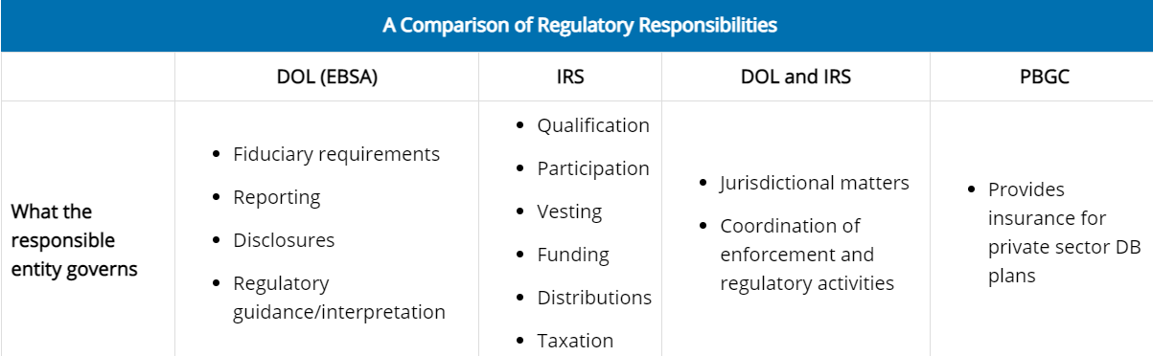

**Internal Revenue Code (IRC**): To encourage business owners to establish a retirement plan for employees, and to encourage employees to participate in qualified retirement plans, the IRC offers tax benefits to both plan sponsor employers and participants of qualified retirement plans.  
  
Employers can deduct their contributions to the plan from their current taxable income as a business expense, and pre-tax salary deferral contributions made by plan participants are excluded from their current taxable income when the contributions are made. In addition, plan participants can *defer* paying taxes on an employer's pre-tax contributions until they are distributed.

What government entity is responsible for enforcing the fiduciary requirements for retirement plans?

Ans- As part of the DOL, EBSA is responsible for enforcing a retirement plan's fiduciary requirements. The DOL also enforces the rules governing the conduct of those managing the plan, investment of plan assets, reporting and disclosure of plan information, and benefit rights of workers.

**The Qualified Retirement Plan**

**Learning Objectives**

* Identify the key elements of a qualified plan and the plan document.
* Describe plan fiduciary and administrator responsibilities.
* Identify the types of communications that a qualified retirement plan must provide to government entities and to plan participants.

ERISA does not require employers to offer a retirement plan. However, employers who choose to offer a qualified retirement plan must satisfy ERISA requirements. A qualified plan must have the following key elements:

* A written plan document detailing the benefit structure and plan operation
* A trust to hold plan assets
* A recordkeeping system for transaction tracking
* Documents to provide information to government agencies and plan participants

**Plan Document**

The plan document outlines the plan's key elements. Plan sponsors establishing individually designed plans may request a determination letter from the IRS to ensure their plan satisfies the requirements necessary to receive tax benefits. However, retirement plans are often set up using pre-approved plans.

Plan document A detailed legal agreement that establishes the existence of an employer-sponsored retirement plan and specifies the rights and obligations of various parties to the plan.

Determination letter A letter issued by the Internal Revenue Service (IRS)—in response to a retirement plan sponsor's request that the IRS evaluate a plan—that communicates a retirement plan's qualification status.

Pre-approved plan A plan that the IRS has already approved that is sold to employers by a document provider, such as a financial institution.

Pre-approved plans are plans that have been submitted to the IRS and received a favourable opinion letter. Depending on the type of pre-approved plan document used and the plan provisions selected, plan sponsors often can rely on the favourable opinion letter. In some circumstances, however, plan sponsors using a pre-approved plan document must request a determination letter from the IRS for reliance.

Having a favourable opinion letter and/or determination letter (when necessary) provides the plan sponsor with reliance that

* The plan is qualified under IRC Section 401(a).
* The trust assets are exempt from income taxes under IRC Section 501(a), which means the plan assets are not subject to federal taxation while held in the trust.

In general, if a plan operates according to the terms of a plan document with a favourable determination letter, or if a plan is a pre-approved plan, it will satisfy the legal requirements for a qualified plan.

The plan document identifies the plan's fiduciaries and a plan administrator, among many other things.

**Plan fiduciaries**

Qualified plans are required to have a *named fiduciary* identified in the plan document. The named fiduciary has authority and discretion to control the operation and administration of the plan and may be (1) a specific person, (2) a position within the company, (3) a committee, or (4) an outside entity. The plan document frequently names the employer/plan sponsor as the named fiduciary, but the plan sponsor often delegates a committee or outside entity to act as the fiduciary for the plan.

In addition to the named fiduciary, a plan typically has other fiduciaries based on the functions performed for the plan. A *functional fiduciary* may not be named in the plan but is considered a fiduciary because the person or entity has discretionary authority over the management of the plan or the plan's assets. ERISA specifically states that someone who gives investment advice to a plan for a fee is a fiduciary.

Fiduciaries must act only in the interest of plan participants and their beneficiaries. Plan participants and beneficiaries have a legal right under ERISA to file lawsuits against a plan sponsor or any other plan fiduciary for a failure to satisfy fiduciary responsibilities.

Because DOL rules are complex and can change over time, a fiduciary is responsible for paying close attention to the plan's operations to ensure that the plan remains in compliance and that plan participants are protected. For example, in 2021, the DOL issued guidance for plan sponsors and plan fiduciaries for best practices for cybersecurity to protect retirement plan benefits. The guidance includes recommendations for hiring and monitoring service providers and suggests ways plan participants and beneficiaries with online account access can reduce the risk of fraudulent activity.

**Plan administrator**

The plan sponsor is responsible for the retirement plan's administration. A **plan administrator** is identified in the plan document and is the entity legally responsible for running the plan. The plan will typically identify the employer/plan sponsor as the official ERISA plan administrator, but professionals (sometimes called service providers or **third-party administrators (TPAs)**) with specialized skills or knowledge are usually hired to manage some or all of a plan's day-to-day operations.

The plan administrator has fiduciary responsibilities in the selection and monitoring of the professionals hired to provide services for plan operations. Selecting experienced and reasonably priced service providers is important in satisfying fiduciary obligations, as is continuing to monitor performance by reading performance reports, evaluating the provider's fees against established benchmarks to ensure that fees are reasonable, and following up on participant complaints.

The plan administrator has key reporting and disclosure responsibilities under ERISA, including the annual regulatory filing of Form 5500 and required disclosure requirements to plan participants.

Plan administrator Under ERISA, the individual or organization responsible for handling the administrative aspects of a retirement plan or other employee benefit plan and ensuring that the plan complies with applicable regulatory requirements.

Third-party administrator (TPA) In the retirement business, an organization that conducts various administration activities (particularly compliance monitoring and plan reporting) for retirement plan administrators.

Form 5500 A standardized report that qualified retirement plans must file with the Internal Revenue Service (IRS), the Department of Labour (DOL), and for DB plans, the Pension Benefit Guaranty Corporation (PBGC) each year. Also known as the Annual Return/Report of Employee Benefit Plan.

**Form 5500**

A qualified retirement plan must file a **Form 5500** each year with the IRS, the DOL, and, for private sector DB plans, the PBGC. The form is submitted through an online portal that supplies information to the agencies. The purpose of Form 5500 is to provide these agencies with information about the plan's operations, financial condition, and compliance with government regulations. Small employers (those with 100 or fewer employees) are allowed to file a simplified version of the form.

Form 5500s are public documents, which means anyone, including plan participants, can access a plan's Form 5500 filing for a given year. Information in the form is used for participant disclosures and also for government research.

example of the first page of Form 5550.

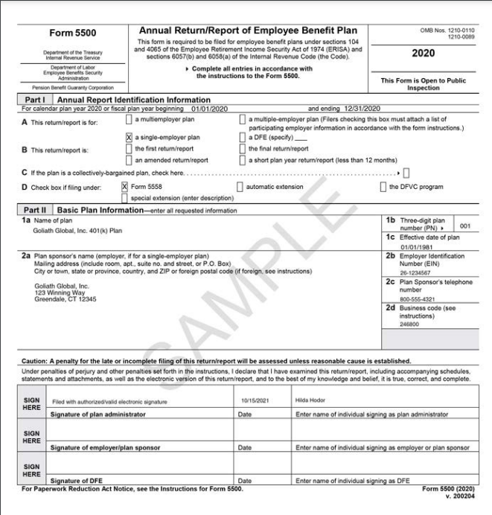

**Required Plan Disclosures**

Participants and beneficiaries have rights regarding access to plan information, such as plan features and funding. For a plan to be compliant with ERISA, plan sponsors are required to communicate certain types of information to plan participants and beneficiaries so that they will understand the benefits provided by the plan and their rights to the benefits. Required communications must be issued in a timely manner and include a summary plan description, a summary annual report, and individual benefit statements.

**Summary Plan Description**

ERISA requires that plan sponsors provide plan participants with a **summary plan description (SPD)** that is understandable by the average plan participant and that reasonably informs participants and beneficiaries of their rights and obligations under the plan. New employees must receive a copy of the SPD within 90 days of becoming covered by the plan, and a copy must be distributed to participants every five years, even if the SPD has not changed.

Among other things, the SPD must include information about

* When and how employees become eligible to participate
* The source of contributions and contribution levels
* When employees become **vested**, or have a nonforfeitable right to their benefits
* How to file a claim for benefits
* A participant's basic rights and responsibilities under the plan
* Contact information for the plan sponsor
* The appeals process if plan rules are not followed

summary plan description (SPD) A written document that a qualified retirement plan must provide to all plan participants and beneficiaries who are receiving benefits. The document must be understandable by the average plan participant and must reasonably inform participants and beneficiaries of their rights and obligations under the plan.

Vested A retirement plan participant's right to receive partial or full benefits under the plan even if the participant terminates employment prior to retirement.

**Summary Plan Description example**

Summary Plan Description

**Goliath Global, Inc. 401(k) Plan**  
Summary Plan Description  
Introduction to Your Plan  
January 2020

**What kind of Plan is this?**

Goliath Global, Inc. 401(k) Plan ("Plan") has been adopted to provide you with the opportunity to save for retirement on a tax-advantaged basis. This Plan is a type of qualified retirement plan commonly referred to as a 401(k) Plan. As a participant under the Plan, you may elect to contribute a portion of your compensation to the Plan.

**What information does this Summary provide?**

This Summary Plan Description ("SPD") contains information regarding when you may become eligible to participate in the Plan, your Plan benefits, your distribution options, and many other features of the Plan. You should take the time to read this SPD to get a better understanding of your rights and obligations under the Plan.

This SPD describes the Plan’s benefits and obligations as contained in the legal Plan document, which governs the operation of the Plan. The Plan document is written in much more technical and precise language and is designed to comply with applicable legal requirements. If the non-technical language in this SPD and the Plan document conflict, the Plan document always governs.

If you wish to receive a copy of the legal Plan document, please contact the Plan Administrator. The name of the Plan Administrator can be found at the end of this SPD in the Article titled "General Information about the Plan."

The Plan and your rights under the Plan are subject to federal laws, such as the Employee Retirement Income Security Act (ERISA) and the Internal Revenue Code (IRC), as well as some state laws. The provisions of the Plan are subject to revision due to a change in laws or due to pronouncements by the Internal Revenue Service (IRS) or Department of Labour (DOL).

**Summary Annual Report**

Plans also must provide participants with a **summary annual report (SAR)** that outlines in narrative form the financial information in the plan's annual report (Form 5500).

summary annual report (SAR):- An annual report that a plan sponsor must provide to plan participants and that outlines in narrative form the financial information in the plan's annual report (Form 5500).

Example of a Summary Annual Report-

#### SUMMARY ANNUAL REPORT FOR **Goliath Global, Inc. 401(k) Plan**

This is a summary of the annual report for the Goliath Global, Inc. 401(k) Plan EIN# **26-1234567**, Plan Number **246800**, for the Plan year **01/01/2020** through **12/31/2020**. The annual report has been filed with the Employee Benefits Security Administration, as required under the Employee Retirement Income Security Act of 1974 (ERISA).

Basic Financial Statement

Plan expenses were **$7,000,000**. These expenses included **$200,000** of administrative expenses, **$6,800,000** in benefits paid to participants and beneficiaries, and **$0** in other expenses. A total number of **479** persons were participants in or beneficiaries of the Plan at the end of the Plan year, although not all of these persons had yet earned the right to receive benefits.

The value of Plan assets, after subtracting liabilities of the Plan, was **$87,000,000** as of the end of the Plan year, compared to **$74,000,000** as of the beginning of the Plan year. During the Plan year, the Plan experienced a change in its net assets of **$13,000,000**. This change includes unrealized appreciation or depreciation in the value of Plan assets. The Plan had total income of **$20,000,000**, including employee contributions of **$4,000,000**, employer contributions of **$2,000,000**, other contributions/other income of **$1,000,000**, and earnings from investments of **$13,000,000**.

Your Rights to Additional Information

You have the right to receive a copy of the full annual report, or any part thereof, on request. To obtain a copy of the full Annual Report, or any part thereof, write or call the office of the Plan Administrator:  
  
**Voyage Financial  
555 Retirement Trail  
Pleasantville, CT 12345  
800-555-1357**

**Individual Benefit Statements**

Each participant must periodically receive an individual benefit statement, which includes information about the account balance and any vested benefits. Both DB plans and DC plans provide these mandatory statements to plan participants:

* DB plans must do this at least every three years.
* DC plans must send these statements quarterly if participants direct the investments of their accounts, or annually, if they don't.
* DC plans must issue a lifetime income estimate statement at least once every 12 months to illustrate the amount of monthly income the account balance could generate.

To maintain its tax qualification, a retirement plan may be required to provide a range of other notices to participants. The notice requirements vary depending on the type of plan and the types of benefits provided.

The figure below is an example of an individual benefit statement for a 401(k) plan.

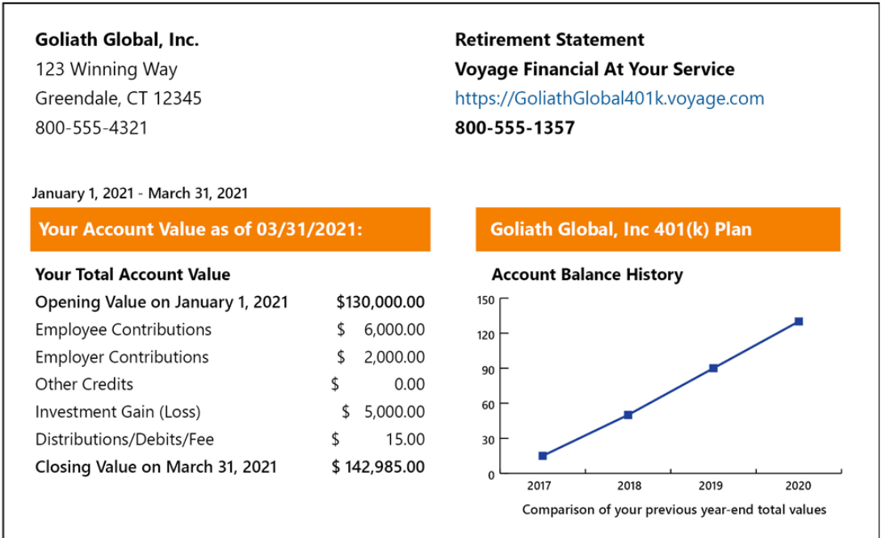

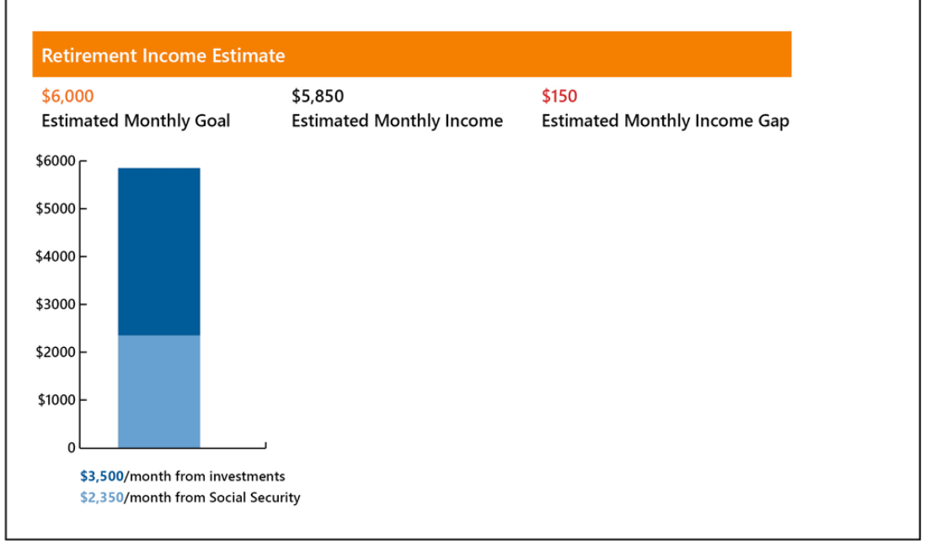

**Plan Assets**

ERISA requires that retirement plan assets be held in a trust for the benefit of plan participants. A trust is a legal entity that is separate from the employer and is required to be for the **exclusive benefit** of the employees and their beneficiaries. If the employer were to go bankrupt, the assets held in the trust would be safe from the employer's creditors. A **plan trustee** has exclusive authority and discretion to manage and control assets on behalf of plan participants and beneficiaries, serving in a fiduciary capacity. The trust assets are often held in a **custodial account** at a financial institution known as the **custodian**. For a 403(b) plan, the assets may be held individually or in a **group annuity** contract.

To avoid inconsistencies, a pre-approved plan must contain a statement that the provisions of the plan override any conflicting provision contained in the trust or custodial account document used with the plan.

Exclusive benefit A rule stated in IRC section 401(a) stipulating that all activities of a retirement plan must be for the sole benefit of plan participants and beneficiaries.

Plan trustee: The entity or group of individuals who hold the plan assets in trust with the authority and discretion to manage the assets for the benefit of plan participants and beneficiaries.

Custodial account An account set up at a bank or other financial institution to hold the assets of a qualified retirement account or individual retirement account (IRA).

Custodian A financial services institution that safeguards assets, provides recordkeeping and other administration services, and offers investment options for retirement accounts.

Group annuity An annuity purchased by a plan sponsor to provide annuity payments at retirement to plan participants.

**Investment Management**

In a qualified plan, the plan sponsor or an investment advisor hired by the plan sponsor has a fiduciary responsibility to

* Exercise the judgment that a prudent investor would use in investing
* Diversify the plan's investments or, for a participant-directed DC plan, the investment options available to participants
* Charge reasonable fees
* Avoid and disclose any material conflicts of interest

Plans must provide participants with a summary annual report that outlines in narrative form the financial information in the plan's annual report, or Form 5500.

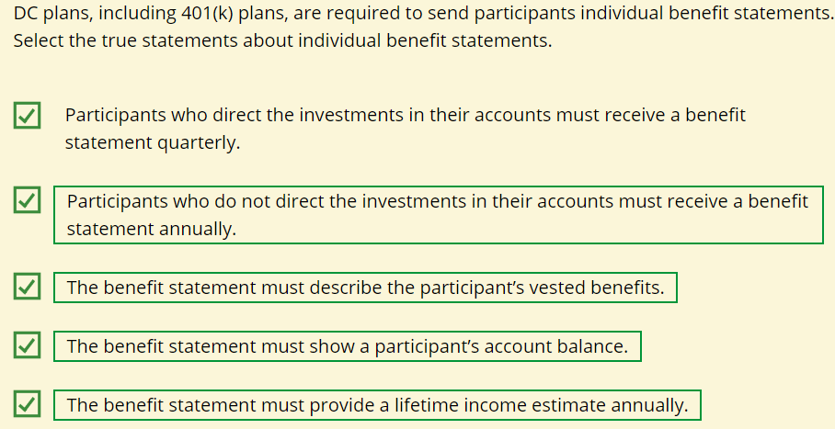

**Plan Participation and Coverage**

**Learning Objective**

Describe requirements for minimum participation, non-discrimination rules, and coverage in a qualified plan.

Qualified retirement plans must adhere to the eligibility requirements for covering employees.

The plan document describes the individuals eligible to participate. The plan typically defines the individuals in a covered group in terms of job class, location of the work site, salary, and/or occupation. For example, an employer may have one plan that covers non-union employees and another for union employees.

**Age and Service Requirements**

Federal law sets age requirements for participation in a retirement plan. A retirement plan may restrict participation in the plan to employees who are age 21, or older. A plan may not set a maximum age for participation.

If a company requires that an employee work for a period of time before becoming eligible to participate in the retirement plan, the maximum service requirement an employer may generally impose is one year of service. However, employers have some flexibility to require additional years of service. For example, if employees are vested immediately upon participating in the plan, the plan may require that employees work for the company for two years before participating in the plan.

The age and service requirements for eligibility to participate in a retirement plan are specified in the plan document and in the summary plan description (SPD). A retirement plan may be more generous than the federal law age and service requirements, allowing employees to participate in the plan at younger ages or before completing a year of service. If no age is specified in the document, the plan has no age requirement. If the document does not provide service requirements, no minimum number of years of employment is required for eligibility.

Regulatory requirements define how to measure a year of service. As a general rule, an employee earns a year of service by working at least 1,000 hours during a 12-month period. Plan sponsors may use certain other equivalent methods of calculating a year of service.

The **Setting Every Community Up for Retirement Enhancement (SECURE) Act** requires that, beginning in 2021, part-time employees who worked 500-999 hours for each of the past three consecutive years must be considered eligible to participate in 401(k) plans if they meet the age requirement. This means that the first year these part-time employees will be eligible to participate in a plan will be 2024 if they worked at least 500 hours in 2021, 2022, and 2023.

(SECURE) Act A U.S. federal law passed in December 2019 designed to strengthen retirement security.

Automatic enrollment A feature under some retirement plans that allows the plan sponsor to open an account for eligible employees and deduct a specified percentage of each employee's periodic compensation for contribution to the plan.

DB plans have additional minimum participation requirements for eligible employees who meet age and service requirements, which we'll explain in the next lesson.

The IRC also sets the rules for *plan entry dates*, which are the dates when an eligible employee must be allowed to participate in the plan. These dates must be the earlier of either

* The first day of the first plan year beginning after the date on which the employee satisfied the minimum age and service requirements; or
* Six months after the date on which the employee satisfied the minimum age and service requirements.

**Plan Enrollment**

Employees who satisfy age and service requirements are eligible to enroll in the retirement plan. In general, DB plans automatically enroll eligible employees.

Some DC plans have provisions that allow the employer to automatically enrol eligible employees as plan participants, but the employer must notify the employees before any payroll deferrals occur. Eligible employees have the right to opt-out of the **automatic enrolment** in the plan or adjust the amount of their contributions to the plan.

Automatic enrolment allows employees to begin accruing benefits or making contributions to the plan as soon as they are eligible. It's also an effective way for an employer to increase participation in its retirement plan, helping ensure that the benefits provided by the plan are available to a wide range of employees.

The age requirement for participation in a retirement plan may be lower than 21 or non-existent, depending upon what the plan document says. A retirement plan may not set a maximum age for participation. Federal law restricts the age requirement from being older than 21. If employees are fully vested after two years of service, then the plan may impose a minimum service requirement of two years.

An automatic enrollment feature automatically enrolls eligible employees at a minimum contribution percentage unless the enrolled employees notify the employer that they do not wish to participate. Enrolled employees who do not notify the employer are assumed to have given permission for the employer to deduct any employee contributions. An automatic enrollment feature is also an effective way for an employer to increase participation in its retirement plan.

safe harbor provision A provision in a law or regulation that protects against liabilities or penalties under specific situations, or if certain conditions are met.

According to the IRC, owning more than 5% of a company would make Josh a highly compensated employee (HCE). Earning above a certain income would also make him highly compensated. Let's learn who is considered an HCE for non-discrimination testing purposes.

**Non-discrimination Requirements**

Qualified retirement plans provide significant tax benefits to plan sponsors and plan participants. The tax laws and regulations contain complex rules and annual tests that are used to evaluate whether a plan discriminates against some employees by disproportionately favouring higher-paid individuals, key employees, or owners of a company. Some plans incorporate **safe harbor provisions** to ensure a minimum level of contributions or benefits for all participants. Plans that do not satisfy safe harbor requirements must pass non-discrimination tests annually in order to preserve the plan's qualified status and associated tax benefits.

**Highly Compensated Employees**

So, who is considered a highly compensated employee? A **highly compensated employee (HCE)** is an individual who

* Owned more than a 5% interest in the company during the current or previous plan year, regardless of the amount of compensation received, or
* Earned more than a specified amount of compensation from the employer in the previous plan year ($150,000 if the previous year was 2023), and, if the employer chooses, was in the top 20% of employees when ranked by compensation.

The IRS adjusts these amounts periodically to account for changes in inflation.

### **Non-discrimination Testing**

To maintain qualified status, plans must demonstrate that they do not discriminate in favor of HCEs. DB plans must perform annual **nondiscrimination testing** by testing either contributions or benefits, while most DC plans must demonstrate non-discrimination by testing contributions, since the eventual benefits are not known in advance.

Highly compensated employee (HCE) An employee who (1) owned 5 percent or more of the employing company during the current or previous plan year or (2) earned more than a specified amount of compensation from the employer in the previous plan year.

Non-discrimination testing The method a retirement plan uses each year to ensure that contributions or benefits provided under the plan do not favour highly compensated or key employees compared to lower paid employees, with results documented and subject to audit by the Internal Revenue Service (IRS).

**Three Questions the IRS Considers to Determine if a Plan is Nondiscriminatory**

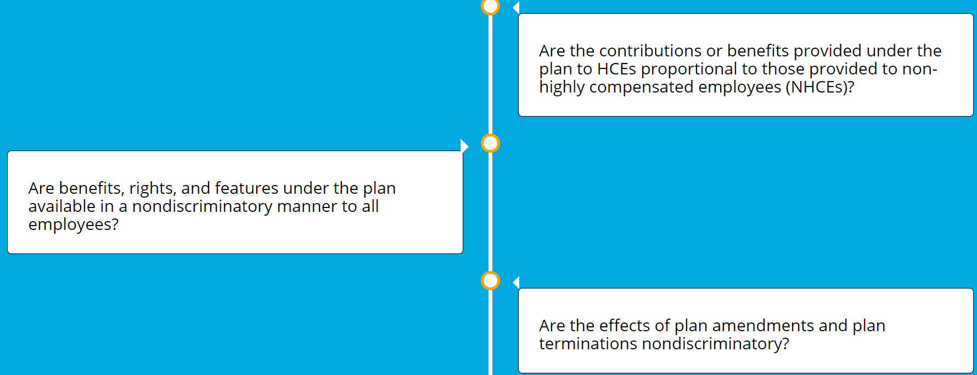

**Coverage Requirements**

As part of the general requirement that qualified retirement plans not disproportionately favour HCEs, the IRC imposes a “minimum coverage” test that compares a plan's coverage of HCEs to the plan's coverage of non-HCEs. There are three basic options for a plan to pass the IRC minimum coverage test.

**Percentage Test** To pass the percentage test, the plan must benefit at least 70% of employees who are not HCEs.

**Ratio Test** To pass the ratio test, the plan must benefit a percentage of NHCEs that is at least 70% of the percentage of HCEs benefiting under the plan.

**Average Benefit Percentage Test** To pass the average benefit percentage test, the average benefit percentage of the NHCEs must be at least 70% of the average benefit percentage of the HCEs.

When conducting the minimum coverage test, employees excluded from participation due to the standard age and/or service requirements (as well as union employees covered by a collective bargaining unit) generally may be excluded from testing.

Administering these coverage tests can be very complicated, and details about the process are outside the scope of this lesson.

**Top-Heavy Plans**

In addition to ensuring plans do not discriminate with contributions (or benefits) on behalf of employees, the IRC has a "top-heavy" rule designed to ensure that accumulated plan assets do not become skewed too much in favor of certain types of employees.

In general, a **top-heavy plan** is one in which 60% of the accrued benefits or account balances under the plan are for the benefit of key employees. Who is considered a key employee?

Top-heavy plan A retirement plan under which, for a given plan year, the present value of accrued benefits for key employees exceeds 60 percent of the present value of accrued benefits for all employees.

key employee For purposes of determining whether a retirement plan is top-heavy, an employee who at any time during the previous plan year (1) owned five percent or more of the employing company, (2) owned one percent or more of the employing company and earned more than a certain dollar amount from the company, or (3) was an officer of the employing company who earned more than a certain dollar amount from the company.

A **key employee** is someone who, at any time during the previous year, met any one of the following criteria:

* Owned more than 5% of the company
* Owned more than 1% of the company *and* earned more than $150,000
* Was an officer of the employer *and* earned more than a stated dollar amount ($215,000 in 2023, as adjusted for inflation)

If a qualified plan becomes top heavy, the IRC imposes additional requirements the plan must satisfy in order to remain a qualified plan. For example, the employer may be required to contribute a minimum amount for all participants.

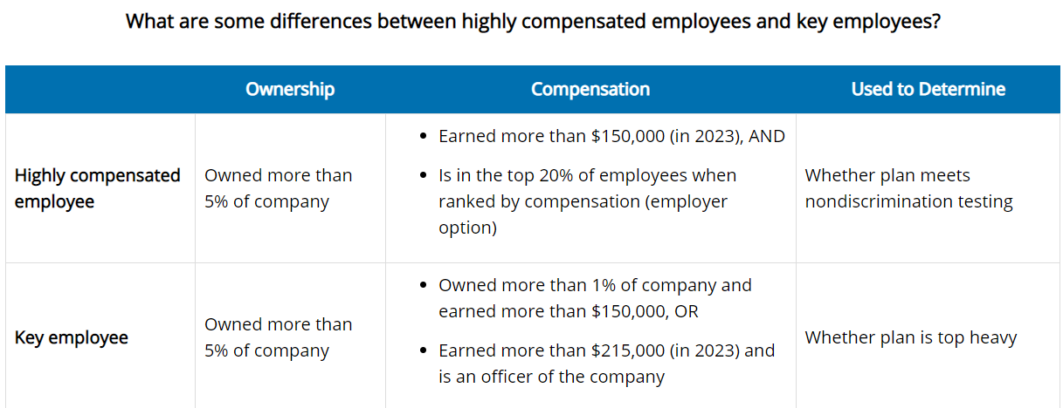

HCEs and key employees are similar, but are subject to different income and ownership or officer status thresholds. Some employees may satisfy both definitions or may only fit one category.

**Controlled Groups**

To determine whether a plan satisfies the non-discrimination requirements, the IRS treats all companies within a **controlled group** as one employer.

The IRC specifies which groups of companies must be treated as a controlled group, and applies complex qualification requirements to controlled groups. The aim of such requirements is to prevent companies from artificially structuring themselves so that their qualified retirement plans can unfairly benefit owners and key employees.

Controlled group Two or more business organizations that have common ownership and/or business relationships and that are treated as one employer for purposes of determining whether their qualified retirement plans meet applicable non-discrimination requirements.

Matt is considered to be a key employee if he was an officer of his employer and earned more than a stated dollar amount ($215,000 in 2023) or if he owned more than 1% of the company and earned more than $150,000.  
  
However, if Matt wasn't an officer of the company earning more than a stated amount, or if he didn't own more than 1% of the company and earn more than the stated amount, he would need to own more than 5% of the company to be considered a key employee.

* An HCE is one who owns more than 5% of the employing company in the current or previous plan year. Because she owns less than 5%, Marlena is not considered to be an HCE unless she also makes more than a stated amount or is in the top 20% of employees when ranked by compensation.
* Qualified plans cannot have contributions or benefits that discriminate in favour of HCEs.

**Plan Vesting, Funding, and Payment of Benefits**

**Learning Objective**

Describe requirements for plan vesting, funding, and payment of retirement plan benefits.

Qualified plans are subject to ERISA's minimum vesting requirements. As an employee, Sheila always owns 100% of her own contributions, but the amount of the employer contributions she owns depends on her length of service and the plan's vesting schedule.

**Plan Vesting**

All qualified plans are required to have vesting schedules outlining when a participant becomes vested. A plan participant always owns, or is vested, in her own contributions to a qualified retirement plan. Frequently, the employee must complete a specified length of time before being eligible to receive partial or full employer-provided benefits. A plan may provide that participants are immediately 100% vested without any waiting time.

When an employee who is not fully vested in either a DB or a DC plan terminates employment, the employee's nonvested benefits will eventually be forfeited unless he or she returns to work within a specified period and accrues additional years of vesting service.

Typically, any forfeited amounts must remain in the plan and be used to offset plan expenses or be allocated to the remaining plan participants. The plan document will stipulate both when nonvested benefits are to be forfeited and how such forfeitures are to be used or allocated.

Employers typically use one of two basic types of vesting schedules for either DB or DC plans, which are described in the next lesson. Regardless of the vesting schedule, participants must become 100% vested when they reach the normal retirement age (NRA) defined in the plan document or when the plan is terminated.

**Plan Funding**

When plan participants are vested, they have legal rights to the plan's benefits, and plans must be funded adequately to provide the promised benefits. A plan may change the rate at which future benefits accrue (for a DB plan) or the amount of future contributions (for a DC plan), but it cannot reduce the amount of the benefits participants have already accumulated. An employer may even terminate a plan, but it is not allowed to reduce any accumulated benefits. Under ERISA, participants have the right to sue for those benefits.

Both DC and DB plan documents outline the plan's funding options and requirements.

**DC Contribution Limits**

The IRS sets maximum limits on how much employers and employees can contribute to a DC plan each year. The plan must specifically state that contributions can't exceed these limits. If the employee's total contributions do exceed these limits, the difference will be included in the employee's gross income for tax purposes. The IRS makes **cost-of-living adjustments (COLAs)** periodically to increase the maximum annual limit.

cost of living adjustment (COLA) An increase applied to benefits when the cost-of-living rises.

Typically, the sum of employer and employee contributions to a participant's account each year cannot exceed the lesser of 100% of an employee's compensation or a stated dollar amount.

The IRS limits the amount of an employee's compensation that can be considered when calculating plan contributions and benefits. The IRC periodically adjusts this dollar limit for inflation.

**DB Benefit Limits**

An employer's contributions to a DB plan are based on what is needed to provide the stated benefits to plan participants in accordance with the plan document. Actuarial assumptions and computations are required to determine the amount of contributions that will ensure minimum funding requirements are met to provide the stated benefits. Therefore, the IRC limits on annual contributions to DB plans are driven by the maximum benefits for which the DB plan may be funded.

In general, the annual benefit for a participant cannot exceed the lesser of

* 100 percent of the participant's average compensation for the highest three consecutive calendar years of employment
* A stated dollar amount

The dollar amount for the maximum benefit is subject to cost-of-living adjustments in future years.

**Retirement Benefits**

Retirement plans must outline how plan participants will receive benefits from the plan. Federal law provides that a plan must start paying retirement benefits no later than the normal retirement age (NRA) specified in the plan or the plan participant's attainment of age 65. However, plans can choose to start paying retirement benefits at an earlier age and some plans allow participants to delay the start of benefits beyond the NRA.

Federal law also sets a mandatory date by which plan participants must start taking distributions from DC retirement accounts. Starting in 2023, this mandatory start date is generally April 1 following the calendar year in which the plan participant turns 73 or, if later, the date on which the participant retires from working for the employer. However, a plan may require plan participants to begin receiving retirement benefits after reaching age 73 even if the participant has not retired. (Note: Business owners are typically precluded from delaying required distributions beyond age 73.)

Participants generally pay any taxes on retirement plan distributions in the year they receive them. The distributions are taxed as ordinary income. For DB plans, the entire amount of the annual pension benefit is taxable. For DC plans, taxes on withdrawals depend on whether the contributions were made with pre-tax or after-tax dollars.

**Termination of Employment**

Plan participants, or their beneficiaries, have rights to their vested plan assets in specific situations, such as when the participant changes jobs or retires, becomes disabled and unable to work, or dies. The plan document will outline how the plan participant or a beneficiary accesses the vested amounts in these situations.

[**Disability Benefits**](https://services.loma.org/HIOS/Prod/SRI121_2022/index.html?AICC_URL=https%3a%2f%2flearning.loma.org%2fKview%2fCustomCodeBehind%2fBase%2fCourseware%2fAICC%2fAICC_HACP_MODEL.aspx&AICC_SID=6C24B708673B4BD4A4470663253F3D89%7c36E1775FD79D46AFB7ECA139F9AB92A7%7cA1#collapse11_1)

Each plan will include a definition of disability. In general, disability refers to the inability to engage in any substantial gainful activity. Disabled participants who satisfy the plan's definition of disability become fully vested in their retirement accounts. Although distributions from a vested account are subject to income taxes, the distribution is not subject to the additional 10 percent penalty tax if the participant has a total and permanent disability.

[**Death Benefits**](https://services.loma.org/HIOS/Prod/SRI121_2022/index.html?AICC_URL=https%3a%2f%2flearning.loma.org%2fKview%2fCustomCodeBehind%2fBase%2fCourseware%2fAICC%2fAICC_HACP_MODEL.aspx&AICC_SID=6C24B708673B4BD4A4470663253F3D89%7c36E1775FD79D46AFB7ECA139F9AB92A7%7cA1#collapse11_2)

If an employee with vested benefits in a retirement plan dies, the plan must state how it will distribute those benefits. A plan may stipulate that an employee becomes fully vested at death. In general, the form of payment is either a lump-sum payment or annual instalments to a beneficiary named by the account owner.

**Locating Missing Participants**

Sometimes, retirement plan participants do not apply for benefits, request distributions, or even respond to plan sponsor communications. A plan sponsor is responsible for ensuring that participants receive promised benefits in a timely manner. The DOL's EBSA has issued guidance for best practices for maintaining accurate participant census data and locating missing participants and beneficiaries.

The IRC limits on annual contributions to DB plans are driven by the maximum benefit for which the DB plan may be funded.

An employee who is not fully vested when he terminates employment forfeits the nonvested portion of his account. A plan may reinstate benefits for an employee who returns to work within a specified amount of time.

Plan participants, or their beneficiaries, have rights to their vested plan assets in specific situations, such as when the participant changes jobs or retires, becomes disabled and unable to work, or dies. The plan document will outline how the plan participant or a beneficiary accesses the vested amounts in these situations.