SDET TRAINING PROGRAM
CAPSTONE PROJECT REPORT
Selenium TestNG Automation Framework

Prepared By: | Shubhank Sharma
Project: | Parabank Automation Testing
Application: | Parabank Demo Banking App
URL: | https://parabank.parasoft.com/parabank
Testing Type: | Functional Automation Testing
Language: | JAVA
Framework Used: | TestNG
Automation Tool: | Selenium
Design Pattern: | Page Object Model
Build Tool: | Maven
CI / CD: | Jenkins
Containerization: | Docker
Reporting Tool: | Extent Reports
Logging Tool: | Log4j2
Version Control: | Git / Github
Github repository: | https://github.com/Shubh039/CapstoneProject_testNG

SECTION 1

TEST PLAN

Test Plan Identifier
Parabank_Automation_TP_001

Introduction
The banking industry relies on secure, reliable, and scalable software systems to manage sensitive customer information and financial transactions. To ensure the quality and stability of critical banking operations, the ParaBank Banking Application Automation Framework was developed using Selenium WebDriver, Java, TestNG, Maven, Jenkins, Docker, and GitHub. This Test Plan outlines the testing scope, objectives, strategy, environment, deliverables, and execution approach for automated validation of the ParaBank application. The framework follows industry best practices such as Page Object Model (POM), Data-Driven Testing, centralized reporting, CI/CD integration, logging, and containerized execution. The application areas covered include:-
- Registration
- Login
- Accounts Overview
- Open Account
- Transfer Funds
- Bill Payment
- Request Loan
- Update Contact Info
- Find Transactions

Test Items
- Registration Module
- Login Module
- Accounts Overview / Open Account Module
- Transfer Funds Module
- Bill Payment Module
- Request Loan Module
- Update Contact Info Module
- Find Transactions Module
- Logout module

Features to be Tested
- New customer registration with valid and data-driven (Excel) inputs
- Login with valid credentials read from registration data (data chaining)
- Opening a new CHECKING/SAVINGS account and verifying balance
- Transferring funds between accounts and verifying before/after balances
- Paying a bill and verifying the resulting transaction activity
- Applying for a loan, including approval and denial scenarios
- Updating contact/profile information
- Searching for transactions by ID and by amount
- Negative/boundary scenarios such as negative amounts, zero amounts, same source/destination accounts, invalid data types, and insufficient funds

Features NOT to be Tested
- Advertisement banners
- Header/footer UI elements
- Third-party links
- Performance testing
- Security testing
- Database-level testing
- API testing
- Penetration testing

Approach
- Selenium WebDriver for browser automation
- TestNG for test execution, grouping, and assertions
- Page Object Model (POM) with constructor-based dependency injection of WebDriver
- Data-Driven Testing using Apache POI to read test data from Excel (TestData.xlsx)
- Data chaining — Registration writes generated credentials which Login later reads
- ThreadLocal WebDriver for thread-safe parallel execution
- ExtentReports for HTML reporting with embedded screenshots
- Log4j2 for structured console and file logging
- Maven for build and dependency management
- Jenkins + Docker for CI/CD pipeline execution

Test Strategy
The ParaBank Automation Framework follows an automation-first testing approach using Selenium WebDriver, TestNG, Maven, and Java to ensure efficient and reliable validation of banking functionalities. The framework implements the following testing methodologies:
Functional Testing :
Validation of core banking features such as user registration, login, account management, fund transfers, bill payments, loan requests, and transaction history against expected business requirements.
Regression Testing :
Execution of automated test suites to verify that existing functionalities continue to work correctly after application updates, bug fixes, or configuration changes.
Data-Driven Testing :
Testing multiple scenarios using external datasets to validate application behavior with different combinations of valid and invalid user inputs.
Negative Testing :
Verification of system stability and error-handling mechanisms by executing test cases with invalid, incomplete, duplicate, or unexpected inputs.

Test Scenarios

Functional (Positive) Test Scenarios :

Test Case ID | Test Scenario | Priority
TC_REG_001 | Register New Customer with Valid Details | High
TC_LOGIN_001 | Login with Valid Credentials | High
TC_ACC_001 | Verify Account Overview After Successful Login | High
TC_ONC_001 | Open new CHECKING / SAVING Account | High
TC_ACC_002 | Verify newly opened account | Medium
TC_TRF_001 | Transfer Funds Between Existing Accounts | High
TC_TRF_002 | Verify Updated Balance After Fund Transfer | High
TC_BILL_001 | Pay Bill with Valid Payee Details | High
TC_BILL_002 | Verify Bill Payment Confirmation Message | High
TC_LOAN_001 | Apply for Loan with Eligible Account | High
TC_LOAN_002 | Verify Loan Approval Request Submission | Medium
TC_NAV_001 | Validate Navigation Across Banking Modules | Medium
TC_LOGOUT_001 | Logout Successfully from Application | High

Planned Negative Test Scenarios

Test Case ID | Test Scenario | Priority
TC_REG_NEG_001 | Register with Existing Username | High
TC_REG_NEG_002 | Register with Empty Mandatory Fields | High
TC_LOGIN_NEG_001 | Login with Invalid Username | High
TC_LOGIN_NEG_002 | Login with Invalid Password | High
TC_LOGIN_NEG_003 | Login with Empty Username and Password | High
TC_LOGIN_NEG_004 | Login with Special Characters in Credentials | Medium
TC_TRF_NEG_001 | Transfer Funds with Insufficient Balance | High
TC_TRF_NEG_002 | Transfer Funds with Empty Amount Field | High
TC_TRF_NEG_003 | Transfer Funds with Invalid Amount Value | Medium
TC_BILL_NEG_001 | Pay Bill with Empty Mandatory Fields | High
TC_BILL_NEG_002 | Pay Bill with Invalid Account Number | Medium
TC_BILL_NEG_003 | Pay Bill with Invalid Amount Value | Medium
TC_LOAN_NEG_001 | Request Loan with Invalid Loan Amount | Medium
TC_LOAN_NEG_002 | Request Loan Without Required Account Selection | Medium

Test Data Requirements
Registration Data :
- First Name
- Last Name
- Address
- City
- State
- Zip Code
- Phone Number
- SSN
- Username
- Password
Login Data
- Valid Credentials (username and password)
Banking Data (For paying bill)
- Payee Name
- Address
- City
- State
- Zip Code
- Phone Number
- Account Number
- Amount

Entry Criteria
Testing activities may begin when:
- ParaBank application is accessible.
- Test environment is configured.
- Selenium framework setup is completed.
- Maven dependencies are installed.
- Test data is available.
- Jenkins environment is configured.
- Docker environment is available.

Suspension Criteria
- Application/server unavailable
- HTTP 500 errors blocking core flows
- Jenkins build failure
- Browser driver / WebDriver session failure
- Critical functionality failure preventing further execution

Resumption Criteria
- Environment restored and Parabank application accessible
- Blocking defects fixed or workaround identified
- Test data (Excel/config) available and valid
- Jenkins pipeline operational

Test Deliverables
- Test Plan and Test Cases
- Automation Framework (source code)
- ExtentReports (HTML execution reports with screenshots)
- Jenkins build/pipeline reports
- Defect/Bug Reports (Jira)
- Test Summary / Defect Analysis Report

Environmental Needs
- Java JDK 11
- Selenium WebDriver 4.25.0
- TestNG 7.9.0
- Maven 3.8.6
- Jenkins
- Docker Desktop
- Git / GitHub
- Google Chrome (latest)
- Windows 10/11, 8GB RAM minimum

Responsibilities
Test Lead: Shubhank Sharma — Test Design, Automation Development, Execution, Defect Logging, Jenkins CI/CD Setup.

Schedule
- Planning (Day 1)
- Test Design (Day 2)
- Framework Setup — POM, Utilities, Config (Day 3 - 4)
- Script Development — Page Objects & Test Cases (Day 5–6)
- Execution — Positive & Negative Suites (Day 7-9)
- Reporting, Defect Logging & Retesting (Day 10)

Risks and Contingencies
- Parabank demo site instability or downtime
- HTTP 500 errors from the application under test
- Browser compatibility issues across Chrome/Firefox/Edge
- Internet connectivity issues
- Jenkins/Docker configuration issues

Tools Used
- Selenium WebDriver
- Java
- TestNG
- Maven
- Jenkins
- Docker
- GitHub
- ExtentReports
- Log4j2
- Jira

Approvals
Trainer: Dr Vaishali
Project: Parabank Automation Framework — SDET Capstone Project

SECTION - 2

Project Overview

What Was Built
A production-quality Hybrid Test Automation Framework built in Java using Selenium WebDriver and TestNG, designed to automate end-to-end banking workflows on the Parabank application. The framework combines the Page Object Model (POM) for maintainability with Data-Driven Testing using Apache POI for flexibility, reflecting real-world SDET practices used in the industry.

What Was Tested
Seven core banking modules were automated — Registration, Login, Open Account, Transfer Funds, Bill Payment, and Request Loan — covering both positive flows and negative/boundary scenarios. An additional three modules (Update Contact Info, Find Transactions, and UI Navigation) were tested manually through exploratory testing.

Key Highlights
- 23 automated test cases executed across Smoke, Regression, and Negative suites
- 16 defects discovered and documented — 9 via automation, 7 via manual testing
- Full CI/CD pipeline built with Jenkins and Docker, executing all suites automatically on every code push
- Professional reporting via ExtentReports with embedded screenshots and structured Log4j2 logging
- Data Driven implemented — Registration dynamically writes credentials to Excel which Login reads, simulating real test dependency management
- Bug documentation pattern built into the framework — defects are captured, reported, and evidenced with screenshots without failing the pipeline.

Tech Stack at a Glance
Layer | Technology
Language | Java 11
Test Framework | TestNG 7.9
Browser Automation | Selenium WebDriver 4.25
Build Tool | Maven 3.8.6
Test Data | Apache POI (Excel)
Reporting | ExtentReports 5.1.1
Logging | Log4j2
CI/CD | Jenkins + Docker
Bug Tracking | Jira (Project: PB)
Version Control | GitHub

Framework Structure
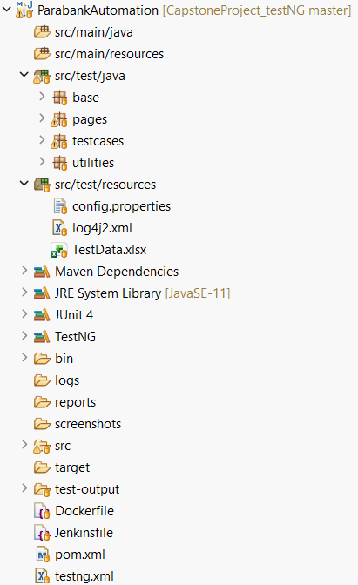

End To End Flow Diagram
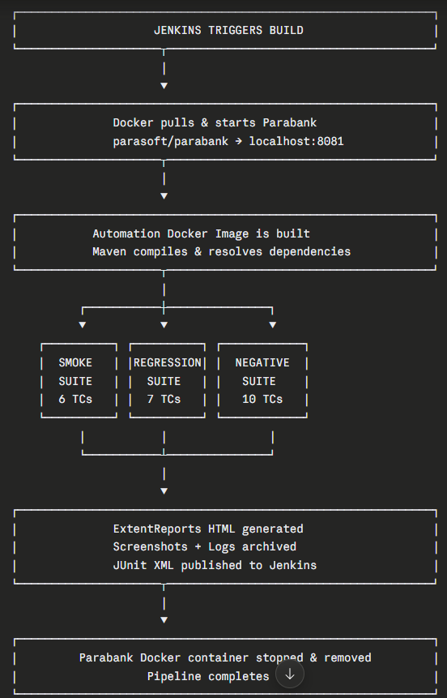

Data Flow Across Modules
A key design feature of this framework is data driven approach — test modules don't use hardcoded credentials. Instead, data flows dynamically between modules through Excel.
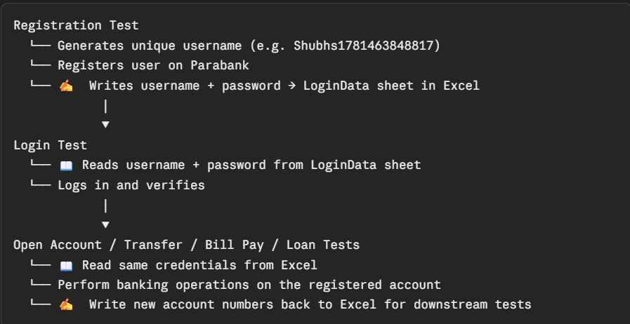

Positive Test Case Flow — Step by Step

Suite 1: Smoke Tests (6 Test Cases)
Step 1 — Registration (TC-REG-01)
Objective : Verify successful customer registration.
Execution steps :
- Browser launches in headless Chrome and navigates to the Parabank home page
- ExcelUtils reads registration data from the Registration sheet in TestData.xlsx — first name, last name, address, city, state, zip, phone, SSN, base username, and password
- A timestamp is appended to the base username to guarantee uniqueness (e.g. Shubhs1781465034361)
- The Register link is clicked on the home page
- All form fields are filled with the Excel data
- The Register button is clicked
- The success message is verified — confirms Welcome message contains the new username
- The generated username and password are immediately written back into the LoginData sheet in the same Excel file — this is the data chaining step
- The framework navigates to Accounts Overview and logs the account number and balance (e.g. Account 13566, Balance $515.5)
- User logs out
- Browser closes ✅
Expected result : Customer should be registered successfully
Actual result : Customer registration completed successfully and login was verified.
STATUS : PASSED

Step 2 — Login (TC-LOG-01)
Objective : Verify successful customer login.
Execution steps :
- Fresh browser instance launches and navigates to Parabank home
- ExcelUtils reads the username and password from the LoginData sheet — the credentials that were written by the Registration test
- Username and password are entered into the login form
- Log In button is clicked
- URL is verified to contain overview.htm — confirming successful login
- User logs out
- Browser closes ✅
Expected result : Customer logins successfully.
Actual result : Customer login completed successfully and login was successful.
STATUS : PASSED

Step 3 — Open Checking / Savings Account (TC-OAC-01)
Objective : Verify successful Account opening.
Execution steps :
- Fresh browser launches and navigates to Parabank home
- Logs in using credentials from LoginData sheet in Excel
- Navigates to Accounts Overview and records the source account number (13566) and its current balance ($515.5)
- Click Open New Account in the navigation panel
- Selects account type: CHECKING / SAVINGS
- Selects the source account from the dropdown
- Clicks Open New Account button
- The new account number is captured from the confirmation page (e.g. 13677)
- Navigates back to Accounts Overview
- Verifies the new CHECKING account appears in the list
- Verifies new account balance = $100.00
- Verifies source account balance reduced by exactly $100 — from $515.5 to $415.5
- New account number and type are written to Excel for use by downstream tests
- User logs out
- Browser closes ✅
Expected result : New CHECKING/ SAVINGS Account should open successfully and proper balance handling in account overview.
Actual result : New account opened successfully with valid balance details in accounts overview.
STATUS : PASSED

Step 4 — Transfer Funds (TC-TRF-01)
Objective : Verify successful funds transfer.
Execution steps :
- Fresh browser launches and navigates to Parabank home
- Logs in using credentials from LoginData sheet
- Navigates to Accounts Overview and records both account balances:
  - FROM account 13566 → $415.5
  - TO account 13677 → $100.0
- Navigates to Transfer Funds page
- Enters amount: $100
- Selects FROM account 13566 and TO account 13677 from dropdowns
- Clicks Transfer button
- Verifies Transfer Complete success message
- Navigates to Accounts Overview and records balances AFTER transfer:
  - FROM account 13566 → $315.5 (reduced by $100)
  - TO account 13677 → $200.0 (increased by $100)
- Balance verification assertion passes ✅
- Navigates to FROM account activity — verifies debit transaction exists ✅
- Navigates to TO account activity — verifies credit transaction exists ✅
- User logs out
- Browser closes ✅
Expected result : Funds should be transferred successfully along with proper balance handling in the accounts overview and transaction records.
Actual result : Funds transferred successfully along with balance verification and transaction records found for both debit and credit.
STATUS : PASSED

Step 5 — Bill Payment (TC-BILL-01)
Objective : Verify successful Bill payment.
Execution steps :
- Fresh browser launches and navigates to Parabank home
- Logs in using credentials from LoginData sheet
- Navigates to Accounts Overview and records FROM account balance: $315.5
- Navigates to Bill Pay page
- Fills in all payee details — name (Shubhank), address, city, state, zip, phone
- Enters Account Number: 12345 and Verify Account Number: 12345
- Enters Amount: $100
- Selects FROM account 13566
- Clicks Send Payment
- Verifies success message: Bill Payment Complete — Bill Payment to Shubhank in the amount of $100.00 from account 13566 was successful
- Verifies payee name and amount in the success message ✅
- Navigates to Accounts Overview — verifies balance reduced by $100: $315.5 → $215.5 ✅
- Navigates to account activity — verifies bill pay transaction record exists ✅
- User logs out
- Browser closes ✅
Expected result : Bill payment should be done successfully with correct balance details and transaction records.
Actual result : Bill paid successfully along with correct updated balance in accounts overview and transaction records.
STATUS : PASSED

Step 6 — Request Loan (TC-LOAN-01)
Objective : Verify if the request for the loan page is working.
Execution steps :
- Fresh browser launches and navigates to Parabank home
- Logs in using credentials from LoginData sheet
- Navigates to Accounts Overview and records source account balance: $215.5
- Navigates to Request Loan page
- Enters Loan Amount: $1000
- Enters Down Payment: $100
- Selects FROM account 13566
- Clicks Apply Now
- Verifies loan result is displayed
- Verifies Loan Status = Approved from provider Wealth Securities Dynamic Loans (WSDL) ✅
- Captures new loan account number (e.g. 13788) — verifies it is not empty ✅
- Navigates to Accounts Overview — verifies new loan account appears in the list ✅
- Verifies source account balance reduced by down payment: $215.5 → $115.5 ✅
- User logs out
- Browser closes ✅
Expected result : Loan request should be made and check if the result is displayed.
Actual result : Successful display of loan result after request and if approved then the balance is also handled correctly.
STATUS : PASSED

Suite 2: Regression Tests (7 Test Cases)
Runs the exact same 6 flows above but with a brand new registered user — a fresh registration happens first, new credentials are written to Excel, and all subsequent tests run against this new user's accounts. One additional test is added:
Open Savings Account (TC-OAC-02)
After the Checking account is opened for the regression user, a second account is opened:
- Login with regression user credentials
- Navigate to Open New Account
- Select account type: SAVINGS
- Source account balance recorded, new SAVINGS account created (e.g. 14121)
- New account balance verified = $100.00
- Source account balance verified reduced by $100
- New SAVINGS account number saved to Excel
- User logs out ✅

Key Design Principle
Every test case opens its own fresh browser instance, performs its task independently, and closes the browser on completion. No state is shared between tests through the browser — all shared data flows through the Excel file via ExcelUtils read/write operations. This makes every test independently repeatable and failure in one test does not cascade to the next.

Negative Test Case Flow — Step by Step

Suite 3: Negative Tests (10 Test Cases)
Important design note: Every negative test that requires a logged-in user registers its own brand new user at runtime using registerNegativeTestUser(). This means the negative suite is completely self-contained and never depends on any data from the positive suites.
Test 1 — Invalid Login: Wrong Username & Password (PB-L01 Scenario 1)
- Fresh browser launches and navigates to Parabank home
- No user registration needed — this test uses hardcoded invalid credentials
- Enters username: wrongUser_xyz and a wrong password
- Clicks Log In
- Waits for response — verifies ErrorShown = true and LoginWorked = false
- Confirms the error message is displayed correctly on the login page
- Bug Status logged: WORKING AS EXPECTED ✅ — Parabank correctly rejects invalid credentials
- Browser closes ✅

Test 2 — Invalid Login: Empty Username & Password (PB-L01 Scenario 2)
- Fresh browser launches and navigates to Parabank home
- Both username and password fields are left completely empty
- Clicks Log In
- Waits for response — verifies ErrorShown = true and LoginWorked = false
- Confirms error message shown for empty submission
- Bug Status logged: WORKING AS EXPECTED ✅
- Browser closes ✅

Test 3 — Invalid Login: Valid Username, Wrong Password (PB-L01 Scenario 3)
- Fresh browser launches and navigates to Parabank home
- Enters a real existing username: Shubhs with an incorrect password
- Clicks Log In
- Verifies ErrorShown = true and LoginWorked = false
- Confirms system correctly rejects a valid username paired with wrong password
- Bug Status logged: WORKING AS EXPECTED ✅
- Browser closes ✅

Test 4 — Negative Transfer: Negative Amount (PB-001)
- Fresh browser launches and navigates to Parabank home
- registerNegativeTestUser() runs — auto-fills registration form with unique username (e.g. Shubhs_1781465109186) and registers on Parabank
- Logs in immediately with the newly registered credentials
- Navigates to Accounts Overview — records the default source account (14343)
- Opens a second SAVINGS account to use as the destination account (14454)
- Navigates to Transfer Funds
- Enters Amount: -100, selects FROM: 14343, TO: 14454
- Clicks Transfer
- Bug Reproduced — system returns Transfer Complete for a negative amount
- printBugReport() logs the full bug report — Bug ID PB-001, input data, expected vs actual result
- Screenshot captured and saved to disk + embedded in ExtentReports as WARNING
- Test marked PASS — defect is documented, not a framework failure
- User logs out, browser closes ✅

Test 5 — Negative Bill Payment: Negative Amount (PB-002)
- Fresh browser launches and navigates to Parabank home
- registerNegativeTestUser() registers a fresh user (Shubhs_1781465112679)
- Logs in and navigates to Accounts Overview — records source account (14565)
- Navigates to Bill Pay page
- Fills payee details — name: Shubhank, address, city, state, zip, phone
- Enters Account Number: 12345, Verify Account: 12345, Amount: -100
- Selects FROM account 14565 and clicks Send Payment
- Bug Reproduced — system returns Bill Payment Complete — Bill Payment to Shubhank in the amount of $-100.00 from account 14565 was successful
- printBugReport() logs Bug ID PB-002 with full details
- Screenshot captured and embedded in report
- Test marked PASS — defect documented
- User logs out, browser closes ✅

Test 6 — Negative Transfer: Same Source and Destination Account (PB-003)
- Fresh browser launches and navigates to Parabank home
- registerNegativeTestUser() registers a fresh user (Shubhs_1781465116109)
- Logs in and navigates to Accounts Overview — records the only account (14676)
- Navigates to Transfer Funds
- Enters Amount: 10, selects account 14676 as BOTH the FROM and TO account
- Clicks Transfer
- Bug Reproduced — system returns Transfer Complete for a self-transfer
- printBugReport() logs Bug ID PB-003
- Screenshot captured and embedded in report
- Test marked PASS — defect documented
- User logs out, browser closes ✅

Test 7 — Bill Payment: Mismatched Account Numbers (PB-004)
- Fresh browser launches and navigates to Parabank home
- registerNegativeTestUser() registers a fresh user (Shubhs_1781465119157)
- Logs in and navigates to Accounts Overview — records source account (14787)
- Navigates to Bill Pay page
- Fills valid payee details
- Enters Account Number: 12345 and Verify Account Number: 67890 — deliberately mismatched
- Enters Amount: 5 and clicks Send Payment
- Framework waits — confirms the payment success div does NOT appear
- Working as expected — mismatch error shown, payment correctly blocked
- Bug Status logged: WORKING AS EXPECTED ✅
- User logs out, browser closes ✅

Test 8 — Negative Transfer: Zero Amount (PB-005)
- Fresh browser launches and navigates to Parabank home
- registerNegativeTestUser() registers a fresh user (Shubhs_1781465137976)
- Logs in and navigates to Accounts Overview — records source account (14898)
- Opens a second SAVINGS account to use as destination (15009)
- Navigates to Transfer Funds
- Enters Amount: 0, selects FROM: 14898, TO: 15009
- Clicks Transfer
- Bug Reproduced — system returns Transfer Complete with $0
- printBugReport() logs Bug ID PB-005
- Screenshot captured and embedded in report
- Test marked PASS — defect documented
- User logs out, browser closes ✅

Test 9 — Request Loan: Negative Down Payment (PB-006)
- Fresh browser launches and navigates to Parabank home
- registerNegativeTestUser() registers a fresh user (Shubhs_1781465142248)
- Logs in and navigates to Accounts Overview — records source account (15120) and balance: $515.5
- Navigates to Request Loan page
- Enters Loan Amount: 1000, Down Payment: -10 (negative value), selects FROM account 15120
- Clicks Apply Now
- Bug Reproduced — loan is Approved despite a negative down payment value. Balance remains $515.5 — the system processed a nonsensical negative down payment without any validation error
- printBugReport() logs Bug ID PB-006
- Screenshot captured and embedded in report
- Test marked PASS — defect documented
- User logs out, browser closes ✅

Test 10 — Request Loan: Down Payment Exceeds Balance (PB-007)
- Fresh browser launches and navigates to Parabank home
- registerNegativeTestUser() registers a fresh user (Shubhs_1781465146381)
- Logs in and navigates to Accounts Overview — records source account (15342) and balance: $515.5
- Navigates to Request Loan page
- Enters Loan Amount: 1000, Down Payment: 600 (exceeds available balance of $515.5), selects FROM account 15342
- Clicks Apply Now
- Loan result returned: Denied
- Framework checks balance after — still $515.5, wentNegative = false
- Working as expected — loan correctly denied, account balance fully protected
- Bug Status logged: WORKING AS EXPECTED ✅
- User logs out, browser closes ✅

Suite Result: 10/10 PASSED — Total across all three suites: 23/23 PASSED in 130.7 seconds

MANUAL TESTING REPORT

How Manual Testing Was Conducted
After the automated suites were completed, exploratory and boundary testing was performed manually on modules not covered by automation. Each module was tested by navigating through the application, entering valid and invalid data combinations, and observing system behaviour. All findings were noted and logged as defects in Jira under project key PB.

Module 1 — Update Contact Info
What was tested: Whether the profile update flow correctly reflects changes across the entire UI.
Steps performed:
- Logged in with valid credentials
- Navigated to Update Contact Info from the left panel
- Changed First Name from John to Joh, kept all other fields the same
- Clicked Update Profile
- Read the success message carefully
- Observed the Welcome message in the left navigation panel
- Clicked Update Contact Info again to verify if the change was saved internally
Findings:
Bug PB-010 — Incorrect success message field description The success message displayed was Your updated address and phone number have been added to the system even though only the First Name was changed. The message does not accurately describe which field was updated — it always shows the same generic message regardless of what was actually modified.
Bug PB-011 — Welcome message not updated after name change After updating the First Name to Joh, the left panel still showed Welcome John Smith. The updated name is correctly reflected if you re-open the Update Contact Info form — confirming the change was saved to the database — but the session-level display name is stale and does not refresh until the user logs out and back in.

Module 2 — UI Navigation (Right Panel)
What was tested: Whether the right side navigation panel links work correctly.
Steps performed:
- Logged in with valid credentials
- Located the navigation options in the right panel of the application
- Clicked each available link one by one
- Observed what page or content was loaded
Findings:
Bug PB-016 — Right panel links navigate to raw XML/HTML files Every link in the right panel, instead of navigating to the correct application page, opens a raw XML or HTML file in the browser. The page renders as unformatted file content rather than the expected application UI. This makes the entire right panel navigation completely non-functional for end users.

Module 3 — Find Transaction
What was tested: Whether the search feature correctly validates input and provides meaningful feedback when no results are found.
Steps performed:
- Logged in with valid credentials
- Navigated to Find Transactions from the left panel
- Tested each search type individually
Find by Transaction ID:
- Entered letters → system showed Invalid transaction id — working correctly
- Entered a valid numeric ID that doesn't exist → navigated to an empty results page with no error message
Find by Date:
- Entered letters or wrongly formatted date → system showed Invalid date format — working correctly
Find by Date Range:
- Same behaviour as Find by Date — format validation works correctly
Find by Amount:
- Entered letters → system showed Invalid amount — working correctly
- Entered a valid number that has no matching transactions → navigated to empty results page with no error or feedback message
- Entered a negative amount (e.g. -100) → system accepted it and navigated to empty results page with no validation error
Findings:
Bug PB-012 — No feedback message when search returns no results When a valid numeric transaction ID or amount is entered but no matching transaction exists, the system silently navigates to an empty table. There is no message such as No transactions found matching your criteria. The user has no way to distinguish between a failed search and genuinely empty results.
Bug PB-013 — Find by Amount accepts negative values without validation Entering -100 as a search amount is accepted without any error. A negative amount is not a valid transaction amount and should be rejected at input level with a clear validation message.

Module 4 — Request Loan (Manual Boundary Testing)
What was tested: Boundary and invalid input behaviour across all three loan form fields.
Steps performed:
- Logged in with valid credentials
- Navigated to Request Loan from the left panel
- Tested each field individually with valid, boundary, and invalid inputs.
Select Account field:
- Correctly shows all available accounts in a dropdown — working as expected
Loan Amount field:
- Entered text/letters → system threw An internal error has occurred and has been logged instead of a proper client-side validation message — Bug PB-008
- Entered very large values (5 digits and above) → loan was denied with message We cannot grant a loan in that amount with your available funds but no maximum limit is communicated to the user — Bug PB-009
- Entered values under ~5000 → loan processed normally
Down Payment field:
- Entered letters → system threw An internal error has occurred and has been logged — same server error as loan amount field
- Entered a large down payment that exceeds account balance → system correctly showed You do not have sufficient funds for the given down payment
- Entered down payment of 1000 on an account with $0 balance → loan was approved and account balance went to -$1000 — Bug PB-007 (also covered by automation)
- Entered a negative down payment (e.g. -10) on account with $0 balance → loan approved, balance went to -$(-10) = +$10 direction — the negative down payment actually adds to the balance rather than deducting, completely breaking financial logic — Bug PB-006 (also covered by automation)
Findings summary for this module:
Bug PB-008 — Letters in amount/down payment fields cause a server-level error instead of a friendly client-side validation message.
Bug PB-009 — Loan denial for large amounts does not communicate what the maximum allowed loan amount is, leaving the user with no actionable guidance.

Module 5 — Bill Payment (Field Validation)
What was tested: Whether all form fields in Bill Pay enforce correct data type validation.
Steps performed:
- Logged in with valid credentials
- Navigated to Bill Pay
- Tested each field by entering an invalid data type and observing the response.

Field | Input Tested | Expected Behaviour | Actual Behaviour
Zip Code | Letters (e.g. ABCDE) | Reject with validation error | Accepted — no error
Phone Number | Letters (e.g. abcdefghij) | Reject with validation error | Accepted — no error
Payee Name | Numbers (e.g. 12345) | Reject with validation error | Accepted — no error
City | Numbers (e.g. 12345) | Reject with validation error | Accepted — no error
State | Numbers (e.g. 12) | Reject with validation error | Accepted — no error
Account Number | Letters | Reject with validation error | Shows Please enter a valid number ✅
Verify Account | Letters | Reject with validation error | Shows Please enter a valid number ✅
Amount | Letters | Reject with validation error | Shows Please enter a valid amount ✅
Finding:
Bug PB-014 — Bill Payment form accepts invalid data types in Zip, Phone, Name, City and State fields Five out of eight fields accept completely wrong data types and allow the payment to be submitted successfully with corrupt data. Only the Account Number, Verify Account, and Amount fields have working validation. The remaining fields have no client-side type enforcement whatsoever.

Module 6 — Registration (Field Validation)
What was tested: Whether the Registration form enforces correct data types for all fields before allowing account creation.
Steps performed:
- Navigated to the Parabank home page and clicked Register
- Tested each field by entering an invalid data type.
- In every case, registration completed successfully with no validation error shown.
- The corrupt data was stored in the system and visible when logging in and navigating to the profile.
Field | Input Tested | Expected Behaviour | Actual Behaviour
First Name | Numbers (e.g. 12345) | Reject — names must be alphabetic | Accepted, registration completed ❌
Last Name | Numbers (e.g. 67890) | Reject — names must be alphabetic | Accepted, registration completed ❌
City | Numbers (e.g. 12345) | Reject — city must be alphabetic | Accepted, registration completed ❌
State | Numbers (e.g. 12) | Reject — state must be alphabetic | Accepted, registration completed ❌
Zip Code | Letters (e.g. ABCDE) | Reject — zip must be numeric | Accepted, registration completed ❌
Phone | Letters (e.g. abcdefghij) | Reject — phone must be numeric | Accepted, registration completed ❌
SSN | Letters (e.g. abc-de-fghi) | Reject — SSN must be numeric | Accepted, registration completed ❌
- In every case, registration completed successfully with no validation error shown
- The corrupt data was stored in the system and visible when logging in and navigating to the profile
Finding:
Bug PB-015 — Registration form accepts invalid data types across all fields All seven personally identifiable fields on the Registration form accept completely wrong data types. Numbers are accepted in name fields, letters are accepted in zip, phone, and SSN fields, and the system completes registration in every case without a single validation error. This means the application can store structurally corrupt user profile data, which is a data integrity issue affecting every user record.

Manual Testing Summary

Bug ID | Module | Severity | Description
PB-010 | Update Contact Info | Medium | Success message shows wrong field description
PB-011 | Update Contact Info | Medium | Welcome message not updated after name change
PB-012 | Find Transaction | Medium | No feedback when search returns no results
PB-013 | Find Transaction | Medium | Negative amount accepted as search input
PB-014 | Bill Payment | Medium | 5 fields accept invalid data types
PB-015 | Registration | Medium | All 7 fields accept invalid data types
PB-016 | UI Navigation | High | Right panel links open raw XML/HTML files
Total manual defects found: 7

COMPLETE CI / CD :

JENKINS PIPELINE
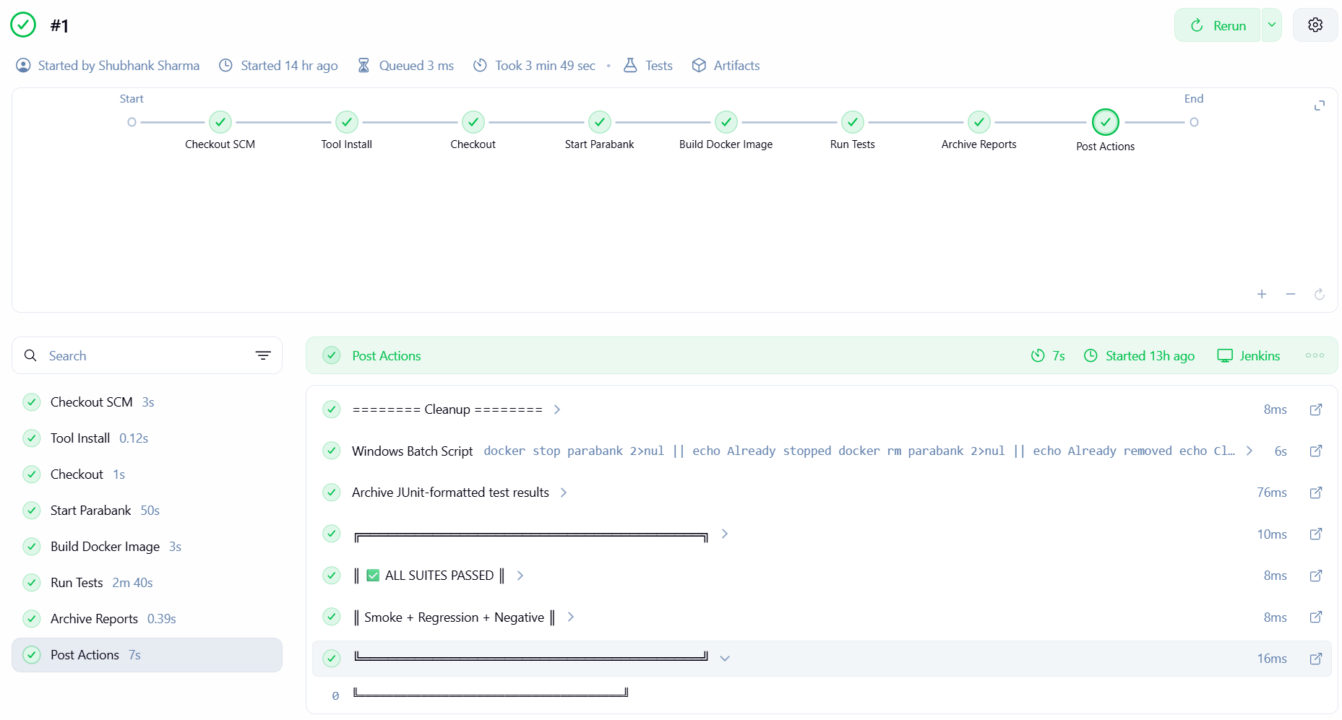

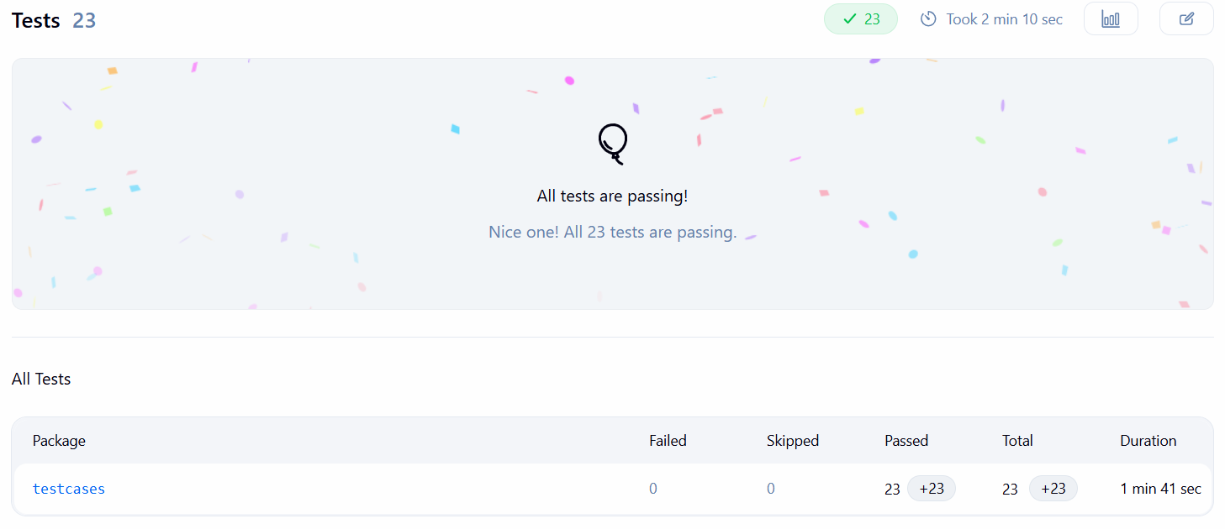

DOCKER IMPLEMENTATION
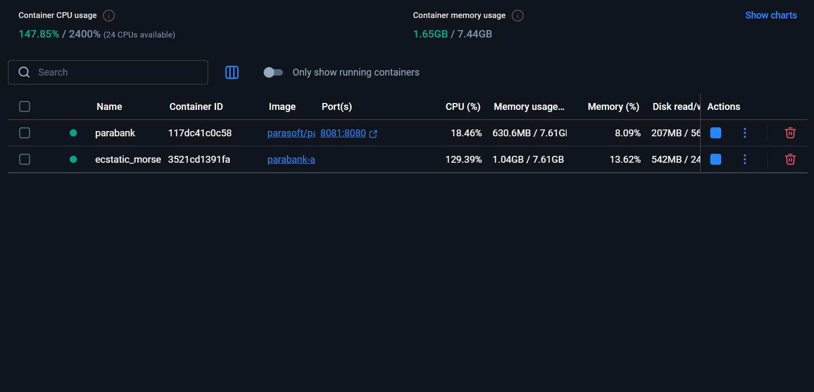

IN JENKINS :

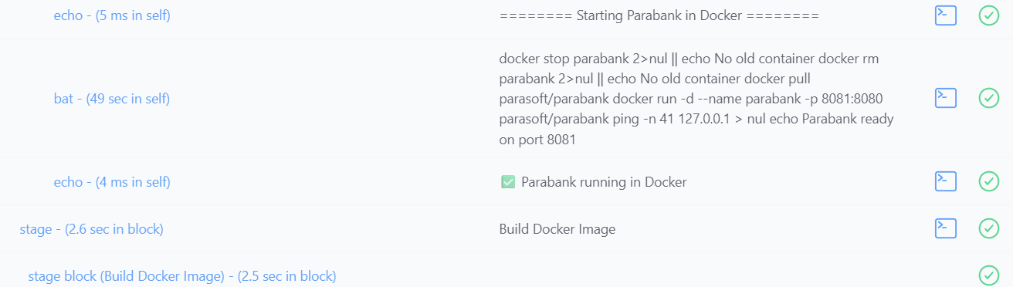

CONCLUSION :
This capstone project successfully demonstrates the design, development, and execution of a production-quality test automation framework for the Parabank Demo Banking Application, built using industry-standard tools and practices.
Over the course of the project, a Hybrid Automation Framework combining the Page Object Model and Data-Driven Testing was built from scratch in Java, covering six core banking modules through fully automated end-to-end test flows. The framework was integrated into a CI/CD pipeline using Jenkins and Docker, enabling automated test execution on every code push with zero manual intervention.
Beyond automation, seven additional modules were explored through manual and exploratory testing, uncovering defects that automated scripts alone would not have caught — particularly around field-level input validation and UI navigation behaviour.
The framework demonstrates several real-world SDET competencies including data chaining across test modules, self-contained negative test isolation, professional defect documentation with screenshot evidence embedded directly into HTML reports, structured Log4j2 logging, and thread-safe WebDriver management for parallel execution readiness.
This project reflects a complete software testing lifecycle — from test planning and framework architecture through script development, CI/CD integration, defect discovery, and documentation — and serves as a strong foundation for professional automation work in a BFSI or enterprise testing environment.

