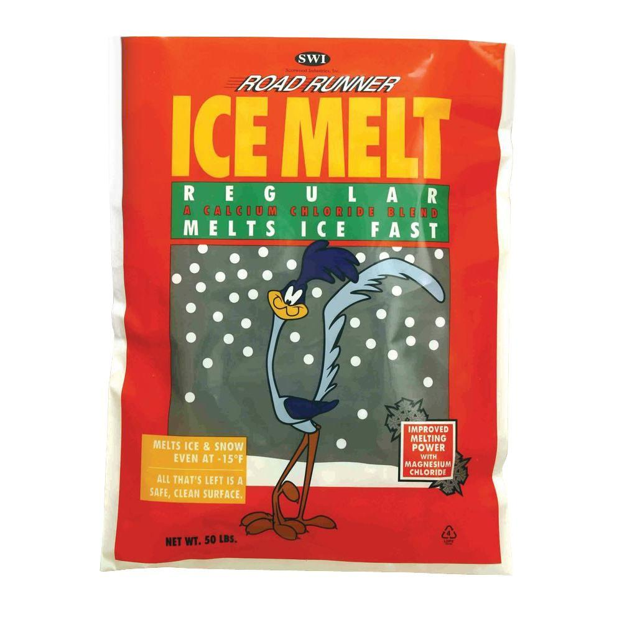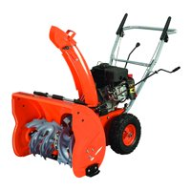

Ice Melt $9.99 per bag!

Snow Blowers $149.99!

FREE SHIPPING ON ORDERS $50.00 OR MORE!

Shawna and Shawn’s Snow Show

Snow Shovels only $19.99!