**PHASE2PROJECT ---- LEARNERS ACADEMY**

**Screenshots**

**Login:**

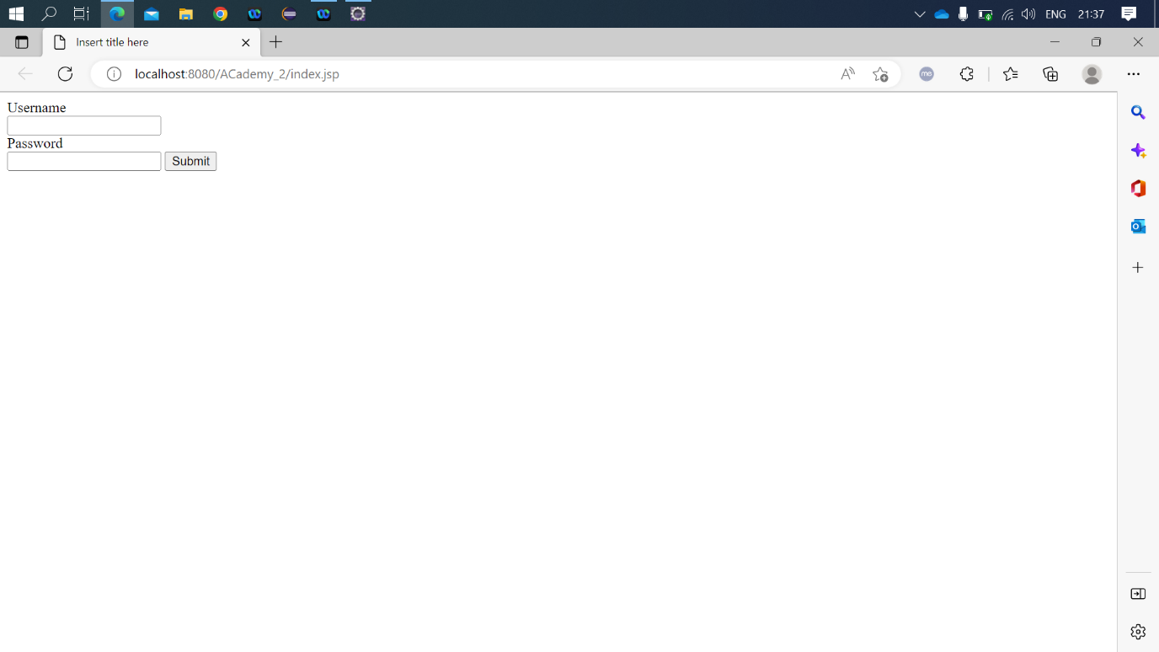

**Choice:**

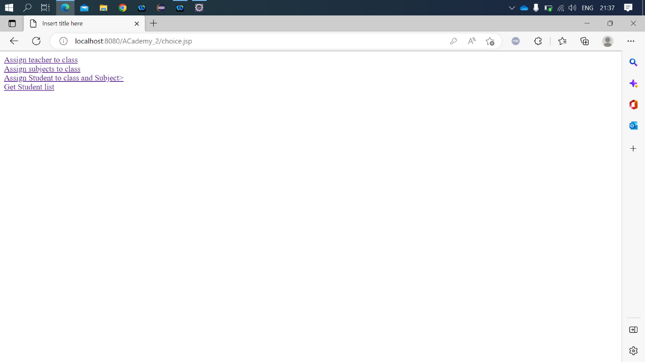

**Subjects.jsp**

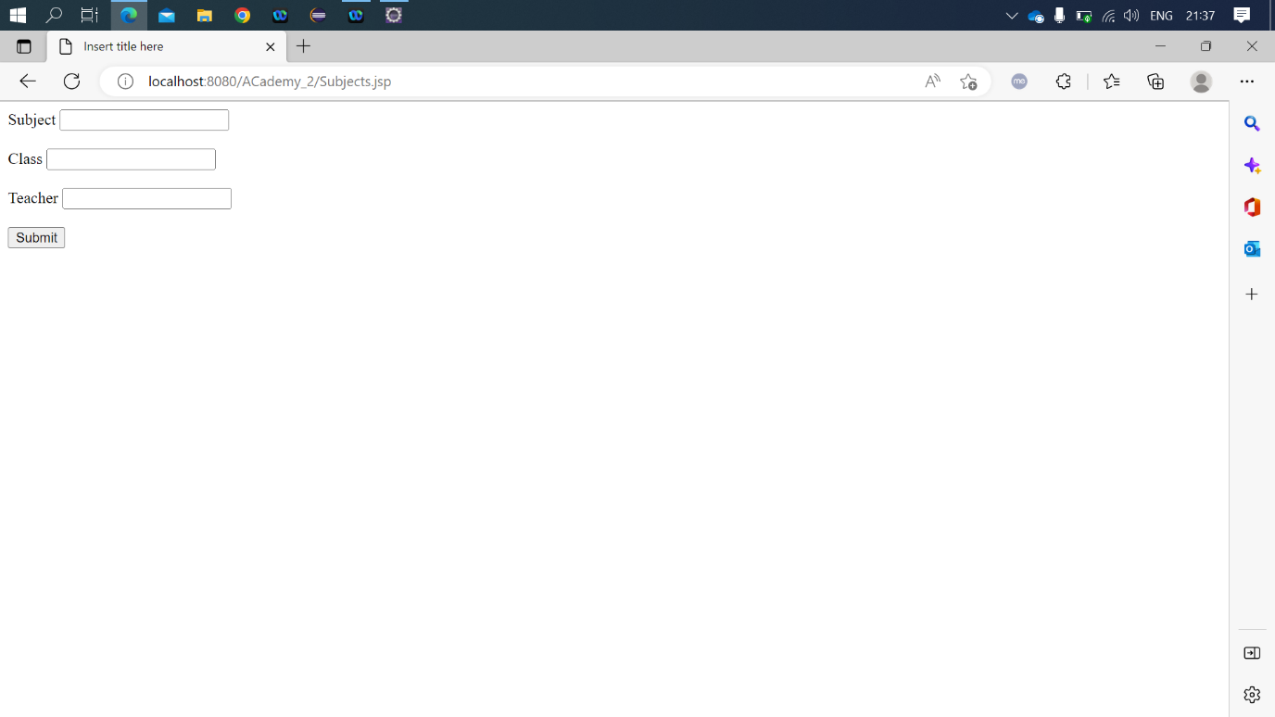

**Choice.jsp**

**Students_list.jsp**

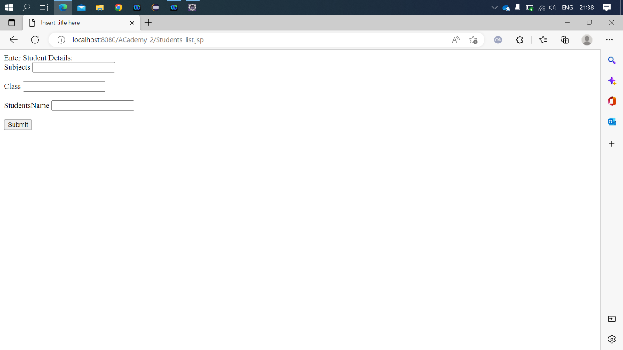

**Result.jsp**

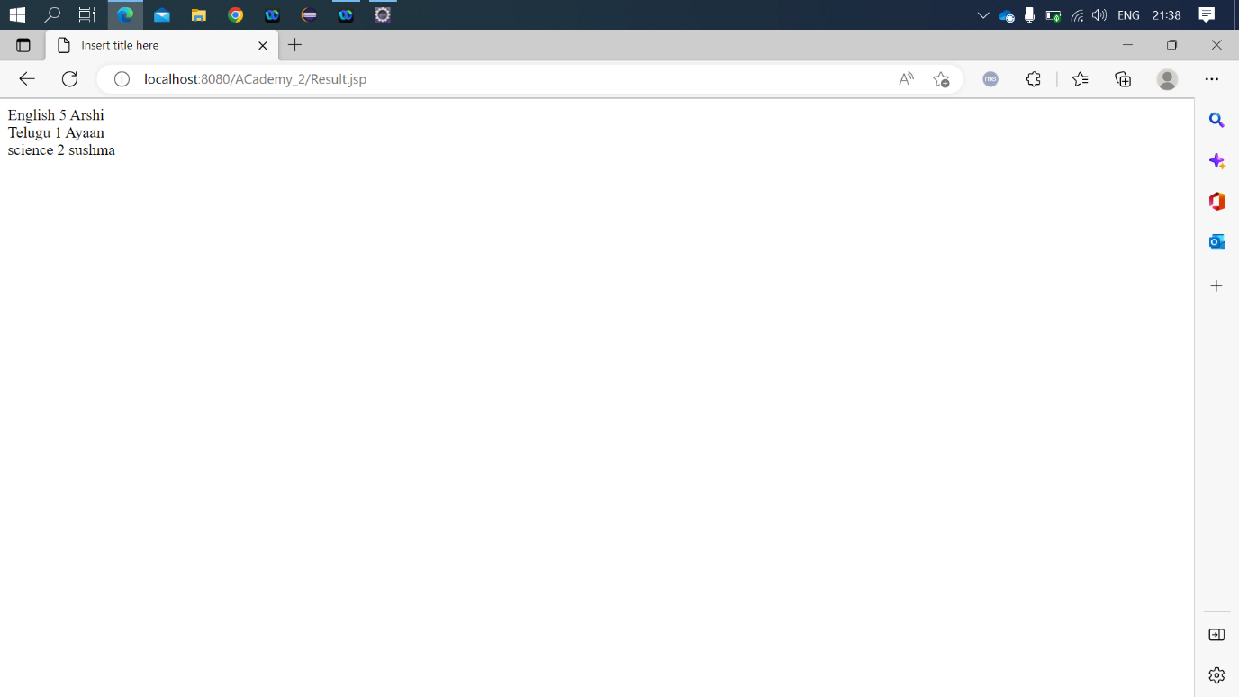

English 5 Shubham

Telugu 1 Ronak

Science 2 Rishabh