Project Documentation
RealifyLens -AI Image Authenticity Analyzer

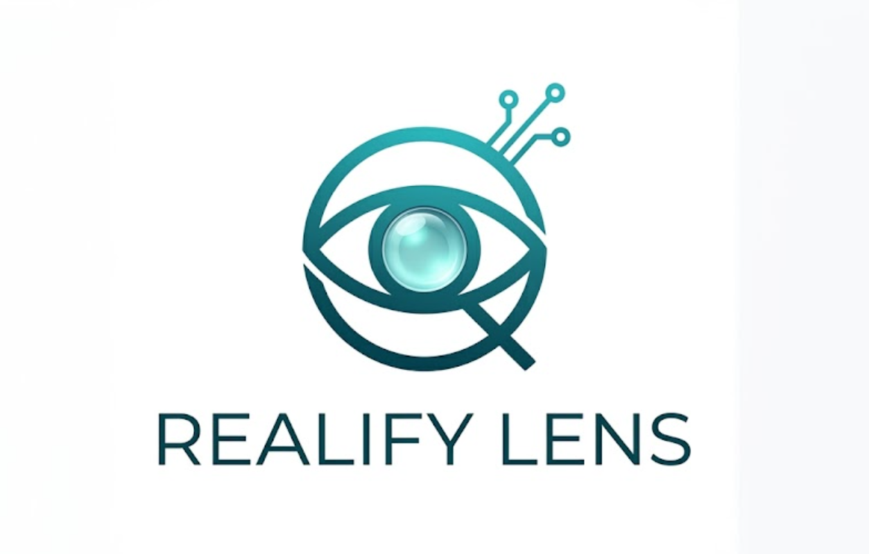

1. Introduction
RealifyLens is a full-stack web application designed to detect whether an uploaded image is AI-generated or authentic using image forensics and AI-based classification techniques.
The system combines:
- image forensic analysis
- Error Level Analysis (ELA)
- pretrained AI detection models
- visualization techniques
to provide explainable results to users.

2. Objective of the Project
The main objective of this project is to:
- identify AI-generated images
- analyse suspicious image regions
- provide visual forensic explanations
- help users verify image authenticity
This project addresses the growing issue of:
- deepfakes
- synthetic media
- misinformation
- manipulated digital content

3. Technologies and Tools Used

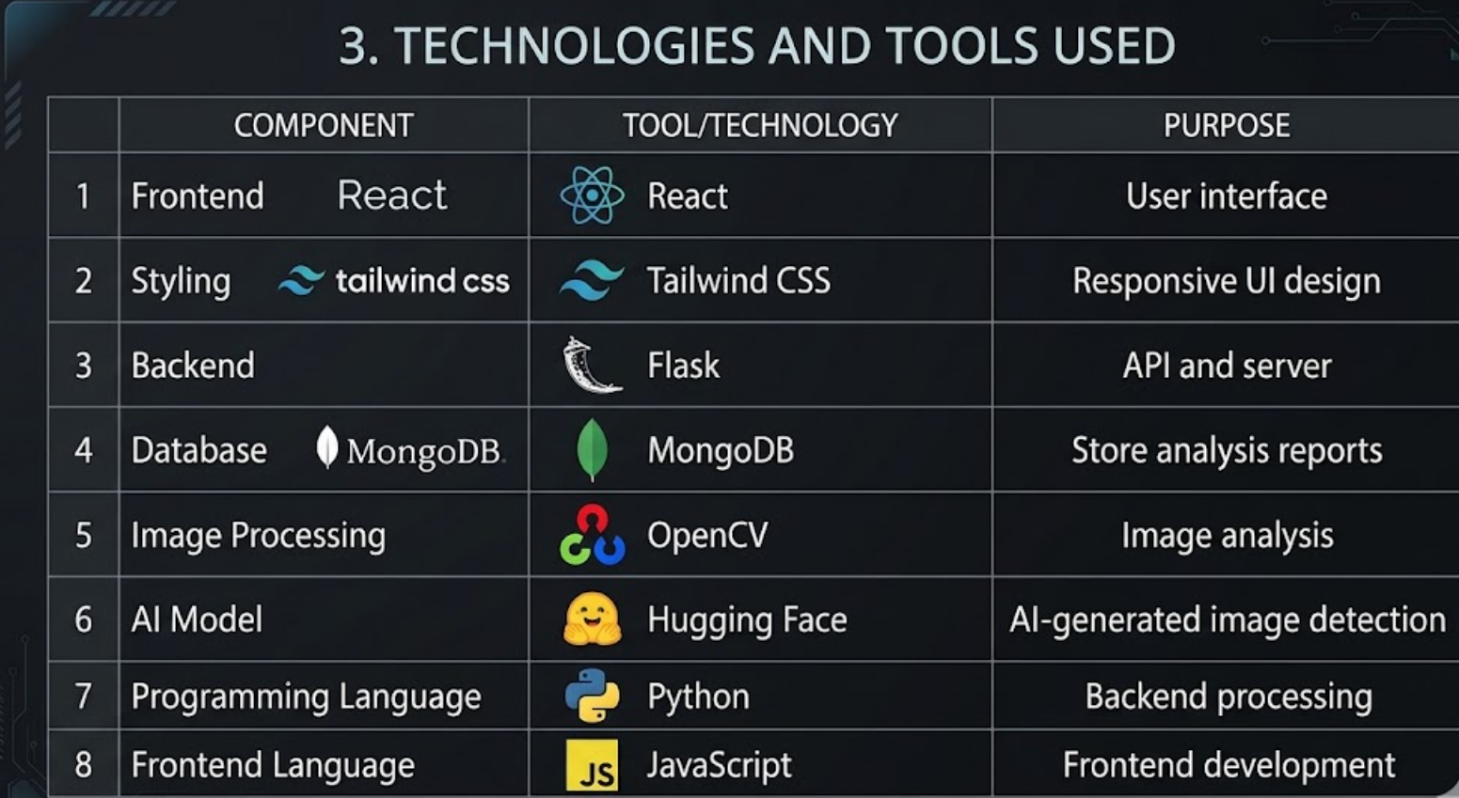

4. System Architecture

Workflow
- User uploads image
- Flask backend receives image
- OpenCV performs image preprocessing and ELA
- Hugging Face pretrained model predicts AI or real
- MongoDB stores results
- React frontend displays:
  - prediction
  - confidence score
  - forensic heatmap
  - metadata

5. Features of the Project

Main Features
- AI-generated image detection
- Error Level Analysis (ELA)
- Suspicious region visualization
- Confidence score generation
- Metadata analysis
- Upload history management
- User-friendly dashboard

6. What is ELA in This Project?
ELA (Error Level Analysis) is an image forensic technique used to detect suspicious image regions by analyzing compression inconsistencies.
In this project:
- the uploaded image is recompressed
- pixel differences are calculated
- suspicious areas are highlighted using heatmaps
This helps provide explainable visual analysis instead of only showing prediction labels.

7. Benefits of the Project

Technical Benefits
- Demonstrates full-stack development
- Integrates AI with web applications
- Uses computer vision techniques
- Implements image forensics

Practical Benefits
- Helps identify fake images
- Supports misinformation detection
- Assists in digital media verification
- Improves awareness about AI-generated content

Academic Benefits
- Enhances understanding of:
  - APIs
  - databases
  - image processing
  - AI integration
  - cybersecurity concepts

8. Advantages of Technologies Used

React
- Fast UI rendering
- Component-based architecture
- Easy frontend management

Flask
- Lightweight backend framework
- Easy integration with Python AI libraries
- Beginner friendly

MongoDB
- Flexible JSON document storage
- Suitable for image-analysis data
- Easy scalability

OpenCV
- Efficient image processing
- Easy ELA implementation
- Large community support

Hugging Face Models
- Pretrained AI models
- No need for large-scale training
- Faster integration

9. Threats and Security Concerns

1. Adversarial Attacks
Attackers may modify images slightly to fool AI detection models.

2. False Positives
Real images may sometimes be classified as AI-generated.

3. False Negatives
Advanced AI-generated images may bypass detection.

4. Model Bias
The pretrained model accuracy depends on its training dataset.

5. Metadata Removal
Attackers may remove metadata to hide image origin.

6. Large File Upload Attacks
Malicious users may upload oversized files to overload the server.

10. Can the AI Model Be Injected or Manipulated?

Yes, partially.
Like many AI systems, pretrained models can be vulnerable to:
- adversarial inputs
- manipulated images
- poisoned datasets
- evasion attacks

Example
An attacker may:
- slightly alter pixel patterns
- compress image multiple times
- add noise
to reduce model accuracy.

Security Measures That Can Be Added
- File size validation
- Image format verification
- Input sanitization
- Rate limiting
- Multiple detection methods
- Hybrid forensic analysis

11. Future Scope
Future improvements may include:
- video deepfake detection
- real-time camera analysis
- browser extension support
- social media URL scanning
- blockchain-based authenticity verification

12. Conclusion
RealifyLens is a modern AI-powered image authenticity analyser that combines:
- computer vision
- image forensics
- explainable AI
- full-stack web development
to identify AI-generated images and visually explain suspicious regions using ELA-based forensic analysis.

