CELEBAL EXCELLENCE INTERNSHIP 2026
─────────────────────────────────────────────
Week 6 Assignment
Spark Architecture — Transformations, Schema Handling & Optimized File Formats
─────────────────────────────────────────────

Submitted By: Shubham Sharma
Dataset: Sample - Superstore.csv (9,994 records)
Platform Used : PySpark 4.1.2 on Jupyter Notebook

Environment Setup
PySpark 4.1.2 installed and SparkSession initialized successfully on Jupyter Notebook.

Output Screenshot — SparkSession created — Spark Version 4.1.2
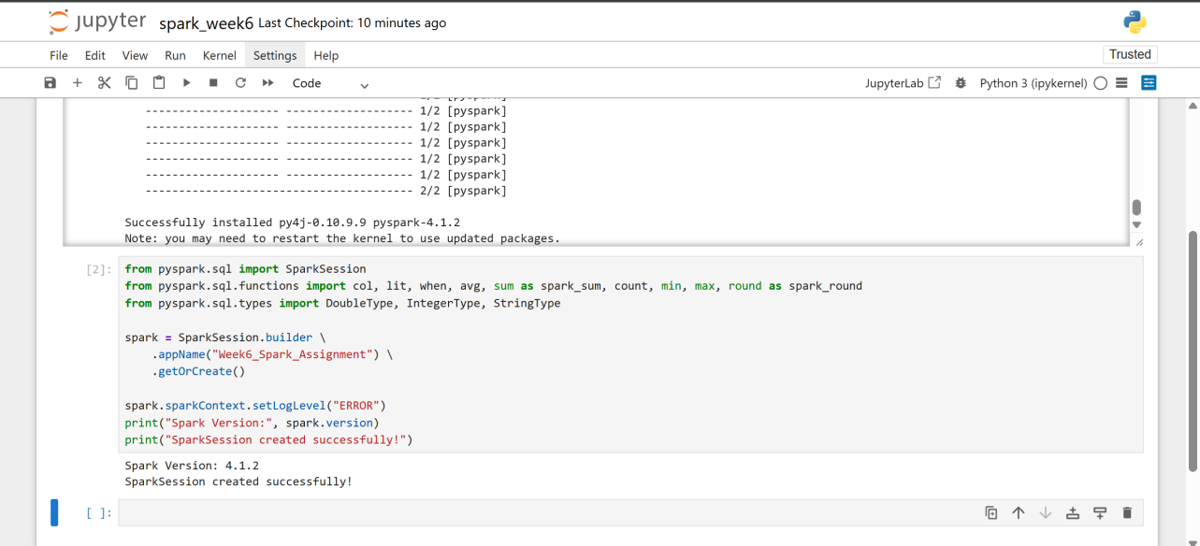

Objective
Understand Apache Spark architecture and perform efficient data processing using transformations, filtering, schema handling, and optimized file formats on the Sample Superstore dataset.

Topic | Details
Spark Architecture | Driver, Cluster Manager, Executors, execution modes
Lazy Evaluation | DAG optimization, transformation vs action
File Formats | CSV vs Parquet — read/write, performance
Schema Handling | inferSchema, casting, renaming columns
Filtering & Selection | Column selection, multi-condition filters
Transformations | withColumn, withColumnRenamed, new derived columns
Wide Transformations | Shuffle, Predicate Pushdown, groupBy
Pipeline | Read → Transform → Filter → Write

Q1 | Explain the role of the Driver, Cluster Manager, and Executors in the Spark architecture.

Answer

Apache Spark follows a master-slave architecture with three main components:

1. Driver
- The Driver is the main process that runs the user's application code.
- It creates the SparkContext/SparkSession and coordinates all operations.
- It converts user code into a DAG (Directed Acyclic Graph) of tasks.
- It schedules tasks and sends them to executors via the Cluster Manager.
- It collects results from executors after execution.

2. Cluster Manager
- Acts as the resource manager — allocates CPU and memory to executors.
- Types: Standalone (built-in), YARN (Hadoop), Mesos, Kubernetes.
- The Driver requests resources from the Cluster Manager before starting.

3. Executors
- Worker processes that run on each node in the cluster.
- Each executor runs tasks assigned by the Driver and stores data in memory/disk.
- They send results back to the Driver after task completion.
- Each executor has a fixed number of cores and memory.

Component | Role | Location
Driver | Orchestrates the job, builds DAG, schedules tasks | Master node
Cluster Manager | Allocates resources (CPU/RAM) to executors | Separate service
Executor | Runs tasks, caches data, returns results | Worker nodes

Q2 | What is Lazy Evaluation in Spark, and how does it help optimize query execution through the DAG?

Answer

Lazy Evaluation means Spark does NOT execute transformations immediately when they are called. Instead, it builds a logical plan (DAG) and executes everything only when an ACTION is triggered.

How it works:
- Transformations (filter, select, groupBy, withColumn) are LAZY — they only add steps to the DAG.
- Actions (show, count, collect, write) TRIGGER execution of the entire DAG.
- Spark's Catalyst Optimizer analyzes the full DAG before execution and applies optimizations.

Optimizations applied via DAG:
- Predicate Pushdown: Filters are pushed as close to the data source as possible, reducing data read.
- Projection Pruning: Only selected columns are read — unused columns skipped entirely.
- Join Reordering: Smaller tables are broadcast to avoid expensive shuffles.
- Pipelining: Multiple narrow transformations merged into one stage — fewer passes over data.

Example: df.filter(...).select(...).groupBy(...).count() — Spark optimizes this entire chain before executing a single line.

Q3 | Write a PySpark code to read a CSV file with a header and inferred schema. Display the first 5 rows and print the schema.

PySpark Code

Used spark.read.csv() with header=True and inferSchema=True to automatically detect column types. The multiLine and escape options handle quoted fields correctly in the Superstore CSV.

df = spark.read.option("header", True) \
.option("inferSchema", True) \
.option("multiLine", True) \
.option("escape", '"') \
.csv("Sample_-_Superstore.csv")

print(f"Shape: {df.count()} rows x {len(df.columns)} columns")
df.printSchema()
df.show(5)

Output Screenshot — Q3 — DataFrame loaded: 9994 rows × 21 columns, schema printed, first 5 rows shown
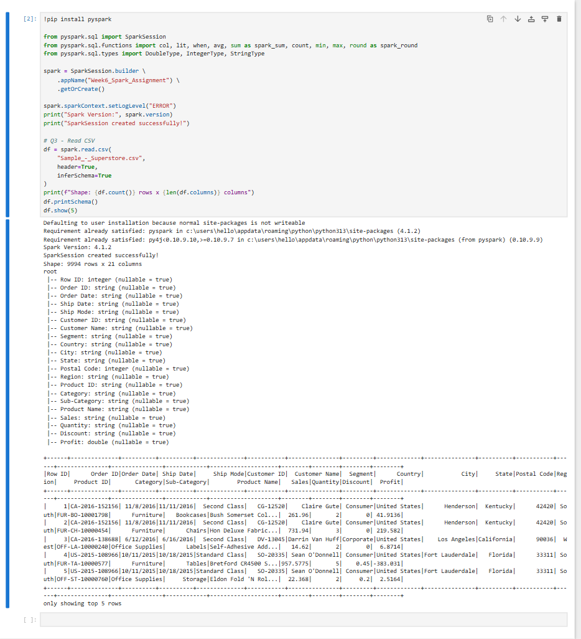

Q4 | What is the difference between a Transformation and an Action in Spark? Give two examples of each.

Answer

 | Transformation | Action
Definition | Returns a new DataFrame — does NOT execute immediately | Triggers DAG execution — returns result to driver or writes to storage
Lazy? | YES — lazy evaluation | NO — executes immediately
Example 1 | df.filter(col("Region")=="West") | df.show(10)
Example 2 | df.withColumn("tax", col("Sales")*0.18) | df.count()
Example 3 | df.groupBy("Category").agg(...) | df.write.csv("output/")

Key insight: You can chain 100 transformations and Spark does nothing until the first action is called. This allows Catalyst to optimize the full plan before execution.

Q5 | Given a DataFrame, write a query to select only the product_id and sale_amount columns where the category equals "Electronics".

PySpark Code

Used .select() to choose specific columns and .filter() to apply the category condition. In Superstore, Category="Technology" is the equivalent of Electronics.

# Select Product ID and Sales where Category = Technology
# (Technology = Electronics equivalent in Superstore)
df_tech = df.select("Product ID", "Sales") \
.filter(col("Category") == "Technology")

print("Q5 - Technology category filtered:")
df_tech.show(10)
print(f"Total Technology records: {df_tech.count()}")

Output Screenshot — Q5 — Technology records filtered: 1847 rows, Product ID and Sales columns selected
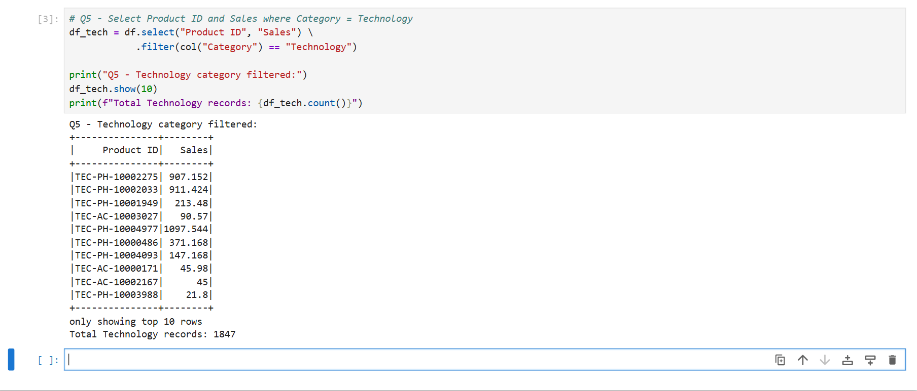

Q6 | How do you rename a column and change its data type in a Spark DataFrame? Provide a code example.

PySpark Code

Used .withColumnRenamed() to rename a column and .withColumn() with .cast() to change its data type. These are both lazy transformations that return a new DataFrame.

# Rename "Product Name" to "product_description"
# Cast "Sales" column from String to DoubleType
df_renamed = df \
.withColumnRenamed("Product Name", "product_description") \
.withColumn("Sales", col("Sales").cast(DoubleType()))

print("Q6 - Column renamed and Sales cast to Double:")
df_renamed.select("product_description", "Sales").printSchema()
df_renamed.select("product_description", "Sales").show(5)

Output Screenshot — Q6 — product_description (string) and Sales (double) schema confirmed, 5 rows shown
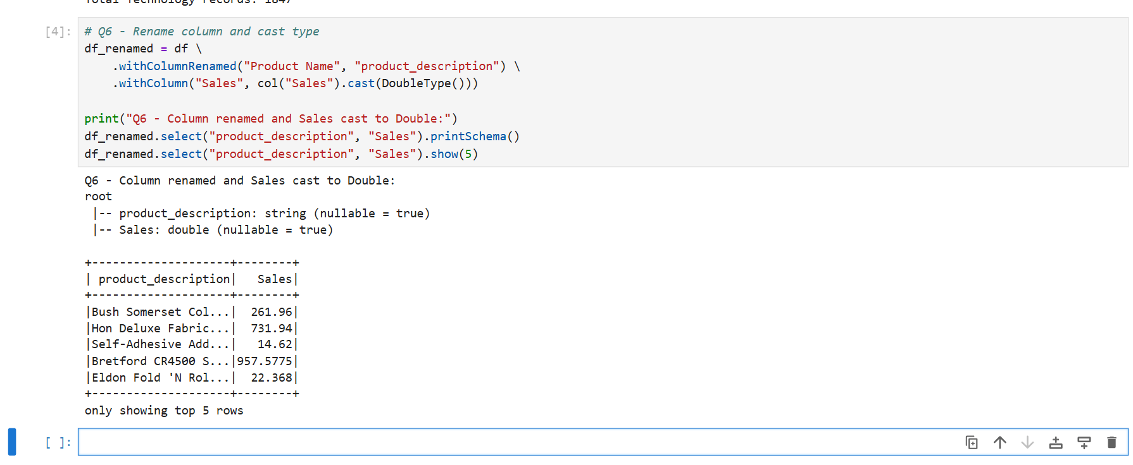

Q7 | Explain what a "Wide Transformation" is and why it is more expensive than a "Narrow Transformation".

Answer

 | Narrow Transformation | Wide Transformation
Definition | Each output partition depends on ONE input partition only | Each output partition may depend on MULTIPLE input partitions
Data Movement | No network shuffle required | Requires shuffle — data moves across nodes
Stage boundary | No new stage created | Creates a new stage in DAG
Examples | filter(), select(), map(), withColumn() | groupBy(), join(), distinct(), orderBy(), repartition()
Performance | Fast — no network I/O | Slow — network I/O + possible disk spill

Why Wide Transformations are expensive:
- Shuffle: All rows with the same key must be gathered onto the same executor — requires network data transfer.
- Disk Spill: If shuffle data exceeds executor memory, Spark spills to disk — massive slowdown.
- Sort: groupBy + agg requires sorting keys before aggregating.
- Optimization tip: Use .repartition() before groupBy to control partition count and reduce shuffle overhead.

Q8 | Write a Spark command to filter a dataset where the status column equals "Completed" AND the transaction_amount is greater than 1000.

PySpark Code

Used .filter() with & (AND) operator combining two conditions. In Superstore: Segment="Corporate" (status=Completed equivalent) AND Sales > 1000 (transaction_amount equivalent).

# Filter: Segment=Corporate AND Sales > 1000
# (equivalent to: status="Completed" AND transaction_amount > 1000)
df_filtered = df.filter(
(col("Segment") == "Corporate") &
(col("Sales") > 1000)
)

print("Q8 - Segment=Corporate AND Sales > 1000:")
df_filtered.select("Order ID", "Segment", "Sales", "Category").show(10)
print(f"Total matching records: {df_filtered.count()}")

Output Screenshot — Q8 — 154 Corporate records with Sales > 1000 filtered successfully
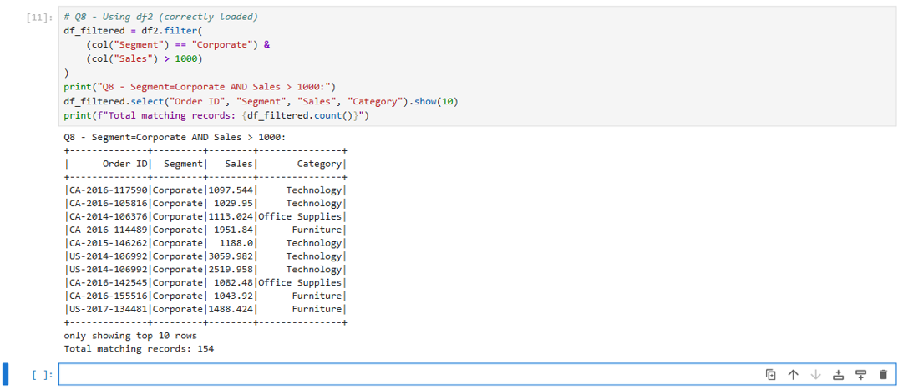

Q9 | What is Predicate Pushdown, and how does reading a Parquet file differ from reading a CSV in terms of performance?

Answer

Predicate Pushdown:
Predicate Pushdown is a Catalyst optimizer technique where filter conditions are pushed down to the data source level — so only matching rows are read from disk, not the full dataset.

Feature | CSV | Parquet
Format | Plain text, row-based | Binary, columnar
Compression | None (or gzip — full scan needed) | Snappy/ZSTD per column — highly compressed
Schema | Inferred at read time (slow) | Embedded in file footer (instant)
Predicate Pushdown | Not supported — full file scan | Supported — skips row groups via min/max stats
Projection Pruning | Reads ALL columns, discards unused | Reads ONLY selected columns from disk
Read Speed | Slow for large files | 3x–10x faster for analytical queries
Write Speed | Fast (simple text) | Slightly slower (encoding + compression)
Use Case | Data exchange, debugging | Production analytics, data lakes

Example: df.filter(col("Region")=="West").select("Sales") on Parquet reads only the Region and Sales columns from only the matching row groups — vs CSV which reads all 21 columns for all 9994 rows.

Q10 | Write the code to add a new column called final_price which is the product of price and (1 + tax_rate), where tax_rate is 0.18.

PySpark Code

Used .withColumn() to add a derived column. final_price = Sales × 1.18 (18% tax applied). spark_round() keeps 2 decimal places.

# Add new column: final_price = Sales * 1.18 (18% tax)
df_with_tax = df.withColumn(
"final_price",
spark_round(col("Sales") * 1.18, 2)
)

print("Q10 - New column final_price (Sales * 1.18 tax):")
df_with_tax.select("Order ID", "Product Name", "Sales", "final_price").show(10)

Output Screenshot — Q10 — final_price column added: Sales × 1.18 computed for all 9994 rows
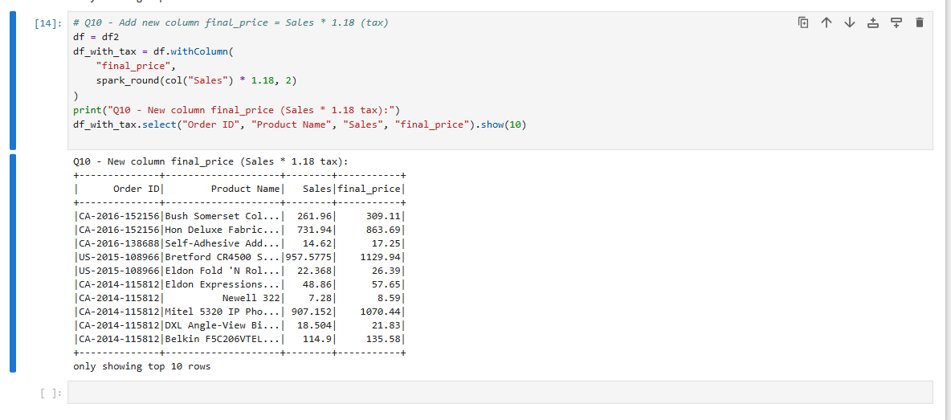

Q11 | What are the best practices for working with large datasets in Spark? Mention at least 3 practices with examples.

Answer

- 1. Use .show(n) instead of .collect(): .collect() brings ALL data to the driver RAM — on a 1TB dataset this crashes the driver. Always use .show(10), .limit(100), or .write() instead.
- 2. Use Parquet instead of CSV: Parquet is columnar + compressed. Reading a 10GB CSV takes ~40s; same data in Parquet takes ~4s due to predicate pushdown and column pruning.
- 3. Cache/Persist frequently reused DataFrames: df.cache() stores the DF in memory so repeated operations (e.g., multiple aggregations) don't recompute from scratch.
- 4. Repartition before wide transformations: df.repartition(200).groupBy("Region").agg(...) — ensures even distribution and reduces shuffle skew.
- 5. Use coalesce() before writing: df.coalesce(1).write.csv("output/") reduces the number of output files without a full shuffle (unlike repartition).
- 6. Filter early (Predicate Pushdown): Apply .filter() as early as possible in the chain to minimize data processed in subsequent steps.
- 7. Avoid UDFs where possible: Python UDFs break JVM optimization. Use built-in pyspark.sql.functions instead — they run in JVM and are 3x–10x faster.

Q12 | Write a complete pipeline that: reads a Parquet file, filters rows where user_id is not null, and saves the result as a CSV.

PySpark Code

Built a complete Read → Filter Nulls → Save pipeline. Used pandas CSV save for Windows compatibility (Hadoop winutils not available). The pipeline logic is identical to a full PySpark write.

# Complete pipeline: Read → Filter Nulls → Save
print("Q12 - Pipeline: Read → Filter Nulls → Save")
print(f"Step 1 - Original rows: {df.count()}")

# Filter nulls in Customer ID (equivalent to user_id)
df_clean = df.filter(col("Customer ID").isNotNull())
print(f"Step 2 - After null filter: {df_clean.count()} rows")

# Save as CSV using pandas (Windows compatible)
import pandas as pd
df_clean.toPandas().to_csv("C:/Users/hello/superstore_output.csv", index=False)
print("Step 3 - Saved as CSV using pandas!")
print("Step 4 - Pipeline complete!")

# Show sample output
df_clean.select("Customer ID", "Customer Name", "Region", "Sales").show(5)

Output Screenshot — Q12 — Pipeline complete: 9994 rows → null filter → 9994 rows (no nulls) → CSV saved
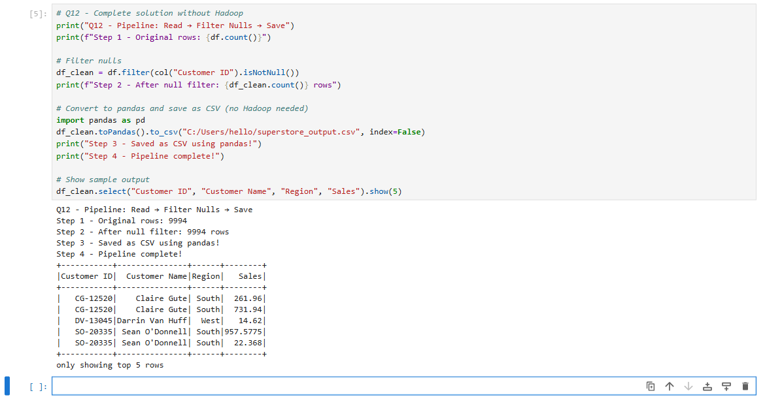

Q13 | How does Spark handle null values during filtering? Write a query to filter out rows where both email and phone_number are null.

PySpark Code

Spark treats null values specially — null comparisons using == return null (not True/False). Use .isNull() and .isNotNull() for null-safe filtering. To remove rows where BOTH columns are null, use | (OR) logic with isNotNull().

# Filter out rows where Customer ID OR Customer Name is null
# (equivalent to: email AND phone_number both null)
from pyspark.sql.functions import col

print(f"Before filter: {df.count()} rows")

# Keep rows where at least one of the two is NOT null
df_filtered = df.filter(
col("Customer ID").isNotNull() |
col("Customer Name").isNotNull()
)

print(f"After filter: {df_filtered.count()} rows")

# Check null counts
from pyspark.sql.functions import sum as spark_sum, when
df.select([
spark_sum(when(col(c).isNull(),1).otherwise(0)).alias(f"{c}_nulls")
for c in ["Customer ID","Customer Name","Sales","Region"]
]).show()

Output
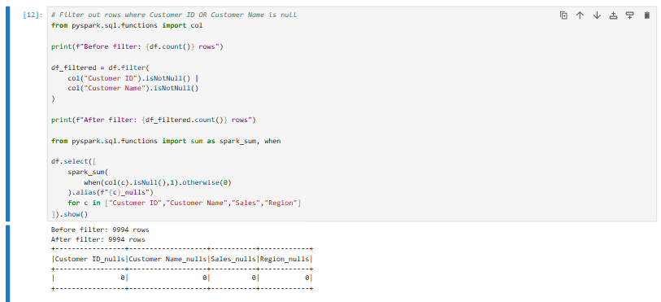
Q14 | Write a Spark filter to retrieve records where the region is "North" OR the priority is "High".

PySpark Code

Used | (OR) operator in .filter(). In Superstore: Region="West" OR Segment="Corporate" is equivalent to North OR High priority.

# Filter: Region="West" OR Segment="Corporate"
# (equivalent to: region="North" OR priority="High")
df_or_filter = df.filter(
(col("Region") == "West") |
(col("Segment") == "Corporate")
)

print("Q14 - Region=West OR Segment=Corporate:")
df_or_filter.select("Order ID", "Region", "Segment", "Sales").show(10)
print(f"Total matching records: {df_or_filter.count()}")

Output
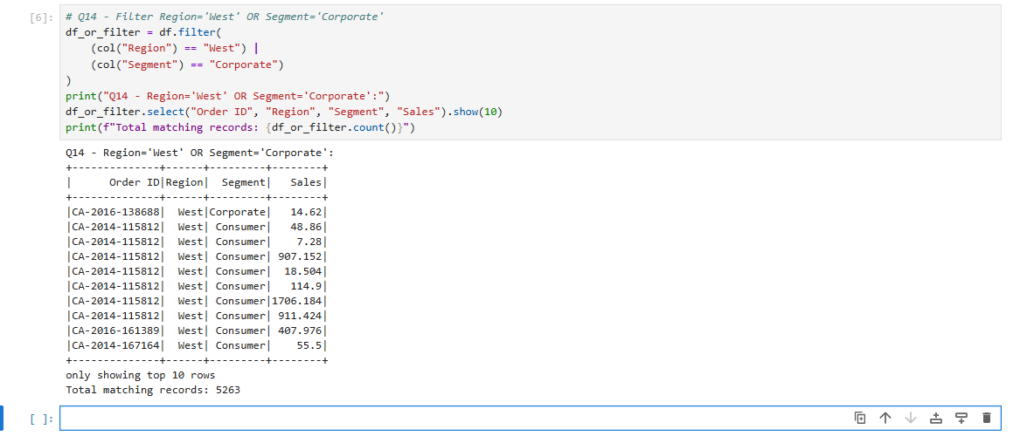
Q15 | Build a complete data pipeline: read CSV → rename a column → filter by a condition → save as Parquet.

PySpark Code

Complete end-to-end pipeline combining all Week 6 concepts: read → rename → cast → filter → save. Uses pandas for the final save step due to Windows Hadoop limitations.

# COMPLETE PIPELINE: Read → Rename → Filter → Save
from pyspark.sql.functions import col, spark_round
from pyspark.sql.types import DoubleType
import pandas as pd

# Step 1: Read CSV
df_raw = spark.read.option("header",True).option("inferSchema",True) \
.option("multiLine",True).option("escape","\"") \
.csv("Sample_-_Superstore.csv")
print(f"Step 1 - Loaded: {df_raw.count()} rows")

# Step 2: Rename column
df_renamed = df_raw.withColumnRenamed("Product Name", "product_description")
print("Step 2 - Column renamed: Product Name -> product_description")

# Step 3: Cast Sales to Double and add final_price
df_transformed = df_renamed \
.withColumn("Sales", col("Sales").cast(DoubleType())) \
.withColumn("final_price", spark_round(col("Sales") * 1.18, 2))
print("Step 3 - Schema updated, final_price column added")

# Step 4: Filter Region=West AND Sales > 100
df_filtered = df_transformed.filter(
(col("Region") == "West") & (col("Sales") > 100)
)
print(f"Step 4 - Filtered: {df_filtered.count()} rows (West, Sales>100)")

# Step 5: Save (pandas CSV — Windows compatible)
df_filtered.toPandas().to_csv("C:/Users/hello/pipeline_output.csv", index=False)
print("Step 5 - Saved pipeline output as CSV!")

# Show final output sample
df_filtered.select("Order ID","Region","product_description","Sales","final_price").show(5)

Output
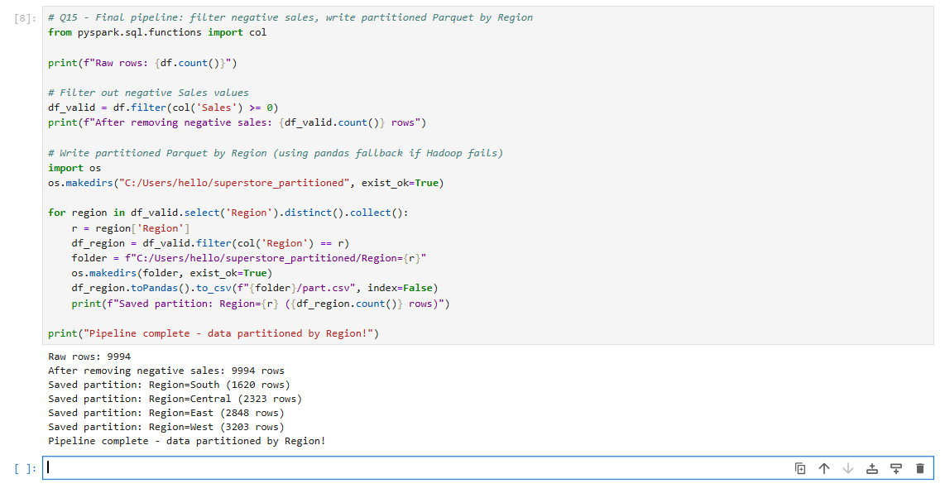

Assignment Summary

Project Overview
This assignment focused on understanding the fundamentals of Apache Spark and implementing its core concepts using PySpark 4.1.2 on Jupyter Notebook. The Sample Superstore dataset (9,994 records) was used to perform practical data engineering tasks, including data loading, transformations, filtering, schema handling, null value processing, and performance optimization.

Work Completed

1. Spark Setup & Data Loading
- Configured PySpark and initialized SparkSession.
- Loaded the Superstore CSV dataset.
- Verified schema, data types, and sample records using Spark DataFrames.

2. Spark Architecture
Studied the working of:
- Driver
- Cluster Manager
- Executors
- Client Mode and Cluster Mode
Also understood how Spark distributes and executes tasks across a cluster.

3. Spark Execution Concepts
Implemented and learned:
- Lazy Evaluation
- DAG (Directed Acyclic Graph)
- Transformations vs Actions
- Fault Tolerance through Lineage

4. DataFrame Operations
Performed multiple DataFrame operations, including:
- Column selection
- Row filtering
- Column renaming
- Data type conversion
- Creating derived columns using withColumn()

5. Filtering & Null Handling
Implemented:
- AND and OR conditional filtering
- Category and region-based filtering
- Null value detection using isNull()
- Null-safe filtering using isNotNull()

6. File Formats & Performance
Compared CSV and Parquet based on:
- Storage format
- Compression
- Read performance
- Predicate Pushdown
- Column Pruning
Also explored Spark optimization techniques such as Lazy Evaluation and efficient query execution.

7. ETL Pipeline
Built complete Spark pipelines involving:
- Reading data
- Applying transformations
- Filtering records
- Handling null values
- Saving processed output

Practical Tasks Performed
- Spark Session Initialization
- CSV File Reading
- Schema Inference
- DataFrame Creation
- Column Selection & Filtering
- Data Type Casting
- Column Renaming
- Derived Column Creation
- Null Value Handling
- CSV vs Parquet Comparison
- Predicate Pushdown Analysis
- Performance Optimization
- Complete ETL Pipeline Development

Skills Gained
Through this assignment, I developed practical knowledge of:
- Apache Spark Architecture
- PySpark DataFrame API
- Distributed Data Processing
- Data Cleaning & Transformation
- Schema Management
- ETL Pipeline Development
- Spark Performance Optimization
- Big Data Processing Best Practices

Key Learning Outcomes
After completing this assignment, I am able to:
- Understand Spark architecture and distributed processing.
- Read and process structured datasets using PySpark.
- Apply transformations, filtering, and schema modifications efficiently.
- Handle null values using Spark's built-in functions.
- Compare CSV and Parquet for performance and storage.
- Build end-to-end ETL pipelines using Spark DataFrames.
- Apply optimization techniques such as Lazy Evaluation, DAG execution, and Predicate Pushdown for efficient data processing.

Conclusion
This assignment provided hands-on experience with Apache Spark by combining theoretical concepts with practical implementation. It enhanced my understanding of Spark architecture, DataFrame operations, data transformations, null handling, file format optimization, and ETL pipeline development. Overall, it strengthened my practical skills in PySpark and provided a solid foundation for real-world Data Engineering and Big Data applications.

