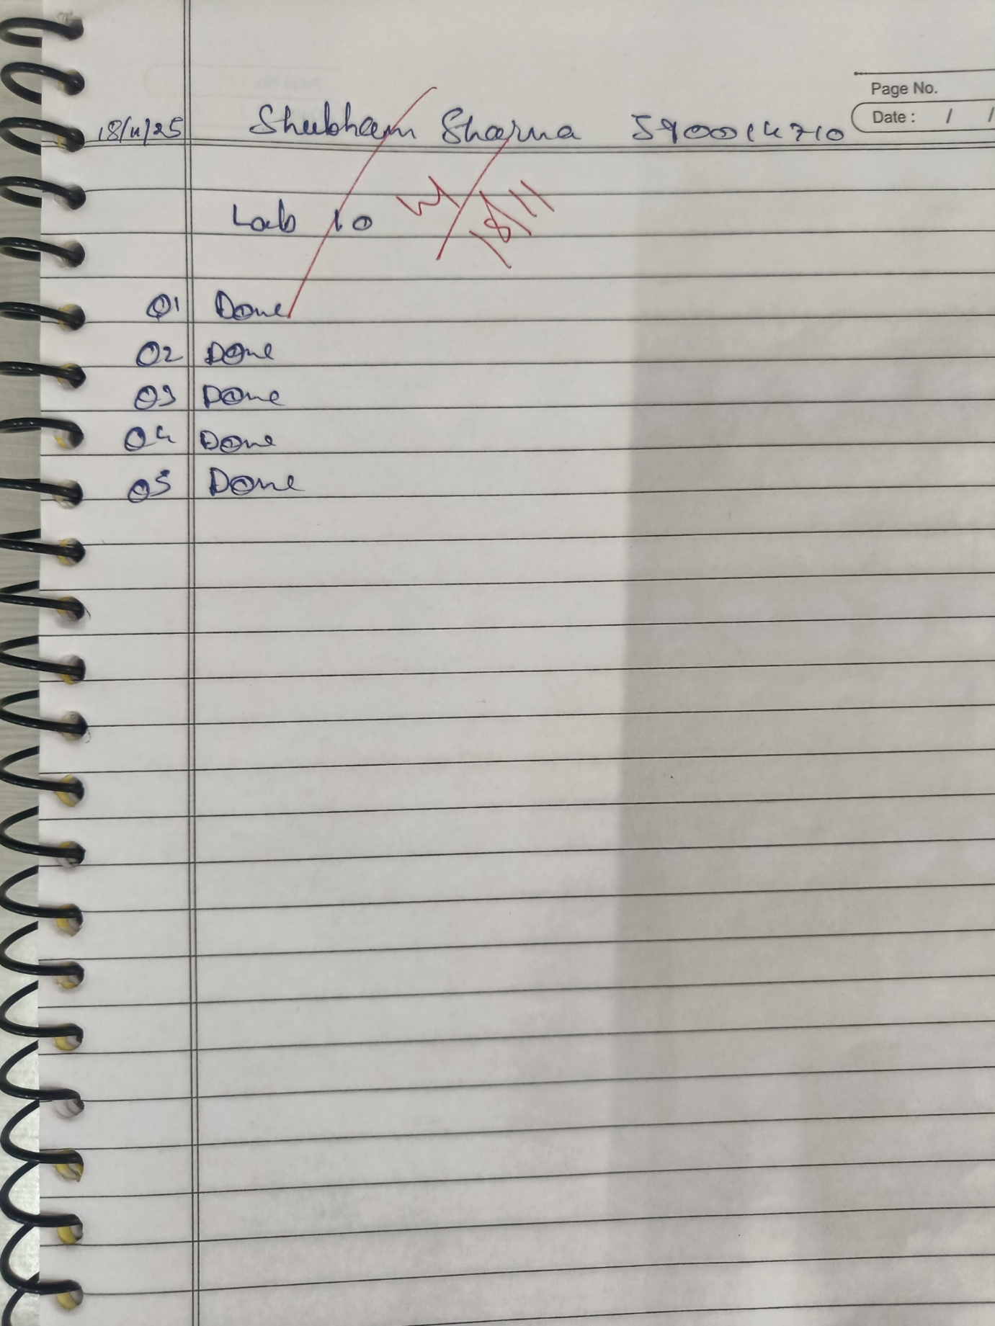
LAB 10 #PL/SQL Commands

Write a PL/SQL code to accept the value of A, B & C display which is greater.
DECLARE
a NUMBER := 10; -- Input value for A b NUMBER := 20; -- Input value for B
c NUMBER := 15; -- Input value for C
BEGIN
IF a > b AND a > c THEN
DBMS_OUTPUT.PUT_LINE('A is greater'); ELSIF b > a AND b > c THEN
DBMS_OUTPUT.PUT_LINE('B is greater');
ELSE
DBMS_OUTPUT.PUT_LINE('C is greater'); END IF;
END;
/
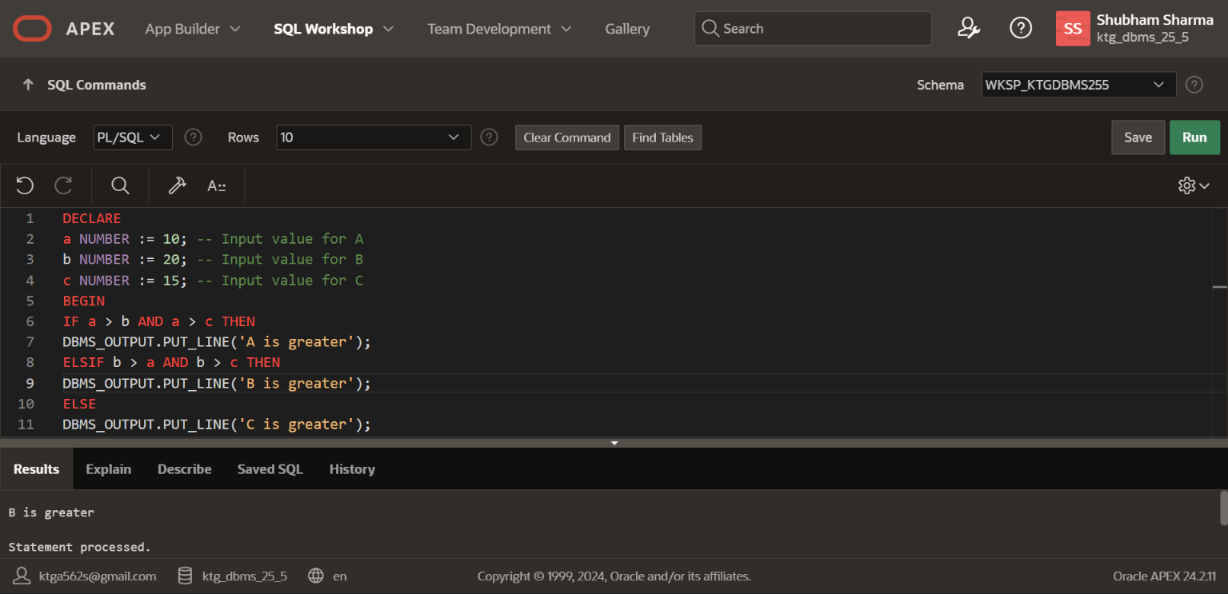
Using PL/SQL Statements create a simple loop that display message “Welcome to PL/SQL Programming” 20 times.
BEGIN
FOR i IN 1..20 LOOP
DBMS_OUTPUT.PUT_LINE('Welcome to PL/SQL Programming'); END LOOP;
END;
/
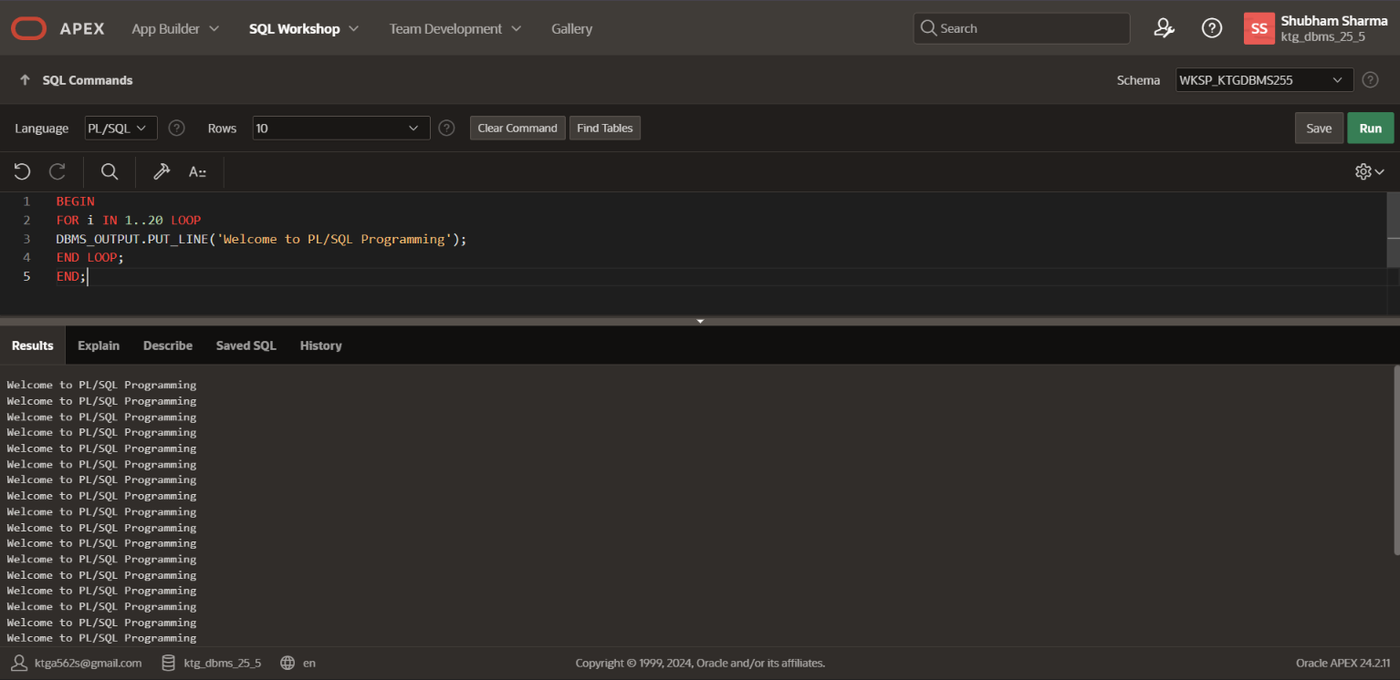
Write a PL/SQL code block to find the factorial of a number.
DECLARE
num NUMBER := 5; -- Input number
factorial NUMBER := 1;
BEGIN
FOR i IN 1..num LOOP
factorial := factorial * i;
END LOOP;
DBMS_OUTPUT.PUT_LINE('Factorial of ' || num || ' is ' || factorial);
END;
/
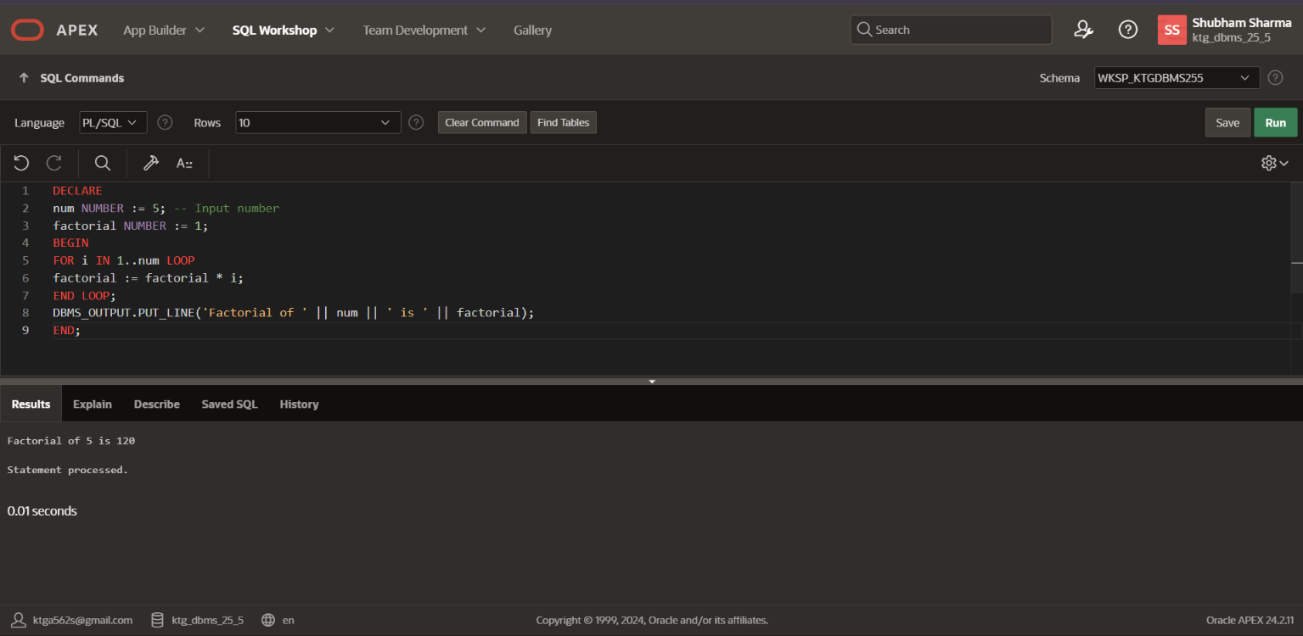
Write a PL/SQL program to generate Fibonacci series.
-- Create a PL/SQL block to generate Fibonacci series
DECLARE
-- Variables to hold Fibonacci sequence
first_number NUMBER := 0; second_number NUMBER := 1; next_number NUMBER; limit_number NUMBER := 100; -- Change this limit as per requirement

-- Cursor declaration to print Fibonacci series
CURSOR fibonacci_cursor IS
SELECT LEVEL AS n, first_number AS Fibonacci_Number FROM DUAL

CONNECT BY LEVEL <= limit_number;
BEGIN
-- Print the initial values
DBMS_OUTPUT.PUT_LINE('Fibonacci Series up to ' || limit_number || ' numbers:');
DBMS_OUTPUT.PUT_LINE('0'); -- First Fibonacci number
DBMS_OUTPUT.PUT_LINE('1'); -- Second Fibonacci number

-- Loop to generate and print Fibonacci series
FOR i IN 3..limit_number LOOP
next_number := first_number + second_number; first_number := second_number;
second_number := next_number;
DBMS_OUTPUT.PUT_LINE(next_number);
END LOOP;
END;
/
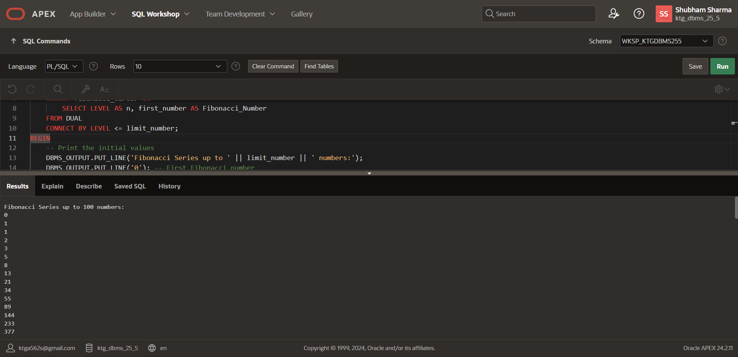
Write a PL/SQL code to find the sum of first N numbers.
-- Create a PL/SQL block to find the sum of first N numbers
DECLARE
-- Variable to hold the sum
total_sum NUMBER := 0;

-- Variable for the number up to which sum is to be calculated N NUMBER := 100; -- Change N to the desired number

BEGIN
-- Loop to calculate the sum of first N numbers
FOR i IN 1..N LOOP
total_sum := total_sum + i;
END LOOP;

-- Print the sum
DBMS_OUTPUT.PUT_LINE('The sum of first ' || N || ' numbers is: ' || total_sum);
END;
/ 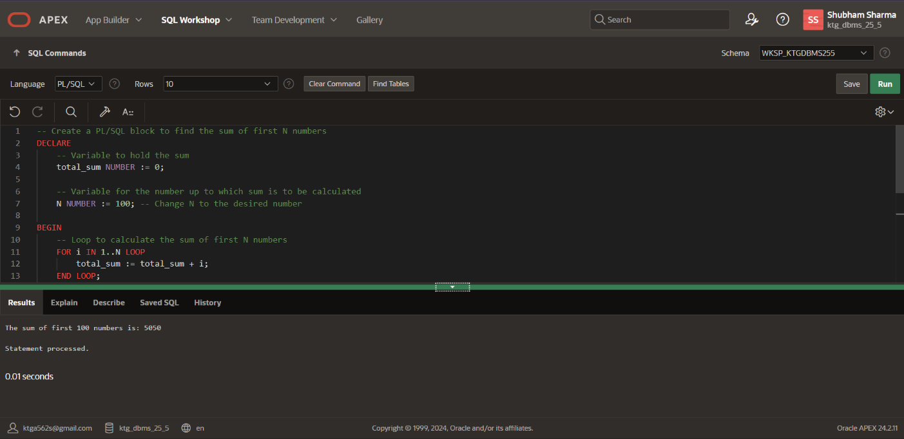
WAP that accept the value of A, B & C display which is greater using Functions and Procedures.
DECLARE
-- Variables to hold the values of A, B, and C
- NUMBER := 10; -- Replace with your desired value for A
- NUMBER := 20; -- Replace with your desired value for B C NUMBER := 15; -- Replace with your desired value for C

-- Function to find the maximum of two numbers
FUNCTION find_maximum(x NUMBER, y NUMBER) RETURN NUMBER IS
BEGIN
IF x > y THEN
RETURN x;
ELSE
RETURN y;
END IF;
END find_maximum;

-- Procedure to compare three numbers and display the greatest
PROCEDURE compare_and_display_greatest(A IN NUMBER, B IN NUMBER, C IN NUMBER)
IS greatest NUMBER; BEGIN
greatest := find_maximum(find_maximum(A, B), C); -- Call the function to find the maximum of three numbers

-- Display the result
IF greatest = A THEN
DBMS_OUTPUT.PUT_LINE('A is the greatest.');
ELSIF greatest = B THEN
DBMS_OUTPUT.PUT_LINE('B is the greatest.');
ELSE
DBMS_OUTPUT.PUT_LINE('C is the greatest.');
END IF;
END compare_and_display_greatest;
BEGIN
-- Call the procedure to compare and display the greatest
compare_and_display_greatest(A, B, C);
END;
/
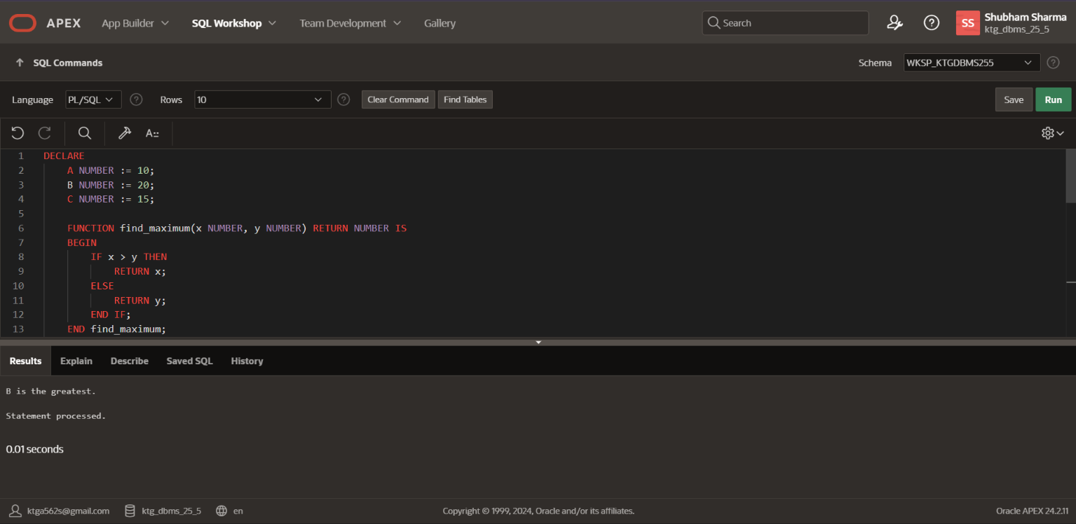
Print the statements “Welcome to PL/SQL Programming” 20 times using Functions and Procedures.
DECLARE
-- Variable to store the message
message VARCHAR2(100) := 'Welcome to PL/SQL Programming';

-- Procedure to display message 20 times
PROCEDURE display_message IS
BEGIN
-- Loop to display the message 20 times
FOR i IN 1..20 LOOP
DBMS_OUTPUT.PUT_LINE(message);
END LOOP;
END display_message;
BEGIN
-- Call the procedure to display the message display_message;
END;
/
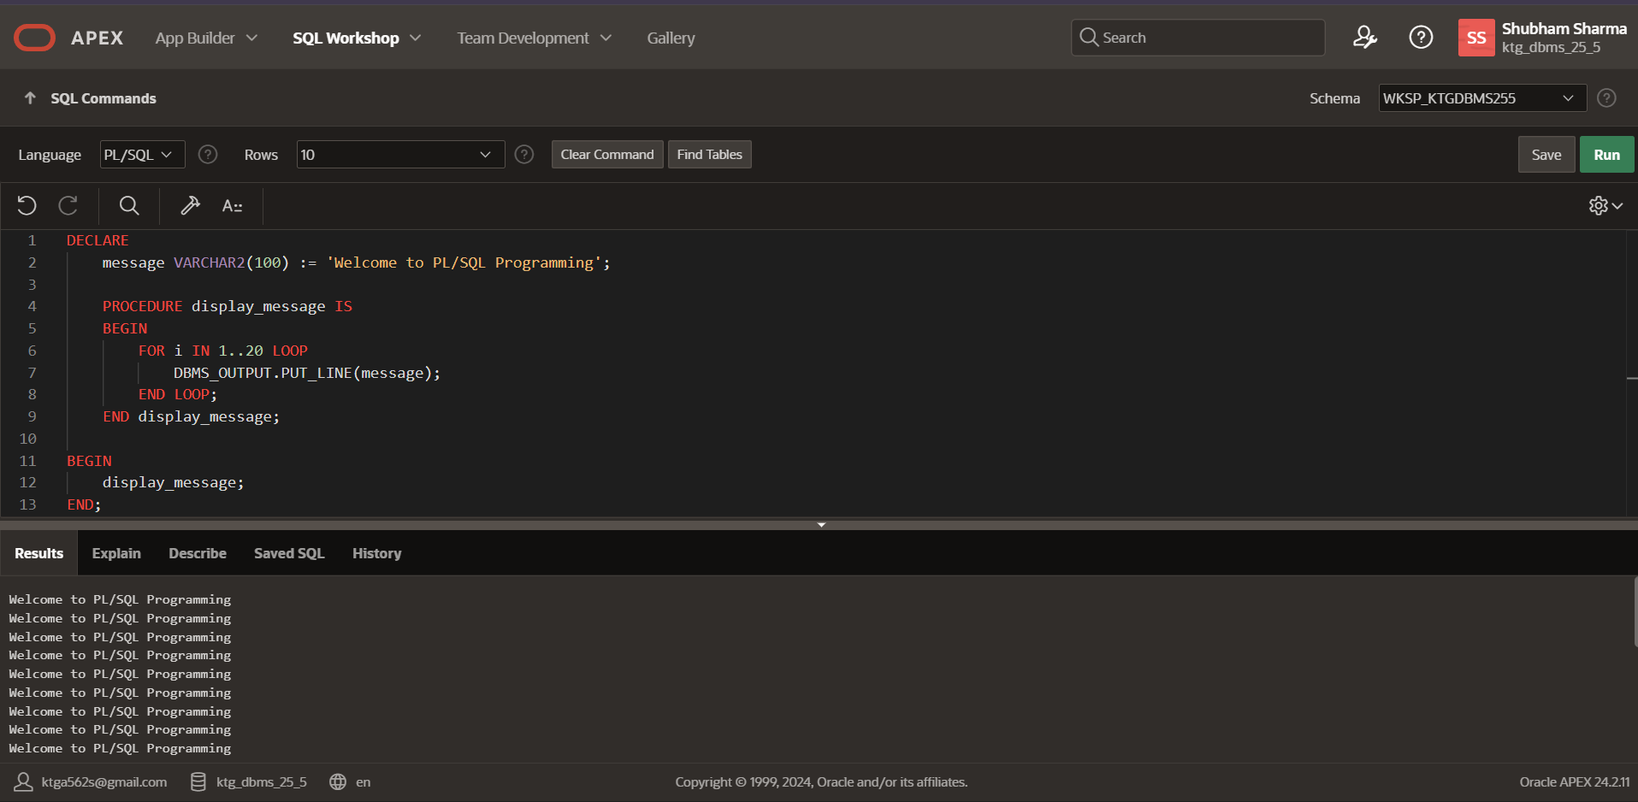
Factorial of a number using function and procedure.
DECLARE
-- Variable to hold the value for factorial calculation
n NUMBER := 5; -- Replace with your desired value for factorial calculation

-- Function to calculate factorial of a number
FUNCTION factorial(num NUMBER) RETURN NUMBER IS result NUMBER := 1;
BEGIN
IF num <= 1 THEN
RETURN result;

ELSE
FOR i IN 2..num LOOP
result := result * i;
END LOOP;
RETURN result;
END IF;
END factorial;

-- Procedure to calculate and display factorial
PROCEDURE calculate_and_display_factorial(n IN NUMBER) IS fact NUMBER; BEGIN
fact := factorial(n); -- Call the function to calculate factorial

-- Display the result
DBMS_OUTPUT.PUT_LINE('Factorial of ' || n || ' is: ' || fact); END calculate_and_display_factorial;
BEGIN
-- Call the procedure to calculate and display factorial
calculate_and_display_factorial(n);
END;
/
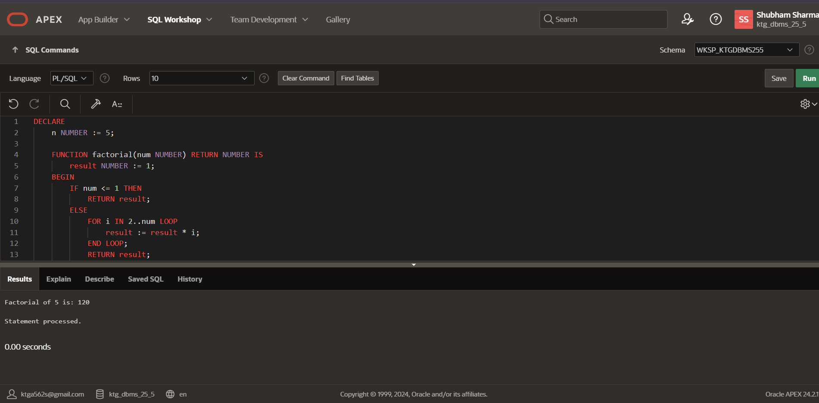
Fibonacci series of a number using function and procedure.
DECLARE
-- Variable to hold the number of terms in the Fibonacci series
num_terms NUMBER := 16; -- Replace with your desired number of terms

-- Function to calculate Fibonacci series
FUNCTION fibonacci_series(num_terms_in NUMBER) RETURN VARCHAR2 IS
fib_series VARCHAR2(1000) := '0, 1'; -- Initial values of Fibonacci series a NUMBER := 0; b NUMBER := 1; next_term NUMBER;
BEGIN
IF num_terms_in <= 0 THEN
RETURN 'Invalid input';
END IF;

IF num_terms_in = 1 THEN
RETURN '0';
END IF;

IF num_terms_in = 2 THEN
RETURN '0, 1';
END IF;

FOR i IN 3..num_terms_in LOOP next_term := a + b; fib_series := fib_series || ', ' || next_term; a := b;
b := next_term;
END LOOP;

RETURN fib_series;
END fibonacci_series;

-- Procedure to display Fibonacci series
PROCEDURE display_fibonacci_series(num_terms_in NUMBER) IS fib_series VARCHAR2(1000); BEGIN
fib_series := fibonacci_series(num_terms_in); -- Call the function to calculate Fibonacci series

-- Display the result
DBMS_OUTPUT.PUT_LINE('Fibonacci series up to ' || num_terms_in || ' terms: ' || fib_series);
END display_fibonacci_series;
BEGIN
-- Call the procedure to display Fibonacci series display_fibonacci_series(num_terms);
END;
/
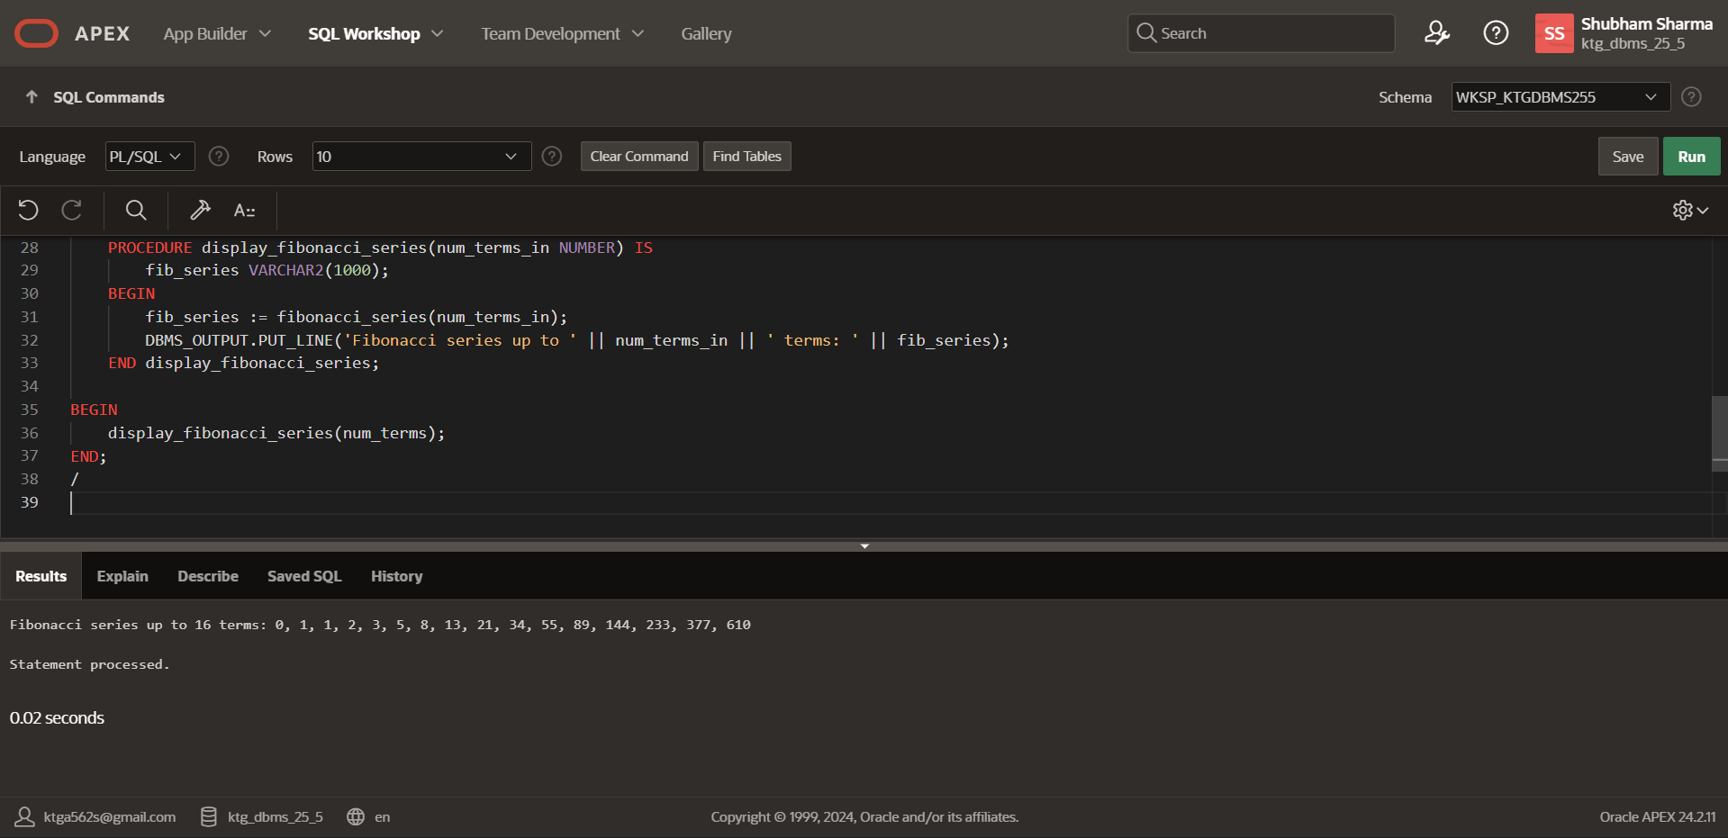
Find the sum of first N numbers using Function and Procedure.
DECLARE
-- Variable to hold the number of terms
num_terms NUMBER := 16; -- Replace with your desired number of terms

-- Function to calculate the sum of first N numbers
FUNCTION sum_of_first_n_numbers(n NUMBER) RETURN NUMBER IS total_sum NUMBER := 0;
BEGIN
IF n <= 0 THEN
RETURN 0; -- Return 0 for non-positive input
END IF;

FOR i IN 1..n LOOP
total_sum := total_sum + i; -- Add each number from 1 to n to total_sum END LOOP;

RETURN total_sum;
END sum_of_first_n_numbers;

-- Procedure to display the sum of first N numbers
PROCEDURE display_sum_of_first_n_numbers(n NUMBER) IS sum_result NUMBER; BEGIN
sum_result := sum_of_first_n_numbers(n); -- Call the function to calculate sum -- Display the result
DBMS_OUTPUT.PUT_LINE('Sum of first ' || n || ' numbers: ' || sum_result); END display_sum_of_first_n_numbers;
BEGIN
-- Call the procedure to display the sum display_sum_of_first_n_numbers(num_terms);
END;
/
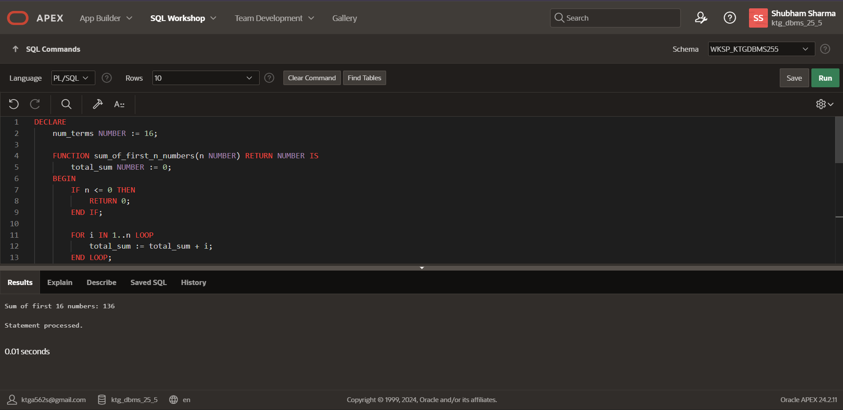
Lab Performance Questions
- Write a PL/SQL code to calculate the area of a circle given its radius.
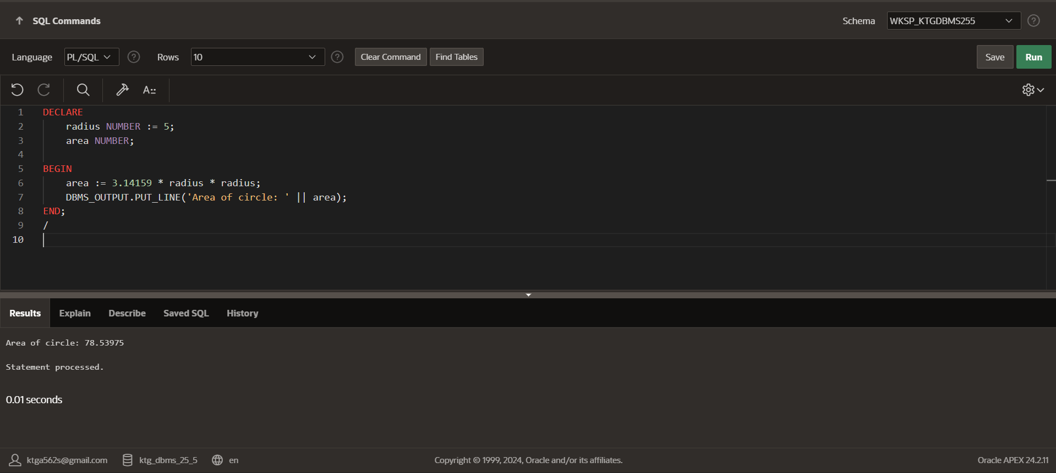

- Create a PL/SQL program to check whether a given number is prime or not.
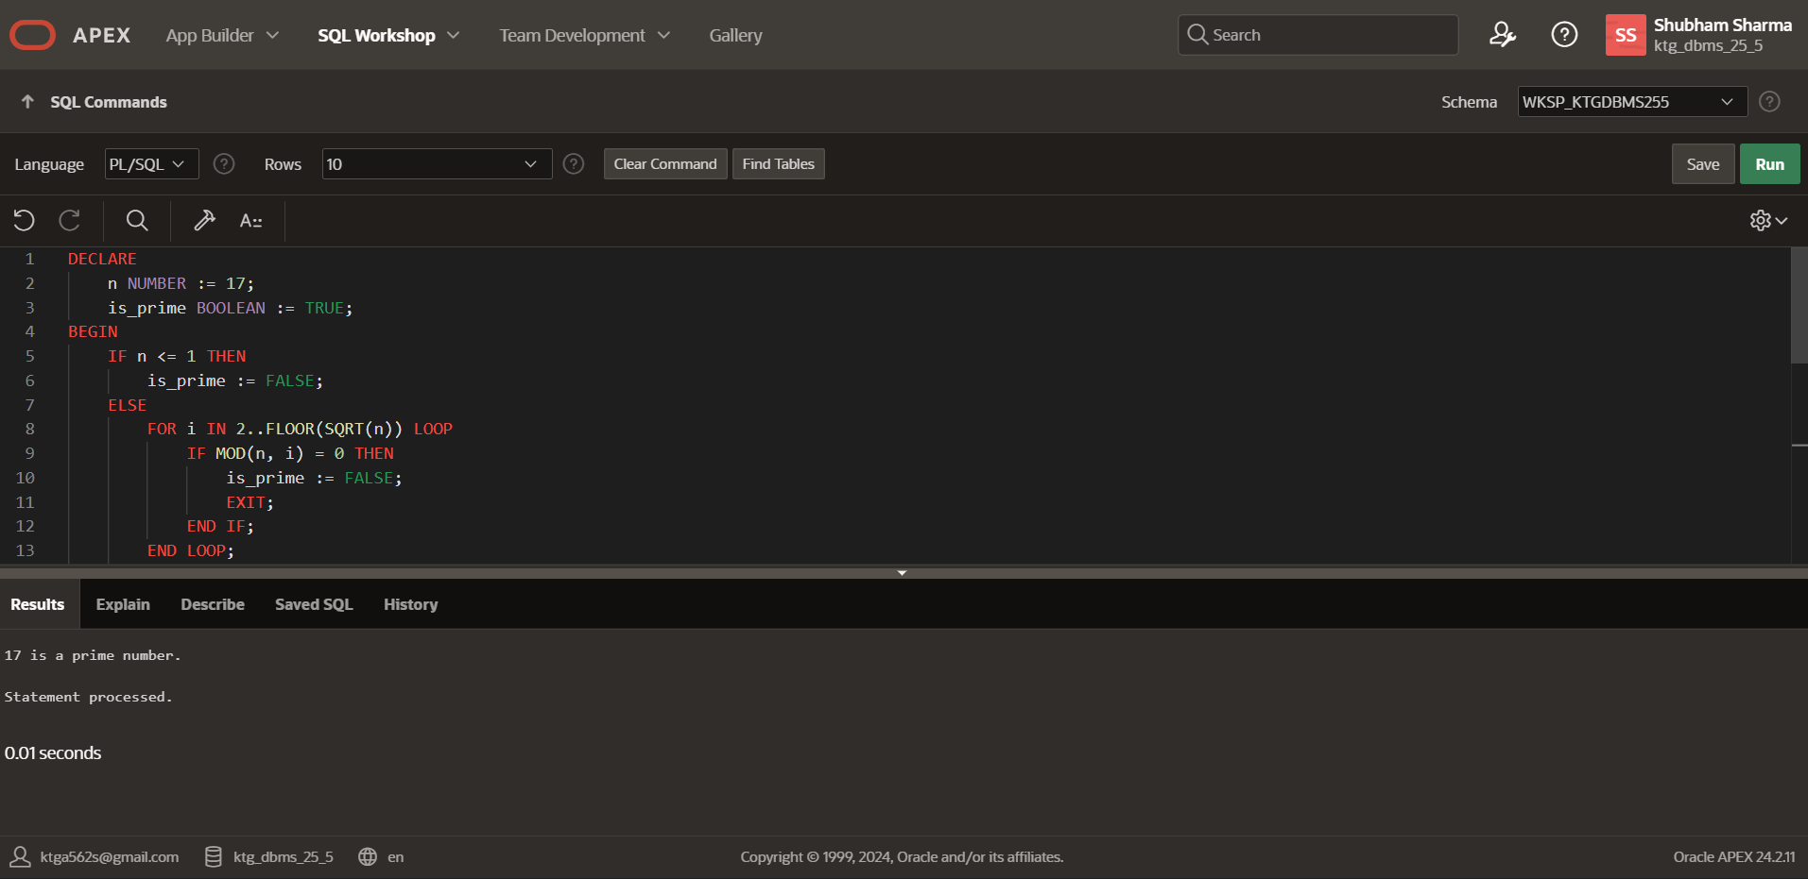
- Develop a PL/SQL script to reverse a string entered by the user.
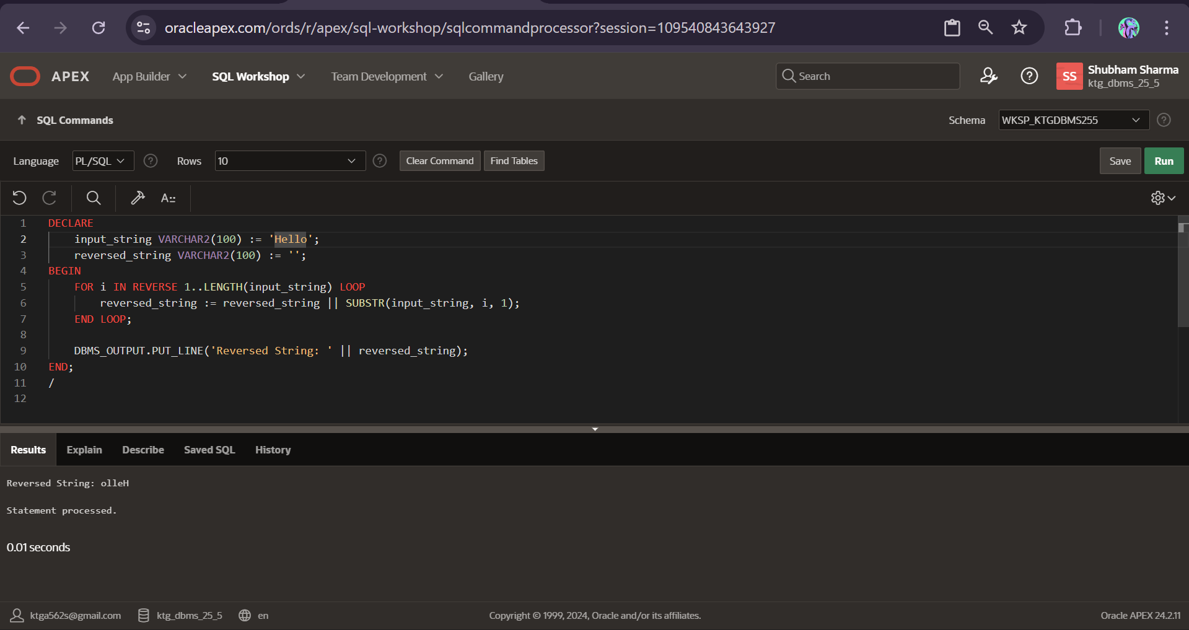
- Design a PL/SQL code to find the largest and smallest number among three given numbers.
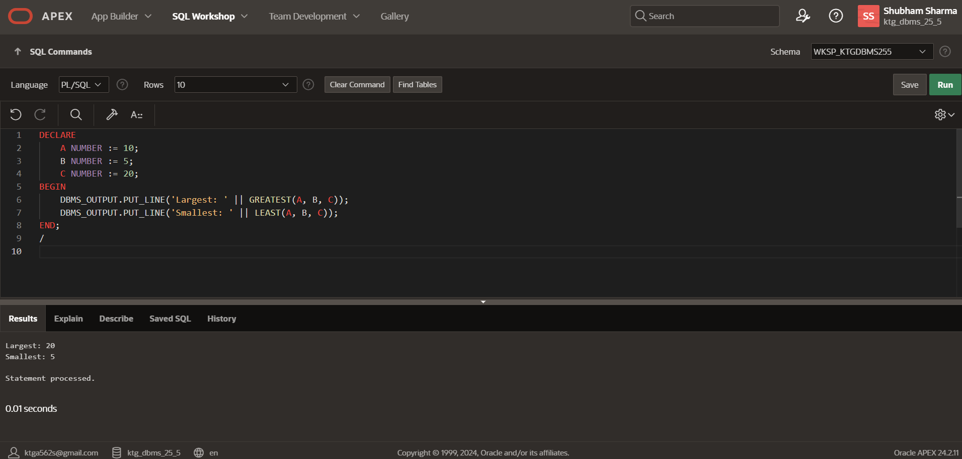

- Implement a PL/SQL program to calculate the compound interest for a given principal amount, rate, and time period.
