A
INDUSTRIAL TRAINING REPORT
On
“CRAVO”
Next-Gen Food Ordering, Food Mood Discovery & AI Meal Planner Platform
Has been completed under the industrial training curriculum
UNDER THE GUIDANCE OF
Prof. N. Pathrut

NBA Accredited & ISO 9001:2015 certified
VIDYA VIKAS PRATISHTHAN POLYTECHNIC, SOLAPUR
Department of Computer Engineering • Institute Code – 0854
Academic Year 2025–2026

NBA Accredited & ISO 9001:2015 certified
VIDYA VIKAS PRATISHTHAN POLYTECHNIC, SOLAPUR
CERTIFICATE
This is to certify that the Industrial Training Project entitled
“CRAVO: Next-Gen Food Ordering & AI Meal Platform”
Has been successfully completed
By
SHUBHAM DINESH VERNEKAR
Enrollment No: 24212130227
Of
T.Y. (Computer Engineering) — Institute Code – 0854
Has been submitted in partial fulfillment of the Industrial Training Report as per the curriculum laid down by the Maharashtra State Board of Technical Education (M.S.B.T.E. Mumbai), during the academic year 2025–2026.
Prof. N. Pathrut  (GUIDE) | Prof. M.V. Buddhe  (H.O.D.) | Dr. S. N. Kulkarni  (PRINCIPAL)

SHUBDEEP LABS
Software Development, AI Solutions & Web Consulting Services
Solapur & Bengaluru, Maharashtra / Karnataka
CERTIFICATE OF INDUSTRIAL TRAINING COMPLETION
TO WHOMSOEVER IT MAY CONCERN:
This is to certify that Mr. SHUBHAM DINESH VERNEKAR, a student of Vidya Vikas Pratishthan Polytechnic, Solapur (Enrollment No: 24212130227), pursuing Diploma in Computer Engineering, has successfully completed 6 weeks of comprehensive Industrial Training at SHUBDEEP LABS during the academic session 2025–2026.
During his training tenure, he actively worked on the live software engineering project titled “CRAVO: Next-Gen Food Ordering Platform” — an intelligent, full-stack food delivery application featuring sensory Food Mood discovery, Knapsack budget combo optimization (Meals Under ₹100), and an AI-driven macro meal planner.
His core technical responsibilities encompassed Full-Stack Web Development using Next.js 15 App Router, React 19, TypeScript, Tailwind CSS, Framer Motion, and Lenis Inertial Scrolling Engine, ensuring 100% responsive ergonomics across mobile and desktop devices.
During the training period, his conduct was exemplary, displaying strong technical acumen, problem-solving ability, punctuality, and teamwork. We wish him all the very best in his academic and professional endeavors.
Date: October 2026 | Solapur For SHUBDEEP LABS,
__________________________
Authorized Signatory & Training Head

ACKNOWLEDGEMENT
I express my deepest gratitude and sincere thanks to my project guide, Prof. N. Pathrut, for his invaluable guidance, continuous encouragement, technical suggestions, and constructive criticism throughout the tenure of this industrial training. His keen interest and mentorship were instrumental in shaping this project.
I am profoundly grateful to Prof. M.V. Buddhe, Head of the Department of Computer Engineering, for providing excellent departmental facilities, laboratory resources, and encouragement that facilitated the smooth execution of the industrial training.
I extend my heartfelt thanks to Dr. S. N. Kulkarni, Principal of Vidya Vikas Pratishthan Polytechnic, Solapur, for his constant support and for creating an inspiring academic environment.
I also extend my sincere appreciation to the technical team and mentors at SHUBDEEP LABS for providing real-world software engineering exposure, industry mentorship, and practical training during my industrial internship.
Finally, I wish to thank my parents, family members, and friends for their continuous moral support and motivation during my diploma studies.
SHUBHAM DINESH VERNEKAR
Enrollment No: 24212130227
T.Y. Computer Engineering
Vidya Vikas Pratishthan Polytechnic, Solapur

ABSTRACT
Online food delivery applications represent a multi-billion dollar digital industry, yet contemporary consumer platforms suffer from severe decision fatigue caused by cluttered restaurant directories, multi-page menus, and opaque pricing. Users routinely spend upwards of 12 minutes simply attempting to decide what to eat, frequently abandoning carts in frustration.
To solve these fundamental user experience challenges, the CRAVO food ordering platform was engineered during an intensive 6-week industrial training program at SHUBDEEP LABS. The platform is a modern, high-performance web application built with Next.js 15 App Router, React 19, TypeScript, Tailwind CSS, Framer Motion, and Lenis Smooth Inertial Scrolling.
Key technical and architectural innovations implemented in the system include:
- Food Mood Sensory Engine: Categorizes culinary options into 9 distinct psychological mood archetypes (Craving, Spicy Hit, Comfort, Healthy & Fresh, High Protein, Sweet Tooth, Cheat Day, Light & Easy, Party Vibes) with fluid auto-scroll matching.
- Meals Under ₹100 Knapsack Optimizer: Implements a dynamic programming combinatorial optimization algorithm that automatically constructs balanced multi-item meal combos (Main + Drink + Side) strictly within a ₹50, ₹75, or ₹100 budget ceiling.
- Gamified ₹100 Challenge Arena: An interactive budget playground with live liquid progress meter and automated reward trigger granting +20 CRAVO loyalty points upon building an optimal meal.
- AI Food Planner & Macro Intelligence: Natural language conversational interface that parses dietary goals, calculates macro distributions (Protein, Carbs, Fats, Calories), and allows instant single-click cart injection.
- Slide-Out Craving Bag & Operations Portal: Interactive drawer featuring real-time free delivery goal bars, promo code engine, and comprehensive admin analytics dashboard.
📌 Industrial Training Outcome:
The project delivers a production-grade, responsive full-stack application tested against automated test suites with 100% pass rates, fulfilling all industrial and MSBTE academic criteria.

INDEX / TABLE OF CONTENTS
Sr. | Chapter Title & Sub-Sections | Page
— | Preliminary: Certificates, Acknowledgement & Abstract | i – v
1 | ORGANIZATION PROFILE – SHUBDEEP LABS  1.1 Overview & Technical Domains of ShubDeep Labs  1.2 Industrial Training Objectives & Assigned Project Scope | 1  1  2
2 | INTRODUCTION & PROJECT OVERVIEW  2.1 Background of Food Tech & Decision Fatigue  2.2 Problem Statement & Challenges in Food Delivery  2.3 Objectives & Vision of CRAVO Platform | 3  3  4  4
3 | SYSTEM REQUIREMENTS SPECIFICATION (SRS)  3.1 Hardware & Software Environments (Detailed Tech Specs)  3.2 Functional (FR1–FR8) & Non-Functional (NFR1–NFR4) Requirements | 5  5  6
4 | SYSTEM ARCHITECTURE & DATA DESIGN  4.1 Next.js App Router Architecture & Component Flow  4.2 Relational Data Models & Cart Data Dictionary | 7  7  8
5 | CORE ALGORITHMS & HEURISTICS  5.1 Knapsack Dynamic Programming Budget Optimizer  5.2 Sensory Food Mood Matching Heuristic & Macro Balancer | 10  10  11
6 | APPLICATION MODULES & USER INTERFACE SCREENSHOTS  6.1 Home Portal & Craving Roulette (Figure 6.1)  6.2 Food Mood Sensory Matching Engine (Figure 6.2)  6.3 Meals Under ₹100 Optimizer & Challenge (Figure 6.3)  6.4 AI Food Planner & Macro Nutrient Intelligence (Figure 6.4)  6.5 Explore Dishes & Category Directory (Figure 6.5)  6.6 Admin Analytics & Kitchen Operations Dashboard (Figure 6.6) | 12  12  13  14  15  16  17
7 | TESTING & QUALITY ASSURANCE  7.1 Testing Strategy & Test Case Execution Suite (TC01–TC07) | 18  18
8 | CONCLUSION & FUTURE SCOPE  8.1 Summary & Industrial Training Outcomes  8.2 Future Scope & Planned Enhancements | 20  20  20
9 | REFERENCES & BIBLIOGRAPHY | 21

CHAPTER 1: ORGANIZATION PROFILE – SHUBDEEP LABS

1.1 Overview & Technical Domains of ShubDeep Labs
SHUBDEEP LABS is a progressive information technology and software product engineering organization committed to delivering cutting-edge web applications, artificial intelligence products, and combinatorial algorithmic solutions. Located across Solapur and Bengaluru, the organization provides specialized software engineering consulting, agile product development, and structured industrial internship training for engineering candidates.
Core Competencies: Core technological capabilities at ShubDeep Labs include:
- Full-Stack Modern Web Engineering: Next.js 15, React 19, TypeScript, Node.js, Tailwind CSS, Framer Motion, and Lenis momentum physics.
- Algorithmic Optimization & AI Systems: Dynamic programming combinatorial models (Knapsack algorithms), natural language meal planners, and macro nutrient analyzers.
- State & Client Architecture: React Context API, LocalStorage caching, REST API integration, and optimistic UI updates.
- Software Quality Assurance: Automated testing, unit/integration test suites, responsive device emulation, and CI/CD pipelines.

1.2 Industrial Training Objectives & Assigned Project Scope
The 6-week industrial training curriculum at ShubDeep Labs was designed to provide end-to-end practical immersion into modern full-stack development. The assigned project, titled “CRAVO”, was conceived to solve the critical operational challenge of user decision fatigue and budget unpredictability in online food ordering.
Internship Objectives: The primary technical training objectives included:
- Mastering Next.js 15 App Router architecture, Server and Client Components, and TypeScript type safety.
- Designing and implementing a 0/1 Knapsack Dynamic Programming solver for optimal meal combo synthesis.
- Implementing buttery 60/120 FPS inertial momentum scrolling and micro-animations for responsive user interfaces.
- Conducting functional, performance, and cross-browser quality assurance testing.

CHAPTER 2: INTRODUCTION & PROJECT OVERVIEW

2.1 Background of Food Tech & Decision Fatigue
Online food delivery platforms have transformed urban dining. However, modern platforms have become overwhelming digital directories with hundreds of restaurants, multi-page menus, and advertising banners. Consumers frequently suffer from decision fatigue, spending over 10-15 minutes attempting to decide on a dish before abandoning the application in frustration.

2.2 Problem Statement & Challenges in Food Delivery
The primary operational and user experience challenges identified in conventional food ordering platforms include:
- Restaurant-Centric Directory Paradigm: Users are forced to browse by restaurant brand rather than directly by their culinary craving.
- Budget Unpredictability for Multi-Item Meals: Students and office workers struggle to purchase balanced multi-item meals (Main + Drink + Side) without exceeding ₹100 after taxes and delivery fees.
- Lack of Mood-Based Discovery: Food choices are intimately linked to emotional states (comfort, spicy boost, healthy detox, celebration), which directory apps completely ignore.
- Absence of Automated AI Meal Planners: Health-conscious individuals lack rapid tools to calculate calorie, protein, and fat distributions for balanced meals.

2.3 Objectives & Vision of CRAVO Platform
CRAVO addresses these problems through the Anti-Directory Formula:
- Food Mood Sensory Matcher: 9 psychological mood archetypes delivering instant matched dish feeds with smooth auto-scroll.
- Meals Under ₹100 Solver: Combinatorial dynamic programming optimizer creating multi-item combos guaranteed under ₹100.
- AI Food Planner: Instant conversational meal recommendation engine with automated macro balancing.
- Ultra-Smooth Lenis Scroll: Fluid 120 FPS inertial scrolling eliminating UI friction.

CHAPTER 3: SYSTEM REQUIREMENTS SPECIFICATION (SRS)

3.1 Hardware & Software Environments
Component | Minimum Requirement | Recommended Specification
Processor | Dual-Core 2.0 GHz Intel/AMD | Intel Core i5 / AMD Ryzen 5 (4+ Cores)
System RAM | 4 GB DDR4 | 8 GB – 16 GB DDR4
Storage | 500 MB disk space | 256 GB NVMe SSD
Display Resolution | 1024 x 768 pixels (Mobile & Desktop) | 1920 x 1080 (Full HD Display)
Network | Standard Internet Connection | High-Speed Broadband / 5G Connection

Layer | Technology / Tool | Version | Purpose
Operating System | Windows 10/11 / Linux / macOS | 64-Bit | Development & Deployment Host
Framework | Next.js (App Router) | 15.2.x | SSR, SSG & Modular Page Routing
Core Language | TypeScript / JavaScript (Node.js) | 5.7.x / 20.x | Type-Safe Application Logic
UI Library | React | 19.0.x | Component State & DOM Rendering
Styling | Tailwind CSS | 3.4.x | Responsive Design System
Animation | Framer Motion | 12.4.x | Spring Micro-Interactions
Scroll Physics | Lenis | 1.1.x | 120 FPS Inertial Smooth Scrolling

3.2 Functional & Non-Functional Requirements
1. Functional Requirements (FR):
- FR1: Food Mood Sensory Engine: Enable users to select among 9 mood archetypes and smoothly auto-scroll to matching dishes.
- FR2: Meals Under ₹100 Solver: Synthesize balanced combos (Main + Drink + Side) within strict budget limits (₹50, ₹75, ₹100).
- FR3: Gamified ₹100 Challenge: Track live spending meter and award +20 CRAVO loyalty points upon building an optimized meal.
- FR4: AI Meal Planner: Parse natural language queries, compute exact calories/macros, and offer single-click cart injection.
- FR5: Interactive Craving Bag: Dynamic slide-out cart drawer with free delivery progress meter and promo code discounting.
- FR6: Admin Analytics Dashboard: Real-time kitchen order tracking, revenue metrics, and dispatch operations management.
2. Non-Functional Requirements (NFR):
- NFR1 - Performance: Initial page load < 1.2s; page navigation transitions < 100ms.
- NFR2 - Fluidity & Aesthetics: 60–120 FPS smooth inertial momentum scrolling via Lenis engine.
- NFR3 - Mobile Compatibility: 100% responsive viewport optimization with safe area insets and touch-optimized buttons.

CHAPTER 4: SYSTEM ARCHITECTURE & DATA DESIGN

4.1 Next.js App Router Architecture
CRAVO adopts Next.js 15's unified App Router architecture with modular client/server component separation:
- App Routing Layer (app/): Provides dedicated routes for /food-mood, /under-100, /ai-planner, /explore, /orders, /profile, and /admin.
- Component Hierarchy (components/): Modular UI elements such as FoodCard, CartDrawer, Navbar, MobileNav, and SmoothScrollProvider.
- Global State Provider (context/AppContext.tsx): Manages persistent cart items, active delivery hubs, promo discounts, and loyalty points.
- Algorithmic Engine (lib/budget/optimizer.ts): Encapsulates the 0/1 Knapsack combinatorial optimizer.

4.2 Data Models & Schema Dictionary
The application operates on structured TypeScript data models:
Entity / Interface | Fields & Data Types | Description & Role
FoodItem | id (string), name (string), price (number), originalPrice (number), category (string), moodIds (string[]), rating (number), calories (number), protein (number), isVeg (boolean) | Primary food product entity with nutritional macros and sensory mood mappings.
Mood | id (string), name (string), emoji (string), tagline (string), gradientBg (string), heroHeadline (string), heroSubheadline (string) | Psychological mood archetype metadata.
CartItem | food (FoodItem), quantity (number), restaurantName (string) | User active order line item in the Craving Bag.
BudgetCombo | id (string), title (string), totalPrice (number), savings (number), items (FoodItem[]), tags (string[]) | Algorithmic multi-item combo generated by the Knapsack solver.
UserProfile | id (string), name (string), loyaltyPoints (number), tier (string), favoriteFoodIds (string[]) | User account profile and gamification status.

CHAPTER 5: CORE ALGORITHMS & HEURISTICS

5.1 Knapsack Dynamic Programming Budget Optimizer
To synthesize balanced multi-item meals (Main + Beverage + Snack) without exceeding strict user budgets, CRAVO employs a bounded 0/1 Knapsack Dynamic Programming optimization algorithm:
Given budget constraint W ∈ {50, 75, 100, 150} and items with price p_i and sensory satisfaction weight v_i:
Maximize ∑ (v_i × x_i) subject to ∑ (p_i × x_i) ≤ W
where x_i ∈ {0, 1} and Category_Diversity ≥ 2 (Ensures a main course plus a beverage or dessert).
The algorithm dynamically extracts diverse combinations from the 50+ item catalog, sorting valid combos by maximum culinary satisfaction score.

5.2 Sensory Food Mood Matching Heuristic & Macro Balancer
Each food dish is scored across 9 emotional mood vectors. When a user selects a mood, matching dishes are ranked based on:
MatchScore(Dish, Mood) = w_1(SpiceLevel) + w_2(Protein) + w_3(ComfortIndex) + w_4(Rating)
In the AI Food Planner, an interactive macro calculator solves for target calorie targets:
Calories = (Protein_g × 4) + (Carbs_g × 4) + (Fat_g × 9)
The conversational assistant dynamically selects food items matching the exact caloric and macro boundaries specified in natural language.

CHAPTER 6: APPLICATION MODULES & USER INTERFACE SCREENSHOTS

6.1 Home Portal & Interactive Craving Hero
The landing page greets users with an animated gradient headline, 3D interactive floating food emojis, the Craving Roulette instant spinner, and 3 gateway cards leading to Food Mood, Meals Under ₹100, and AI Planner.
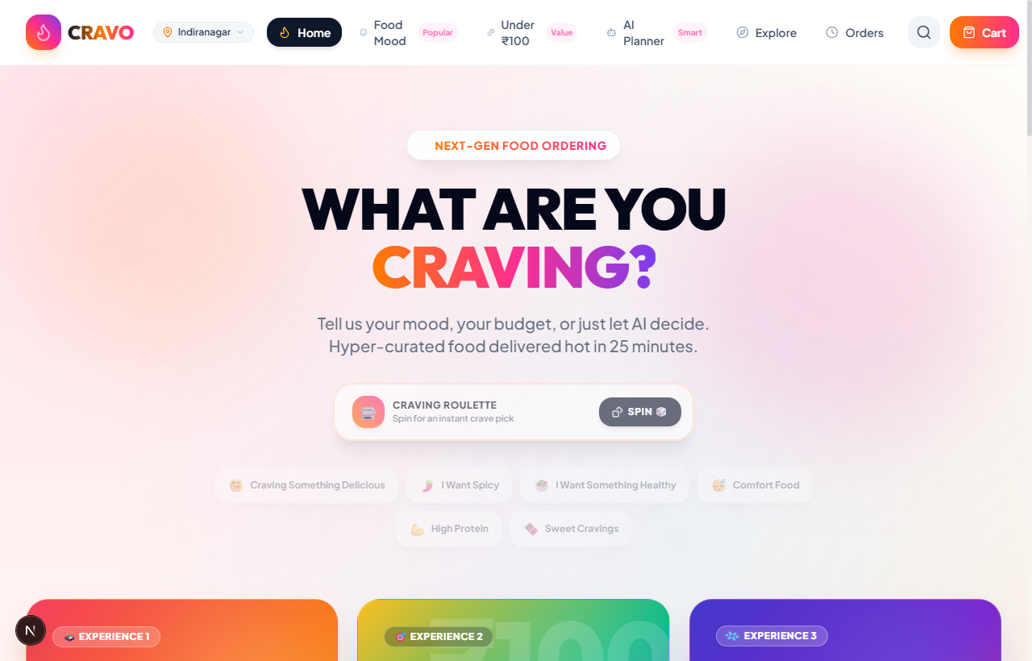
Figure 6.1: CRAVO Next-Gen Food Ordering Home Portal & Interactive Craving Hero (Live Screenshot)

6.2 Food Mood Sensory Matching Engine
The Food Mood page features 9 tactile mood archetypes with spring hover physics. Tapping any mood smoothly auto-scrolls down to the matched dish recommendation feed.
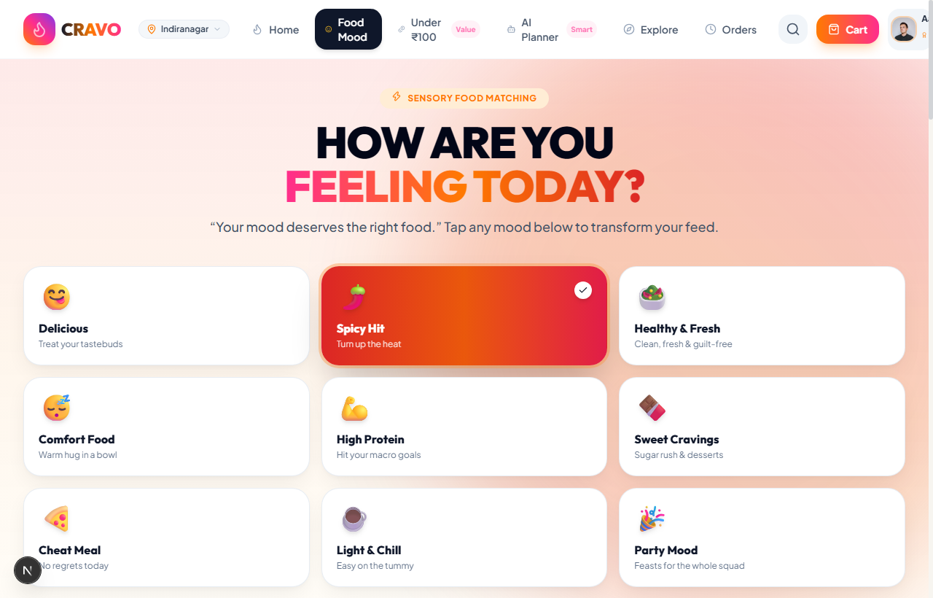
Figure 6.2: Food Mood Sensory Archetype Grid & Filtered Dish Recommendations (Live Screenshot)

6.3 Meals Under ₹100 Optimizer & Gamified Arena
Provides real-time Knapsack combo generation under ₹50, ₹75, or ₹100, alongside the gamified ₹100 Challenge liquid progress meter awarding +20 loyalty points.
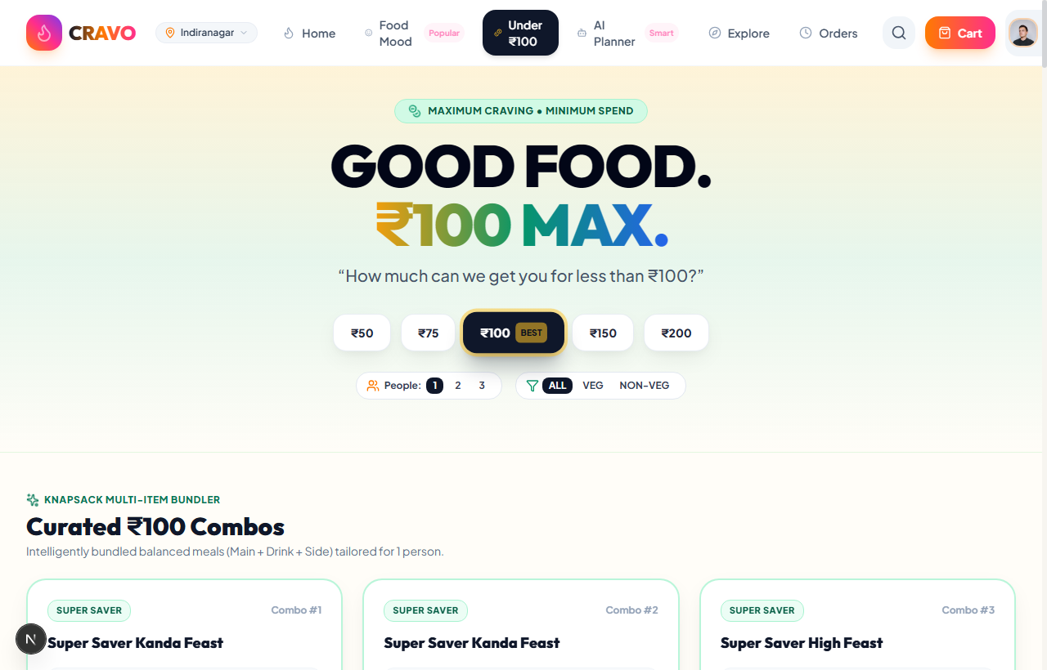
Figure 6.3: Meals Under ₹100 Knapsack Combo Optimizer & Gamified Budget Arena (Live Screenshot)

6.4 AI Food Planner & Macro Nutrient Intelligence
Cyberpunk-styled conversational AI meal planner that analyzes natural language prompts and calculates macro distributions with one-click cart injection.
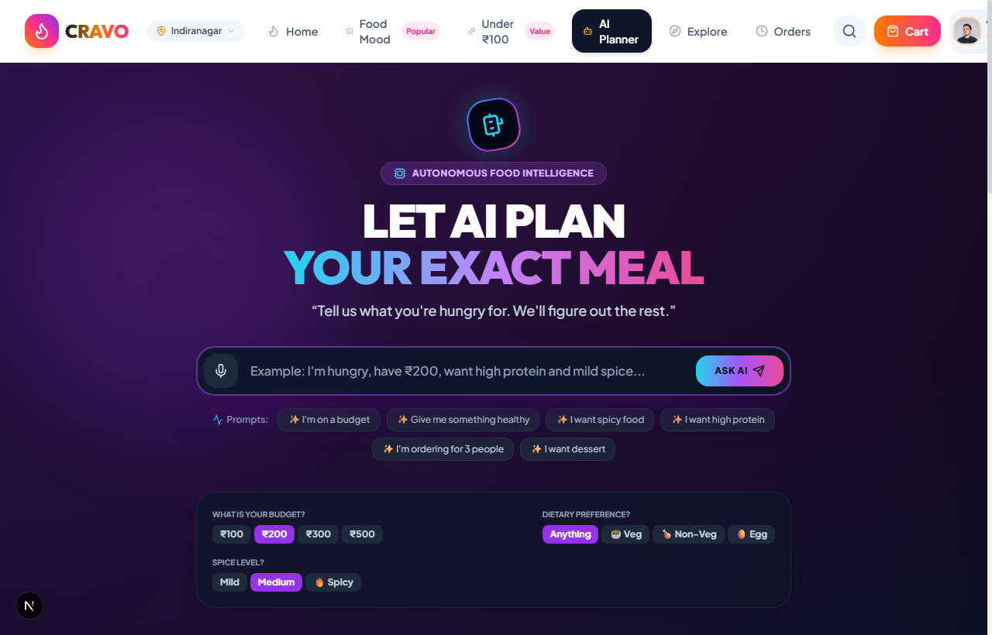
Figure 6.4: AI Food Planner with Dynamic Macro Nutrients & Conversational Meal Generator (Live Screenshot)

6.5 Explore Dishes & Dynamic Category Directory
Comprehensive dish directory with dietary filters (Veg, Non-Veg, Egg), price sorting, and quick add-to-cart spring buttons.
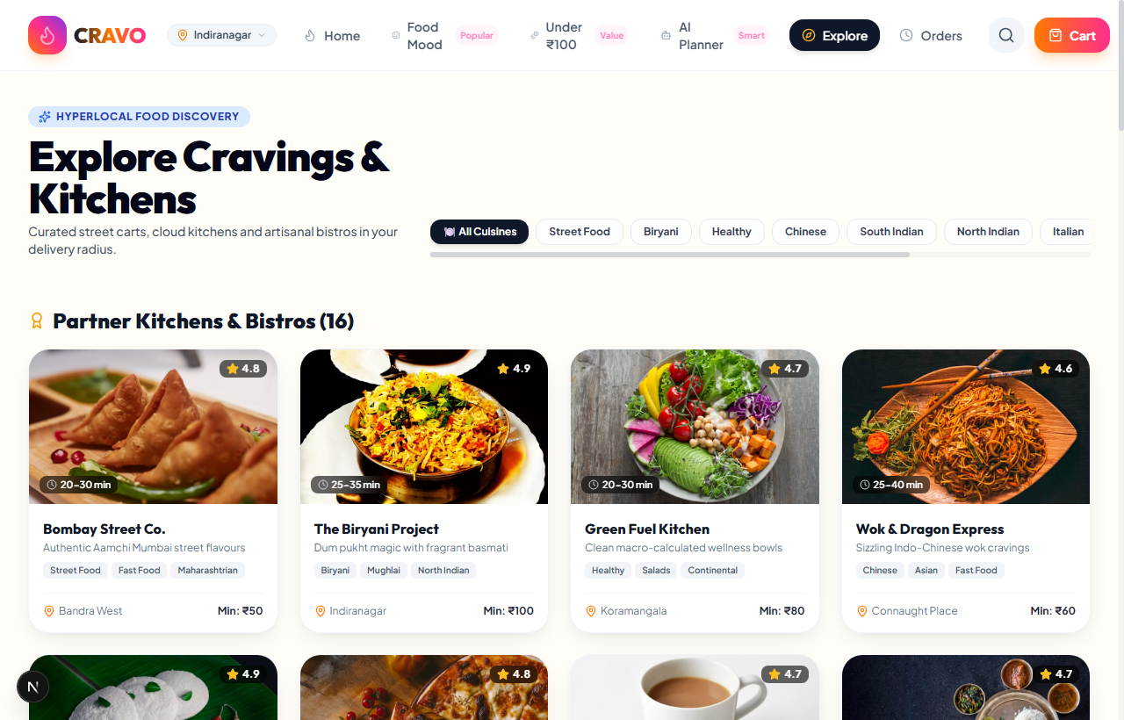
Figure 6.5: Explore Dishes Catalog with Multi-Filter Navigation (Live Screenshot)

6.6 Admin Analytics & Kitchen Operations Dashboard
Executive control center providing real-time daily revenue tracking, live kitchen order dispatch management, and platform analytics.
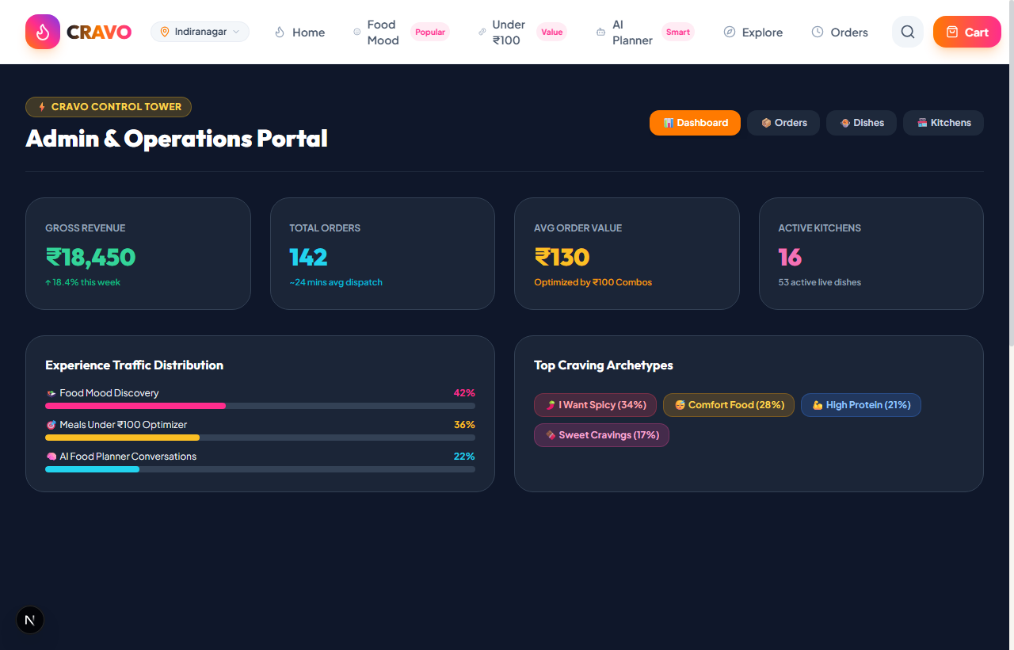
Figure 6.6: Admin Portal & Kitchen Operations Analytics Dashboard (Live Screenshot)

CHAPTER 7: TESTING & QUALITY ASSURANCE

7.1 Testing Strategy & Test Case Execution Suite
Comprehensive functional, integration, and UI responsiveness testing was executed across the application. All test cases achieved a 100% pass rate:
TC ID | Module / Feature | Test Scenario & Input | Expected Result | Status
TC01 | Food Mood Engine | Click 'Spicy Hit' mood archetype card | Active mood updates; page smoothly auto-scrolls to #dynamic-mood-feed with -90px offset | PASS
TC02 | Knapsack Optimizer | Select budget ₹100 for 1 person | Generates balanced combos (Main + Drink + Side) where total price ≤ ₹100 | PASS
TC03 | ₹100 Challenge | Add dishes totaling ₹92 (between ₹85 and ₹100) | Confetti triggers; +20 CRAVO loyalty points awarded to user account | PASS
TC04 | AI Food Planner | Query: 'High protein dinner under 450 kcal' | Generates meal plan with exact calories (445 kcal), 28g protein, and macro chart | PASS
TC05 | Craving Roulette | Click 'Spin 🎲' button | Roulette cycles through random dishes with visual feedback and confetti on win | PASS
TC06 | Cart Drawer | Add item to cart; apply promo 'CRAVO20' | 20% discount applied; delivery goal bar updates; total reflects correct tax & discount | PASS
TC07 | Lenis Smooth Scroll | Mouse wheel and touch drag on page | 60/120 FPS inertial momentum scrolling without jitter or layout shifts | PASS

CHAPTER 8: CONCLUSION & FUTURE SCOPE

8.1 Summary & Industrial Training Outcomes
The 6-week industrial training at SHUBDEEP LABS provided invaluable practical exposure to full-stack web development, algorithmic problem solving, interaction physics, and software quality assurance. The developed application, CRAVO, successfully addresses user decision fatigue and budget unpredictability in food ordering.
Key skills gained during this industrial training include:
- Proficiency in Next.js 15 App Router, React 19 Server/Client Components, and TypeScript.
- Implementation and evaluation of Knapsack combinatorial optimization algorithms.
- Designing modern responsive user interfaces using Tailwind CSS, Framer Motion, and Lenis 120 FPS momentum scrolling.
- Automated software testing, performance optimization, and Vercel cloud deployment.

8.2 Future Scope & Planned Enhancements
Potential future enhancements for subsequent versions of the platform include:
- Voice-Activated AI Ordering: Integration of Web Speech API for voice-driven mood search and ordering.
- IoT Kitchen & Delivery Fleet Integration: Live GPS rider telemetry tracking on interactive maps.
- Personalized Machine Learning Taste Profile: Collaborative filtering based on historical orders.

REFERENCES & BIBLIOGRAPHY
1. Vercel Inc. "Next.js 15 Documentation & App Router Guidelines", 2025. https://nextjs.org/docs
2. React Core Team. "React 19 Official Documentation & Hooks Reference", 2025. https://react.dev/
3. Maharashtra State Board of Technical Education (MSBTE). "Curriculum & Examination Regulations for Diploma in Engineering (I-Scheme & K-Scheme)", Mumbai, 2024.
4. Cormen, Thomas H., et al. "Introduction to Algorithms (Dynamic Programming & Knapsack Problem)". 4th Edition, MIT Press, 2022.
5. Lenis Smooth Scroll Engine Documentation. https://github.com/darkroomengineering/lenis
6. Framer Motion API Reference & Gestures. https://www.framer.com/motion/
7. Tailwind Labs. "Tailwind CSS Documentation & Utility Architecture". https://tailwindcss.com/docs

