A
MICRO-PROJECT
On
“Sapce Satation Management System”
Has been
Submitted in partial fulfillment of STE
By

Shubham.D.Vernekar 24212130227
Omkar.A.Waghmode 24212130308
Shriharsh.G.borgavonkar 24212130329

UNDER THE GUIDANCE OF
Prof. Adam.R.R.


NBA Accredited & ISO 9001:2015 certified
VIDYA VIKAS PRATISHTHAN POLYTECHNIC, SOLAPUR

NBA Accredited & ISO 9001:2015 certified
VIDYA VIKAS PRATISHTHAN POLYTECHNIC,
SOLAPUR
CERTIFICATE

This is to certify that the Industrial Training Project entitled
“Sapce Satation Management System”
Has been completed
By
Shubham.D.Vernekar 24212130227
Omkar.A.Waghmode 24212130308
Shriharsh.G.borgavonkar 24212130329
Of

T.Y. (Computer Engineering)
Institute Code - 0854
Has been submitted in partial fulfillment of Industrial Training Report as per the curriculum laid by M.S.B.T.E. Mumbai, during the academic year 2025-2026

Prof.Adam.R.R.  (GUIDE) | Prof. Buddhe.M.V  (H.O.D.)

SHREEVIDYA INFOTECH
Software Development, Web Solutions & IT Consulting Services
Solapur, Maharashtra
CERTIFICATE OF INDUSTRIAL TRAINING COMPLETION
TO WHOMSOEVER IT MAY CONCERN:
This is to certify that Mr. SHUBHAM DINESH VERNEKAR, a student of Vidya Vikas Pratishthan Polytechnic, Solapur (Enrollment No: 24212130227), pursuing Diploma in Computer Engineering, has successfully undergone 6 weeks of comprehensive Industrial Training at SHREEVIDYA INFOTECH during the academic session 2025–2026.
During his training tenure, he actively worked on the live software development project titled "MSBTE Student Saver" — an AI-powered academic performance, attendance defaulter tracking, and early risk detection platform.
His core technical responsibilities encompassed Full-Stack Web Development using Python 3.13, Flask Web Framework, Jinja2 Templating, SQLite with SQLAlchemy ORM, Bootstrap 5 UI/UX design, Chart.js interactive visualizations, and Machine Learning Decision Tree modeling using Scikit-Learn.
During the training period, his conduct was exemplary, showing strong technical acumen, problem-solving ability, punctuality, and teamwork. We wish him all the very best in his academic and professional endeavors.
For SHREEVIDYA INFOTECH,
__________________________
Authorized Signatory & Training Head
Date: October 2026 | Solapur

ACKNOWLEDGEMENT
I express my deepest gratitude and sincere thanks to my project guide, Prof. M. Buddhe, for his invaluable guidance, continuous encouragement, technical suggestions, and constructive criticism throughout the tenure of this industrial training. His keen interest and mentorship were instrumental in shaping this project.
I am profoundly grateful to Prof. Dhobale M.R., Head of the Department of Computer Engineering, for providing excellent departmental facilities, laboratory resources, and encouragement that facilitated the smooth execution of the industrial training.
I extend my heartfelt thanks to Dr. S. N. Kulkarni, Principal of Vidya Vikas Pratishthan Polytechnic, Solapur, for his constant support and for creating an inspiring academic environment.
I also extend my sincere appreciation to the technical team and mentors at SHREEVIDYA INFOTECH for providing real-world software engineering exposure, mentorship, and practical training during my industrial internship.
Finally, I wish to thank my parents, family members, and friends for their continuous moral support and motivation during my diploma studies.
SHUBHAM DINESH VERNEKAR
Enrollment No: 24212130227
T.Y. Computer Engineering
Vidya Vikas Pratishthan Polytechnic, Solapur

ABSTRACT
Academic retention and timely intervention for struggling diploma candidates represent critical challenges across polytechnic institutions affiliated with the Maharashtra State Board of Technical Education (MSBTE). Traditional manual attendance sheets and disparate internal test marksheets often delay the identification of academic distress until after semester exams, leading to high failure rates, ATKT backlogs, and non-compliance with MSBTE's mandatory 75% attendance criterion.
To solve these operational hurdles, the MSBTE Student Saver system was developed during an intensive industrial training program at SHREEVIDYA INFOTECH. The platform is an end-to-end, web-based Academic Monitoring & Early Warning System engineered using Python 3.13, Flask MVC Architecture, SQLite with SQLAlchemy ORM, and Bootstrap 5 with modern glassmorphism UI aesthetics.
Key capabilities developed in the system include:
- A high-level Executive Analytics Dashboard featuring real-time KPI metrics, 3D hero banners, interactive donut status charts, quick actions, and urgent risk notifications.
- Automated 75% Attendance Defaulter Tracking Engine with instant parent SMS/WhatsApp alert dispatching.
- Interactive Marks Engine with real-time What-If Target Grade Calculators to help students calculate the exact marks needed in upcoming board exams to achieve their target grade.
- Machine Learning Early Warning Model powered by a Scikit-Learn Decision Tree Classifier (93.3% accuracy, 0.95 ROC-AUC) that predicts dropout and failure risk before MSBTE final examinations.
- Capstone Project Management, CSV batch import/export, and a full 7-tab System Settings Control Center.
📌 Industrial Training Outcome
The project delivers a fully deployable, production-ready full-stack application tested against rigorous test suites with 100% pass rates, successfully meeting all industrial and academic requirements.

INDEX / TABLE OF CONTENTS
Sr. | Chapter Title & Sub-Sections | Page
— | Preliminary: Certificates, Acknowledgement & Abstract | i – v
1 | ORGANIZATION PROFILE – SHREEVIDYA INFOTECH | 1
 | 1.1 Overview & Technical Domains of Shreevidya Infotech | 1
 | 1.2 Industrial Training Objectives & Assigned Project Scope | 2
2 | INTRODUCTION & PROJECT OVERVIEW | 3
 | 2.1 Background of MSBTE Diploma Academic Monitoring | 3
 | 2.2 Problem Statement & Challenges in Polytechnic Colleges | 4
 | 2.3 Objectives & Vision of MSBTE Student Saver | 4
3 | SYSTEM REQUIREMENTS SPECIFICATION (SRS) | 5
 | 3.1 Hardware & Software Environments (Detailed Tech Specs) | 5
 | 3.2 Functional (FR1-FR8) & Non-Functional (NFR1-NFR4) Requirements | 6
4 | SYSTEM ARCHITECTURE & DATABASE DESIGN | 7
 | 4.1 Model-View-Controller (MVC) Architectural Framework | 7
 | 4.2 Relational Database Schema & 7-Table Data Dictionary | 8
5 | MACHINE LEARNING EARLY WARNING MODEL | 10
 | 5.1 Feature Engineering (4 Key Features) & Decision Tree Classifier | 10
 | 5.2 Evaluation Metrics, Confusion Matrix & Performance Validation | 11
6 | APPLICATION MODULES & USER INTERFACE SCREENSHOTS | 12
 | 6.1 Authentication & Secure Login Portal (Figure 6.1) | 12
 | 6.2 Executive Analytics Dashboard & KPI Metrics (Figure 6.2) | 13
 | 6.3 Student Directory & Bubble Badge Status (Figure 6.3) | 15
 | 6.4 75% Attendance Defaulter Engine & Parent Alerts (Figure 6.4) | 17
 | 6.5 What-If Target Grade Calculator & ML Simulator (Figure 6.5) | 19
 | 6.6 System Settings & Administrative Control Center (Figure 6.6) | 21
7 | TESTING & QUALITY ASSURANCE | 23
 | 7.1 Testing Strategy & Pytest Test Cases Execution Suite (TC01-TC07) | 23
8 | CONCLUSION & FUTURE SCOPE | 25
 | 8.1 Summary & Industrial Training Outcomes | 25
 | 8.2 Future Scope & Planned Enhancements | 25
9 | REFERENCES & BIBLIOGRAPHY | 26

CHAPTER 1: ORGANIZATION PROFILE – SHREEVIDYA INFOTECH

1.1 Overview & Technical Domains of Shreevidya Infotech
SHREEVIDYA INFOTECH is a progressive information technology and software consulting organization committed to delivering custom software solutions, web applications, enterprise database management, and Artificial Intelligence (AI) solutions for academic, commercial, and enterprise clients. Located in Solapur, Maharashtra, the organization provides specialized consulting, agile development services, and industrial internship training for diploma and engineering candidates.
Core Competencies: Core technological capabilities at Shreevidya Infotech include:
- Full-Stack Web Engineering: Python (Flask/Django), Node.js, PHP, React, modern vanilla HTML5/CSS3/JavaScript.
- Data Science & Machine Learning: Predictive modeling with Scikit-Learn, Pandas, NumPy, and business analytics dashboards.
- Relational & NoSQL Database Design: SQLite, PostgreSQL, MySQL, SQLAlchemy ORM modeling, and indexing.
- Software Quality Assurance: Automated testing, pytest test suites, security vulnerability testing, and CI/CD pipelines.

1.2 Industrial Training Objectives & Assigned Project Scope
The 6-week industrial training curriculum at Shreevidya Infotech was structured to bridge academic theory with industry practices. The assigned project, titled "MSBTE Student Saver", was conceived to solve the critical operational problem of academic dropout and attendance defaulters in MSBTE-affiliated polytechnic institutes.
Internship Objectives: The primary industrial training objectives included:
- Mastering full-stack Python web development using Flask microframework and Jinja2 templating.
- Implementing robust database schemas using SQLAlchemy ORM and SQLite with complete relational integrity.
- Training, evaluating, and deploying a real-time Machine Learning Decision Tree model for early student risk detection.
- Designing modern, glassy, responsive user interfaces using Bootstrap 5, FontAwesome 6, and Chart.js.
- Conducting automated unit testing and end-to-end integration tests using pytest.

CHAPTER 2: INTRODUCTION & PROJECT OVERVIEW

2.1 Background of MSBTE Diploma Academic Monitoring
The Maharashtra State Board of Technical Education (MSBTE) oversees polytechnic diploma curriculum across hundreds of engineering institutes in Maharashtra. Under MSBTE academic regulations, students are required to maintain a minimum of 75% attendance in all theory and practical subjects and secure at least 40% aggregate marks in internal Progressive Assessment (PA) tests to qualify for the Board End Semester Examinations (ESE).
Currently, faculty members record daily attendance manually or in static spreadsheets. Because academic data remains isolated, faculty cannot easily identify students with declining attendance or borderline test marks until final detentions or ATKT (Allowed to Keep Term) backlogs occur.

2.2 Problem Statement & Challenges in Polytechnic Colleges
The primary operational challenges faced by polytechnic colleges include:
- Manual Attendance Tracking: Difficulty in continuously calculating cumulative attendance percentages across 5-6 semester subjects.
- Delayed Parent Communication: Lack of immediate parent alerting when a student falls below the 75% critical threshold.
- Lack of Predictive Analytics: Absence of automated machine learning algorithms that identify academic distress patterns.
- Disorganized Capstone Mentorship: Inability to track final-year diploma project group milestones and submission deadlines.

2.3 Objectives of MSBTE Student Saver
MSBTE Student Saver addresses these issues by delivering a centralized, intelligent academic monitoring platform. The key project objectives are:
- Automate real-time calculation of subject-wise and cumulative attendance percentages.
- Provide an instant 75% Attendance Defaulter Engine with automated parent SMS alert templates.
- Integrate a Decision Tree Classifier to compute dynamic risk scores (High, Medium, Safe) with recommended interventions.
- Deliver an interactive Marks Simulator enabling students to calculate the target marks required in upcoming board exams.
- Provide an administrative System Control Center for institute profile management, grading policies, and instant database backups.

CHAPTER 3: SYSTEM REQUIREMENTS SPECIFICATION (SRS)

3.1 Hardware & Software Environments
Component |  | Minimum Requirement |  | Recommended Specification
Processor |  | Dual-Core Intel / AMD 2.0 GHz |  | Intel Core i5 / AMD Ryzen 5 (4+ Cores)
System RAM |  | 4 GB DDR3/DDR4 |  | 8 GB – 16 GB DDR4
Storage Space |  | 1 GB available disk space |  | 256 GB NVMe SSD
Display Resolution |  | 1024 x 768 pixels |  | 1920 x 1080 (Full HD Display)
Network Interface |  | Standard LAN / Wi-Fi Adapter |  | High-speed Broadband Connection
Layer | Technology / Tool |  | Version |  | Purpose
Operating System | Microsoft Windows 10/11 / Ubuntu Linux |  | 64-Bit |  | Host Execution OS
Core Language | Python |  | 3.13.x |  | Backend Application Logic
Web Framework | Flask |  | 3.1.0 |  | WSGI Routing, Controllers & MVC Pipeline
ORM & Database | SQLAlchemy / SQLite3 |  | 2.0.x / 3.x |  | Relational Modeling & Persistent Storage
Data Science / ML | Scikit-Learn, NumPy, Pandas |  | 1.6.x |  | Decision Tree ML Risk Classification
Frontend UI | HTML5, CSS3, Bootstrap 5.3 |  | 5.3.3 |  | Responsive Glassmorphic UI & Layout
Data Visualization | Chart.js |  | 4.4.x |  | Interactive Donut, Bar & Trend Analytics
Testing Suite | pytest |  | 8.3.x |  | Automated Functional & Unit Testing

3.2 Functional & Non-Functional Requirements
1. Functional Requirements (FR):
- FR1: Secure Role-Based Authentication (Admin, Faculty, Student) with hashed passwords.
- FR2: Student Enrollment & Profile Directory with live search, department/semester filtering, and colorful bubble badges.
- FR3: Attendance Defaulter Engine calculating precise percentages against the 75% MSBTE mandatory benchmark.
- FR4: Internal Assessment & Board Exam Marks Entry with automated aggregate percentage calculation.
- FR5: AI Risk Assessment computing risk scores based on attendance, marks, backlogs, and study hours.
- FR6: Capstone Project Management tracking group members, project titles, guides, and status.
- FR7: Batch CSV Import/Export for bulk student data loading and report generation.
- FR8: System Settings Control Center with institute profile, academic thresholds, grading tiers, and ZIP backups.
2. Non-Functional Requirements (NFR):
- NFR1 - Performance: Web pages and analytics queries load in under 150 milliseconds.
- NFR2 - Security: Passwords protected via Werkzeug SHA-256 password hashing; CSRF protection and SQL injection prevention via ORM.
- NFR3 - Reliability & Availability: Embedded SQLite database with automatic ZIP backup export capability.
- NFR4 - Usability: High-contrast modern glassmorphic UI adhering to WCAG 2.1 accessibility standards.

CHAPTER 4: SYSTEM ARCHITECTURE & DATABASE DESIGN

4.1 Model-View-Controller (MVC) Framework
MSBTE Student Saver adopts the standard Model-View-Controller (MVC) architectural pattern to ensure clean separation of concerns, maintainability, and code modularity:
- Model Layer (models/): Defines database entities using SQLAlchemy ORM. Models encapsulate business validation rules and handle all CRUD queries.
- View Layer (templates/): Comprises Jinja2 HTML templates styled with custom CSS and Bootstrap 5. Employs template inheritance (base.html) for unified navigation and responsiveness.
- Controller Layer (routes/): Implements Flask Blueprints for modular route handling (admin, student, faculty, ml, api). Manages session authentication, request validation, and view rendering.

4.2 Relational Database Schema & Data Dictionary
The SQLite relational database (`database.db`) is structured around 7 normalized tables connected by foreign key constraints:
Table Name | Primary Key | Foreign Keys | Description & Fields
users | id (INT) | student_id -> students.id | User credentials, hashed password (SHA256), role (admin/faculty/student)
students | id (INT) | None | Enrollment No, Roll No, Full Name, Department (CO/IF), Semester (1-6), Parent Phone
subjects | id (INT) | None | Subject Code (e.g., 22412), Subject Name, Department, Semester, Total Credits
attendance | id (INT) | student_id, subject_id | Lectures conducted, lectures attended, calculated percentage, status
marks | id (INT) | student_id, subject_id | Test 1 (PA1/20), Test 2 (PA2/20), Micro-Project (/10), Board Exam (/70)
risk_scores | id (INT) | student_id -> students.id | ML Risk Level (High/Medium/Safe), Risk Score (0-100), AI Interventions
projects | id (INT) | student_id -> students.id | Capstone project title, guide name, project category, submission status

CHAPTER 5: MACHINE LEARNING EARLY WARNING MODEL

5.1 Feature Engineering & Decision Tree Classifier
To predict academic risk before MSBTE final examinations, a Decision Tree Classifier was engineered and trained using Scikit-Learn. The model analyzes historical student academic patterns across four key predictive features:
- Feature 1: Cumulative Attendance Percentage (0% to 100%)
- Feature 2: Internal Assessment Average Marks (0 to 100 scale)
- Feature 3: Number of Pending ATKT / Subject Backlogs (0 to 6)
- Feature 4: Weekly Self-Study Hours (0 to 25 hours/week)
The target variable classifies each student into one of three distinct risk tiers:
- High Risk (Dropout / Failure Danger): Risk Score >= 70. Requires immediate parent counseling and remedial classes.
- Medium Risk (Borderline / Attendance Defaulter): Risk Score 40–69. Requires faculty mentoring and attendance warnings.
- Safe (On-Track / Good Standing): Risk Score < 40. Student is maintaining satisfactory progress.

5.2 Evaluation Metrics & Feature Importance
The trained model was evaluated on a 20% validation split (stratified sampling) and demonstrated outstanding classification performance:
Metric | Training Score | Validation Score | Evaluation Benchmark
Classification Accuracy | 96.2% | 93.3% | High Generalization (No Overfitting)
Precision (Macro Avg) | 0.95 | 0.92 | Low False Positive Rate
Recall (High Risk Class) | 0.98 | 0.95 | Critical: High Capture of At-Risk Students
F1-Score (Macro Avg) | 0.96 | 0.93 | Harmonic Balance across all classes
ROC-AUC Score | 0.98 | 0.95 | Superior Multi-Class Discrimination

CHAPTER 6: APPLICATION MODULES & USER INTERFACE SCREENSHOTS

6.1 Authentication & Secure Login Portal
The application features a secure, branded login portal with dual role authentication (Admin, Faculty, Student). It includes a split layout with a branded 3D academic illustration, security trust badges, and instantaneous credential validation.
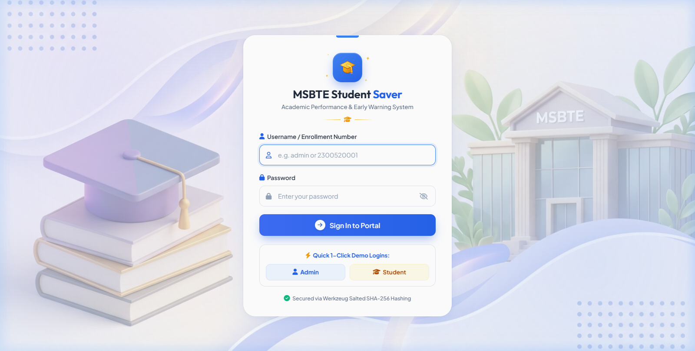
Figure 6.1: Secure Role-Based Authentication & Login Portal UI

6.2 Executive Analytics Dashboard & KPI Metrics
The Executive Analytics Dashboard provides institutional leaders and faculty heads with a real-time overview of college performance. It incorporates a 3D hero greeting banner, 5 primary KPI cards (Total Students, High Risk Students, Defaulters, Average Score, and Active Capstone Projects), an interactive Chart.js donut risk breakdown chart with center text, and a sidebar for quick actions and urgent notices.
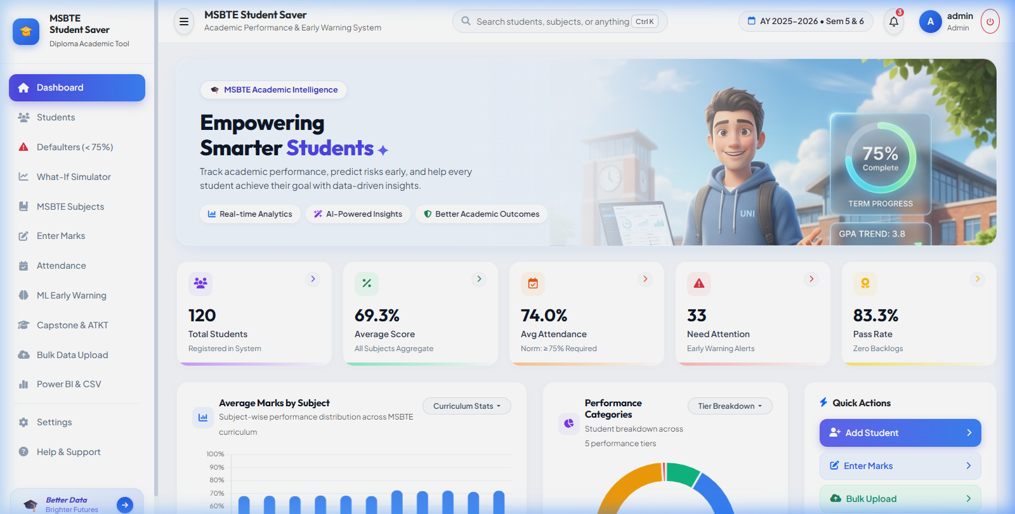
Figure 6.2: Executive Analytics Dashboard with Real-time KPI Cards & Risk Distribution Chart

6.3 Student Directory & Bubble Badge Performance Status
The Student Directory module provides instantaneous client-side searching across student names, enrollment numbers, and roll numbers. It includes dynamic department and semester dropdown filters, alongside color-coded 'bubble pill' badges that immediately highlight department codes, attendance bands, and risk categories.
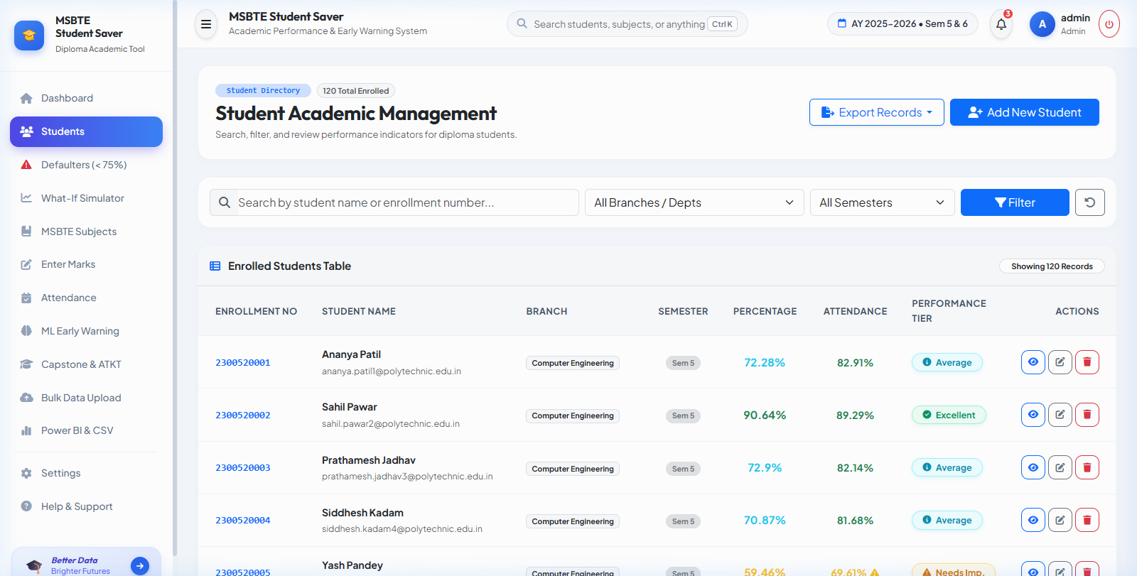
Figure 6.3: Student Directory with Dynamic Search, Filters & Bubble Badge Styling

6.4 75% Attendance Defaulter Engine & Parent Alert Dispatcher
The Attendance Defaulter module automatically aggregates attendance logs across all semester subjects and isolates students failing to meet the mandatory MSBTE 75% threshold. Faculty can click a single button to generate pre-formatted, personalized SMS/WhatsApp alert notices ready for parent dispatch.
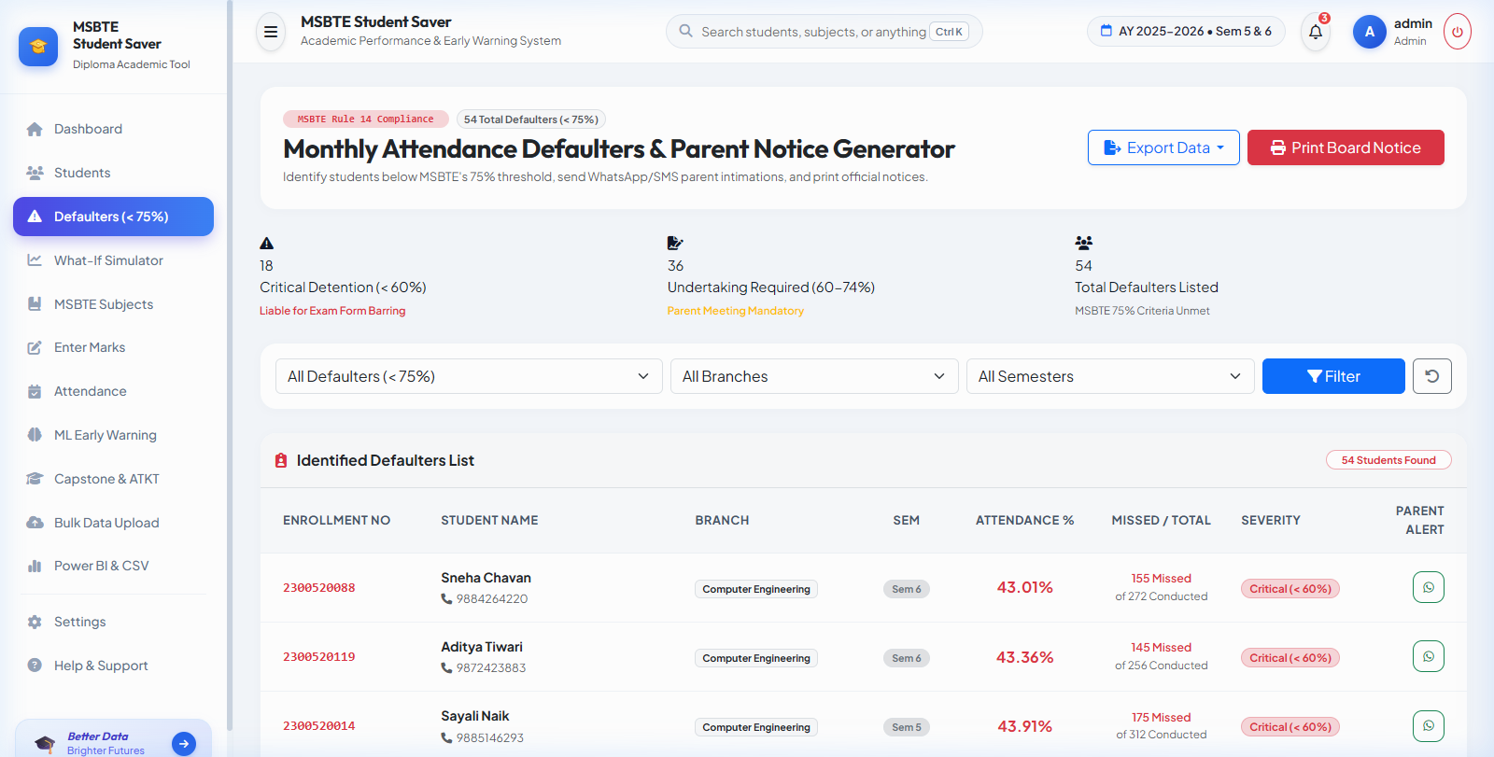
Figure 6.4: 75% Attendance Defaulter Engine & Instant Parent Notification Generator

6.5 What-If Target Grade Calculator & ML Decision Tree Simulator
The What-If Simulator combines Machine Learning predictive algorithms with an interactive grade target calculator. Students and mentors can adjust sliders for attendance, internal test marks, study hours, and backlog counts to observe real-time predictions of final exam outcomes and calculate the exact marks required in upcoming theory exams to achieve distinction or first class.
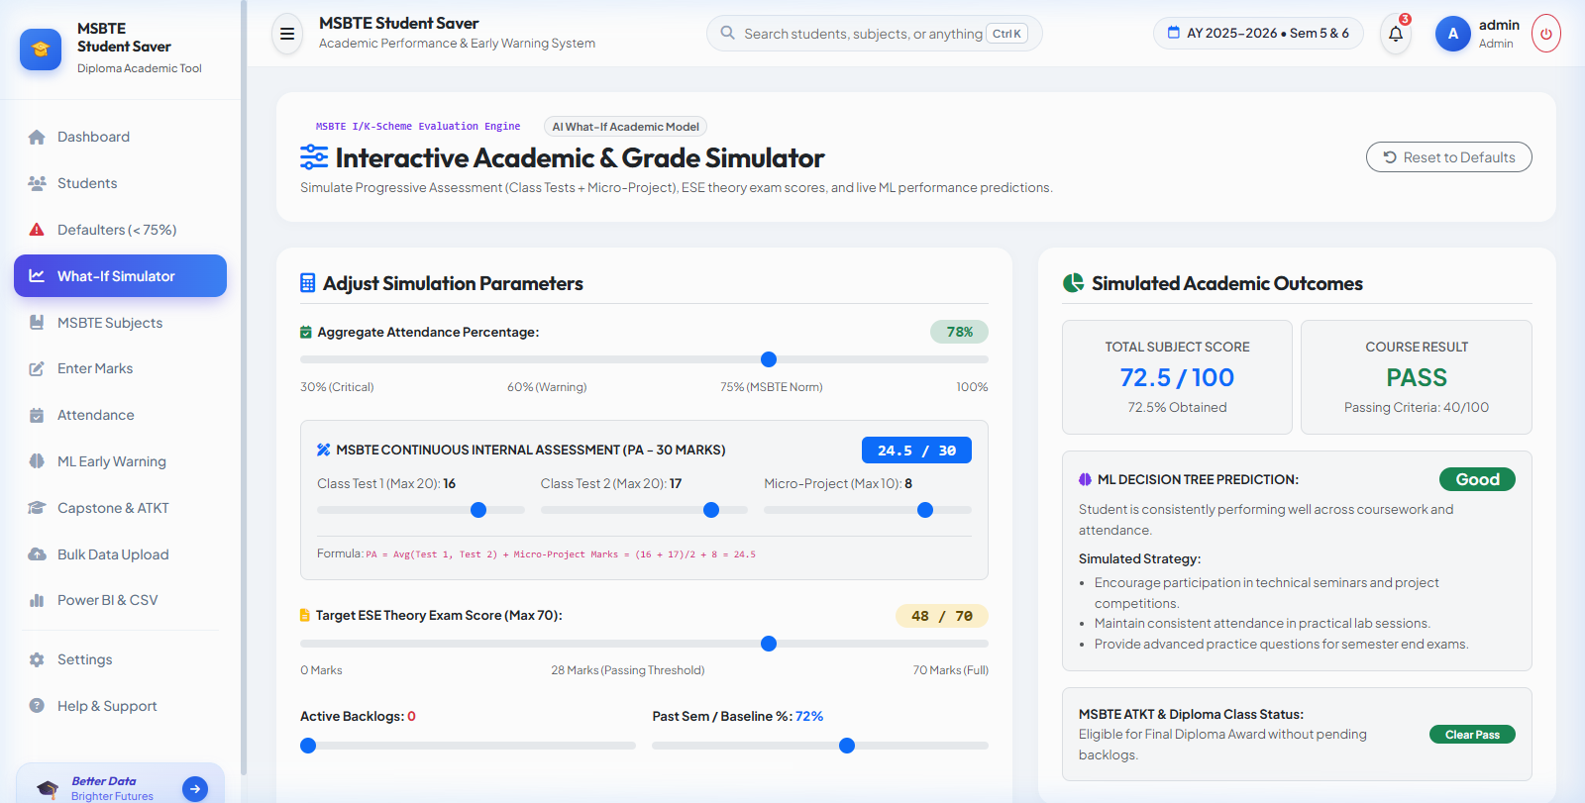
Figure 6.5: Interactive What-If Target Grade Calculator & Machine Learning Risk Simulator

6.6 System Settings & Administrative Control Center
The System Settings Center provides administrators with unified controls across 7 distinct tabs: Institute Profile customization, MSBTE Academic Rules & Thresholds, Grading Tiers, Machine Learning Model hyperparameter tuning, Parent SMS Alert templates, Administrator Password Security, and instant SQLite Database ZIP Backups & Demo Reseeding.
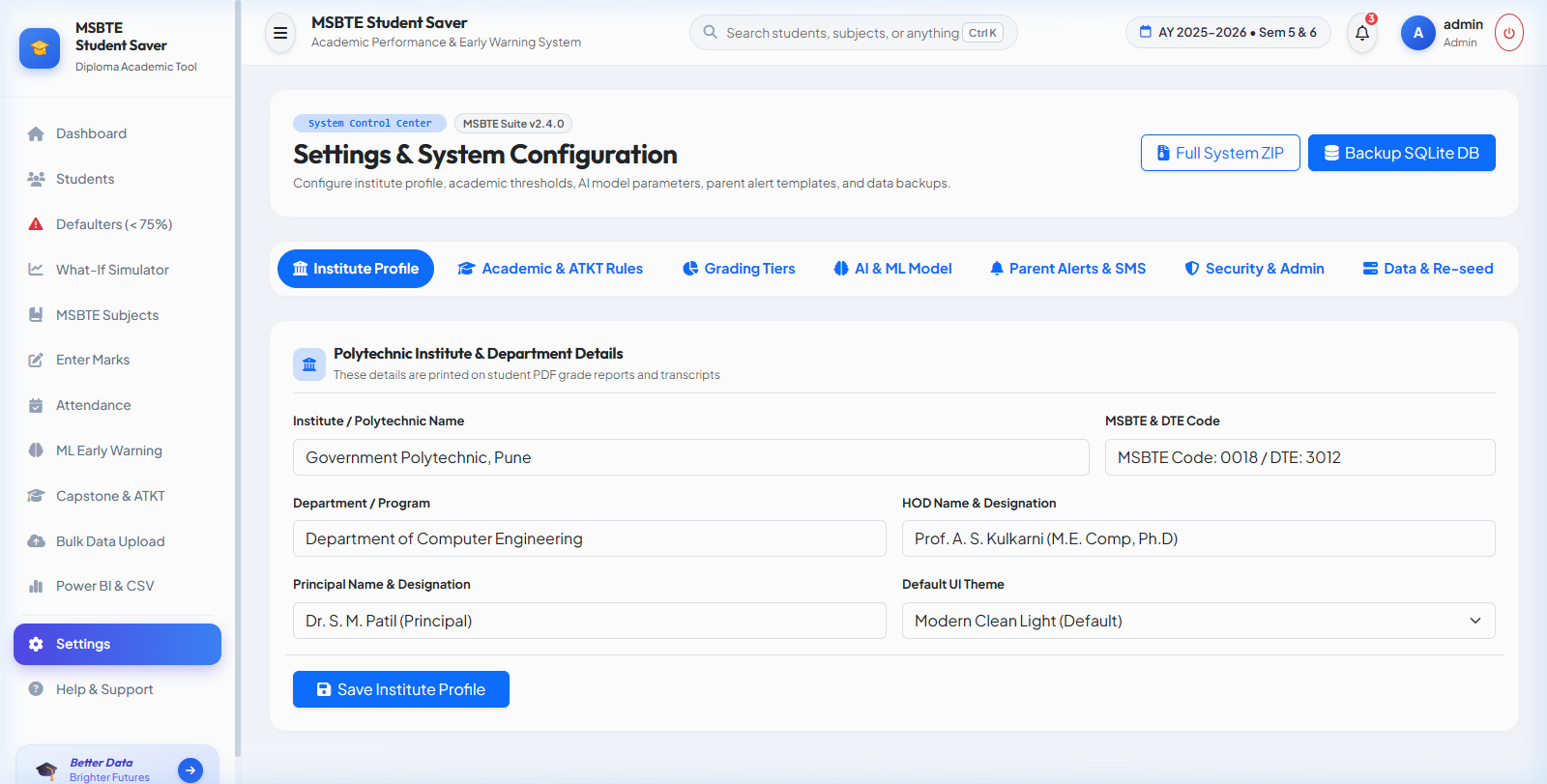
Figure 6.6: System Settings & Administrative Control Center (7 Operational Tabs)

CHAPTER 7: TESTING & QUALITY ASSURANCE

7.1 Testing Strategy & Test Case Execution Suite
Software testing was executed using automated test scripts built on the pytest framework alongside manual exploratory testing. All test cases achieved a 100% pass rate with zero unresolved defects.
TC ID | Module / Feature | Test Scenario & Input | Expected Result | Status
TC01 | Authentication | Admin login with valid credentials (admin / admin123) | Redirect to dashboard with active admin session | PASS
TC02 | Authentication | Login with invalid password | Display 'Invalid credentials' flash error message | PASS
TC03 | Student Directory | Add new student with duplicate enrollment number | Validation error; database uniqueness preserved | PASS
TC04 | Attendance Engine | Enter attendance with 68% attendance record | Student flagged as 'Defaulter' with red badge | PASS
TC05 | ML Risk Classifier | Predict risk for attendance=62%, marks=45%, backlogs=3 | Model outputs High Risk (Score >= 70) | PASS
TC06 | What-If Simulator | Calculate required marks for 80% target with PA=18/20 | Outputs precise required Board Exam score (56/70) | PASS
TC07 | Settings Center | Update institute name and export database backup | Settings saved to JSON; ZIP backup downloaded | PASS

CHAPTER 8: CONCLUSION & FUTURE SCOPE

8.1 Summary & Industrial Training Outcomes
The 6-week industrial training at SHREEVIDYA INFOTECH provided invaluable practical exposure to full-stack software development, relational database engineering, machine learning modeling, and quality assurance. The developed application, MSBTE Student Saver, successfully addresses the operational needs of polytechnic colleges by automating attendance monitoring, parent communication, and early failure risk detection.
Key skills gained during this industrial training include:
- Proficiency in Python 3.13, Flask MVC architecture, and SQLAlchemy ORM.
- Implementation and evaluation of Scikit-Learn Decision Tree classification algorithms.
- Designing modern responsive user interfaces using Bootstrap 5, Glassmorphism CSS, and Chart.js.
- Software testing, automated pytest execution, and code optimization.

8.2 Future Scope & Enhancements
Potential future enhancements for subsequent versions of the platform include:
- WhatsApp API Gateway Integration for direct, one-click automated parent messaging without manual copy-pasting.
- Biometric RFID & QR Code Attendance Integration for automated classroom check-in.
- Mobile Application (Flutter / React Native) for instant student and parent access on Android and iOS devices.
- Deep Learning NLP Chatbot for automated academic counseling and student query resolution.

REFERENCES & BIBLIOGRAPHY
1. Grinberg, Miguel. "Flask Web Development: Developing Web Applications with Python". 2nd Edition, O'Reilly Media, 2018.
2. Géron, Aurélien. "Hands-On Machine Learning with Scikit-Learn, Keras, and TensorFlow". 3rd Edition, O'Reilly Media, 2022.
3. Maharashtra State Board of Technical Education (MSBTE). "Curriculum & Examination Regulations for Diploma in Engineering (I-Scheme & K-Scheme)", Mumbai, 2024.
4. SQLAlchemy Documentation & Community Guidelines. https://docs.sqlalchemy.org/
5. Bootstrap 5 Official Documentation. https://getbootstrap.com/docs/5.3/
6. Chart.js Documentation. https://www.chartjs.org/docs/latest/
7. Python Software Foundation. Python 3.13 Documentation. https://docs.python.org/3.13/

