SD - CONSOLIDATED OVERVIEW

**Scatterplot of ff1 vs ff2**

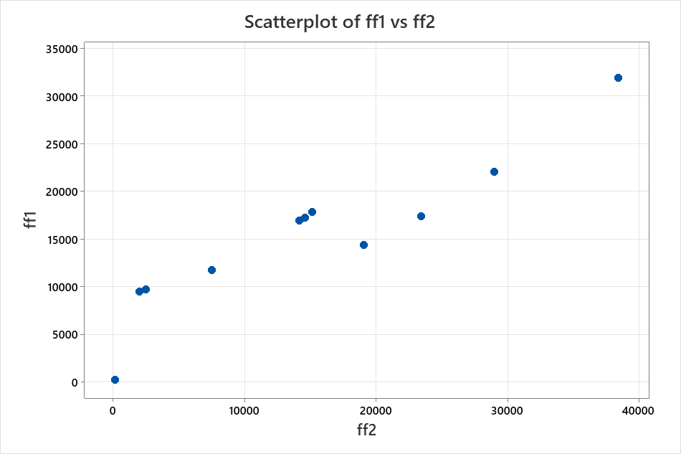

SD - CONSOLIDATED OVERVIEW

**Data Display**

**Data**

|  |  |  |
| --- | --- | --- |
| **Row** | **ff1** | **ff2** |
| 1 | 16920.0 | 14165.0 |
| 2 | 17222.3 | 14560.8 |
| 3 | 22067.0 | 28960.2 |
| 4 | 203.1 | 131.0 |
| 5 | * | * |
| 6 | 14377.1 | 19027.7 |
| 7 | 11755.8 | 7496.1 |
| 8 | 17348.8 | 23424.9 |
| 9 | 9478.9 | 1980.8 |
| 10 | 31892.8 | 38400.3 |
| 11 | 9727.2 | 2474.4 |
| 12 | * | * |
| 13 | 17836.0 | 15136.6 |

SD - CONSOLIDATED OVERVIEW

**Chart of ff1**

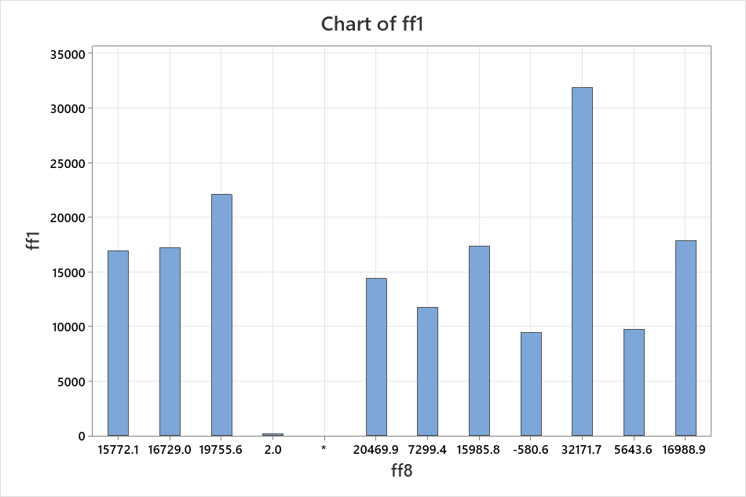

* WARNING * Multiple observations were summed. If you want a different function, recalculate  
your summaries.

SD - CONSOLIDATED OVERVIEW

**Chart of ff1**

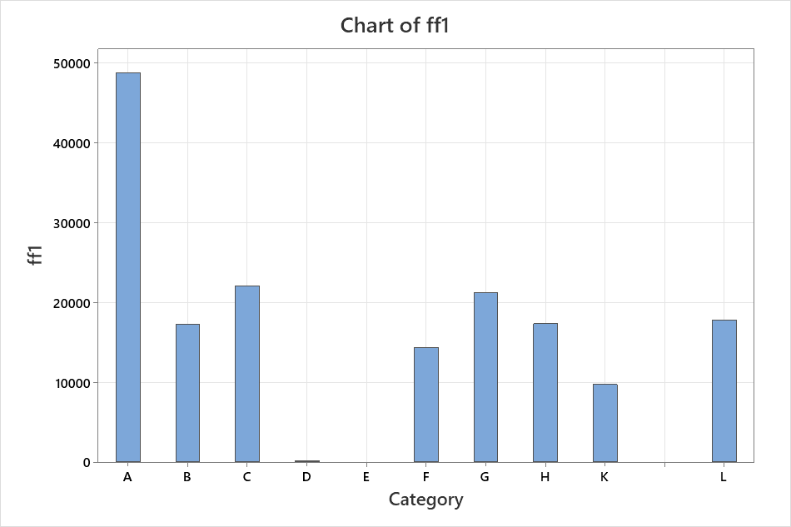

* WARNING * Multiple observations were summed. If you want a different function, recalculate  
your summaries.

SD - CONSOLIDATED OVERVIEW

**Pie Chart of Category**

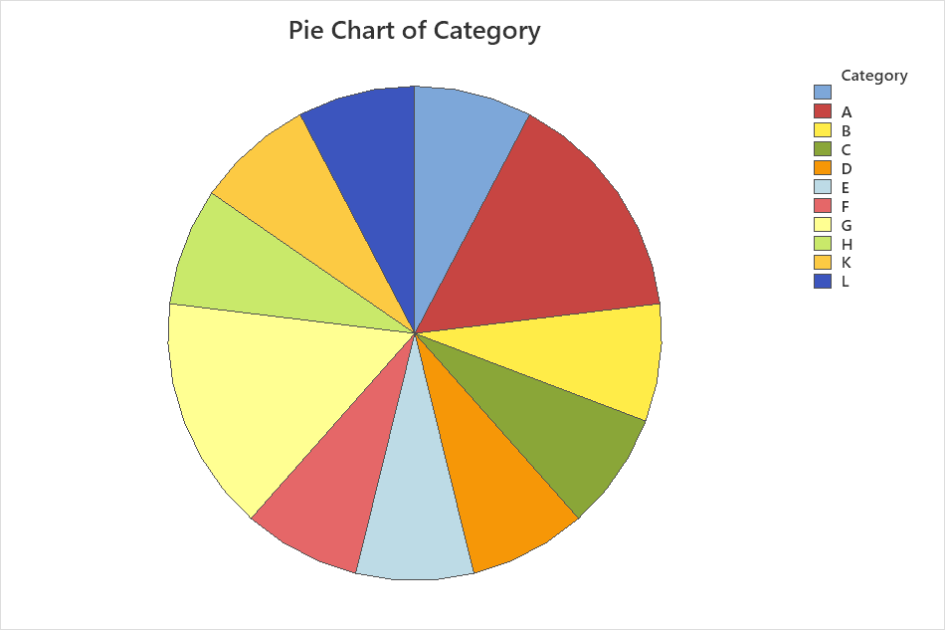

SD - CONSOLIDATED OVERVIEW

**Pie Chart of Category**

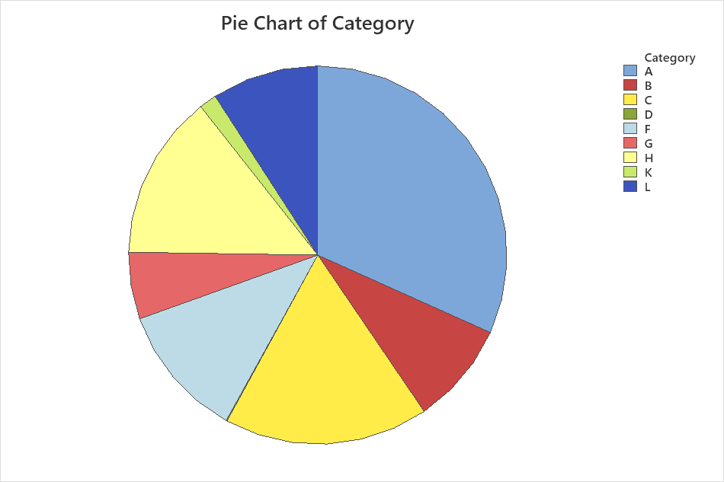

SD - CONSOLIDATED OVERVIEW

**Pareto Chart of ff1**

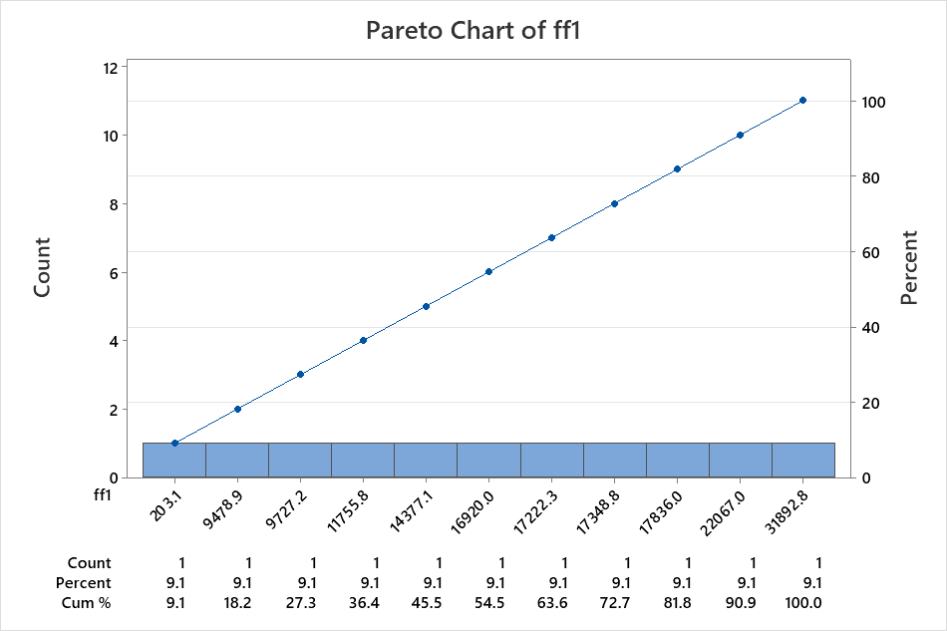

SD - CONSOLIDATED OVERVIEW

**Pareto Chart of Category**

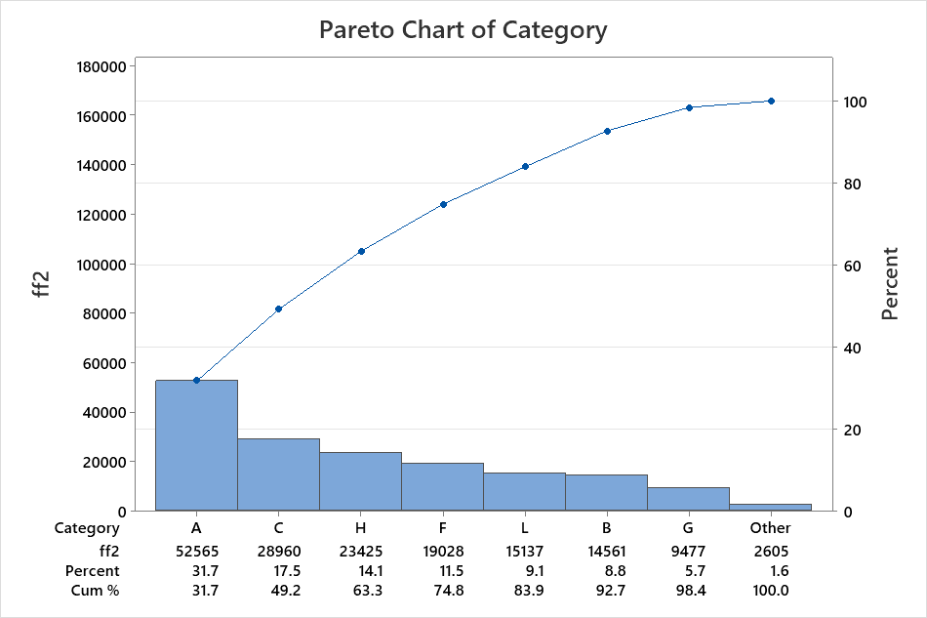

SD - CONSOLIDATED OVERVIEW

**Empirical CDF of ff2**

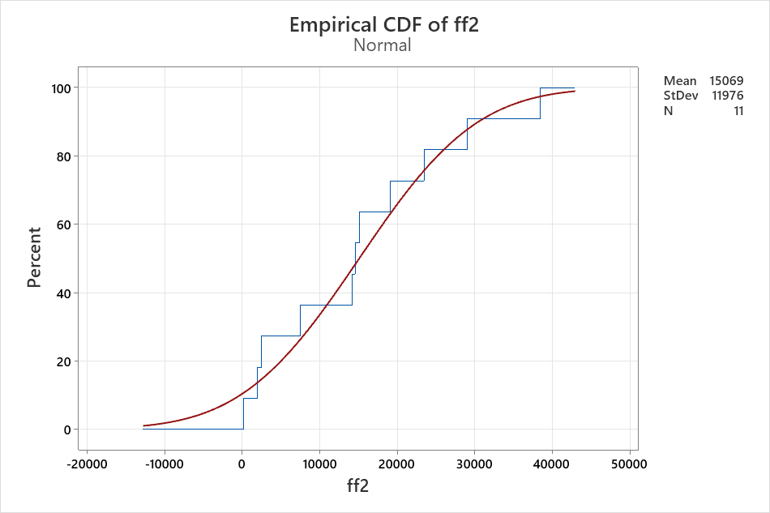

SD - CONSOLIDATED OVERVIEW

**Probability Plot of ff3**

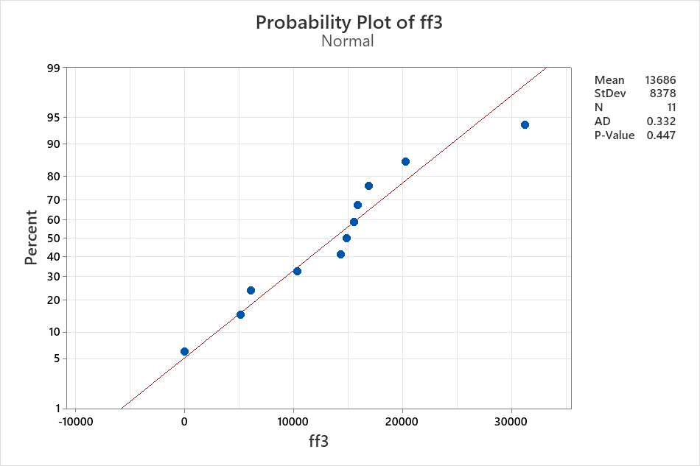

WORKSHEET 3

**Probability Plot of Data**

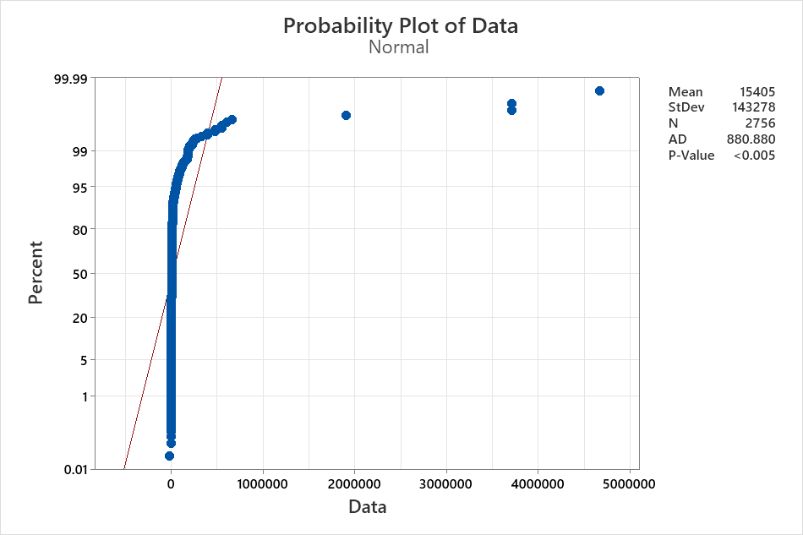

WORKSHEET 3

**Run Chart of Data**

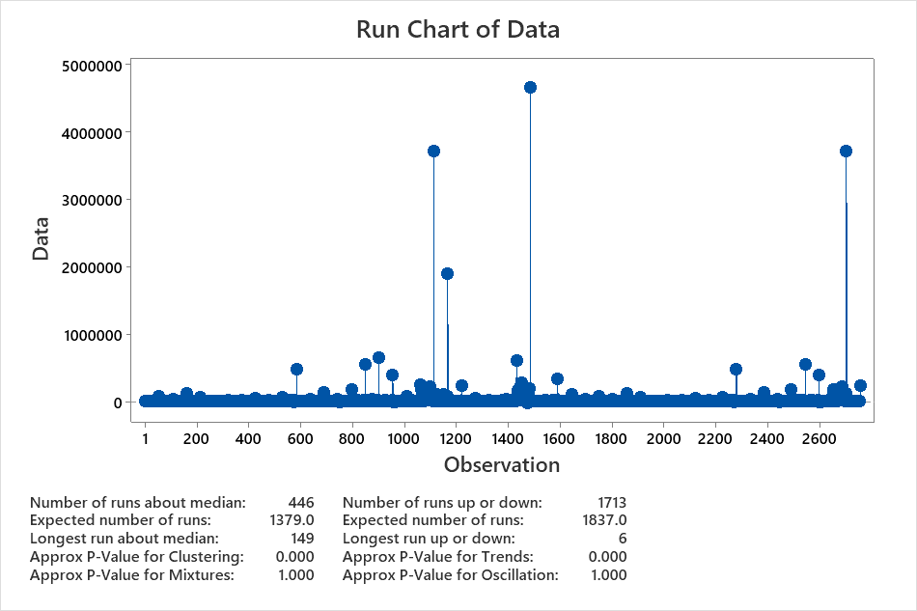

SD - CONSOLIDATED OVERVIEW

**Scatterplot of ff2 vs ff10**

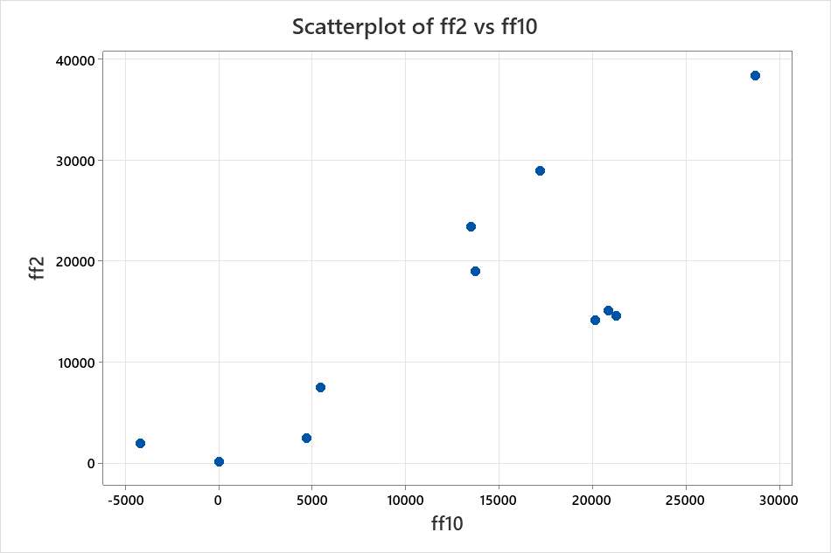

WORKSHEET 3

**Run Chart of Data**



WORKSHEET 3

**Histogram of Data**

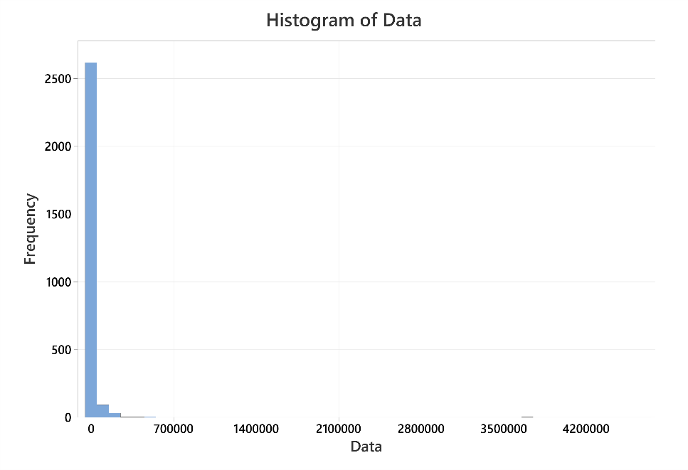

WORKSHEET 3

**Histogram of Data**

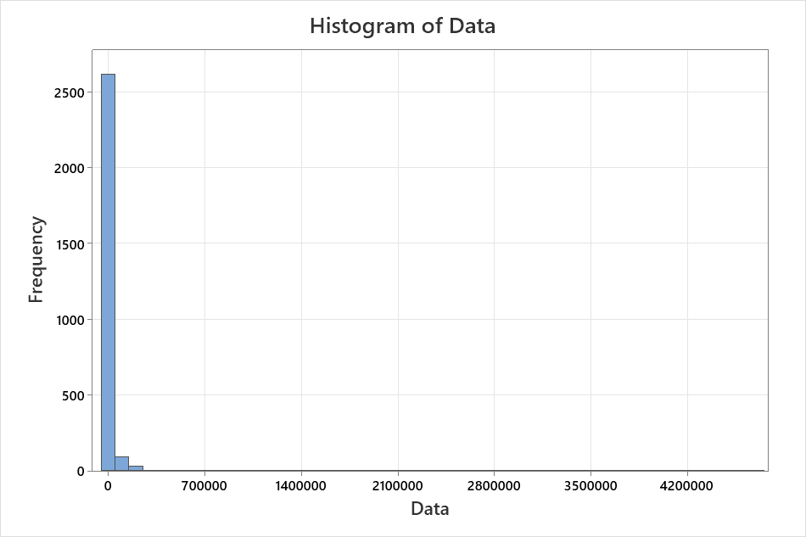

WORKSHEET 3

**Histogram of Vals**

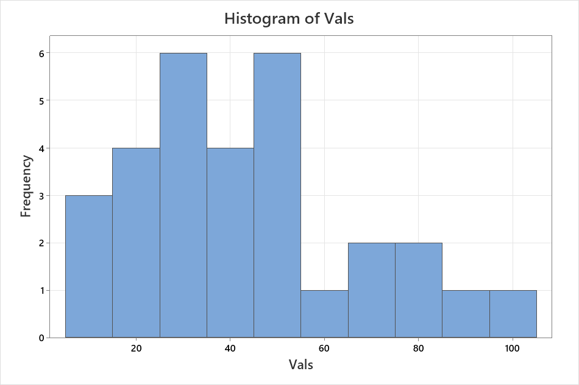

WORKSHEET 3

**Boxplot of Vals**

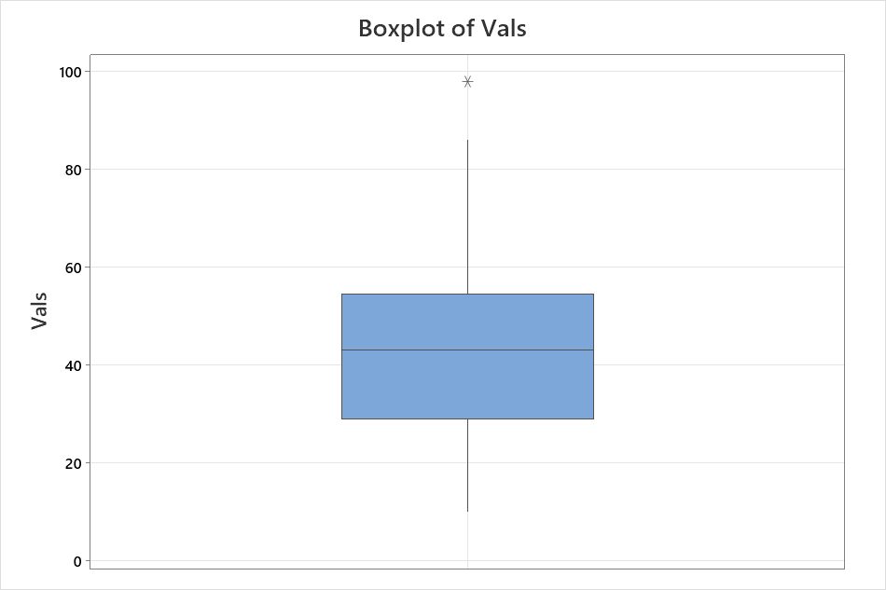

WORKSHEET 3

**Descriptive Statistics: Data**

**Statistics**

|  |  |  |  |  |  |  |  |  |  |  |  |  |  |  |
| --- | --- | --- | --- | --- | --- | --- | --- | --- | --- | --- | --- | --- | --- | --- |
| **Variable** | **N** | **N\*** | | **Mean** | **SE Mean** | | **StDev** | | **Minimum** | **Q1** | **Median** | **Q3** | **Maximum** | **IQR** |
| Data | 2756 | 0 | | 15405 | 2729 | | 143278 | | -20037 | 450 | 1267 | 5149 | 4664253 | 4699 |
| **Variable** | **Mode** | | **N for Mode** | | | **Skewness** | |
| Data | 186, 271 | | 8 | | | 25.87 | |

WORKSHEET 3

**Sample Size for Estimation**

**Method**

|  |  |
| --- | --- |
|  |  |
| Parameter | Mean |
| Distribution | Normal |
| Standard deviation | 1 (estimate) |
| Confidence level | 95% |
| Confidence interval | Two-sided |

**Results**

|  |  |
| --- | --- |
| **Margin of Error** | **Sample Size** |
| 0.5 | 18 |

WORKSHEET 3

**Sample Size for Estimation**

**Method**

|  |  |
| --- | --- |
|  |  |
| Parameter | Mean |
| Distribution | Normal |
| Standard deviation | 10 (estimate) |
| Confidence level | 95% |
| Confidence interval | Two-sided |

**Results**

|  |  |
| --- | --- |
| **Margin of Error** | **Sample Size** |
| 0.3 | 4271 |