Pre-Proposal Technical Document

Mudda: An AI-Assisted Municipal Decision Intelligence System for Public Infrastructure Operations and Service Delivery

1. Preliminary Evidence in Support of the Technology Readiness Level

Current Problem
Citizens communicate problems to urban local bodies and government departments in various ways, including via mobile applications, grievance portals, WhatsApp, call centres, emails, and on-site inspections. In the past decade, substantial amounts of resources have been put towards developing digitised grievance registration and tracking systems via platforms like CPGRAMS and municipal grievance management systems. This development has enabled greater transparency and accessibility for citizens in terms of being able to lodge a complaint and track the status of their complaint online. [1]
While digitised grievance registration exists, the process of analysing, prioritising, routing and coordinating across departments for a complaint takes a significant amount of manual intervention, resulting in delays and backlog of grievances. As a result, municipal officers and departmental personnel often must do various manual tasks related to the complaint narrative to establish severity; manually identify duplicate complaints; route complaints to the appropriate department; prioritise which field resources to utilise from a limited number of resources; and monitor the status of their resolution across the various systems. Most existing grievance platforms operate more as a recording system or a workflow-management system than as an operational intelligence tool providing any level of predictive prioritisation or augmentation of decision-making. [2]
Public agencies are struggling to cope with increasing complaint numbers leading to longer periods of unresolved complaints, poor coordination between the different departments that handle grievances, and differences in how different departments respond. Complaint systems in the public sector continue to show an increase in unresolved complaints, periods between receiving resolution of a grievance, and escalating grievances. These trends indicate that a better way to support these organizations should be created. [3]
Recent research has similarly identified the need for AI-assisted grievance management systems capable of reducing human effort in complaint analysis, classification, and routing while improving the efficiency of public service delivery. [4] [5]

Existing Technology Readiness
The proposed system is built upon a foundation of mature technologies, integrating Large Language Models (LLMs) for multilingual understanding with agentic workflow orchestration frameworks. It leverages Geographic Information Systems (GIS), human-in-the-loop decision support systems, and robust process automation engines to streamline municipal operations. This technical integration facilitates the automation of manual communications—including calls, emails, internal CRM requests, and PDF generation—to replace existing labor-intensive methods. [6]
Initial proof-of-concept experiments have validated the system's ability to convert citizen complaints into structured operational records and automatically classify infrastructure issues. These experiments also demonstrated success in identifying duplicate complaints through semantic clustering and generating draft work orders paired with routing recommendations. By supporting officer approval before final execution, the project has reached a Technology Readiness Level (TRL) of 3–4, confirming that core concepts and prototype components are effective in controlled environments.

2. Scientific Merit, Novelty & Expected Advancement of Technology

Scientific Merit
Current grievance systems focus primarily as workflow management tools that record complaints, assign them to departments, and track their resolution status. They provide limited capabilities for automated incident understanding, prioritization, resource allocation, or operational decision support. Existing approaches typically treat each complaint as an independent transaction rather than as part of a larger infrastructure incident or service disruption, limiting the ability of administrators to assess city-wide impact and coordinate responses effectively. [1]
Recent research in AI-enabled grievance management has primarily focused on complaint classification and routing. While these approaches improve administrative efficiency, they do not adequately address higher-level operational challenges such as incident-level intelligence generation, cross-departmental coordination, dynamic prioritization, and explainable decision support for public officials [3]. Consequently, there remains a significant research gap in developing AI systems capable of transforming large volumes of citizen-generated reports into actionable operational intelligence for municipal governance.
The proposed research addresses this gap by investigating how advances in Large Language Models (LLMs), semantic similarity analysis, knowledge graphs, geospatial intelligence, and human-in-the-loop AI systems can be combined to create a Decision Intelligence Framework for public infrastructure operations. Instead of treating complaints as isolated records, the system will automatically identify and aggregate related complaints into incident-level representations, estimate impact and severity, recommend prioritization strategies, and provide explainable recommendations to decision-makers.
This work advances the state of the art from grievance management to municipal decision intelligence, introducing a new paradigm in which citizen-generated data serves as a real-time sensing layer for urban infrastructure management. [7]

Novel Contributions
The project proposes research and development in:

A. Incident-Centric Intelligence Layer
Rather than treating each complaint as an independent case, the system will automatically aggregate multiple reports into a unified incident representation.
Example:
50 complaints about a water pipeline burst across a locality become one operational incident with impact metrics.

B. Multilingual Civic Understanding
Development of domain-adapted AI models capable of understanding:
The project will focus on developing domain-adapted AI models capable of processing English, Hindi, Hinglish, and various regional language inputs, even when dealing with noisy, citizen-generated content.

C. Human-AI Collaborative Decision Framework
The system will generate recommendations while maintaining officer oversight and approval.
Research focus includes:
Within this framework, the research focuses on explainability, trust calibration, and auditability to ensure governance compliance. The system will also perform comprehensive SWOT analyses to evaluate the potential consequences of various actions or delays.

D. Operational Prioritization Engine
Novel prioritization methods combining:
This engine utilizes novel prioritization methods that synthesize data on severity, geographic spread, citizen impact, and infrastructure criticality. By incorporating historical patterns, the system assists and accelerates municipal resource allocation more effectively than current manual methods.
to assist and accelerate municipal resource allocation.

Expected Technological Advancement
The project aims to establish a new category of public-sector AI systems:
Decision Intelligence Platforms for Government Operations, moving beyond traditional complaint management and workflow automation solutions.
The expected technological advancement lies in transforming citizen-generated reports from passive administrative records into active operational intelligence assets. Current grievance systems largely function as repositories that facilitate complaint registration, assignment, and tracking. The proposed research seeks to create a new technological framework capable of continuously interpreting large volumes of multimodal citizen inputs and converting them into actionable insights for infrastructure management and public service delivery.
The project is expected to advance the state-of-the-art in the following areas:
A. Incident-Level Urban Intelligence
Development of novel methodologies for automatically identifying and aggregating geographically and semantically related complaints into unified infrastructure incidents. This enables municipal agencies to shift from complaint-centric operations to incident-centric decision-making.
B. AI-Assisted Infrastructure Operations
Creation of a decision-support framework capable of recommending prioritization, routing, escalation, and resource allocation strategies based on real-time operational conditions, citizen impact, and infrastructure criticality.
C. Public-Sector Human-AI Collaboration Frameworks
Advancement of explainable and auditable AI systems specifically designed for government decision-making environments. The research will contribute methodologies for maintaining human oversight while leveraging AI-generated recommendations in governance workflows.
D. Municipal Knowledge Graphs and Civic Intelligence Models
Development of domain-specific knowledge representations that capture relationships between infrastructure assets, complaints, locations, departments, historical incidents, and operational outcomes. These knowledge structures can serve as foundational building blocks for future smart-city and digital-governance applications.
E. Indigenous AI Capability for Governance
The project contributes toward technological self-reliance by creating AI models, workflows, datasets, and operational intelligence frameworks tailored to Indian governance contexts, multilingual environments, and public infrastructure systems. These assets can reduce dependence on imported governance technologies and support future Digital Public Infrastructure initiatives.
F. Foundational Platform for Predictive Governance
While the initial focus is on grievance-driven infrastructure management, the resulting architecture can serve as a foundation for future research in predictive maintenance, urban resilience planning, disaster response coordination, utility management, and city-scale operational intelligence systems.
Long-Term Vision
The long-term outcome of the proposed research is the emergence of a new class of AI-enabled governance systems that operate as decision intelligence layers above existing government platforms. Rather than replacing current grievance management systems, these platforms augment administrative capacity by providing real-time situational awareness, evidence-based prioritization, and explainable recommendations for public officials.
Such systems have the potential to become a core component of next-generation digital governance infrastructure, enabling municipalities and public agencies to respond more effectively to citizen needs while improving operational efficiency, accountability, and service delivery outcomes.

3. Research Approach & Feasibility

Phase 1: Data Understanding and Knowledge Modelling
During the initial phase, activities focus on the collection of historical municipal complaint datasets, the development of an infrastructure taxonomy, and the mapping of departmental workflows alongside operational policy extraction. These efforts will result in a comprehensive civic infrastructure ontology and a department-specific knowledge graph.

Phase 2: AI-Based Incident Understanding
The second phase involves multilingual complaint processing and the detection of semantic similarity between reported issues. By implementing duplicate complaint clustering within an incident generation framework, the system produces an intelligence engine that routes issues to the correct departments while significantly reducing redundant data models.

Phase 3: Decision Intelligence Layer
The third phase centres on building a priority scoring framework and a resource recommendation engine for automated work-order generation. Accompanied by an explainability layer, these activities culminate in a human-AI collaborative decision support module that provides end-to-end audits of all steps taken by both the AI and human officers.

Phase 4: Pilot Deployment and Validation
In the final phase, the system is integrated into existing municipal workflows for human-in-the-loop validation and operational benchmarking. Evaluation metrics for this deployment include measurable reductions in complaint triage time and duplicate processing, alongside improvements in response prioritization and overall officer usability scores.

Application Awareness and Expected Impact
The proposed research is application-driven from inception and is motivated by a well-defined operational challenge faced by urban local bodies and public infrastructure agencies. While existing grievance management systems have successfully digitized complaint registration, routing, and tracking, they remain primarily workflow-management platforms with limited capabilities for incident intelligence, operational prioritization, cross-departmental coordination, and decision support. Consequently, municipal officers continue to rely on manual interpretation and administrative judgement for critical operational decisions.
The proposed research seeks to bridge this gap by introducing a Decision Intelligence Layer that augments existing municipal systems rather than replacing them. This approach significantly lowers adoption barriers and improves translational feasibility, as the resulting technology can be integrated with existing grievance platforms, ERP systems, command-and-control centres, and departmental workflows.
Originality and Differentiation from Existing Technologies
Existing grievance management platforms such as CPGRAMS and DIGIT [1] have significantly improved the digitization of complaint registration, tracking, and departmental routing. However, these systems are primarily designed as workflow-management platforms and focus on complaint lifecycle administration rather than operational decision support. Current research in AI-enabled grievance systems has largely concentrated on complaint classification, prioritization, and routing automation, with limited emphasis on incident-level intelligence, cross-departmental infrastructure coordination, or explainable decision support for public officials. [5]
The proposed research introduces a novel paradigm in which citizen-generated complaints are treated not as isolated service requests but as distributed urban signals capable of revealing underlying infrastructure incidents. By combining Large Language Models, semantic clustering, geospatial intelligence, municipal knowledge graphs, and human-in-the-loop reasoning, the system aims to automatically identify incident-level events, estimate their impact, and recommend operational responses [3]. This represents a shift from grievance management towards municipal decision intelligence, a capability not explicitly addressed by existing public grievance platforms or contemporary AI grievance-routing solutions. Furthermore, the proposed framework emphasizes explainability, auditability, and officer oversight, which are increasingly recognized as critical requirements for trustworthy AI deployment in governance environments.
Technical Viability and Economic Feasibility
The proposed research leverages a collection of mature and commercially validated technologies, including Large Language Models, semantic vector search, knowledge graphs, geospatial analytics, and workflow orchestration systems. These technologies have already demonstrated effectiveness across enterprise knowledge management, customer support automation, public service delivery, and decision-support applications [5]. Preliminary proof-of-concept experiments have further demonstrated the feasibility of transforming unstructured citizen complaints into structured records, identifying semantically similar complaints, generating routing recommendations, and supporting human-in-the-loop review processes. Consequently, the project does not depend on the invention of entirely new foundational AI technologies but rather on the novel integration and adaptation of existing technologies to the municipal governance domain [2].
From an economic perspective, the proposed architecture is designed as an augmentation layer that integrates with existing grievance management systems rather than replacing them. This substantially reduces deployment costs and implementation risks for public agencies. The expected operational benefits include reduced complaint triage effort, lower administrative overhead, decreased duplicate field dispatches, improved utilization of municipal resources, and faster incident resolution. Given the large volumes of grievances processed by urban local bodies, even modest improvements in prioritization efficiency and routing accuracy can generate significant cost savings while improving citizen service delivery outcomes. [8]
Interdisciplinary Integration
The proposed research is inherently interdisciplinary and requires the integration of expertise across multiple scientific and engineering domains. Artificial Intelligence and Natural Language Processing are required to understand multilingual citizen-generated complaints and generate contextual recommendations. Knowledge Representation and Reasoning techniques are necessary to model relationships between infrastructure assets, departments, locations, historical incidents, and operational policies. Geospatial Analytics contributes location-aware incident detection and infrastructure impact assessment, while Human-Computer Interaction and Explainable AI support the development of transparent and trustworthy decision-support interfaces for government officers [7].
Equally important is the integration of Urban Governance and Public Administration expertise to ensure that the proposed models align with actual municipal workflows, escalation mechanisms, regulatory requirements, and service-delivery objectives. The research therefore sits at the intersection of computer science, artificial intelligence, geospatial systems, public policy, and urban infrastructure management. This multidisciplinary approach is essential because the challenge being addressed is not purely technical; it involves translating advanced AI capabilities into practical governance tools that can operate effectively within complex public-sector environments.

4. Alternate Strategies in Case the Proposed Approach Fails
Several technical and operational risks have been identified:
Risk | Mitigation Strategy
Insufficient AI accuracy | Hybrid AI + rule-based systems with human validation
Poor duplicate detection performance | Multi-modal clustering using semantic, temporal, and geospatial signals
Low officer trust in recommendations | Explainability layer, confidence scoring, and approval-based workflows
Data quality limitations | Active learning, feedback loops, and synthetic data generation
Integration challenges | API-first architecture and modular deployment model

Risk 1: Insufficient Accuracy of LLM-Based Understanding
Municipal complaints are often submitted in unstructured formats, containing incomplete descriptions, spelling mistakes, abbreviations, colloquial expressions, multilingual content, and domain-specific terminology. These factors can reduce the accuracy of Large Language Models in classification, incident identification, and recommendation generation. To mitigate this risk, the project will employ domain-specific fine-tuning using municipal datasets, retrieval-augmented reasoning, and hybrid AI-rule-based validation frameworks. Human validation checkpoints will be incorporated for high-impact decisions, while continuous feedback from officers will be used to iteratively improve model performance. In cases where confidence scores fall below predefined thresholds, the system will automatically escalate decisions for manual review
Risk 2: Poor Duplicate Detection Performance
Infrastructure incidents often generate multiple complaints that differ significantly in wording despite referring to the same underlying issue. Conventional semantic similarity techniques may fail when complaints contain sparse information, multiple languages, or varying contextual details. To address this challenge, the proposed system will combine semantic similarity analysis with temporal, geospatial, and departmental metadata. If duplicate detection performance remains inadequate, alternative graph-based clustering approaches will be adopted to identify relationships among complaints based on location, time of occurrence, infrastructure asset proximity, and historical incident patterns. GIS-assisted clustering will provide an additional validation layer to improve incident aggregation accuracy and reduce redundant processing.

Risk 3: Low Officer Trust in AI Recommendations
Public-sector decision-making requires transparency, accountability, and compliance with established administrative procedures. Officers may be reluctant to adopt AI-generated recommendations if they perceive them as opaque or unreliable. To mitigate this risk, the system will be designed around a human-in-the-loop framework where AI recommendations serve as advisory inputs rather than autonomous decisions. Every recommendation will be accompanied by confidence scores, supporting evidence, reasoning traces, and incident impact assessments. Comprehensive audit logs will maintain records of both AI-generated suggestions and human decisions, ensuring accountability and regulatory compliance. User feedback mechanisms will also be incorporated to continuously refine recommendation quality and improve trust over time.
Risk 4: Lack of Data Quality
Municipal datasets frequently suffer from missing information, inconsistent categorization, duplicate records, incomplete location data, and variations in reporting standards across departments. Such limitations can negatively affect model training and operational performance. To address these challenges, the project will employ data cleaning, normalization, and standardization pipelines during the initial stages of development. Synthetic dataset generation and data augmentation techniques will be used to compensate for underrepresented categories, while semi-supervised learning approaches will enable the effective utilization of partially labelled datasets. Active learning mechanisms will further allow the system to continuously improve through officer feedback, thereby enhancing model robustness despite data quality constraints.
Risk 5: Integration Challenges with Existing Government Systems
Government departments often operate heterogeneous software environments consisting of legacy systems, departmental applications, and independently managed databases. These variations may create challenges in data exchange, interoperability, and workflow integration. To mitigate this risk, the proposed solution will adopt an API-first and modular architecture capable of operating alongside existing grievance management platforms without requiring large-scale system replacement. Standardized interfaces, configurable workflow adapters, and phased deployment strategies will be employed to reduce integration complexity. Pilot deployments will initially focus on limited-scope use cases to validate interoperability before scaling to broader departmental environments. This approach minimizes operational disruption while ensuring gradual and sustainable adoption of the technology.

5. Technology Translation Plan
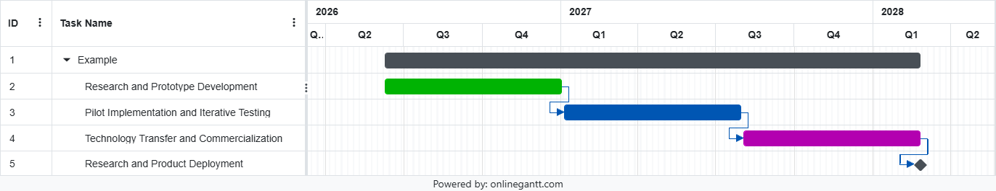
Month 1 to 3
Research and prototype development.
Deliverables:
Months 1 to 3 involve research and prototype development, delivering the incident intelligence prototype, knowledge graph framework, and the core prioritization engine.

Month 4 to 8
Pilot implementation.
Target sectors:
Between months 4 and 8, pilot implementation will target urban local bodies, water utilities, and public infrastructure departments to produce a pilot-ready platform and performance reports. These pilot programs aim to have real world iterative re-doing of the technology to fit the research and product to market and user standards.

Month 9 to 12
Technology transfer and commercialization.
Activities:
Finally, months 9 to 12 focus on technology transfer and commercialization through state-level deployments, integration partnerships, and licensing opportunities. This will result in a finalized software platform, research publications, patent filings, and a clear government adoption roadmap.

6. Figures / Diagrams
Figure 1: Mudda Decision Intelligence Architecture
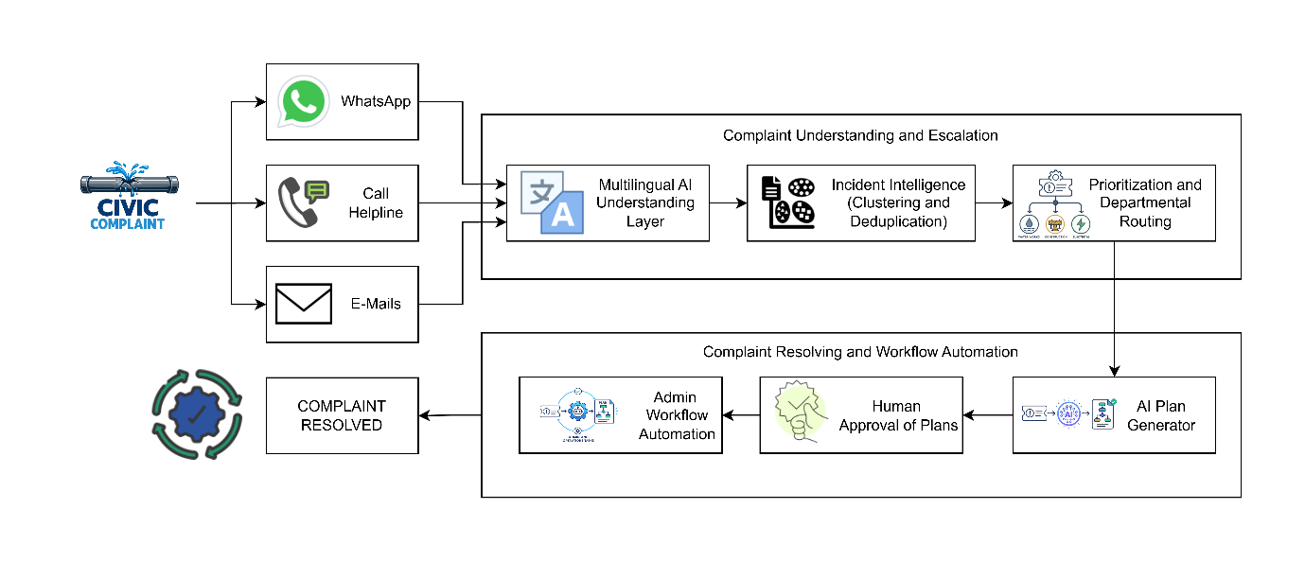
Figure 2: Technical Architecture Diagram
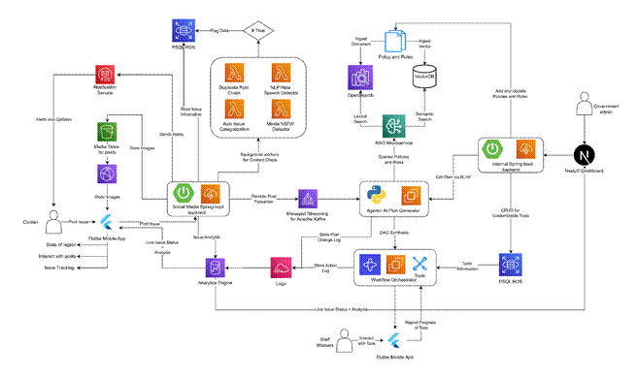

References

[1] | “DIGIT Complaints Management,” 2026.
[2] | D. S. I. T. P. M. A. Keshvee Patel, “LokSevaAI: Smart Governance Complaint Redressal System,” International Journal of Science, Engineering and Technology (IJSET), Vols. Volume 14, Issue 2, 2026.
[3] | V. A. D. S. K. H. R. V. N. J. J. M. K. Devi, “AI-Powered Grievance Management System for Petition Analysis, Prioritization, Routing and Transparent Tracking,” 2026.
[4] | S. B. H. K. S. A. S. N. R. S. S. M. R. H. P. B. Shrey Ganatra, “Grahak-Nyay: Consumer Grievance Redressal through Large Language Models,” 2025.
[5] | S. T. N. B. V. K. C. R. K. G. Raphael Benadit, “Grievassist: AI-Powered Public Grievance Redressal System,” International Research Journal on Advanced Engineering Hub (IRJAEH, vol. 4, no. 4, pp. 2320-2324, 2026.
[6] | S. Pundir, “Mudda - Workflow Automation for Governments,” Mudda, [Online]. Available: https://www.mudda.dev/use-cases.
[7] | S. J. G. F. D. R. C. R. J.-L. D. Shin Koseki, “AI and Cities: Risks, Applications and Governance,” United Nations Human Settlements Programme (UN-Habitat), 2022.
[8] | Department of Administrative Reforms and Public Grievances (DARPG), “CPGRAMS Annual Report 2024,” 2024.

