Part 4 – Mini System Design
Lightweight Sales Insight & Alert System

1. Executive Summary
This document outlines the design of a lightweight Sales Insight & Alert System that continuously monitors sales pipeline performance, analyzes deal progression, generates insights, and provides real-time recommendations to sales teams. The system integrates deal stage tracking, AI-powered insight generation, and continuous feedback from sales calls and remarks.

2. High-Level Architecture
The system is composed of modular components that work together to provide continuous monitoring, analysis, and feedback across the sales lifecycle.
Core Components:
• Sales CRM Data Layer (Deals, Stages, ACV, Outcomes)
• Continuous Sales Deal Cycle Module
• Insight Engine (Analytics + AI Models)
• AI Sales Agent (Call & Remark Analysis)
• Alert & Notification System
• Logging & Monitoring Layer
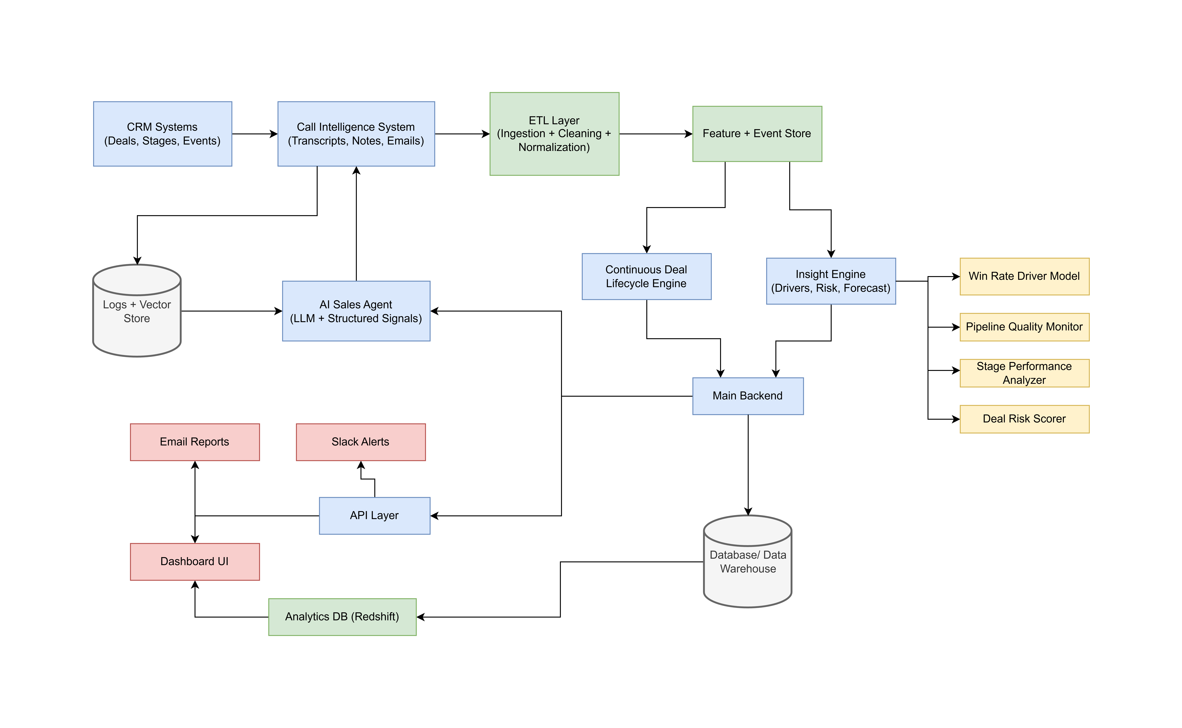

3. Data Flow
Step 1: Data Ingestion
Sales data (deal_id, deal_stage, deal_amount, is_won, timestamps, sales rep, etc.) is ingested from CRM systems at scheduled intervals.
Step 2: Continuous Deal Stage Tracking
Each deal flows through predefined stages (Qualified → Demo → Proposal → Negotiation → Closed). The system records stage transitions and timestamps.
Step 3: Insight Engine Processing
The Insight Engine calculates win rates, stage conversion rates, deal velocity, ACV trends, and exit-stage distributions. It detects anomalies and performance shifts.
Step 4: AI Agent Feedback Loop
Sales call transcripts and remarks are logged continuously. An AI agent analyzes sentiment, objection patterns, buying signals, and aligns findings with stage performance metrics.
Step 5: Alert & Recommendation Generation
When thresholds or anomalies are detected, alerts are triggered. The AI agent provides contextual recommendations to improve deal progression.

4. Continuous Sales Deal Cycle Module
This module tracks every deal's lifecycle and integrates feedback at each stage.
Features:
• Stage Transition Monitoring
• Time-in-Stage Tracking
• Conversion Rate Analysis
• Feedback Injection from Insight Engine
• AI-Generated Suggestions Per Stage
Example: If Demo-to-Proposal conversion drops below threshold, the system alerts the sales manager and suggests reviewing demo quality or pricing objections.

5. Example Alerts & Insights
Stage-Based Alerts:
• Demo win rate dropped 12% compared to previous quarter.
• Negotiation stage average time increased by 18%.
• Late-stage loss rate exceeded 40% threshold.
AI-Driven Recommendations:
• High frequency of pricing objections detected in calls.
• Deals over $50K ACV have lower conversion in Proposal stage.
• Suggest involving senior leadership earlier for enterprise deals.

6. Execution Frequency
• Data Sync: Every 1 hour
• Insight Engine Batch Processing: Daily
• Real-Time Alerts: Trigger-based
• Strategic Performance Report: Weekly
• Executive Summary Dashboard: Quarterly

7. Failure Cases & Limitations
Potential Failure Cases:
• Incomplete or delayed CRM data updates
• Misclassification of deal stages
• Poor quality call transcripts affecting AI analysis
• Alert fatigue due to excessive notifications
System Limitations:
• Insight accuracy depends on data quality
• Early-stage trends may lack statistical significance
• AI suggestions require human validation
• Cannot replace strategic sales leadership decisions

8. Productization Vision – SkyGeni
If productized, this system would function as an intelligent Sales Co-Pilot. It would integrate seamlessly with CRM platforms, provide role-based dashboards (Sales Rep, Manager, VP Sales), and deliver predictive insights.
Key Product Features:
• Deal Health Score per Opportunity
• Predictive Close Probability Modeling
• Stage-Specific Playbooks
• AI Coaching After Every Sales Call
• Executive Trend Analytics Dashboard
The system would be cloud-based, scalable, secure, and modular, allowing organizations to adopt analytics incrementally.

