1.

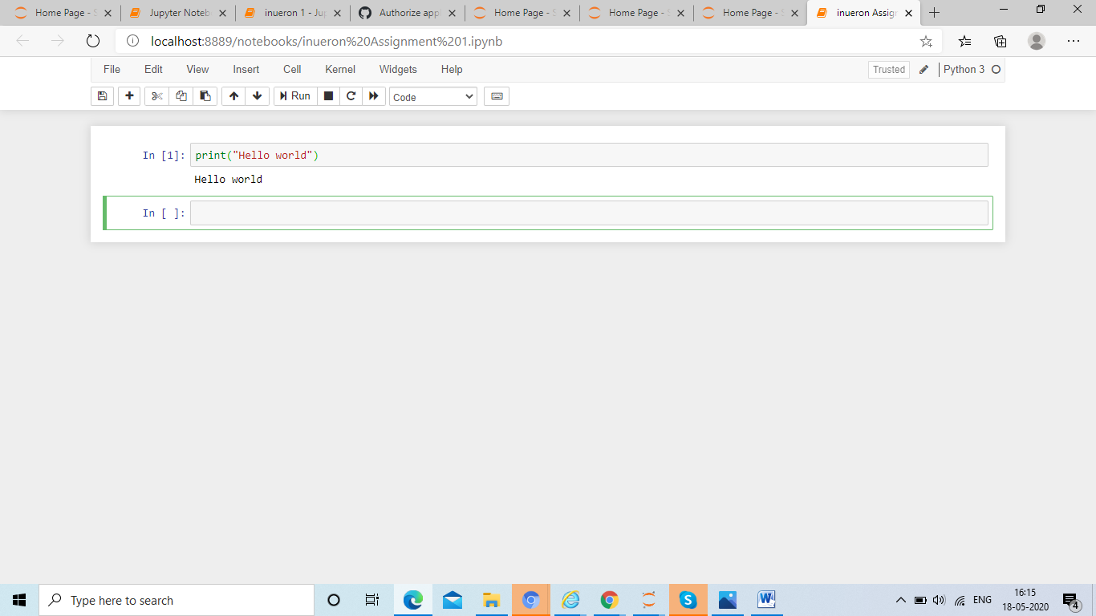

2.

l = list(range(2000,3201))

m = []

for i in range(0,len(l)):

if (l[i]%7 == 0) & (l[i]%5 !=0):

m.append(l[i])

print(m)

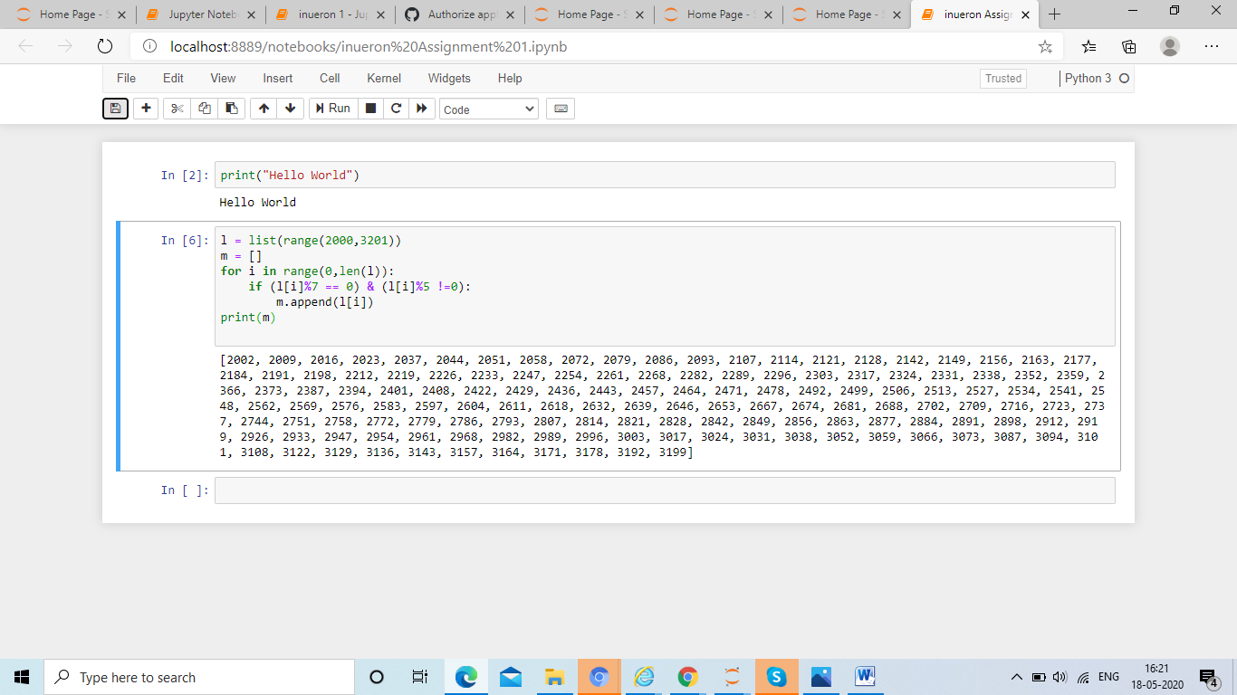

3. Write a Python program to accept the user's first and last name and then getting them printed in the the reverse order with a space between first name and last name.

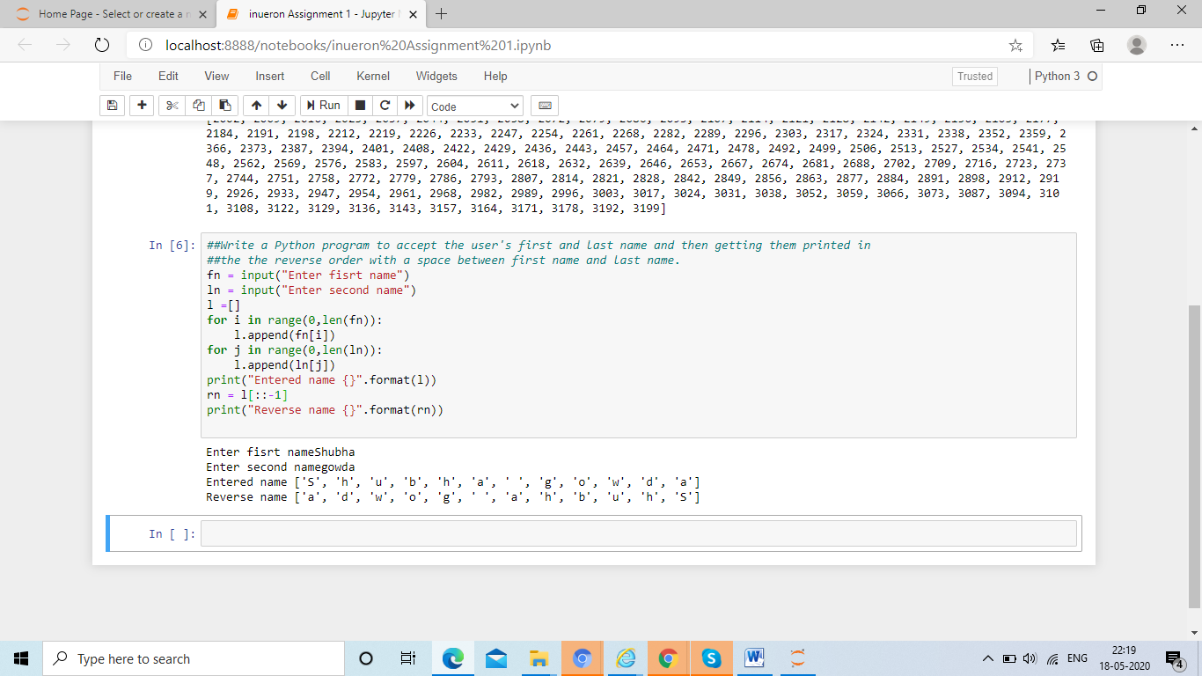

fn = input("Enter fisrt name")

ln = input("Enter second name")

l =[]

for i in range(0,len(fn)):

l.append(fn[i])

for j in range(0,len(ln)):

l.append(ln[j])

print("Entered name {}".format(l))

rn = l[::-1]

print("Reverse name {}".format(rn))

4. Write a Python program to find the volume of a sphere with diameter 12 cm. Formula: V=4/3 \* π \* r 3

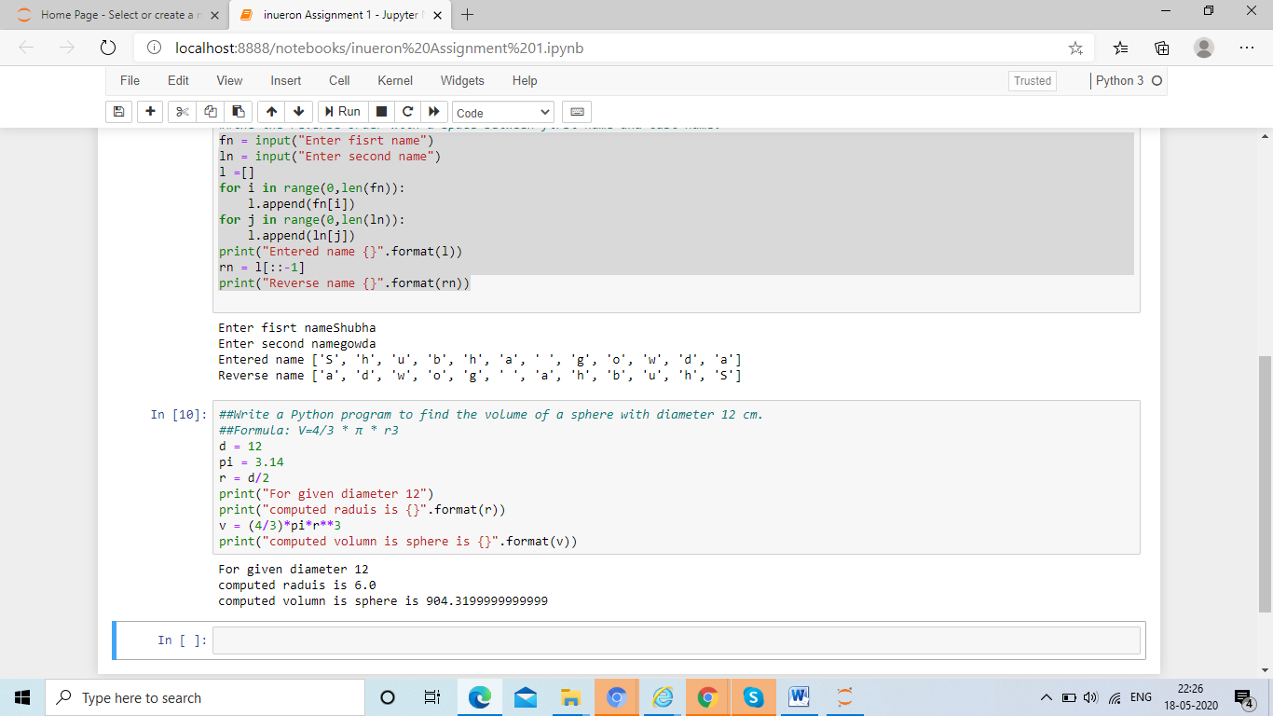

d = 12

pi = 3.14

r = d/2

print("For given diameter 12")

print("computed raduis is {}".format(r))

v = (4/3)\*pi\*r\*\*3

print("computed volumn is sphere is {}".format(v))

Task 2

1. Write a program which accepts a sequence of comma-separated numbers from console and generate a list.
2. 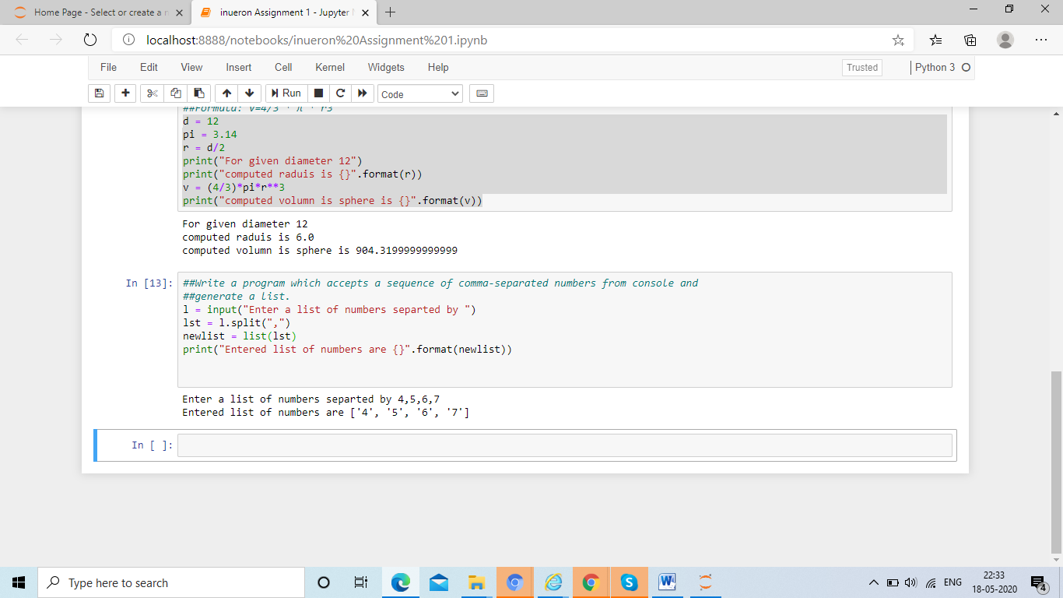

l = input("Enter a list of numbers separted by ")

lst = l.split(",")

newlist = list(lst)

print("Entered list of numbers are {}".format(newlist))

3.

2. Create the below pattern using nested for loop in Python. \* \* \* \* \* \* \* \* \* \* \* \* \* \* \* \* \* \* \* \* \* \* \* \* \*

row = int(input("enter number of rows"))

for i in range(0,row):

for j in range(0,i+1):

print("\*",end=' ')

print('\n')

for i in range (row,0,-1):

for j in range(0,i-1):

print("\*",end =' ')

print('\n')

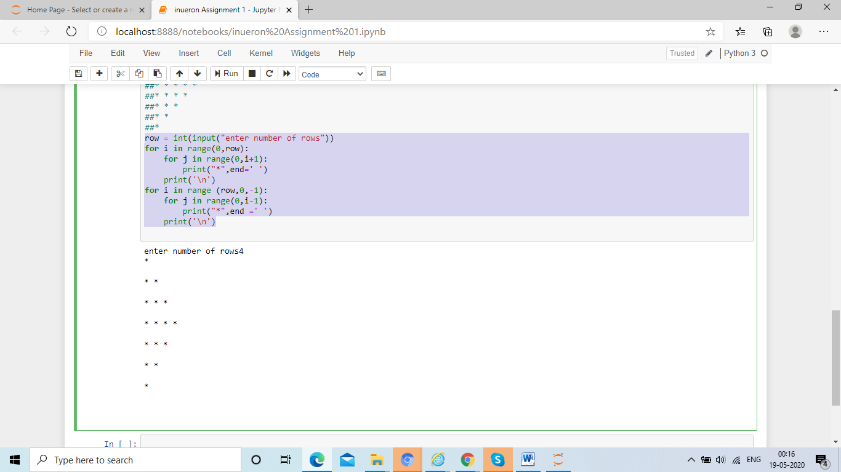

Write a Python program to reverse a word after accepting the input from the user. Sample Output: Input word: AcadGild Output: dilGdacA

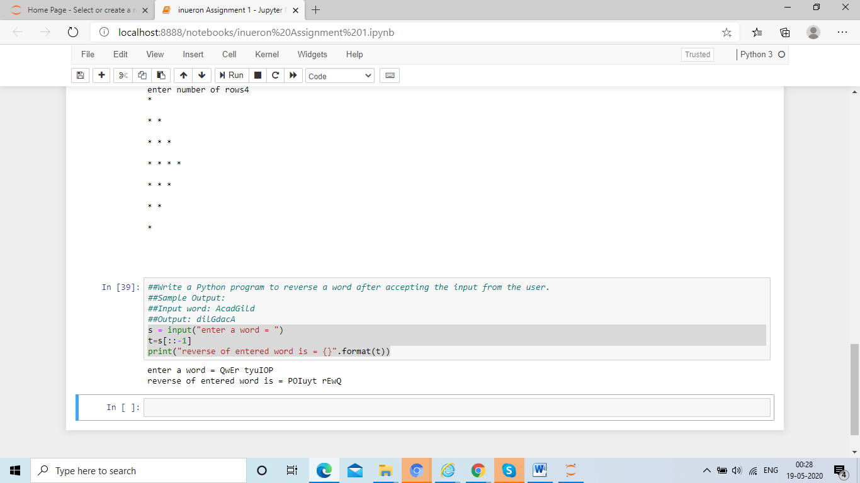

s = input("enter a word = ")

t=s[::-1]

print("reverse of entered word is = {}".format(t))

