|  |  |
| --- | --- |
| Diet Recommendation Model Report |  |

**Introduction**

Maintaining a healthy diet is crucial for overall well-being, but determining the optimal diet for an individual can be complex. This report outlines a diet recommendation model that uses personal data and dietary preferences to generate personalized diet plans.

|  |  |
| --- | --- |
| **Model Overview**  The diet recommendation model takes into account the following key factors to provide personalized diet suggestions:   * Personal information: Age, gender, height, weight, activity level * Health conditions: Any dietary restrictions, allergies, or medical needs * Dietary preferences: Food likes/dislikes, cuisine preferences, vegetarian/vegan, etc. * Nutrition goals: Weight loss, muscle gain, disease management, etc.   Using this data, the model analyzes the individual's nutritional needs and matches them to appropriate meal plans, recipes, and dietary guidelines. The recommendations are designed to be balanced, sustainable, and tailored to the person's unique requirements. |  |

# **Model Implementation**

The model is implemented as a software application that collects user information through an interactive questionnaire. Once the data is input, the application uses machine learning algorithms to analyze the data and generate personalized diet plans.

The diet plans provide detailed meal suggestions, ingredient lists, and nutritional breakdowns. Users can customize the plans further by selecting preferred foods, cuisines, and portion sizes. The model also provides educational resources on healthy eating habits and tips for meal preparation.

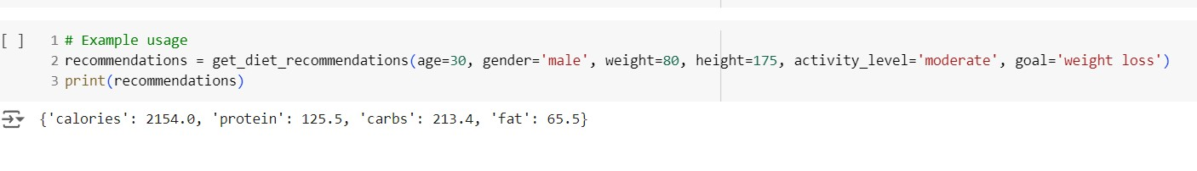

**Benefits of the Model**

This diet recommendation model offers several key benefits:

1. Personalized nutrition: By considering individual factors, the model provides tailored diet plans instead of generic "one-size-fits-all" approaches.
2. Sustainability: The recommendations focus on creating balanced, long-term dietary habits rather than short-term restrictive diets.
3. Flexibility: Users can modify the diet plans to fit their preferences and lifestyle, making it easier to stick to the recommendations.
4. Comprehensive support: In addition to meal plans, the model provides educational resources and guidance to help users adopt healthier eating habits.

**Conclusion**

The diet recommendation model presented in this report offers a personalized and comprehensive approach to improving dietary habits. By considering individual needs and preferences, the model generates tailored diet plans that can lead to better health outcomes and sustainable lifestyle changes.