|  |  |  |  |  |
| --- | --- | --- | --- | --- |
| Prepared | Verified | Approved | Rev No. :- 00 | Page :- 1 of 2 |
| Gunasekaran | Ramakrishna | Ramakrishna | 13Feb2017 |  |

|  |  |
| --- | --- |
|  | **Work Instruction** |
|  |  |

**Steel Mill as cast Billet / Bloom sample and Rolled/Coil bar submission Procedure**

**Scope**  : Submission of Billet / Bloom sample & Rolled/Coil bar sample to BTC Lab for approval.

**Objective** : Approval on Steel mill / Specific Grade steel / Caster size for new part development.

**Procedure** :

1. Purchase will interact with Supplier development – Metallurgist about new part development Material Grade, steel mill and Caster size details.
2. Supplier development – Metallurgist check for the steel mill which is approved in B1-A ( Pre-qualified Vendor list ).
3. If steel mill name is not in the B1-A list , Supplier development-Metallurgist will send B1 specification for the cast Billet & Rolled bar acceptance by Meritor & Steel mill Metallurgical survey form to Steel mill supplier.
4. Steel mill supplier has to fill steel mill Metallurgical survey form and send to Meritor ( SD India ) .
5. SD India to review the steel mill form and send it to Troy Materials Engineering
6. Material engineering will review the steel mill survey form , provide feedback for further information if necessary , followed by audit the steel mill.
7. Steel mill will submit Billet / Bloom sample to BTC Lab for approval along with the reports to SD India for review . The sample is to be collected as First , Middle & Last from each strand of the selected steel grade .

**Example :**

No. of strands taken as 3 ( A,B,C..) & No of blooms per strand considered as 10.(sample collection start , middle , end )

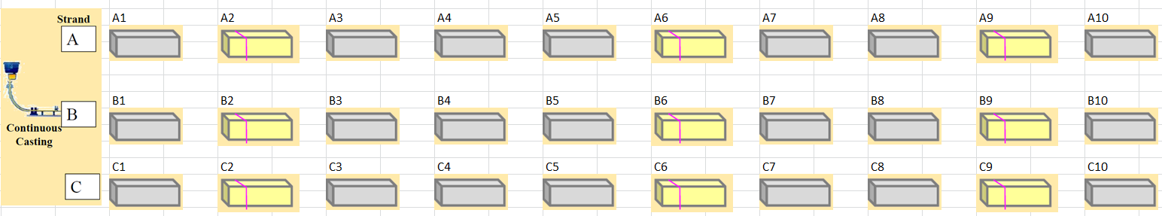

|  |  |
| --- | --- |
|  | **Work Instruction** |
|  |  |



1. Samples shall be of 1 inch thickness & free of rust and surface imperfections as below in the picture ( milling / turning & mild finish grinding is mandatory on one side ) and submit in RP oiled condition to BTC .

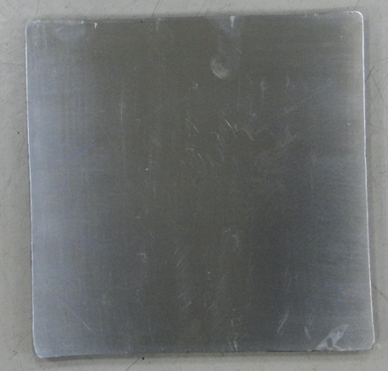

1. Samples should be identified properly with Heat number , Strand number, Billet / bloom number.
2. Rolled bar sample to be collected randomly and submitted to BTC Lab of sample quantity 3 bars each have length 300mm.
3. If the supply condition is in coil form, Coil sample to be collected randomly and submitted to BTC Lab of sample quantity 3 Nos each have length 300mm.
4. If the steel mill is in approved list in B1-A, Supplier development – Metallurgist will check the Material Grade / Caster size approved already from the same steel mill for other parts from SD Folder – “**Meritor part nos and current steel mill list”.**
5. Supplier development – Metallurgist will interact with Material engineering for the approval process with the collected data.
6. Material engineering will direct supplier development-Metallurgist on Caster sample / Rolled bar submission requirements.
7. Material engg – Contact person
8. NA region : Kenneth Yu , Kotz chad
9. EU region : Assumpta
10. SA region : Antunes joao

|  |  |  |  |  |
| --- | --- | --- | --- | --- |
| Prepared | Verified | Approved | Rev No. :- 01 | Page :- 2 of 2 |
| Gunasekaran | Ramakrishna | Ramakrishna | 22/12/2017 |  |

|  |  |
| --- | --- |
| Date | Change |
| 22/12/2017 | Coil samples submission requirements |
| 13/2/2017 | First release |