1. **Introduction to Apache Airflow**

Apache Airflow is an **open-source workflow orchestration platform** created by Airbnb in 2014 and later donated to the Apache Software Foundation. It is designed to programmatically author, schedule, and monitor workflows. Airflow allows data engineers and developers to manage complex pipelines by defining tasks as code, making them easy to maintain, version control, and automate.

A workflow in Airflow is represented as a **Directed Acyclic Graph (DAG)**, where:

* **Nodes** represent tasks.
* **Edges** represent dependencies between tasks.

This structure ensures that workflows are executed in a defined sequence without looping back, which guarantees proper task execution.

Airflow is widely used in **data engineering, ETL (Extract, Transform, Load) pipelines, machine learning model training, data integration, and process automation.**

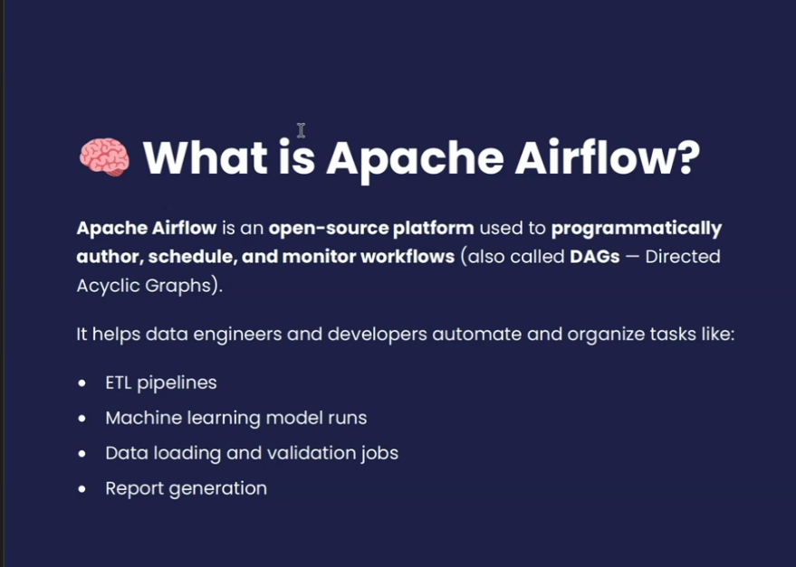

**2. Key Features of Apache Airflow**

* **Dynamic Pipeline Generation**: Workflows are written in Python, enabling dynamic creation of tasks.
* **Scalability**: Can scale from running a few tasks to thousands across multiple machines.
* **Extensibility**: Supports custom plugins, operators, and integrations with cloud platforms.
* **Monitoring & UI**: Provides a rich web-based UI for monitoring, retrying, and debugging tasks.
* **Scheduling**: Built-in scheduler for time-based or event-based workflow execution.
* **Integration**: Connects with popular systems like AWS, GCP, Azure, Hadoop, Spark, PostgreSQL, MySQL, etc.

**3. Why is Apache Airflow Used?**

Apache Airflow is used because it provides a **reliable, scalable, and flexible way to manage workflows.** Organizations adopt it for:

* **Data Pipelines (ETL/ELT)**: Automating extraction, transformation, and loading of data.
* **Machine Learning Workflows**: Orchestrating data preprocessing, training, validation, and deployment steps.
* **Business Automation**: Scheduling recurring tasks like report generation, backups, or file transfers.
* **Cloud Orchestration**: Managing workflows across AWS, GCP, and Azure services.
* **Monitoring & Alerting**: Tracking success, failure, and duration of tasks.
* **Reproducibility**: DAGs as code make workflows version-controlled and repeatable.

Airflow is especially popular in **data-driven companies** where automation, scheduling, and monitoring of workflows are crucial for handling large volumes of data reliably.

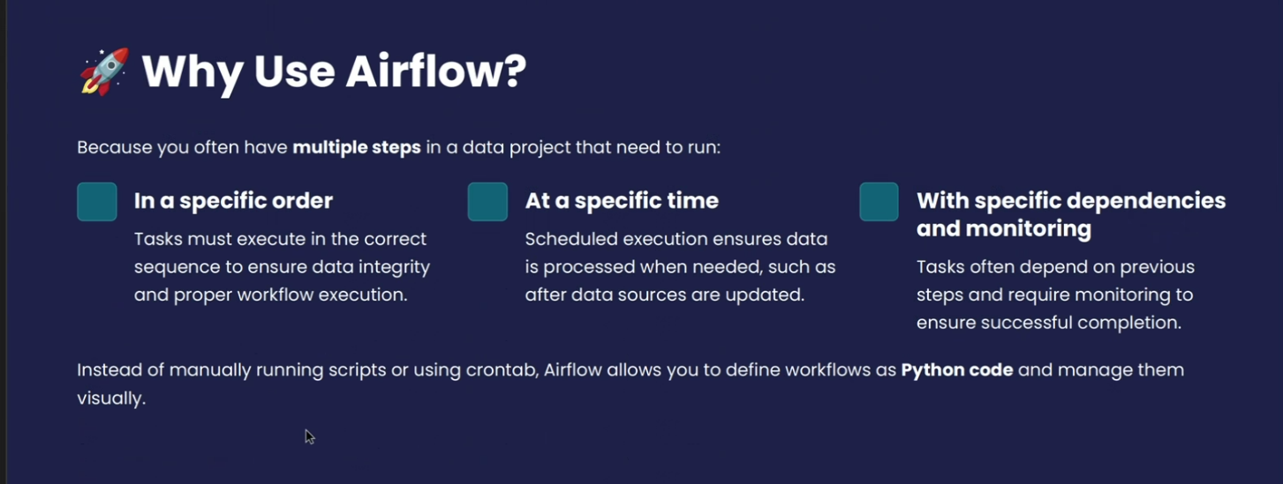

**4. Advantages of Apache Airflow**

1. **Open Source & Free** – No licensing costs; backed by a strong community.
2. **Python-Based** – Easy for developers to define workflows as code.
3. **Extensible** – Custom operators, hooks, and sensors allow integration with almost any tool.
4. **Scalable** – Can handle simple workflows to highly complex data pipelines.
5. **Clear Visualization** – DAGs make workflow dependencies visually easy to understand.
6. **Retry & Error Handling** – Failed tasks can be retried automatically.
7. **Scheduling Flexibility** – Supports cron-like scheduling and event triggers.
8. **Cloud & Big Data Friendly** – Integrates with cloud providers and big data frameworks.
9. **Separation of Concerns** – Each task is isolated, making debugging simpler.

**5. Disadvantages of Apache Airflow**

1. **Steep Learning Curve** – Requires strong understanding of Python and DAG concepts.
2. **Complex Setup** – Initial installation and configuration can be difficult.
3. **Resource Intensive** – The scheduler, workers, and web server require considerable system resources.
4. **Not Ideal for Real-Time Processing** – Better suited for batch processing than streaming tasks.
5. **Scalability Challenges at Extreme Scale** – Requires good infrastructure to handle very large workflows.
6. **Maintenance Overhead** – Managing dependencies, upgrades, and monitoring can be time-consuming.
7. **No Native Data Processing** – Airflow only orchestrates; it does not process or transform data itself.

