**Payment system**

Created epic and its features

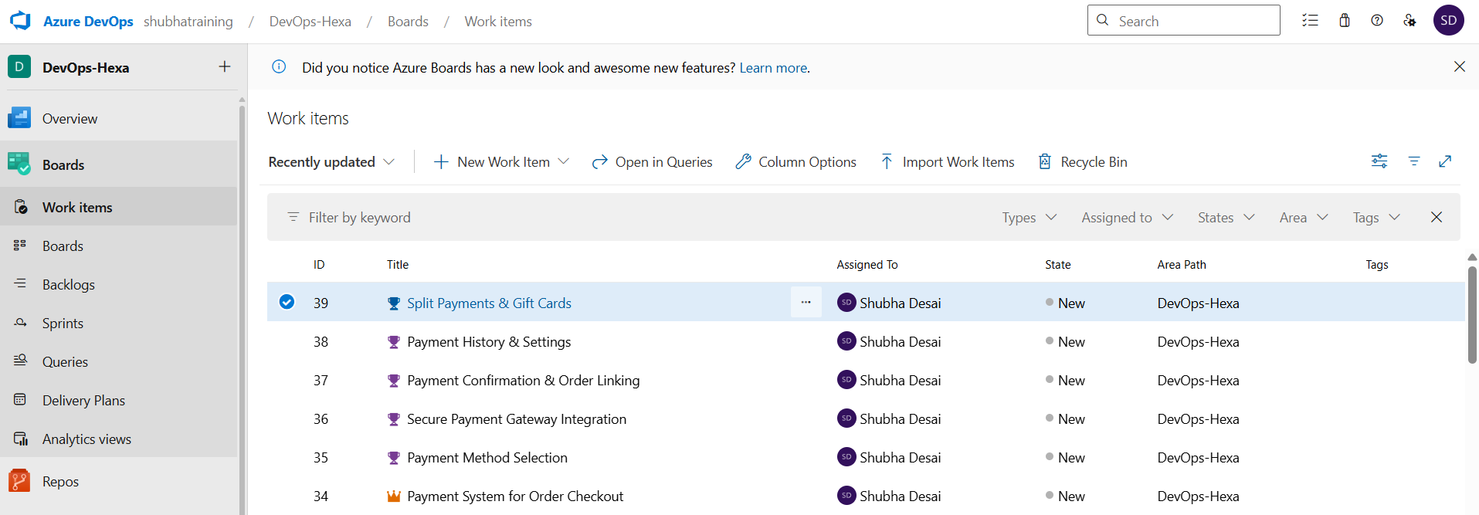

Created User Story for the first Feature(Payment Method Selection)

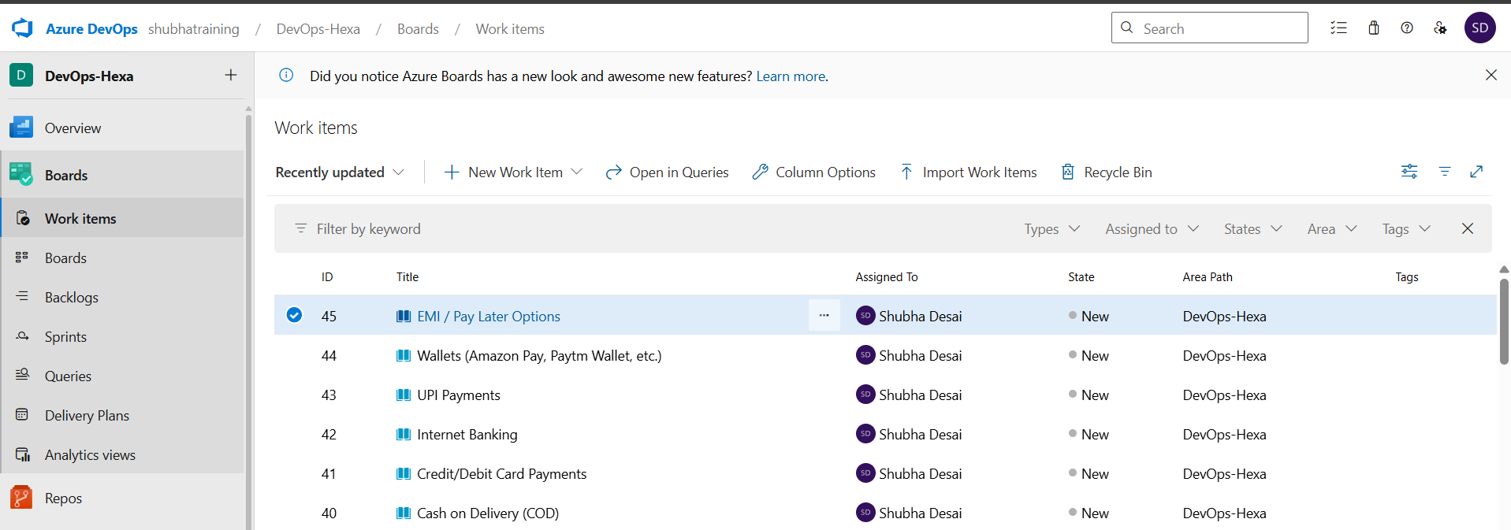

Created the User Story for the second Feature (Secure Payment Gateway Integration)

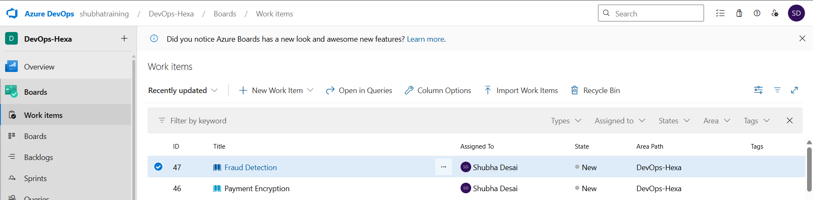

Created the User Story for the third Feature (Payment Confirmation & Order Linking)

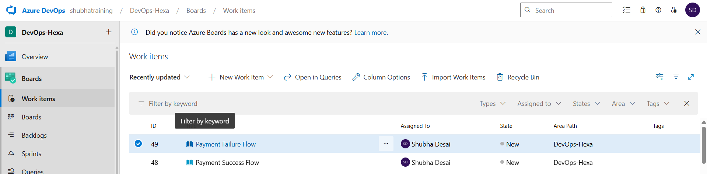

Created the User Story for the forth Feature (Payment History & Settings)

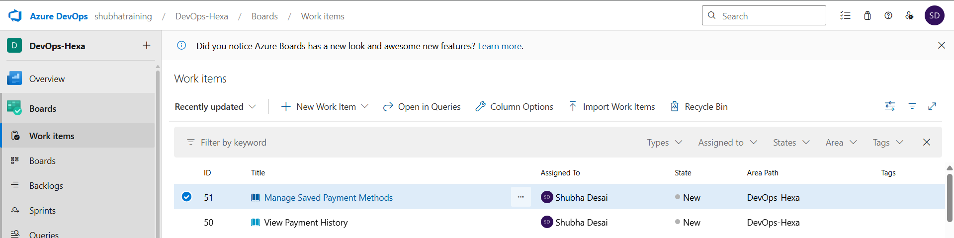

Created the User Story for the fifth Feature(Split Payments & Gift Cards)

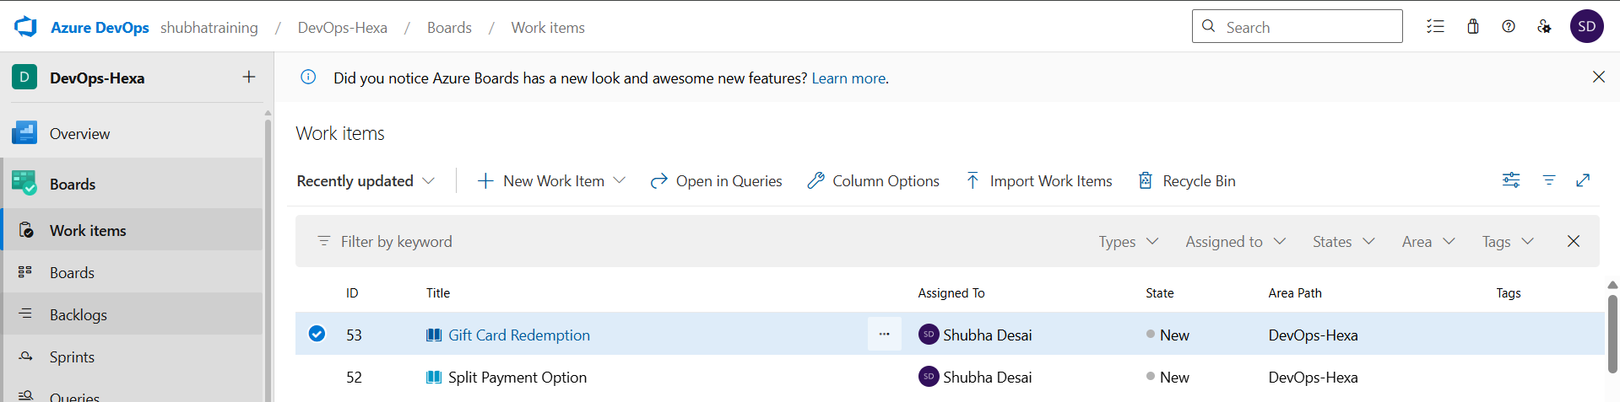

Created the task for first Features according to their User Story

(Feature 1)

1)

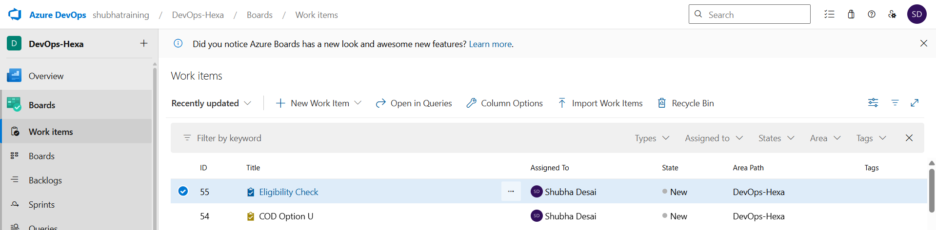

2)

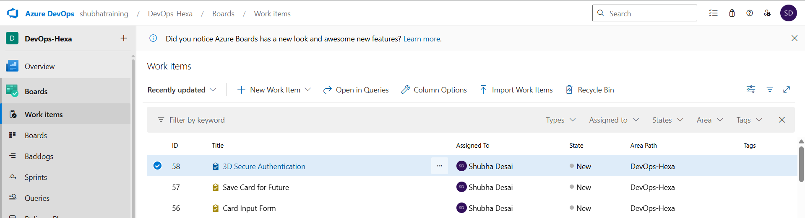

3,4,5,6)

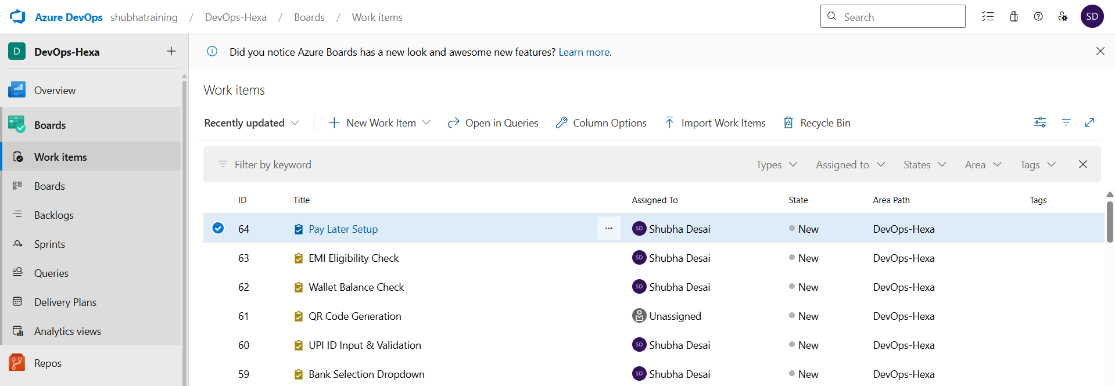

(Feature 2)

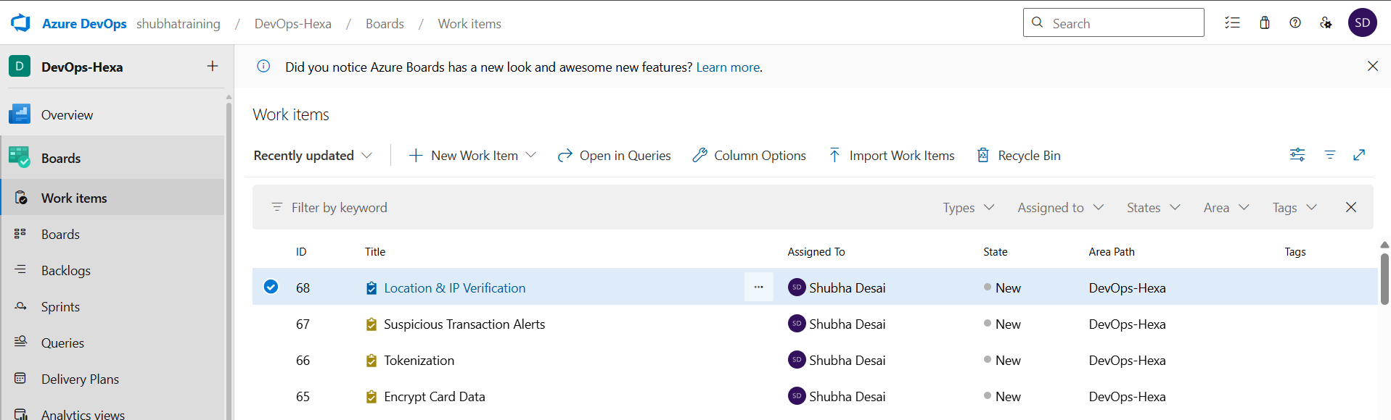

(Feature3)

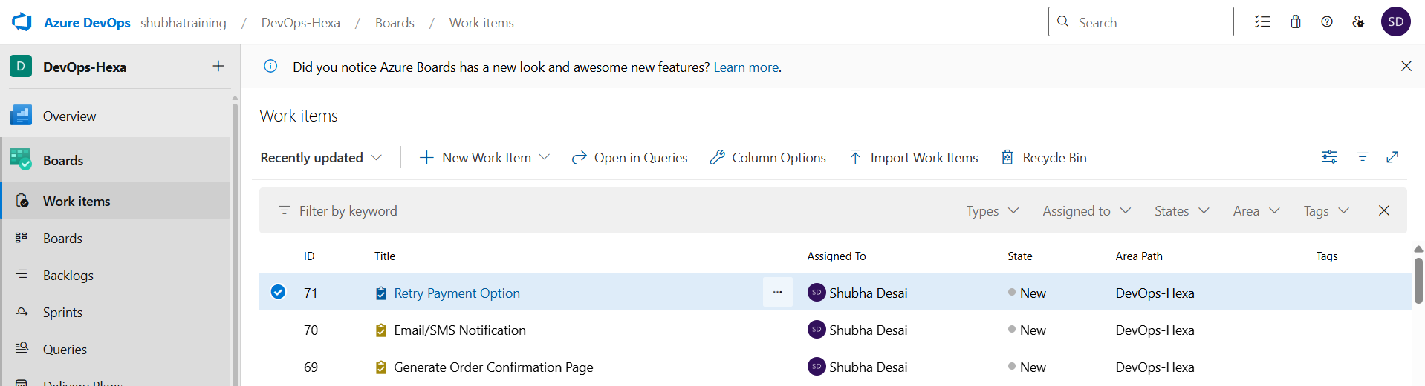

(Feature 4)

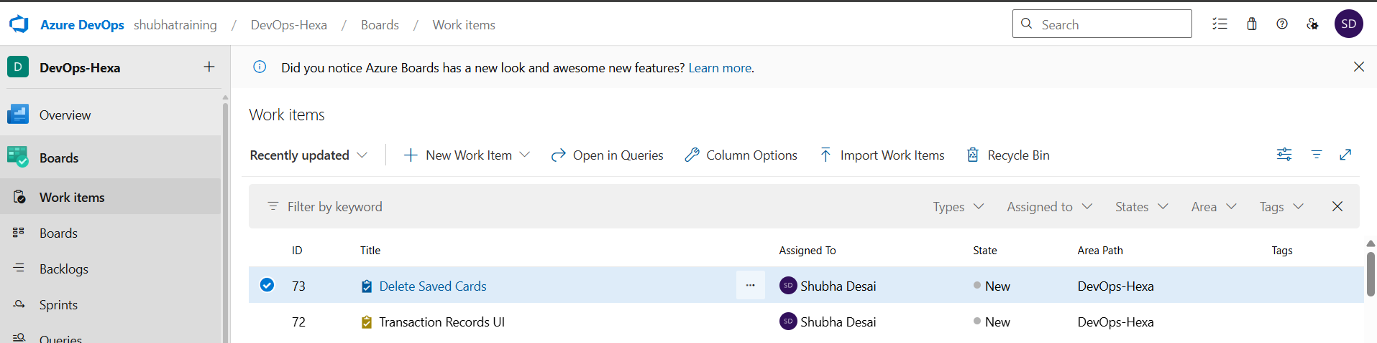

(Feature 5)

