**What is the Spark Revolution?**

The **Spark Revolution** refers to the paradigm shift in big data processing introduced by **Apache Spark**, which overcame the limitations of Hadoop's MapReduce by offering **in-memory computation**, **faster processing**, and **support for advanced analytics** like machine learning and streaming.

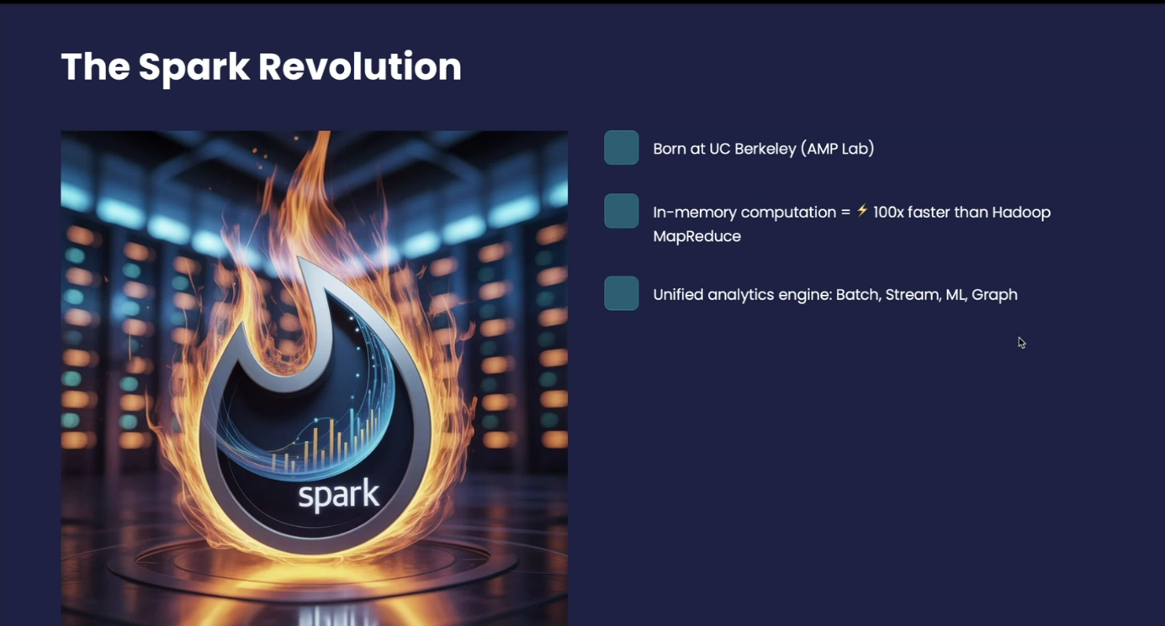

**💡 Why Spark?**

* Faster than Hadoop (up to 100x with in-memory)
* Supports batch & real-time processing
* Built-in modules: SQL, Streaming, MLlib, GraphX
* Easy APIs in Python, Java, Scala, R

**🕰️ Historical Context:**

* **Pre-Spark:** MapReduce dominated big data, but was slow due to disk I/O.
* **With Spark:** Processing became **interactive, iterative, and scalable**, thanks to in-memory caching and DAG-based execution.

**Spark Architecture & Modes of Deployment**

**🧱 Basic Spark Architecture**

Apache Spark follows a **master-slave** architecture consisting of:

* **Driver Program** (Master)
* **Cluster Manager**
* **Worker Nodes** with **Executors**

The **Driver Program** communicates with the cluster manager, which manages **worker nodes** that run **executors** (actual data processing).

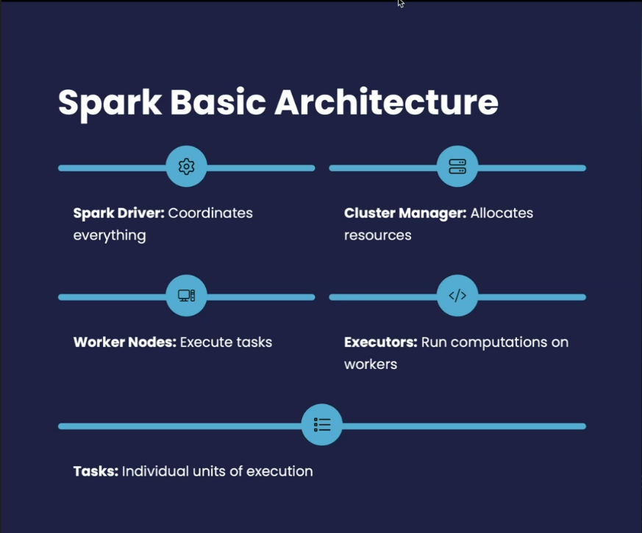

**Client Mode vs Cluster Mode**

| **Feature** | **Client Mode** | **Cluster Mode** |
| --- | --- | --- |
| **Driver Location** | On the machine that submits job | Inside the cluster |
| **Resilience** | Less reliable (driver crash = fail) | More reliable (runs in cluster) |
| **Use Case** | Local testing or debugging | Production deployments |
| **Latency** | Lower in small clusters | Better for large-scale workloads |

**Client Mode** is often used during development and testing. **Cluster Mode** is preferred in production environments for better scalability and fault tolerance.

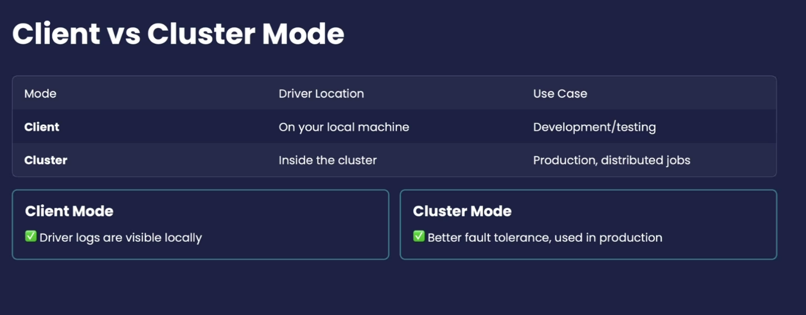

**Core Components of Apache Spark**

**🔹 Driver Node**

* Runs the **main program** of Spark application.
* Maintains **SparkContext**, coordinates all execution.
* Converts user code into **DAG** and **tasks**.

**🔹 Worker Node**

* Physical machine in the cluster.
* Executes tasks assigned by the driver.

**🔹 Executors**

* Live on worker nodes.
* Run individual tasks and return results to the driver.
* Responsible for **caching**, task execution, and reporting.

**🔹 Cluster Manager**

* Allocates resources to applications.
* Can be **Standalone**, **YARN**, **Mesos**, or **Kubernetes**.

**🔹 Spark Context**

* Entry point to low-level API.
* Manages resources and connects the driver to the cluster.
* Used to initialize RDDs.

**🔹 Spark Session**

* Entry point for DataFrame and SQL API.
* Unified API introduced in Spark 2.0+.

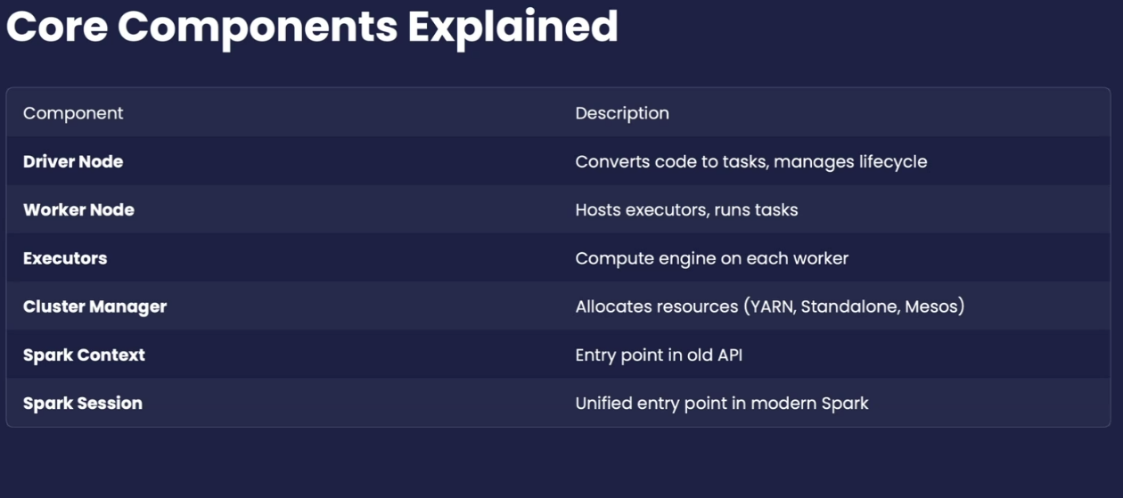

**DAG and Lazy Evaluation**

**🧵 DAG (Directed Acyclic Graph)**

* Spark builds a **logical execution plan** using DAGs.
* Each node is an **RDD transformation**; edges represent **dependencies**.
* Replaces MapReduce's two-stage execution with flexible task scheduling.

**💤 Lazy Evaluation**

* Spark **does not execute operations immediately**.
* Transformations (like map, filter) are **lazy** and just build the DAG.
* Actions (like collect, count) **trigger the execution**.

**Benefits:**

* Optimization: Spark can analyze the full DAG and apply execution strategies.
* Efficiency: Prevents unnecessary computations.

