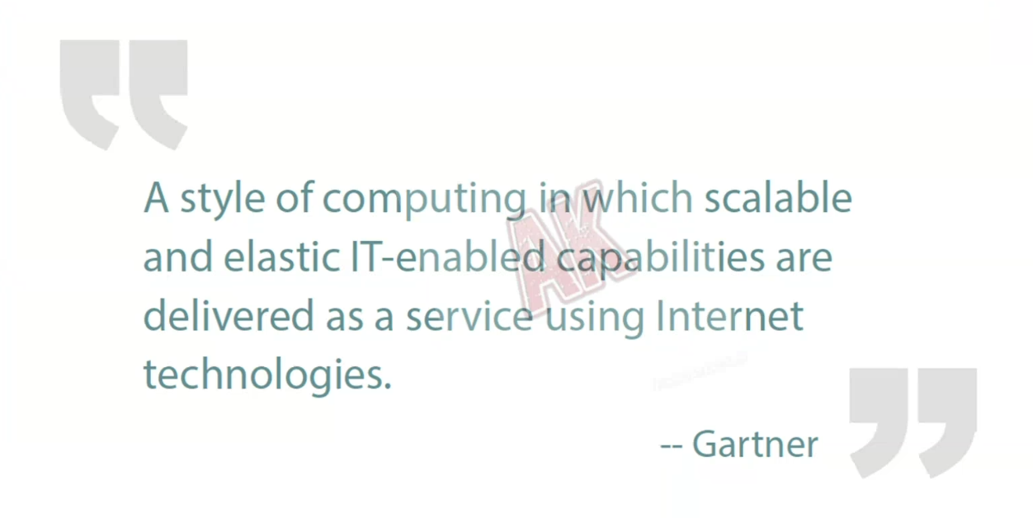

**1. What is Cloud?**

* **Definition:** Cloud computing is the delivery of computing services—such as servers, storage, databases, networking, software, and analytics—over the internet (“the cloud”) instead of owning and maintaining physical infrastructure yourself.
* **Key Features:**
  + On-demand access to resources.
  + Pay-as-you-go pricing.
  + Scalability and flexibility.
  + Managed by cloud providers like AWS, Azure, GCP.
* **Examples:**
  + **AWS EC2** → Virtual servers in the cloud.
  + **Google Drive** → Cloud storage.

**Advantages:**

* No need to maintain physical hardware.
* Access from anywhere with internet.
* Quick scalabilit

**2. What is On-Premises**

* **Definition:** On-premises computing means running servers, storage, and networking equipment **within your own organization’s physical location**, not in the cloud.
* **Key Features:**
  + Infrastructure owned and maintained by the organization.
  + Full control over security and operations.
* **Advantages:**
  + Greater security control.
  + No dependency on internet for local access.
* **Disadvantages:**
  + High upfront hardware cost.
  + Maintenance and upgrades are the company’s responsibility.

**Example:**

* A bank running its **own local servers** in its building to store customer transaction data.

**3. What is a Data Center?**

* **Definition:** A **data centre** is a physical facility that houses an organization’s IT infrastructure—servers, storage, networking equipment, and cooling systems.
* **Purpose:** Store, process, and manage data for businesses or cloud services.
* **Components:**
  + Servers (for computing power)
  + Storage systems (for saving data)
  + Networking devices (routers, switches, firewalls)
  + Power supply & cooling systems
* **Types:**
  + **Enterprise Data Center** – Owned by a single organization.
  + **Colocation Data Center** – Space rented in a shared facility.
  + **Cloud Provider Data Center** – Owned by AWS, Azure, Google Cloud, etc.

**Example:**

* **Google’s Data Center** hosts the infrastructure behind Google Search, Gmail, and YouTube.

**Comparison Table**

| **Feature** | **Cloud** | **Data Center** | **On-Premises** |
| --- | --- | --- | --- |
| **Ownership** | Cloud provider | Organization / Provider | Organization |
| **Location** | Provider’s site | Physical facility | Company site |
| **Cost Model** | Pay-as-you-go | Capital + Opex | Capital + Opex |
| **Scalability** | High | Moderate | Low to Moderate |
| **Maintenance** | Provider | Provider / Org | Organization |
| **Example** | AWS EC2 | Google Data Center | Bank’s internal server room |

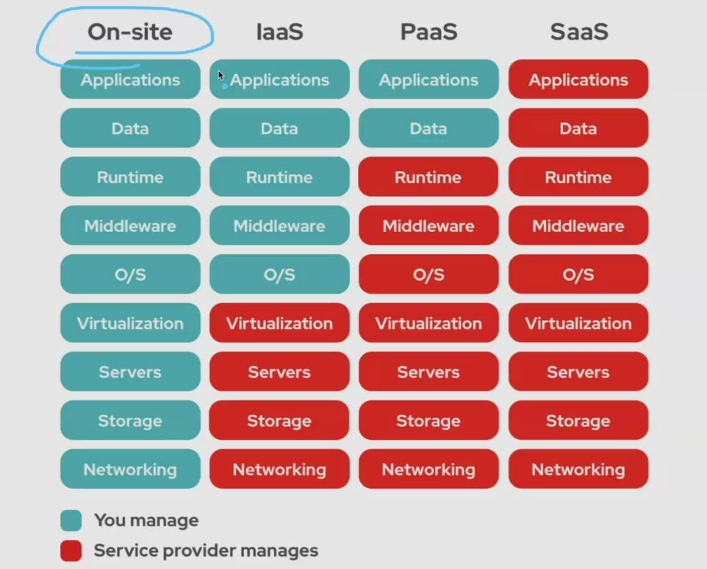

**1. Virtual Machine (VM)**

* **Definition:**  
  A **virtual machine** is a software-based simulation of a physical computer. It runs on top of a **hypervisor** that allows multiple VMs to share the same physical hardware.
* **Purpose:**
  + Run multiple operating systems on the same physical server.
  + Isolate workloads for security and reliability.
* **Example:**
  + On a single server, you can run **Windows VM** and **Linux VM** side by side.
* **In Cloud Context:**  
  VM is the basic compute unit in cloud services like AWS EC2, Azure Virtual Machines, GCP Compute Engine.

**2. Load Balancer**

* **Definition:**  
  A **load balancer** is a system that distributes incoming network traffic across multiple servers to ensure **no single server is overloaded**.
* **Purpose:**
  + Improves **availability** (if one server fails, traffic goes to others).
  + Improves **performance** (spreads requests evenly).
* **Example:**
  + In an e-commerce website, a load balancer routes traffic to multiple backend servers to handle heavy user loads.
* **Cloud Example:**  
  AWS Elastic Load Balancing, Azure Load Balancer, GCP Cloud Load Balancing.

**3. IaaS, PaaS, SaaS – Explained Using Your Image**

Your image shows **what you manage** vs **what the cloud provider manages**.

**a) On-Premises (On-Site)**

* You manage **everything**:
  + Networking, Storage, Servers, Virtualization, OS, Middleware, Runtime, Data, Applications.
* **Example:**  
  A company runs its own local servers for hosting a website.

**b) Infrastructure as a Service (IaaS)**

* **You manage:**  
  Applications, Data, Runtime, Middleware, OS.
* **Provider manages:**  
  Virtualization, Servers, Storage, Networking.
* **Example:**
  + AWS EC2, Azure Virtual Machines, Google Compute Engine.
* **Use Case:**
  + When you want control over OS and applications but don’t want to manage hardware.

**c) Platform as a Service (PaaS)**

* **You manage:**  
  Applications, Data.
* **Provider manages:**  
  Runtime, Middleware, OS, Virtualization, Servers, Storage, Networking.
* **Example:**
  + AWS Elastic Beanstalk, Google App Engine, Azure App Service.
* **Use Case:**
  + When you want to develop apps without managing OS, runtime, or hardware.

**d) Software as a Service (SaaS)**

* **You manage:**  
  Nothing – everything is managed by the provider.
* **Provider manages:**  
  Applications, Data, Runtime, Middleware, OS, Virtualization, Servers, Storage, Networking.
* **Example:**
  + Gmail, Google Docs, Microsoft 365, Zoom.
* **Use Case:**
  + When you just want to use software without worrying about infrastructure.

**4. Summary Table**

| **Feature** | **On-Premises** | **IaaS** | **PaaS** | **SaaS** |
| --- | --- | --- | --- | --- |
| You manage | All layers | App, Data, Runtime, Middleware, OS | App, Data | None |
| Provider manages | None | Virtualization, Hardware, Networking | Runtime, Middleware, OS, Hardware | Everything |
| Example | Company-owned data center | AWS EC2 | Google App Engine | Gmail |