**POINTERS:**

**1. Array of pointers to store string.**

e.g.

#include <stdio.h>

const int MAX = 4;

int main () {

char *names[] = {

"Zara Ali",

"Hina Ali",

"Nuha Ali",

"Sara Ali"

};

int i = 0;

for ( i = 0; i < MAX; i++) {

printf("Value of names[%d] = %s\n", i, names[i] );

}

return 0;

}

**2. Return Pointer from function.**

It is not a good idea to return the **address of a local variable** outside the function, so you would have to define the local variable as **static** variable.

#include <stdio.h>

#include <time.h>

#include <stdlib.h>

int * getRandom( ) {

static int r[10]; // this variable is declared as static as we are returing its address outside the //function

int i;

for ( i = 0; i < 10; ++i) {

r[i] = rand();

printf("%d\n", r[i] );

}

return r;

}

int main () {

int *p;

int i;

p = getRandom();

for ( i = 0; i < 10; i++ ) {

printf("*(p + [%d]) : %d\n", i, *(p + i) );

}

return 0;

}

**STRING:**

**Some inbuilt functions:**

**1.strchr(s1,ch)**

**char *strchr(const char*, int);**

Returns a pointer to the first occurrence of character ch in string s1.

#include<stdio.h>

#include<string.h>

void main(){

char str[] ="i am gonna strive hard for the next 6 months.";

char ch = 'm';

char *ptr;

ptr = strchr(str, ch);

int k=1;

while(ptr!=NULL){

printf("occurance: %d", k);

printf("\nthe position of the occurance of the word |%c| is %ld", ch, ptr-str+1);

printf("\nthe string after the charecter |%c| is |%s|\n\n\n", ch, ptr);

ptr= strchr(ptr+1, ch);

k++;

}}

**2.strstr(s1,s2).**

Returns a pointer to the first occurrence of string s2 in string s1.

**3. strcpy()**

**4. strcat()**

**5. strcom(**)

**STRUCTURE:**

**struct [structure tag] {**

**member definition;**

**member definition;**

**...**

**member definition;**

**} [one or more structure variables];**

**STRUCTURE as function argument:**

#include<stdio.h>

#include<string.h>

struct kaka_pg {

char name[10];

char institute[10];

char course[10];

} Ashok;

void func(struct kaka_pg uncle);

void main(){

strcpy(Ashok.name, "vivek");

strcpy(Ashok.institute, "vector");

strcpy(Ashok.course, "embedded system");

func(Ashok);

}

void func(struct kaka_pg uncle){

printf("name of the student:%s\n", uncle.name);

printf("name of the institute:%s\n", uncle.institute);

printf("name of the course:%s\n", uncle.course);

}

**Pointer to structure:**

**struct [name of structure] *structure pointer;**

we can store the address of a structure variable in the above defined pointer variable. To find the address of a structure variable, place the '&'; operator before the structure's name as follows--

**struct_pointer = &structure variable;**

#include<stdio.h>

#include<string.h>

struct kaka_pg {

char name[10];

char institute[10];

char course[16];

} Ashok;

void func(struct kaka_pg *uncle);

void main(){

strcpy(Ashok.name, "vivek");

strcpy(Ashok.institute, "vector");

strcpy(Ashok.course, "embedded system");

func(&Ashok);

}

void func(struct kaka_pg *uncle){

printf("name of the student:%s\n", uncle->name);

printf("name of the institute:%s\n", uncle->institute);

printf("name of the course:%s\n", uncle->course);

}

**typedef & #define:**

* typedef is limited to giving symbolic names to types only where as #define can be used to define alias for values as well, q., you can define 1 as ONE etc.
* Typedef interpretation is performed by the **compiler** whereas #define statements are processed by the **pre-processor.**

**Pre-Processing / Compilation / Linking**

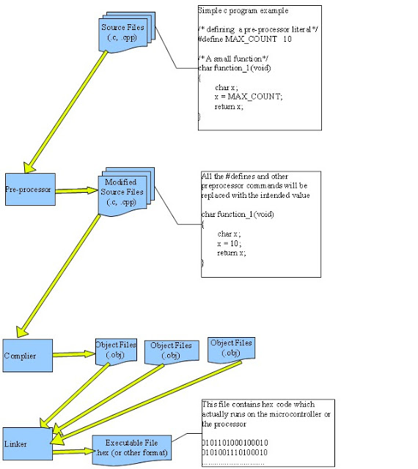

**Assembly / Linking**

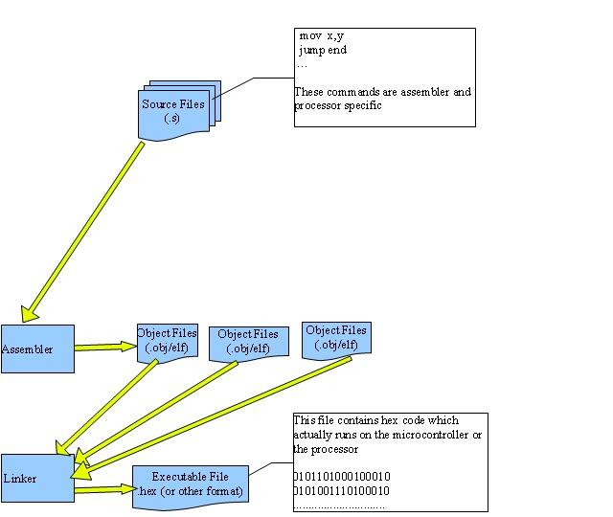

**Little endian and big endian architecture:**

In Big-Endian, Most-Significant-Byte (MSB) is stored at lowest address while, in Little-Endian, Least-Significant-Byte (LSB) is stored at lowest address.

x four byte integer contains a hex value0x76543210 (0xstands for hex), the least significant byte will contain 0x10 and the most significant byte will store 0x76. Now if you take a pointer c of type char and assign x's address to c by casting x to char pointer, then on little endian architecture you will get 0x10 when *c is printed and on big endian architecture you will get 0x76 while printing down *c. Thereby you can find out the endianness of your machine.

#include <stdio.h>

int main ()

{

unsigned int x = 0x76543210;

char *c = (char*) &x;

printf ("*c is: 0x%x\n", *c);

if (*c == 0x10)

{

printf ("Underlying architecture is little endian. \n");

}

else

{

printf ("Underlying architecture is big endian. \n");

}

return 0;

}

**FILE:**

**OPENING FILES:**

**fopen()** function is used to open or create a new new file.

**Syntax**: FILE *fopen(const char * file name, const char * mode);

|  |  |
| --- | --- |
| **Mode** | **Description** |
| **r** | Opens an existing text file for reading purpose. |
| **w** | Opens a text file for writing. If it does not exist, then a new file is created. Here your program will start writing content from the beginning of the file. |
| **a** | Opens a text file for writing in appending mode. If it does not exist, then a new file is created. Here your program will start appending content in the existing file content. |
| **r+** | Opens a text file for both reading and writing. |
| **w+** | Opens a text file for both reading and writing. It first truncates the file to zero length if it exists, otherwise creates a file if it does not exist. |
| **a+** | Opens a text file for both reading and writing. It creates the file if it does not exist. The reading will start from the beginning but writing can only be appended. |

**Closing a file:**

**Syntax: int fclose(FILE *fp);**

The fclose () function returns zero on success, or EOF if there is any error in closing the file. This function actually flushes any any data still pending in the buffer to the file, close the file, and release any memory used by the file. The EOF is a constant define in the **stdio.h header** file.

**Writing a FILE:**

**Syntax: 1. int** fputc**(int** c**, FILE** *fp**);**

**2.** **int** fputs**(const char** *s**, FILE** *fp**);**

both of the above functions returns a non negative number on success and EOF on failure.

**Reading a FILE:**

**Syntax:**

**1. int fgetc(FILE *fp);**

**2. char *fgets(char *buf, int n, FILE *fp);**

The **fgetc()** reads a charecter from the file pointed by the file pointer. The return value is the charecter read, in case of failure it returns EOF.

The functions **gets()** reads up to n-1 characters from the input stream referenced by fp. It copies the read string into the buffer **buf**, appending a **null** character to terminate the string.

If this function encounters a newline character '\n' or the end of the file EOF before they have read the maximum number of characters, then it returns only the characters read up to that point including the new line character.

#include<stdio.h>

void main(){

FILE *fp;

char buff[255];

fp=fopen("file.txt", "r");

fscanf(fp,"%s", buff); //reads untill it encounters a space

printf("1 :%s\n", buff);

fgets(buff, 255, fp); //reads untill the \o i.e. NULL charecter

printf("2 :%s", buff);

fgets(buff, 255, fp);

printf("3 :%s\n", buff);

fclose(fp);

}

**C-PREPROCESSOR**

The **C Preprocessor** is not a part of the compiler, but is a separate step in the compilation process. In simple terms, a C Preprocessor is just a text substitution tool and it instructs the compiler to do required pre-processing before the actual compilation.

All preprocessor command begins with a symbol hask (#)

|  |  |
| --- | --- |
| **Directive** | Description |
| **#define** | Substitutes a preprocessor macro. |
| **#include** | Inserts a particular header from another file. |
| **#undef** | Undefines a preprocessor macro. |
| **#ifdef** | Returns true if this macro is defined. |
| **#ifndef** | Returns true if this macro is not defined. |
| **#if** | Tests if a compile time condition is true. |
| **#else** | The alternative for #if. |
| **#elif** | #else and #if in one statement. |
| **#endif** | Ends preprocessor conditional. |
| **#error** | Prints error message on stderr. |
| **#pragma** | Issues special commands to the compiler, using a standardized method. |

**Predefined macros:**

|  |  |
| --- | --- |
| **Macro** | **Description** |
| **__DATE__** | The current date as a character literal in "MMM DD YYYY" format. |
| **__TIME__** | The current time as a character literal in "HH:MM:SS" format. |
| **__FILE__** | This contains the current filename as a string literal. |
| **__LINE__** | This contains the current line number as a decimal constant. |
| **__STDC__** | Defined as 1 when the compiler complies with the ANSI standard. |

**Memory allocation:**

**1. malloc :** stands for memory allocation.

The function **malloc()** reserves a block of memory of specified size and return a pointer of type **void**, which can be casted into a pointer of any form.

syntex: ptr =(cast_type *) malloc (size);

mallocl() does not initialize the memory location with any value. i.e. the memory allocate with the hepl of malloc() contains garbage value.

**2. calloc :** stands for contiguous allocation.

calloc is also used for dynamic memory allocation. The difference between calloc and malloc is that calloc takes two arguments(number of block and size of each block) while maloc takes only one argument. Calloc initialize the location with zero value which malloc does not.

Syntex: ptr =(cast_type *) calloc (number of block, size of each block);