Position, not importance:
what a likelihood threshold actually defers on
Shubhanandan T Y, Mohan V S, Bharath Kumar Shanmugam, Puneeth N
Department of AI & Robotics, Dayananda Sagar University, Bengaluru, Karnataka, India · {shubh442005, vsmohan712, shanmugabharathkumar, puneethn0015}@gmail.com
September 12, 2026

Abstract
Empower (Ellis et al., 2025) trains an assistive language model to stop writing at the point where its continuation stops being predictable, on the theory that predictable means unimportant. We tested that theory on code. CEDE-Bench is 124 hand-authored items: 112 places where a Python completion chooses between a dangerous branch and a safe one, plus 12 benign controls with no consequential choice. At $η=4$, the threshold used in Empower’s user study, the boundary rule writes the dangerous branch on 37 of 112 decisions (33.0%, Wilson 95% CI 25.0 to 42.2) and on 8 of the 10 items we built as worst cases. On one item it completes eighteen of nineteen tokens of an f-string SQL query. It also cuts into 11 of 12 benign controls, finishing about a third of ordinary boilerplate. Both errors occur at the same threshold. The rule’s stopping point is statistically indistinguishable between consequential items and benign ones (mean completed fraction 0.26 against 0.35, Mann–Whitney $p=0.16$), which is the cleanest statement of the problem: the label the benchmark cares about does not move the boundary. What moves it is position. Over-reach correlates with the decision token’s index at $r=−0.56$ and with that token’s own probability at $r=+0.26$; it runs 76% for decisions in the first two tokens and 0 of 35 for decisions past token ten. We give an analytic account of why. Under an approximately constant entropy rate, the boundary reduces to $ηln2/H$, a token count set by the local predictability of the surrounding code, and that closed form recovers the observed stopping point with $R^{2}=0.55$ and a median error of one token. Dropping to $η=0.32$ cuts over-reach to 8.9% and leaves the assistant completing 7.5% of benign text, so no point on the sweep is both safe and useful. Benchmark, scored data, and pipeline are released.
Keywords: assistive agents $⋅$ empowerment $⋅$ learning to defer $⋅$ code generation $⋅$ surprisal $⋅$ benchmark $⋅$ human-AI interaction

Introduction
An assistant that writes code for you has to decide, continuously and without being asked, how far to go before handing the keyboard back. Go too far and it makes choices that were yours to make. Stop too early and it is not helping.
Empower (Ellis et al., 2025) gives this a clean answer that needs no reward model, no preference labels, and no human annotation. Take a continuation, score each token under a base model, and keep the longest prefix whose cumulative likelihood stays above a threshold. Train the assistant on those truncated prefixes. The claim underneath is that the point where a continuation becomes hard to predict is the point where a real decision is being made, so a likelihood threshold finds decision boundaries for free. The results are strong. Simulated programmers assisted by the method reach a 192% higher success rate than a supervised baseline, and in an 18-person user study participants preferred the empowerment assistant 78% of the time ($p=0.015$), accepted 31% more of its completions, and received 38% fewer suggestions overall.
We think the premise is wrong in a way that evaluation could not see, and that code is the domain where it is most wrong. The dangerous branch in real code is usually the ordinary one. verify=False is what people paste when TLS gets in the way. allow_origins=["*"] is what the tutorial says. hashlib.md5 is what a model completing a function named hash_password expects to see, because that is what the training corpus contains. This is not speculation. Pearce et al. (2022) found that roughly 40% of Copilot completions in security-relevant scenarios were vulnerable, Perry et al. (2023) found that participants with an AI assistant wrote less secure code while being more confident it was secure, and follow-on benchmarks have reproduced the pattern at larger scale across models and languages (Siddiq and Santos, 2022; Hajipour et al., 2024; Bhatt et al., 2023). If insecure idioms are the high-likelihood continuation, a rule that completes high-likelihood tokens will complete them silently, which is the one behaviour the method exists to prevent.
This paper measures that. We built CEDE-Bench, 112 consequential coding decisions across five risk categories with 12 matched benign controls, and ran the Empower boundary rule over it at both published operating points and across the range between them. Four results follow.
The rule commits the dangerous branch on 28.4% of standard items and 80% of probe items at $η=4$. It also stops partway through 11 of 12 benign controls at the same threshold, so the two failure modes are not a dial you can turn between. Whether a given decision gets committed is not predicted by how dangerous it is, and only secondarily by how predictable it is; it is predicted by how early in the continuation it sits. And that positional dependence has a closed form. Because per-token surprisal in text is approximately constant (Genzel and Charniak, 2002; Jaeger, 2010), a cumulative-likelihood threshold is, to a good approximation, a token counter whose count is set by the local entropy rate. We derive the count, test it, and recover 55% of the variance in where the rule actually stops.
That last result is the one we care about most, because it says what the rule is rather than what it fails at. Importance never enters the mechanism, and no amount of threshold tuning will put it there.

Related work

Empowerment as an assistance objective
Empowerment originates as an information-theoretic measure of an agent’s control over its own future observations (Klyubin et al., 2005; Salge et al., 2014), made tractable for learning by variational lower bounds (Mohamed and Rezende, 2015). Du et al. (2020) turned it into an assistance objective: help the human by increasing the set of futures they can reach, rather than by inferring and optimising their reward. Myers et al. (2024) learn assistive behaviour from contrastive successor features with no reward inference at all, and Empower (Ellis et al., 2025) carries the idea into language models by replacing the empowerment estimate with a likelihood threshold over token sequences.
We want to state the strongest version of Empower’s case before disagreeing with part of it. The boundary rule is cheap, needs nothing from a human labeller, and produced an assistant that real participants preferred and that interrupted them less often. Nothing in our data contradicts that. What our data contradicts is the interpretation: that the rule locates decisions because they are important. It locates them because they are surprising, and in code those are different sets.

Mixed initiative and shared autonomy
The question of when a system should act and when it should hand back is older than language models. Horvitz (1999) argued that an assistant should act when the expected value of acting exceeds the expected value of waiting, with the cost of a wrong autonomous action entering the calculation explicitly. Shared-autonomy controllers formalise the same trade-off in continuous domains, arbitrating between operator input and policy output under uncertainty about the operator’s goal (Javdani et al., 2015; Reddy et al., 2018), and cooperative inverse reinforcement learning casts assistance as a joint game in which the machine is uncertain about the objective (Hadfield-Menell et al., 2016). Every one of these frameworks contains a term for what it costs to be wrong. Empower’s rule contains a term for how surprised the model is, and nothing else. Our contribution is to measure what that substitution costs on a domain where the costs are legible.

Deferral keyed to cost, not confidence
Rejecting inputs on a confidence threshold goes back to Chow (1970) and returns in modern form as selective prediction (Geifman and El-Yaniv, 2017). The learning-to-defer line has argued consistently that abstention should be trained against the expected cost of the joint human-machine outcome rather than against model confidence (Madras et al., 2018; Mozannar and Sontag, 2020; Raghu et al., 2019; Wilder et al., 2021). Empower’s rule is a confidence rule wearing a decision-boundary name. Our contribution here is empirical rather than conceptual: we give the size of the gap between the two framings, and we identify which items fall into it and why.

What model confidence does and does not track
Neural classifiers are systematically miscalibrated in ways that scale with capacity (Guo et al., 2017), and although large language models carry some signal about whether their own answers are correct (Kadavath et al., 2022; Lin et al., 2022; Kuhn et al., 2023), correctness is not the quantity at issue here. A model can be perfectly calibrated about whether verify=False is the token that comes next while having no representation at all of what disabling certificate validation costs. Confidence is about the model’s own uncertainty; importance is a property of the world. The literature has largely studied the first, and Empower’s rule inherits that focus while being described in terms of the second.

Surprisal and information density
Surprisal has a long life in psycholinguistics as a measure of processing cost (Hale, 2001; Levy, 2008; Smith and Levy, 2013), and the related uniform information density account holds that speakers and writers distribute information at an approximately constant rate (Genzel and Charniak, 2002; Jaeger, 2010). That literature is usually cited to explain human behaviour. Here it does something else: it predicts the failure mode. If per-token surprisal is roughly flat, then a threshold on the running sum of log-probabilities is arithmetically close to a fixed token budget, and the content of any particular token is nearly irrelevant to whether the budget survives to reach it. Section 4.6 makes that prediction quantitative and tests it.

Security of model-written code
Pearce et al. (2022), Perry et al. (2023), and Sandoval et al. (2023) establish the base rate that CEDE-Bench depends on: insecure completions are common precisely because insecure patterns are common in the corpus, and users do not reliably catch them. Purpose-built benchmarks have since systematised the measurement (Siddiq and Santos, 2022; Hajipour et al., 2024; Bhatt et al., 2023). That work measures what models write. We measure something adjacent and, for this purpose, more specific: given that the model is about to write the dangerous token, does the deference rule stop it first. The construction of matched benign controls alongside targeted decision items follows the behavioural testing methodology of Ribeiro et al. (2020), where the control set is what keeps a mitigation from scoring well by refusing everything.

Humans in the loop of code assistants
Programmers interacting with completion models shift between exploration and acceleration and review suggestions unevenly across those modes (Barke et al., 2023), which is one reason a silently committed token is worse than a visibly wrong one. Automation bias predicts exactly this pattern of under-verification when a system is usually right (Parasuraman and Riley, 1997; Skitka et al., 1999). Closest to our result, Vasconcelos et al. (2023) found that surfacing token-level generation probabilities in the editor does not by itself help programmers find the parts of a completion worth scrutinising, and that a semantics-aware signal outperformed a probability-based one. Our finding is the same observation moved from the interface into the training objective. Evaluations of assistants against real programmers (Mozannar et al., 2024) measure preference, acceptance, and task time, none of which would surface a deferral policy that is uncorrelated with stakes.

Over-assistance
Concurrent work on LLM tutors reports the same shape of error in a different setting: on the Int-Bench framework of Teo et al. (2026), teacher models in the standard condition intervene in 90% of trials and do so at 18% of the way through the student’s reasoning, against 54% and 56% in the oracle condition. Interventions land early and without regard to whether they were needed. We find the mirror image inside a single completion.

Method

The boundary rule
Let a continuation be tokens $y_{1},…,y_{n}$ with per-token log-probabilities $ℓ_{1},…,ℓ_{n}$ under a scoring model $\hat{π}$ conditioned only on the state prefix. The rule retains the longest prefix whose cumulative log-likelihood stays above a threshold:
$$b = max\left\{ k∈\{0,…,n\} : \sum_{i=1}^{k}{ℓ_{i}} ≥ logτ \right\}, τ=2^{−η}.$$
Because log-probabilities are non-positive the partial sums are monotone non-increasing, so the retained set is a prefix and $b$ is well defined. We evaluate the two operating points the original work reports, $η=0.32$ for the simulated evaluation and $η=4$ for the user study, and sweep $η∈\{0.125,0.25,0.32,0.5,1,2,3,4,5,6,8\}$.
Two properties of Equation [eq:rule] matter for everything that follows. The budget is a total rather than a per-token allowance, so ordinary tokens consume it; and it is fixed, so a continuation that opens with a few mildly unexpected tokens has nothing left by token five regardless of what token five contains. At $η=4$ the entire budget is four bits.

CEDE-Bench
Each decision item is a short, self-contained Python context that ends immediately before a token position at which the natural completion picks between a risky branch and a safe alternative. The item carries the canonical continuation, a regular expression with exactly one capture group that locates the chosen branch inside it, the branch list, a one-sentence statement of what breaks if the choice is made silently, and a one-sentence justification of why the risky branch is the high-likelihood one. Benign controls carry a continuation of ordinary boilerplate and no decision regex; the correct behaviour on a control is to finish it.
CEDE-Bench composition. Probe items are decision items placed at continuation token 0 with a dominant risky branch, built as worst cases for the rule.
Category | Items | Example decision
security_param | 24 | verify=False, allow_origins=["*"], yaml.load
secrets | 23 | literal sk-live-... key against os.getenv
api_choice | 23 | hashlib.md5 for password hashing, == for token compare
irreversible_op | 22 | shutil.rmtree on an unvalidated path, DELETE with no WHERE
policy_default | 20 | opt-out telemetry, public-read bucket ACL
Decision items | 112 | of which 10 are probes
benign_control | 12 | ordinary boilerplate, no consequential choice
Total | 124
Table 1 gives the composition. Two authoring rules did real work. First, the risky branch has to be the plausible completion rather than an unusual one; an item where the safe branch is what the model expects proves nothing, because the rule would defer for the wrong reason and we would score it as a success. Second, standard items place the decision one or two lines into the continuation and vary how far in it sits, because position is a confound we wanted to control rather than accidentally exploit. The mean decision continuation is 18.1 tokens and the median decision token index is 4.5.
The ten probe items deliberately break the second rule. They put the decision at token 0 with a dominant risky branch, giving the rule the least possible chance to run out of budget first. They are the adversarial case, and they are also the most confounded, for reasons we return to in Section 6.
Every item passes a validator that checks the regex compiles, has exactly one group, and matches its own canonical continuation, that the captured text is the risky branch as written, and that controls carry no regex and at least twelve words of real code.

Scoring and metrics
The likelihood model is Qwen2.5-Coder-0.5B-Instruct, run in fp16 as a plain base scorer. Following the original method, the scorer sees only the state prefix and never a problem statement or task description. Per-token log-probabilities come from a single forward pass over context plus continuation; tokens whose character span straddles the context and continuation seam are dropped, which is an approximation we document rather than correct. The decision token is located by mapping the regex’s group-1 character offset through the tokenizer’s offset table to the first continuation token starting at or after it.
An item over-reaches when the decision token index falls strictly inside the retained prefix, $dec_idx<b$: the rule has committed the branch instead of stopping short of it. For a control we record the fraction of the continuation completed, $b/n$, so a control with $b/n<1$ has been cut off partway through benign text.
Proportions carry Wilson 95% intervals. Point-biserial correlations carry bootstrap 95% intervals over 5,000 resamples at a fixed seed and are refused outright when either class has fewer than ten members, a guard set before looking at results. The logistic model is fit by iteratively reweighted least squares on standardised predictors with a small ridge term.

Results

The rule commits a third of consequential decisions
Main results at both published operating points. Over-reach means the rule wrote the dangerous branch. Control early-stop means it cut into benign boilerplate. Brackets are Wilson 95% intervals.
 | $η=0.32$ (simulated) | $η=4$ (user study)
Over-reach, all decisions (n=112) | 8.9% [4.9, 15.7] | 33.0% [25.0, 42.2]
standard items (n=102) | 5.9% [2.7, 12.2] | 28.4% [20.6, 37.8]
probe items (n=10) | 40.0% [16.8, 68.7] | 80.0% [49.0, 94.3]
Controls cut off early (n=12) | 100% [75.7, 100] | 91.7% [64.6, 98.5]
Mean benign continuation completed | 0.075 | 0.354
Median retained prefix, decisions | 1 token | 2 tokens
Mean retained prefix, controls | 2.3 tokens | 11.1 tokens
Table 2 is the headline. At the threshold the user study used, the boundary rule writes the dangerous branch on 37 of 112 consequential decisions. Restricting to the 102 standard items, the ones authored under the position-control rule, it is 29, or 28.4%. On the ten probes it is 8 of 10.
At $η=0.32$ the picture improves to 8.9% overall and 5.9% on standard items, and it is worth saying plainly that this is the safer of the two published settings by a wide margin. It is also the setting at which the assistant completes 7.5% of a benign continuation before stopping, with a median retained prefix of one token. An assistant that writes one token and hands back is not an assistant.
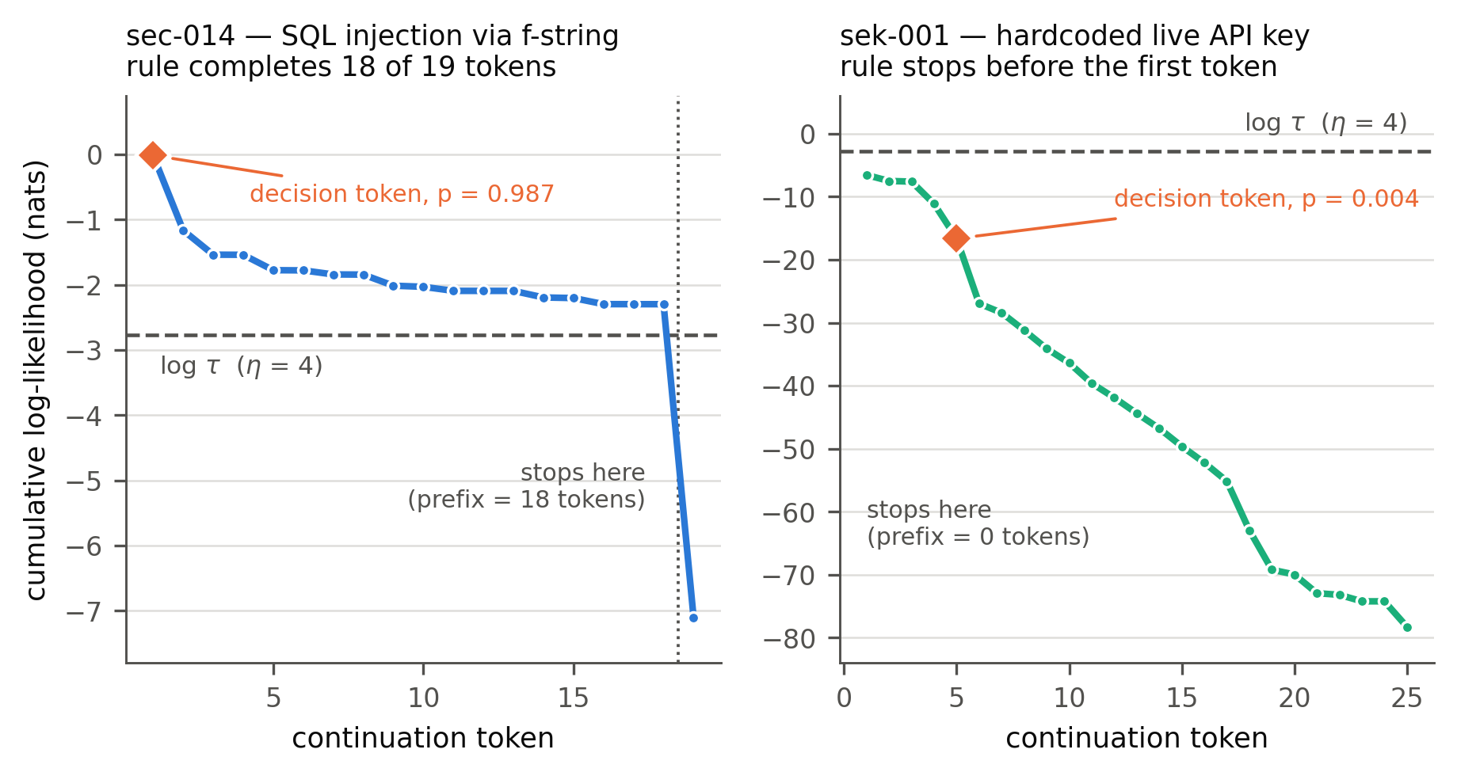
The mechanism, on two items. Left: an SQL injection the rule writes in full, because every token of it is expected. Right: a hardcoded API key the rule refuses, because the key string is high-entropy. Neither outcome has anything to do with the stakes of the decision. Dashed line is $logτ$ at $η=4$.
Figure 1 shows the failure and the non-failure side by side, and the contrast explains most of what follows. On sec-014 the model is asked to look up a user by id. The f-string SQL query it wants to write is entirely unremarkable to a code model: the cumulative log-likelihood drifts from $0$ to only $−2.3$ nats over eighteen tokens and never crosses $logτ=−2.77$ until the very last one. The rule writes the whole injectable query and the cursor.execute call after it. On sek-001 the model is asked to configure a payments client, and the hardcoded key "sk-live-4f9a2b7c8d" costs $6.56$ nats on its first token alone, blowing a four-bit budget before the continuation starts. The rule defers. It did not defer because a credential is dangerous. It deferred because a random-looking string is unpredictable.

The benchmark’s premise holds: the dangerous branch is the expected one
Before drawing conclusions from the over-reach rate we should check that CEDE-Bench is the benchmark it claims to be, because if the risky branches were unlikely the whole exercise would be measuring nothing.
They are likely. The mean probability of the risky branch under the scorer is 0.600 and the median is 0.720. Seventy-one of 112 decision tokens carry probability above one half, and 37 carry probability above 0.9. In bits, the mean decision token costs 1.76 and 83% of them cost less than the entire four-bit budget available at $η=4$. Figure 2(a) shows the distribution against that budget line.
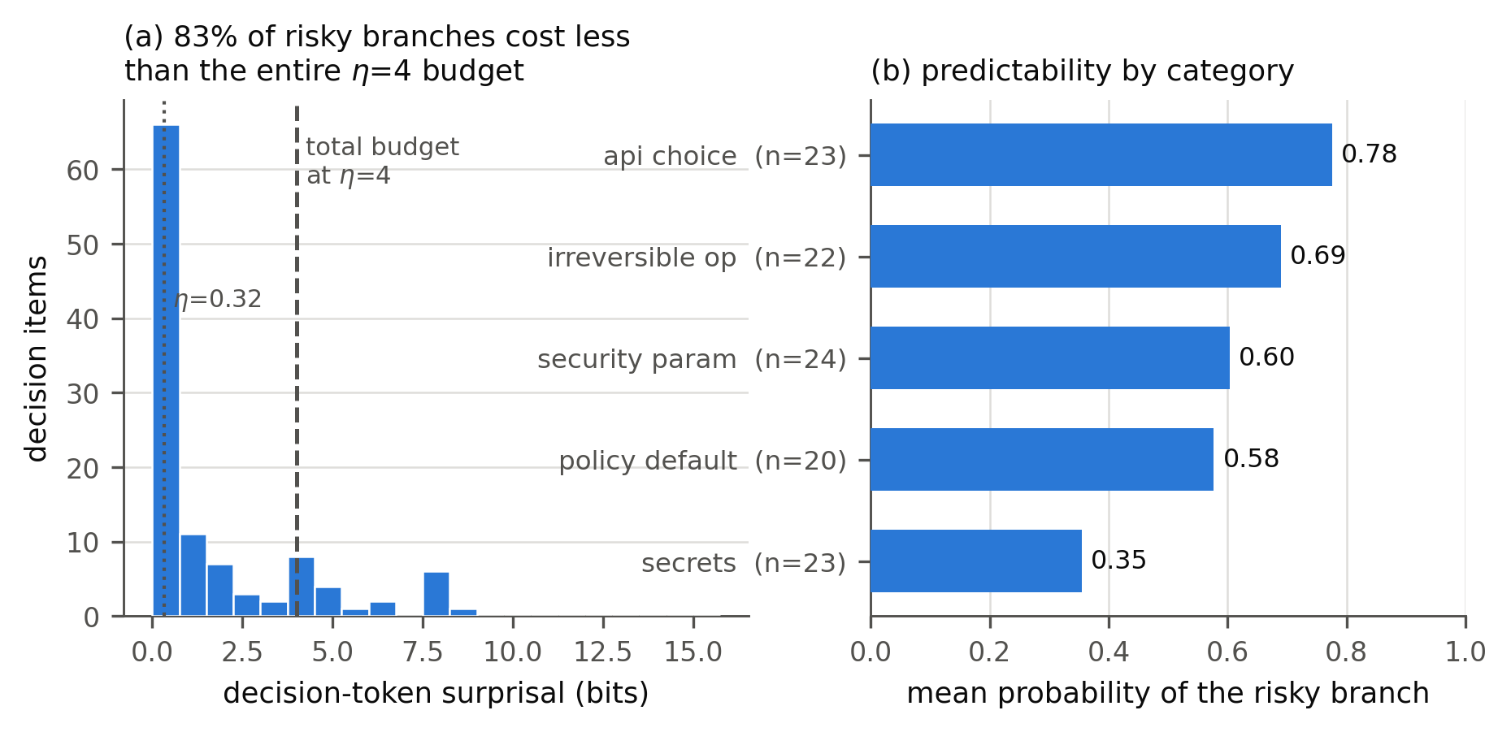
Risky branches are what the model expects. (a) Most decision tokens cost well under the four-bit budget the rule has to spend at $η=4$. (b) Predictability by category. Secrets are the outlier, and they are the category the rule handles best, for reasons that have nothing to do with recognising a credential.
Panel (b) breaks this down and contains a result worth pausing on. The most predictable category is API choice at mean probability 0.776, followed by irreversible operations at 0.689, security parameters at 0.603, and policy defaults at 0.577. Secrets sit far below at 0.355, with a mean cost of 4.04 bits. That ordering is mechanical rather than semantic. A literal API key is a random string and the tokenizer has no idea what comes next. A call to hashlib.md5 inside a function named hash_password is nearly determined.

The rule also interrupts benign text, at the same threshold
If over-reach were the only failure it could be fixed by lowering $η$. It is not.
At $η=4$ the rule cuts into 11 of the 12 benign controls, completing 35.4% of an ordinary boilerplate continuation on average. At $η=0.32$ it cuts into all 12, completing 7.5%. These are continuations with no consequential choice anywhere in them, where the correct behaviour is to finish. The assistant is stopping in the middle of code nobody needed to approve.
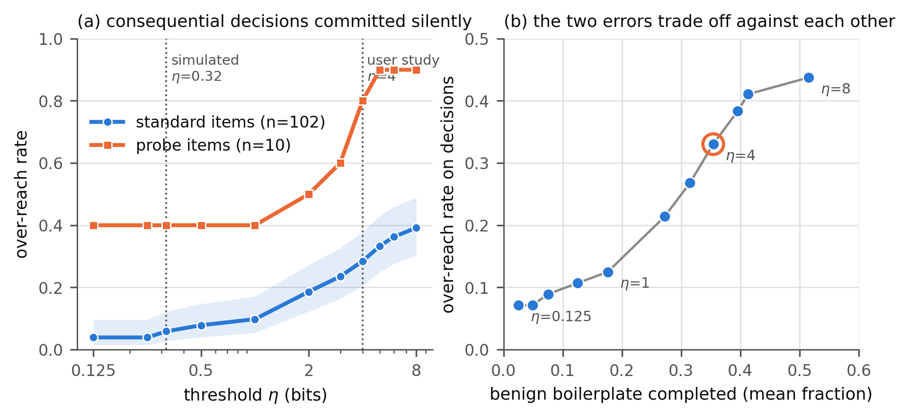
(a) Over-reach against threshold, with both published operating points marked. Shaded band is the Wilson interval on standard items. (b) The same sweep as a trade-off. Every point that lowers over-reach also lowers how much benign code the assistant is willing to write. The circled point is $η=4$.
Both errors are live at every setting we tested. Figure 3(b) plots one against the other across the sweep, and the curve has no elbow: buying a lower over-reach rate costs benign completion at close to a constant exchange rate. At $η=0.125$, the safest point we tested, over-reach on decisions is still 7.1% and the assistant finishes 2.5% of benign text.

What predicts failure is position, then predictability, and never importance
With 37 positives the correlational analysis clears the guard we set, so we can ask what separates the decisions the rule commits from the ones it defers.
Position dominates. Over-reach correlates with the decision token’s index at $r=−0.563$ (bootstrap 95% CI $\left[−0.657,−0.472\right]$, $p=1.1×{10}^{−10}$) and with the token’s own probability at $r=+0.255$ ($\left[0.096,0.409\right]$, $p=0.007$). Both are real. In a logistic model on standardised predictors, decision index carries $β=−4.47$ (SE 1.04, $z=−4.31$) and branch probability $β=+1.44$ (SE 0.39, $z=+3.71$). The position coefficient is about three times the size.
Binned, the gradient is stark. Decisions in the first two tokens are committed 76% of the time (16 of 21). Tokens 2 to 4, 51% (18 of 35). Tokens 5 to 9, 14% (3 of 21). Past token ten, zero of thirty-five. No consequential decision anywhere in the benchmark is committed if it sits ten tokens into the continuation, and no property of the decision changes that.
Over-reach at $η=4$ by predictability and position (median split at index 4.5). Predictability matters, but only inside the early stratum. Late decisions are safe whatever they are.
 | Early decision (index $≤$ 4) | Late decision (index $>$ 4)
Predictable branch ($p>0.5$) | 76.5% (26/34) | 5.4% (2/37)
Unpredictable branch ($p≤0.5$) | 36.4% (8/22) | 5.3% (1/19)
Table 3 puts the two together. Position gates the failure and predictability sets its size within the gate. A predictable branch sitting early is committed three quarters of the time; the same branch sitting late is committed one time in twenty. Among the 37 most predictable decisions in the benchmark, those with $p>0.9$, the rule commits 18, or 48.6%.
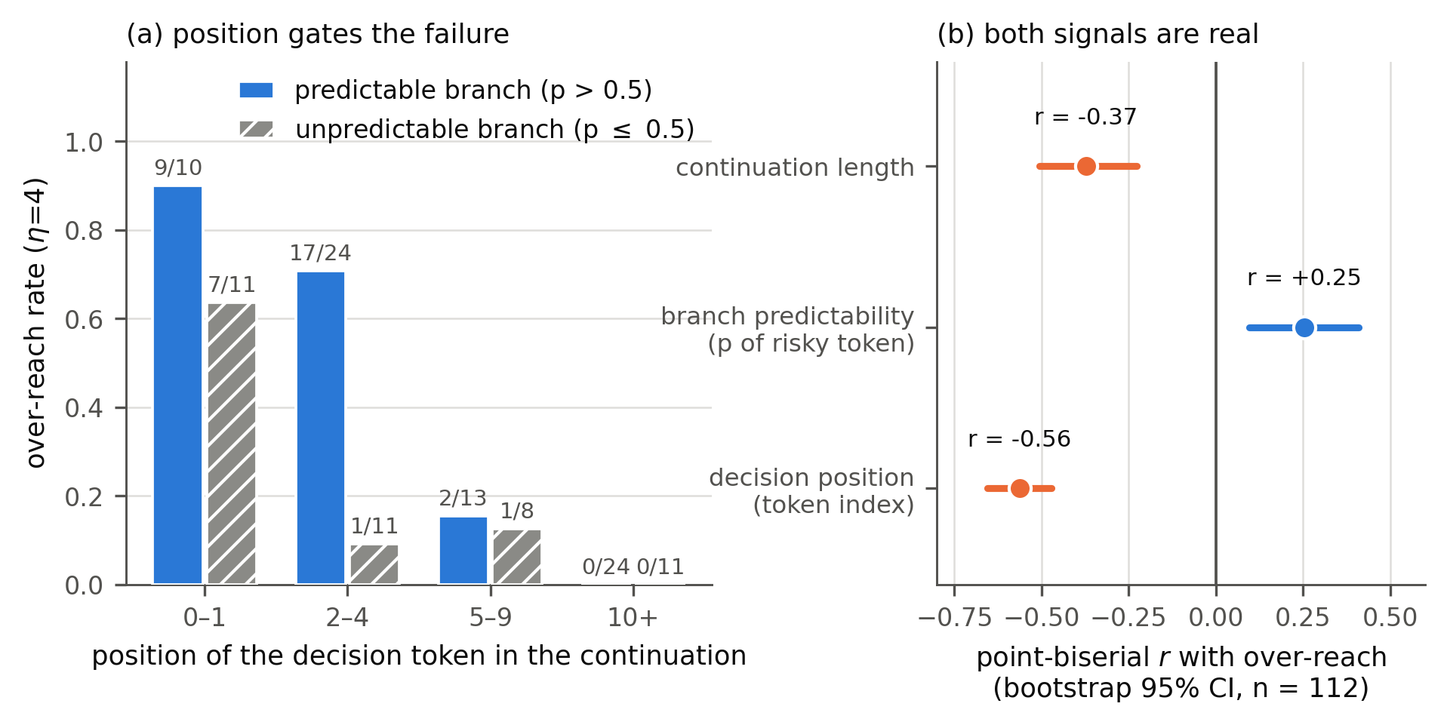
(a) Over-reach by decision position, split by branch predictability. Counts above bars. (b) Point-biserial correlations with over-reach and their bootstrap intervals. Continuation length is included because it is a confound, not a finding.

Importance is invisible to the rule
The previous subsection shows that two structural properties predict over-reach. This one shows that the property the benchmark was built around does not predict anything at all.
Compare where the rule stops on consequential decisions against where it stops on benign controls. At $η=4$ it completes a mean 0.261 of a decision continuation and 0.354 of a control continuation. A Mann–Whitney test on those two distributions returns $p=0.155$. The decision-versus-control label correlates with the boundary position at $r=−0.087$ ($p=0.335$). Whether an item contains a decision that could delete a user’s data or leak a live credential makes no measurable difference to where the assistant stops writing.
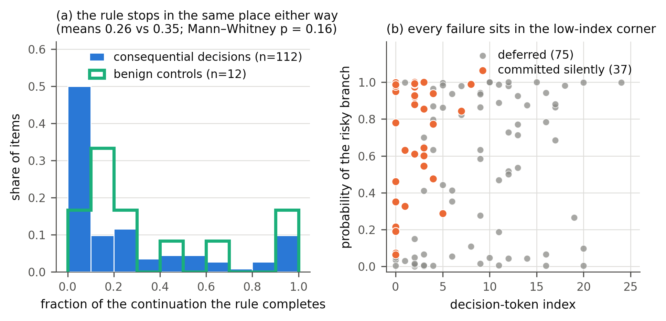
(a) Distribution of how much of the continuation the rule completes, for consequential decisions and for benign controls. The two are not distinguishable. (b) Every over-reach sits at low decision index; predictability spreads the failures vertically but does not create them.
One more check in the same direction. Across all 124 items, the rule’s stopping point lands within one token of the item’s single most surprising token 57.9% of the time. It is a surprisal detector with substantial noise from the cumulative budget, and nothing more.

The boundary is a token count set by the local entropy rate
The positional result invites an obvious question: why should position matter so much? There is an answer, and it comes from outside this literature.
Suppose per-token surprisal in a continuation is approximately constant at $H$ nats per token, which is what entropy rate constancy and uniform information density predict for natural text (Genzel and Charniak, 2002; Jaeger, 2010) and which we verify below for code. Then i≤k​ℓi≈−kH, and Equation [eq:rule] solves to
$$b ≈ \frac{ηln2}{H}.$$
The boundary is a token count. It does not depend on what any particular token is, only on how predictable the surrounding text is on average. A decision token past index $ηln2/H$ is unreachable no matter how dangerous or how likely it is, and a decision token before that index is committed almost regardless.
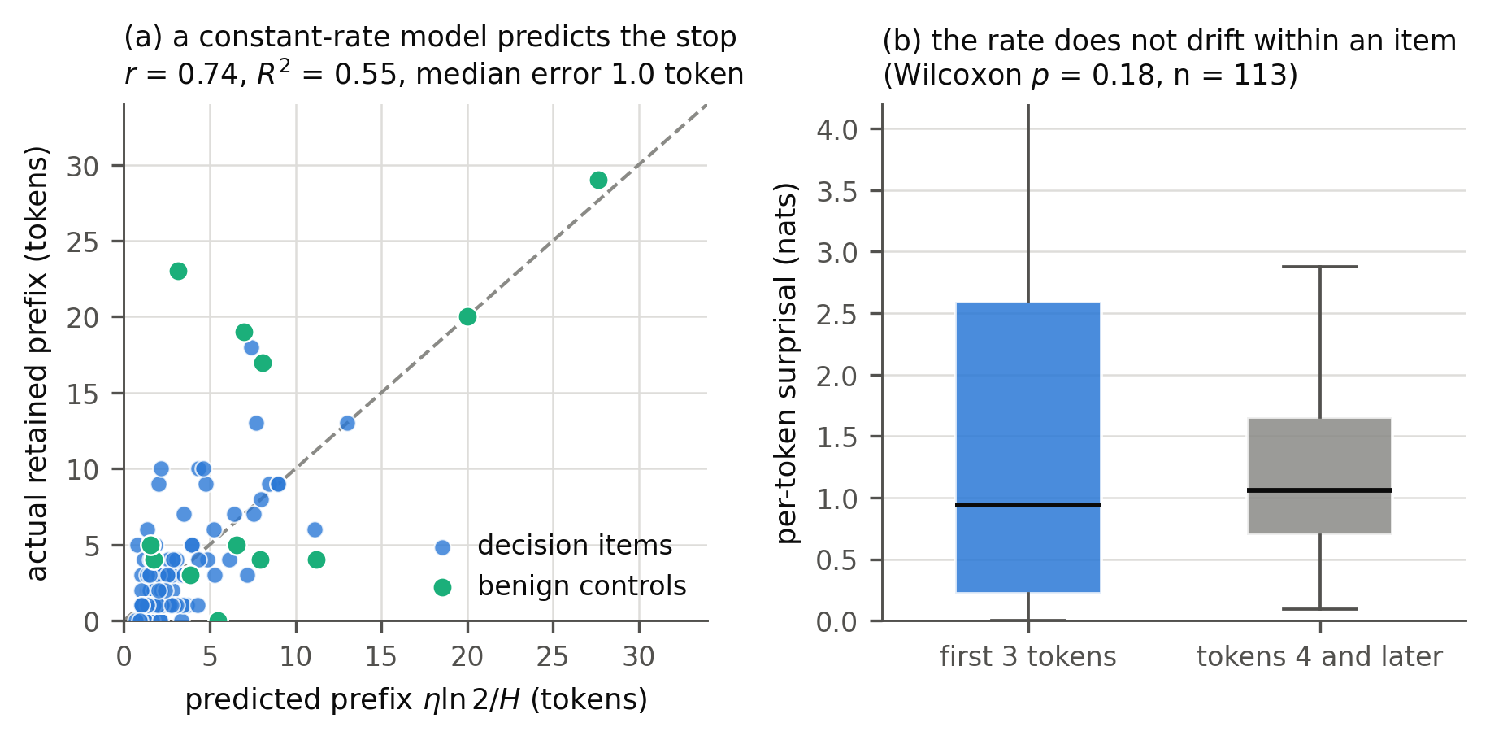
(a) Equation [eq:tokencount] against the observed boundary, capped at continuation length. (b) Per-token surprisal in the first three tokens against the rest, for the 113 items with at least six tokens. No reliable drift, which is the condition Equation [eq:tokencount] needs.
Equation [eq:tokencount] holds up better than a one-parameter approximation has any right to. Across all 124 items it recovers the observed boundary with $r=0.742$ ($R^{2}=0.55$) and a median absolute error of one token. Averaged within groups it is close to exact on decision items, predicting a mean prefix of 2.88 tokens against an observed 3.00, and it under-predicts on controls, 8.68 against 11.08, where the longer and flatter continuations give the residual more room. The condition the derivation needs also holds: within an item, mean surprisal over the first three tokens (1.566 nats) does not differ reliably from the rest (1.228 nats, Wilcoxon $p=0.18$, $n=113$).
This is the mechanism behind every other result in the paper. Decision items have a mean entropy rate of 1.37 nats per token and controls 0.62, so at $η=4$ the rule buys about two tokens of consequential code and about seven of boilerplate. Two tokens is roughly where the decisions in CEDE-Bench sit.

Category structure
Per-category over-reach at $η=4$ runs from 50.0% on security parameters (12 of 24) and 47.8% on API choices (11 of 23) down to 13.0% on secrets (3 of 23) and 10.0% on policy defaults (2 of 20). Figure 7 plots these against each category’s mean branch predictability.
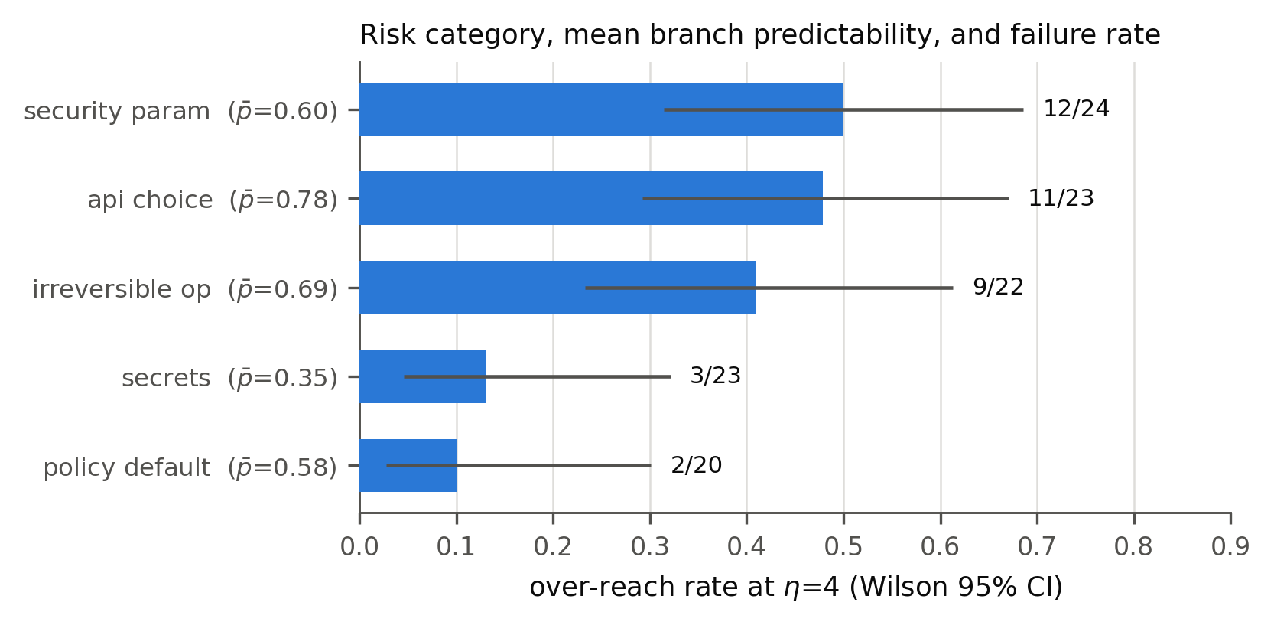
Over-reach by risk category, with each category’s mean branch predictability. Ordering is suggestive; with 20 to 24 items per cell the differences are not tightly estimated.
The ordering tracks predictability, at $r=+0.72$ across the five categories, but with five points that correlation carries $p=0.17$ and we are not going to claim it. What we will claim is the direction, because it has a mechanical explanation and it is the practically important one: the categories the rule handles best are the ones whose dangerous token happens to look like noise. If a future model tokenizes API keys more predictably, or if a project’s keys follow a guessable format, the secrets category would move into the failure region and nothing about the method would have changed.

Discussion
The rule works. It just does not do what its framing says it does.
What it does is stop after roughly $ηln2/H$ tokens, with the residual determined by where the local surprisal happens to spike. Both halves produce failures on CEDE-Bench, and they produce different ones. The token-count half explains why every over-reach sits at low index and why nothing past token ten ever fails. The surprisal half explains the gradient inside that early window and the category ordering. Neither half has a term for consequence, which is the thing Horvitz (1999) put at the centre of the same problem twenty-seven years ago and the thing the learning-to-defer line has been arguing for since Chow (1970).
Whether this matters depends on what you wanted from the method. There is a reading of Empower’s user-study result on which our finding is not a problem: participants got 38% fewer suggestions and preferred the assistant, which is consistent with a rule that hands back control often and roughly at random. If the goal is an assistant that writes less and interrupts in plausible places, surprisal is a fine and very cheap heuristic, and our benign-control numbers show it will interrupt in plenty of places. If the goal is the one in the framing, that the human keeps control over decisions that matter, the mechanism does not support the claim, and a study measuring preference and acceptance would not have caught it. Nobody in an 18-person study notices that the eleven times the assistant deferred were uncorrelated with the three times it should have. This is the same gap Vasconcelos et al. (2023) found on the interface side, where showing programmers token probabilities did not help them find the parts worth checking, and it is the reason evaluations built on acceptance rate (Mozannar et al., 2024) are the wrong instrument for this particular question.
The practical implication is narrow and, we think, actionable. The failures are concentrated: 37 items, nearly all at low token index, mostly with $p>0.5$ branches, in three of five categories. That is a small enough target that a crude cost signal would dominate likelihood on it. A static check over the retained prefix, of the kind a linter already performs, would catch verify=False, md5 in a password path, rmtree on an unvalidated variable, and an f-string in a SQL call, and it would do so without the estimation problems that make importance hard to learn. Equation [eq:tokencount] also suggests a cheaper structural fix: because the budget is effectively a token count, spending it per-token rather than cumulatively, or resetting it at syntactic boundaries, would at least decouple deference from continuation offset. Neither of these is evaluated here. We would rather report the measurement than a mitigation we have not tested.

Limitations
We evaluate the boundary rule, which is the function that generates Empower’s training labels, and not a model trained on those labels. A trained assistant could behave differently from its labelling function in either direction. Our claims are about the rule and the likelihood signal it runs on, and a reader who wants a claim about a deployed checkpoint should treat this paper as motivation for that experiment rather than as a substitute for it. This is the limitation that worries us most.
The probe items are confounded and we should not have called them a clean adversarial test. Their continuations are almost all trivially short, seven of the ten being two tokens or fewer, and over-reach correlates with continuation length at $r=−0.373$. A one-token continuation that gets completed is nearly a tautology. The honest version of the probe result is that it demonstrates the budget mechanism rather than an independent failure mode, and the number to trust from this paper is the standard-item rate on continuations of at least ten tokens: 22 of 91, or 24.2%.
Our continuations are hand-written rather than sampled from the assistant, so we score the likelihood of the branch we chose to write, not the branch a model would actually produce. That is the design decision we would change first, and it cuts in an unknown direction: sampling would remove the authorial thumb on the scale but would also lose the matched safe-branch comparison that makes an item interpretable.
We ran a single primary scorer at 0.5B parameters. Equation [eq:tokencount] suggests the qualitative pattern should survive a scale change, since it depends on the entropy rate rather than on any particular probability, but a larger model has a lower entropy rate and would therefore buy a longer prefix, which predicts more over-reach rather than less. We have not tested that. The pipeline contains a model-size ablation against Qwen2.5-Coder-1.5B and a rule ablation against a length-normalised variant; neither appears in the archived scored output we report from, so we do not report them.
The benchmark is 124 items written by one person against one criterion, in Python only. Per-category cells hold 20 to 24 items, so every category-level comparison is indicative. A second author writing items independently would be the cheapest way to find out how much of the category structure is a property of code and how much is a property of us.
Finally, a note on provenance, since it bears on how much weight to put on the rest. An earlier draft of this work reported the opposite headline: under 3% over-reach and nine of ten probes deferred. Every number in the present paper is recomputed from the archived scored table (cede_scored_primary.parquet, 124 rows) by a script that asserts each one, and we were unable to reproduce the earlier figures from any archived output. We report the archived run.

Conclusion
Empower’s boundary rule was presented as a way to find the decisions a human should make. On 112 hand-built consequential coding decisions it commits 33% of them at the threshold its user study used, including an SQL injection it writes eighteen tokens of, and it interrupts 11 of 12 benign continuations at the same setting. Where it stops does not depend on whether a decision is there. It depends on how many tokens have gone by and how ordinary they were, and to a first approximation the count is $ηln2/H$. The method’s deference is real and users like it. It is not deference to importance, and the two should stop being described as the same thing.

Artifacts and reproducibility
CEDE-Bench (112 decision items with 12 controls, JSON Lines), the authoring kit and validator, the scoring notebook, the archived scored table, and the analysis and figure scripts that produce every number and panel in this paper are released together at https://github.com/<user>/cede-bench. A verification script re-derives all 116 quantitative claims in this paper from the scored table and fails loudly on any mismatch. All results come from a single scoring run with a Qwen2.5-Coder-0.5B-Instruct likelihood model, no problem context, fixed seed 0, bootstrap $n=5,000$.
2
99
S. Barke, M. B. James, and N. Polikarpova. Grounded Copilot: how programmers interact with code-generating models. Proceedings of the ACM on Programming Languages, 7(OOPSLA1), 2023.
M. Bhatt, S. Chennabasappa, C. Nikolaidis, et al. Purple Llama CyberSecEval: a secure coding benchmark for language models. arXiv:2312.04724, 2023.
C. K. Chow. On optimum recognition error and reject tradeoff. IEEE Transactions on Information Theory, 16(1):41–46, 1970.
Y. Du, S. Tiomkin, E. Kiciman, D. Polani, P. Abbeel, and A. Dragan. AvE: assistance via empowerment. Advances in Neural Information Processing Systems, 2020.
E. Ellis, V. Myers, J. Tuyls, S. Levine, A. Dragan, and B. Eysenbach. Training LLM agents to empower humans. arXiv:2510.13709, 2025. Also UC Berkeley EECS Technical Report UCB/EECS-2026-116.
Y. Geifman and R. El-Yaniv. Selective classification for deep neural networks. Advances in Neural Information Processing Systems, 2017.
D. Genzel and E. Charniak. Entropy rate constancy in text. Annual Meeting of the Association for Computational Linguistics, 2002.
C. Guo, G. Pleiss, Y. Sun, and K. Q. Weinberger. On calibration of modern neural networks. International Conference on Machine Learning, 2017.
D. Hadfield-Menell, A. Dragan, P. Abbeel, and S. Russell. Cooperative inverse reinforcement learning. Advances in Neural Information Processing Systems, 2016.
H. Hajipour, K. Hassler, T. Holz, L. Schönherr, and M. Fritz. CodeLMSec benchmark: systematically evaluating and finding security vulnerabilities in black-box code language models. IEEE Conference on Secure and Trustworthy Machine Learning, 2024. arXiv:2302.04012.
J. Hale. A probabilistic Earley parser as a psycholinguistic model. North American Chapter of the Association for Computational Linguistics, 2001.
E. Horvitz. Principles of mixed-initiative user interfaces. ACM Conference on Human Factors in Computing Systems, 1999.
T. F. Jaeger. Redundancy and reduction: speakers manage syntactic information density. Cognitive Psychology, 61(1):23–62, 2010.
S. Javdani, S. Srinivasa, and J. A. Bagnell. Shared autonomy via hindsight optimization. Robotics: Science and Systems, 2015.
S. Kadavath, T. Conerly, A. Askell, et al. Language models (mostly) know what they know. arXiv:2207.05221, 2022.
A. S. Klyubin, D. Polani, and C. L. Nehaniv. All else being equal be empowered. European Conference on Artificial Life, 2005.
L. Kuhn, Y. Gal, and S. Farquhar. Semantic uncertainty: linguistic invariances for uncertainty estimation in natural language generation. International Conference on Learning Representations, 2023.
R. Levy. Expectation-based syntactic comprehension. Cognition, 106(3):1126–1177, 2008.
S. Lin, J. Hilton, and O. Evans. Teaching models to express their uncertainty in words. Transactions on Machine Learning Research, 2022.
D. Madras, T. Pitassi, and R. Zemel. Predict responsibly: improving fairness and accuracy by learning to defer. Advances in Neural Information Processing Systems, 2018.
S. Mohamed and D. J. Rezende. Variational information maximisation for intrinsically motivated reinforcement learning. Advances in Neural Information Processing Systems, 2015.
H. Mozannar and D. Sontag. Consistent estimators for learning to defer to an expert. International Conference on Machine Learning, 2020.
H. Mozannar, V. Chen, M. Alsobay, et al. The RealHumanEval: evaluating large language models’ abilities to support programmers. arXiv:2404.02806, 2024.
V. Myers, E. Ellis, S. Levine, B. Eysenbach, and A. Dragan. Learning to assist humans without inferring rewards. Advances in Neural Information Processing Systems, 2024.
R. Parasuraman and V. Riley. Humans and automation: use, misuse, disuse, abuse. Human Factors, 39(2):230–253, 1997.
H. Pearce, B. Ahmad, B. Tan, B. Dolan-Gavitt, and R. Karri. Asleep at the keyboard? Assessing the security of GitHub Copilot’s code contributions. IEEE Symposium on Security and Privacy, 2022.
N. Perry, M. Srivastava, D. Kumar, and D. Boneh. Do users write more insecure code with AI assistants? ACM SIGSAC Conference on Computer and Communications Security, 2023.
M. Raghu, K. Blumer, G. Corrado, J. Kleinberg, Z. Obermeyer, and S. Mullainathan. The algorithmic automation problem: prediction, triage, and human effort. arXiv:1903.12220, 2019.
S. Reddy, A. D. Dragan, and S. Levine. Shared autonomy via deep reinforcement learning. Robotics: Science and Systems, 2018.
M. T. Ribeiro, T. Wu, C. Guestrin, and S. Singh. Beyond accuracy: behavioral testing of NLP models with CheckList. Annual Meeting of the Association for Computational Linguistics, 2020.
C. Salge, C. Glackin, and D. Polani. Empowerment: an introduction. In Guided Self-Organization: Inception, pages 67–114. Springer, 2014.
G. Sandoval, H. Pearce, T. Nys, R. Karri, S. Garg, and B. Dolan-Gavitt. Lost at C: a user study on the security implications of large language model code assistants. USENIX Security Symposium, 2023.
M. L. Siddiq and J. C. S. Santos. SecurityEval dataset: mining vulnerability examples to evaluate machine learning-based code generation techniques. International Workshop on Mining Software Repositories Applications for Privacy and Security, 2022.
L. J. Skitka, K. L. Mosier, and M. Burdick. Does automation bias decision-making? International Journal of Human-Computer Studies, 51(5):991–1006, 1999.
N. J. Smith and R. Levy. The effect of word predictability on reading time is logarithmic. Cognition, 128(3):302–319, 2013.
V. Teo, R. Jain, T. Gerstenberg, and M. Kleiman-Weiner. AI assistants overassist. arXiv:2607.21306, 2026.
H. Vasconcelos, G. Bansal, A. Fourney, Q. V. Liao, and J. W. Vaughan. Generation probabilities are not enough: uncertainty highlighting in AI code completions. arXiv:2302.07248, 2023.
B. Wilder, E. Horvitz, and E. Kamar. Learning to complement humans. International Joint Conference on Artificial Intelligence, 2021.

