class04.R
shubha
2024-10-11
# My first Rscript
x <- 1:50
plot(x)
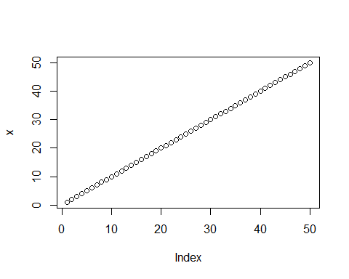
plot(x, sin(x), type = "l", col = "blue", lwd = 3)
