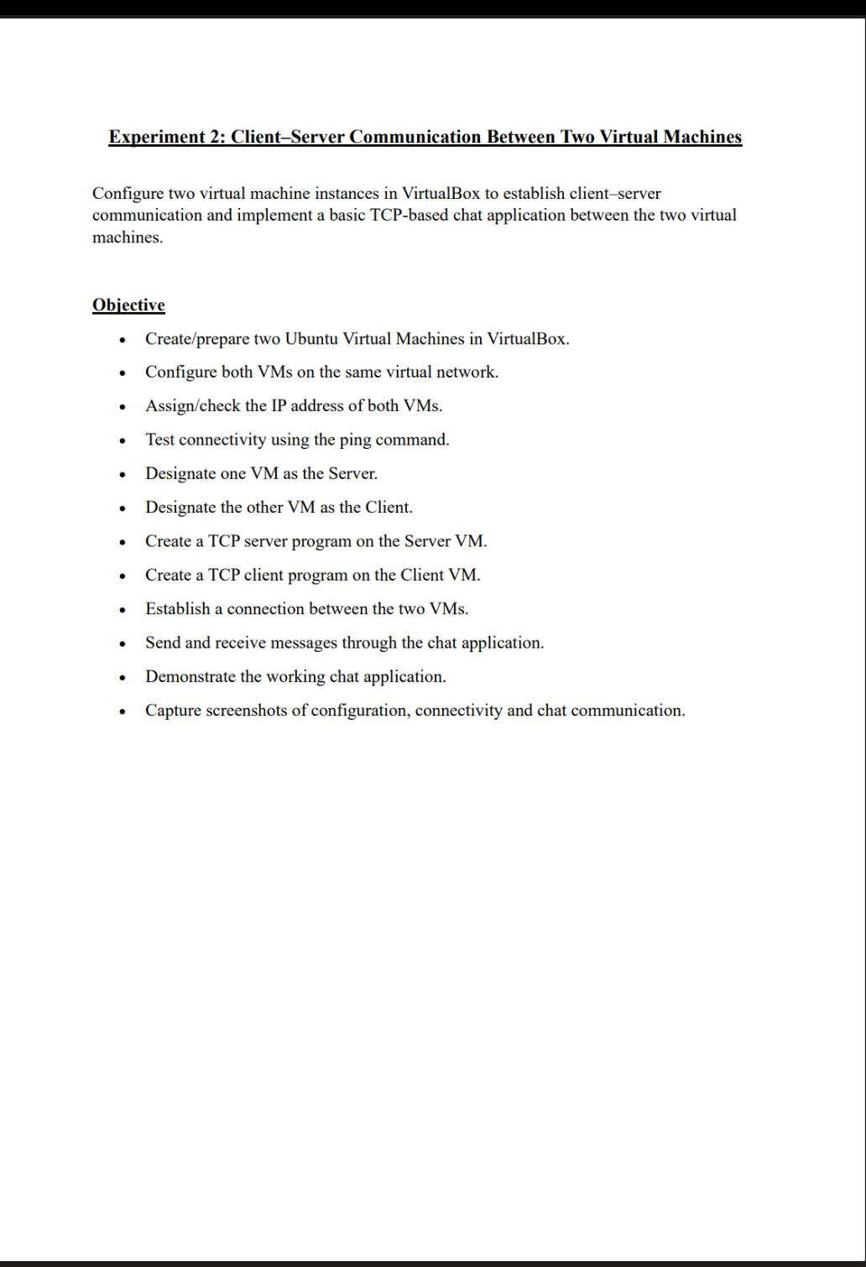
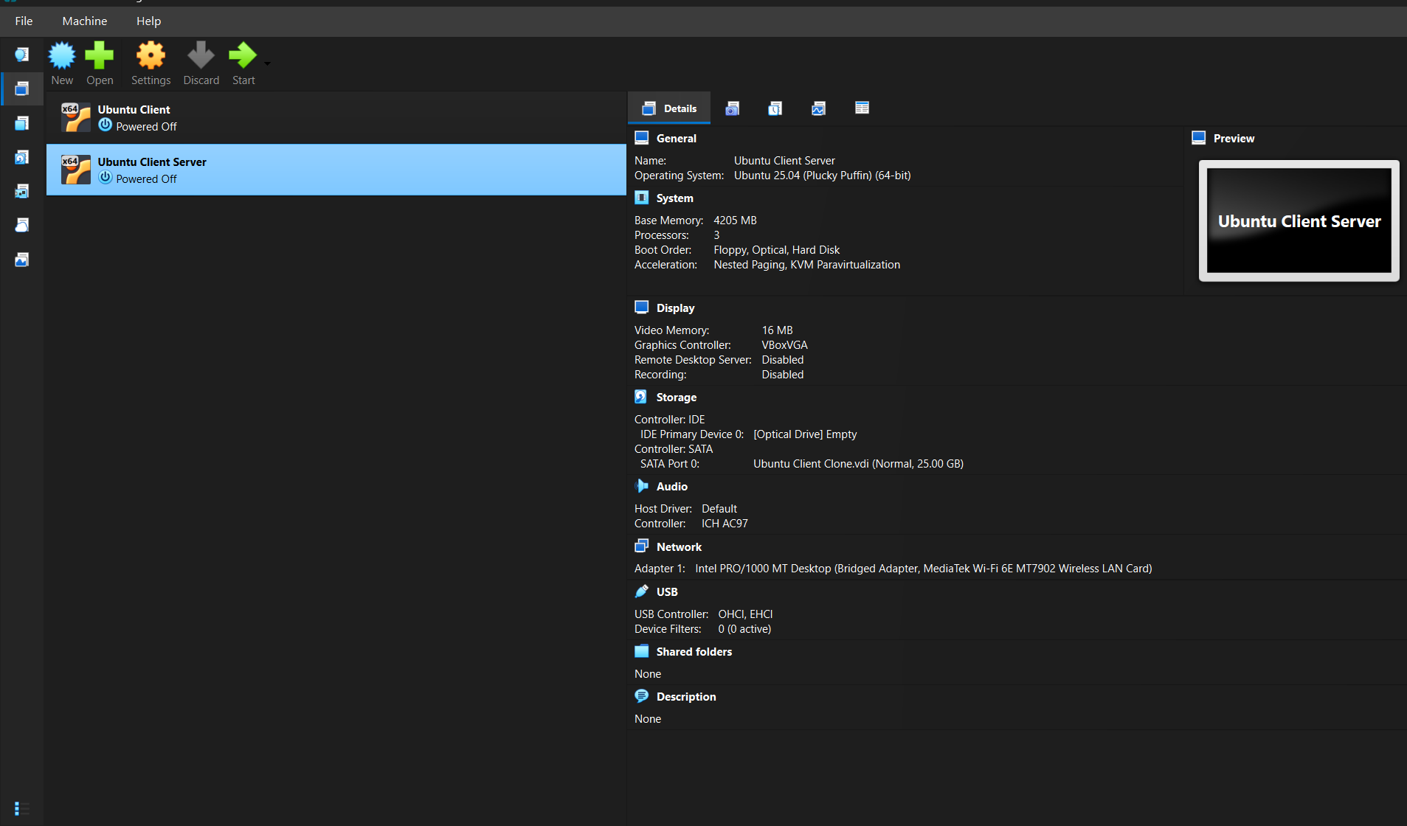
- Creating and preparing two Ubuntu Virtual Machines in VirtualBox.

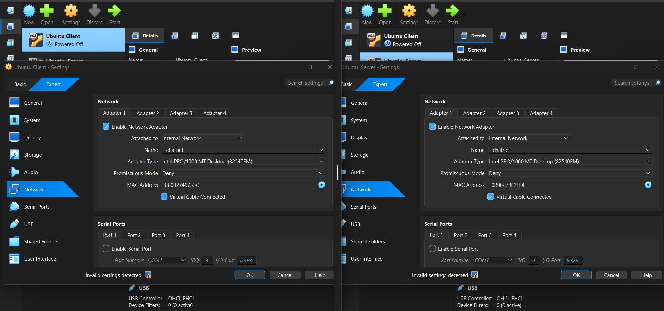
- Configure both VMs on the same virtual network.

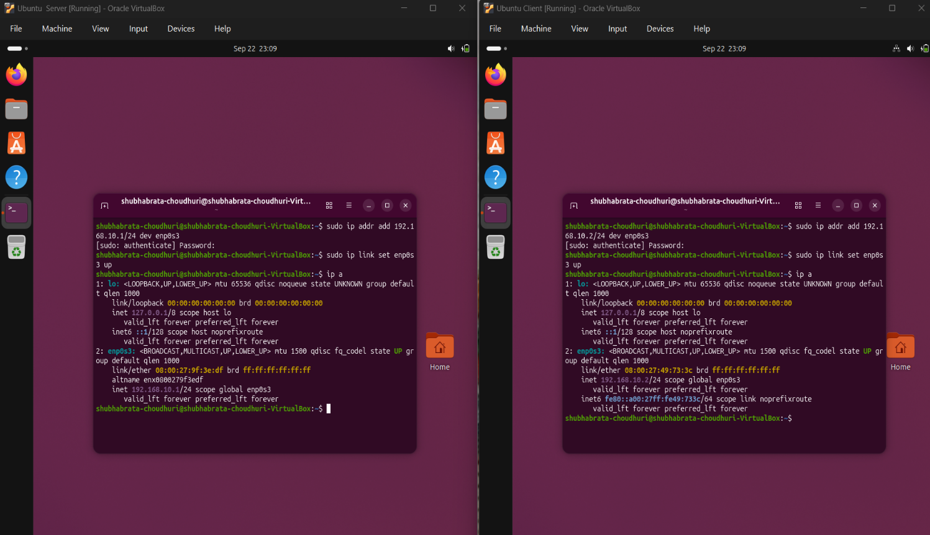
- Checking the IP address of both VMs.

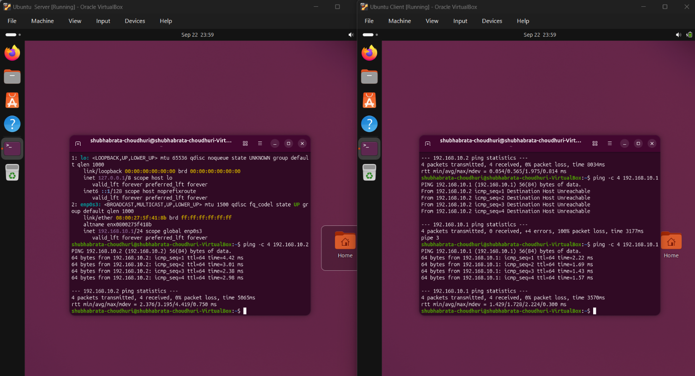
- Testing connectivity using the ping command
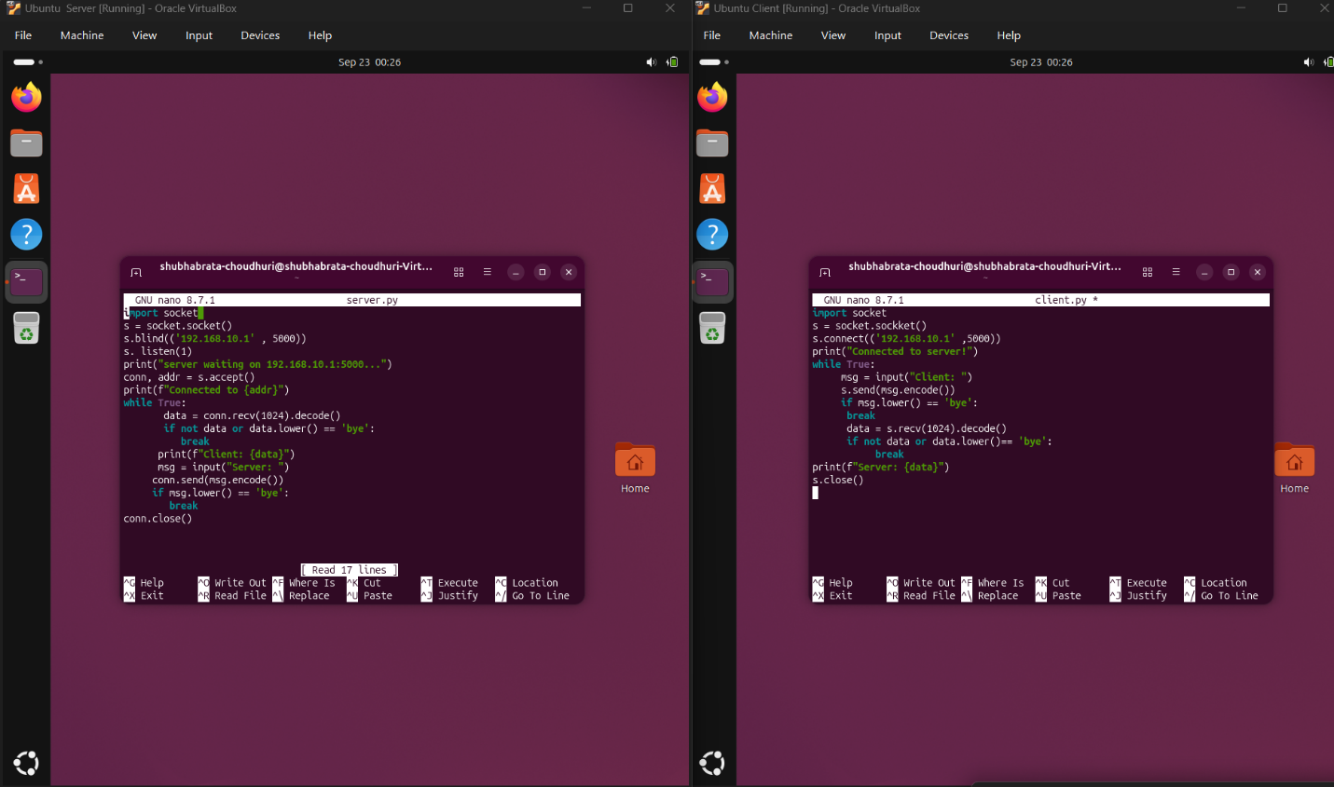
- Create a TCP server program on the Server VM and Client VM

- Sending and receiving messages through the chat application.
