EXPERIMENT 1
Installation of Hypervisors and Initiation of VMs with image file

SOFTWARE USED:
1. Oracle VirtualBox 7.2.16 (Open-source Type-2 Hypervisor)
2. Ubuntu 22.04 LTS ISO image file
PROCEDURE:
Task 1: Install Oracle VirtualBox
Downloaded from http://virtualbox.org and installed on Windows 11 host.
Task 2: Obtain VM image/ISO file
Downloaded http://ubuntu-22.04.iso (3.5 GB).
Task 3 & 4: Create and Configure new VM
New -> Name: Ubuntu-VM -> Type: Linux -> Version: Ubuntu 64-bit
Configuration: CPU: 2 Cores, RAM: 2048 MB, Storage: 20GB VDI Dynamic, Network: NAT
Task 5: Attach the image/ISO file to the VM
Settings -> Storage -> Controller: IDE -> Empty -> Choose Disk -> http://ubuntu-22.04.iso
Task 6: Start and boot the VM
Clicked Start. VM booted from ISO.
Task 7: Complete the guest OS installation
Installed Ubuntu. Created username and password. Ubuntu Desktop appeared.
Task 8: Verify that the VM is running successfully
Ubuntu desktop is running inside VirtualBox window. Verified.
Task 9: Installing required build tools and Linux kernel headers
This step is required to install Guest Additions for full-screen and shared clipboard.

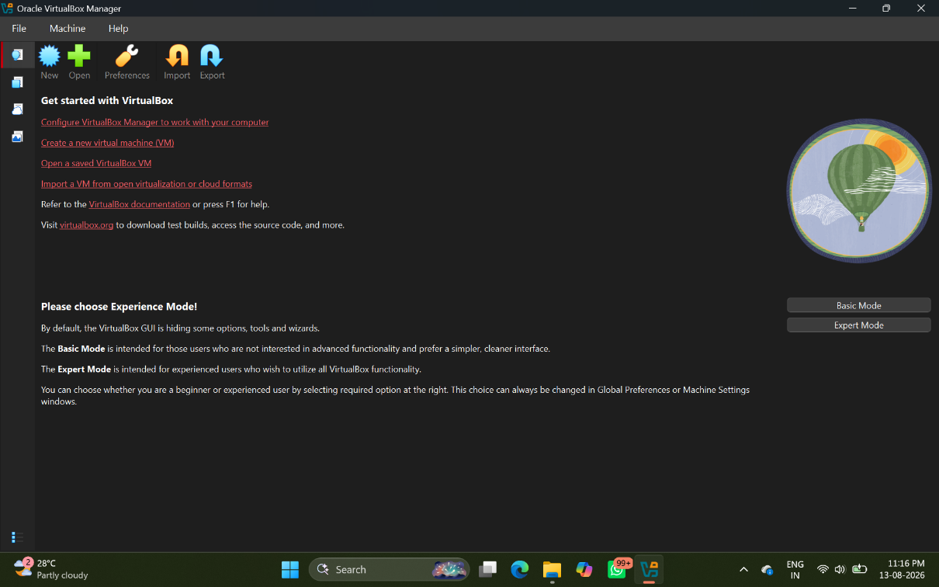
- Installing and opening Oracle Virtual Machine

- Uploading ISO file for OS installation in VM
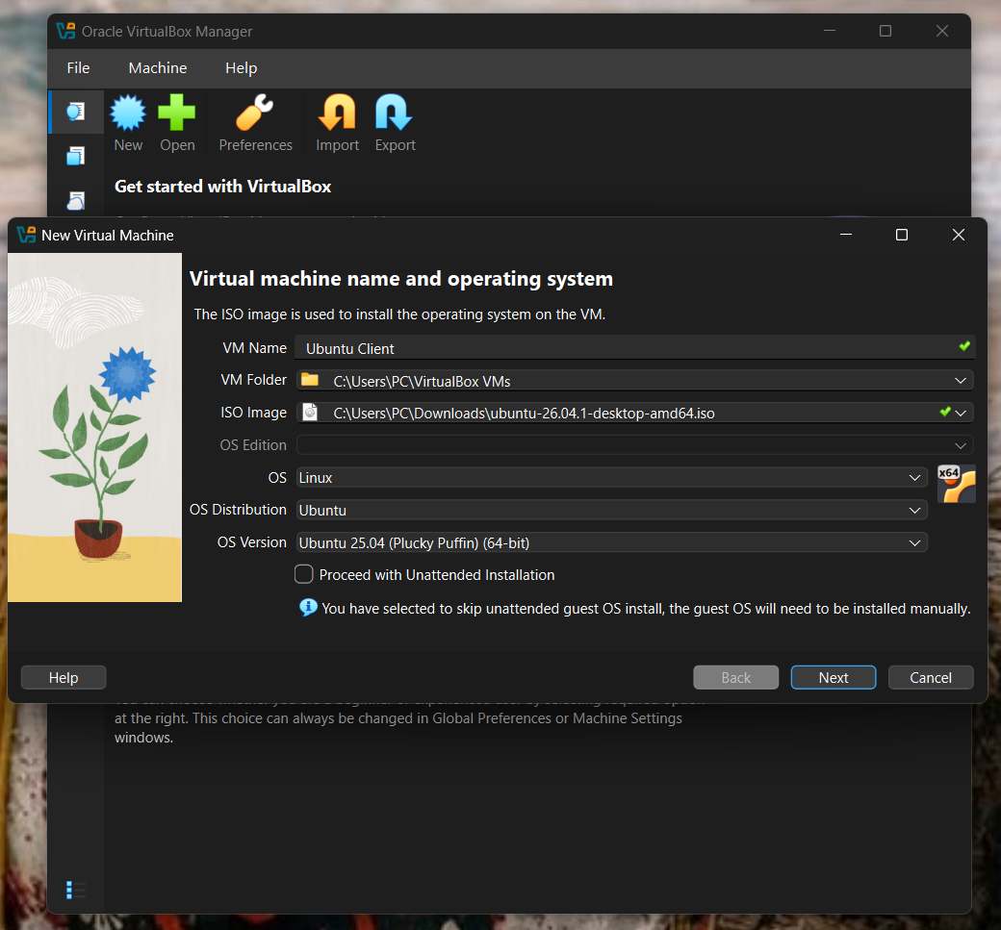

- Hardware setup for VM
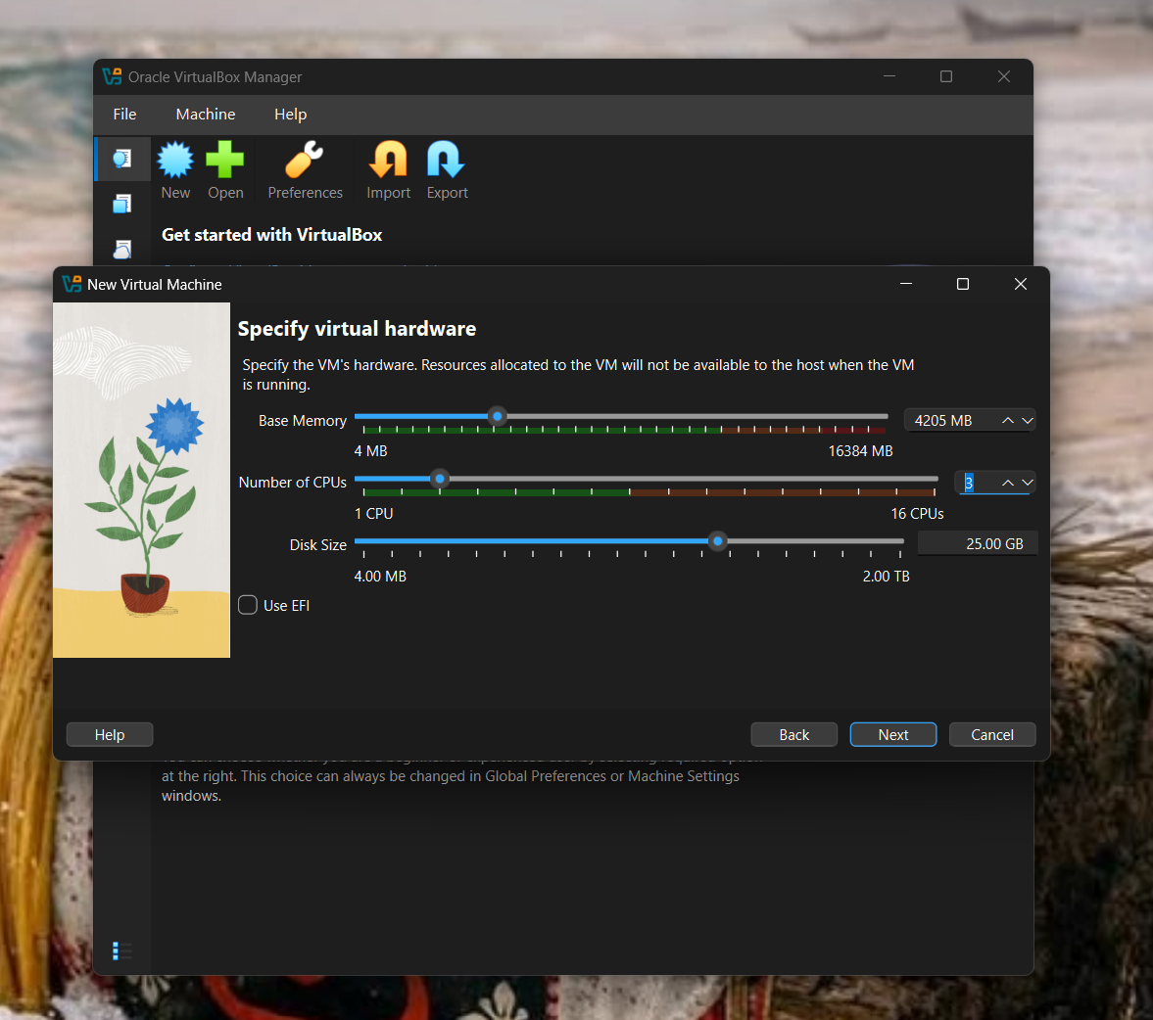

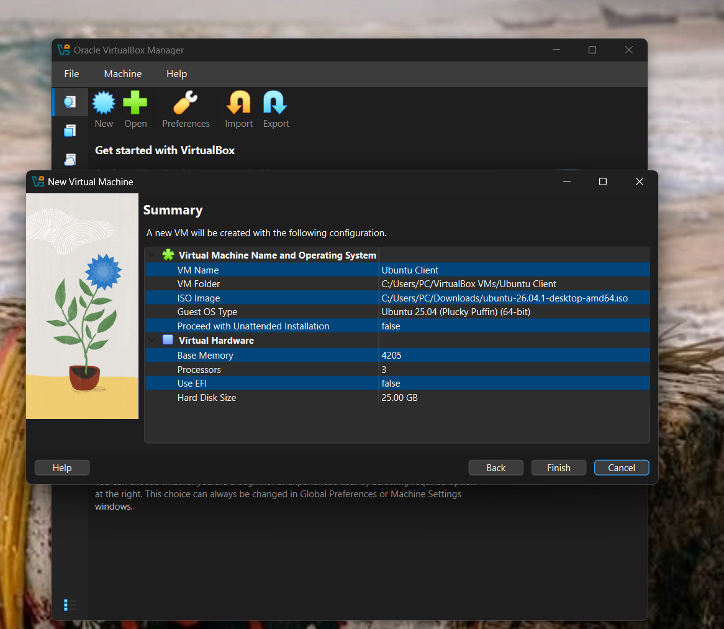
- Virtual Machine Configuration

- Ubuntu installation in VM
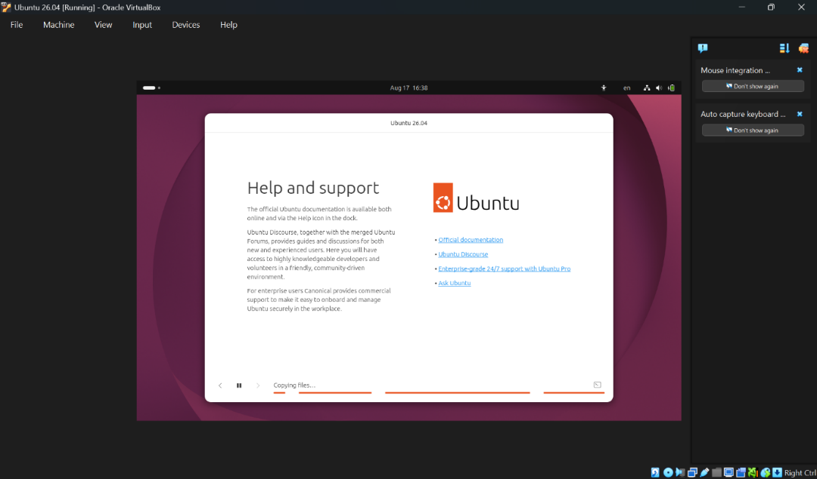

- User login in Ubuntu
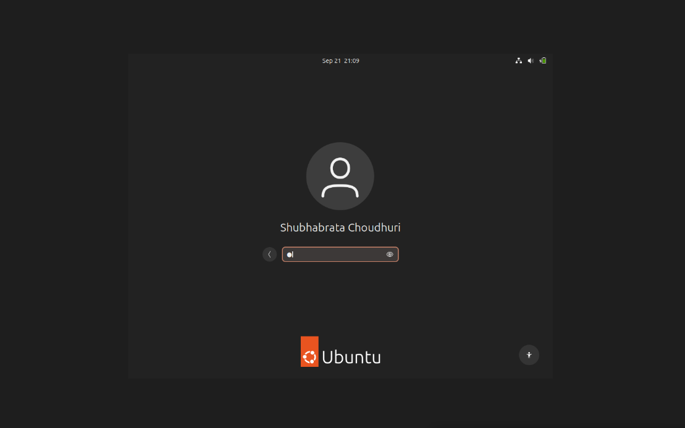
- Ubuntu Home Screen

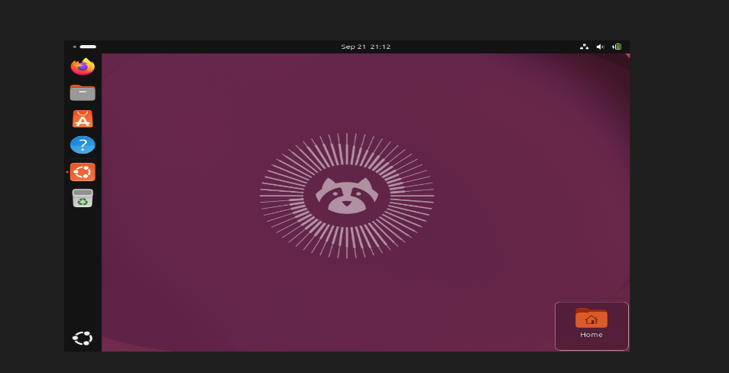

- Install build tools & kernel headers using following command
- sudo apt update
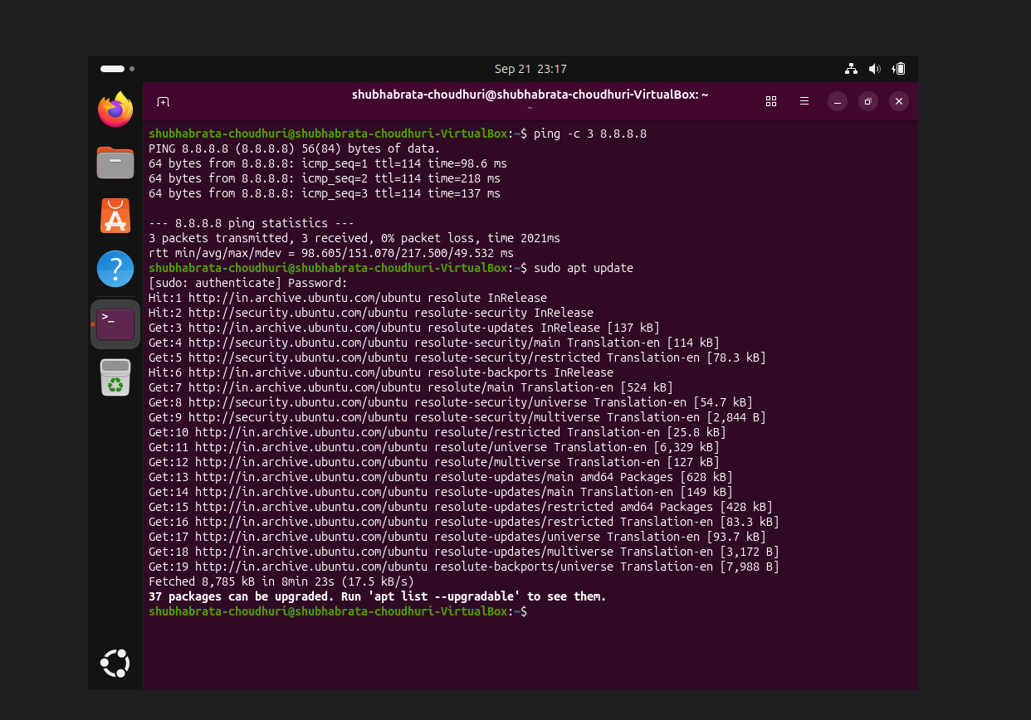
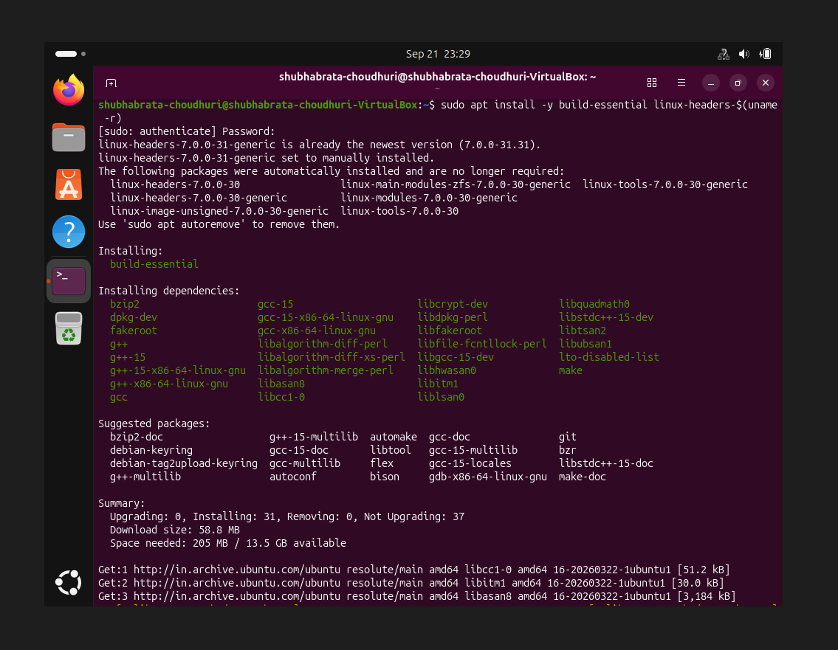
- sudo apt install -y build-essential linux-headers-$(uname -r)

