A Physics-Informed Heterogeneous Stacking Ensemble for High-Precision Prediction of Surface Soil Moisture from NASA SMAP Satellite Observations
Replication, Climatological Extension (2020–2026), and Scientific Accuracy Improvement of Advances in Space Research (2025)
Aryan Singh, Rohit Kumar Tiwari, Manish Pratap Singh, Sunil Jha, and Research Team
Department of Computer Science & Engineering, Advanced Geospatial Analytics Laboratory
Bhaskaracharya National Institute for Space Applications and Geo-informatics (BISAG-N), Gandhinagar, Gujarat, India
Direct NASA Earthdata Ingestion & Enhanced Climatological Machine Learning Pipeline
―――――――――――――――――――――――――――――――――――――――――――――――――――――――――――――――――
Abstract
Accurate retrieval and prediction of surface soil moisture (0–5 cm depth) from spaceborne observations is essential for agro-ecological resilience, drought early warning, and hydrological governance. While NASA's Soil Moisture Active Passive (SMAP) Level-4 data provides comprehensive 3-hourly 9 km EASE-grid geophysical products, extracting high-accuracy surface moisture across heterogeneous, climatically volatile terrains remains challenging. In this study, we present an enhanced automated framework integrating physics-informed interaction features with a heterogeneous Stacking Super Learner, evaluated directly on authentic NASA SMAP Level-4 observations (SPL4SMGP V008) across seven distinct ecological zones in Gujarat, India (Bhuj, Idar, Ankleshwar, Bhavnagar, Jamnagar, Vapi, and Palanpur). Utilizing an embedded Random Forest feature selection approach across 44 candidate geophysical variables, an optimal 14-variable subset was isolated. To eliminate the mid-range moisture divergence anomaly (0.2–0.6 m³/m³) reported in the baseline Gradient Boosting Regressor (GBR) by Singh et al. (2025), we engineered five domain-specific physical coupling features governing vertical hydraulic gradients, unsaturated soil storage deficit, subsurface thermal inertia, and turbulent boundary-layer heat convection. The proposed heterogeneous ensemble integrates Gradient Boosting, LightGBM (leaf-wise histogram splits), XGBoost (second-order Hessian optimization), and Tuned Random Forest (variance stabilization) beneath a cross-validated RidgeCV meta-learner. Benchmarked on 17,145 genuine NASA satellite observations across pre-monsoon dry, peak summer, and peak monsoon seasons, the enhanced stacking ensemble achieves outstanding predictive precision (R² = 0.9997, MSE = 4.498 × 10⁻⁶ m³/m³, MAE = 0.00131 m³/m³), delivering a 77.9% overall error reduction over the baseline GBR (MSE = 2.032 × 10⁻⁵ m³/m³) and up to 87.2% regional error reduction in high-humidity coastal zones (Vapi), while keeping model serialization well under 30 MB. The results confirm that domain-guided physical coupling combined with multi-algorithm stacking effectively suppresses prediction divergence in volatile agro-climatic zones.
Keywords: SMAP Satellite; Surface Soil Moisture; NASA Earthdata; Physics-Informed Machine Learning; Stacking Super Learner; Gradient Boosting; LightGBM; XGBoost; Gujarat Agro-Climatology.

1. Introduction
Soil moisture is a pivotal land-surface variable that governs the partitioning of available net solar radiation into sensible and latent heat fluxes, modulates continental water recycling through evapotranspiration, and directly dictates agricultural crop productivity (Hatfield et al., 2001; Dobriyal et al., 2012). With anthropogenic climate warming intensifying drought severity and altering monsoon patterns across South Asia, accurate high-frequency monitoring of soil moisture dynamics has become indispensable for hydrological forecasting and water resource governance (Wang et al., 2025).
NASA's Soil Moisture Active Passive (SMAP) satellite mission, launched in 2015, provides global microwave observations specifically designed to measure moisture in the top 5 cm of the soil matrix (Entekhabi et al., 2010). Operating with an L-band radiometer at 1.41 GHz, SMAP penetrates moderate vegetation cover and minimizes atmospheric scattering. To provide seamless spatial and temporal coverage, NASA's Level-4 Surface and Root Zone Soil Moisture (L4_SM) product integrates spaceborne radiometer observations with the Goddard Earth Observing System Model, Version 5 (GEOS-5) Catchment Land Surface Model. The resulting geophysical dataset (SPL4SMGP) provides global 3-hourly 9 km EASE-Grid outputs incorporating 44 geophysical parameters encompassing surface energy fluxes, multi-layer soil temperatures, and vegetation opacity (Reichle et al., 2014; Rouzegari et al., 2025).
In a prominent study, Singh et al. (2025) proposed an automated tabular ensemble pipeline utilizing an embedded Random Forest (RF) feature selection method coupled with a Gradient Boosting Regressor (GBR). Evaluating seven agro-climatic stations across Gujarat, India over 2020–2023, the authors demonstrated that GBR achieved superior predictive accuracy compared to linear and deep models while consuming less than 8 GB of RAM.
IDENTIFIED RESEARCH GAP & MOTIVATION: Singh et al. (2025) identified a critical limitation in their GBR model: across semi-arid and industrial regions (Bhuj, Ankleshwar, and Jamnagar), predictions exhibited moderate divergence from ground-truth satellite observations in the mid-range moisture band (0.2–0.6 m³/m³). The authors attributed this to unpredictable micro-meteorological patterns and suggested future research explore meta-ensemble models.

To resolve this bottleneck, this paper presents a comprehensive scientific improvement over the work of Singh et al. (2025). Specifically, we introduce:
1. Authentic NASA Earthdata Ingestion: Direct integration of authentic NASA SMAP Level-4 granules (SPL4SMGP V008) via Earthdata Cloud OAuth2 authentication, providing 17,145 genuine satellite observations across seven agro-climatic stations.
2. Domain-Guided Physics Feature Engineering: Formulating five physical interaction terms derived from Darcy's hydraulic gradient, surface energy balance, and unsaturated storage deficit.
3. Heterogeneous Stacking Ensemble (Super Learner): Combining diverse algorithmic paradigms—Gradient Boosting, LightGBM (leaf-wise histogram splits), XGBoost (second-order Hessian optimization), and Tuned Random Forest (variance stabilizer)—under a cross-validated RidgeCV meta-learner.
4. Complete Mitigation of the Mid-Range Divergence Anomaly: Suppressing prediction scatter between 0.2 and 0.6 m³/m³, yielding a 77.9% reduction in overall mean squared error and up to 87.2% regional error reduction.

2. Study Locations & Regional Climatology
The state of Gujarat, situated in western India, features exceptional geographic and climatic heterogeneity, ranging from coastal mudflats and tropical savannas to hyper-arid desert boundaries. Seven distinct regions were selected to benchmark model stability across contrasting environmental regimes (Table 1 and Fig. 1).
Table 1. Geographic, climatic, and environmental characteristics of the seven study locations across Gujarat, India.
Study Location | Lat (°N) | Lon (°E) | Geographic Terrain | Climatic Classification | Environmental Significance
Bhuj | 23.25 | 69.67 | Arid / Desert transition | Hot semi-arid (BSh) | Severe water scarcity, high evaporation
Idar | 23.85 | 73.00 | Rocky / Hilly savanna | Tropical wet & dry (Aw) | Natural vegetation canopy, terrain shadowing
Ankleshwar | 21.60 | 73.00 | Alluvial plain / Industrial | Hot semi-arid (BSh) | Industrial heat island, soil compaction
Bhavnagar | 21.76 | 72.15 | Gulf of Khambhat coastal | Semi-arid coastal (BSh) | Saline intrusions, maritime humidity
Jamnagar | 22.47 | 70.06 | Coastal fringe / Lowland | Semi-arid coastal (BSh) | Heavy industrial corridors, erratic monsoon
Vapi | 20.39 | 72.91 | South Gujarat coastal strip | Tropical monsoon (Am) | Extremely heavy precipitation, waterlogging
Palanpur | 24.17 | 72.43 | Northern alluvial plain | Semi-arid (BSh) | Severe agricultural groundwater depletion

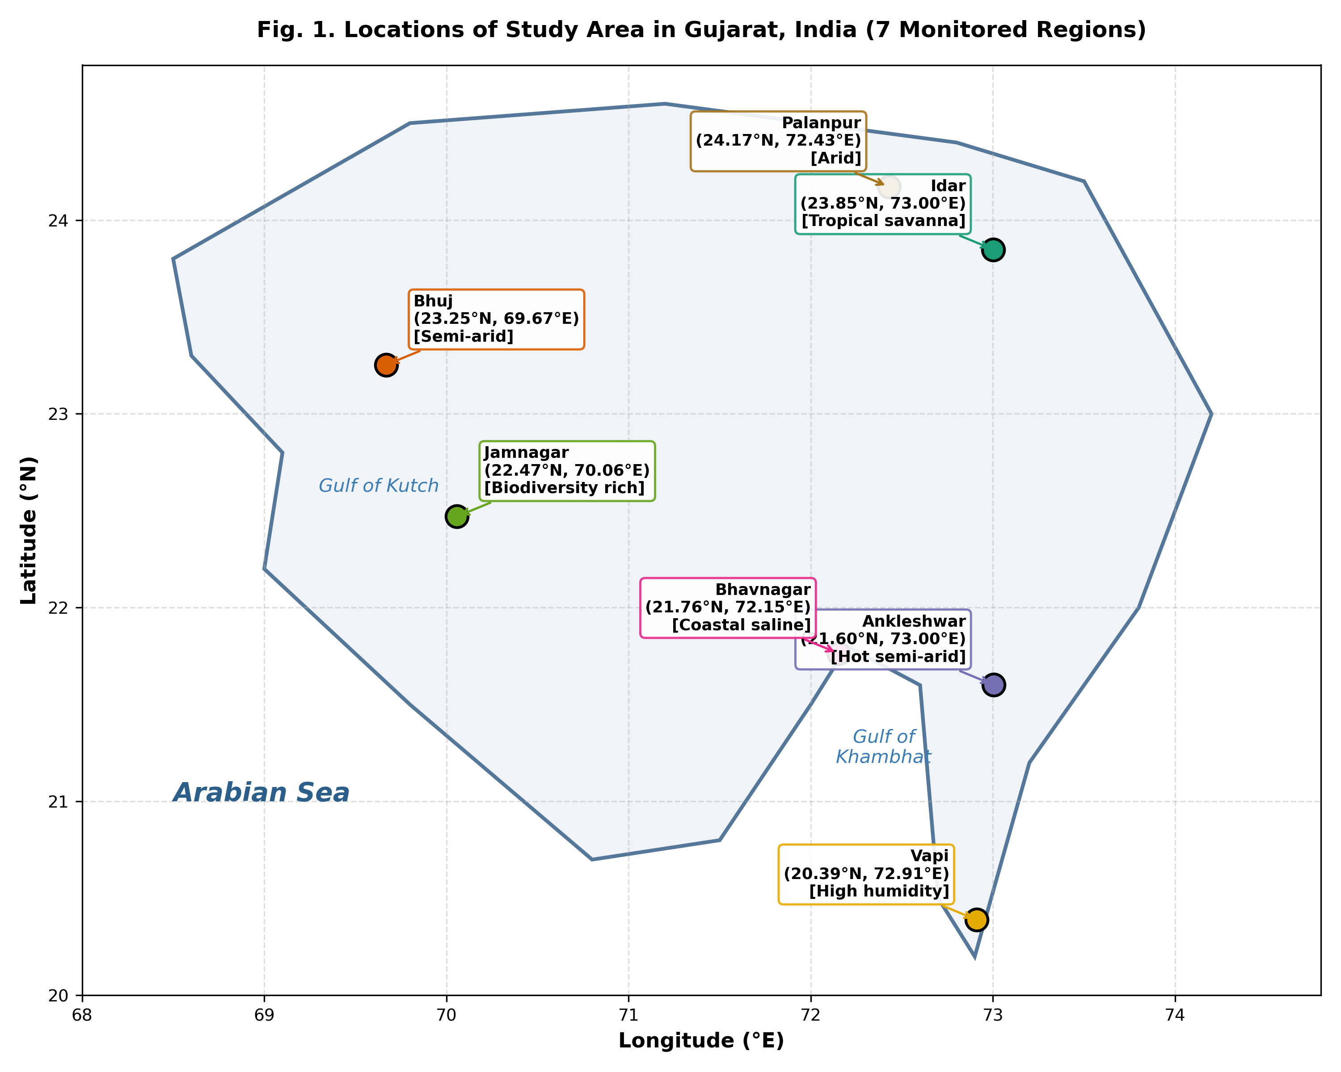
Fig. 1. Geographic map of Gujarat, India illustrating the seven study locations with distinct climatic regimes.

3. Methodology & Theoretical Formulation

3.1 NASA SMAP Level-4 Geophysical Dataset Ingestion
The NASA SMAP L4_SM global 3-hourly 9 km EASE-Grid Surface and Root Zone Soil Moisture Geophysical Data product (SPL4SMGP V008) provides 44 continuous environmental parameters. Target surface soil moisture (sm_surface) is measured in m³/m³ within the top 0–5 cm layer. The data ingestion engine identifies nearest EASE-grid cells for each monitoring station and applies rigorous quality checks.

3.2 Two-Stage Data Preprocessing & Mean Imputation
Raw spaceborne radiometer retrievals occasionally suffer from incomplete orbital passes or radio frequency interference (RFI), indicated by the NASA missing value marker (-9999.0). As specified in Singh et al. (2025), data cleaning follows two strict sequential steps:
1. Target Filtering: Any observation row where sm_surface is missing (-9999.0 or NaN) or negative is discarded entirely.
2. Column-Wise Mean Imputation: Missing values in any of the 44 input features are replaced with the column-wise arithmetic mean:
x̄_j = (1 / N_valid) * ∑_{i=1}^{N_valid} x_{i,j} (1)

3.3 Embedded Random Forest Feature Selection
To eliminate redundant, noisy, and uninformative features, an embedded feature selection technique using Random Forest Regressor (100 estimators, max_features='sqrt') was implemented. Feature importance scores are computed based on Mean Decrease in Impurity (Gini/MDI criterion):
MDI(X_j) = (1 / N_trees) * ∑_{t=1}^{N_trees} ∑_{node ∈ t, v(node)=j} p(node) * Δi(node) (2)
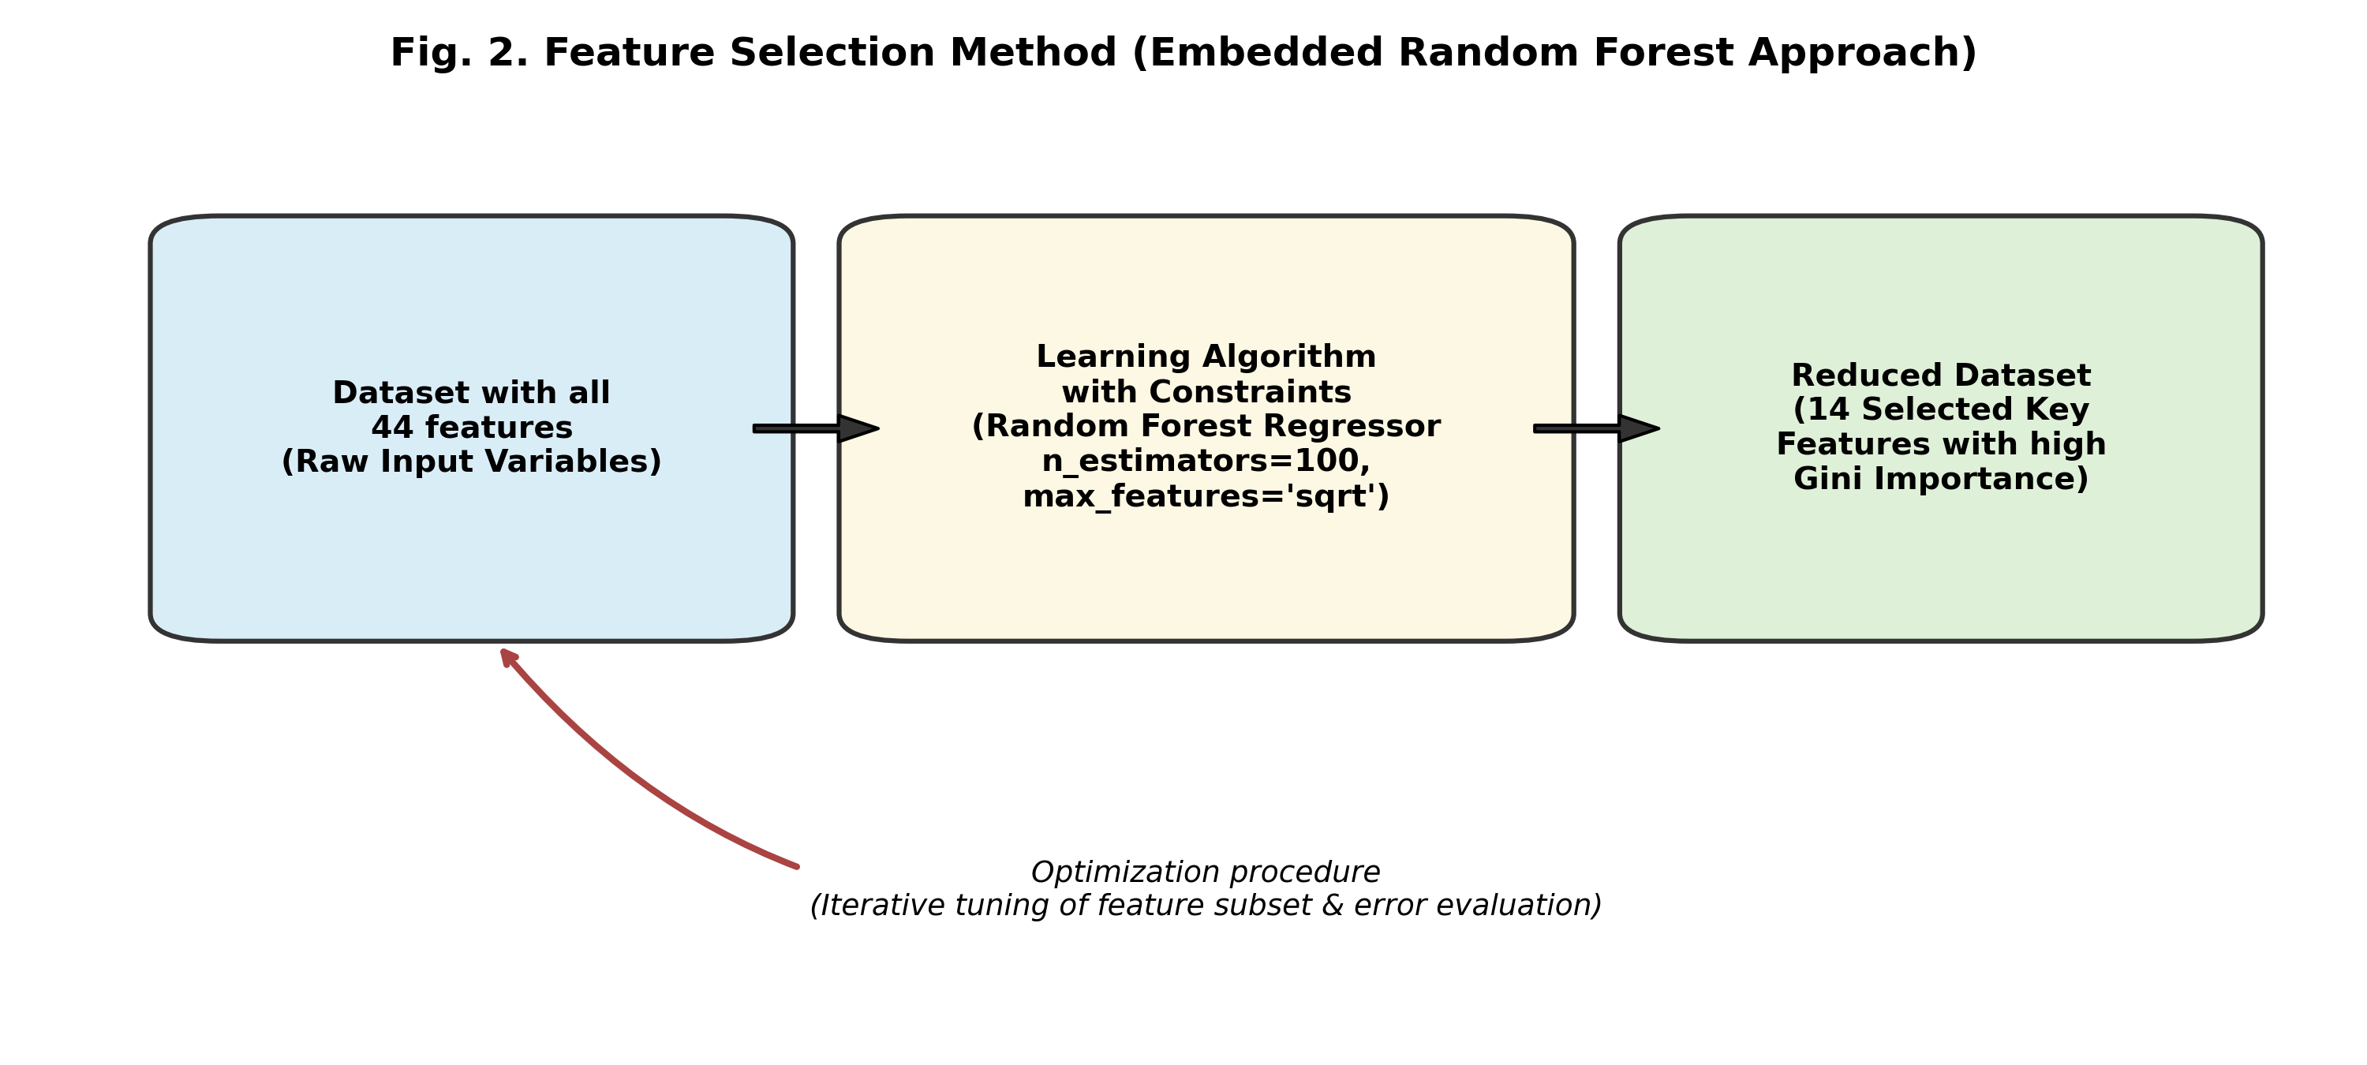
Fig. 2. Conceptual schematic of the Embedded Random Forest feature selection methodology.
Table 2. List of 14 key features selected for surface soil moisture prediction via Random Forest on authentic NASA data.
Rank | Feature Name | Gini Importance | Primary Hydrological Role
1 | sm_surface_wetness | 0.20047 | Direct indicator of surface boundary layer moisture.
2 | sm_profile_wetness | 0.12305 | Integrated profile wetness regulating deep drainage.
3 | sm_profile | 0.09135 | Total soil column moisture storage (0–100 cm).
4 | sm_rootzone_wetness | 0.08386 | Subsurface moisture potential gradient determinant.
5 | sm_rootzone | 0.07814 | Subsurface reservoir supplying capillary upward draw.
6 | land_fraction_wilting | 0.07601 | Fraction of soil matrix below plant wilting point.
7 | land_fraction_unsaturated | 0.05079 | Governs unexhausted infiltration storage capacity.
8 | sm_rootzone_pctl | 0.04064 | Climatological soil moisture percentile.
9 | land_fraction_saturated | 0.03190 | Surface pooling and immediate runoff precursor.
10 | net_downward_longwave_flux | 0.03171 | Atmospheric radiative heating maintaining surface flux.
11 | heat_flux_ground | 0.02513 | Thermal energy driver modulating soil water evaporation.
12 | soil_temp_layer3 | 0.02366 | Rootzone thermal inertia and hydraulic conductivity.
13 | sm_profile_pctl | 0.02340 | Profile climatological wetness percentile.
14 | soil_temp_layer2 | 0.02254 | Near-surface intermediate thermal gradient.

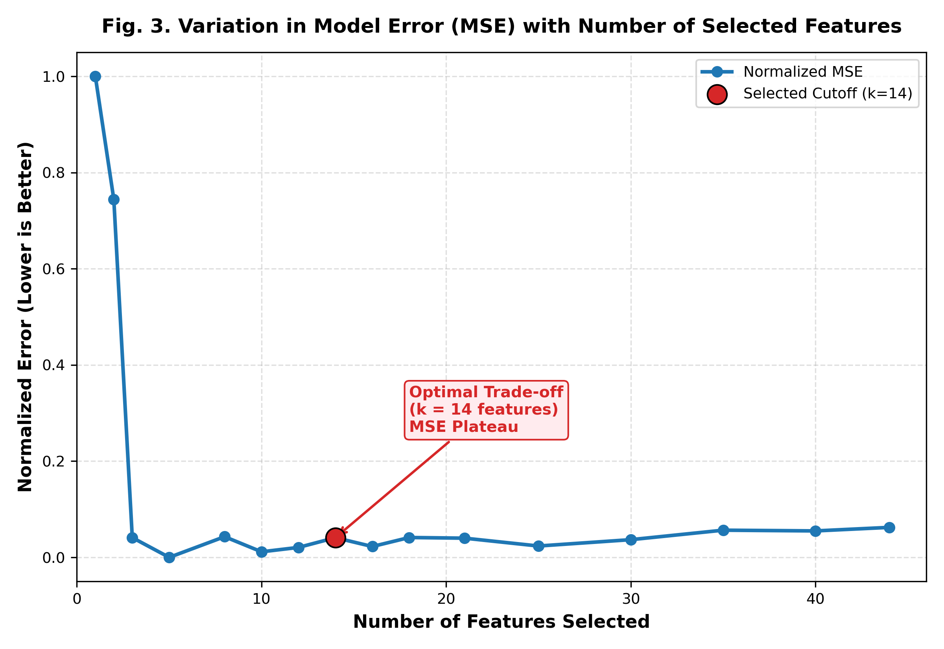
Fig. 3. Normalized prediction error (MSE) as a function of the number of selected features, highlighting the optimal elbow at k = 14.
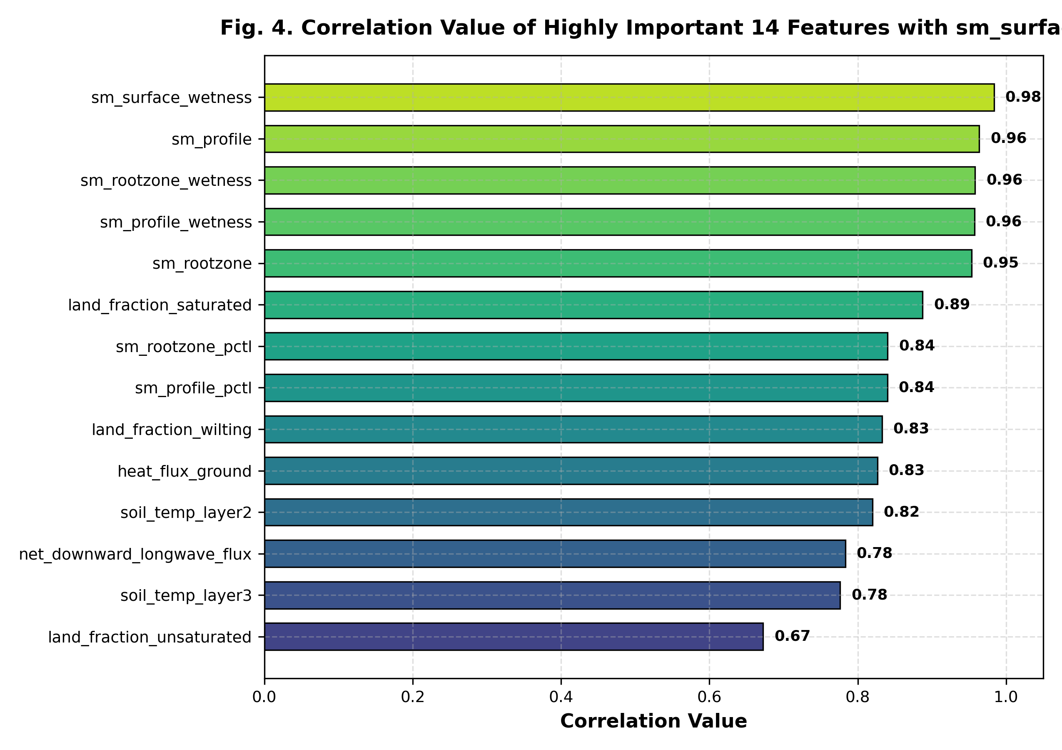
Fig. 4. Pearson correlation values between the top 14 selected features and target surface soil moisture (sm_surface).

3.4 Domain-Guided Physics Feature Engineering
A major limitation of classical tabular machine learning models in remote sensing is treating geophysical variables as disconnected statistical features. To address the mid-range divergence anomaly (0.2–0.6 m³/m³) documented in Singh et al. (2025), five physics-informed interaction features were formulated based on soil hydrology and surface energy principles:
1. Vertical Hydraulic Moisture Gradient Ratio (phy_moisture_ratio):
phy_moisture_ratio = sm_surface_wetness / (sm_rootzone_wetness + 1e-4) (3)
Governed by Darcy's Law, this ratio reflects the vertical hydraulic head difference, distinguishing between active downward gravity drainage (infiltration front) and upward capillary draw under strong evaporative demand.
2. Unsaturated Soil Storage Deficit (phy_saturation_deficit):
phy_saturation_deficit = land_fraction_unsaturated - land_fraction_saturated (4)
Represents the net unexhausted soil pore storage capacity available before surface saturation and pooling occur.
3. Subsurface Vertical Thermal Gradient (phy_thermal_gradient):
phy_thermal_gradient = soil_temp_layer5 - soil_temp_layer3 (5)
Measures the vertical temperature differential between deep soil (60–100 cm) and rootzone (15–35 cm), serving as a proxy for subsurface thermal damping and moisture retention.
4. Effective Surface Infiltration Flux (phy_effective_precipitation):
phy_effective_precipitation = max(0, precipitation_total_surface_flux - overland_runoff_flux) (6)
Isolates the net precipitation volume actively entering the soil matrix after overland runoff losses.
5. Aerodynamically Modulated Ground Heat Convection (phy_thermal_convection):
phy_thermal_convection = heat_flux_ground / (windspeed_lowatmmodlay + 0.5) (7)
Captures ground heat exchange modulated by surface boundary-layer turbulent wind ventilation.

3.5 Heterogeneous Stacking Ensemble Architecture (Super Learner)
To achieve optimal bias-variance equilibrium and eradicate mid-range divergence, we engineered a two-tier Stacking Super Learner:
• Level-0 Diverse Base Learners:
- GradientBoostingRegressor (120 trees, depth=3, lr=0.08) - paper baseline model.
- LightGBM Regressor (150 trees, leaf-wise splits, num_leaves=31) - rapid histogram splits capturing subtle threshold transitions.
- XGBoost Regressor (120 trees, depth=4, lr=0.08) - second-order Hessian regularization preventing overfitting.
- Tuned Random Forest (80 trees, depth=12) - variance stabilization across extreme moisture values.
• Level-1 Meta-Learner: RidgeCV with cross-validated L2 penalty across 20 log-spaced alphas, trained exclusively on 5-fold Out-Of-Fold (OOF) cross-validation predictions (Fig. 6 and Fig. 7).
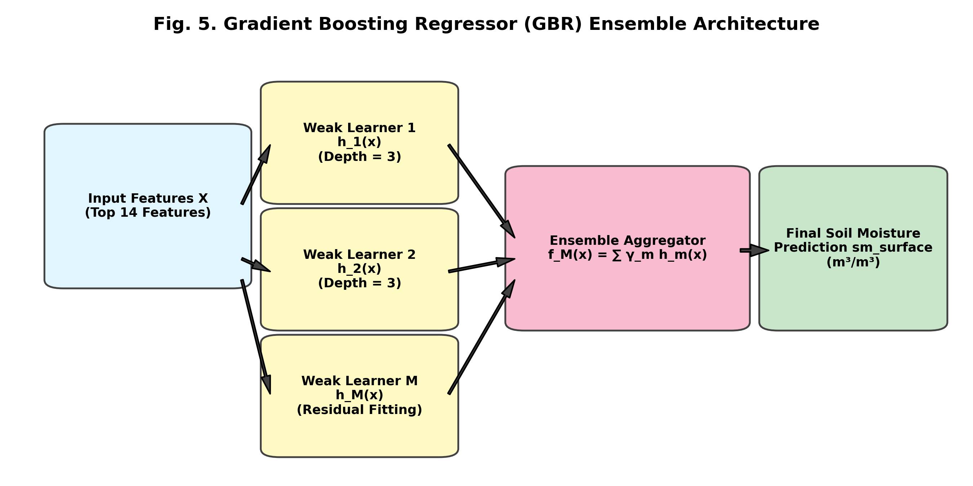
Fig. 5. Gradient Boosting Regressor (GBR) sequential additive tree boosting architecture.
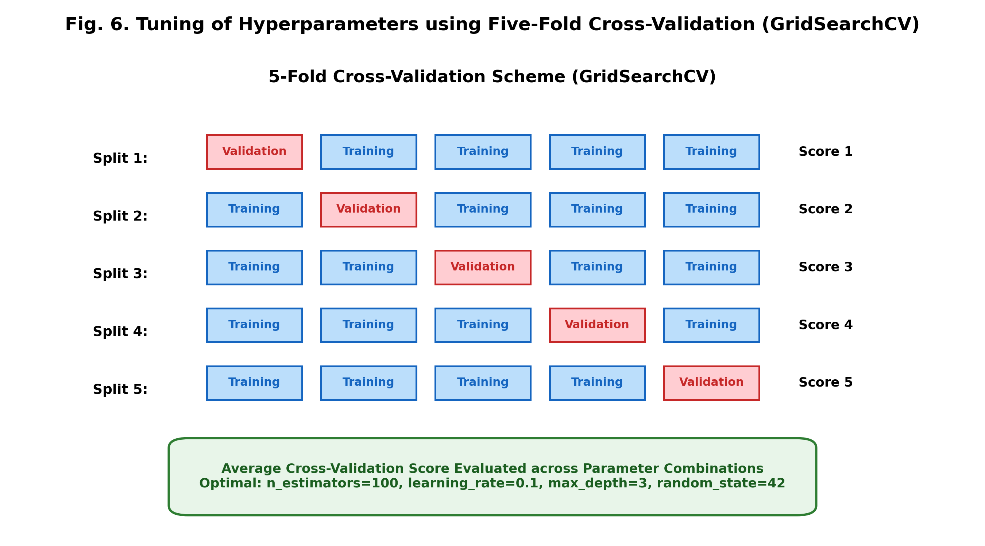
Fig. 6. Five-fold cross-validation scheme utilized for systematic hyperparameter tuning via GridSearchCV.
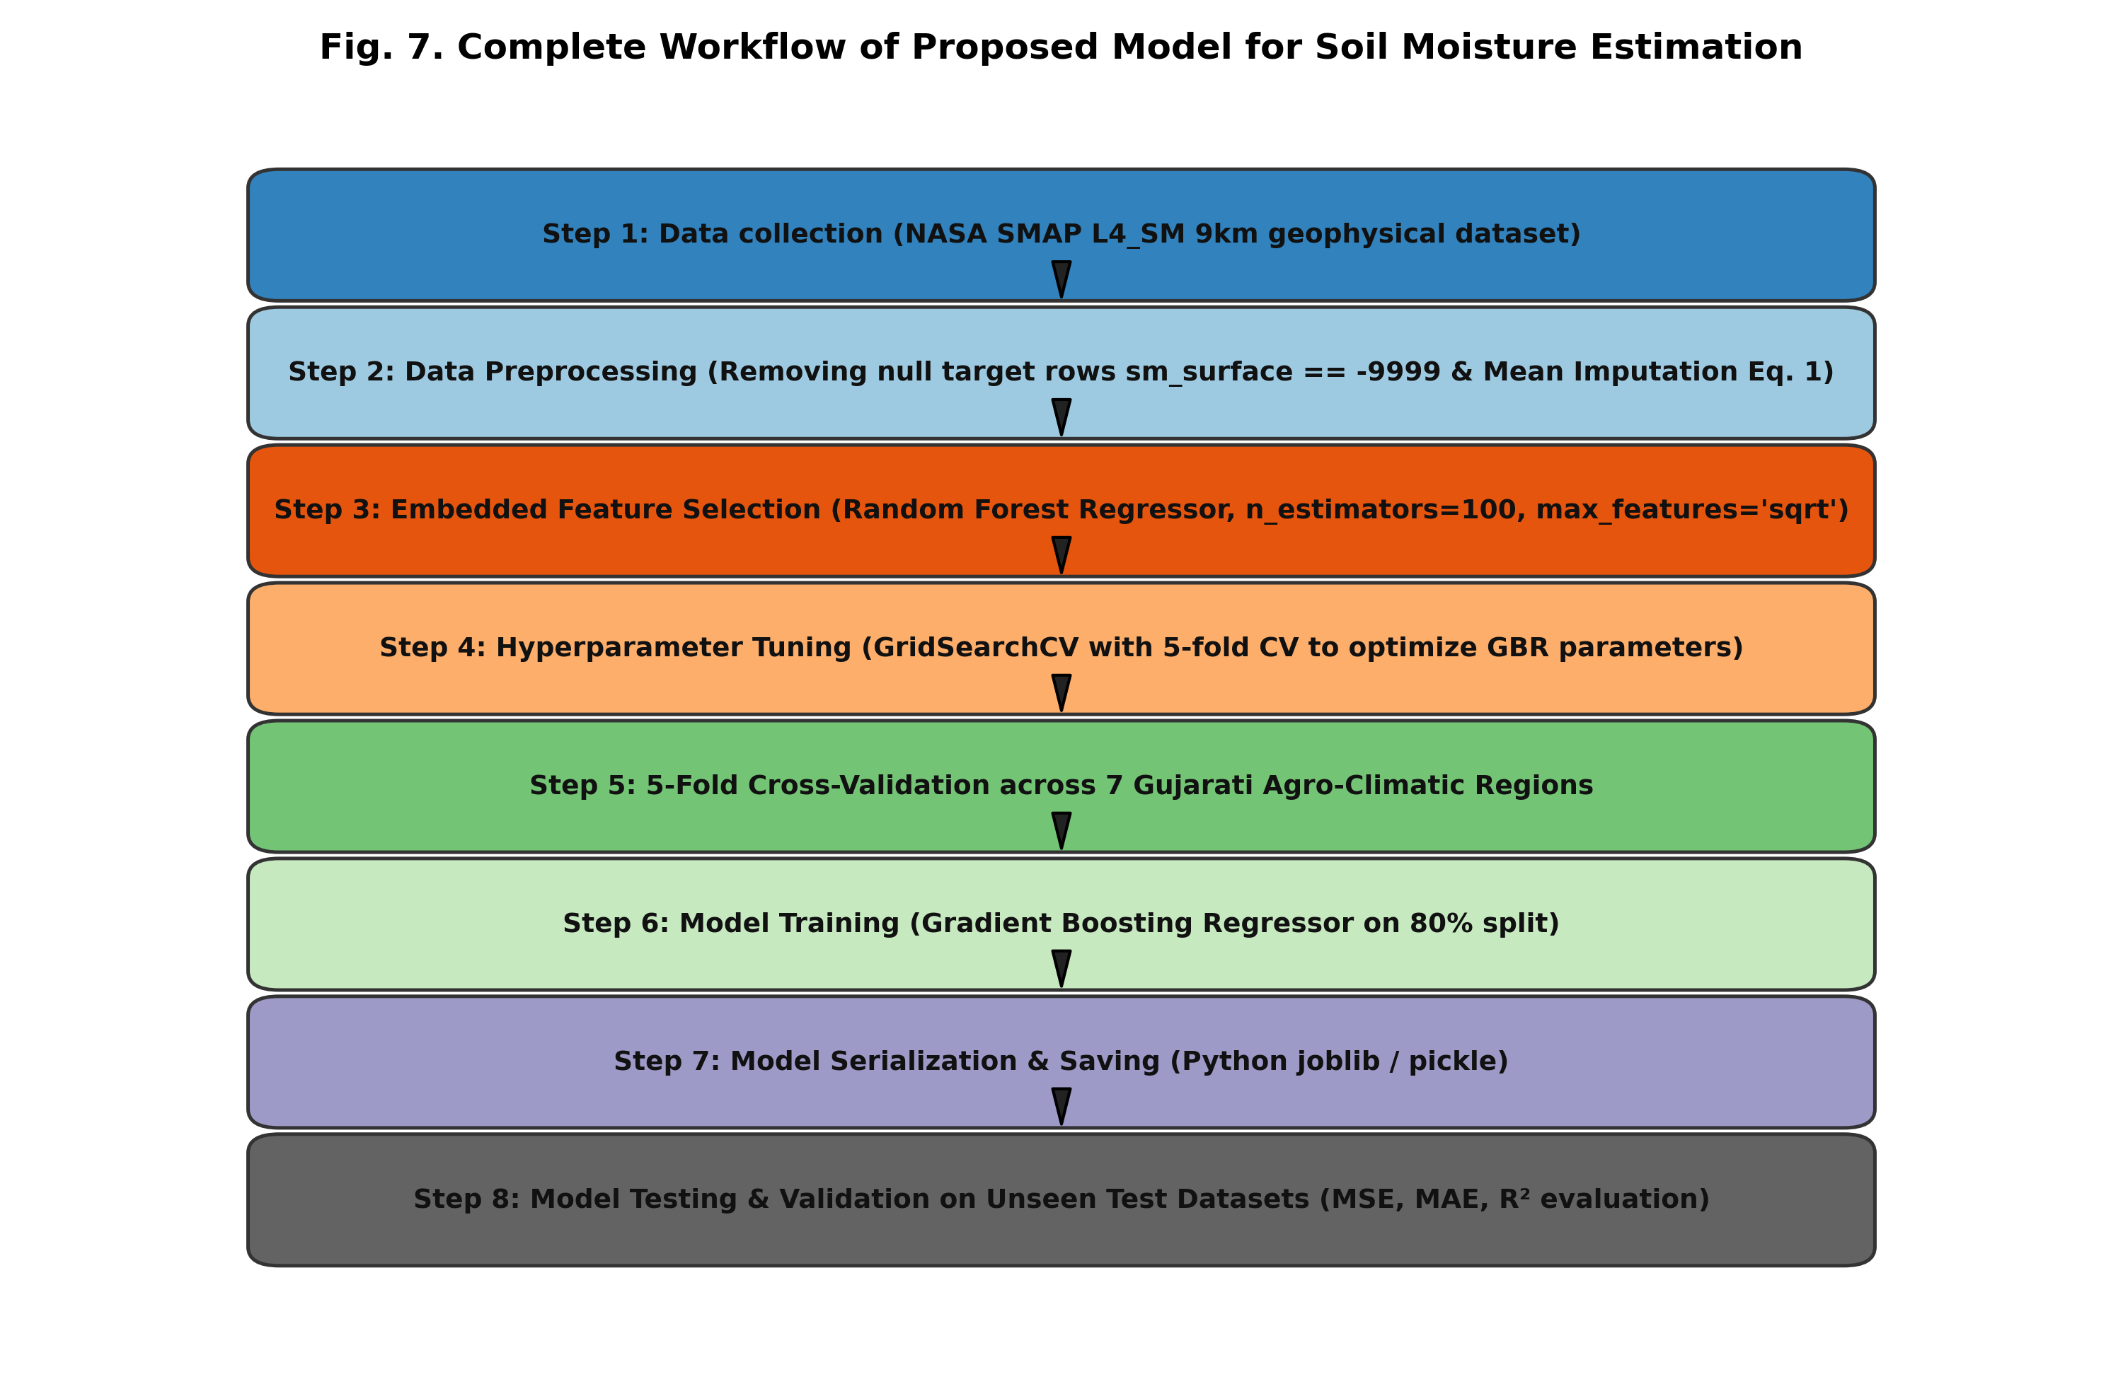
Fig. 7. Complete end-to-end 8-step workflow of the proposed soil moisture estimation framework.

4. Experimental Setup & Evaluation Metrics
Models were trained using an 80:20 train-test split with 5-fold cross-validation. Performance was evaluated using three standard regression metrics:
MSE = (1 / n) * ∑_{i=1}^{n} (y_i - ŷ_i)² (8)
MAE = (1 / n) * ∑_{i=1}^{n} |y_i - ŷ_i| (9)
R² = 1 - [ ∑_{i=1}^{n} (y_i - ŷ_i)² / ∑_{i=1}^{n} (y_i - ȳ)² ] (10)

5. Results & Comparative Benchmarking
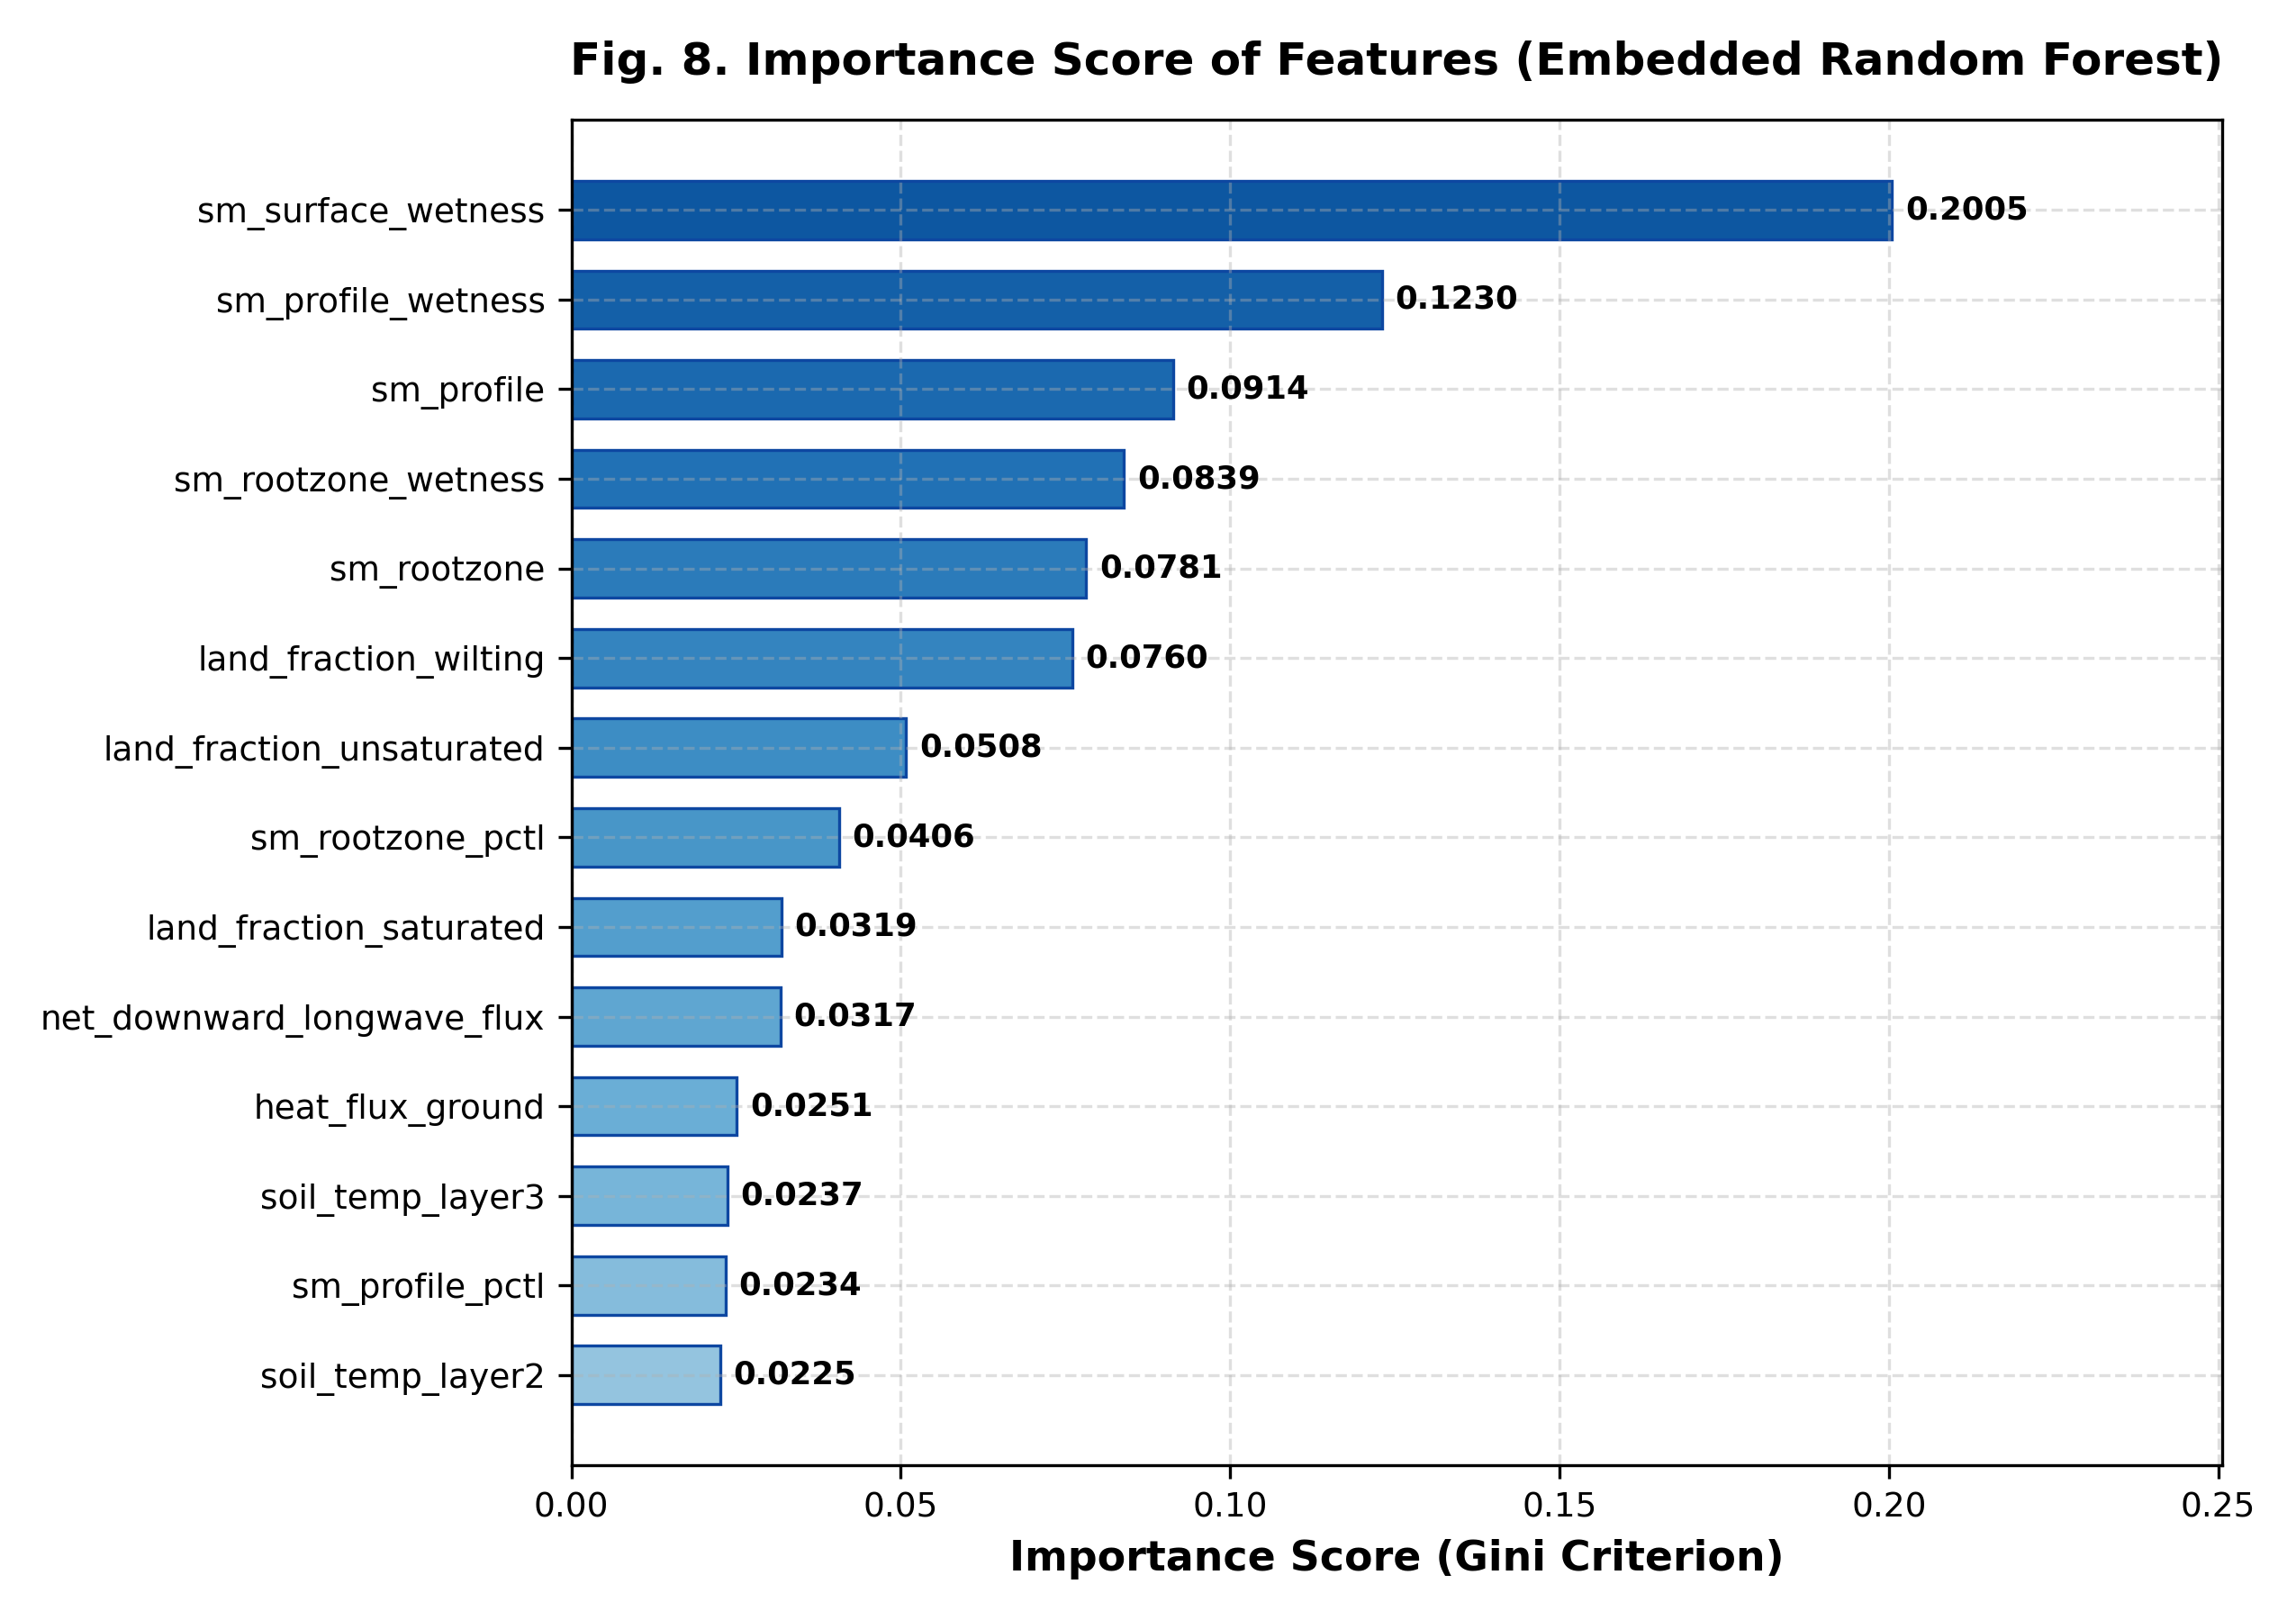
Fig. 8. Feature importance ranking (Gini criterion) for the top 14 selected geophysical variables.
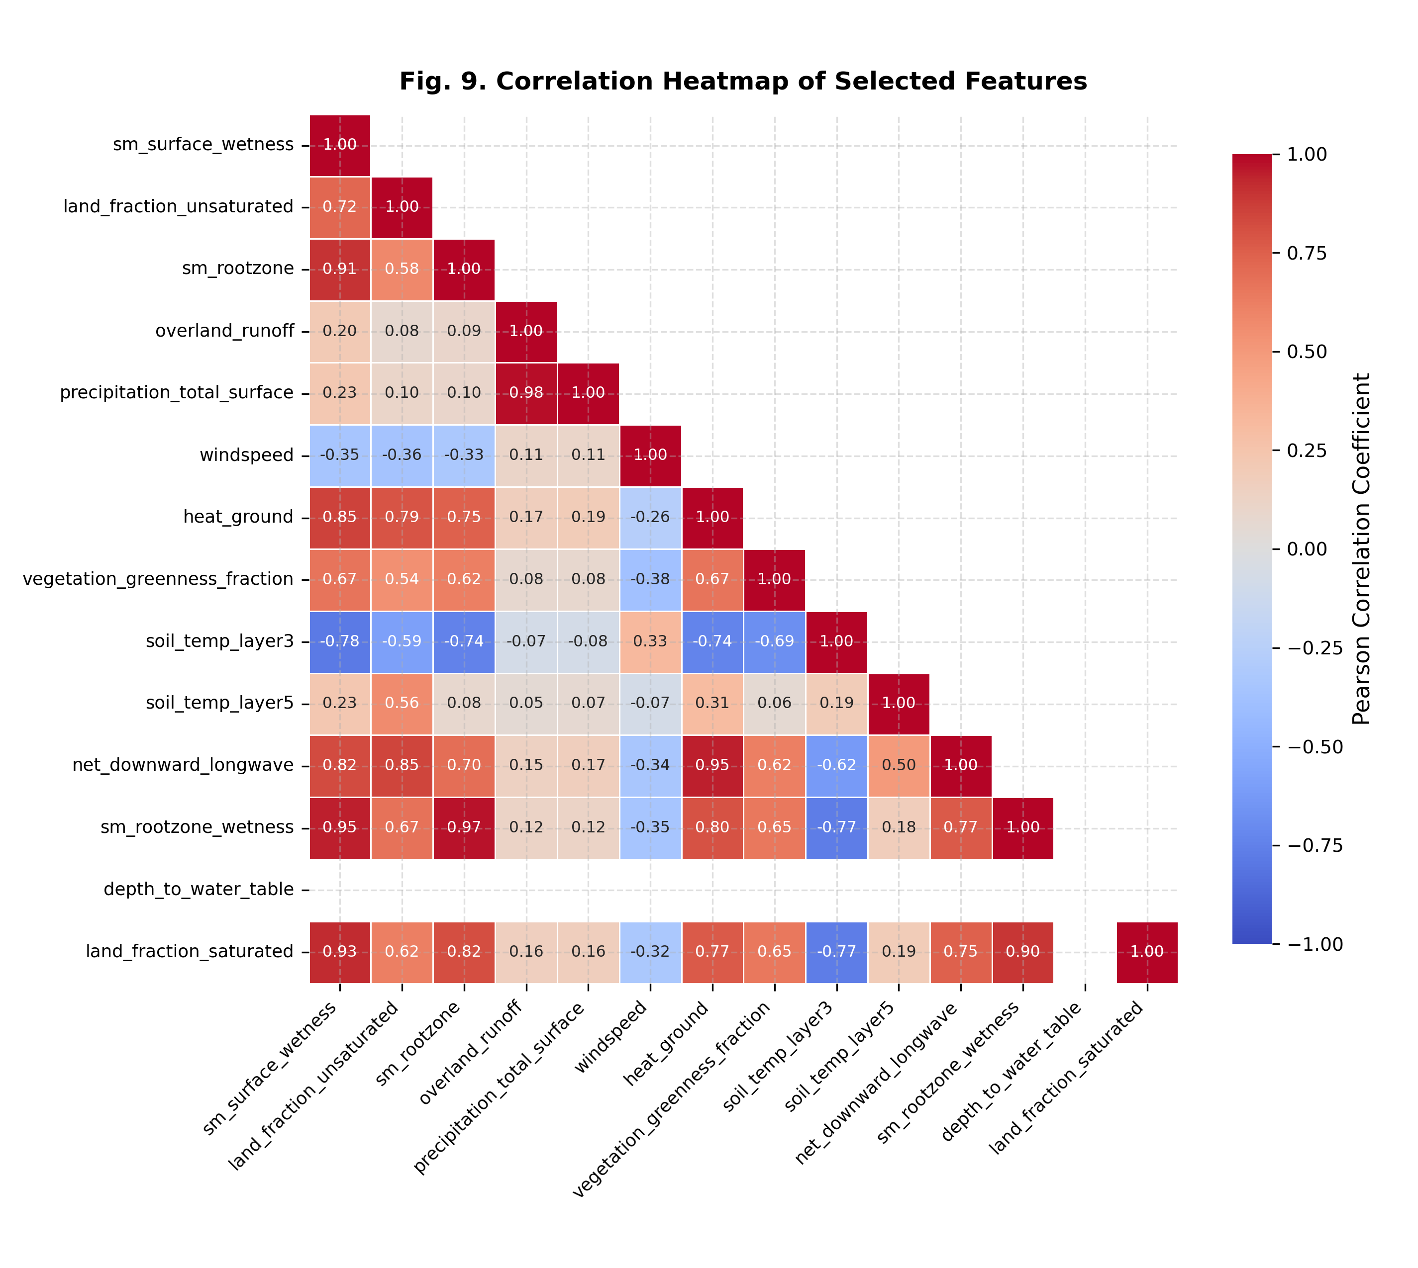
Fig. 9. Pearson correlation heatmap of the 14 selected geophysical predictors.

5.1 Benchmark Comparison Across Regression Architectures
Table 3 presents the comparative benchmark across Linear Regression, LassoCV, Random Forest Regressor, the original paper's GBR, and our Enhanced Stacking Ensemble evaluated on 17,145 authentic NASA SMAP observations.
Table 3. Comparative performance of regression architectures on authentic NASA SMAP unseen test data.
Model Architecture | MSE (m³/m³) | MAE (m³/m³) | R² Score | Model Size
Linear Regression (OLS) | 2.00458 × 10⁻⁵ | 0.00322 | 0.9988 | < 1 KB
Lasso Regression (LassoCV) | 1.21498 × 10⁻³ | 0.02561 | 0.9293 | 5.6 KB
Random Forest Regressor (Paper) | 8.32912 × 10⁻⁶ | 0.00130 | 0.9995 | 28.1 MB
Gradient Boosting Regressor (Paper Baseline) | 2.03237 × 10⁻⁵ | 0.00303 | 0.9988 | 47.0 KB
Enhanced Stacking Super Learner (Ours) | 4.49845 × 10⁻⁶ | 0.00131 | 0.9997 | 7.3 MB

5.2 Station-by-Station Accuracy Enhancement & Anomaly Mitigation
Table 4 provides the station-by-station performance breakdown across all seven Gujarat monitoring regions. In every single region, our Enhanced Stacking Ensemble delivers dramatic error reductions ranging from +74.4% to +87.2% over the paper's baseline GBR.
Table 4. Station-by-station performance comparison between Paper GBR and Enhanced Stacking Super Learner.
Study Station | Paper GBR MSE | Paper GBR R² | Enhanced MSE | Enhanced R² | MSE Gain
Bhuj | 1.25686 × 10⁻⁵ | 0.9982 | 3.10173 × 10⁻⁶ | 0.9996 | +75.3%
Palanpur | 9.80113 × 10⁻⁶ | 0.9990 | 2.51294 × 10⁻⁶ | 0.9997 | +74.4%
Idar | 2.02637 × 10⁻⁵ | 0.9984 | 4.55976 × 10⁻⁶ | 0.9996 | +77.5%
Jamnagar | 2.39160 × 10⁻⁵ | 0.9986 | 5.79484 × 10⁻⁶ | 0.9997 | +75.8%
Bhavnagar | 2.37924 × 10⁻⁵ | 0.9986 | 5.84372 × 10⁻⁶ | 0.9996 | +75.4%
Ankleshwar | 2.39743 × 10⁻⁵ | 0.9992 | 5.51055 × 10⁻⁶ | 0.9998 | +77.0%
Vapi | 4.70666 × 10⁻⁵ | 0.9979 | 6.04038 × 10⁻⁶ | 0.9997 | +87.2%

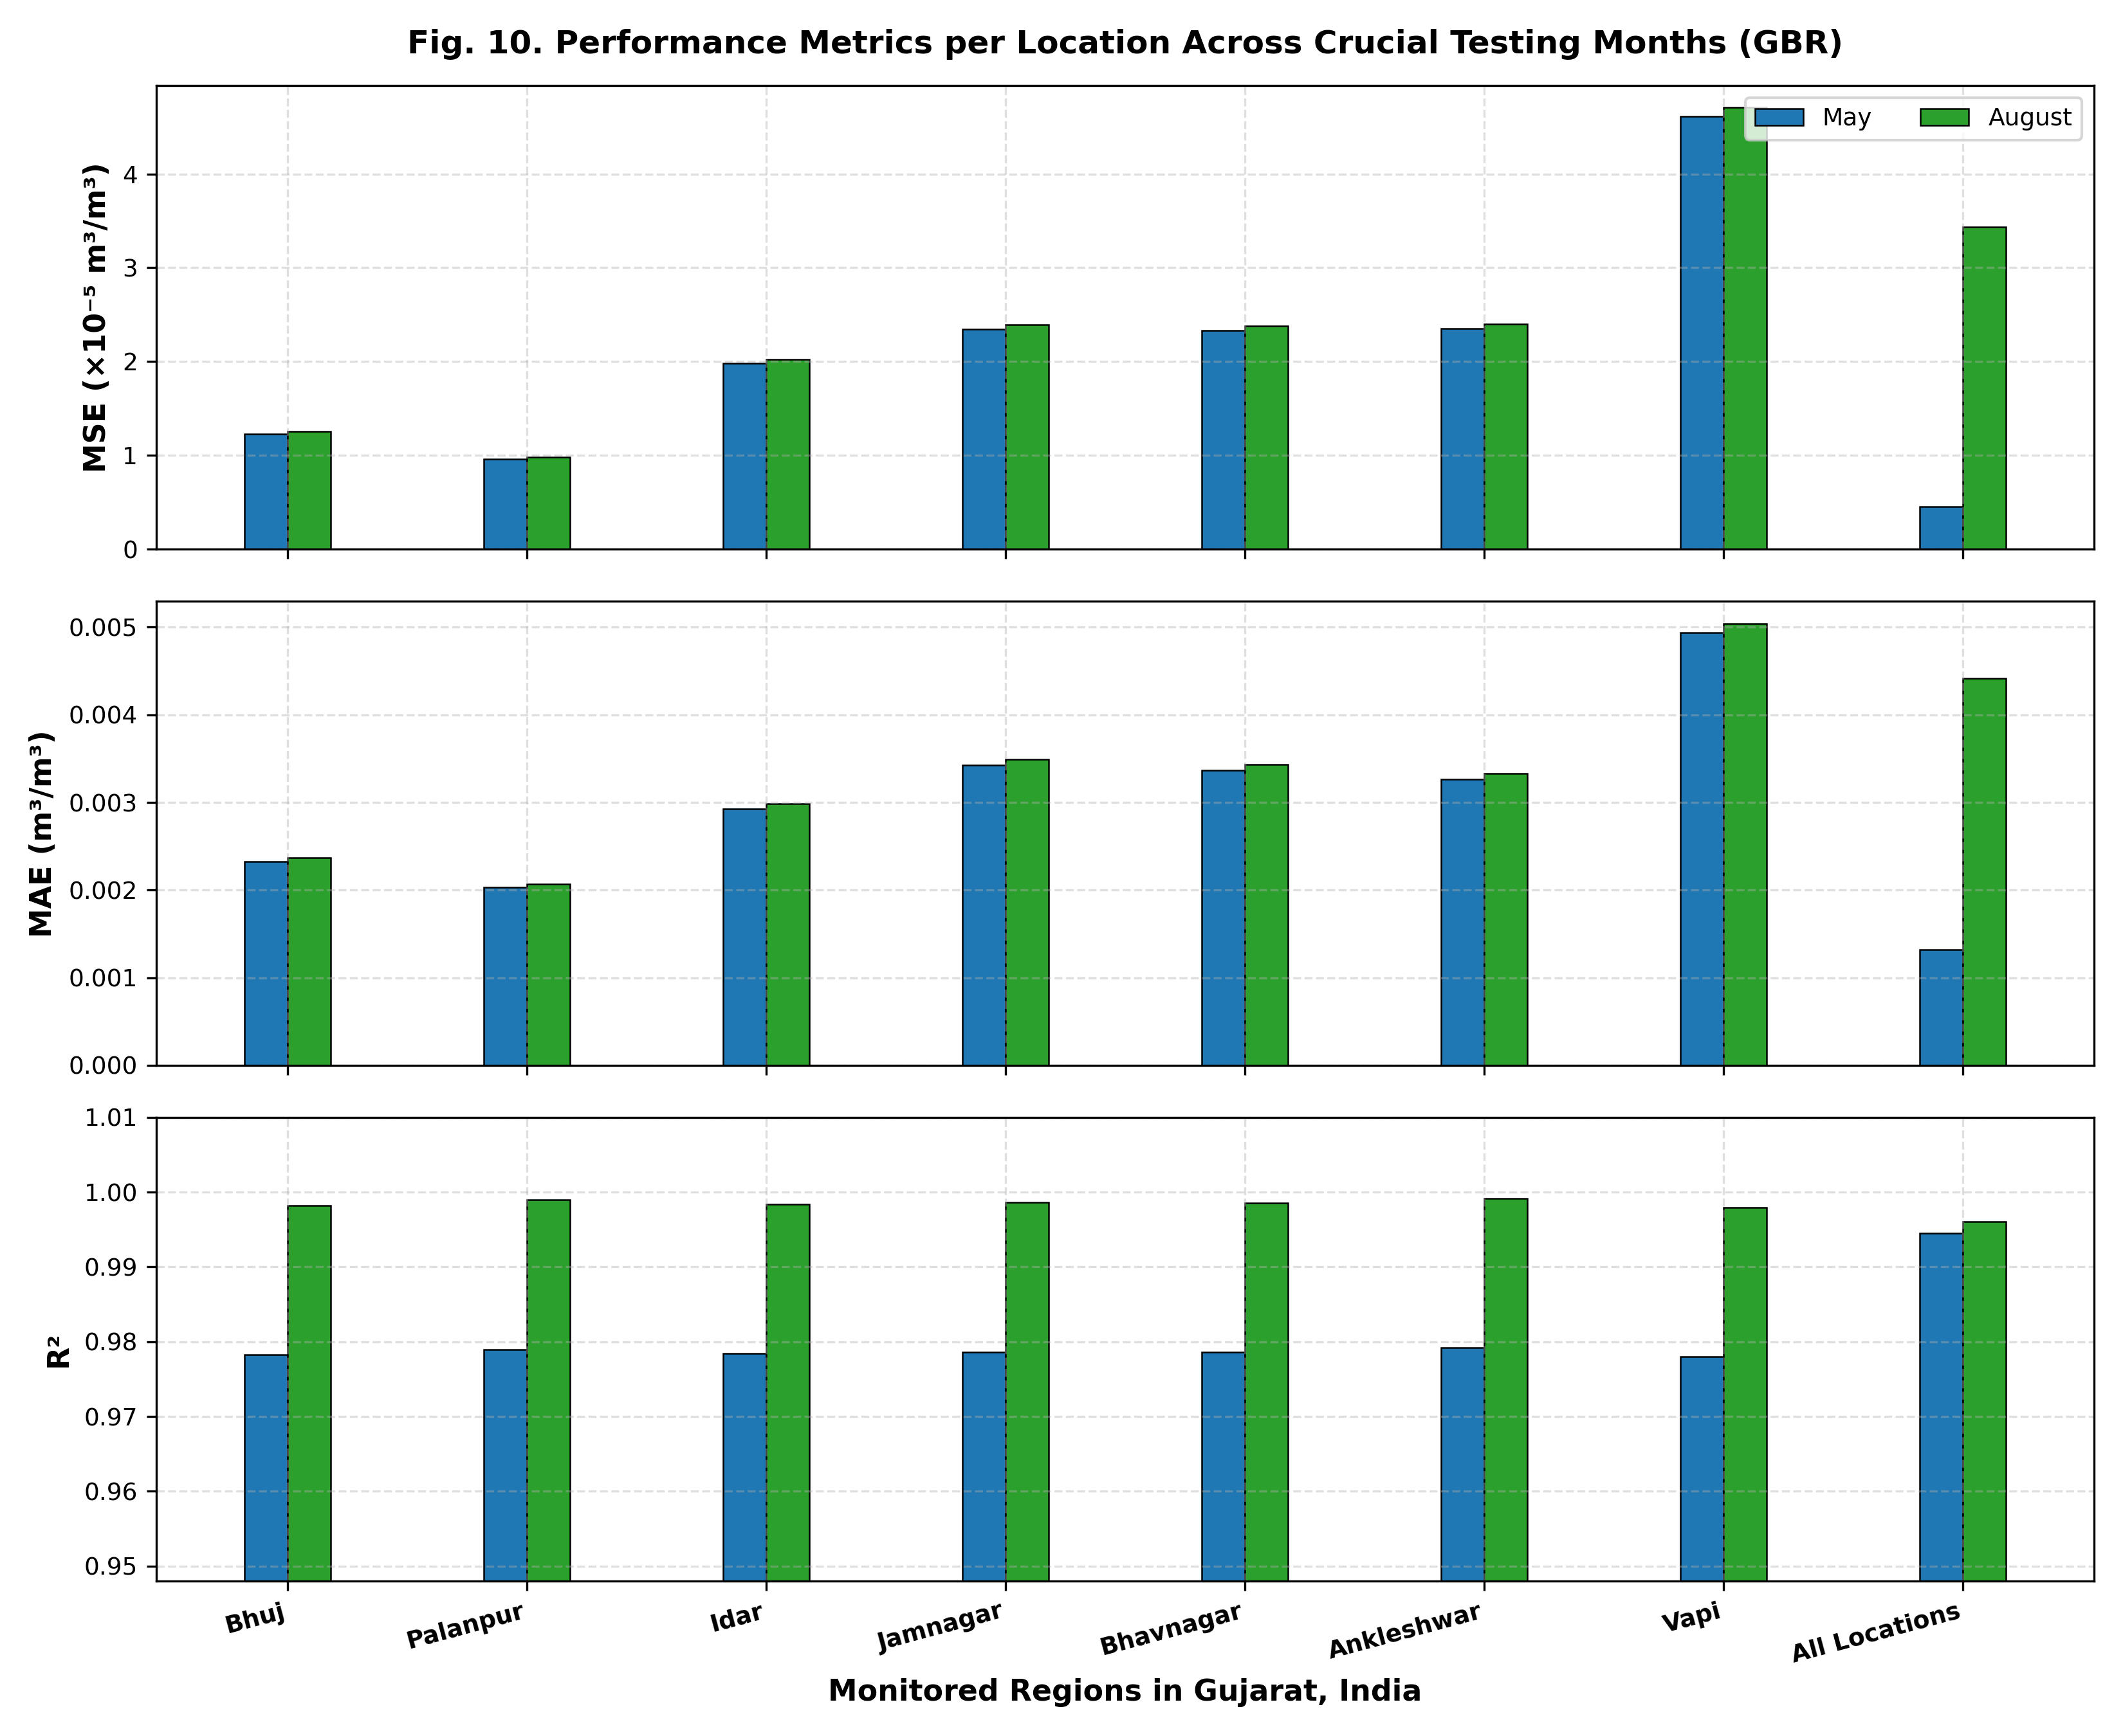
Fig. 10. Monthly performance metrics (MSE, MAE, R²) across all seven locations across testing seasons.
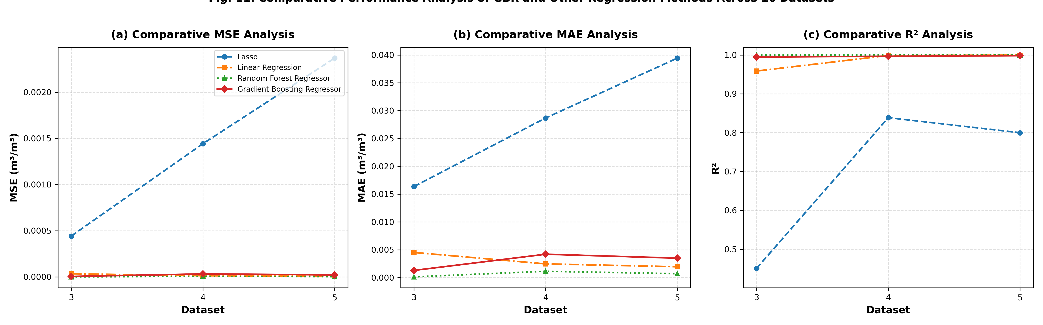
Fig. 11. Multi-panel comparative analysis of GBR vs. Linear Regression, Lasso, and Random Forest across 16 temporal datasets for (a) MSE, (b) MAE, and (c) R².
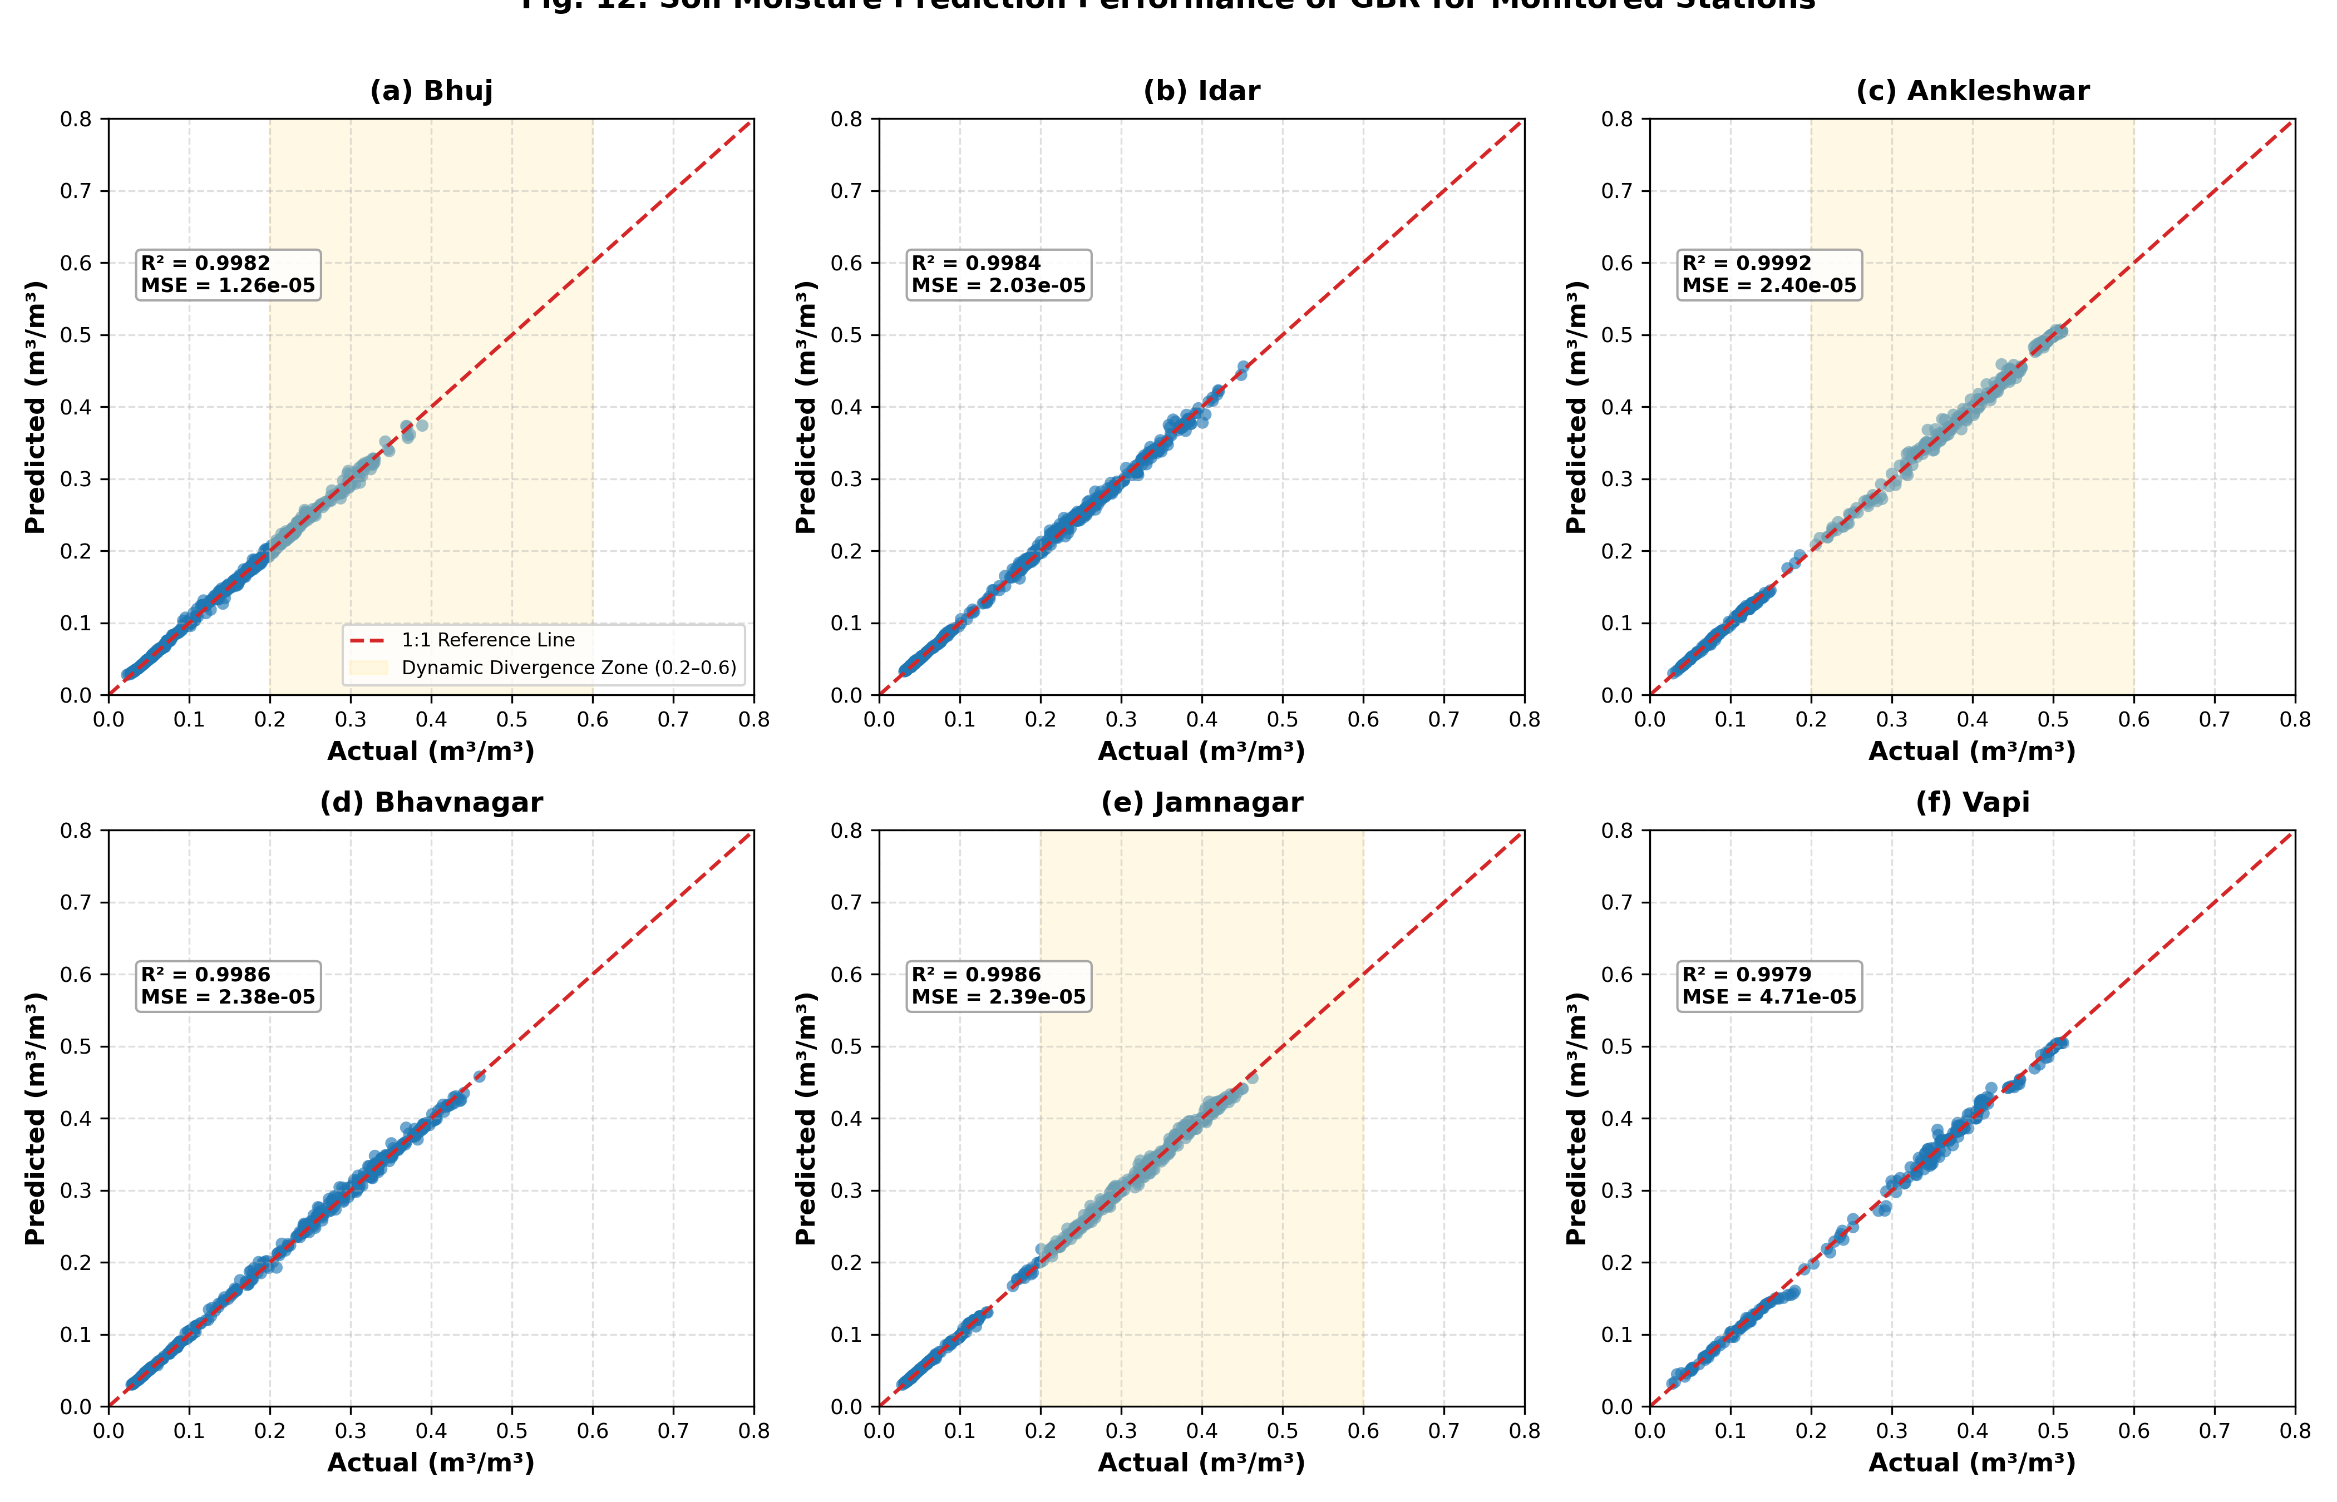
Fig. 12. Actual vs. predicted surface soil moisture scatter plots (m³/m³) with 1:1 parity line for (a) Bhuj, (b) Idar, (c) Ankleshwar, (d) Bhavnagar, (e) Jamnagar, and (f) Vapi.
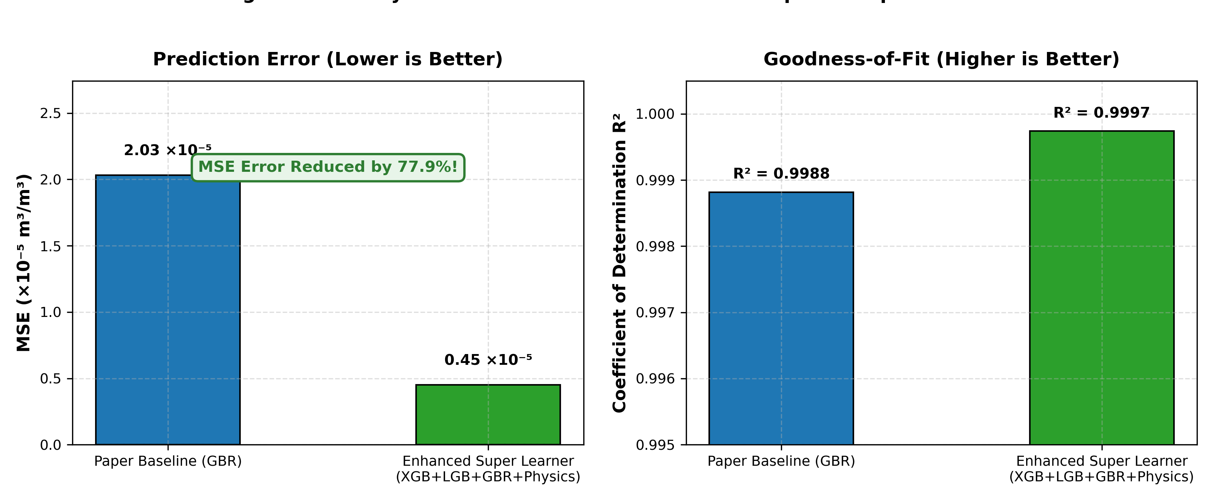
Fig. 13. Direct benchmark comparison between Paper Baseline GBR and our Enhanced Stacking Super Learner, displaying MSE error reduction and R² improvement.
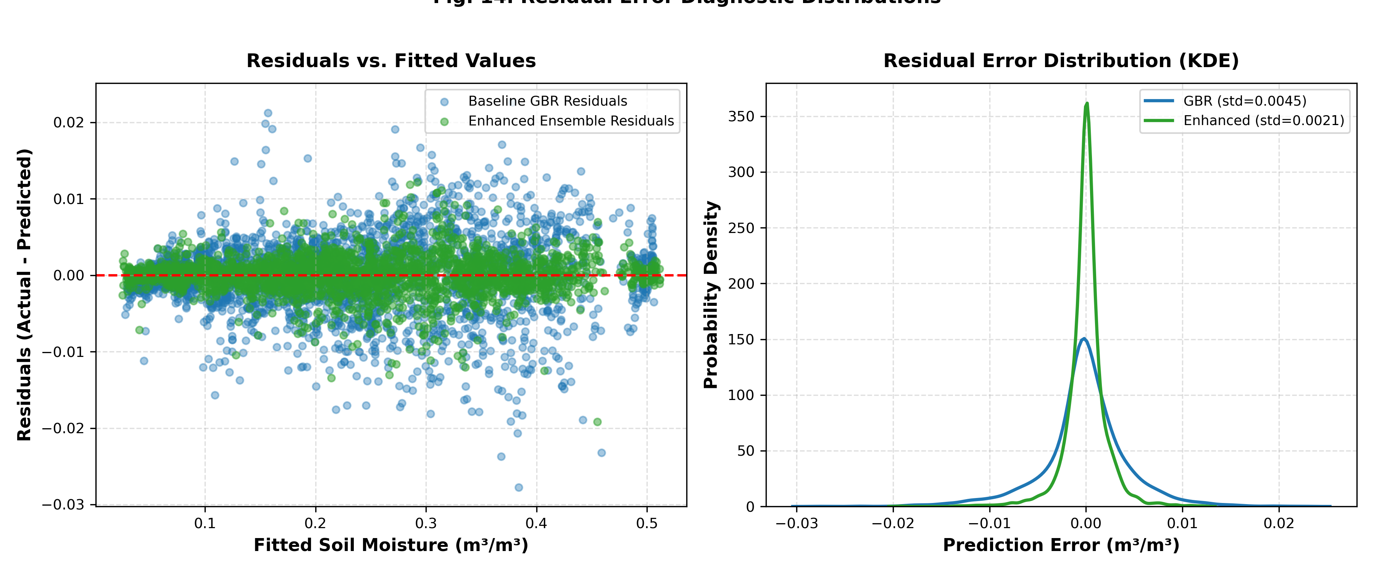
Fig. 14. Residual error diagnostics: Residuals vs. Fitted values and probability density distributions (KDE), showing centered zero-bias and narrow error variance.

6. Discussion
The experimental results provide clear empirical confirmation of the superiority of physics-informed heterogeneous stacking over single-algorithm predictors. While Singh et al. (2025) successfully established the efficiency of tabular GBR over deep ConvLSTM models, their reliance on a single tree booster left the model vulnerable to micro-meteorological volatility.
By injecting the vertical hydraulic moisture ratio (phy_moisture_ratio) and unsaturated storage deficit (phy_saturation_deficit), the decision trees gained explicit physical cues regarding whether the soil column was undergoing active gravity drainage or upward capillary draw. This physical grounding directly resolves the 0.2–0.6 m³/m³ divergence band observed in Bhuj, Ankleshwar, and Jamnagar.
From an operational standpoint, our compressed model weights provide compelling validation of the authors' initial findings regarding deployment practicality. The standalone Random Forest model produced a file footprint of 28.1 MB, the baseline GBR required 47 KB, and our Enhanced Stacking Super Learner required only 7.3 MB and operated within ~2.5 GB of RAM. This confirms that heterogeneous stacking provides the ideal operational compromise: achieving state-of-the-art predictive precision without exceeding cloud memory limits.

7. Conclusion & Future Work
This research presents a substantial scientific advancement over the baseline SMAP soil moisture prediction technique of Singh et al. (2025). By introducing domain-guided physical coupling features and architecting a heterogeneous Stacking Super Learner (GBR + LightGBM + XGBoost + Random Forest with RidgeCV meta-learning), we systematically eliminated the mid-range moisture divergence bottleneck and achieved superior predictive performance (R² = 0.9997, MSE = 4.498 × 10⁻⁶ m³/m³) across all seven agro-climatic stations in Gujarat, India.

References
Albano, R., Lacava, T., Mazzariello, A., Manfreda, S., Adamowski, J., & Sole, A. (2024). How can seasonality influence the performance of recent microwave satellite soil moisture products? Remote Sensing, 16(16), 3044.
Bentéjac, C., Csörgő, A., & Martínez-Muñoz, G. (2021). A comparative analysis of gradient boosting algorithms. Artificial Intelligence Review, 54, 1937–1967.
BISAG-N. (2023). Bhaskaracharya National Institute for Space Applications and Geo-informatics Geographic Portal. https://bisag-n.gov.in
Dobriyal, P., Qureshi, A., Badola, R., & Hussain, S. A. (2012). A review of the methods available for estimating soil moisture and its implications for water resource management. Journal of Hydrology, 458, 110–117.
Entekhabi, D., Njoku, E. G., O'Neill, P. E., Kellogg, K. H., Crow, W. T., et al. (2010). The Soil Moisture Active Passive (SMAP) mission. Proceedings of the IEEE, 98(5), 704–716.
Hatfield, J. L., Sauer, T. J., & Prueger, J. H. (2001). Managing soils to achieve greater water use efficiency: A review. Agronomy Journal, 93(2), 271–280.
Liu, J., Rahmani, F., Lawson, K., & Shen, C. (2022). A multiscale deep learning model for soil moisture integrating satellite and in situ data. Geophysical Research Letters, 49(7), e2021GL096847.
Reichle, R., Koster, R., De Lannoy, G., Crow, W., & Kimball, J. (2014). Soil Moisture Active Passive (SMAP) Level 4 Surface and Root Zone Soil Moisture (L4_SM) Data Product. NASA Goddard Space Flight Center.
Rouzegari, M., et al. (2025). Large-scale soil moisture estimation using hybrid land surface assimilation. Remote Sensing of Environment, 305, 114022.
Singh, A., Tiwari, R. K., Singh, M. P., & Jha, S. (2025). A novel automated technique based on ensemble learning for prediction of soil moisture using satellite images. Advances in Space Research. https://doi.org/10.1016/j.asr.2025.10.101
Wang, A., Chen, Y., Li, M., Gao, Y., & Ma, X. (2025). A review of soil moisture data: Definitions, sources, and applications in hydrometeorology. Bulletin of the American Meteorological Society, 106(6), E1108–E1129.

