Create mount for adlsgen2 storage account using access Key

This is temperory view, it scope is only for one session.

And to continue with other session we can use global view 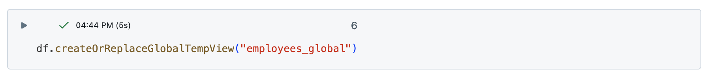It is created successfully , now we can use this global view in different notebook using same cluster

A global view scope is within the entire cluster.

Hive

Hive is created successfully.

