Design Lab Project
Development of an Application for Receiving Orders for Printing Digital Photographs

Prepared by

Rishav Das(21)

Shubhajyoti Dutta(31)

Sk Aktar Hossain(40)

Supratik Pal(54)

Koushik Kumar Saha(61)

ST. THOMAS' COLLEGE OF ENGINEERING & TECHNOLOGY

COMPUTER SCIENCE & ENGINEERING
8th SEMESTER

INDEX

TABLE OF CONTENTS | PAGE NO
Chapter 1: Introduction | 3-5
1.1 Abstract | 3
1.2 Keywords | 3
1.3 Functional Components of the project | 3
1.4 Steps to Start off the Project | 4
1.5 Requirements | 4
1.6 Milestones and Timelines | 5
Chapter 2 : Design and Implementation | 6-11
2.1 Design | 6
2.2 Implementation | 9
Chapter 3 : Result Analysis and Conclusion | 12-15
3.1 Result Analysis | 12
3.2 Future Scope | 15
3.3 Conclusion | 15

CHAPTER 1

Introduction

1.1 Abstract

A customer can have a set of digital photographs in his desktop which he/she wants to print. He/she can provide the application the path to the folder where the photographs are stored and can choose the photos that he/she wants to print and choose the size of the prints. The application will calculate the price after downloading the price information from the database for the different print sizes and show it to the user. The user will enter his/her credit card/other payment option (or choose any other mode of payment) and shipping information if he/she wants to go ahead with the order. If the credit card information is found correct, the photos are uploaded to the server and a purchase order is created in the database.

1.2 Keywords

Generic Technology keywords

Operating Systems, Databases, Programming, Network and Middleware

Specific Technology keywords

PHP,HTML,CSS, SQL Server/Oracle

Project type keywords

Design, Implementation, User Interface

1.3 Functional components of the project

- The price information for the different print sizes will be stored in the database.
- The user will specify the path to the folder in his desktop which will contain the photographs in jpeg format which he wants to print.
- The application will show all the jpeg files in the folder to the user. The user can then choose the size(s) and the number of prints that he/she wants to print for each size for each photograph.
- The application will calculate the total price for the order.
- If the user decides to buy the prints, he/she will be asked to enter the mode of payment (credit card/direct payment in the nearest branch office) and the shipping address. If credit card option is chosen, the credit card information will be encrypted and sent to the server for verification.
- The server will decrypt the credit card information and verify it. If found correct, the photos will be uploaded to the server.
- After completion of the uploading, a purchase request will be created in the database. The purchase order number will be sent to the user in an email.
- An administrator user then can see the purchase request and can execute the same.
- Once the photos are printed and shipped, the directory containing these photographs will be deleted from the server. A mail notification will be sent to the user.

1.4 Steps to start-off the project

To start this project, following should be helpful:

- Knowledge of how file transfer happens between different systems
- Knowledge about encryption/decryption techniques
- VB and database knowledge

1.5 Requirements

Hardware requirements

Number | Description | Alternatives (If available)
1 | PC with 2 GB Hard disk and 256 MB RAM | NA

Software requirements

Number | Description | Alternatives (If available)
1 | Windows OS | NA
2 | Oracle database | SQL Server/MS Access

Manpower requirements

3 persons should be able to complete this project in 3 months.

1.6 Milestones and Timelines
.

Number | Milestone Name | Milestone Description | Timeline | Remarks
1 | Requirements Analysis | Complete specification of the system | 2 weeks from start | A detailed document should be there for each requirement
2 | High Level Design | Identify the modules and the different entities and their relationship | 1 Week | Should have all the modules in place
3 | Detailed Design | Database design, program specs etc | 2 weeks | The database design should get complete. Also, the different screens needed should be decided upon
4 | Build | Code for the system | 5/6 Weeks | Database should be created and populated for reference data, the file upload programs, the mail sending programs, the front end screens should be completed
5 | Integration Test | Test the different modules together | 2 Weeks | The front end, the database, the file upload modules and the mail handling programs should work together
6 | Final Review |  | 2 Weeks | All the requirements are fulfilled

CHAPTER 2

Design and Implementation

2.1 Design

We know that the first step of creating a software is to create its Data Flow Diagram(DFD) and Entity-Relationship Diagram(ERD).
From the DFD we will able to see the processes and the flow of data and the data stores involved in the project. As we are using relational databases the datastores are simply databases for us.

Context level DFD/Level-0 DFD

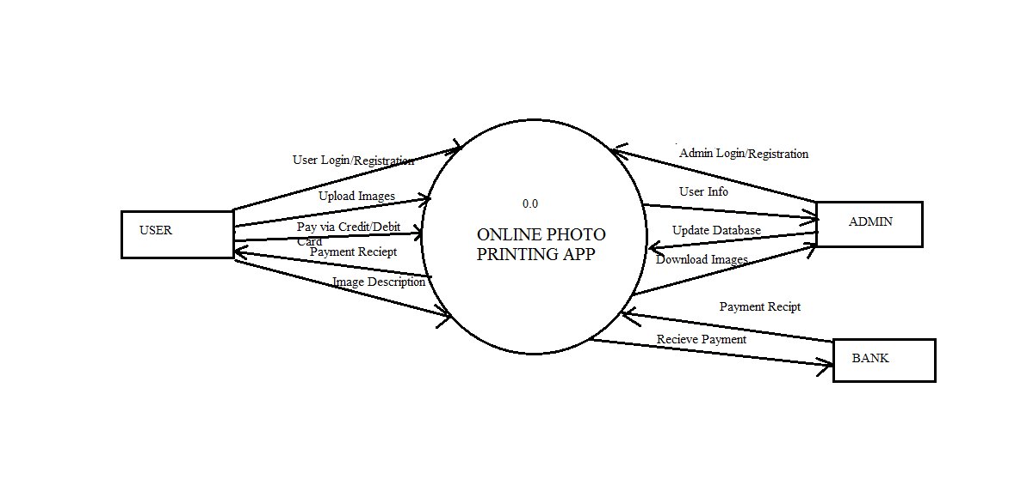
This is our level-0 DFD. Here we can see we have 3 external entities i.e,
1.User
2.Admin
3.Bank

The user should register into the application, after that he have to login as many times he opens the application. He have to provide all his/her details and can upload images, pay via credit/debit cards etc.

The admin also needs to login each time he enters, he can download the images, print them, update the databases etc.

The bank is there only for transaction purposes. It just receives the money and store it into the company's account and send a payment receipt as confirmation.

Level 1 DFD

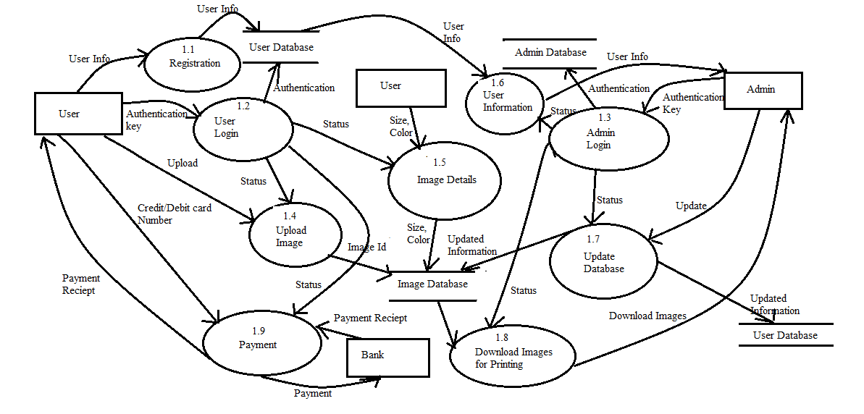

This is just a detailed version of level 1 DFD. The processes are shown here.
We have 8 processes here.

1.Registration:
Here the user registers himself by providing valid information about himself,this is actually creating his own account.

2.User Login:
After creating his account he need to verify that he is an existing user by entering his username and password, if it matches with our database then he will able to access the website.

3.Admin Login:
The admin also needs to login every time for security purposes.

4.Upload Image:
The user uploads the image, when he uploads the image gets an image id and the id is stored into our database.

5.Image details:
The user needs to provide the image size, number of copies he want to print etc.

6.User Information:
The admin can access the databases via this process.

7.Update database:
The admin updates the database via this process.
e.g, if an admin prints an image its status will be changed to 'YES' so that any other admin doesn't print it again.

8.Download Images for Printing:
The admin can download images for printing by this process.

9.Payment:
This process is used for online payment. It actually connects the user to the bank and estimates the amount user needs to pay. It also confirms the transaction by sending a receipt to the user which is printable.

Now the next step of design process is to create an entity relationship diagram. We have 3 databases and they are relational.

Entity Relationship Diagram

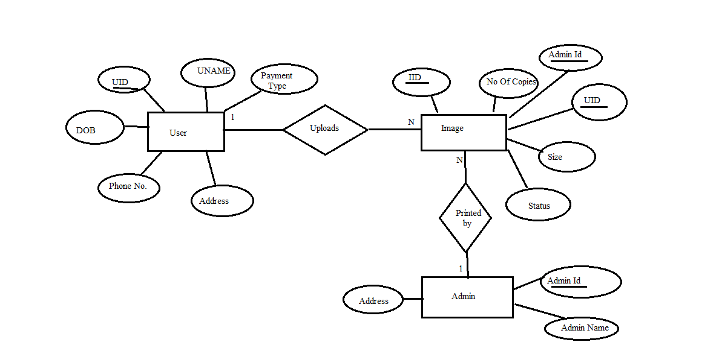
From the entity relationship diagram we can see we have 3 databases namely

1.User Database:

UID int (Primary Key, Not Null),
UNAME varchar(255),
Email varchar(255),
DOB date,
Phone Number varchar(255),
Address varchar(255),
Payment type varchar(255)

2.Admin Database:

Admin Id int (Primary Key, Not Null),
Admin Name varchar(20),
Address varchar(255)

3.Image Database:

IID int (Primary Key, Not Null),
No. of Copies int,
Admin Id int (Foreign key References Admin Database(Admin Id)),
UID int (Foreign key References User Database(UID)),
Size varchar(5),
Status varchar(3)(YES/NO)

2.2 Implementation

To create front end we used HTML and CSS. For the backend implementation we used PHP.

Front end Implementation

We have created a homepage which have register, login, about us etc.
From that page the user can navigate to those pages. After login the user will be redirected to the image upload page where he can upload his images, select the size and number of copies he want to print and if he has already placed his order he can check his order status.
We are providing some sample codes of our front end below.

</style>
</head>
<body>

<form action="register1.php" method="post">

<h1>Sign Up</h1>

<fieldset><div>
<legend><span class="number">1</span>Your basic info</legend>
<label for="name">Name:</label>
<input type="text" id="name" name="user_name" required/>

<label for="mail">Email:</label>
<input type="email" id="mail" name="user_email" required/>

<label for="password">Password:</label>
<input type="password" id="password" name="user_password" required/>

<label for="name">Phone No:</label>
<input type="text" id="name" name="user_pno" required/>

<label for="bio">Address</label>
<textarea id="bio" name="user_add" required/></textarea>
</div></fieldset>

<button type="submit">Sign Up</button>
</form>

</body>
</html>

This is the register page. The screenshots are attached in the results section.

Back end Implementation

The back end is implemented with PHP. The webpages are connected with databases using XAMPP. The email id, password formats are coded successfully.
Like the email id should be in the format "abc@xyz.pqr". Else it wont be accepted.
The password must be of atleast 8 characters.
Sample code of backend is provided.

<?php
include("db_connection.php");
$conn = OpenCon();
function GetImageExtension($imagetype)
{
if(empty($imagetype)) return false;
switch($imagetype)
{
case 'image/bmp': return '.bmp';
case 'image/gif': return '.gif';
case 'image/jpeg': return '.jpg';
case 'image/png': return '.png';
default: return false;
}
}
if (!empty($_FILES["uploadedimage"]["name"])) {
$file_name=$_FILES["uploadedimage"]["name"];
$temp_name=$_FILES["uploadedimage"]["tmp_name"];
$imgtype=$_FILES["uploadedimage"]["type"];
$ext= GetImageExtension($imgtype);
$imagename=date("d-m-Y")."-".time().$ext;
$target_path = "images/".$imagename;
if(move_uploaded_file($temp_name, $target_path)) {
$query_upload="INSERT into myimgdb2 (images_path,submission_date)
VALUES('".$target_path."','".date("Y-m-d")."')";
mysqli_query($conn,$query_upload) or die("error in $query_upload == ---->".mysql_error());
echo"Image uploaded";
}else{
exit("Error While uploading image on the server");
}}
CloseCon($conn);
?>;

This is a code in PHP for saving the image uploaded by the user.

CHAPTER 3

Result Analysis and Conclusion

3.1 Result Analysis

This is an web based application for receiving orders online. Our application is a basic one and it is working fine. The screenshots are provided below.

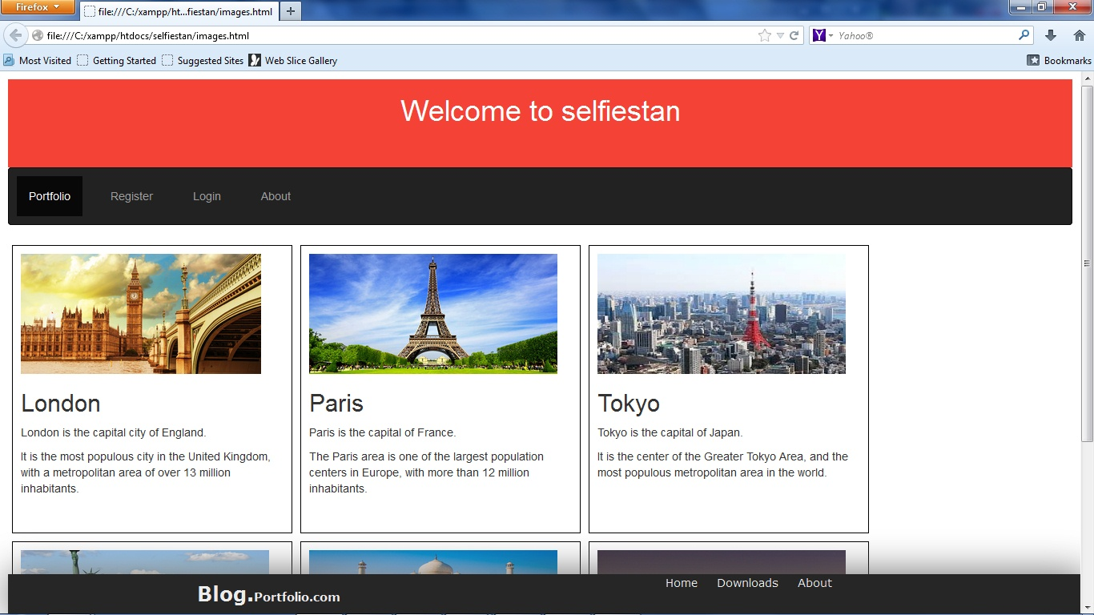

This is the homepage. From here the user can register and login.

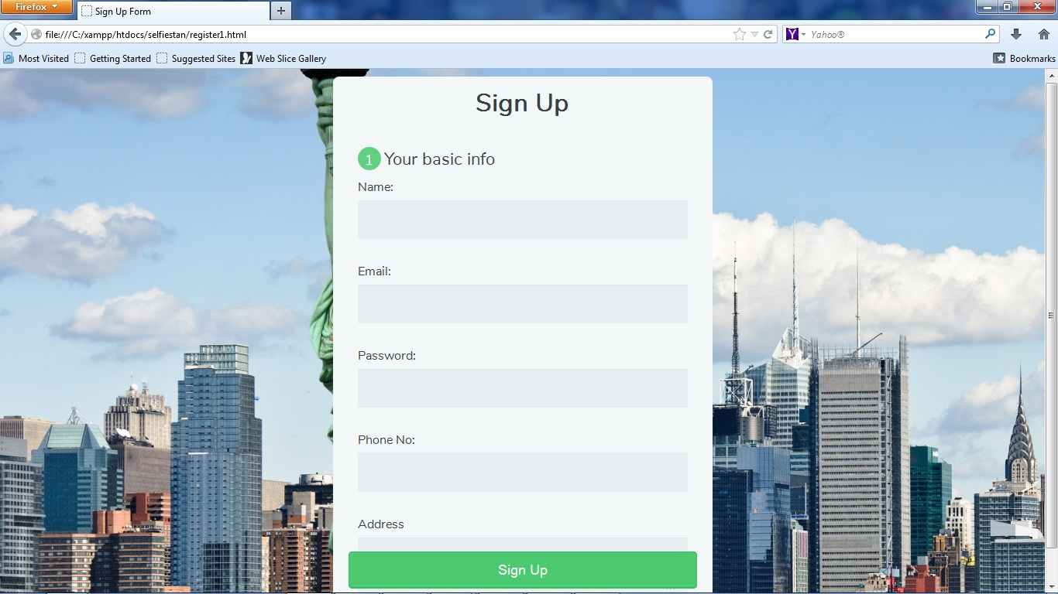

This is the sign up page. When the user enters our website for the first time he needs to sign up first.

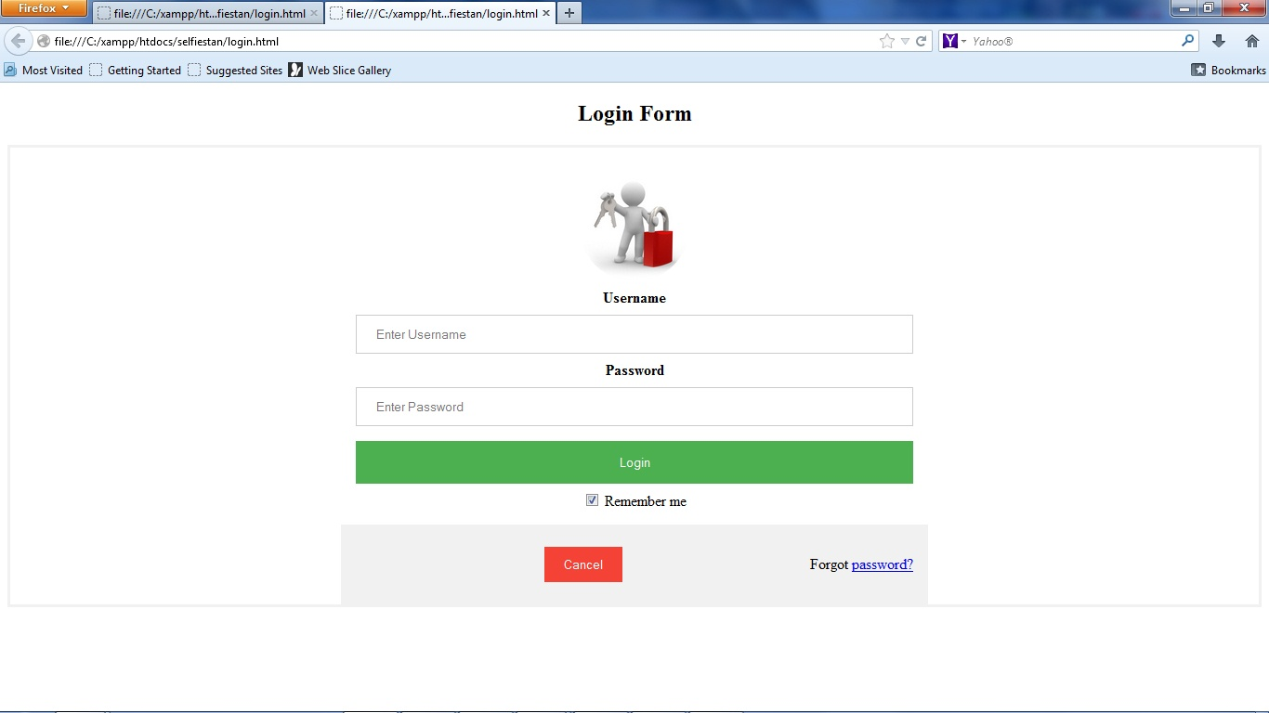

This is the login page. Everytime an user enters our website he needs to login in order to access the whole website.

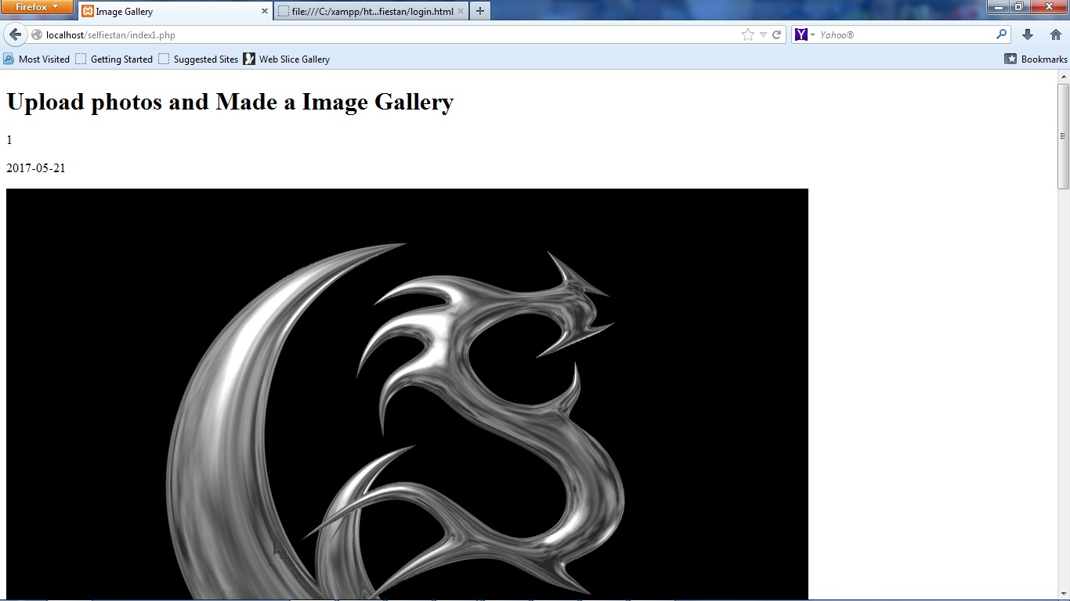

Here the admin the see the uploaded images, each image has an unique image id and the date and time of upload.

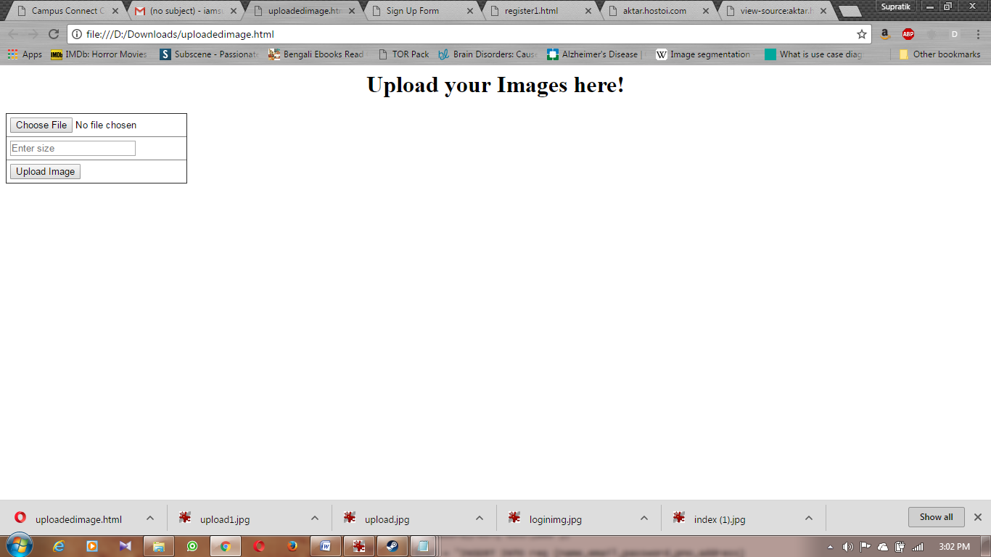

This is the page from where the user can browse and upload his images and set the size of the image he wants.

3.2 Future Scope

The project can be improved a lot.

1. Net banking and COD(Cash on delivery) facilities can be added

2. A collage functionality can be added.

3. Courier tracking can be added.

3.3 Conclusion

We have created an application for taking orders and printing digital images online. From this application an user can upload his/her own images from his/her gallery
and set the size and the number of copies he want to print. We will estimate the cost and he have to pay the money via credit or debit cards. The printed copies will be delivered to him within the estimated date of delivery.
We have used HTML, CSS, PHP, MySQL to complete this application.A lot of improvements can be done and we are working on it.

