Consent Form
Researcher: ####
Affiliation: ####
Contact: ####
Date: ####
You are being invited to participate in a research study titled “Automated Question Generation for Fact Checking” . This study is led by #### from the ####. The purpose of this research study is to create a dataset that contains the questions asked by journalists to fact check a set of claims. Each claim will take you approximately 20 minutes to complete.
You will be shown a claim and asked to write down the questions that need to be answered in order to verify the claim. The data produced from this study will be used for publication. After you completed the survey you will be rewarded as stated on Prolific. As with any online activity the risk of a breach is always possible.
To the best of our ability your personal data in this study will remain confidential. We will ask you general questions about yourself, like your political leaning, your prior experience with fact checking , if any. Should you agree to take part, your participation will be completely confidential. You will be identified only through your Prolific ID. All information gathered in the survey will be stored securely in compliance with the standards set by the European Union General Data Protection Regulation (GDPR). No one outside the research group will have access to the data. Demographic data will be kept by the research group until the analyses are finalized, at the latest in December 2024. By this date, demographic data will be aggregated and individual demographic information will be destroyed. Upon analysis and publication, the aggregated demographic data and the annotation data will be stored and made available open access for other researchers to analyse.
This study is approved by the Human Research Ethics Committee of ### University (date ####). Your participation in this study is entirely voluntary and you can withdraw at any time. You are free to not answer any of the questions related to you personally. You can end your participation by closing the browser window. If you want to withdraw your participation after completing a session, please contact ####. It is only possible to withdraw up to one week after the end of participation. it is not possible to withdraw after the publication of the data.
For questions, concerns, or complaints, please contact #### (see email information above). If you wish to participate in this study, please click the button that says “I agree to participate”. You will then be directed to the first session. Otherwise, please close the browser window.
- I agree to participate
- I don't agree to participate

Q2 How would you describe your political ideology?
- Left wing
- Right wing
- Neutral
- Prefer not to say

Q3 How would you describe your experience with fact checking tasks prior to this survey?
- Not knowledgeable at all
- Slightly knowledgeable
- Moderately knowledgeable
- Very knowledgeable
- Extremely knowledgeable
-------------------------------------------------------------------------------------------------------------------------------
Instructions

Important note: We highly recommend that you complete this task on a computer and not your phone, because the task involves substantial amount of typing, which will be easy on a computer.
We are researchers at ###, conducting a study on fact-checking. Your responses will help us in developing novel techniques for fact checking.
Fact-checking is the process of verifying the accuracy of a claim. Fact checking involves collecting relevant evidence, deciding the truthfulness of the claim, and justifying that decision. Here, we are focus on the first part of this process- collecting relevant evidence. This depends on asking the right questions about the claim. This survey is created with the purpose of investigating the questions that could be asked when fact checking a claim. The claims in this survey are political claims in the context of USA.
This survey consists of 3 tasks:
Task 1 - Click the following link and keep the instructions for Tasks 2 and 3 open while you complete this survey so that you refer to it whenever required: Claim Annotation Instructions
Task 2 - Ask questions based on your own understanding of the claim.
Task 3 - Read an analysis of the claim in Task 2, and deduce what questions a journalist had asked when they fact checked that claim.
You will be shown one complete example of task 2 and 3 before you do it yourself.
-------------------------------------------------------------------------------------------------------------------------------

Reference Example Task 2:
Statement: Immigrants wanted by ICE have victimized tens of thousands of children in North Carolina.
Speaker/Source: Dan Forest
Statement date: November 25, 2019
What questions would you ask to fact check this claim? Separate each question with '//'.
What does "wanted by ICE" precisely mean?// Are "immigrants wanted by ICE" wanted because they are criminals or for other reasons?// Is it possible to precisely quantify number of victimized children?// What is the time range taken into account? // How many crimes committed by illegal immigrants were towards children in North Carolina?
(Note: This is a sample list of questions. It is not an exhaustive list.)
-------------------------------------------------------------------------------------------------------------------------------
Task 2

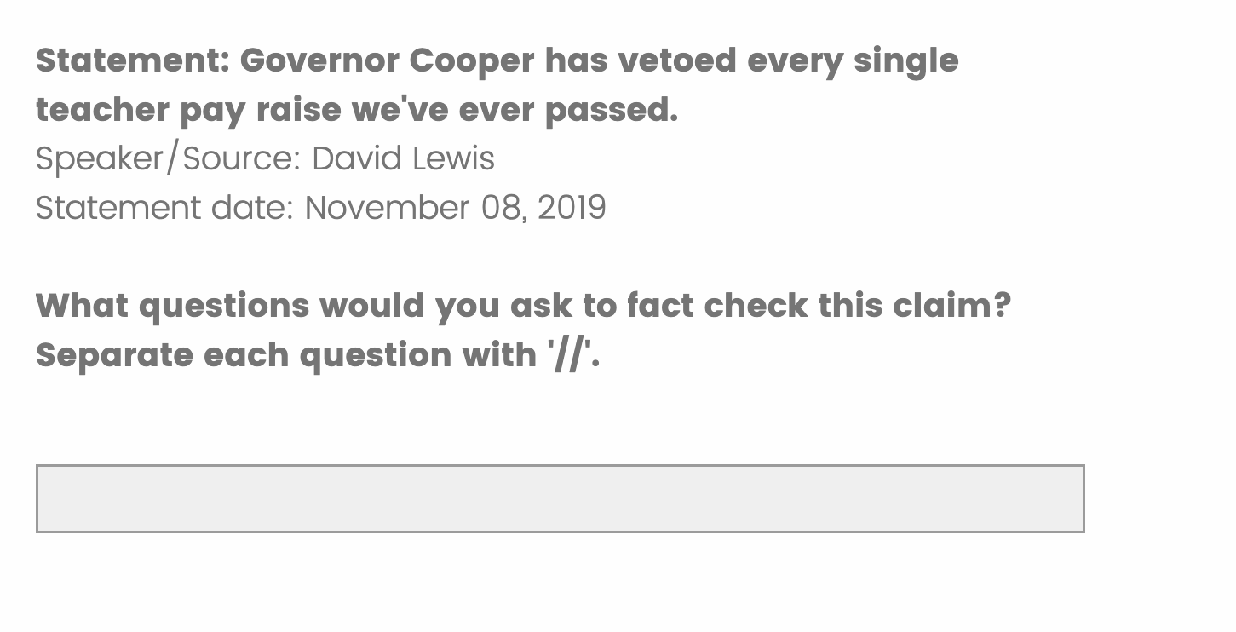
Reference Example Task 3:
Statement: Immigrants wanted by ICE have victimized tens of thousands of children in North Carolina.
Speaker/Source: Dan Forest
Statement date: November 25, 2019
Instruction: Read the analysis and deduce what question the journalist must have asked while fact checking this claim. Text boxes are provided after every paragraph. If there is more than one question that you can think of, from the same paragraph, separate them with '//' in the same text box. Be as detailed as you can. If you cannot think of a question corresponding to a paragraph, leave the text box blank. Extra text boxes are provided for all claims to enter more questions.
(Note: This is a sample list of questions. It is not an exhaustive list.)
North Carolina politicians are divided over what should be done with undocumented immigrants after they're arrested. After the 2018 election, a new wave of Democratic sheriffs vowed to halt their jails' practice of holding undocumented immigrants on behalf of U.S. Immigration and Customs Enforcement, known as ICE. The sheriffs' position: if a judge or magistrate grants a person's release, he or she should be released -- regardless of immigration status. In response, some Republicans said the sheriffs were endangering public safety, and the GOP-controlled North Carolina legislature passed a bill that would require sheriffs to comply with ICE requests. But Democratic Gov. Roy Cooper vetoed it.
Separate each question with '//'.
What is the enforcement policy of illegal immigration in North Carolina?
Lt. Gov. Dan Forest, who's running for governor against Cooper, recently spoke at a press conference about the impact of the Democrats' decisions. Speaking about immigrants wanted by ICE, Forest encouraged the media to use certain terms. "Please think carefully about the words that you use. Many of you are going to be struggling to try not to use words like illegal and alien and words like criminal and rapist and murder and child sex offender," he said. "But if we have tens of thousands of children in our state -- tens of thousands of children in our state that have been victims of these violent criminals already, you have a lifetime, tens of thousands of lifetimes of victims in our state that are going to grow up with that on their mind." His speech can be viewed in a YouTube video, and his claim was first flagged by the liberal American Independent website.
Separate each question with '//'.
What is the context surrounding the statement?
Forest's claim stuck out to us because it's not specific to a number or timeframe, but loaded with a hefty accusation. So we wondered: have undocumented immigrants victimized "tens of thousands" of children in North Carolina? To answer this question, we knew we'd need a credible source that tracks: violent crimes committed by immigrants in the U.S. illegally, the age of the victims of those crimes, and a state-level breakdown of those statistics. Contacted by PolitiFact, Forest's campaign cited news stories about crimes committed by undocumented immigrants. But none of the stories verify Forest's claim that "tens of thousands" of children have been victimized by undocumented immigrants.
Separate each question with '//'.
One big reason Forest's claim can't be verified: There is no federal government database or study tracking how many people have been victimized by undocumented immigrants or the age of the victims. Forest's campaign says they meant the word "victim" in a general sense as much as a legal one. We'll get to his argument later. But first, let's look at the legal meaning of what Forest said, and whether there's data to back it up. "The thing is, it's very easy to identify individual cases and want to extrapolate up. But that is a major, major fallacy in statistics," said Charis E. Kubrin, professor of criminology, law and society at the University of California Irvine. She called Forest's claim "very vague and problematic."
Separate each question with '//'.
Is there a source that tracks the immigration state of offender?
Generally speaking, Forest's claim is similar to others made by Republicans. President Trump, for instance, frequently expresses concern about crimes committed by immigrants who are in America illegally. But the lack of data makes it difficult to get a clean look at claims like the one Forest made. ICE doesn't track crimes committed by immigrants in the United States illegally, nor does it track the age of victims of those crimes, Lindsay Williams, spokeswoman for the agency, told us in an email. North Carolina-specific data isn't available, either. Neither the NC Attorney General's Office, the State Bureau of Investigation, nor the Department of Public Safety tracks the statistic Forest mentioned, according to spokespeople for those agencies. Texas is the only state that tracks the immigration status of those convicted on the state level, said Alex Nowrasteh, director of immigration studies at the Cato Institute, a libertarian think tank.
Separate each question with '//'.
Are records kept regarding crimes committed by illegal immigrants?// Are records kept regarding the age of the victims of the violent crimes committed by illegal immigrants?
Forest spokesman Andrew Dunn emailed us a list of news stories to back up the Lt. Governor's statement. One was a story by WBTV that details 1,020 criminal charges and 407 convictions for immigrants sought by ICE in 2019 but released from NC jails before ICE could obtain custody. But many of those charges were for driving offenses, larceny and other nonviolent crimes. And it's unclear whether the charged immigrants were convicted, or if their victims were children. "Two of those examples identify children as the victim," Nowrasteh said. To back up his claim, Forest would "need 10,000 times as many examples." Dunn also suggested the word "victim" refers to an emotional toll on children who aren't directly involved in a crime. He noted that, in Charlotte, "hundreds of families were evacuated from their homes and countless thousands impacted during a 9-hour SWAT standoff with an illegal immigrant accused of kidnapping, strangulation and assault on a female." Still, those numbers and anecdotes don't back up Forest's original claim.
Separate each question '//'.
What is the statistics about violent crimes committed by illegal immigrants? // How many crimes committed by illegal immigrants were towards children in North Carolina?

-------------------------------------------------------------------------------------------------------------------------------
Task 3

